Warning: Non-numeric data was found. This could mean that you are attempting to
retrieve data from a channel or field that has non-numeric points. Set
'OutputFormat' property to 'table' or 'timetable' to read non-numeric data.
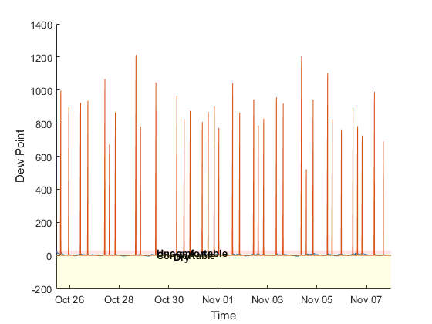
Published with MATLAB® R2016a

