Fitts' Law Target Selection Study: Analyzing Performance with Mouse and Touchpad

By Somesh Joshi & Ishaan Singh Yadav

**Introduction:**

This study was performed with the purpose of measuring the performance differences between a mouse and a touchpad using Fitts law. Fitts law predicts the time required to move to a target as a function of the distance to the target and its size. This experiment involved a controlled setup where participants performed target selection under varying conditions of target size and distance.

**Methodology:**

**Apparatus:**

We created an application for our experiment using Unity. The setup included three target sizes (0.01m, 0.02m, 0.03m) and three distances (0.1m, 0.2m, 0.3m). The targets were arranged in a circular pattern and each click was logged with the following information as string and integers:

* Technique (mouse or touchpad)
* Size of the target
* Distance to the target
* Time it took to reach the target
* Whether the target was correctly selected

**Procedure:**

There were three participants in the study who were asked to click one of nine circles that would sequentially glow red. After that participant had completed clicking all nine within a specific combination of target size and distance, the screen would change to a new combination and the participants were asked to repeat the process again.

This was done nine times within nine combinations and twice by each participant to compare the performance of a mouse against a touchpad. Each participant performed 162 trials which allowed us to cover all combinations of target sizes and distances.

**Results:**

The data collected was then analyzed to determine the average selection time for each combination of target size and distance. The results revealed that the mouse generally outperformed the touchpad in terms of speed, particularly for small targets with greater distances. These findings were highlighted further through the creation of a Fitts law graph of Time vs. Index of Difficulty (Figure 1)

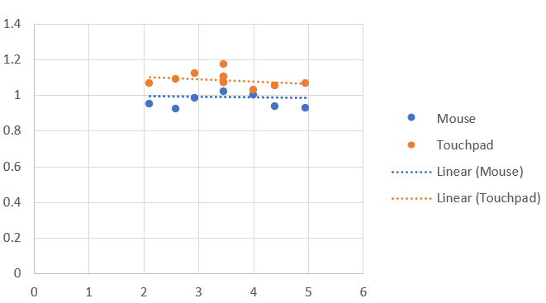

Figure 1

**Observations:**

* Linear Trendlines: The graph includes linear trendlines for both input methods, indicating a general trend. The dotted lines suggest that the mouse consistently performs faster than the touchpad across varying levels of difficulty.
* Performance Difference: There is a noticeable difference in performance, with the mouse (blue points) showing lower average movement times compared to the touchpad (orange points). This difference suggests that participants found it easier to select targets using the mouse.
* Consistency: The mouse data points appear more consistent, while the touchpad data points show more variation. This could indicate that the mouse offers more stable control, which is particularly beneficial at higher difficulties (higher IDs).
* Range of IDs: The range of IDs appears to span from approximately 2 to 5, which aligns with typical Fitts' Law experiments. Both input methods show increased movement time with increasing ID, consistent with Fitts' Law predictions.

**Collaboration and Challenges:**

The project was divided between two members who were in completely opposite time zones. Ishaan focused on completing the application development, including setting up the target selection interface and logging mechanisms and Somesh was responsible for testing, troubleshooting, data collection, and analysis. We faced challenges in ensuring consistent data logging, particularly with touchpad sensitivity, which we mitigated by refining the application settings. Finding an appropriate time for meetings was also difficult as per the difference in time zones but compromises from both members ensured consistency.

**Conclusion:**

The graph supports our hypothesis that the mouse allows for a more consistent and accurate target selection, especially as tasks become more difficult. The linear trendlines reinforce the applicability of Fitts' Law in predicting user performance with different input devices. The greater variation in the touchpad data could reflect the challenges users face with this input method, such as weak precision and control.

Overall, the data extracted from this experiment offers an effective comparison of performance for the two input methods, highlighting the advantages of using a mouse for tasks requiring precise control.