PRISM Vertical Shorts
Procedure: cutting a long episode into 9:16 shorts
Vertical Shorts cuts a long-form programme into stand-alone 9:16 clips. The AI Vision model rates the picture, the dialogue is transcribed, and a story model proposes stretches that stand on their own. You review, adjust and render.
Note: the screenshots are from the real PRISM screens, using a synthetic sample episode and mocked AI services, so the moments and scores are illustrative.

1. Overview
- Sign in (section 2) and create or open a project for the programme (section 3).
- Source: pick the video, set length, and analyse.
- Moments: review, trim, reframe and caption each short.
- Render, then play and download from "Shorts in this project".

2. Sign in to PRISM
- Open PRISM in your browser at the address your administrator gave you.
- If the Sign in box does not appear, press "Log in" at the top right.
- Type your Username and Password (the credentials issued to you by your PRISM administrator), then press Continue. If your account has two-step verification, enter the 6-digit code from your authenticator app, or a backup code, on the next screen.
- No account yet? Press "Request access". An administrator must approve it before you can sign in. After too many wrong attempts the form pauses for a few minutes.
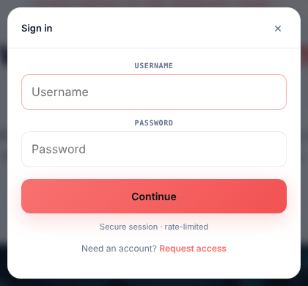
Figure 1. Sign in box (see steps 1 to 4)

3. Create a new project
Shorts are made inside a project: the episode they are cut from. Create the project first, then make its shorts there. Everyone with access to Vertical Shorts sees every project.
- Press Vertical Shorts in the left menu. The Projects list opens (Figure below).
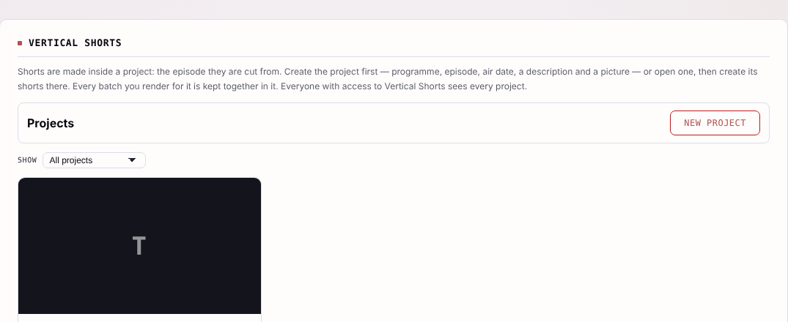
Figure 2. Vertical Shorts project list (see steps 1 and 2)
- Press New project at the top right. The New project form opens.
- Fill in the form (the table below says what goes in each field). Only the Programme title is required.
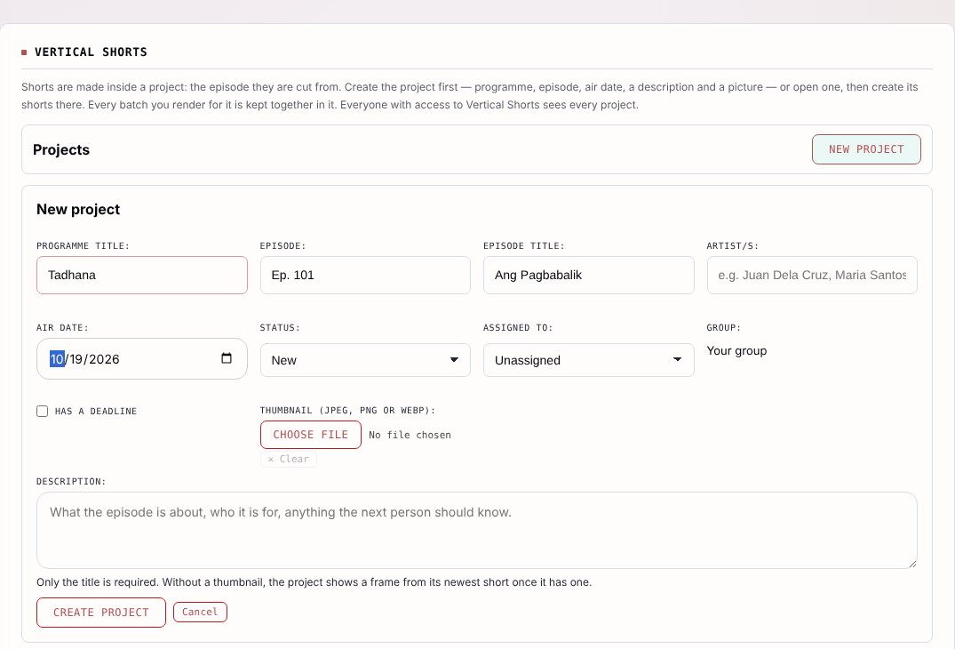
Figure 3. New project form, filled in as an example (see steps 2 and 3)
Field | What to enter
Programme title (required) | The show name, for example Tadhana.
Episode | The episode number, for example Ep. 101.
Episode title | The title of that episode, for example Ang Pagbabalik.
Artist/s | Optional. The cast to feature, separated by commas.
Air date | The date the episode airs. The form suggests today.
Status | New for a project just started; change it as the work moves on.
Assigned to | The team member responsible, or Unassigned.
Group | Shows your own group. It is not typed in.
Has a deadline | Tick it to enter a due date.
Thumbnail | Optional picture (JPEG, PNG or WebP). Without one, the project shows a frame from its newest short once it has one.
Description | Optional notes: what the episode is about, who it is for, anything the next person should know.

- Press Create project. The project page opens with its title, episode, air date and status at the top, and the Source screen below, ready for the video (Figure below). Press Cancel instead to close the form without saving.
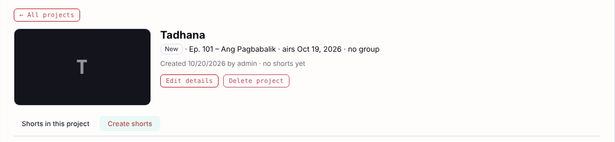
Figure 4. The new project page (see step 4)
- Later, press Edit details to change any field, or Delete project to remove it. Press All projects to go back to the list, and open any project by clicking it.

4. Source screen
- Choose the long-form video with Browse library. Add optional captions (.srt/.vtt/.scc) if you have them.
- If the episode has several files, press "This episode comes in more than one part".
- Set "What to make", the length of each short (for example 20 to 40 s), the number of moments to find, and the spoken language (Auto-detect for mixed Filipino and English).
- Press Analyse. A queue card shows progress. When it says "Ready to review" the Moments screen opens.
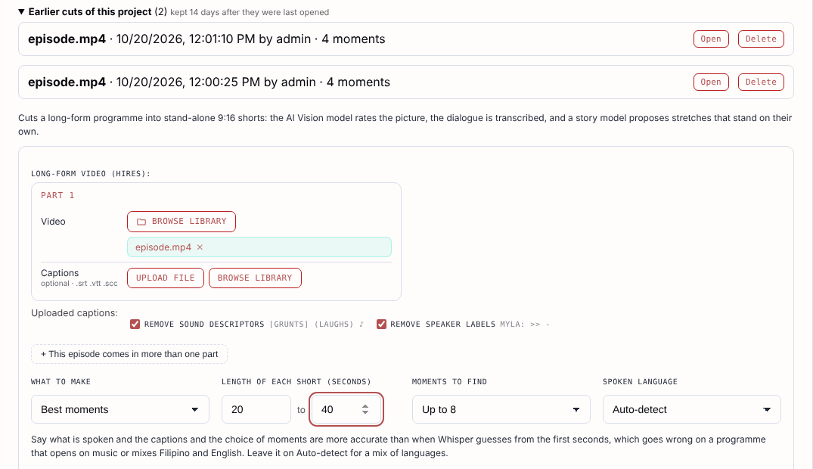
Figure 5. Source screen: video, length, moments and language (see steps 1 to 4)
Earlier cuts of this project are listed at the top. Press Open to return to one without re-analysing; they are kept 14 days after last opened.

5. More options
Open "More options" to steer the result.
- Feature / avoid: say what to prefer or keep out of the shorts.
- Names and terms: character and place names, so the captions spell them right.
- Leave out of every short: billboards, sponsor reads, credits, narration, host talk, recaps, teasers, black, logos, title cards, and talking heads. All are ticked by default; untick one to allow it.
- Leave out these parts: time ranges such as 0:00-1:45, 22:10-23:30 that no moment may include.
- Advanced: choose the AI vision model, story model, and frames to rate.
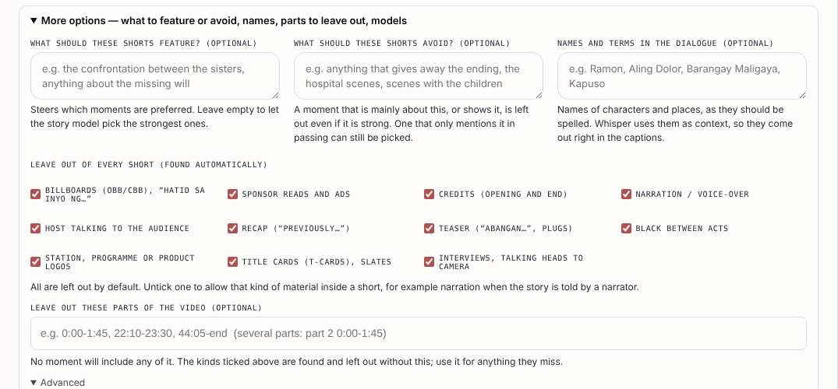
Figure 6. More options

6. Output settings
Output settings holds the defaults for the batch. They are saved to the project, and you can save a set as a template.
- Framing: Auto reframes two-shots by splitting the screen, else follows the subject. "Follow the speaker" tracks who talks.
- Cuts: how pieces join (short crossfade by default).
- Captions: burn in, size, position over a split screen (on the join between the panes or low), and Word highlighting.
- EP labels: opening label (for example "EP {n}") and closing label (for example "NEXT: EP {n} >>"). Type any wording; {n} is the number.
- Delivery: file format and audio level (for example -14 LUFS for online video).
- Ending: the last short can fade to black, so the cliffhanger is not cut or held.
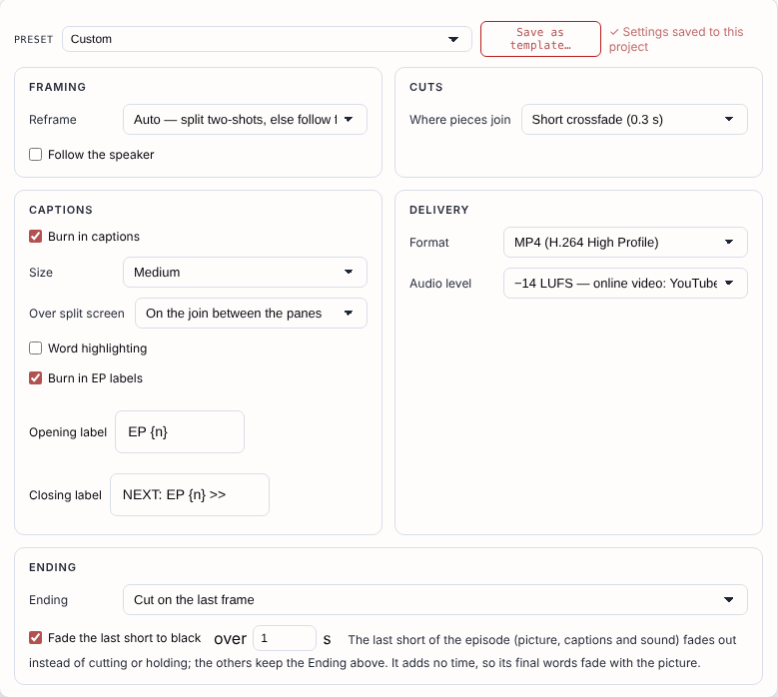
Figure 7. Output settings panel

7. Moments screen
The left list holds the proposed shorts with a score. Use "Add your own moment" for a cut the AI missed.
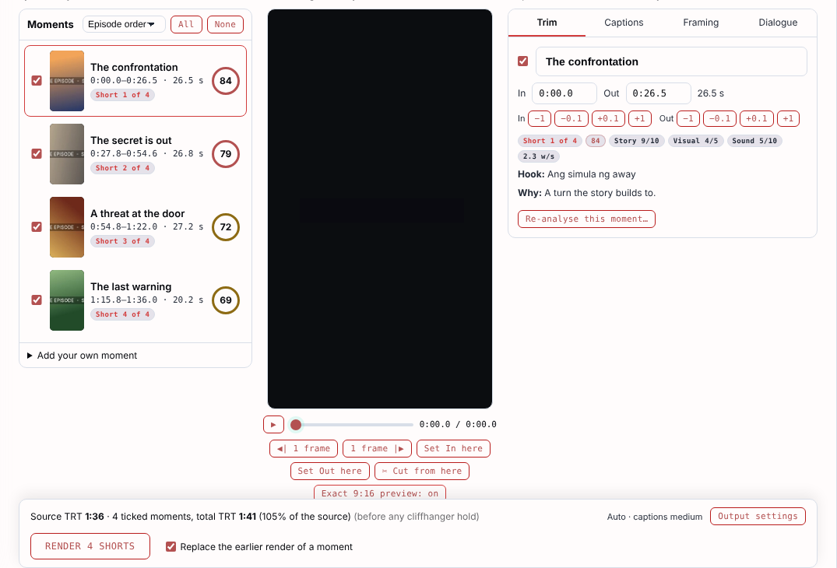
Figure 8. Moments list, player and Trim tab
- Untick a moment in the left list to leave it out. Select one to preview it in the 9:16 player.
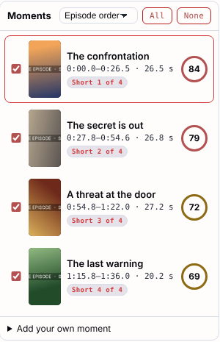
Figure 9. Moments list: tick, untick and select
- Trim tab: type In and Out, or use the -1, -0.1, +0.1, +1 buttons; in the player use 1 frame, Set In here, Set Out here and Cut from here. The title can be edited. Use Re-analyse this moment to ask the AI again.
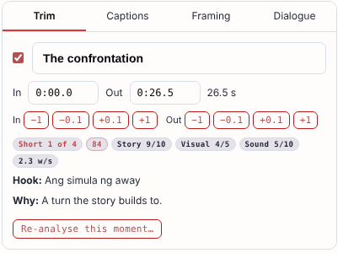
Figure 10. Trim tab: In and Out, score, hook and reason

8. Framing
- Open the Framing tab. Each shot of the moment shows a dashed crop box.
- For each shot choose As worked out, Centre crop, Crop here (slide the box), Whole frame, or Split screen (two people stacked).
- Press "Show in the preview" to see the result, captions and all, in the 9:16 player. The 9:16 preview does not autoplay; press play when ready.
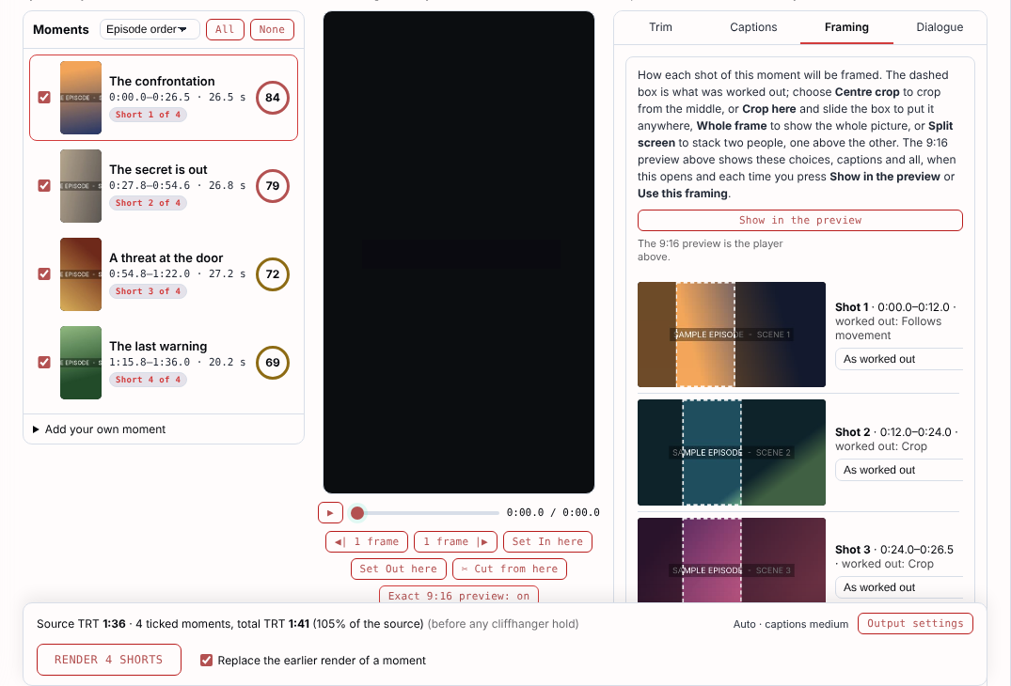
Figure 11. Framing tab
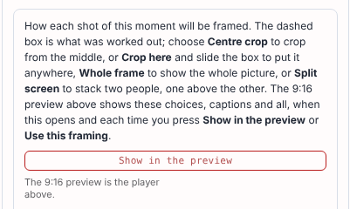
Figure 12. Framing options per shot and the Show in the preview button

9. Captions and dialogue
The Captions tab edits the caption text and timing of the burned-in subtitles. The Dialogue tab shows the transcript lines for the moment.
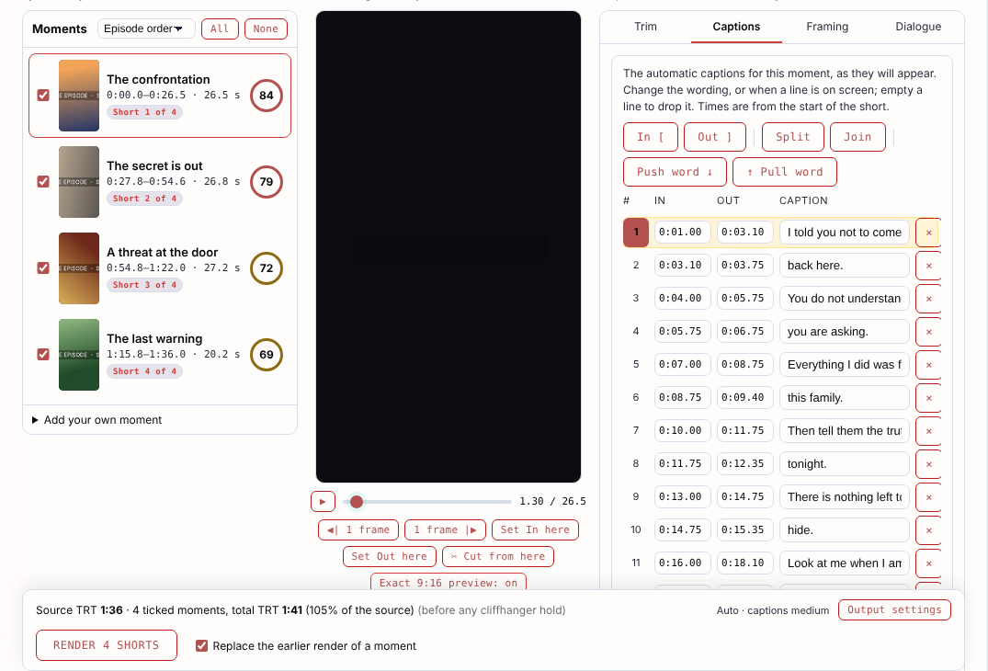
Figure 13. Captions tab
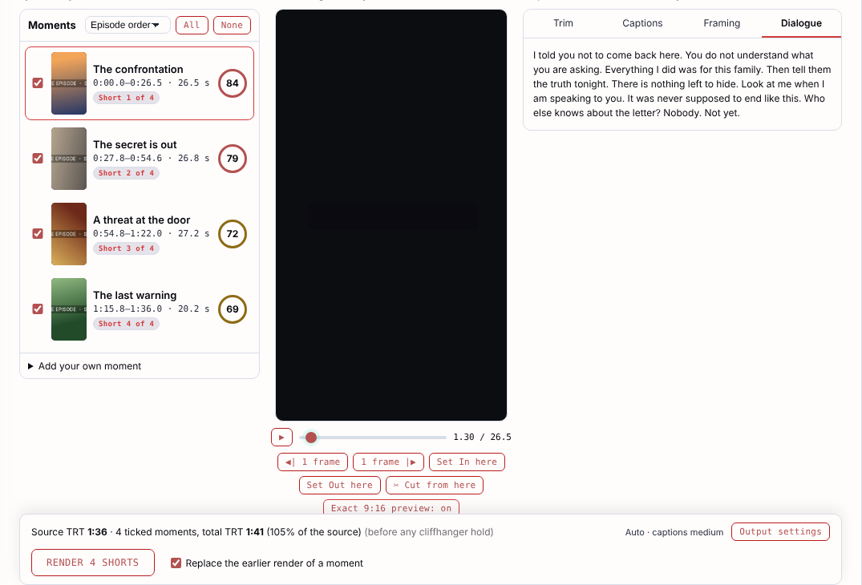
Figure 14. Dialogue tab

10. Render
- Check the footer: ticked moments, total running time against the source.
- Leave "Replace the earlier render of a moment" ticked to re-render a single short in place.
- Press Render N shorts. The queue shows each short as it encodes. A light preview copy is made for smooth playback over Wi-Fi or VPN.
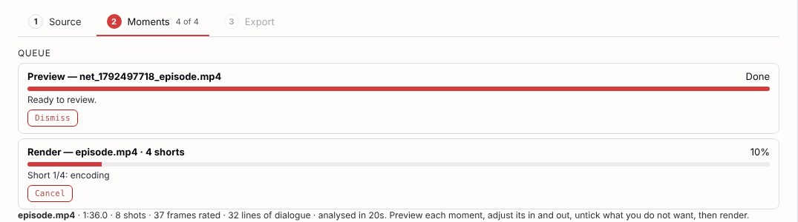
Figure 15. Render progress in the queue

11. Results
When finished, press "Show the shorts", or open the "Shorts in this project" tab. Each short shows its title, length, size and shot treatment. Click to play; download MP4 or SRT, edit Captions, or use "Download all (.zip)".
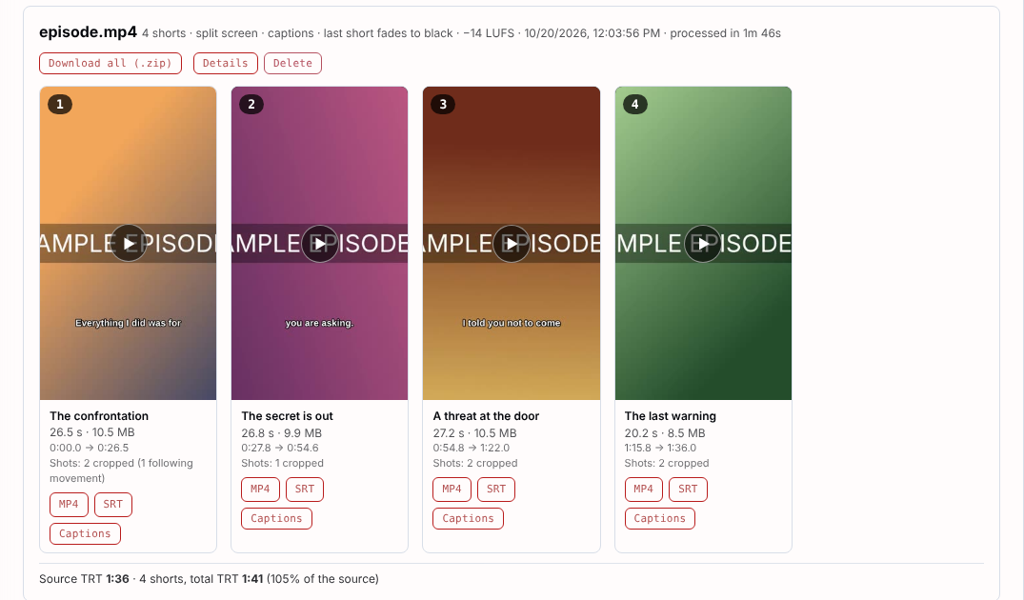
Figure 16. Shorts in this project

12. Tips
- Re-rendering one short keeps its closing label and cliffhanger.
- Mini-drama chapters can end shorter than the minimum; the leftover at the end of a stretch is not padded.
- If something unwanted appears (a billboard, a host shot), add its time range under "Leave out these parts" and re-analyse.
- Settings are saved per project and restored on reload.

