VN priority hyperparameter analysis

Purpose and recommendation
This study asks a practical configuration question: which variable-neighbourhood shift ladder and iteration budget should the project use for its priority-based heavy-maintenance optimiser? It compares four deliberately grounded ladders at 200, 400 and 800 outer-loop iterations on three saved forecast states. The optimiser, maintenance rules and selection policy are unchanged, so the comparison isolates only those two hyperparameters.
The cross-dataset recommendation is Current live ladder with max_iters=400. This is a practical choice, not a claim that one run proved universal superiority. Several 400- and 800-iteration results are exactly tied on the complete lexicographic quality score. In those cases 400 is selected by the approved lower-budget tie-break, because spending the extra iterations did not improve the endpoint. Each timing is one observed run, while quality is deterministic for the fixed inputs.

Method and datasets
The matrix contains 36 trials: three datasets multiplied by four ordered shift strategies and three iteration budgets. Every trial begins from a fresh deep copy of its dataset. The quality window is 21 January 2026 through 18 January 2038, inclusive. Events outside that reporting window remain in the full model so that overlaps, sequence rules and due-date resets are still checked across the complete maintenance horizon.
The original workbook supplies the unstaggered starting point. The moderate- and wide-stagger workbooks are loaded with their saved opening due clocks and sequence positions; reconstructing those values from the spreadsheets alone would describe a different maintenance state. Checks already commenced before the reporting window are frozen. After each search, the endpoint is replayed through the production rule validator and its daily availability is independently rebuilt from aircraft occupancy masks.
Quality is ordered lexicographically: maximise minimum fleet availability first, then minimise population standard deviation, then maximise mean availability. A gain in smoothness or mean cannot compensate for losing one aircraft from the minimum. Within each dataset, exact score ties share a competition rank. Runtime only resolves ties after quality, rank and budget rules; it never outranks schedule quality.

Parameter choices
The earlier tuned baseline uses four half-step neighbourhoods, ending with (-3, -1, 1, 3). The current live ladder instead uses seven symmetric pairs from ±56 down to ±1. Dense pairs adds ±21 while retaining a paired structure, and the fourth strategy adds an initial ±42 level to the earlier baseline. These alternatives test whether broad first moves, denser intermediate moves or the historical mixed-width levels help the deterministic search.
At each outer pass, the search examines shift sets in their listed order. Within one shift set it inspects maintenance priority levels from worst availability upward, stops at the first level containing an improving candidate, and accepts that level's best lexicographic candidate. Only one move can be accepted per pass. A pass with no improvement records local exhaustion; otherwise the run stops when its iteration budget is consumed.
The 200 budget is a deliberately short run, 400 is the live default, and 800 is a convergence check. There are no random seeds, selection-policy variants or repeated quality runs. This keeps the experiment interpretable: endpoint differences come from the ordered shifts and available number of passes rather than from changing several optimiser mechanisms at once.
Strategy | Ordered shift sets
Earlier tuned baseline | -28,-14,14,28 | -14,-7,7,14 | -7,-3,3,7 | -3,-1,1,3
Current live ladder | -56,56 | -42,42 | -28,28 | -14,14 | -7,7 | -3,3 | -1,1
Dense paired ladder | -28,28 | -21,21 | -14,14 | -7,7 | -3,3 | -1,1
Earlier tuned baseline plus ±42 | -42,42 | -28,-14,14,28 | -14,-7,7,14 | -7,-3,3,7 | -3,-1,1,3

Original dataset
For Original, the reported winner is Earlier tuned baseline plus ±42 at max_iters=400. It records minimum availability 18, population standard deviation 1.401929, and mean availability 21.707601. The minimum is considered first, so lower-ranked rows with a smoother profile cannot displace it if they lose minimum availability.
The run accepted 302 moves over 303 outer passes and stopped by local exhaustion. Its 800-iteration counterpart has the exact same lexicographic score. The 400 result is therefore selected by the lower-budget tie-break, not because 400 produced a singularly stronger endpoint.
The table keeps all twelve configurations visible so that the recommendation is auditable. Equal competition ranks indicate identical full score tuples. Runtime is intentionally omitted from the main quality columns because it is only a late tie-breaker after dataset rank, worst rank and budget.
Rank | Strategy | Budget | Minimum | Std | Moves
1 | Earlier tuned baseline plus ±42 | 400 | 18 | 1.4019 | 302
1 | Earlier tuned baseline plus ±42 | 800 | 18 | 1.4019 | 302
3 | Earlier tuned baseline | 400 | 18 | 1.4041 | 300
3 | Earlier tuned baseline | 800 | 18 | 1.4041 | 300
5 | Current live ladder | 400 | 18 | 1.4097 | 332
5 | Current live ladder | 800 | 18 | 1.4097 | 332
7 | Dense paired ladder | 400 | 18 | 1.4106 | 315
7 | Dense paired ladder | 800 | 18 | 1.4106 | 315
9 | Earlier tuned baseline | 200 | 18 | 1.4297 | 200
10 | Earlier tuned baseline plus ±42 | 200 | 18 | 1.4349 | 200
11 | Current live ladder | 200 | 18 | 1.4611 | 200
12 | Dense paired ladder | 200 | 17 | 1.4501 | 200

Moderate stagger
For Moderate stagger, the reported winner is Current live ladder at max_iters=400. It records minimum availability 19, population standard deviation 0.883419, and mean availability 21.469071. The minimum is considered first, so lower-ranked rows with a smoother profile cannot displace it if they lose minimum availability.
The run accepted 367 moves over 368 outer passes and stopped by local exhaustion. Its 800-iteration counterpart has the exact same lexicographic score. The 400 result is therefore selected by the lower-budget tie-break, not because 400 produced a singularly stronger endpoint.
The table keeps all twelve configurations visible so that the recommendation is auditable. Equal competition ranks indicate identical full score tuples. Runtime is intentionally omitted from the main quality columns because it is only a late tie-breaker after dataset rank, worst rank and budget.
Rank | Strategy | Budget | Minimum | Std | Moves
1 | Current live ladder | 400 | 19 | 0.8834 | 367
1 | Current live ladder | 800 | 19 | 0.8834 | 367
3 | Dense paired ladder | 800 | 19 | 0.8876 | 414
4 | Dense paired ladder | 400 | 19 | 0.8912 | 400
5 | Earlier tuned baseline plus ±42 | 400 | 19 | 0.8922 | 314
5 | Earlier tuned baseline plus ±42 | 800 | 19 | 0.8922 | 314
7 | Earlier tuned baseline | 400 | 19 | 0.8985 | 358
7 | Earlier tuned baseline | 800 | 19 | 0.8985 | 358
9 | Earlier tuned baseline plus ±42 | 200 | 19 | 0.9510 | 200
10 | Current live ladder | 200 | 19 | 0.9800 | 200
11 | Earlier tuned baseline | 200 | 19 | 1.0003 | 200
12 | Dense paired ladder | 200 | 19 | 1.0315 | 200

Wide stagger
For Wide stagger, the reported winner is Current live ladder at max_iters=400. It records minimum availability 20, population standard deviation 0.586797, and mean availability 21.475006. The minimum is considered first, so lower-ranked rows with a smoother profile cannot displace it if they lose minimum availability.
The run accepted 291 moves over 292 outer passes and stopped by local exhaustion. Its 800-iteration counterpart has the exact same lexicographic score. The 400 result is therefore selected by the lower-budget tie-break, not because 400 produced a singularly stronger endpoint.
The table keeps all twelve configurations visible so that the recommendation is auditable. Equal competition ranks indicate identical full score tuples. Runtime is intentionally omitted from the main quality columns because it is only a late tie-breaker after dataset rank, worst rank and budget.
Rank | Strategy | Budget | Minimum | Std | Moves
1 | Current live ladder | 400 | 20 | 0.5868 | 291
1 | Current live ladder | 800 | 20 | 0.5868 | 291
3 | Dense paired ladder | 400 | 20 | 0.6077 | 362
3 | Dense paired ladder | 800 | 20 | 0.6077 | 362
5 | Earlier tuned baseline plus ±42 | 400 | 20 | 0.6090 | 316
5 | Earlier tuned baseline plus ±42 | 800 | 20 | 0.6090 | 316
7 | Current live ladder | 200 | 20 | 0.6379 | 200
8 | Earlier tuned baseline plus ±42 | 200 | 20 | 0.6928 | 200
9 | Earlier tuned baseline | 400 | 19 | 0.6333 | 309
9 | Earlier tuned baseline | 800 | 19 | 0.6333 | 309
11 | Earlier tuned baseline | 200 | 19 | 0.7102 | 200
12 | Dense paired ladder | 200 | 19 | 0.7303 | 200

Cross-dataset comparison
The ranked-quality chart separates the three datasets because their starting states differ. The wide-stagger data reaches the highest minimum availability, followed by moderate stagger and then the original forecast. That ordering must not be described as an optimiser gain: staggering changed the input maintenance state before this experiment began. The fair comparison is among configurations within each panel, using the displayed minimum and horizontal standard-deviation position together.
Across all datasets, the selected shared setting is Current live ladder at 400 iterations. Its ranks provide the best approved compromise when one operational setting is required. The original dataset nevertheless has a different dataset-level winner, showing why a single recommendation should be framed as a robust shared choice rather than the winner of every panel. Dataset-specific settings remain reasonable when separate configuration and governance are acceptable.
Exact 400/800 ties occurred for: Original / Earlier tuned baseline; Original / Current live ladder; Original / Dense paired ladder; Original / Earlier tuned baseline plus ±42; Moderate stagger / Earlier tuned baseline; Moderate stagger / Current live ladder; Moderate stagger / Earlier tuned baseline plus ±42; Wide stagger / Earlier tuned baseline; Wide stagger / Current live ladder; Wide stagger / Dense paired ladder; Wide stagger / Earlier tuned baseline plus ±42. These matches cover the full score tuple, not merely the minimum availability. The 400 configurations therefore win through the lower-budget tie-break whenever all earlier quality and rank criteria remain equal. This rule avoids presenting an unchanged 800-iteration endpoint as additional evidence of quality.
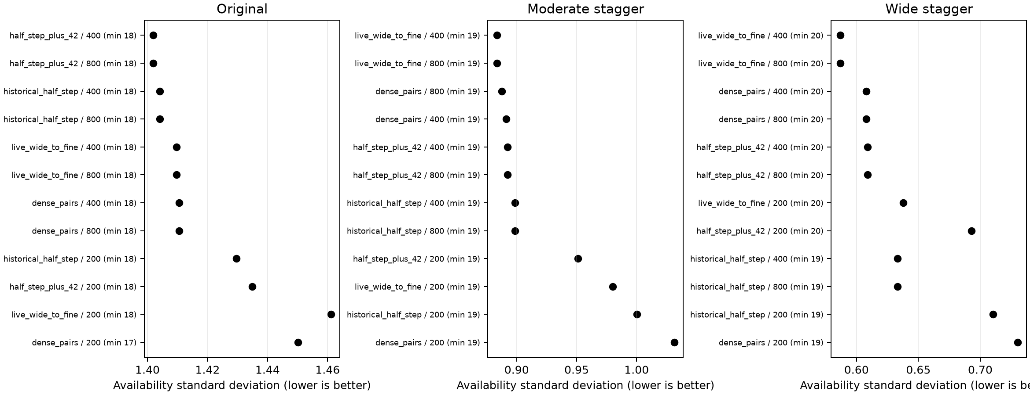

Runtime and convergence
Of the 36 searches, 23 ended by local exhaustion and 13 reached their iteration cap. Local exhaustion means an entire outer pass found no improving candidate under any configured shift set. The convergence chart should therefore be read with both accepted moves and the 'local' annotations: a flat line caused by exhaustion is different from a run that simply stopped at its budget.
Observed search times ranged from 2.31 to 15.72 seconds in this environment. Each bar is one observed run; it excludes workbook loading, validation, charting and report construction. The values are useful for describing practical scale, but they are not averages and do not support variance, confidence or significance claims. Machine load could change a later timing without changing the deterministic endpoint.
The exact 400/800 quality ties are the clearest convergence signal in this small study. Where both budgets finish at the same score and endpoint, 800 adds work without a measured quality return. Some 200-iteration runs remain capped and rank lower, so 200 is not a safe general replacement. Together these observations support 400 as a balanced default while preserving 800 as a diagnostic budget for future materially different datasets.
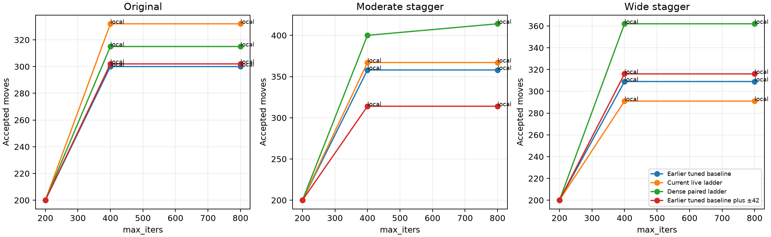
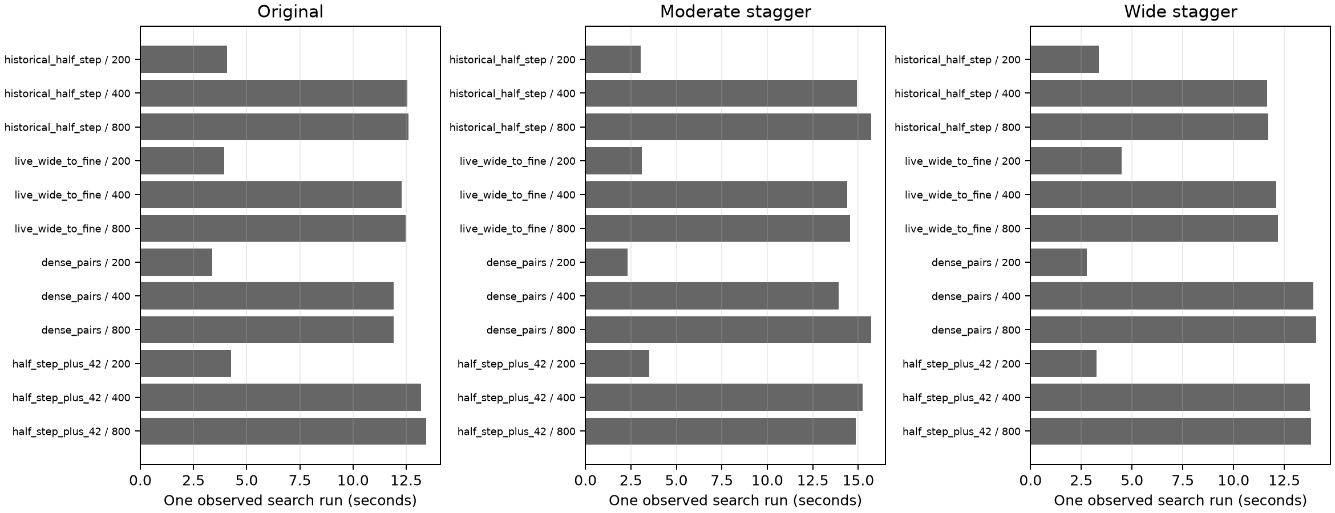

Limitations
This is a descriptive benchmark over three related forecast states, not a statistical experiment over independent samples. Determinism justifies one quality run per configuration, but one observed runtime cannot quantify timing variability. The matrix also covers four motivated ladders rather than every possible shift sequence, so the selected setting is the best practical choice among those tested and is not proof of a global optimum.
The objective summarises daily fleet availability through its minimum, population standard deviation and mean. It does not represent every operational preference. In particular, the saved loose, medium and tight operational scenarios are not enforced inside this optimiser. Those scenarios must be assessed separately before an optimised schedule is adopted. Dataset differences likewise reflect different opening states and cannot be attributed solely to the optimiser.
Rule compliance is strong within the implemented maintenance model: legal windows, same-aircraft overlap, check sequence and due resets are replayed, and availability is independently reconstructed. It does not guarantee that source assumptions are complete or that unmodelled engineering and resource constraints will be satisfied. Recommendations should therefore be reviewed with domain owners rather than applied as an automatic production change.

Practical recommendation and reproduction
When one setting must serve all three forecasts, use Current live ladder with max_iters=400. The choice keeps the live wide-to-fine search behaviour and avoids paying for 800 iterations where 400 and 800 are exactly tied. If each dataset may be configured separately, use its rank-one result from the preceding sections, while retaining the same validation and change-control process.
Treat 400 as a default rather than a permanent constant. Rerun this deterministic matrix when maintenance rules, fleet size, opening clocks, reporting dates or the production selection policy materially change. Keep runtime secondary to quality, and retain the endpoint hashes so that repeated runs can confirm deterministic equality. Do not infer extra confidence by repeating unchanged deterministic quality runs.
From the repository root, reproduce the study with: python3 analysis/vn_hyperparameter_analysis.py. The command loads the three approved inputs, runs the exact 36-trial matrix, validates all endpoints, and publishes JSON, CSV, three charts and this report only after the complete set succeeds. The production optimiser and source workbooks are not rewritten.

