Variable-neighbourhood parameter analysis
Use the wide-to-fine shift ladder (±56, ±42, ±28, ±14, ±7, ±3 and ±1 days) with a 400-iteration limit. It gave the strongest overall result across the three forecasts and was best on the moderate and wide stagger forecasts. The baseline ladder (±28, ±14, ±7, ±3 and ±1 days) reached the same minimum availability—18, 19 and 20 aircraft—but its day-to-day availability varied slightly more. The difference in standard deviation was 0.0037 to 0.0233 aircraft. The improvement is small, but it is consistent across all three forecasts.

What we tested
The analysis compared 13 ordered shift strategies on the original, moderate stagger and wide stagger forecasts. Each strategy was tested at 200, 400 and 800 iterations. The two slowest-converging strategies were also tested at 1600 iterations, giving 123 trials in total. A shift moves a candidate maintenance event earlier or later, and the optimiser accepts the move that gives the best improvement.
Results were ranked by minimum available aircraft first, then lower standard deviation, then higher average availability. Standard deviation measures how much daily availability changes across the forecast. Availability was measured from 21 January 2026 to 18 January 2038. All schedules passed the implemented maintenance checks.

Best results
Forecast | Best strategy | Iterations | Minimum | SD | Average
Original | Overlapping half-step sets plus ±42 | 400 | 18 | 1.4019 | 21.7076
Moderate stagger | Wide-to-fine ladder (±56 to ±1) | 400 | 19 | 0.8834 | 21.4691
Wide stagger | Wide-to-fine ladder (±56 to ±1) | 400 | 20 | 0.5868 | 21.4750

The forecasts begin from different maintenance states, so their availability levels should not be compared directly. The original forecast favoured the overlapping half-step ladder with ±42, while the wide-to-fine ladder was best on the two staggered forecasts. A single shared setting avoids changing the optimiser between forecasts for a very small loss on the original forecast: it kept the same minimum of 18 aircraft and increased standard deviation by only 0.0078 aircraft.

All strategies at 400 iterations
Strategy | Original | Moderate | Wide
Wide-to-fine ladder (±56 to ±1) | 18 / 1.4097 | 19 / 0.8834 | 20 / 0.5868
Overlapping half-step sets plus ±42 | 18 / 1.4019 | 19 / 0.8922 | 20 / 0.6090
Pairs from ±42 (±42 to ±1) | 18 / 1.4034 | 19 / 0.8886 | 20 / 0.6219
Dense paired ladder | 18 / 1.4106 | 19 / 0.8912* | 20 / 0.6077
Baseline (±28, ±14, ±7, ±3, ±1) | 18 / 1.4135 | 19 / 0.9067 | 20 / 0.6062
Overlapping half-step sets | 18 / 1.4041 | 19 / 0.8985 | 19 / 0.6333
Baseline steps in one set | 18 / 1.4093 | 19 / 0.9436 | 19 / 0.6680
Pairs from ±14 (±14 to ±1) | 18 / 1.4167 | 19 / 0.9550* | 20 / 0.6559
Overlapping sets without ±28 | 18 / 1.4152 | 19 / 0.9706* | 20 / 0.6757
Pairs from ±7 (±7 to ±1) | 18 / 1.4480* | 19 / 1.0812* | 20 / 0.7695*
Pairs from ±3 (±3, ±1) | 17 / 1.6104* | 19 / 1.2687* | 19 / 0.9929*
±1 only | 17 / 1.7650* | 18 / 1.5220* | 18 / 1.2258*
Baseline steps, fine first (±1 to ±28) | 17 / 1.7650* | 18 / 1.5220* | 18 / 1.2258*

Each result is minimum available aircraft / standard deviation. Lower standard deviation is better when minimum availability is equal. * indicates that the search reached the 400-iteration limit and may improve with more passes.
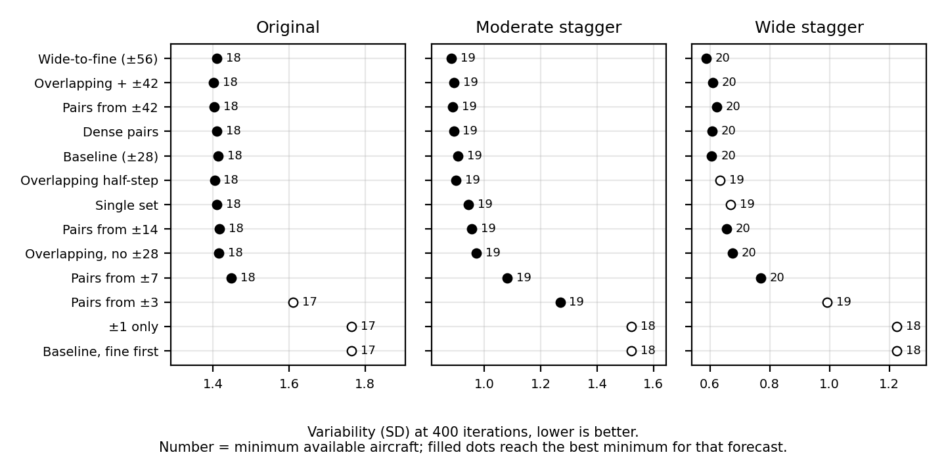
Figure 1. Standard deviation at 400 iterations. Point labels show minimum available aircraft; filled points reach the best minimum for that forecast.

What the results show
Large shifts help. Removing the largest shifts progressively increased variability. Ladders beginning at ±28, ±14 and ±7 retained the same minimum availability at 400 iterations, but ±3 and ±1 lost aircraft on at least two forecasts. In the recommended ladder, 36% of accepted moves were ±42 or ±56, showing that the larger shifts were actively used rather than simply adding search cost.
Search coarse to fine. Reversing the baseline ladder so that ±1 was searched first produced the same schedules as using ±1 alone through 800 iterations. Small improvements kept the search in the first neighbourhood, so it never reached the larger shifts. At 400 iterations this reduced the minimum availability from 18/19/20 aircraft to 17/18/18. Larger shifts should therefore be searched first.
Use 400 iterations. Every 200-iteration run reached its limit, so 200 is too short. The recommended ladder found no further improving move after 291 to 367 accepted moves on the three forecasts, and its 800-iteration results were identical. A 400-iteration limit captures its full result without unnecessary work.
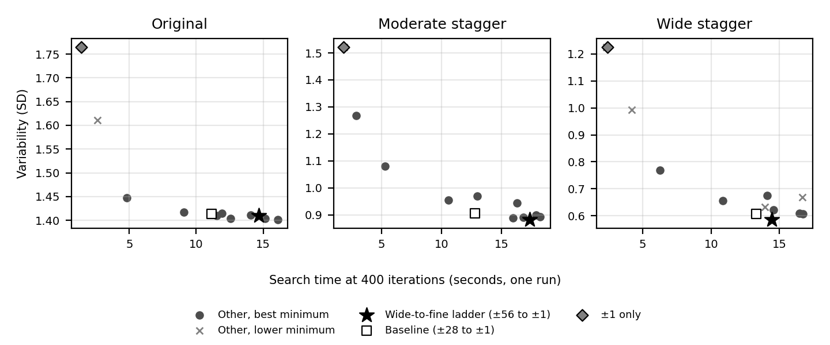
Figure 2. Search time against standard deviation at 400 iterations. Timings are single observations and are useful for relative comparison only.

Limits and next step
The analysis covers three related forecasts and deterministic runs, so it does not show variation across repeated trials or establish a global optimum. Differences between the leading strategies are only hundredths of an aircraft in standard deviation and may change on a different fleet or starting schedule. The optimiser also does not enforce the separate loose, medium and tight operational scenarios; those constraints still need review before deployment.
Keep the wide-to-fine ladder at 400 iterations as the shared setting. If simplicity is more important than the small reduction in variability, the ±28 baseline is a reasonable alternative because it preserves the same minimum availability. Repeat the comparison when the fleet, maintenance rules or starting schedule changes. The workbook contains the complete trial results.

