Robert Crimi

10/2/15

Learnability Analysis

1. In order from most complex to least complex.
   1. Axis-Aligned Rectangles. VC Dimension = 4

The following sets of 4 points can be shattered.

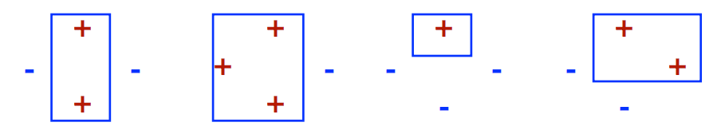

This combination of 5 points cannot be shattered.

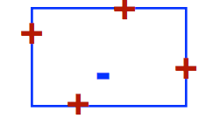

* 1. Arbitrary Hyperplanes. VC Dimension = 3

The following sets of 3 points can be shattered.

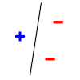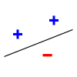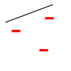

The following 4 points cannot be shattered.

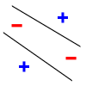

* 1. Hyperplanes passing through origin. VC Dimension = 1

A single point can always be shattered while if two points lie on the same line from the origin and one is positive and one is negative than no line can correctly classify both points.

1. For any sample m>0 and choice of labels:

Wxj = **π** (2-j + sum(2i-j y’j)

= **π** (2-j+(sum2i-j y’i)+y’j+sum(2iy’i))

= **π** (2-j+(sum2i-j y’i)+y’j)

= **π** (sum2-iy’i+2-j+y’j)

< **π** (sum(2-i+y’j))

< **π** (1+y’j)

> **π** y’j

So,

Sign(wxj) = {1 for yj = 1, -1 for yj = -1}

3) Assuming w = 1. The points **π/2, 3π/2, 5π/2, and 7π/2** cannot be shattered. For example, if the first and second points were positive and the third and fourth points were negative, this classifier would incorrectly classify the points.