Robert Crimi

October 9, 2015

SVM

1. I created a python script that looks similar to the knn homework. One difference was the filtering of training and test points not corresponding to 3’s or 8’s. Another difference is the use of an SVM classifier rather than a KNN classifier.
2. The following table shows the accuracy for specified kernels and regularization parameters. All runs were run limiting the data to 1000 samples.

|  |  |  |
| --- | --- | --- |
| Regularization Param (C) | Polynomial | RBF |
| 1 | 0.505150 | 0.960275 |
| 2 | 0.505150 | 0.966160 |
| 3 | 0.520844 | 0.965669 |
| 4 | 0.590976 | 0.968122 |
| 5 | 0.661599 | 0.967631 |
| 6 | 0.729769 | 0.968122 |
| 10 | 0.871015 | 0.966160 |

1. Below are examples of the linear kernel support vectors:

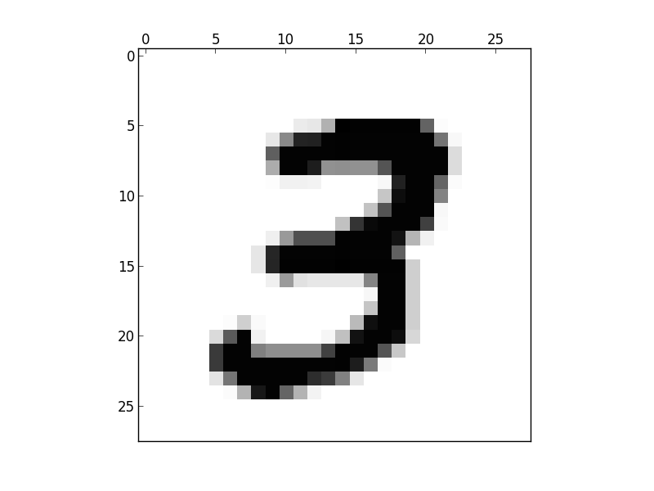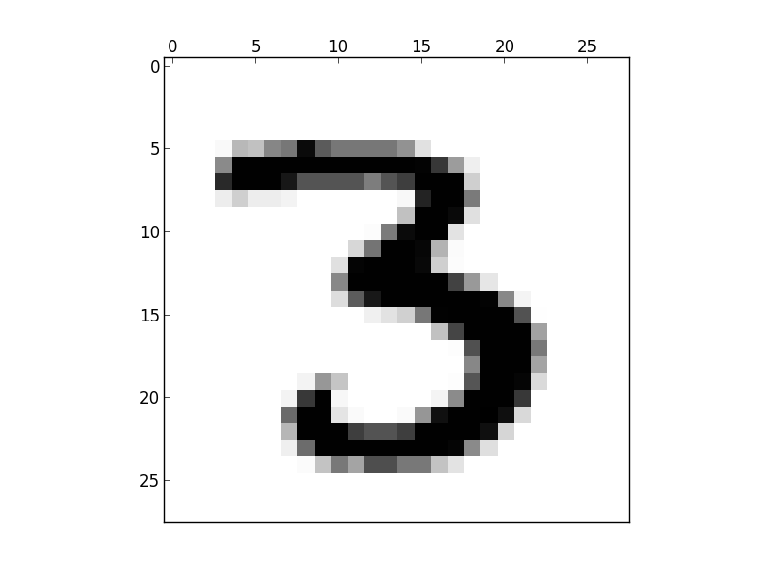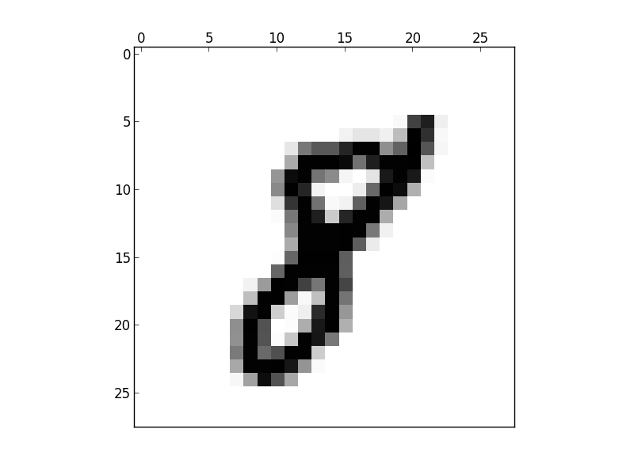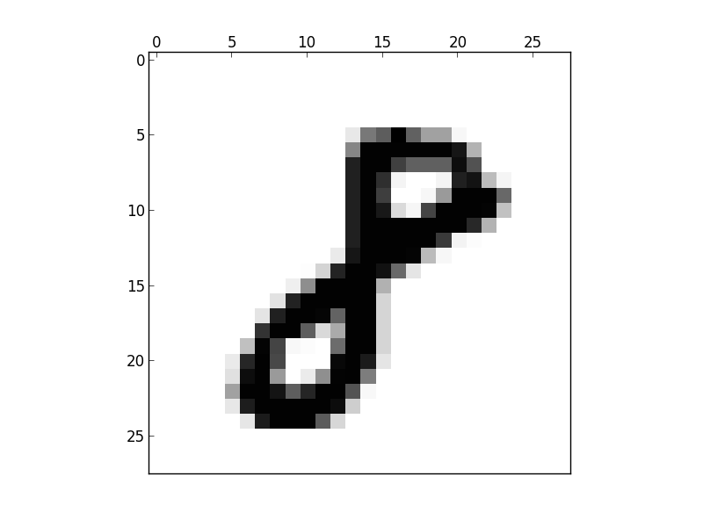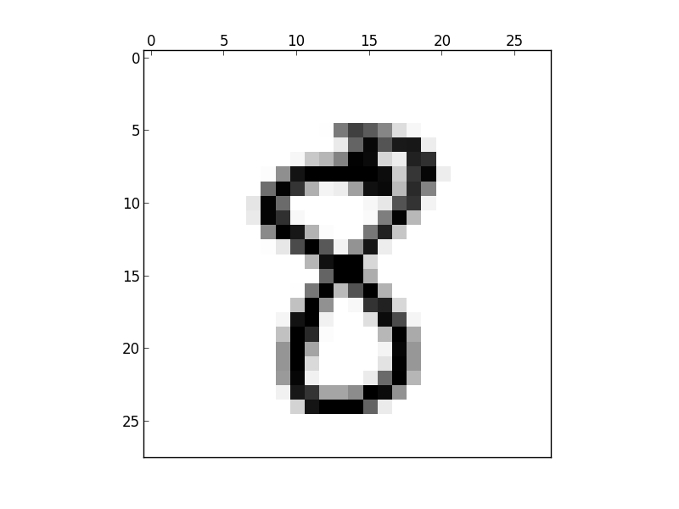

Looking at these examples of support vectors shows that a linear kernel will select numbers that are drawn in a very structured way. The examples above are all written in a very easy to recognize way. Using a rbf or polynomial kernel returned support vectors that were harder to interpret, though more generalized. For example, the following is an example of a support vector that the rbf kernel picked:

