Issue：

1. Should combine the result here within the 1-1000 data analysis

2. need to adjust the filename for extract.txt

3. maybe add the line of doccano as well in here

Manual labeling issue:

1. **Song track vs album**:  
   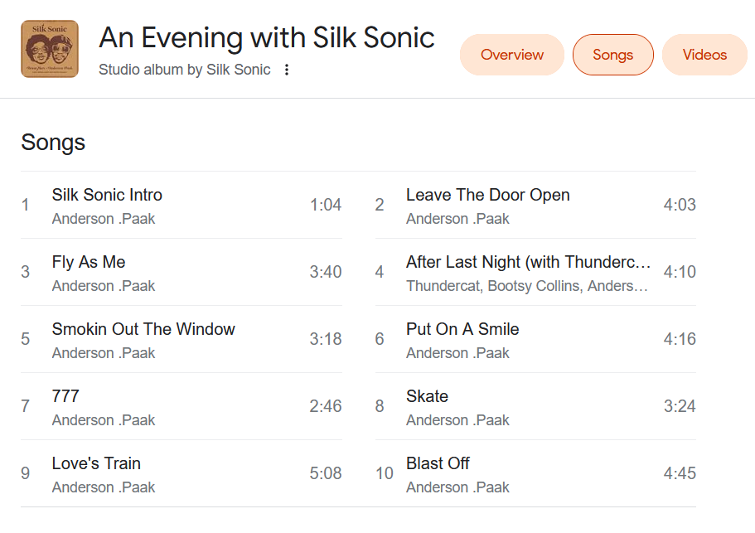
   1. Album seems to contain many track names....
   2. Most times the entry is song track, but sometimes it’s the album:  
      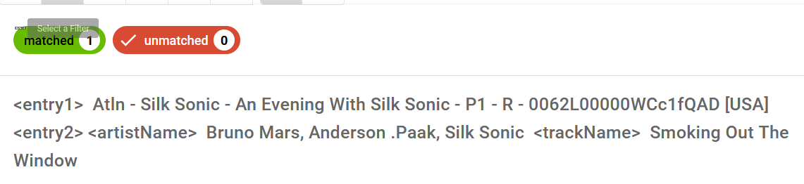
   3. Another example:  
        
      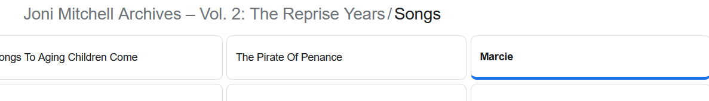
      1. Previous labels may be problematic

Summarize the issue:

Hi Kevin,

There is an issue in performing entity matching on the Wavo data that will need your verification：the campaign name sometimes is an album name instead of a song track name:  


As shown in here, the Wavo data <entry1> is the campaign name with artist *Joni Mitchell* and the album name *Archieves Vol.2*. The database <entry2> shows the artist as *Joni Mitchell* and the track name as *Marcie*.

Here is the online resource:  


Joni Mitchell has the album called *Archieves Vol.2*. This album contains the song *Marcie*. Then the question is that do we want to label the campaign name with artist+albumName to the database with artist+trackName?