Revision History
Revision | Description | Date | Release
0 | Validation template as placed on the sharepoint
1 | Revised 5.1 Line fluctuations and added 5.5 LED Driver compatibility | 2010/05/03
2 | Revised Section 6.5 to show Conducted and Radiated Emissions and list correct FCC part. Was 18 now 15. | 2010/06/24
3 | Revised Section 7.5 so that text matches table. | 2010/08/04
4 | Accepted changes and added tables for surge limits. | 2013/05/16
5 | Added Flicker and Driver Compatibility sections | 2013/05/21

Approvals
 | Title: | Signature: | Date:
Created By: | Principal Electrical Engineer
 |  | Signature: | Date:
Reviewed By: | Director Engineering Innovation
 |  | Signature: | Date:
Approved By: | Director Innovation
 |  | Signature: | Date:
Approved By:
 | Director Standards & Product Integrity

Table of Contents
1 Revision History 1
2 Overview 3
2.1 Objective 3
2.2 Scope 3
2.3 Normative References 3
2.4 Associated Documents 4
3 General Requirements 4
3.1 Test Environmental Conditions 4
3.2 Compliance Criteria 4
3.3 Test Report 4
4 Device Characteristics and Operation 5
4.1 Functional Demonstration 5
5 Electromagnetic Compatibility Tests 6
5.1 Conducted and Radiated Emissions 6
5.2 Surge – 1.2/50 µs – 8/20 µs Combination Wave 7
5.3 Surge – 0.5 µs – 100 kHz Ring Wave 8
5.4 Electrical Fast Transient (EFT) 9
5.5 Electrostatic Discharge (ESD) 10
6 Electrical Tests 12
6.1 Flicker 12
6.2 LED Driver Compatibility 12
6.3 Line Fluctuations – Voltage Variation and Interrupts 14
6.4 Ramp Input Voltage 15
6.5 Leakage Current 16
6.6 Steady State Characteristics 17
6.7 Harmonics 18
6.8 Inrush Current 19
7 Environmental Tests 20
7.1 Temperature/Voltage Cycle 20
7.2 Thermal Shock – Sub assembly - Operating 22
7.3 Condensing Humidity 23
7.4 Dust Ingress 25
7.5 Moisture Ingress 26
7.6 Corrosion 27
8 Mechanical Tests 28
8.1 Vibration 1 – Sub Assembly 28
8.2 Vibration 2 29
8.3 Mechanical Shock – Sub Assembly 30
8.4 Drop Test 31
9 Appendix 32
9.1 Wiring diagrams 32

Overview

Objective
This document specifies the validation testing required for qualification of LED luminaires, luminaire subassemblies, and electronic components with appropriate sections and test levels selected based on the intended application. Selected test sections are identified on the Certification and Testing Strategy Validation Check list with appropriate test levels identified by filling the form fields of this document using the product specification matrix. Some sections are intended to be performed on sub assemblies of the luminaire. These sections are identified by insertion of sub assembly in the title.
The validation testing verifies the product performance within the specification limits. The test plan also includes testing for application environment. It does not include all testing required for regulatory requirements (UL, CSA, etc.) or for making reliability predictions.

Scope
This document includes specifications for electrical, mechanical, environmental testing and electromagnetic compatibility testing. The document does not cover the photometric performance of the product.
Complete assemblies shall be used as test samples, unless otherwise noted. Use of subassemblies (as stated in some test specifications) is allowed when it does not affect the test results.
Luminaire assemblies and subassemblies provided for the testing per this specification shall be of final design but not necessarily manufactured on the production line.
Validation test data may be used to develop Reliability Test Specifications for the device under test.

Normative References
The following standards are referenced in this document:
ANSI/IEEE C62.41.1 | Guide on the Surge Environment in Low-Voltage (1000 V and Less) AC Power Circuits
ANSI/IEEE C62.41.2 | Recommended Practice on Characterization of Surges in Low-Voltage (1000 V and Less) AC Power Circuits
ANSI C82.77 | Harmonic Emission Limits-Related Power Quality Requirements for Lighting Equipment
ANSI C136.31 | American National Standard for Roadway Lighting Equipment – Luminaire Vibration
ASTM B 117 | Standard Practice for Operating Salt Spray (Fog) Apparatus
ASTM D 5276 | Standard Test Method for Drop Test of Loaded Containers by Free Fall
FCC Title 47 CFR Part 15 | Federal Communications Commission
IEC 60068-2-3 | Basic Environmental Testing Procedure, Part 2 – Tests, Damp Heat Steady State
IEC 60068-2-6 | Basic Environmental Testing Procedure, Part 2 – Tests, Vibration
IEC 60068-2-14 | Basic Environmental Testing Procedure, Part 2 – Tests, Change of Temperature
IEC 60068-2-27 | Basic Environmental Testing Procedure, Part 2 – Tests, Shock
IEC 60529 | Degrees of protection provided by enclosures (IP code)
IEC 60598 | Luminaires – Part 1: General requirements and tests
IEC 61000-4-2 | Electromagnetic Compatibility (EMC): Testing and measurement techniques – Electrostatic discharge immunity test

IEC 61000-4-3 | Electromagnetic compatibility (EMC): Radiated electromagnetic field requirements
IEC 61000-4-4 | Electromagnetic compatibility (EMC): Testing and measurement techniques – Electrical fast transient/burst immunity test
IEC 61000-4-5 | Electromagnetic compatibility (EMC): Testing and measurement techniques – Surge immunity test
IEEE 519 | Recommended Practices and Requirements for Harmonic Control in Electric Power Systems
NEMA 410 | Performance Testing for Lighting Controls and Switching Devices with Electronic Fluorescent Ballasts
UL 991 | Tests for Safety-Related Controls Employing Solid-State Devices
UL1012 | Power Units Other than Class 2
UL 1029 | High-Intensity-Discharge Lamp Ballasts
UL1598 | Luminaires
UL 8750 | Light Emitting Diode (LED) Equipment for Use in Lighting Products

Associated Documents
The following documents are required for the reference during validation testing:
Product Specification
Validation Test Report
Acuity Brands Certification and Test Strategy (C&TS) Validation Checklist

General Requirements

Test Environmental Conditions
Unless otherwise specified the environmental ranges for testing shall be:
Ambient Temperature: | 25 +/- 5°C
Relative Humidity: | ≤ 75%

Compliance Criteria
Criterion A | No discernible effects on the DUT’s (Device Under Test) operation.
Criterion B | The operation of the DUT may be affected but must recover with no lasting damage or operational effects if safety is not compromised by the failure mode.
Criterion C | Permanent damage may occur to the DUT if safety is not compromised by the failure mode.

Test Report
All test data shall be included in the Validation Test Report.
The test report shall include results of Functional Demonstration before and after each test.
If more then one test is performed on a single DUT, the report shall list the order in which the tests were executed.

Device Characteristics and Operation

Functional Demonstration

Objective
The functional demonstration is intended to verify an operational integrity of the DUT before and after the DUT is subject to testing, as required by the test plan.

Applicable Standards
NA

Device under Test
Luminaire Subassembly Electronic Component

Test Levels and Limits
Operating Voltage: Lowest Nominal Line Voltage (LNLV) (e.g.120VAC)
Highest Nominal Line Voltage (HNLV) (e.g.277VAC)

Equipment List
Adjustable AC Voltage Source
Power Analyzer

Procedure
Refer to Figure 9.1.2 (Section 9) for equipment power connections.
An initial functional demonstration shall be performed to establish baseline characteristics that may be used for comparison after additional testing. Visual inspection shall be performed on the DUT. A visual inspection shall verify correct parts and placement as well as inspect for damage.
Visual Inspection
- Verify that all correct components are installed in the system.
- Verify system wiring and connectors polarity
- Inspect components for damage, corrosion and other defects
Functional Test
- Connect DUT to Programmable AC Power Supply.
- Apply power to the DUT
- Measure DUT parameters in ON mode (photo control output is ON, LED Module is energized) for the input voltages specified in the table below
- Verify that every emitter of the DUT’s LED Module is energized.
Point of Measurement | Parameter | Operating Voltage (V AC)
Point of Measurement | Parameter |  |  | ON
Point of Measurement | Parameter |  |  | LNLV | HNLV
DUT Input | Current |  |  | X | X
DUT Input | Power |  |  | X | X
LED Driver Output | Voltage |  |  | X | X
LED Driver Output | Current |  |  | X | X
All measured parameters and observed conditions must be documented as test data.
The data shall be recorded for all variations (models) of the product.

Compliance
All measured characteristics must comply with Product Specification.

Electromagnetic Compatibility Tests

Conducted and Radiated Emissions

Objective
This test ensures that the DUT does not electrically interfere with other electronic devices via power line or radiated.

Applicable Standards
FCC Title 47 CFR Part 15

Device under Test
Luminaire Subassembly Electronic Component

Test Levels and Limits
Lowest Nominal Line Voltage (LNLV) (e.g.120VAC)
Highest Nominal Line Voltage (HNLV) (e.g.277VAC)
Class A (Non-consumer) Class B (Consumer) as defined in FCC Title 47 CFR Part 15.

Procedure
This test shall be performed in accordance with FCC Title 47 CFR Part 15 at an outside test facility. A test report, provided by the testing laboratory, shall include the test setup, test conditions, test procedure, and test results.

Compliance
Conducted emissions from the DUT shall comply with the limits specified by FCC Title 47 CFR Part 15 with at least 3 dB margin (on average).

Surge – 1.2/50 µs – 8/20 µs Combination Wave

Objective
This test will demonstrate the ability for an electronic product to survive surge transients in typical operating environments.

Applicable Standards
ANSI/IEEE C62.41.1
ANSI/IEEE C62.41.2
IEC 61000-4-5

Device under Test
Luminaire Subassembly Electronic Component

Test Levels and Limits
Select the surge levels by selecting use and location check boxes.

 |  | Indoor |  |  | Outdoor |  |  | Roadway
 |  | Voltage KV | Current KA |  | Voltage KV | Current KA |  | Voltage KV | Current KA
Residential |  | NA | NA |  | 2 | 1 |  | NA | NA
Commercial |  | 2 | 1 |  | 6 | 3 |  | 10 | 5
Industrial |  | 6 | 3 |  | 6 | 3 |  | 10 | 5

Operating Voltage: Lowest Nominal Line Voltage (LNLV) (e.g.120VAC)
Highest Nominal Line Voltage (HNLV) (e.g.277VAC)

Equipment List
Surge Generator
Oscilloscope

Procedure
The test area will be set up according to IEC 61000-4-5.
The DUT shall undergo the following tests:
Parameter | Test Level/ Configuration
Short Circuit Current Peak (CP from table) | kA
Open Circuit Voltage Peak (PV from table) | kV
Source Impedance | 2Ω
Coupling | L1 to L2  L1 to PE  L2 to PE  L1 and L2 to PE
Polarity and Phase Angle | Positive at 90° and Negative at 270°
Number of Pulses | 5 for each setting
Time Between Pulses | 1 minute
The DUT shall be tested for all of the listed configurations.

Compliance
Criterion level B is required for this test. No unsafe operating conditions may occur during the test including smoke, flame and arcing to the enclosure.

Surge – 0.5 µs – 100 kHz Ring Wave

Objective
This test will demonstrate the ability for an electronic product to survive surge transients in typical operating environments.

Applicable Standards
ANSI/IEEE C62.41.1
ANSI/IEEE C62.41.2
IEC 61000-4-5

Device under Test
Luminaire Subassembly Electronic Component

Test Levels and Limits
ANSI/IEEE C61.42.2
Select the surge levels by selecting use and location check boxes.

 |  | Indoor |  |  | Outdoor |  |  | Roadway
 |  | Voltage KV | Current KA |  | Voltage KV | Current KA |  | Voltage KV | Current KA
Residential |  | 6 | 0.2 |  | 2 | .07 |  | NA | NA
Commercial |  | 2 | 0.07 |  | 6 | .5 |  | NA | NA
Industrial |  | 6 | 0.05 |  | 6 | 0.05 |  | NA | NA

Operating Voltage: Lowest Nominal Line Voltage (e.g.120VAC)
Highest Nominal Line Voltage (e.g.277VAC)

Equipment List
Surge Generator
Oscilloscope

Procedure
The test area will be set up according to IEC 61000-4-5.
The DUT shall undergo the following tests:
Parameter | Test Level/Configuration
Short Circuit Current Peak (CP from table) | kA
Open Circuit Voltage Peak (PV from table) | kV
Source Impedance | 12 Ω
Coupling | L1 to L2  L1 to PE  L2 to PE  L1 and L2 to PE
Polarity and Phase Angles | Positive at 90° and Negative at 270°
Number of Pulses | 10 for each setting
Time between Pulses | 1 minute
The DUT shall be tested for all of the listed configurations.

Compliance
Criterion level B is required for this test. No unsafe operating conditions may occur during the test including smoke, flame and arcing to the enclosure.

Electrical Fast Transient (EFT)

Objective
The EFT test simulates a low energy, high transition rate interference that can be caused by various conditions on the power line. These conditions might include equipment switching, faulty equipment, and other man-made interference.

Applicable Standards
ANSI/IEEE C62.41.1
ANSI/IEEE C62.41.2
IEC 61000-4-4

Device under Test
Luminaire Subassembly Electronic Component

Test Levels and Limits
Parameter | Test Level/ Configuration
Peak Voltage ( PV)(Open Circuit) | 2kV (Direct Coupling)
Burst Repetition Rate (BRR) | 5kHz
Polarity | Positive and Negative
Burst Duration | 15 mS
Burst Period | 300 mS
Coupling | L1, L2, PE, L1:L2, L1:PE, L2:PE, L1:L2:PE
Test Duration for Each Coupling and Polarity | 1 Minute (14 minutes of testing)

Equipment List
Surge Generator
Oscilloscope

Procedure
The test set-up and procedure shall be conducted in accordance with IEC 61000-4-4.

Compliance
Criterion level A is required for this test.

5.5 Electrostatic Discharge (ESD)

Objective
The intent of this test is to subject the DUT to ESD conditions expected in manufacturing, installation, operation or maintenance. Direct discharges occur when personnel physically touch the enclosure or exposed electronics, or when the DUT comes into contact with objects that are electro-statically charged. Indirect discharges simulate events such as a collapsing electric field created by nearby ESD radiated emission or by relays making or breaking a load.
The ESD test includes points and surfaces that are accessible to users during normal use and includes points inside the assembly that are accessed during normal customer maintenance. Typical customer maintenance does not include troubleshooting or replacing components.

Applicable Standards
IEC 61000-4-2

Device under Test
Luminaire Subassembly Electronic Component

Test Levels and Limits
Parameter | Direct Discharge |  | Indirect Discharge
Parameter | Contact | Air | Indirect Discharge
ESD Peak Voltage (PV) (IEC 61000-4-2,) )
ESD Polarity | Positive and Negative
DUT Operating Voltage | Lowest Nominal Line Voltage (e.g.120VAC)  Highest Nominal Line Voltage (e.g.277VAC)

Equipment List
ESD Simulator
The test area shall be setup in accordance with IEC 61000-4-2
Adjustable AC Voltage Source

Procedure
The test shall be conducted per IEC 61000-4-2 procedure
- Direct Contact Discharge
The tip of the ESD simulator probe must always be in contact with the DUT before the discharge switch is operated.
  - Ten discharges (5 in each polarity) shall be made at each point as shown in the Figure 6.1.1. The DUT shall be in its normal operating state during the test. The test shall be repeated for each operating voltage.
  - Ten discharges (5 in each polarity) shall be made at each point as shown in the Figure 6.1.2. The DUT shall be de-energized during the test.
Any anomalies and DUT failures during the test shall be recorded.
The test shall be followed by a functional demonstration (refer to Section 4.1 of this document).
- Direct Air Discharge
The tip of the ESD simulator probe shall be moved as fast as possible (without causing mechanical damage) toward the DUT with the discharge switch held active. The ESD simulator tip shall be held perpendicular to the surface of the DUT during the approach. After each discharge, the ESD simulator shall be moved away from the DUT and reset for a new discharge.
- Ten discharges (5 in each polarity) shall be made at each point as shown in the Figure 6.1.1. The DUT shall be in its normal operating state during the test. The test shall be repeated for each operating voltage.
- Ten discharges (5 in each polarity) shall be made at each point as shown in the Figure 6.1.2. The DUT shall be de-energized during the test.
Any anomalies and DUT failures during the test shall be recorded.
The test shall be followed by a functional demonstration (refer to Section 4.1 of this document).
- Indirect Discharge
The indirect discharge method involves a discharge onto a horizontal couple plane and a vertical coupling plane.
- Twenty discharges (ten in each polarity) shall be applied to the horizontal coupling plane. The DUT shall be in its normal operating state during the test. The test shall be repeated for each operating voltage.
- Twenty discharges (ten in each polarity) shall be applied to the vertical coupling plane. The DUT shall be in its normal operating state during the test. The test shall be repeated for each operating voltage.
Any anomalies and DUT failures during the test shall be recorded.
The test shall be followed by a functional demonstration (refer to Section 4.1 of this document).

Insert Figure Here

Figure 6.1.1. ESD discharge points, external

Insert Figure Here

Figure 6.1.2. ESD discharge points, wiring compartment

Compliance
Criterion level A is required for this test.

Electrical Tests

Flicker
Reserved for Flicker Test Method

6.2 LED Driver Compatibility

Objective
To determine the DUT’s sensitivity to short voltage interrupt conditions.

Applicable Standards
N/A

Device under Test
DUT - a luminaire assembly or a complete functional electronic system subassembly

Test Levels and Limits
Operating voltage: 305 VAC (300 VAC is acceptable is it is a limit of Programmable AC Power Supply)

Equipment List
Programmable AC Power Supply
Oscilloscope

Procedure
Step # | Supply Voltage, VAC | Phase Angle | Dwell Time, s | Notes
1 | 0 | - | - | To develop the test profile for a specific generator, perform an initial sweep test to determine the most severe combination (highest LED driver output current):  - Phase Angle: 80 and 90 degrees  - Dwell time for step 2: 1 line cycle and 2 line cycles  - Dwell time for step 3: start at 0.2 seconds, and increase the time in 0.1 second increments
2 | 305 | 80 - 90 | 0.016 - 0.033
3 | 0 | - | 0.200 – 0.700
4 | 305 | 80 - 90 | 5.00
5 | 0 | - | 5.00

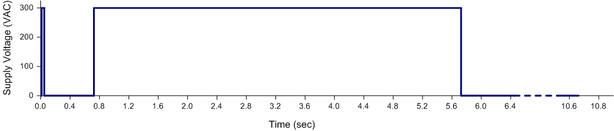
LED Driver Compatibility Test Profile
Repeat the test cycle sixteen times.
The following parameters shall be monitored and documented:
- Driver input voltage
- LED Driver input current
- LED Driver output current
- LED Driver output voltage

Compliance
Criterion level B is required for this test.
The DUT shall pass the test profile all sixteen times.
Maximum allowed driver output current – XXX.

Line Fluctuations – Voltage Variation and Interrupts

Objective
This test simulates common voltage variation and interrupts that occur on utility power lines.

Applicable Standards
IEC61000-4-11 – Section 5 (Power Supply Voltage Dips and Short Interruption Tests)

Device under Test
Luminaire Subassembly Electronic Component
.

Test Levels and Limits
Nominal voltage: Lowest Nominal Line Voltage (LNLV) (e.g.120VAC)
Highest Nominal Line Voltage (HNLV) (e.g.480VAC)

Under-voltage: (70% of nominal voltage)
(40% of nominal voltage)

Equipment List
Programmable AC Power Supply
Step-up transformer
Oscilloscope

Procedure
Refer to Section 9 for equipment power connections, as specified in the table below.
The DUT shall be supplied with nominal operating voltage. The power supply shall be programmed to set the required voltage test level instantaneously. The interval between each test shall be no less than 10 seconds.
The tests shall be repeated for each specified nominal voltage.
The data shall be recorded for all variations (models) of the product.
The report shall include a scope reading from each test levels in the table below.
Test Voltage | Phase Angle | Duration | Test Criteria
70% | 0 | 0.5 sec | Criterion A
40% | 0 | 0.5 sec | Criterion A
0 | Use worst case value from 4.4 | 1 line cycle | Criterion A
0 | Use worst case value from 4.4 | 12 line cycles | Criterion A
0 | Use worst case value from 4.4 | 0.7 sec | Criterion B
0 | Use worst case value from 4.4 | 30 sec | Criterion B

Compliance
Criteria levels A or B are required for this test.

Ramp Input Voltage

Objective
To determine the DUT’s sensitivity to “brown-out” conditions.

Applicable Standards
UL 991 – Section 13 (Voltage Variation Test)

Device under Test
Luminaire Subassembly Electronic Component

Test Levels and Limits
Operating voltage: Lowest Nominal Line Voltage (LNLV) (e.g.120VAC)
40% of Lowest Nominal Line Voltage (LNLV40)) (e.g.48VAC)

Equipment List
Programmable AC Power Supply
Oscilloscope

Procedure
Refer to Figure 9.1.3 (Section 9) for equipment power connections.
Test procedure per UL 991 with the following voltage assignments:
- Set the supply voltage to DUT at LNLV and verify that the DUT operates as intended.
- Ramp the supply voltage down to LNLV40. Ramp time - 2 seconds (+/- 0.4 sec).
- Maintain the supply voltage at LNLV40 for 1 second.
- Ramp the supply voltage up to LNLV. Ramp time – 2 seconds (+/- 0.4 sec).
- Maintain the supply voltage at LNLV for 1 second.
- Ramp the supply voltage down to zero. Ramp time – 2 seconds (+/- 0.4 sec).
- Maintain the supply voltage at zero for 1 second.
- Ramp the supply voltage up to LNLV. Ramp time – 2 seconds (+/- 0.4 sec).
- Repeat the test cycle three times with 10-seconds intervals between each test cycle.
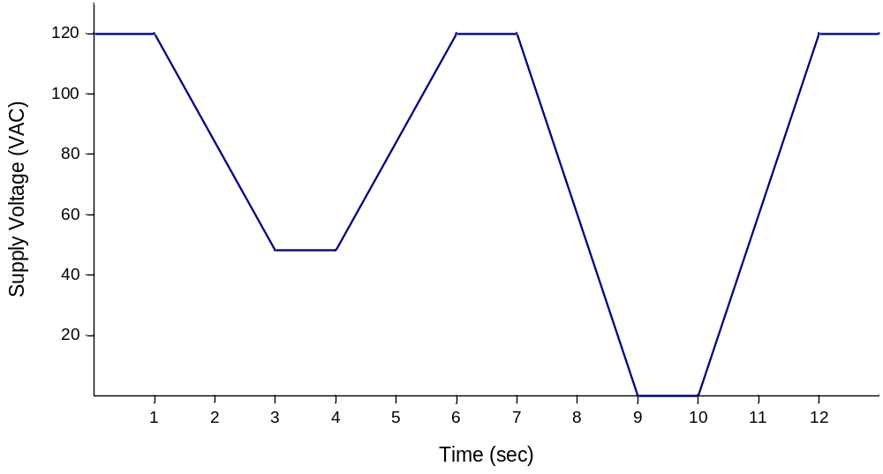
Ramp Input Voltage Test Cycle

Compliance
Criterion level B is required for this test.

Leakage Current

Objective
This test verifies that the DUT does not have an unsafe amount of leakage current to ground.

Applicable Standards
UL1029 – Section 19 (Leakage Current Tests)

Device under Test
Luminaire Subassembly Electronic Component

Test Levels and Limits
Line Voltage: Highest Nominal Line Voltage (HNLV) (e.g.277VAC)
Leakage Current Limit: 0.75 mA

Equipment List
Leakage Current Test Fixture

Procedure
The test shall be conducted per UL 1029 procedure.
Refer to Figure 9.1.7 (Section 9) for the wiring connection.

Compliance
The leakage current shall not exceed 0.75 mA for the duration of this test.

Steady State Characteristics

Objective
Nominal operating measurements are required for product labeling, agency requirements, specification approval, and general product comparison.

Applicable Standards
NA

Device under Test
Luminaire Subassembly Electronic Component

Test Levels and Limits
Operating Voltage: Lowest Nominal Line Voltage (LNLV) and -10%
Other Intermediate Nominal Line Voltages (INLV1) , (INLV2) , (INLV3) , Etc.
Highest Nominal Line Voltage (HNLV) and +10%

Equipment List
Adjustable AC Voltage Source
Power Analyzer
Oscilloscope

Procedure
Refer to Figure 9.1.2 (Section 9) for equipment power connections.
Measure the following DUT characteristics for the specified input voltage conditions:
Point of Measurement | Parameter | Operating Voltage (V AC)
Point of Measurement | Parameter | LNLV-10% | LNLV | INLV1 | INLV2 | HNLV | HNLV+10%
DUT Input | Current | X | X | X | X | X | X
DUT Input | Power | X | X | X | X | X | X
DUT Input | Power Factor | X | X | X | X | X | X
LED Driver Output | Voltage | X | X | X | X | X | X
LED Driver Output | Voltage Ripple | X | X | X | X | X | X
LED Driver Output | Current | X | X | X | X | X | X
LED Driver Output | Current Ripple | X | X | X | X | X | X
LED Driver Output | Efficiency | X | X | X | X | X | X
LED Driver Output | Regulation | X | X | X | X | X | X
All measured parameters must be documented as test data. In addition, measured parameters for nominal operating voltages (LNLV, INLVs, and HNLV VAC) shall be presented in a table format.
The data shall be recorded for all variations (models) of the product.

Compliance
All measure characteristics must comply with Product Specifications.

Harmonics

Objective
Electronic devices for use in residential, commercial, and industrial applications shall comply with the harmonic emission limits as set forth by this specification.

Applicable Standards
ANSI C82.77
IEEE 519

Device under Test
Luminaire Subassembly Electronic Component

Test Levels and Limits
Total harmonic distortion (THD) is the ratio of the RMS value of the harmonic currents through order 40 to the RMS value of the 60Hz fundamental current. For this specification, THD limits are thus set in terms of product input current THD. This definition is referred to a THD (fundamental).
DUT shall have a maximum line current THD of using the following THD definition: (measurement through order 40)
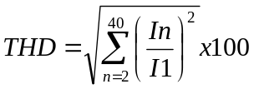
Operating voltage: Lowest Nominal Line Voltage (LNLV)
Other Intermediate Nominal Line Voltages (INLV1) , (INLV2) , (INLV3) , Etc.
Highest Nominal Line Voltage (HNLV)

Equipment List
Adjustable AC Voltage Source
Power Analyzer

Procedure
Refer to Figure 9.1.2 (Section 9) for equipment power connections.
Measure the following DUT characteristics using ANSI C82.77 procedure, for the specified input voltage conditions:
Point of Measurement | Parameter | Operating Voltage (V AC)
Point of Measurement | Parameter | LNLV | INLV1 | INLV2 | HNLV
DUT Input | THD | X | X | X | X
All measured parameters must be documented as test data.
THD data shall be recorded for all variations (models) of the product.

Compliance
DUT shall have a maximum line current THD of or below.
In addition, per Annex 1 of ANSI C82.77, DUT shall not exceed the following:
- 2nd harmonic - 5%
- Individual harmonics >11th – 7%

Inrush Current

Objective
The test will measure the inrush current of the DUT during startup and compare the result to the product specification. The inrush characteristics are essential to lighting system design. A large inrush current can cause the electrical system to fail.

Applicable Standards
NEMA 410

Device under Test
Luminaire Subassembly Electronic Component

Test Levels and Limits
Operating Voltage: Lowest Nominal Line Voltage (LNLV) (e.g.120VAC)
Highest Nominal Line Voltage (HNLV) (e.g.480VAC)

Equipment List
Adjustable AC Voltage Source
Current Probe
Oscilloscope

Procedure
Refer to Figure 9.1.1 (Section 9) for equipment power connections.
Insure the total line impedance provided to the DUT is approximately 450 mOhms and 100 uH
Apply power to DUT at the worst case phase angle (90, 270,) and measure inrush current, including waveforms.
A minimum of five measurements shall be taken at 5 minute intervals.
Record the maximum inrush current and phase angle.

Compliance
The inrush current measurement must comply with NEMA 410, Table B-2.

Environmental Tests

Temperature/Voltage Cycle

Objective
To verify DUT’s ability to operate at the minimum and maximum specified environmental parameters.

Applicable Standards
NA

Device under Test
Luminaire Subassembly Electronic Component

Test Levels and Limits
Operating Voltage: | Lowest Nominal Line Voltage-10%(LNLV90) (e.g.120VAC)  Highest Nominal Line Voltage+20% (HNLV120) (e.g.277VAC)
Operating Temperature: | Low Temperature Test Point (LTTP)°C,  Operating High Temperature Test Point (OHTTP)°C,  Non-Operating High Temperature Test Point (NHTTP)°C
   | LTTP | OHTTP | NHTTP
  Indoor | 0 | 40 | 55
  Outdoor | -40 | 40 | 55
  Roadway | -40 | 40 | 55

Equipment List
Temperature Chamber
Data Acquisition Equipment
Adjustable AC Voltage Source
Switching Control system

Procedure
Refer to Figure 9.1.5 (Section 9) for equipment power connections.
The DUT shall be set inside the temperature chamber for the duration of this test. The chamber, the adjustable AC power source and the switching control system shall be set-up to follow the steps below:
Step | Voltage (VAC) | Temperature (°C) | Duration (hrs) | DUT Operation
1 | 0 | NHTTP | 22 | -
2 | 0 | Ramp down from NHTTP to LTTP | 2 | -
3 | 0 | LTTP | 24 | -
4 | LNLV90 | LTTP | 9 | Power cycling - 2 hours on, 1 hours off
5 | HNLV120 | LTTP | 9 | Power cycling – 2 hours on, 1 hours off
6 | HNLV120 | Ramp up from LTTP to OHTTP | 2 | Power - off
7 | HNLV120 | OHTTP | 9 | Power cycling - 2 hours on, 1 hours off
8 | LNLV90 | OHTTP | 9 | Power cycling - 2 hours on, 1 hours off
9 | LNLV90 | Ramp down from OHTTP to 20 | 2 | Power - off

The data acquisition system shall monitor and record the following parameters:
- Chamber temperature
- Temperature at Tc point of LED driver
- Luminaire input voltage (AC rms)
- LED driver output voltage (DC)
- Luminaire input current
- LED driver output current
All recorded data shall be included in the report as a graph. Any anomalies found during the test shall be noted.
The test shall be followed by a functional demonstration (refer to Section 4.1 of this document).
The test shall be repeated for all variations (models) of the product

Compliance
Criterion level A is required for this test.

Thermal Shock – Sub assembly - Operating

Objective
The purpose of this test is to ensure that the DUT will withstand being subjected to rapid temperature variations that may be encountered in operating conditions.

Applicable Standards
IEC 60068-2-14, Test Nb: Change of Temperature

Device under Test
Luminaire Subassembly Electronic Component

Test Levels and Limits
Operating Voltage: (OV) | VAC
Low Temperature: (LT) | °C
High Temperature: (HT) | °C
Exposure Time at Each Temperature: | 15 min
Temperature Change Rate: | 3°C/minute
Number of Cycles: | 5

Equipment List
Temperature Chamber
Data Acquisition Equipment

Procedure
The test shall be conducted per IEC 60068-2-14 procedure. The DUT shall be set inside the temperature chamber for the duration of this test. The DUT shall be powered during the test.
The data acquisition system shall monitor and record the following parameters:
- Chamber temperature
- Temperature at Tc point of LED driver
- Luminaire input voltage (AC rms)
- LED driver output voltage (DC)
- Luminaire input current
- LED driver output current
All recorded data shall be included in the report as a graph. Any anomalies found during the test shall be recorded, following by engineering evaluation.
The test shall be followed by a functional demonstration (refer to Section 4.1 of this document).

Compliance
Criterion level A is required for this test. The DUT shall pass a functional demonstration after the test is complete.

Condensing Humidity

Objective
To verify the DUT’s ability to operate in a condensing environment it may be subjected to during storage, shipping or use.

Applicable Standards
NA

Device under Test
Luminaire Subassembly Electronic Component

Test Levels and Limits
Temperature: Low Temperature Test Point (LTTP)°C
High Temperature Test Point (HTTP)°C
Supply Voltage: Lowest Nominal Line Voltage-10% (LNLV90) (e.g.120VAC)
Highest Nominal Line Voltage+10% (HNLV110) (e.g.277VAC)
Power cycle period: 20 minutes (15 minutes ON, 5 minutes OFF)
 | LTTP | HTTP
Indoor | 0 | 40
Outdoor | -20 | 40
Roadway | -20 | 40

Equipment List
Environmental Chamber
Adjustable AC Voltage Source
Switching Control system
Data Acquisition System

Procedure
Refer to Figure 9.1.5 (Section 9) for equipment power connections.
The DUT shall be set inside the temperature chamber for the duration of this test. The chamber, the adjustable AC voltage source and the switching control system shall be set-up to follow the profile below:
Step | Temperature | Duration | Humidity | DUT Operation
1 | 20°C | 1 hr | 90% RH | Power cycling – 15 min ON, 5 min OFF
2 | Ramp up to HTTP°C | 0.5 hrs | 90% RH | OFF
3 | HTTP°C | 1 hr | 90% RH | OFF
4 | Ramp down to 20°C | 0.5 hrs | 90% RH | Power cycling – 15 min ON, 5 min OFF
5 | 20°C | 0.5 hrs | 90% RH | Power cycling – 15 min ON, 5 min OFF
6 | Ramp down to -LTTP°C | 1 hr | Uncontrolled | Power cycling – 15 min ON, 5 min OFF
7 | -LTTP°C | 1 hr | Uncontrolled | Power cycling – 15 min ON, 5 min OFF
8 | Ramp up to 20°C | 1 hr | Uncontrolled | OFF
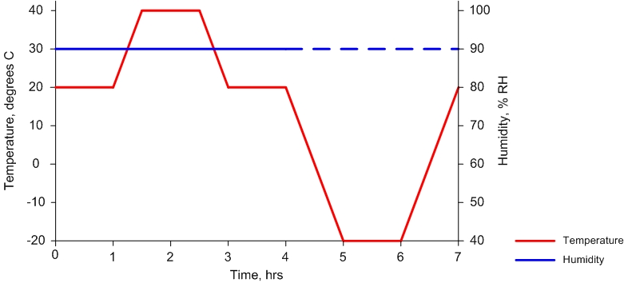
The profile must be repeated a total of 8 times: 4 times at HNLV110 VAC input voltage, and 4 times at LNLV90 VAC input voltage.
The data acquisition system shall monitor and record the following parameters:
- Chamber temperature
- Luminaire input voltage (AC rms)
- Luminaire input current
All recorded data shall be included in the report as a graph. Any anomalies found during the test shall be recorded, following by engineering evaluation.
The test shall be followed by a functional demonstration (refer to Section 4.1 of this document).

Compliance
Criterion level A is required for this test. The DUT shall pass a functional demonstration after the test is complete.

Dust Ingress

Objective
This test ensures that the DUT’s enclosure prevents the dust ingress into electronic chamber.

Applicable Standards
IEC 60529, Section 13 – Test for protection against solid foreign objects indicated by the first character numeral

Device under Test
Luminaire Subassembly Electronic Component

Test Levels and Limits
The limits are defined in IEC 60529 for enclosures or IEC 60598 for Luminaires for IP X rating

Equipment List
Dust Chamber

Procedure
This test shall be performed in accordance with IEC 60529 for IP X rating and Acuity Brands test procedure for Singleton Dust Chamber. A test report shall include the test setup, test conditions, test procedure, and test results.

Compliance
The acceptance conditions for IP X rating are defined in IEC 60529..
The DUT shall pass a functional demonstration after the test is complete.

Moisture Ingress

Objective
This test ensures that the DUT’s enclosure limits moisture ingress to a quantity that does not interfere with DUT’s operation.

Applicable Standards
IEC 60529, Section 14 – Test for protection against water indicated by the second characteristic numeral

Device under Test
Luminaire Subassembly Electronic Component

Test Levels and Limits
The limits are defined in IEC 60529 for enclosures or IEC 60598 for Luminaires for IP X rating

Equipment List
Water Spray System

Procedure
This test shall be performed in accordance with IEC 60529 for IP X rating and Acuity Brands Test Procedure for ED&D Water System. A test report shall include the test setup, test conditions, test procedure, and test results.

Compliance
The acceptance conditions for IP X rating are defined in IEC 60529.
The DUT shall pass a functional demonstration after the test is complete.

Corrosion

Objective
This test ensures that the DUT maintains an operational integrity in corrosive environments.

Applicable Standards
ASTM B 117

Device under Test
Luminaire Subassembly Electronic Component

Test Levels and Limits
ASTM B 117
Salt Spray Resistance – 1,000 hours
5% Neutral Salt Spray

Equipment List
Salt Spray Chamber

Procedure
This test shall be performed in accordance with ASTM B 117 at an outside test facility. A test report, provided by the testing laboratory, shall include the test setup, test conditions, test procedure, and test results.

Compliance
Thru Film Corrosion/Blistering and Creep shall be evaluated per ASTM D1654 and D714.
The DUT shall pass a functional demonstration after the test is complete.

Mechanical Tests

Vibration 1 – Sub Assembly

Objective
The purpose of this test is to ensure the immunity of the DUT to mechanical vibration that can be encountered during operation or shipment.

Applicable Standards
IEC 60068-2-6, Test Fc and guidance: Vibration

Device under Test
Luminaire Subassembly Electronic Component

Test Levels and Limits
Acceleration (Sweep): | 5 Hz ≥ ƒ ≤ 500 Hz at 1.0 g
Acceleration (Dwell): | 3.0 g
Sweep Rate: | 1 Octave / Minute (± 10%)
Dwell Time: | 10 Minutes
Motion: | Sinusoidal
Duration: | 10 sweep cycles per axis on each of three mutually perpendicular axes
Operating Voltage | Lowest Nominal Line Voltage (e.g.120VAC)

Equipment List
Single Axis Vibration System
Accelerometer Monitoring System

Procedure
The DUT must be mounted securely to the vibration generator for the duration of this test. The DUT shall be powered during the test.
The monitoring accelerometers shall be placed in locations on the electronics, near massive electronic components, near high flex areas on a PCB or a mechanical mount.
The DUT shall be tested in each of the three principal axes.
During the 5 to 500 Hz sweep any reference with a gain greater than 2 shall be noted. After the 10 sweeps are complete the DUT shall dwell at each resonant frequency at 3 g acceleration for 10 minutes.
All recorded data shall be included in the report. Any anomalies found during the test shall be recorded, following by engineering evaluation.
The test shall be followed by a functional demonstration (refer to Section 4.1 of this document).

Compliance
Criterion level A is required for this test. The DUT shall pass a functional demonstration after the test is complete.

Vibration 2

Objective
The purpose of this test is to ensure the immunity of the DUT to mechanical vibration that can be encountered during operation or shipment.

Applicable Standards
ANSI C136.31-2001

Device under Test
Luminaire Subassembly Electronic Component
.

Test Levels and Limits
ANSI C136.31-2001
Acceleration (Dwell): | 1.5g or 3g, other
Duration: | 100,000 cycles per axis on each of three mutually perpendicular axes

Equipment List
Single Axis Vibration System
Accelerometer Monitoring System

Procedure
This test shall be performed in accordance with ANSI C136.31-2001. The DUT shall be un-powered during the test.
All recorded data shall be included in the report. Any anomalies found during the test shall be recorded, following by engineering evaluation.
The test shall be followed by a functional demonstration (refer to Section 4.1 of this document).

Compliance
Criterion level A is required for this test. The DUT shall pass a functional demonstration after the test is complete.

Mechanical Shock – Sub Assembly

Objective
The purpose of this test is to ensure the immunity of the DUT to mechanical vibration that can be encountered before or during an installation.

Applicable Standards
IEC 60068-2-27, Test Ea and guidance: Shock

Device under Test
Luminaire Subassembly Electronic Component

Test Levels and Limits
Severity: | 30 g peak
Duration: | 11 ms
Application: | 3 shocks in each direction on three mutually perpendicular axes (18 shocks total)
Motion: | Half sine wave

Equipment List
Single Axis Vibration System

Procedure
This test shall be performed in accordance with IEC 60068-2-27.
The DUT shall be un-powered at the time of the shock.

Compliance
Criterion level A is required for this test. The DUT shall pass a functional demonstration after the test is complete.

Drop Test

Objective
This test is intended to evaluate capability of a shipping container/packaging to protect the DUT from the mechanical stress that can be encountered during shipping and handling.

Applicable Standards
ASTM D 5276

Device under Test
Luminaire Subassembly Electronic Component

Test Levels and Limits
ASTM D 5276

Equipment List
Free-Fall Drop Test Set-up conforming to ASTM D 5276 requirements

Procedure
This test shall be performed in accordance with ASTM D 5276 at an outside test facility. A test report, provided by the testing laboratory, shall include the test setup, test conditions, test procedure, and test results.

Compliance
The package/container performance shall be evaluated per ASTM 5276.
The DUT shall pass a functional demonstration after the test is complete.

Appendix

Wiring diagrams
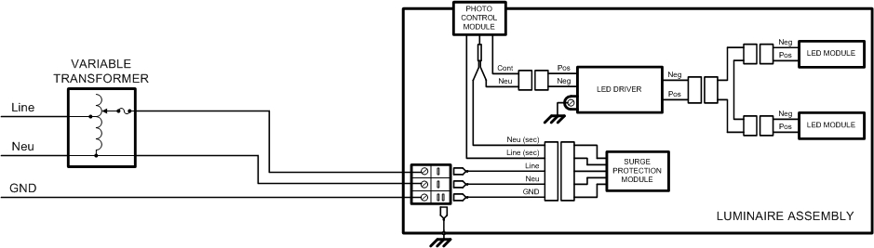
Figure 9.1.1. Set-up with Adjustable AC Voltage Source
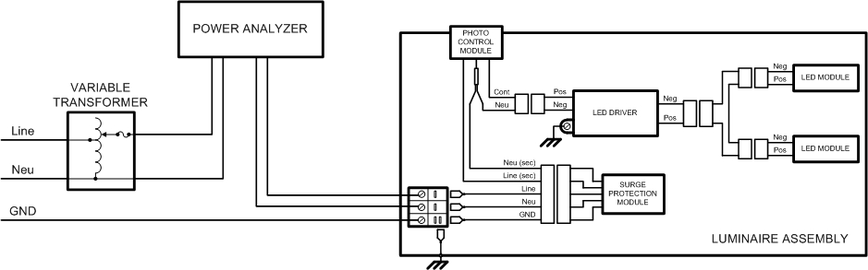
Figure 9.1.2. Set-up with Adjustable AC Voltage Source and Power Analyzer
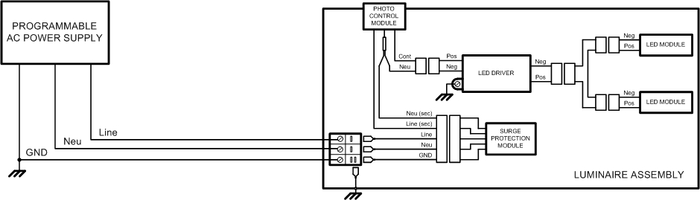
Figure 9.1.3. Set-up with Programmable AC Power Supply
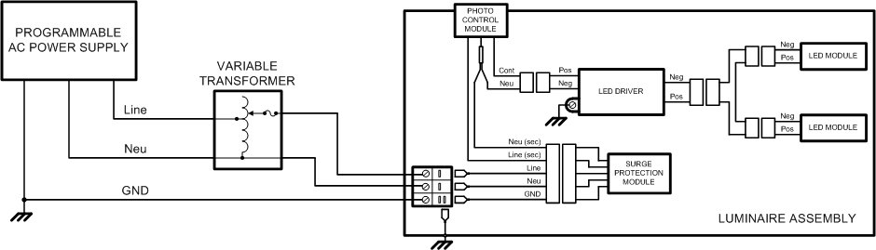
Figure 9.1.4. Set-up with Programmable AC Power Supply and Step-up Transformer
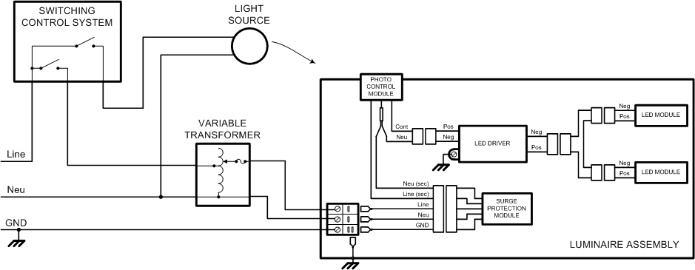
Figure 9.1.5. Set-up with Adjustable AC Voltage Source and Switching Control System
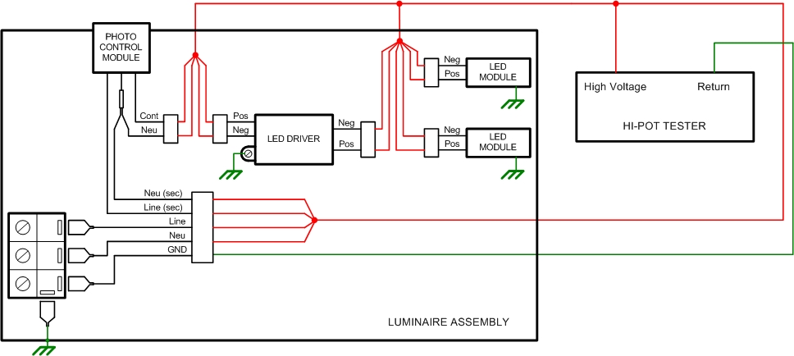
Figure 9.1.6. Dielectric Test Set-up
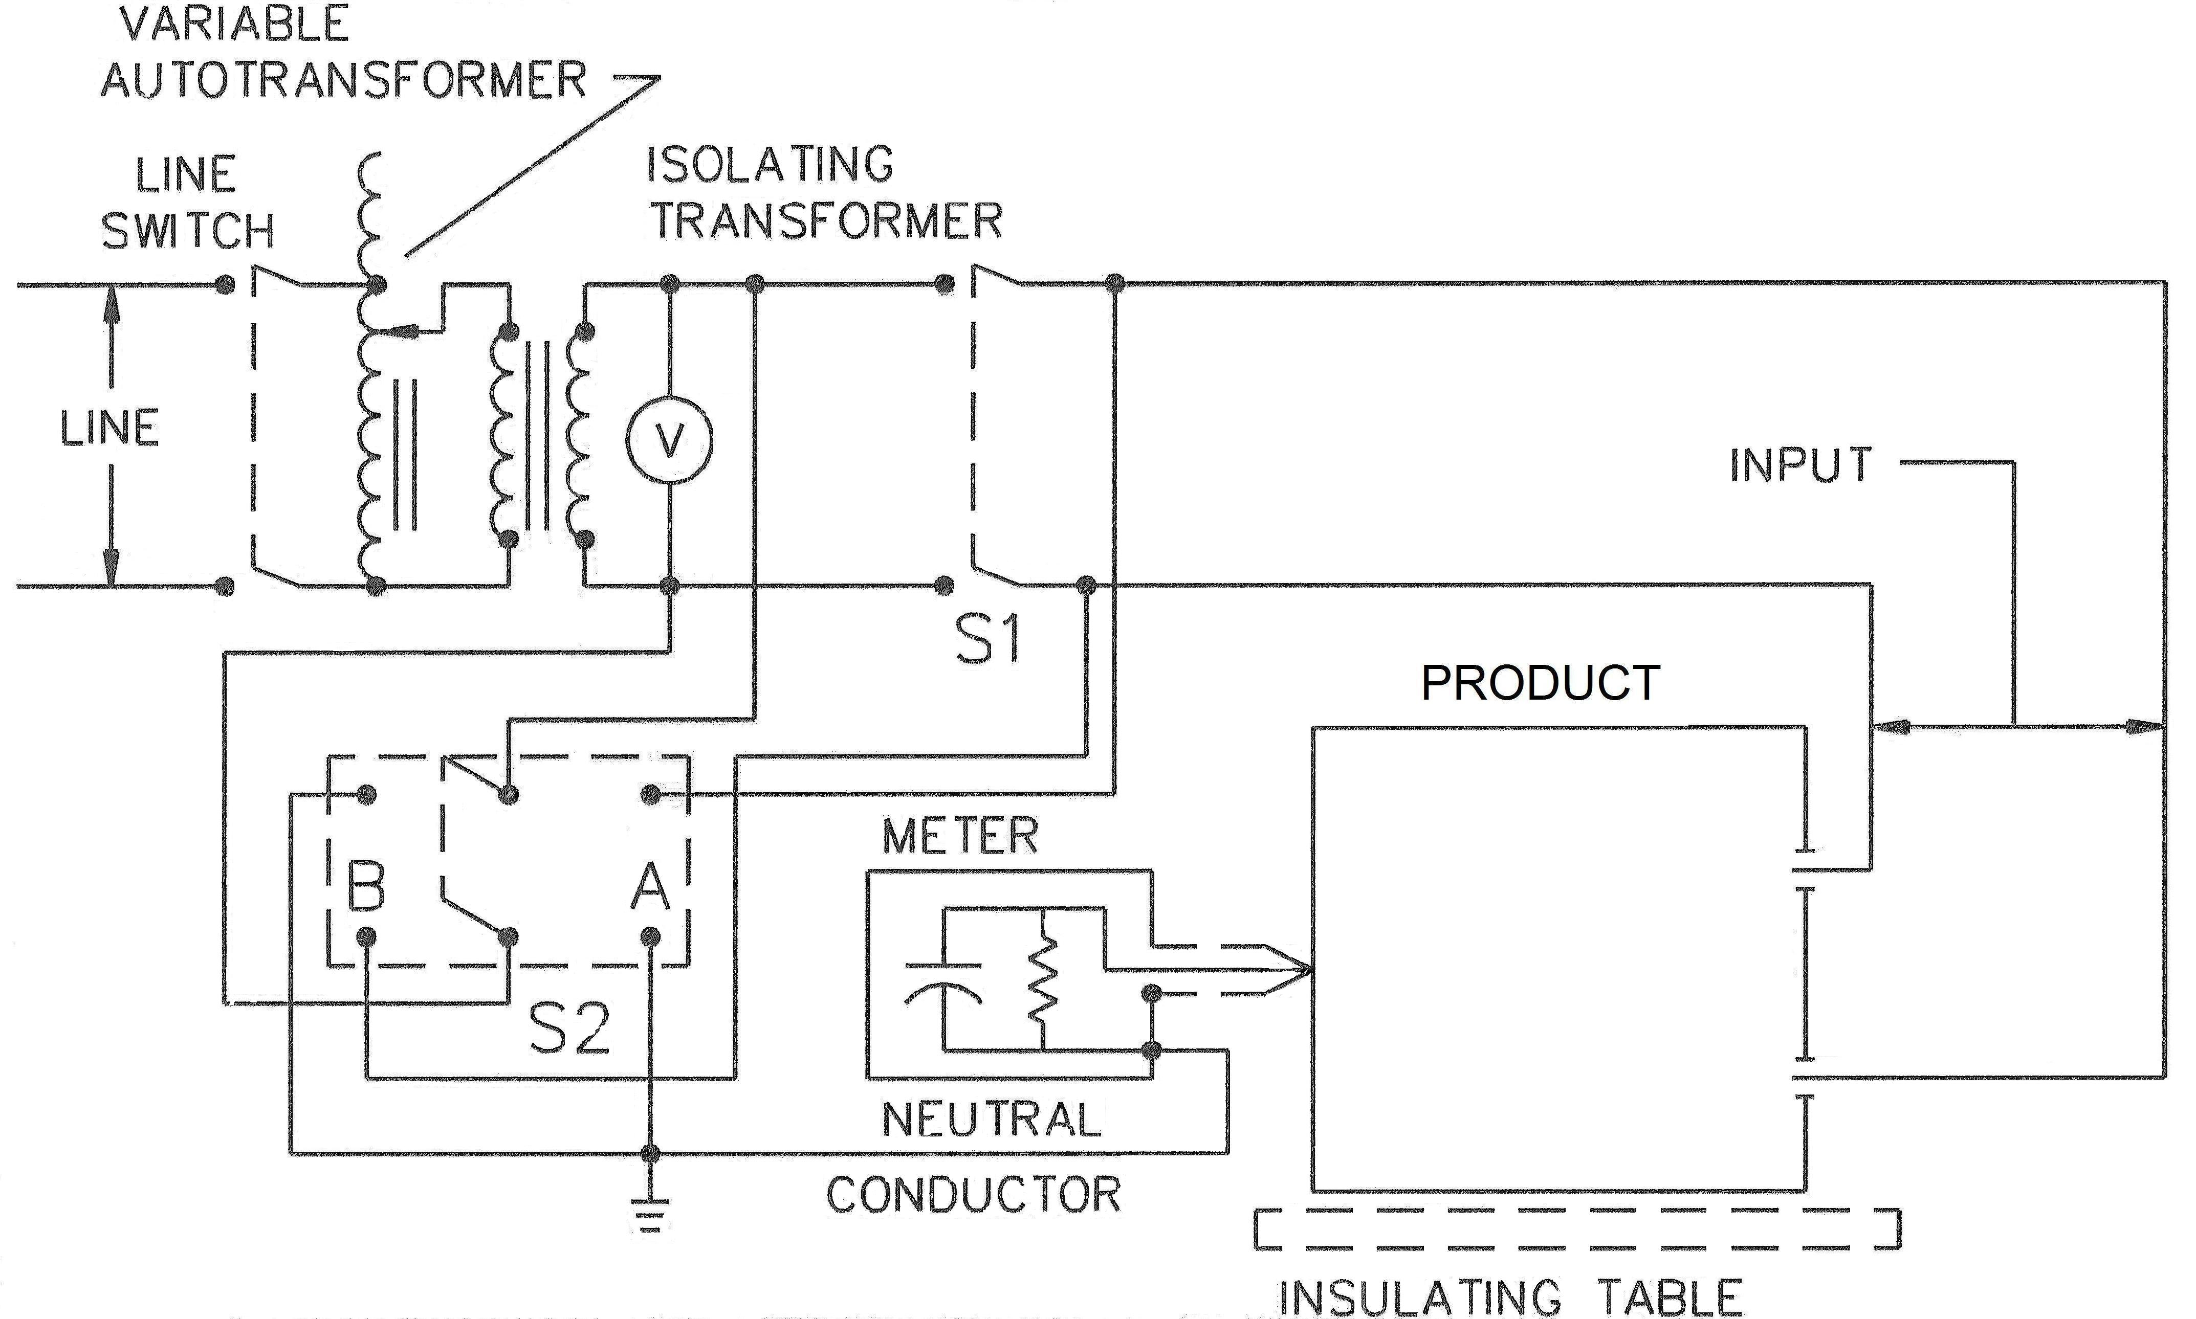
Figure 9.1.7. Leakage Current Test Set-up

