Project Report Template

1.INTRODUCTION

1.1 The banking industry world-wide is being transformed. The global forces for change include technological innovation; the deregulation of financial services at the national level and opening-up to international competition; and - equally important - changes in corporate behaviour, such as growing disintermediation and increased emphasis on shareholder value. In addition, recent banking crises in Asia and Latin America have accentuated these pressures. The banking industries in central Europe and Latin America have also been transformed as a result of privatizations of state-owned banks that had dominated their banking systems in the past. In this project we are trying to analysis the bank related data and able to extract some insights from the data using Business Intelligence tools. To Extract the Insights from the data and put the data in the form of visualizations, Dashboards and Story we employed Tableau tool.

1.2 PURPOSE

1. Define Problem / Problem Understanding
   1. Specify the business problem
   2. Business requirements
   3. Literature Survey
   4. Social or Business Impact.
2. Data Collection & Extraction from Database
   1. Collect the dataset,
   2. Storing Data in DB
   3. Perform SQL Operations
   4. Connect DB with Tableau
3. Data Preparation
4. Prepare the Data for Visualization
5. Data Visualizations
   1. No of Unique Visualizations
6. Dashboard
   1. Responsive and Design of Dashboard
7. Story
   1. No of Scenes of Story
8. Performance Testing
   1. Amount of Data Rendered to DB ‘
   2. Utilization of Data Filters
   3. No of Calculation Fields
   4. No of Visualizations/ Graphs
9. Web Integration
   1. Dashboard and Story embed with UI With Flask
10. Project Demonstration & Documentation
    1. Record explanation Video for project end to end solution
    2. Project Documentation-Step by step project development procedure

2.1 EMPATHY MAP SCREEN SHOT

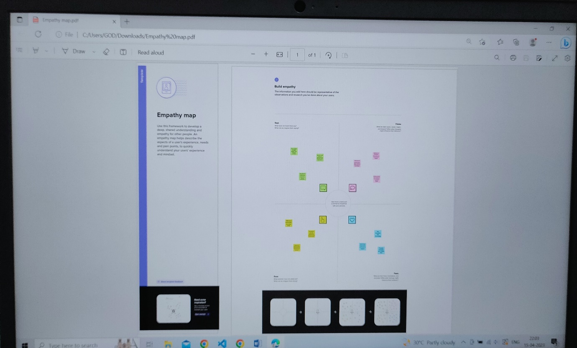

2.2 BRAINSTROMING SCREEN SHOT

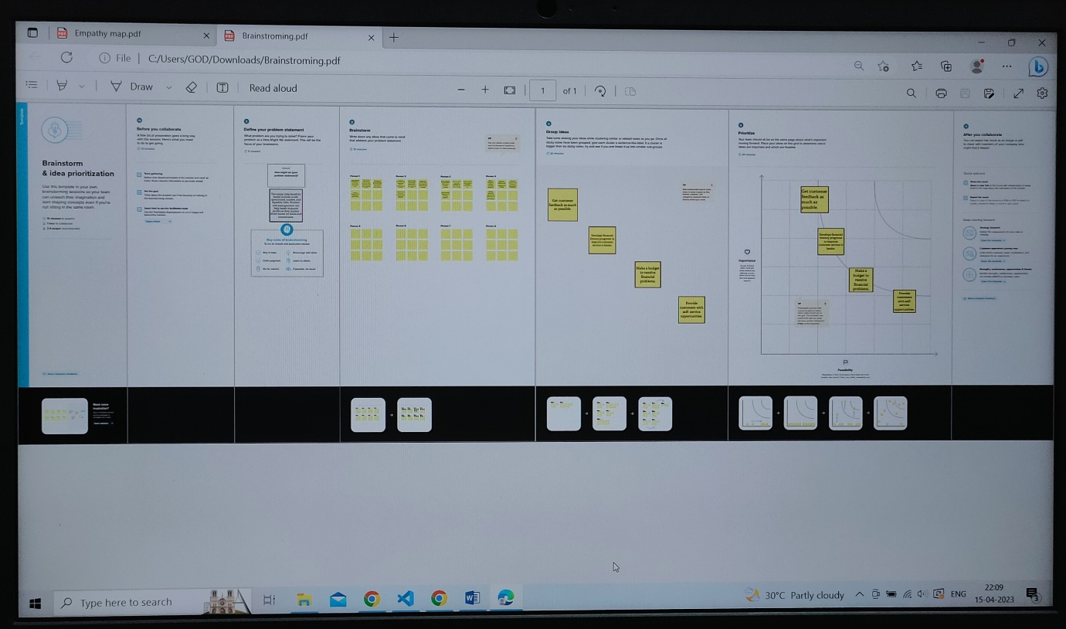

3. DASHBOARD AND STORY SCREEN SHOT

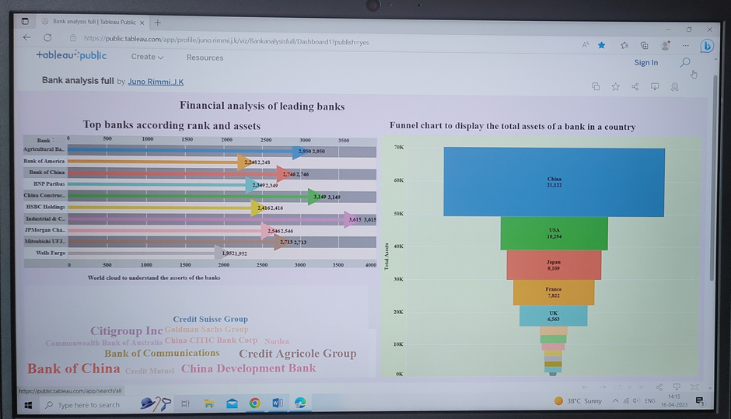

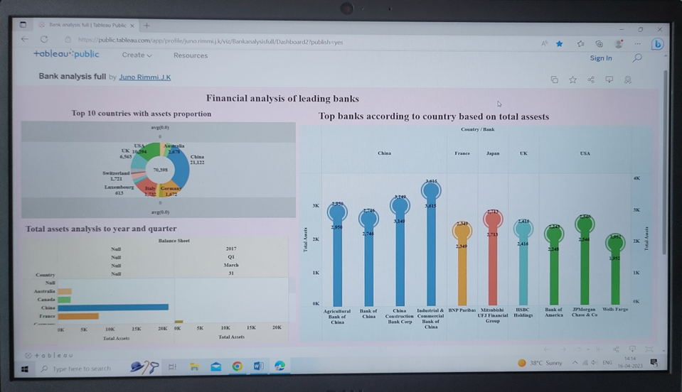

STORY BOARD

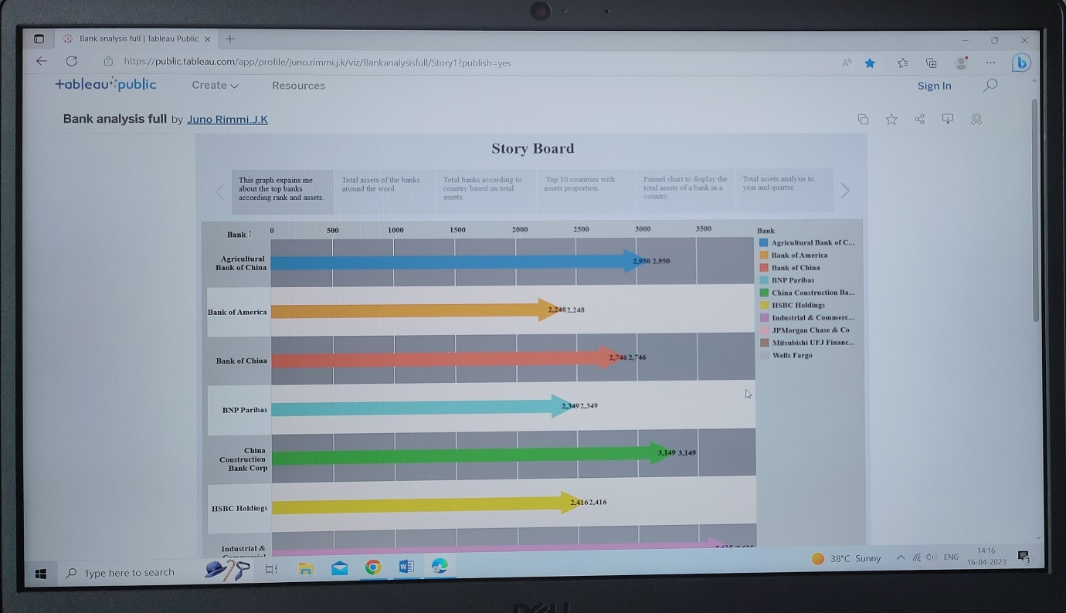

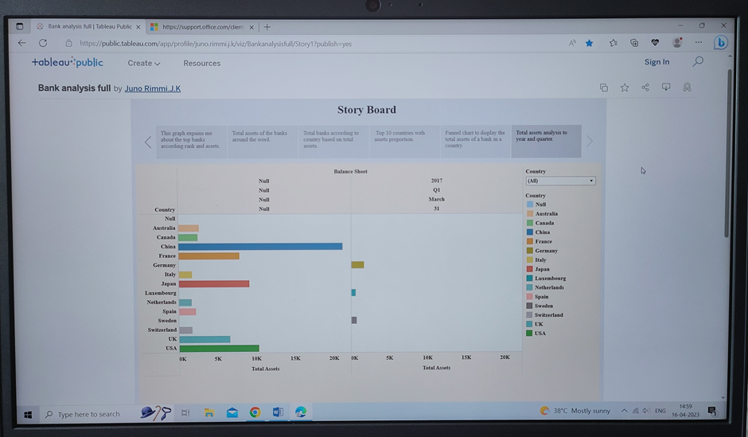

WEB INTEGRATION



BOOT STRAP

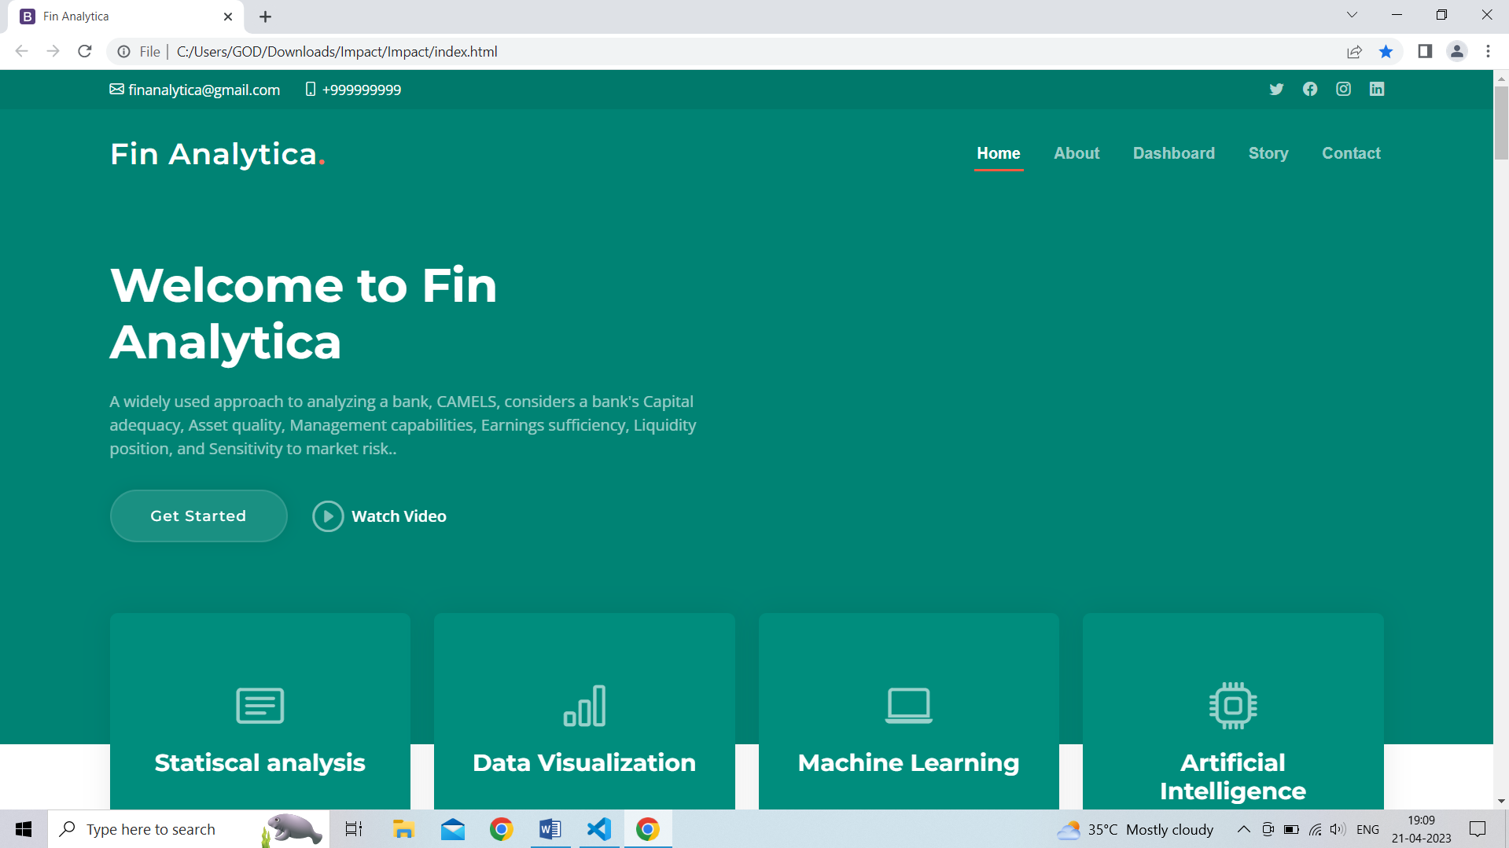

4. ADVANTAGES AND DISADVANTAGES:

|  |  |
| --- | --- |
| ADVANTAGES | DISADVANTAGES |
| Preparations of financial statements | Expresses accounting information in terms of money |
| Decision making | Accounting information is based on estimates |
| Evidence in legal matters | Accounting information may be biased |
| Helps in taxation matters | Recording of fixed assets at the original cost |
| Valuation of business | Manipulation of accounts |
| Maintenance of business records | Money as a measurement unit changes in value |
| Comparison of results | _ |
| Replacement of memory | _ |

5. APPLICATIONS

Financial performance

An appraisal of the literature shows that there is little agreement among researchers on how to measure financial performance. The current study measures financial performance through different indicators include Share of the market, Volume of the sale, Profitability.

Customer response

Researchers depend on different items for measuring customer response (Roschk & Hosseinpour, 2020) measured customer responses by fives dimensions which are Mood(Activation, Valence, and Control); Evaluations (Product evaluations, Environmental Quality, and Shopping satisfaction);Memories (Recall, and Time elusiveness); Intentions(Purchase, and Intention to recommend); Behaviours (Expenditures, and Lingering).

Operations management

Operations Management is a central part of any bank. It’s very important for success in Banks. It is a part of management that is a focus on the production of services at the bank. Operations management practices are meant to develop the effectiveness of production. (Dao et al., 2020) measured operations management by three dimensions detailed in as following: just in time practices (daily schedule adherence–equipment layout–(JIT) delivery by the supplier-Kanban-setup time reduction); quality management practices (cleanliness and organization–process control–supplier quality management–customer focus–maintenance); infrastructure practices (committed leadership–multi-functional training–employee involvement -information and feedback).

6. CONCLUSION

The current study is an attempt to explain the importance of customer response among the bank’s administrator’s concepts. Alongside this, the study investigated the correlation between variables; customer responses and financial performance, customer responses, and operations management, operations management, and financial performance, besides the mediating effect of operations management on the relations between customer response and financial performance. The sample size of the study was 73 questionnaires delivered hand by hand to managers in the top and middle management. Questionnaire items were shown as following; customer responses included three items, operations managements included five items, and financial performance included six items. The attention of customer response affected positively on financial performance and operations management. Operations management related to financial performance positively. Focusing on the outcomes of study financial performance affected by customer response and operations management then banks administrations should be careful about customer response and operations management. The results provided empirical support for the theoretical framework, reflected the fact that the study had adequately addressed the questions of the study. The study also highlighted the implication, limitations, and suggestions for future research.

7. FUTURE SCOPE

Depending on the above limitations of the study, the current study introduced a number of suggestions for further studies. Future researches can repeat this study with increasing sample size and different contexts, such as different sectors or dissimilar states. In addition, the model or framework of the study was simple and limited, further researches can enter several variables, such as moderating variables or increase the aspects of the current variables.