**System to Determine Abnormal Gait**

**Joe Doe**

**Degree Stream : Electronic Engineering**

**Project Supervisor : Dr. Who**



**May 2016**

**Department of Electronic Engineering**

**Maynooth University**

An Interim Project Report submitted in partial fulfilment of the requirements of the Maynooth University for the degree of Batchelor of Engineering

Table of Contents

1 Introduction: 3

2 Problem Statement and Objectives of the projects: 3

3 Background: 3

3.1 History of Gait: 3

3.2 Modern Gait Analysis: 5

3.2.1 Accelerometers, Gyroscopes and Magnetometers: 6

3.2.2 Force Sensitive Resistors: 8

3.2.3 Flexible Goniometer: 8

4 Lit Review: 9

4.1 Report on Gyroscopes for Gait Analysis: 10

4.2 Report on Xsens MVN NIOMECH: 11

4.3 Report on Accelerometer Test-Retest Reliability 12

5 Work Plan and Gantt CHART: 13

6 References 17

Figure 1-Results of Edward Muybridge’s gait experiment. 3

Figure 2-block diagram of gait analysis with cameras. 4

Figure 3-Accelerometer Block Diagram 5

Figure 4-Mems of Accelerometer 5

Figure 5-examples of Flexible goniometers 6

Figure 2-layout of sensors in the shoe 7

Figure 3-Joint angle waveforms and CMC values during one representative level walking trial. 9

Figure 6-Gantt chart part 1 Overview of project layout. 13

Figure 7-Gantt Chart part 2 30/January - 20/March 14

Figure 8-Gantt Chart part 3 17/March - 6/May 14

Figure 9-4/May - 24/May 14

**ABSTRACT**

深度学习是机器学习领域最为重要的一部分，在很多相关领域，采用深度学习的深度神经网络的方法是目前最为先进的解决方案。为了进一步理解深度神经网络在解决实际问题中性能优越的原因，本项目提出使用图信号处理的方法去检测深度神经网络中间层的特征，通过比较不同的特征和度量方式，表明可以使用k-nearest neighbor graph 来解释深度神经网络具有良好性能的原因。

**Declaration**

*I declare that this report and the project it describes is my original work only. I have not plagiarized or excessively quoted the work of others, nor have I colluded with others to represent collaborative work as my own. I confirm that I have appropriately cited all information derived from the published and unpublished work of others.*

*Signed: Student Number: Date:*

**Acknowledgements:**

The project work described in this report has been accommodated with resources including electronic components, background information on the capacitor impedance mentioned in the project title and a generous working environment with consistent efforts to maintain health and safety standards. I would therefore like to acknowledge the continued assistance and support of ……...

# Introduction:

深度学习作为机器学习的一个分支，已经越来越被科研工作者们所重视，许多在传统机器学习理论的基础上无法解决的问题，应用深度学习理论都能得到很好的解决。深度神经网络的输入和输出之间通过多层的参数结构进行连接，虽然可以通过反向传播逐步使得深度神经网络的参数收敛，但是目前深度学习的参数训练仍然有一些明显的缺陷，比如，如果训练集的数据量不够大时，神经网络的精度就比较差，即使训练集的数据量足够大，如果训练集的质量不够高也会导致神经网络的泛化能力比较差，即出现过拟合。

实际上，深度神经网络是由有向无环图组成的，而GSP可以将傅里叶分析扩展到任何使用图来描述的拓扑域。因此本文提出使用图信号处理（GSP）的方法来监视深度神经网络的训练过程，并试图发现深度神经网络性能达到最佳的过程中的特征变化，从而为深度神经网络的训练提供指导。

# Problem Statement and Objectives of the projects:

The problem statement for this project is: “How to design a suitable Deep Neural Networks and choose several representative features such that can monitor the DNNs well”. The project has been broken down into the following main objectives:

1. Design a Deep Neural Network to do some tasks such as classfication.
2. train the above DNN by the typical dataset such as CIFAR-10 to make the accuracy achieve an stable value.
3. Define several representative features about the process of the DNN training.
4. use GSP method to obserse the change of the above features.

These objectives provide a linear progression to the project and help to keep the project on track. These objectives will be discussed in further detail in the work plan section of the report.

# Background:

In this section the various aspects of the background to the project will be presented.

## History of GSP :

Data is all around us, and massive amounts of it. Almost every aspect of human life is now being recorded at all levels: from the marking and recording of processing inside the cells starting with the advent of fluorescent markers, to our personal data through health monitoring devices and apps, financial and banking data, our social networks, mobility and traffic patterns, marketing preferences, fads, and many more. The complexity of such networks [1] and interactions means that the data now reside on irregular and complex structures that do not lend themselves to standard tools.Graphs offer the ability to model such data and complex interactions among them. For example, users on Twitter can be modeled as nodes while their friend connections can be modeled as edges. This paper explores adding attributes to such nodes and modeling those as signals on a graph; for example, year of graduation in a social network, temperature in a given city on a given day in a weather network, etc. Doing so requires us to extend classical signal processing concepts and tools such as Fourier transform, filtering, and frequency response to data residing on graphs. It also leads us to tackle complex tasks such as sampling in a principled way. The field that gathers all these questions under a common umbrella is graph signal processing (GSP) [2], [3]. While the precise definition of a graph signal will be given later in the paper, let us assume for now that a graph signal is a set of values residing on a set of nodes. These nodes are connected via (possibly weighted) edges. As in classical signal processing, such signals can stem from a variety of domains; unlike in classical signal processing, however, the underlying graphs can tell a fair amount about those signals through their structure. Different types of graphs model different types of networks that these nodes represent. Typical graphs that are used to represent common realworld data include Erdo˝s–Rényi graphs, ring graphs, random geometric graphs, small-world graphs, power-law graphs, nearest-neighbor graphs, scale-free graphs, and many others. These model networks with random connections (Erdoo˝s– Rényi graphs), networks of brain neurons (small-world graphs), social networks (scale-free graphs), and others. As in classical signal processing, graph signals can have properties, such as smoothness, that need to be appropriately defined. They can also be represented via basic atoms and can have a spectral representation. In particular, the graph Fourier transform allows us to develop the intuition gathered in the classical setting and extend it to graphs; we can talk about the notions of frequency and bandlimitedness, for example. We can filter graph signals. They can be sampled, a notoriously hard problem; with GSP, one gains access to principled tools mimicking the classical ones. We can denoise graph signals, we can learn their underlying structure, we can model them. If the graphs cannot be directly observed, we can also learn their structure from data.

# history or DeepNeural Network

作为一个非常有效的数学工作，机器学习算法，尤其是神经网络早在上个实际的60年代就已经出现，当时的科学家以生物神经网络为原型，提出了第一代神经网络模型，当时被称为感知器[18]，第一代神经网络的特点是其特征需要人工事先输入，在进行模式识别时，是基于特征权重的。它的局限性在于对具体任务的处理效果不佳。因此第一代神经网络的使用范围往往极为有限，第一代神经网络感知器模型如下。

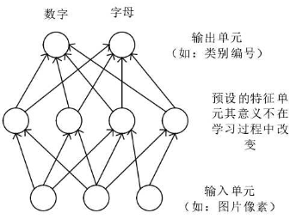

Marvin Minsky 和 Seymour Papert 于1969年[19]探讨了第一代神经网络没有能力处理异或逻辑问题的缺点，这使得其他研究者们对于神经网络越来越没有信心，因此，自1970年起，神经网络的研究和发展进入了一个低潮期。

1982年，物理学家John Hopfiled[20] 提出了一种新的神经网络模型，被称为 Hopfield 模型，并首次提出了能量的定义。Hopfiled 模型具有很强的容错性能，并能够从不完整或失真的数据图像中重构出完整的数据图像。即第一代神经网络模型之后，Hopfield 的模型被称为第二代神经网络，与初代感知器不同的是，Hopfield 模型不再使用预设的特征，而是由算法在训练过程中自动适应，因此就解决了使用范围狭窄的问题。在训练的适合，这类神经网络采用了一种反向传播算法[2][22]，从输入层将样本的误差反向传播到输入层，网络的权值在传播的过程中不断的调整，提高神经网络对于样本的似然度。同时，虽然隐含层可以加强网络的表达能力，但是它的引入也使得网络的复杂度提高了。第二代神经网络模型如图所示。

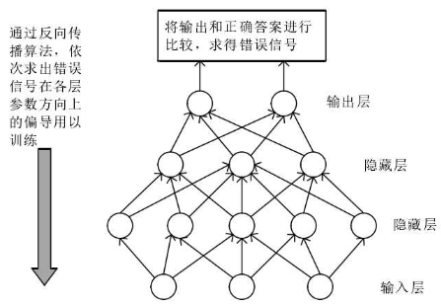

与第一代神经网络相比，第二代虽然能够处理较多的问题，但是还是由明显的缺点：1）监督学习是他唯一的用途，而且在训练数据时要使用标号。绝大多数的真实环境中的数据是没有标号的。（2）训练时间很长，特别是隐含层特别多的情况下，但是如果减少了隐含层就会降低精度。（3）反向传播算法容易陷入局部最优解。因此神经网络的发展又进入了第二个低谷。

直到时间来到了2016年，Hinton[23]首次提出了深度网络和深度学习的理论[28]，并发表在了《科学》杂志上，由此引起了人们对于深度学习的注意。深度学习架构是由多层非线性运算单元构成，能够学习表示高阶抽象概念的复杂函数，从低到高的过程中，底层输出作为高层输入。通过多次的输入数据学习，可以得到它的结构信息的高阶特征表示，用于分类、回归和信息检索等特定问题中。深度学习的诞生给予了研究人工智能的新希望[24]。

不过目前的研究水平，人们还不能掌握每层学习到的特征是什么样的，本设计提出了采用GSP方法来分析深度神经网络中间层的特征，从而为深度神经网络的精度和性能提供依据。

## GSP application

网络或者说图的应用无论是在科研或者是日常生活中都非常常见，比如社交网络，生物网络，通信网络等等。而近几年，随着人工智能的发展，深度神经网络也随之兴起。然而深度学习一直以来都是以“黑盒子”的形态呈现在研究人员的面前，尽管最近有不少深度神经网络结构在各个领域都取得了前所未有的成就，比如图像分类领域，深度神经网络的精度能够达到70%以上(top1)和90%以上(top5)，这样的精度已经达到甚至超过了人类的分类能力。然而，却没有明确的理论支持为什么深度神经网络能够达到这样的精度，实际上，大部分神经网络的构建或者创新往往都有猜测的成分，因此急需一种手段深入神经网络内部去寻找某些可以衡量或者指导神经网络的指标。

深度神经网络本质是有向无环图，其每个节点表示一个可以与标签关联的数据节点，并且通过连接不同节点边以及给每个边分配各自的权重形成图。既然是图，必然遵循图论，因此图论相关的方法在深度神经网络的应用中具有非常重要的指导意义。图信号处理（GSP）是图论中非常重要的工具之一，GSP可以对图的不同节点进行不同形式的处理、过滤等等操作。当数据标签在图上作为信号呈现时，图信号正则化技术可以用于标签估计的过程中，从而优化分类和半监督学习问题中未知标签的预测。

the GSP framework can also be used to design architectures to analyze or classify whole graph signals that originally live on irregular structures. In particular, the GSP toolbox has been extensively used to extend convolutional deep learning techniques to data defined on graphs. The convolutional neural network paradigm has been generalized with help of GSP elements for the extraction of feature descriptors for 3-D shapes [205], [206]. A localized spectral network architecture leveraging on localized vertexfrequency analysis has also been proposed in [207], and the use of heat kernels defined in the graph spectral domain has been developed in [208]. While the previous works mostly address the analysis of 3-D shapes, convolutional neural networks (CNNs) can actually be extended to many other signals in high-dimensional irregular domains, such as social networks, brain connectomes, or words embedding, by reformulation in the context of spectral graph theory. Here, the GSP framework leads to the development of fast localized convolutional filters on graphs [209] along with adapted pooling operators [210]. Unsurprisingly, deep network architectures for graphs signals have been actually tested in various applications domains, such as chemical molecule properties prediction [211], classification tasks on social networks [212], autism spectrum disorder classification [213], or traffic forecasting [214].

# Lit Review:

## Report on GSP for Semi-Superviesd Learning:

In 2014 a report was published which introduced a novel framework for bacth mode active semi-supervised learning based on sampling theory for graph signals. The proposed active learning framework aims to select the subset nodes which maximizes the dimension of the space of uniquely recoverable signals. In the context of sampling theory, this translates to selecting the subset with the maximum cut-oﬀ frequency. This interpretation leads to a very eﬃcient greedy algorithm. They provide intuition about how the method tries to choose the nodes which are most representative of the data. they also present an eﬃcient semi-supervised learning method based on bandlimited interpolation. they show, through experiments on real data, that our two algorithms, in conjunction, perform very well compared to state of the art methods. they used their proposed activate semi-supervised learning algorithm to perform a calssification task on several popular dataset to cimpare with other state of the art methods. The results are ilustrated in Figure 1.

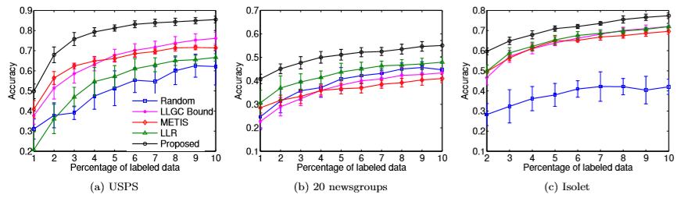

Figure 1

es of the dataset and report the average classiﬁcation error. The results are illustrated in Figure (5a). We observe that our proposed method outperforms the others. A notable feature of our method is that we show very good classiﬁcation results even for very few labeled samples. This is due to our inherent criterion for active learning that tries to select those points that maximize the recoverable dimensions of the underlying data manifold. The classiﬁcation results in Figure (5b) show that our method performs very well compared to others. However, the absolute error rates are not very good. This is due to the high similarity between diﬀerent newsgroups which makes the problem inherently diﬃcult. The experiment is repeated over 10 instances of the dataset and average prediction error is reported in Figure (5c). Note that we start with 2% labeled points to ensure that each method gets a fair chance of selecting at least one point to label from each of the 26 classes. We observe that our method outperforms the others.

## Report on Fourier analysis of DNNs

Another report on the Fourier analysis of Deep Neural Network wa published in 2018. They studied deep ReLU networks through the lens of Fourier analysis. Several conclusions can be drawn from their analysis. While neural networks can approximate arbitrary functions, they ﬁnd that they favour low frequency ones – hence they exhibit a bias towards smooth functions – a phenomenon that was called spectral bias. they also illustrated how the geometry of the data manifold impacts expressivity in a non-trivial way, as high frequency functions deﬁned on complex manifolds can be expressed by lower frequency network functions deﬁned in input space. From the figure2, they ﬁnd that even when higher frequencies have larger amplitudes, the model prioritizes learning lower frequencies ﬁrst. they also ﬁnd that the spectral norm of weights increases as the model ﬁts higher frequency, which is what they expect .

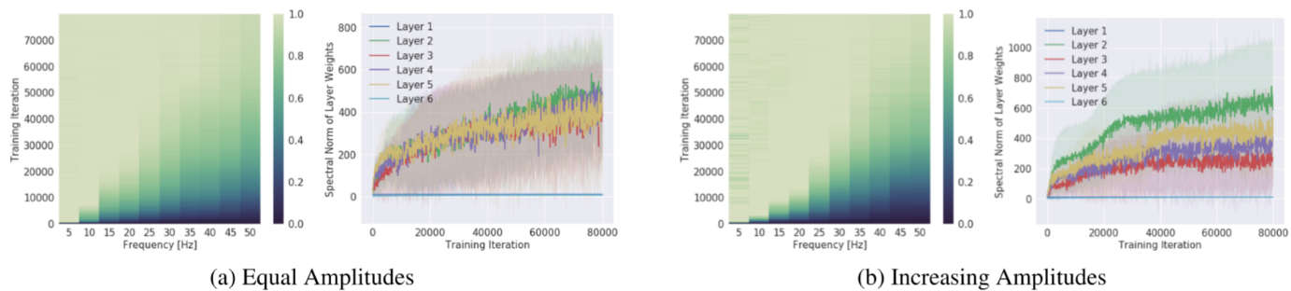

figure 2. . Left (a, b): Evolution of the spectrum (x-axis for frequency) during training (y-axis). The colors show the measured amplitude of the network spectrum at the corresponding frequency, normalized by the target amplitude at the same frequency and the colorbar is clipped between 0 and 1. Right (a, b): Evolution of the spectral norm (y-axis) of each layer during training (x-axis). Figure-set (a) shows the setting where all frequency components in the target function have the same amplitude, and (b) where higher frequencies have larger amplitudes.

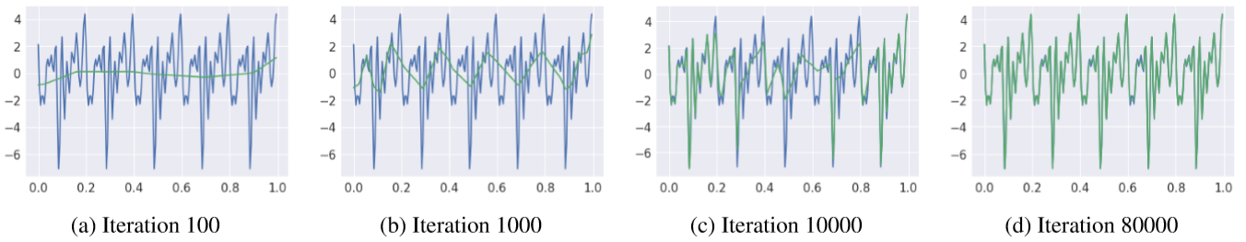

figure 2

Figure 2 shows the learned function at intermediate training iterations. The result is that lower frequencies are regressed ﬁrst, regardless of their amplitudes.

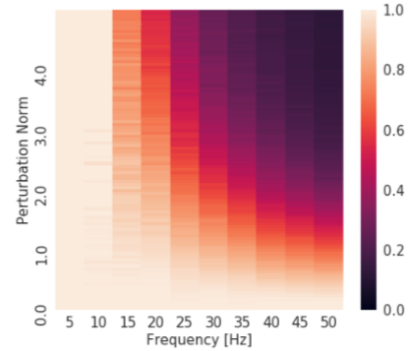

figure 4

The result, shown in Figure 3, demonstrates that higher frequencies are signiﬁcantly less robust than the lower ones, guiding the intuition that expressing higher frequencies requirestheparameterstobeﬁnely-tunedtoworktogether. In other words, parameters that contribute towards expressing high-frequency components occupy a small volume in the parameter space

## Report on Predicting DNNs Overfitting using GSP

another report on predicting DNNs overfitting using GSP was published in 2018. they have shown via experiments that there exists a strong correlation between smoothness gap and generalization abilities in deep neural networks.

Deep Neural Networks (DNNs) have become the state-ofthe-art in many machine learning benchmarks ever since the AlexNet won the ILSVRC-2012 competition. Due to the fact they rely on millions of trainable parameters, DNNs remain black-box methods. As a consequence, there is little understanding of the reasons for their generalization abilities and finding the best hyperparameters for a given problem requires to exhaustively search a lot of combinations. It is often considered that architectures that are not optimal for a given problem suffer either from what is called underfitting or overfitting. Underfitting typically refers to conditions where increasing the number of trainable parameters in some parts of the architecture would lead to better generalization performance. To the contrary, overfitting refers to conditions where the network is containing too many parameters and despite being very efficient at classifying the training set, it fails when facing unseen examples.

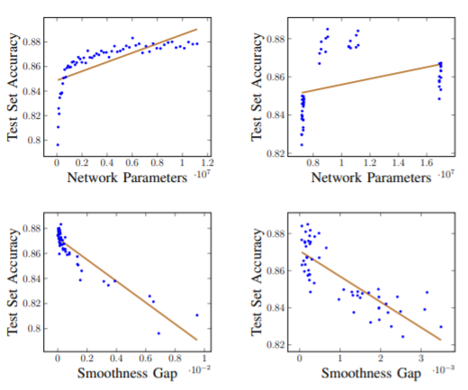

figure 5

Results are depicted in figure 2, The right column shows results where the size of feature maps is changed independently, while the left column the feature maps depend on the size of the first convolutional layer. While the upper row shows the correlation between the number of trainable parameters and the network performance, while the lower row shows the correlation between the smoothness gap and netw ork performance. The brown lines are linear regressions.

# Work Plan and Gantt CHART:

The overall work plan for this project can be broken down into the following objectives:

1. Choose a suitable Deep Neural Network and corresponding dataset.
2. Train the Deep Neural Network to the excepted accuracy.
3. Compare and choose several feature of the intermediate representations of above Deep Nerual Network.
4. Characterize the above intermediate representations using graph signal processing(GSP).
5. Analysis the .performance of the above experiments and research the correlation between overfitting and DNN archittecture and so on.

第一步，我们首先需要学习和总结深度神经网络、深度学习以及图信号处理相关的知识，这一步是完成我们整个项目的基础。深度学习主要是通过人工神经网络（Artificial Neural Network，ANN）来模拟人脑的学习过程，是机器学习领域的一个很有发展前景的分支，得到了国内外学者的广泛关注。而图像分类技术是通过计算机对图像信息进行处理的一种技术，但是人与计算机对图像处理的结果差异较大，深度学习等人工智能方法可以更严谨地、更科学的分析和处理图像数据。当今互联网和互联网技术正高速发展，随着微信、陌陌等新型娱乐工具的兴起以及平板电脑、智能手机等配备数字摄像头的手持终端设备的广泛推广普及，网络上图像数据急剧增加。这些图像覆盖了人类生活的各个方面，传播了大量有用的信息。近年来，如何快速有效地提取和分析这些图像所包含的语义信息并运用到实际问题中已经成为图像分类和识别、图像搜索、图像理解和分析等领域的研究重点。随着图像研究的深入，模糊集方法、决策树分类法、基于知识的分类方法、机器学习方法等智能图像分类算法不断涌现。模糊集方法是通过经验得到的，虽然可以很好地处理一些比较模糊的问题，但存在一定的不确定性与主观性。决策树分类法是一种比较好的分类方法，通过效仿人类思想而得出，但也存在依赖度大、分类决策规则与专家系统不易结合、不能充分利用分类对象的空间特征等缺点。基于知识的分类方法不具备自适应能力，当经验和知识受到外界因素干扰时，该方法的分类效果较差。因此，相较于上述三种方法，机器学习的方法因其理论深厚、效果显著，日益受到学者们的关注。而深度学习算法[1]作为机器学习一个重要的分支，其优异的分析建模能力也为图像分类技术的研究提供了新方向。深度学习算法根据人的视觉系统对信息的处理是分级的这一特点，模拟多层神经网络建立模型。从低级的边缘特征到目标或者形状等，再到高级的整体目标、目标的行为等，越高层的特征表示越能表达图像的语义。深度学习的模型是由大量的简单神经元组成，每层的神经元向更高层的输入，通过输入和输出之间的非线性关系，低层的特征组合成更加高层的抽象化表示，并由此发现所观测数据的分布式特征，自上而下的学习方式，形成多层抽象表示，并且特征学习的多层次化是自动地且无人工干预。之后通过学习得到的网络结构，将输入的样本数据对各种层次的特征进行映射，利用现有的匹配算法和模型对最上层单元的输出进行分类和识别等后续的工作。深度学习研究的初衷主要就是应用于图像识别。迄今为止，尽管深度学习已经被应用到语音、图像、文字、情感等多个领域，但深度学习领域发表的论文中大约 70%是关于图像识别的。深度学习在图像识别分类方面有着巨大的优势。从统计和计算的角度看，在很多问题上，深度学习是目前我们能找到的最好方法。当前深度学习算法有三大趋势：（1）用大数据提高统计估计的精确度，用复杂的模型降低模型偏差，用可扩展的梯度下降算法求解大规模优化问题；（2）深度学习像概率模型一样，利用基于联接主义的建模语言表达数据内在的机构及联系，比如用递归神经网络（Recurrent Neural Network，RNN）处理自然语言等数据中的时序结构，用卷积处理图像中的二维空间结构等；（3）深度学习直接作用于原始数据，自动逐层学习特征，属于端到端机器学习系统，整个过程直接优化某个目标函数，传统机器学习往往被分解为几个不连贯的数据预处理步骤，比如人工抽取特征，这些步骤并非一致地优化某个整体的目标函数。目前，深度学习算法已成为机器学习中的研究热点，在图像分类、语音识别等众多领域中有着广阔的研究价值和应用前景。深度学习采用无监督学习，训练过程中样本标签是未知的，这种学习方法无需人工参与。在信息化的现代，大样本大数据集越来越普遍，深度学习能够利用多层非线性变换来处理大量的图像、声音、文本等类型的无标签数据，从而实现有监督或者无监督的特征提取和转换、模式分析和分类。

近年来，许多学者热衷于高维数据的有效替代和图信号的近似表达。最典型的是图信号处理（Graph signal processing, GSP）技术，GSP 技术的核心是谱图理论，是伴随着谱图理论的发展而出现的一个新研究领域。此外，图傅里叶变换提供了一个与传统傅里叶变换相似的“频率”概念，即图拉普拉斯矩阵特征值作为图信号的“频率”概念，并在图的机器学习和信号处理领域得到广泛应用，如，无监督学习（类聚和降维）、半监督和监督学习（分类和重构）及图信号处理的谱滤波等。以上方法主要是利用谱图理论和图拉普拉斯矩阵将高维数据空间映射到一个低维数据空间，通过提取较少的特征向量，再经数据重构，从而实现高维数据的低维表达。

第二步就是去训练一个合适的的深度神经网络结构，目前研究人员已经开发出来了大量有针对性且复杂的深度神经网络模型来解决不同方面的问题，其中最为典型的就是卷积神经网络，因此本项目也以卷积神经网络为基础来进行展开研究。

第三步就是去选择一个合适的数据集，目前整个领域已经有大量不同的数据集可以免费使用，本项目选取其中比较经典的 CFAIR-10 数据集。CFAIR-10数据集是用于图像分类的数据集，其图像种类被分为10种，每种图像又有超过5000张图片，总计超过50000张图片，足以用于一般深度神经网络的训练。为了验证深度神经网络的训练效果，一般会将整个数据集的2/3作为训练集，其余的1/3作为测试集。

第四步是去选择合适的特征，目前科研界已经有争对图信号处理提出的主流的一些特征，本项目初步决定使用包括Distances and k-Nearest Neighbor Graphs、Label Smoothness和Separation作为特征，后期在实际操作过程中，可能会增加一些新的特征。

第五步，也是最复杂的一步就是要去分析深度神经网络的不同性能于其特征之间的关系，从而为深度神经网络的训练提供可能的指导。

整个项目的程序相关的编写将会基于目前最主流的深度学习框架Tensorflow展开，另外GSP相关的编程在Python也有PyGSP模块提供支持。

|  |  |  |  |
| --- | --- | --- | --- |
| name | Begin date | days | End date |
| Research Graph Signal Processing | 02/01/20 | 14 | 2/15/20 |
| Research Machine Learning and Deep Nerual Network | 02/01/20 | 20 | 2/21/20 |
| write Interim Report | 02/20/20 | 7 | 2/27/20 |
| Submit interim Report | 02/26/20 | 1 | 2/27/20 |
| Config the programme environment of Tensorflow | 02/27/20 | 6 | 3/4/20 |
| Familurise self with the coding of Tensorflow and Python | 03/01/20 | 8 | 3/9/20 |
| write a programme that trains the Deep Nerual Network | 03/07/20 | 15 | 3/22/20 |
| Record the accuracy and perfomance of the Deep Nerual Network | 03/21/20 | 4 | 3/25/20 |
| write a programme that can record the intermediate representation of the DNN | 03/25/20 | 12 | 4/6/20 |
| Test the system to ensure that it is accuratly getting the intermediate representation | 04/06/20 | 3 | 4/9/20 |
| write a programme that uses the GSP to analysis the DNN | 04/09/20 | 18 | 4/27/20 |
| Write final Report | 03/25/20 | 40 | 5/4/20 |
| Submit final Report | 05/05/20 | 5 | 5/10/20 |
| Create Poster | 05/18/20 | 6 | 5/24/20 |
| Submit Poster | 05/22/20 | 6 | 5/28/20 |

Figure 6-Gantt chart part 1 Overview of project layout.

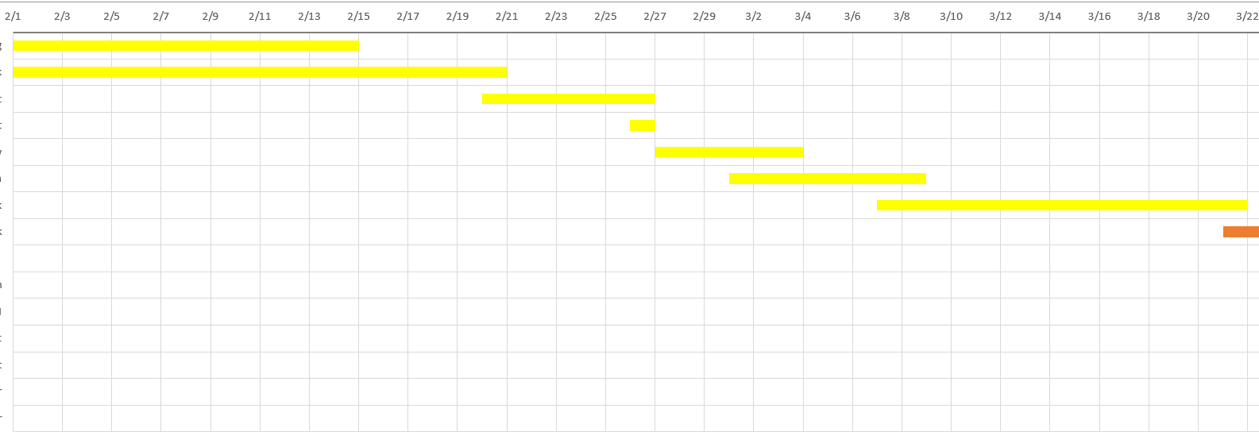

Figure 7-Gantt Chart part 2 30/January - 20/March

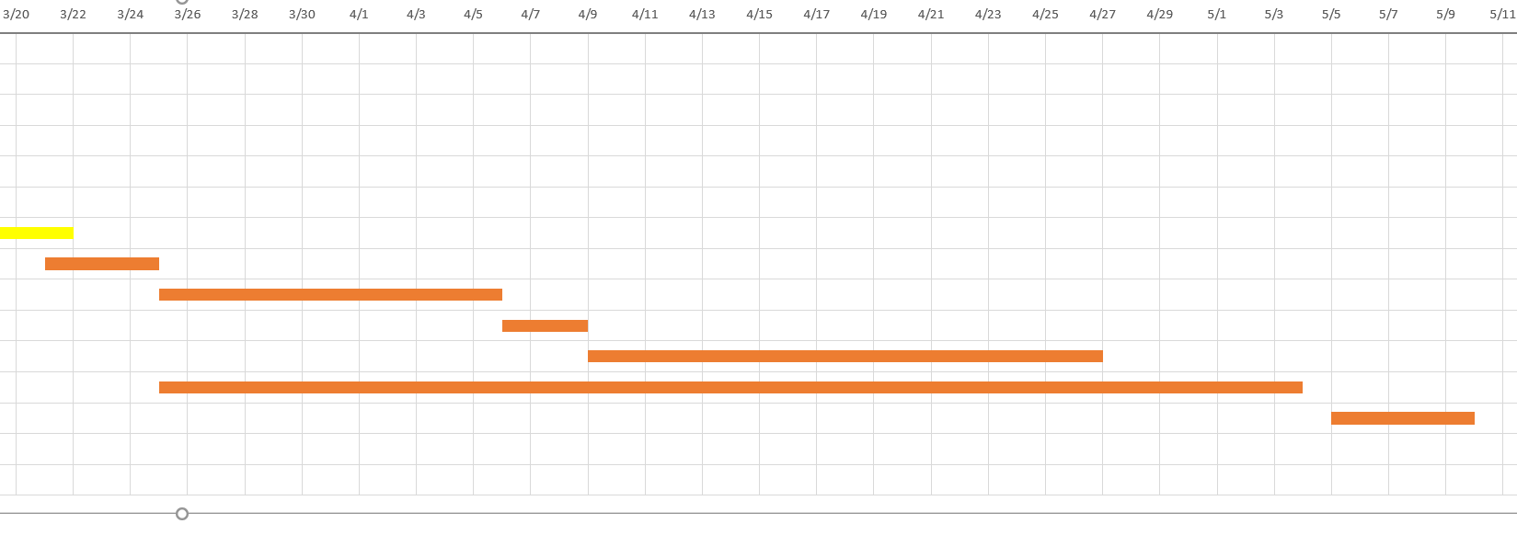

Figure 8-Gantt Chart part 3 17/March - 6/May

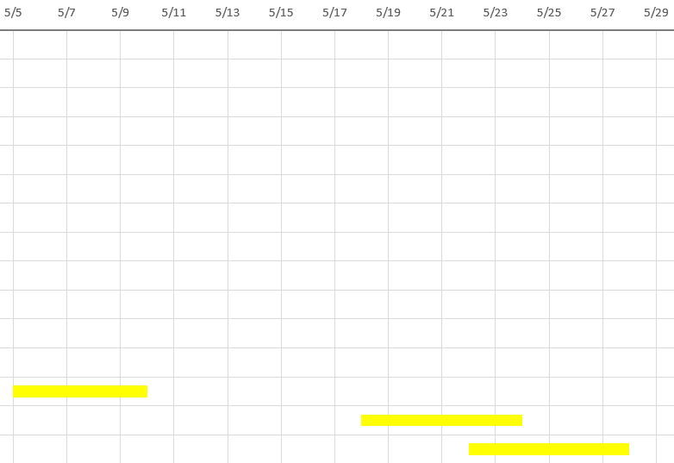

Figure 9-4/May - 24/May

# References

|  |  |
| --- | --- |
| [1] | Aristotle, “Aristotle: Parts of animals, movement of animals, progression of animals,” Harvard Universisty Press, Harvard, 1968. |
| [2] | R. Baker, “The history of gait analysis before theadvent of modern computers,” Science Direct, 2007. |
| [3] | c. J. O, “groups dcs stand,” 2003. [Online]. Available: HTTP://www-groups.dcs.stand.ac.uk/~history/Mathematicians/Galileo.html. [Accessed 2017]. |
| [4] | R. Descretes, “Treatise of man,” Prometheus books, New York, 1972. |
| [5] | I. Newton, “The principia: mathematical principles of natural philosophy,” University of Califorina Press, California, 1999. |
| [6] | G. Borelli, “On the movement of animals,” Spriinger-verlag, Berlin, 1989. |
| [7] | W. Weber, “Mechanics of the human walking apparatus,” Springer-Verlag, Berlin, 1991. |
| [8] | B. M, “Picturing Time: the wokr of etienne-Jules Marey,” University of Chicago Press, Chicago, 1992. |
| [9] | G. Carlet, “Experimental sur la locomotion humaine,” Annales des sciences Naturelles, 1875. |
| [10] | M. E, “The science of hore's motions,” Sci AM, 1878. |
| [11] | M. W.Whittle, Gait Analysis fifth edition, Elsevier, 2012. |
| [12] | A. Herbert, “Horse Motion, Edward Muybridge,” Harrry Ransom Center, [Online]. Available: http://www.hrc.utexas.edu/exhibitions/permanent/windows/southeast/eadweard_muybridge.html. |
| [13] | W. B. &. O. Fischer, “On the centre of gravity of the human body,” Springer-Verlag, Berlin, 1984. |
| [14] | B. G.-Z. a. A. M.-Z. Alvaro Muto-de-la-Herran, “Gati Analysis Method: An Overview of Wearable and non-Wearable System,” Sensors, Deusto, 2014. |
| [15] | D. Roy B, “Clinical Gait Analysis And Its Role in treatment Decision-making,” Medscape, 1999. [Online]. Available: http://www.medscape.com/viewarticle/440148_2. |
| [16] | T. L. R. Z. a. H. Weijun Tao, “Gait Analysis using wearbale sensors,” Sensors, 2012. |
| [17] | Unkown, “A beginner's guid to Acceleromters,” Dimension Engineering, [Online]. Available: https://www.dimensionengineering.com/info/accelerometers. |
| [18] | A. Ronzo, “Gyroscopes,” Sparkfun, [Online]. Available: https://learn.sparkfun.com/tutorials/gyroscope/how-a-gyro-works. |
| [19] | P. Jain, “Magnetometers,” EngineersGarage, [Online]. Available: https://www.engineersgarage.com/articles/magnetometer. |
| [20] | L. Ada, “Force Sensitive Resistors,” Adafruit, [Online]. Available: https://learn.adafruit.com/force-sensitive-resistor-fsr/overview. |
| [21] | E. P. a. F. D. N. Massimilano Donno, “A New Flexible Optical Fiber Goniometer For Dynamic Angular Measurements: Applicatrion to Human Joit Movement Monitoring,” IEEE, 2008. |
| [22] | S. J. Morris, “Gait Analysis using a Shoe-Integrated wireless Sensor System,” IEEE, 2008. |
| [23] | K. Tong, “A Practicall gait Analysis System using Gyroscopes,” Medical Engieering & Physics, Glasgow, 1999. |
| [24] | A. C. N. B. B. a. Q. L. jun-tian Zhang, “Concurrent validation of Xsens MVN measurement of Lower Limb join angular kinematics,” IOP Publishing, 2013. |
| [25] | H. l. R. m.-N. H. B.-s. Marius Henriksen, “Test-retest Reliability of trunk acceleromtric gait analysis,” Elsevier, Bergen, 2003. |
| [26] | D. F. guilou, “New Manufacturing Methodology Substantially Reduces Smart MEMS Costs,” Putting Sensors To Work, December 2003. [Online]. Available: http://archives.sensorsmag.com/articles/1203/20/main.shtml. |
| [27] | Unkown, “Biometrics, Goniometers and Torsiometers,” NExGen Ergonomics, 2014. [Online]. Available: http://www.nexgenergo.com/ergonomics/biosensors.html. |