Temporal ICU Modeling Report
Medformer Transformer + Markov-Chain Trajectory Analysis
Prepared from generated 170 mm main and supplementary temporal-model figures
Core message: tabular baselines and temporal models answer complementary modeling questions, not identical performance-only questions.
Figure folder: /content/drive/MyDrive/IUBDC 2026/Medformer/transformer_temporal_outputs/figures

1. Executive Summary
This report documents the temporal modeling workflow and the generated 170 mm publication-style figure set for ICU mortality prediction. The analysis combines a Medformer-based Transformer model with a Markov-chain trajectory analysis using the same first-48-hour ICU temporal window.
The main purpose of the temporal models is not to directly replace the stronger tabular baselines. Instead, the temporal models address a complementary question: whether patient trajectories over the first 48 hours contain interpretable prognostic structure. The tabular baselines summarize each patient into engineered 48-hour features, whereas the Transformer and Markov-chain analyses preserve temporal ordering and trajectory progression.
The generated figure set includes one main figure and six supplementary figures. Together, these figures show temporal model performance, calibration, temporal attribution, state-transition behavior, and integrated interpretation linking Medformer-predicted risk to Markov-chain severity trajectories.

2. Interpretation: Tabular Baselines vs Temporal Models
The tabular baselines and temporal models were not intended to answer exactly the same modeling question. The logistic regression and XGBoost models used engineered 48-hour summary features, including first, last, mean, standard deviation, measurement count, and missingness indicators. These models therefore represent strong patient-level predictive baselines based on aggregated information from the first 48 hours.
In contrast, the Transformer and Markov-chain analyses used temporally structured representations that preserve patient trajectories over the first 48 hours. The Transformer model evaluated whether sequential 4-hour ICU time bins contained predictive mortality information, while the Markov-chain analysis summarized each patient’s clinical course as transitions across interpretable severity states.
Therefore, lower AUROC or higher Brier score in the temporal models should not be interpreted simply as model failure. Instead, these models provide complementary evidence about temporal progression, deterioration patterns, and trajectory-level explanation, while the tabular models serve as stronger predictive baselines.

3. Analysis Workflow
Step | Description
Input data | Raw ICU long-format time-series files and binary in-hospital mortality labels were loaded from the project data folder.
Temporal binning | The first 48 hours were divided into 12 four-hour bins, creating a shared temporal representation for both the Transformer and Markov-chain branches.
Medformer branch | Each patient was represented as a sequence of standardized dynamic clinical measurement vectors concatenated with binary observation masks. The model was trained on the development cohort and evaluated on the external Set C cohort.
Markov branch | Each four-hour bin was assigned to a clinical severity state. Patient trajectories were summarized using state occupancy, transition matrices, worsening and recovery transitions, entropy, and time in high-risk or critical states.
Integrated interpretation | Medformer-predicted mortality risk was linked to Markov trajectory features to examine whether higher neural-network risk corresponded to interpretable deterioration patterns.
Figure generation | All final figures were exported at 170 mm width as PDF and 600 dpi PNG files.

4. Generated Figure Checklist
The figure-generation notebook reported the following successful exports:
Status | Figure File | Purpose
OK | Figure_temporal_main_170mm.pdf | Main integrated temporal analysis figure
OK | Figure_temporal_S1_data_coverage_170mm.pdf | Temporal data construction and missingness QC
OK | Figure_temporal_S2_medformer_validation_170mm.pdf | Medformer training and external validation
OK | Figure_temporal_S3_medformer_attribution_170mm.pdf | Medformer temporal attribution
OK | Figure_temporal_S4_markov_state_construction_170mm.pdf | Markov state construction and distributions
OK | Figure_temporal_S5_markov_transitions_170mm.pdf | Markov transition matrices
OK | Figure_temporal_S6_integrated_interpretation_170mm.pdf | Integrated Medformer-Markov interpretation

5. Figure-by-Figure Documentation

Figure 1. Main temporal analysis figure
Temporal sequence modeling and interpretable ICU trajectory analysis. Panels summarize the shared temporal representation, Medformer external performance, calibration, time-bin importance, Markov transition differences, and outcome-associated Markov trajectory features.
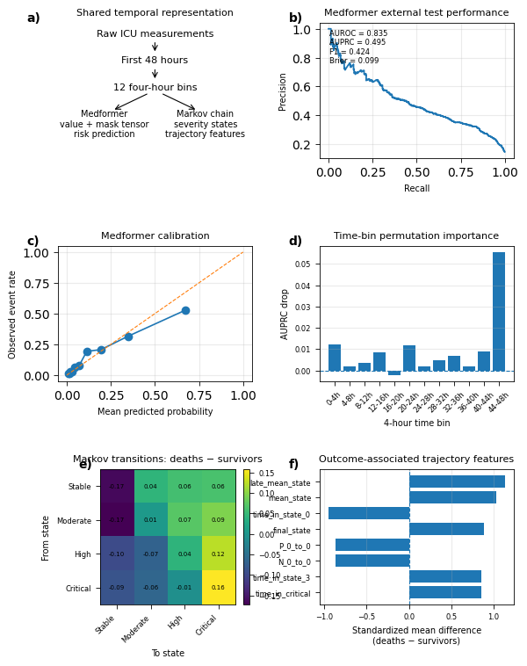
Figure 1. Main temporal analysis figure.

Supplementary Figure S1. Temporal data construction and missingness
Data-quality overview showing cohort outcome prevalence, patient-level temporal coverage, coverage over time, variable-by-time coverage, most missing variables, and observation burden.
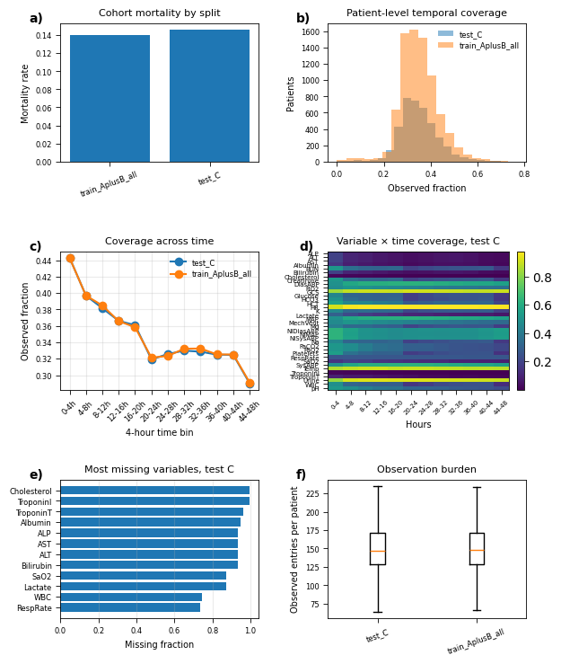
Supplementary Figure S1. Temporal data construction and missingness.

Supplementary Figure S2. Medformer training and external validation
Training and validation diagnostics for the Medformer model, including training loss, validation discrimination, validation Brier score, external ROC, external precision-recall curve, and risk distribution by outcome.
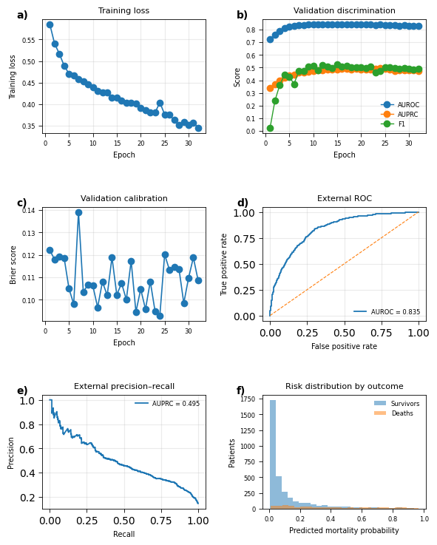
Supplementary Figure S2. Medformer training and external validation.

Supplementary Figure S3. Medformer temporal attribution
Temporal attribution analysis showing time-bin importance by AUROC, AUPRC, and Brier changes, plus feature-by-time attribution, top feature-time pairs, and aggregated variable importance.
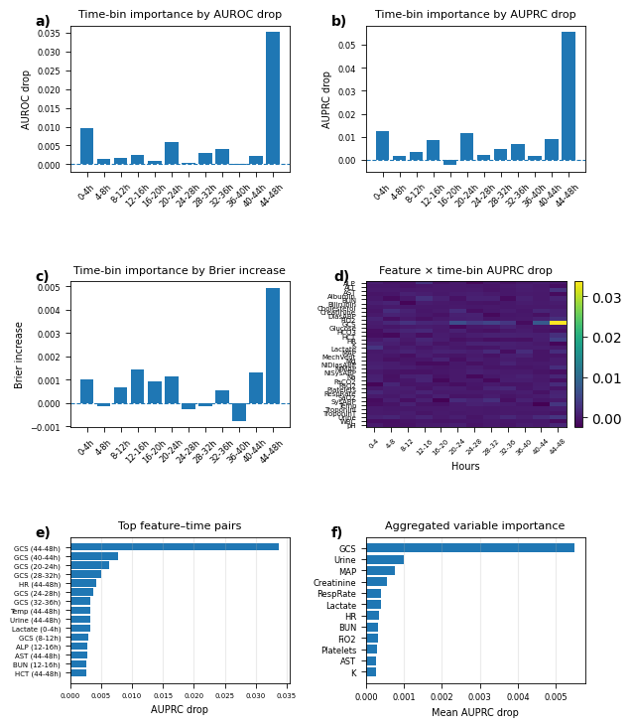
Supplementary Figure S3. Medformer temporal attribution.

Supplementary Figure S4. Markov state construction and distributions
Markov trajectory construction and state-distribution analysis, including clinical severity components, train-derived state cutoffs, severity score distributions, state distributions by outcome, and critical-state occupancy over time.
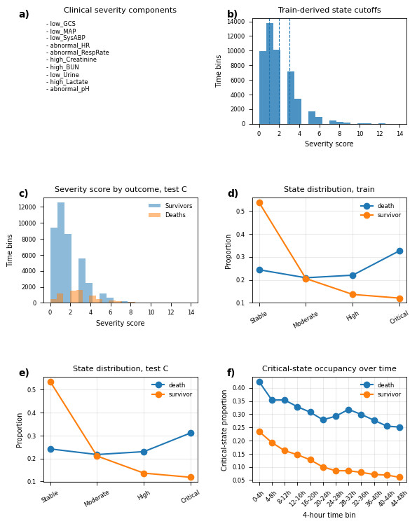
Supplementary Figure S4. Markov state construction and distributions.

Supplementary Figure S5. Markov transition matrices
Full Markov transition matrices for survivors and deaths in the training and external test cohorts, including death-minus-survivor transition differences.
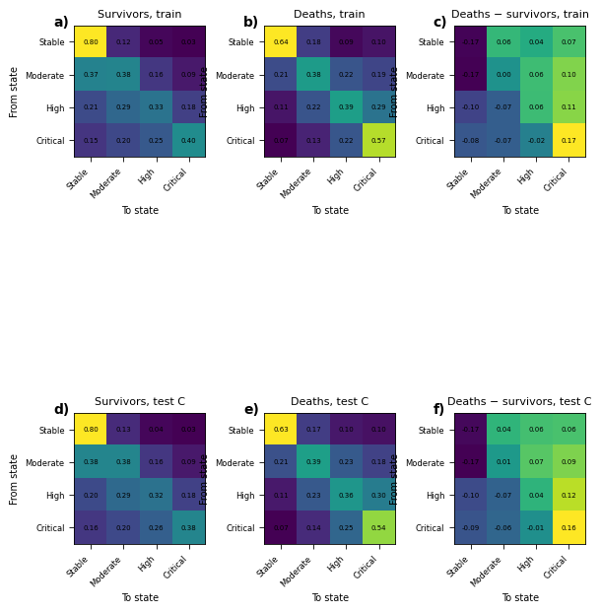
Supplementary Figure S5. Markov transition matrices.

Supplementary Figure S6. Integrated Medformer-Markov interpretation
Integrated interpretation showing how Medformer risk quartiles align with Markov critical-state trajectories, trajectory features, risk-feature correlations, and high-versus-low Medformer risk transition differences.
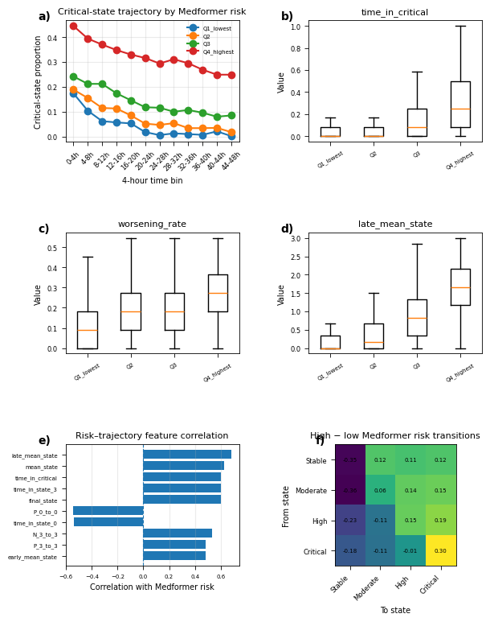
Supplementary Figure S6. Integrated Medformer-Markov interpretation.

6. Suggested Results Narrative
Although the tabular baselines achieved stronger overall predictive performance, the temporal analyses provide a different form of evidence. The Medformer model showed that mortality risk can be estimated from sequential 4-hour ICU trajectories, and time-bin permutation analysis identified which temporal windows contributed most strongly to prediction.
The Markov-chain analysis further showed that mortality was associated with more severe trajectory patterns, including increased occupancy of high-risk or critical states and greater persistence in adverse clinical states. Together, these results suggest that the temporal models are best interpreted as complementary trajectory-level analyses rather than direct replacements for engineered tabular baselines.
The integrated Medformer-Markov figure further supports this interpretation by showing that patients assigned to higher Medformer risk quartiles also tended to show more severe Markov trajectories, including greater critical-state occupancy, higher late mean state, and stronger correlation with trajectory features associated with deterioration.

7. Suggested Main Figure Caption
Temporal sequence modeling and Markov-chain trajectory analysis provide complementary evidence to tabular prediction baselines. The tabular models use engineered 48-hour summary features for strong patient-level mortality prediction, whereas the temporal models preserve the ordering of early ICU measurements to examine prognostic trajectory structure. The Transformer branch evaluates sequence-based mortality prediction, while the Markov-chain branch provides interpretable state-transition summaries of clinical deterioration and recovery.

8. Notes, Limitations, and Recommended Framing
• Do not frame the temporal models as failed simply because tabular baselines may have higher AUROC or lower Brier score. They answer a different question about temporal trajectory structure.
• If Medformer calibration is weaker than tabular baselines, describe this transparently and emphasize calibration curves and Brier score as part of the evaluation rather than hiding the result.
• Use the Markov-chain branch as an interpretable companion analysis. It explains trajectory-level deterioration patterns that are not directly visible from engineered tabular summaries.
• In the manuscript, report the tabular models as predictive baselines and the temporal models as trajectory-level evidence for risk progression over the first 48 hours.

