

literature review

Summary of journals



**Lost and misplaced items and assistive devices in nursing homes: Identifying problems and technological opportunities through participatory design research - Weernink et al. (2017):**

* Using context mapping to draft a solution – investigates needs before deploying technological solution – “wishes and requirements from the healthcare professional, rather than the opportunities that the technology offers”
* Real-Time Location Systems (RTLS) has not been fully explored but is a plausible solution.
* Healthcare professionals wish for efficiency on the work floor – more importance on integration of solution with current tech (such as existing assistive tech, computer and DECT devices) – relearning is undesirable
* Efficiency is defined as: less time spent searching for items -> more time spent on patients
* Each department, let alone nursing home has different requirements; needs careful tailoring to clients’ needs/requirements

**Losing Items in the Psychogeriatric Nursing Home: The Perspective of Residents and Their Informal Caregivers - van Hoof et al., 2016**

* Items which were often mentioned (missing) were personal belongings (small and gets lost easily): jewelry, clothes, dentures, and wheelchairs to name a few
* Lost of items has an impact on caregiver and/or residents’ mental as well as financial well-being – frustration from seeing loved ones suffer and replacement costs
* Some items such as dentures and hearing aid are replaceable but expensive and time consuming – residents are impaired when such items are lost (lost of items impact daily quality of life)

**How Does Matter Lost and Misplace Items Issue and Its Technological Solutions in 2015 -A Review Study – Ahmad, 2015**

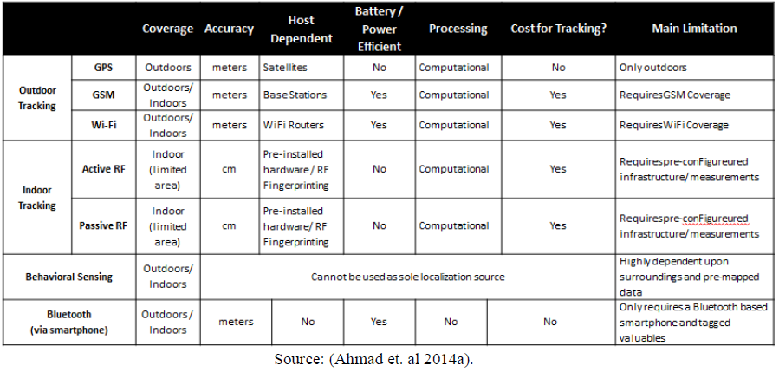

* Author recommends Bluetooth for personal tracking as it is not host dependent, battery efficient, cheap to implement and can track indoors/outdoors
* Such solutions are cheap and easy to implement but they are not gaining traction/low costumer uptake - recommended to work with cellular giants such as Apple, Samsung, and Nokia to market it to consumers

**19 November 2020:**

* Solutions: ease of use (no need to relearn/easy uptake), more of a complement than need/forced usage
* What database is chosen? Give reasons. (Type of data, ease of use, etc.)
* Interface used as communication with database system. (Web app/Mobile app)
* ***Db systems:*** MongoDB, MS SQL, SQLite, MySQL, PostgreSQL, SPARQL (language), RDF
  + NoSQL:
    - **PROS** -quick entry of data, allows unstructured data, easier to scale
    - **CONS –** standardization challenges
  + Relational DB:
    - **PROS –** ACID compliant, more consistent, more support
    - **CONS –** scalability issues, less efficient with NoSQL formats
* ***DB research links:***
  + <https://www.guru99.com/what-is-dbms.html>
  + https://www.xplenty.com/blog/which-database/