Running python batch correction routine

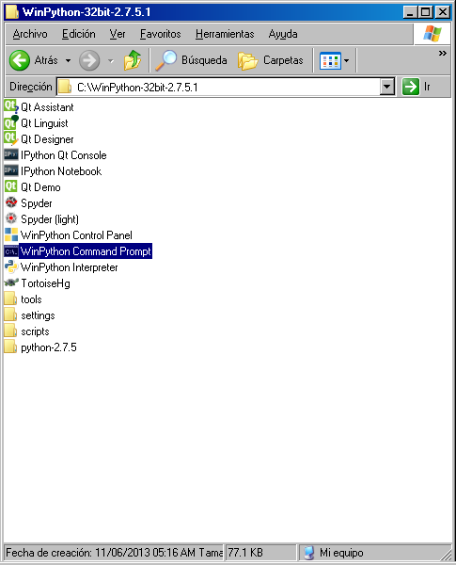

Run highlighted program => you get the following

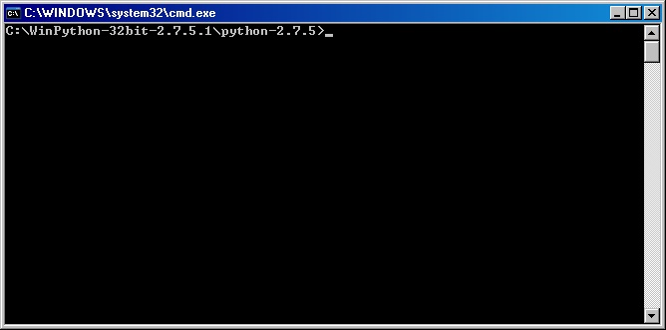

Move to the directory where the data of interest are located (cd directory name)

Run the following command

python BatchCorrection.py

Choose which dark file you want to use.

Confirm the batch correction job and let BatchCorrection.py generate average / sum files for each GE file.

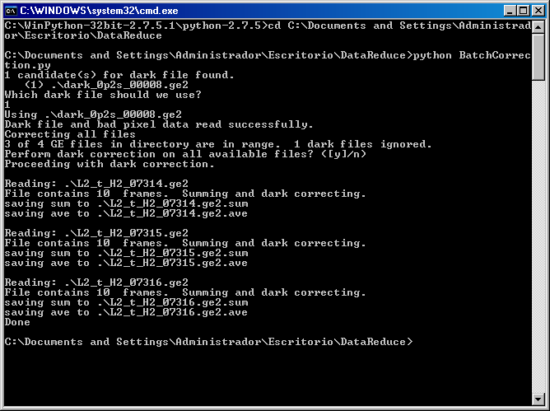

If you want to keep individual frames (generate .corXXX files) run the following.

python BatchCorrection.py –ndel

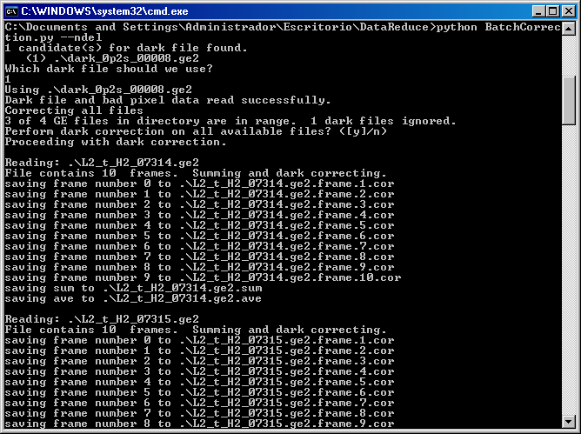

If you want to change the path for the bad pixel file do the following.

1. Open BatchCorrection.py with IDLE
2. Go to line 68 in the file and change the path name where the bad pixel file is located.

