1 Dimensional Neumman Iterative solution in frequency domain

**Vibration/Acoustic Transducers Lab.**

**Junsu Lee**

목차

Initialization   
Dimensionless Burgers equation in time domain   
Physical Properties   
 Medium Selection   
 Dimensionless Burgers equation in frequency domain   
Implementation of the discrete convolution using shape function's properties   
A. Source Selection   
 1. Mono-Frequency Source   
 2. Bi-Frequency Source   
 3. Multi-Frequency Source   
B. Simulation Condition

# Initialization

# Dimensionless Burgers equation in time domain

The following form of Burgers equation may make it easier to apply the Neumaan iterative soling method :

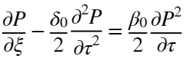

where

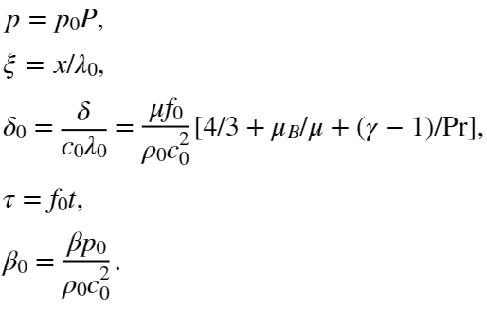

# Physical Properties

## Medium Selection

## Dimensionless Burgers equation in frequency domain

We can try to use the Neumann Iterative numerical solving method to the frequency domain form of the Burgers equation, which may be written as follows:

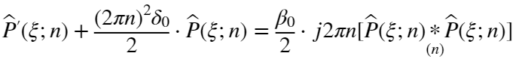

where and 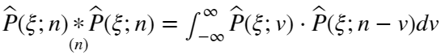. Note that .

Since is real, we have the followings:



Let  where ,

 and  for all integer .

Then,

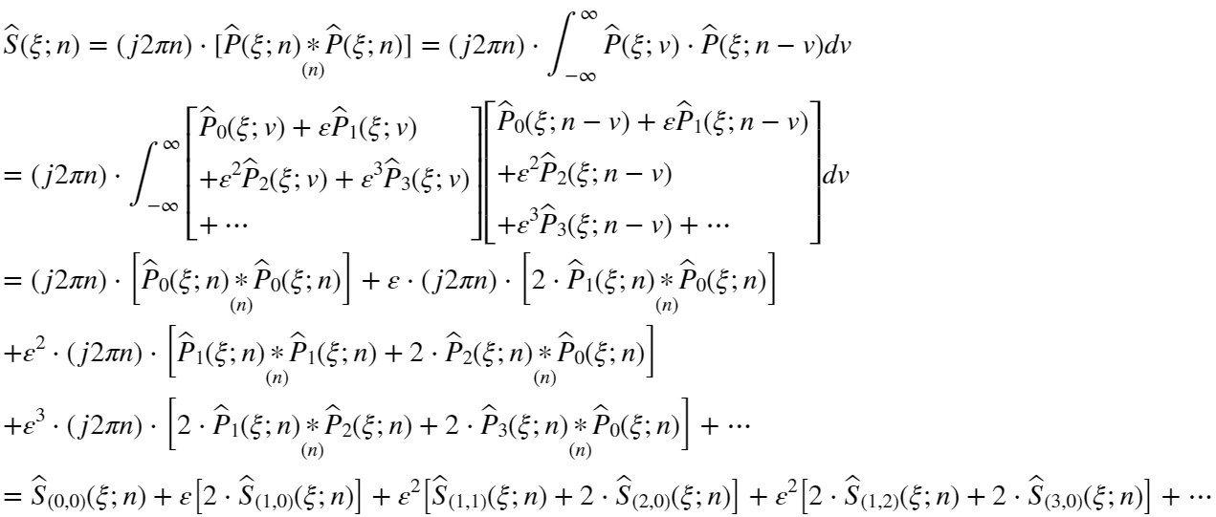

where



Substitute above expression into dimesionless Burgers equation:



since , we have the followings:

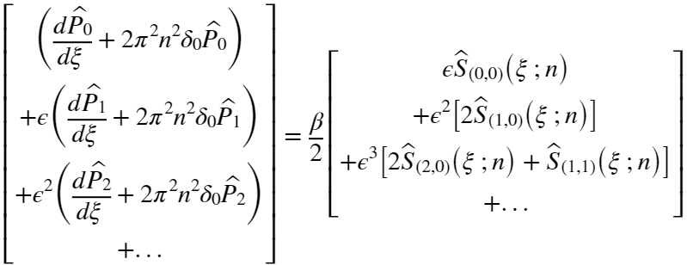

In order to satisfy the above equation for any small , the coefficients for each order of  should be equal.

0-th order of : 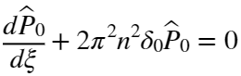

.

First order of : 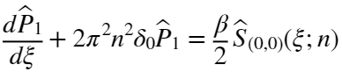

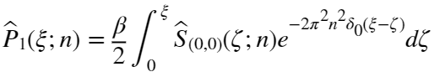

Second order of : 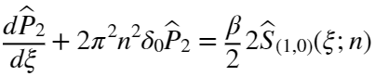,

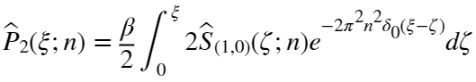

Third order of : 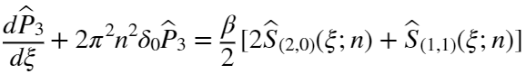,

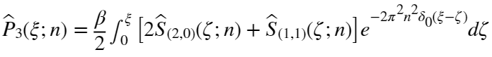.

# Implementation of the discrete convolution using shape function's properties

Let 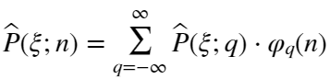

where

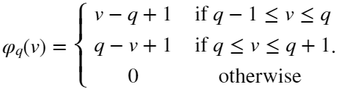

The source term can be rewritten by above the relationship of shape function:

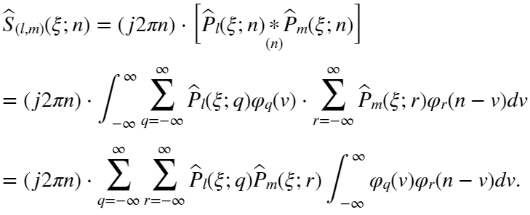

Note that  have the following interesting property for any integer  :

(i) If ,

 is zero except that .

 is zero except that .

Hence, 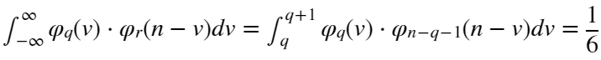.

(ii) If ,

is zero except that .

 is zero except that .

Hence, 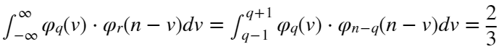.

(iii) If ,

 is zero except that .

 is zero except that .

Hence, 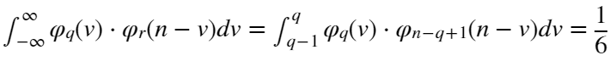.

Therefore,

