1 Dimensional Neumman Iterative solution in frequency domain

**Vibration/Acoustic Transducers Lab.**

**Junsu Lee**

목차

Dimensionless Burgers equation in time domain 2

Dimensionless Burgers equation in frequency domain 3

Implementation of the discrete convolution using Dirac delta function 5

A. Source Selection 6

1. Mono-Frequency Source 6

2. Bi-Frequency Source 6

3. Multi-Frequency Source 6

B. Simulation Condition 6

C. Calculation Process 6

D. Results 6

1D lossless mono-frequency source condition using Dirac delta function 7

# Dimensionless Burgers equation in time domain

The following form of Burgers equation may make it easier to apply the Neumaan iterative soling method :

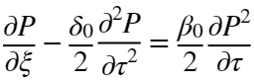

where

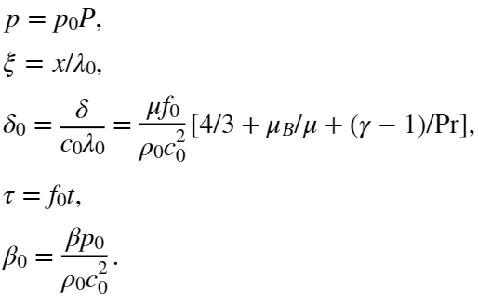

Derivation process :

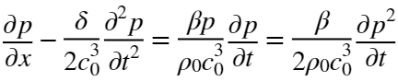

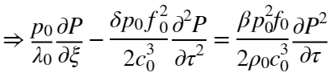

## Dimensionless Burgers equation in frequency domain

We can try to use the Neumann Iterative numerical solving method to the frequency domain form of the Burgers equation, which may be written as follows:

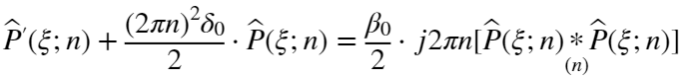

where and 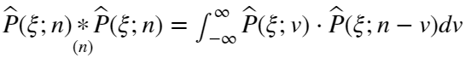. Note that .

Since is real, we have the followings:



Let  where ,

 and  for all integer .

Then,

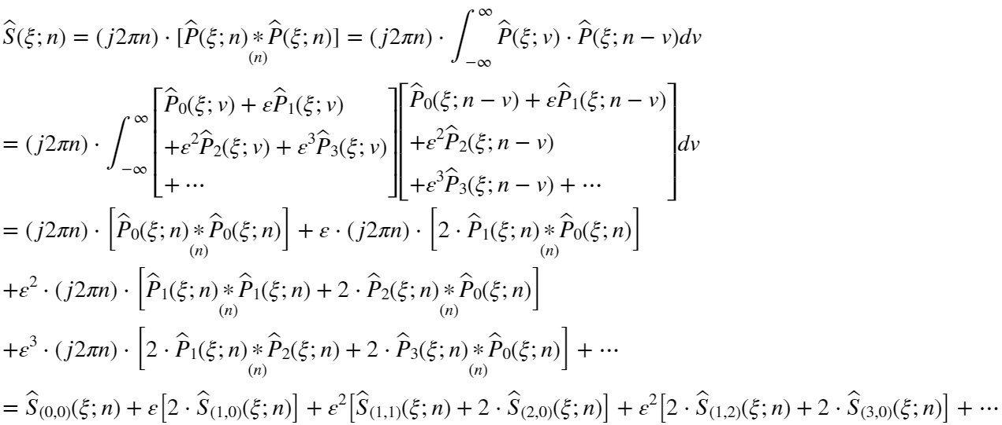

where



Substitute above expression into dimensionless Burgers equation:



since , we have the followings:

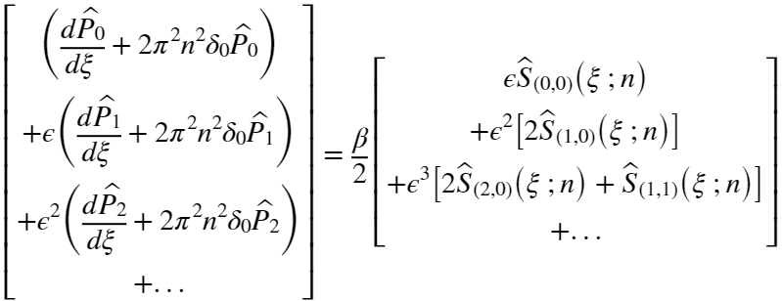

In order to satisfy the above equation for any small , the coefficients for each order of  should be equal.

0-th order of : 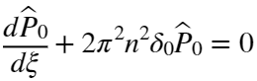

.

First order of : 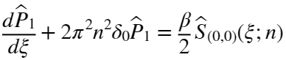

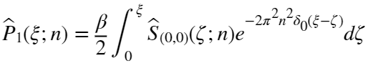

Second order of : 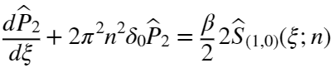,

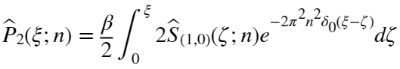

Third order of : 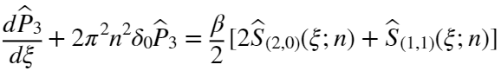,

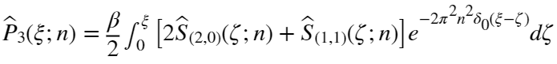.

Mathematical technique :

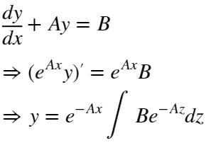

# Implementation of the discrete convolution using Dirac delta function

Let 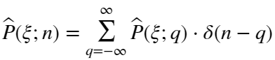

where

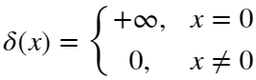

The source term can be rewritten by above the relationship of shape function:

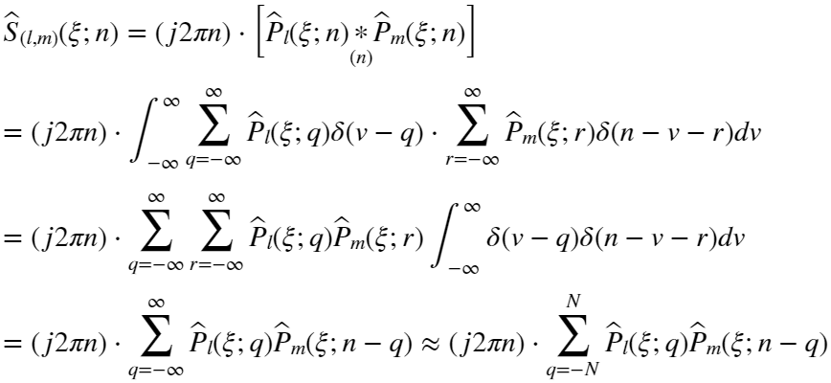

# A. Source Selection

## 1. Mono-Frequency Source

## 2. Bi-Frequency Source

**2.1. Source Pressure**

**2.2. Source Frequencies**

## 3. Multi-Frequency Source

# B. Simulation Condition

# C. Calculation Process

0-th order of : 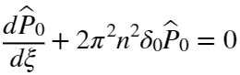

.

First order of : 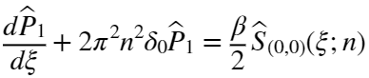

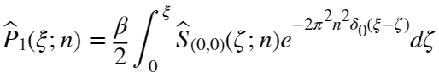

Second order of : ,



Third order of : ,

.

# D. Results

# 1D lossless mono-frequency source condition using Dirac delta function

For simplicity, diffusivity term will be neglected.

Assume that ,

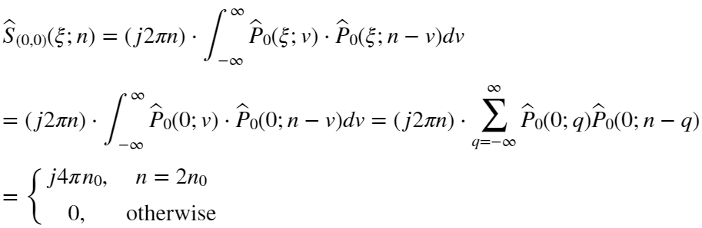

Since 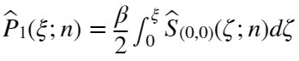,

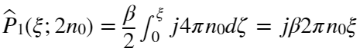.

C:\Users\JunsuLEE\AppData\Local\Temp\ConnectorClipboard3009467585948723883\image16811764697000.png

otherwise, that is C:\Users\JunsuLEE\AppData\Local\Temp\ConnectorClipboard3009467585948723883\image16811764697031.png, C:\Users\JunsuLEE\AppData\Local\Temp\ConnectorClipboard3009467585948723883\image16811764697102.png. it means that C:\Users\JunsuLEE\AppData\Local\Temp\ConnectorClipboard3009467585948723883\image16811764697183.png related to 1st order of *ε* term forms only the second harmonic component at C:\Users\JunsuLEE\AppData\Local\Temp\ConnectorClipboard3009467585948723883\image16811764697234.png.

Next, we consider the 2nd order of  term :

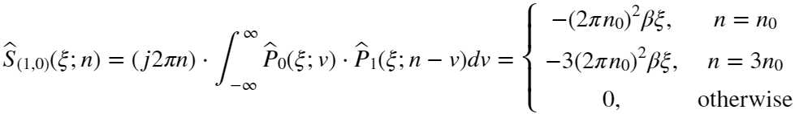

Since 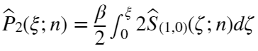,

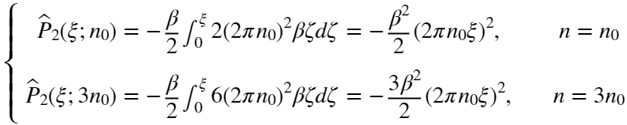.

Next, we will derive the 3rd order of  term :

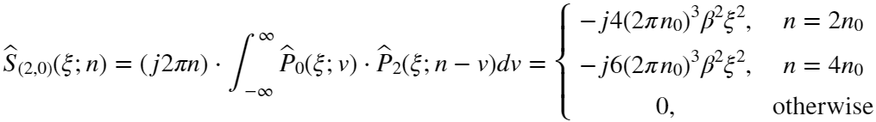

and

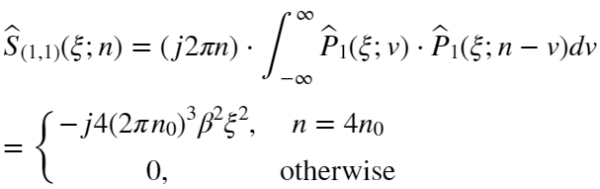

Since 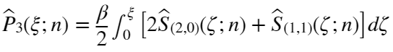,

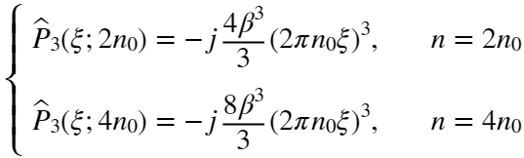

Finally, we will derive the 4th order of  term :

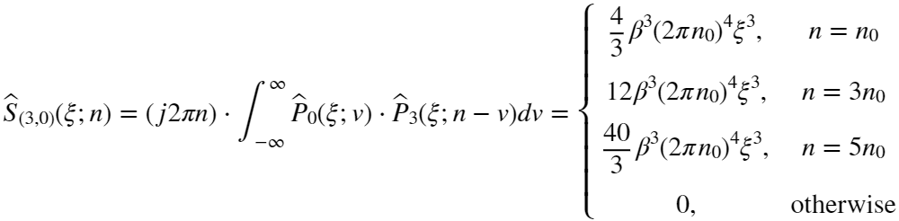

and

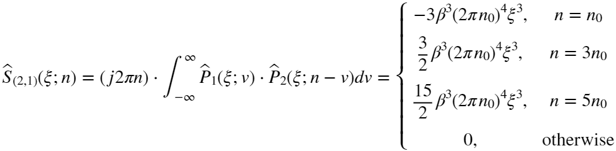

Since 