Matrix form of dimensionless pressure :

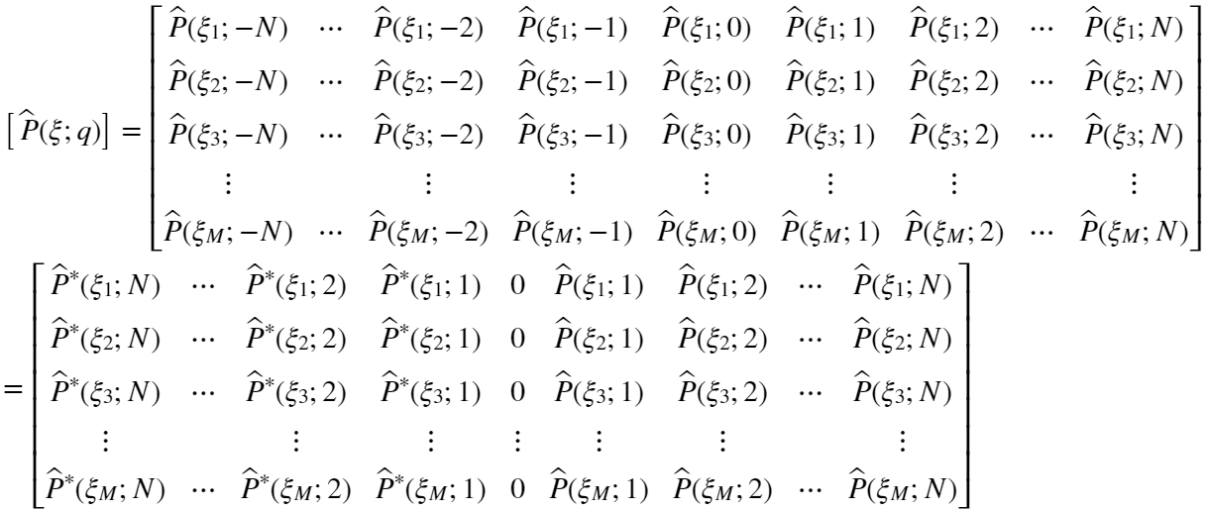

Matrix form of dimensionless source term :

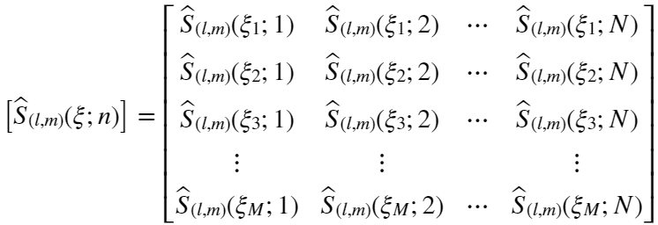

where  and  mean the number of dimensionless displacement  and the number of harmonics of maximum interesting frequency,respectively.

Each column of the above matrix is expressed as follows :

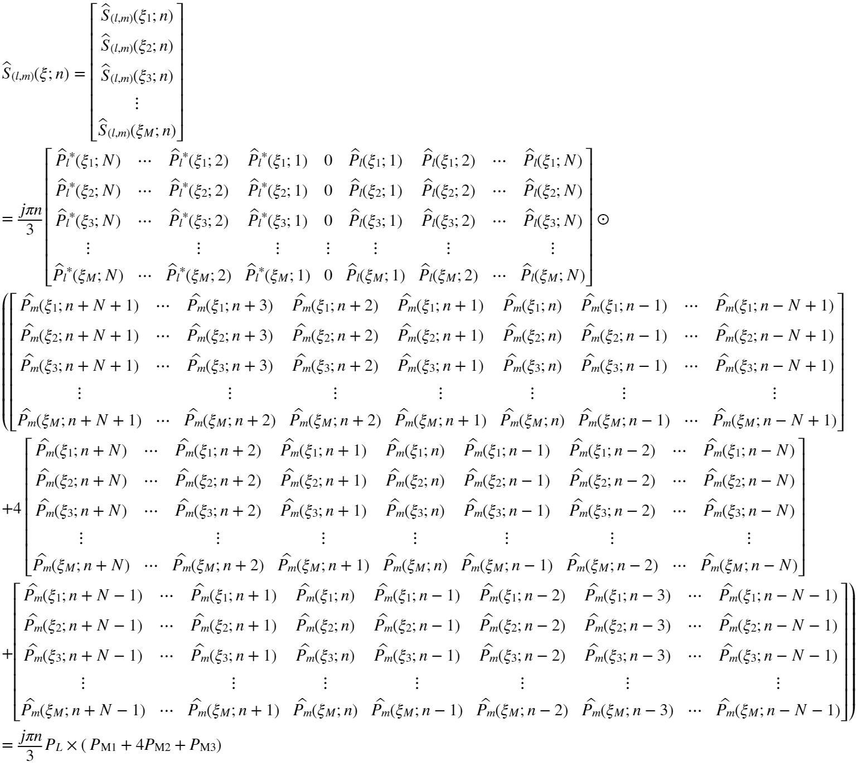

However, some elements of dimensionless pressure has not be defined yet. Therefore, each element should be changed by the following criteria :

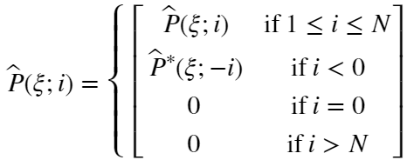

For example, if ,

