Algorithm

Final Project Report

<**15조>**

**2014313795 김성섭**

**2018314894 이지우**

**2016312160 이준성**

1. **Role of each member**

김성섭 – Departure time table 과 Shortest Path 관련 코드 구성 및 제작

이지우 – Reservation record 관련 코드 구성 및 제작, 코드 합치기

이준성 – Airline path 관련 코드 구성 및 제작, 보고서 작성

1. **Introduction**
2. **System objective** – 가장 빠른 경로로 예약해주는 항공 예약 시스템
3. **Available functionalities**
4. 원하는 출발지와 목적지에 따른 최적의 경로 제공 및 예약
5. 출발 시간 및 최적의 경로에 따른 도착시간 제공
6. 예약번호 배정
7. First, Business, Economy 좌석 배정 가능
8. 예약 조회 가능
9. **Restrictions**

항공기 인원 제한 없음(무한 탑승 가능), 좌석 번호 미배정, 하루 한 경로에 대해 하나의 출발시간 만 존재 등등

1. **User interface and modules description**

**모듈 1. City 구조체**

도시의 정보를 나타냄

typedef struct point {

char name;

int x, y;

int distance, needTime, departureTime;

struct point* next;

char paths[26];

int pathsNum;

}City;

**모듈 2. Graph 구조체**

비행경로 저장 공간

typedef struct a {

int num;

City** heads;

}Graph;

**모듈 3. Passenger 구조체**

승객에 관한 정보를 나타냄

typedef struct {

char name[20], source, destination;

int departureTime, departureDate, arrivalTime, arrivalDate, flightTime;

int level;

char flightPath[30];

}Passenger;

**모듈 4. 레드 블랙 트리 관련 구조체 및 함수들**

레드 블랙 트리 - 승객들이 예약/취소할 때마다 저장되는 공간

typedef struct Node {

int key;//= reservation number

int color;

struct Node * parent;

struct Node * leftc;

struct Node * rightc;

Passenger * passenger;

}node;

//RBT==============================================

node* makenode(int key);

node* isexist(node* root, int key);

void Lrotate(node* root, node* cur);

void Rrotate(node* root, node* cur);

void insert_fixup(node* root, node* cur);

node* insert(node* root, node* nod);

node* minnode(node* cur);

node* successor(node* cur);

void delete_fixup(node* root, node* cur);

node* delet(node* root, node* nod);

void printreserve(node* root);

int height(node* root);

**모듈 5. 그래프 관련 함수들**

//Graph============================================

Graph* CreateGraph(int num);

void DestroyGraph(Graph* pgraph);

void AddPath(Graph* pgraph, char src, char dest);

void AddPaths(Graph* pgraph, int num);

int PathExists(Graph* pgraph, char src, char dst);

Graph** CreateTimeTable(Graph* pgraph);

void PrintGraph(Graph* pgraph);

City* ShortestPath(Graph* pgraph, int src, int dst);

City* ExtractMin(City** Q, int* qNum);

void PrintArray(char* arr);

Passenger* module(char* name, char source, char destination, int date, int level);

**Graph* CreateGraph(int num);**

num개의 도시가 있는 기본 그래프를 생성합니다.

**void DestroyGraph(Graph* pgraph);**

그래프 하나를 전부 메모리에 반환합니다.

**void AddPath(Graph* pgraph, char src, char dest);**

pgraph내의 2개 도시간에 bidriectional edge를 1개 생성합니다

**void AddPaths(Graph* pgraph, int num);**

pgraph내에 num개만큼 랜덤하게 AddPath를 실행합니다.

**int PathExists(Graph* pgraph, char src, char dst);**

기존 그래프에 동일 path가 생성되어있는지 확인합니다.

**Graph** CreateTimeTable(Graph* pgraph);**

기본 그래프 pgraph에 departure time을 할당한 31가지 그래프를 만듭니다.

**Void PrintGraph(Graph* pgraph);**

1개 graph의 내용을 출력합니다.

**City* ShortestPath(Graph* pgraph, int src, int dst);**

pgraph내에 내용을 기록한 후 최종 목적도시를 반환합니다.

**City* ExtractMin(City** Q, int* qNum);**

ShortestPath내에서만 쓰이는 함수로서 수도코드의 ExtractMin과 동일합니다.

**Void PrintArray(char* arr);**

char array 프린트하는 함수

**Passenger* module(char* name, char source, char destination, int date, int level);**

승객 객체를 생성한후 리턴하는 함수

**모듈 6. Stackqueue.h 헤더파일**

stack 과 queue관련 구조체와 함수들이 있는 공간

typedef struct {

void* items[MAX_STACK];

int top;

} Stack;

typedef struct {

int front, rear;

void* items[MAX_QUEUE];

} Queue;

**모듈 7. Main.c**

**User Interface**

1. 프로그램 첫 실행 시 – 이미 예약된 500명 중 최근 10개의 기록이 출력된다.

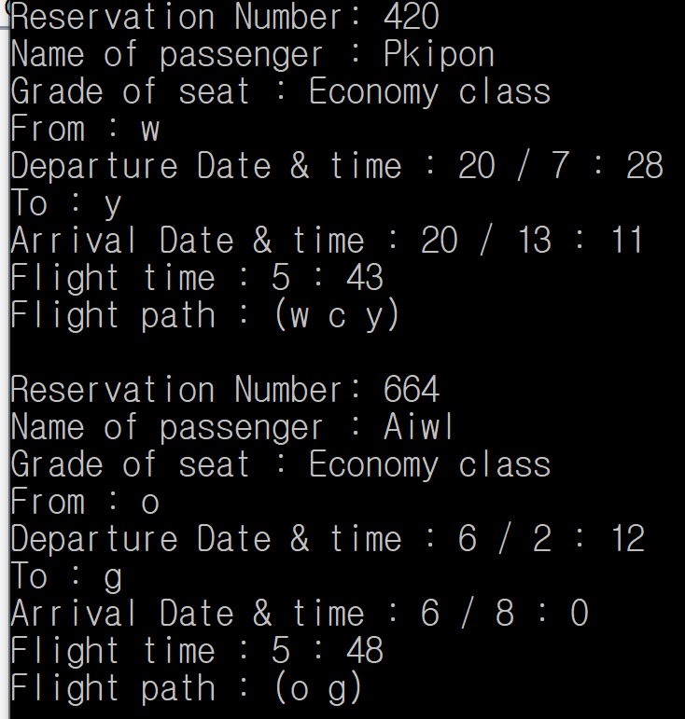

1. 첫 실행 시 – 예약, 취소, 검색, 나가기 중 선택하라고 나온다.

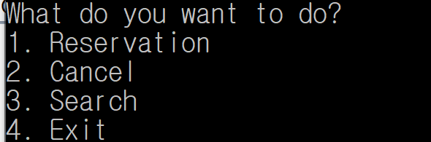

1. 1입력시 아래와 같이 이름을 입력하라고 나온다.

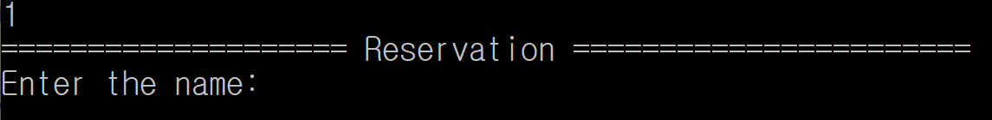

1. 이름을 입력했다면 출발하는 날짜를 입력하라고 나온다.

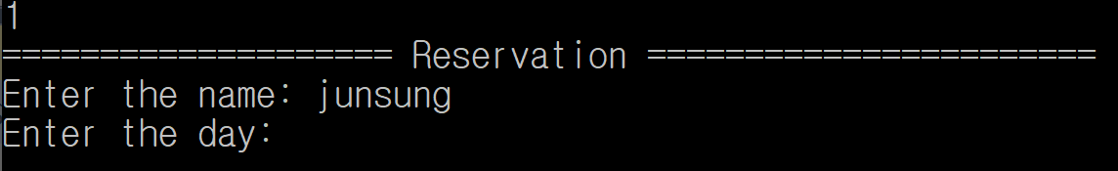

1. 그 다음 출발 도시를 입력

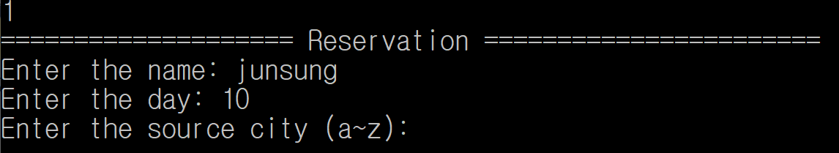

1. 도착 도시를 입력

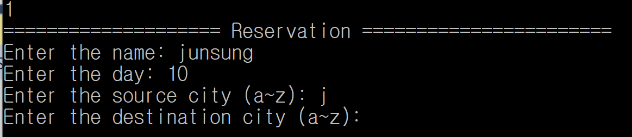

1. 좌석 등급을 선택하라고 나온다.

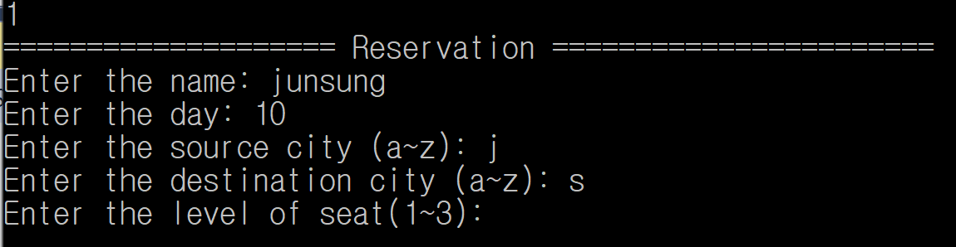

1. 모두 입력 완료 후 정해진 예약번호와 승객 정보와 출발지, 출발시간, 도착지, 도착시간(최단시간), 비행시간, 비행경로가 나온다. 추가로 몇 번째 예약인지 트리의 높이는 무엇인지 나온다.

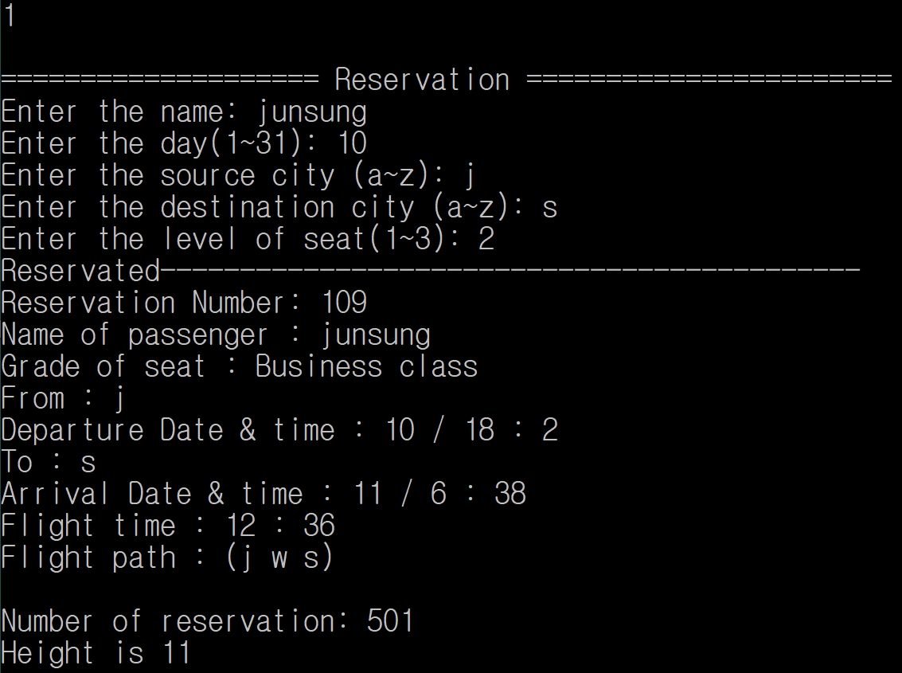

1. 다시 예약, 취소, 검색, 나가기 중 선택하라고 나온다.



1. 2번을 선택했다면 다음과 같이 예약번호 몇번을 취소할건지 물어본다.

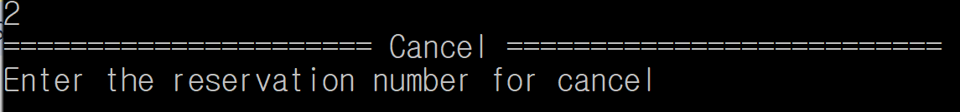

1. 597번을 취소하겠다고 입력하면 다음과 같이 597번에 대한 정보가 나온 뒤 취소되었고 취소된 다음 현 예약 총 수와 트리 높이가 출력된다.

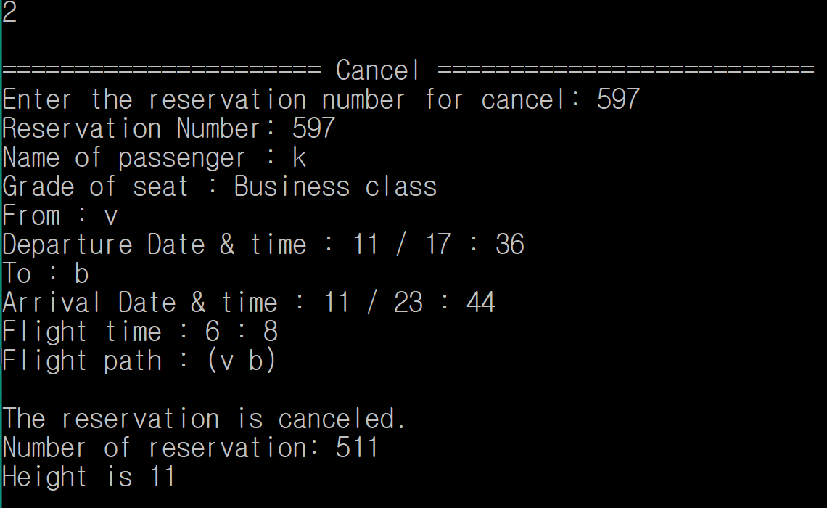

1. 3번을 입력하면 다음과같이 원하는 예약번호를 검색할 수 있고 검색한다면 다음과 같이

정보가 나온다.

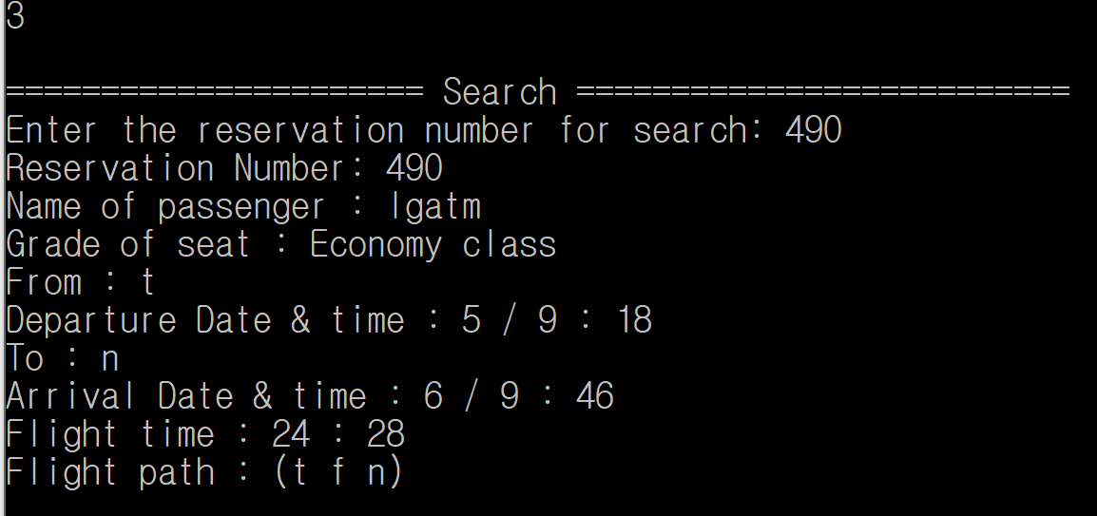

1. 없는 예약번호를 잘못 입력 하였다면 다시 검색하라고 나온다.

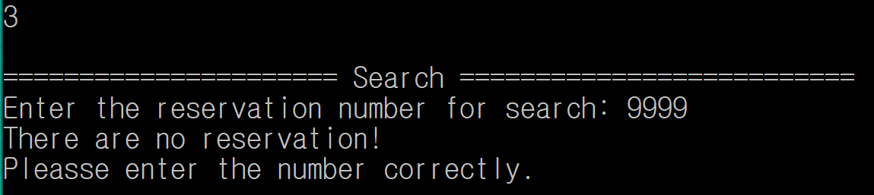

1. 4번을 입력하면 나가지게 된다.

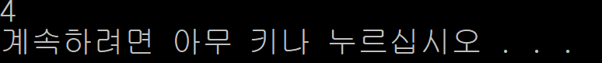

1. **Extensive Execution Examples and Analysis**

**Insertion Test (11 insertions)**

==================== Reservation =======================

Enter the name: junsung

Enter the day(1~31): 20

Enter the source city (a~z): b

Enter the destination city (a~z): s

Enter the level of seat(1~3): 1

Reservated--------------------------------------------

Reservation Number: 195

Name of passenger : junsung

Grade of seat : First class

From : b

Departure Date & time : 20 / 3 : 23

To : s

Arrival Date & time : 20 / 22 : 18

Flight time : 18 : 55

Flight path : (b d s)

Number of reservation: 501

Height is 11

What do you want to do?

1. Reservation

2. Cancel

3. Search

4. Exit

1

==================== Reservation =======================

Enter the name: a

Enter the day(1~31): 1

Enter the source city (a~z): a

Enter the destination city (a~z): z

Enter the level of seat(1~3): 3

Reservated--------------------------------------------

Reservation Number: 9219

Name of passenger : a

Grade of seat : Economy class

From : a

Departure Date & time : 1 / 2 : 44

To : z

Arrival Date & time : 2 / 12 : 43

Flight time : 33 : 59

Flight path : (a i o s l z)

Number of reservation: 502

Height is 11

What do you want to do?

1. Reservation

2. Cancel

3. Search

4. Exit

1

==================== Reservation =======================

Enter the name: b

Enter the day(1~31): 2

Enter the source city (a~z): b

Enter the destination city (a~z): c

Enter the level of seat(1~3): 2

Reservated--------------------------------------------

Reservation Number: 4829

Name of passenger : b

Grade of seat : Business class

From : b

Departure Date & time : 2 / 16 : 6

To : c

Arrival Date & time : 3 / 10 : 9

Flight time : 18 : 3

Flight path : (b d c)

Number of reservation: 503

Height is 11

What do you want to do?

1. Reservation

2. Cancel

3. Search

4. Exit

1

==================== Reservation =======================

Enter the name: c

Enter the day(1~31): 3

Enter the source city (a~z): d

Enter the destination city (a~z): g

Enter the level of seat(1~3): 3

Reservated--------------------------------------------

Reservation Number: 6286

Name of passenger : c

Grade of seat : Economy class

From : d

Departure Date & time : 3 / 13 : 37

To : g

Arrival Date & time : 3 / 23 : 9

Flight time : 9 : 32

Flight path : (d b g)

Number of reservation: 504

Height is 11

What do you want to do?

1. Reservation

2. Cancel

3. Search

4. Exit

1

==================== Reservation =======================

Enter the name: d

Enter the day(1~31): 4

Enter the source city (a~z): d

Enter the destination city (a~z): h

Enter the level of seat(1~3): 2

Reservated--------------------------------------------

Reservation Number: 8893

Name of passenger : d

Grade of seat : Business class

From : d

Departure Date & time : 4 / 14 : 35

To : h

Arrival Date & time : 5 / 4 : 8

Flight time : 13 : 33

Flight path : (d i h)

Number of reservation: 505

Height is 11

What do you want to do?

1. Reservation

2. Cancel

3. Search

4. Exit

1

==================== Reservation =======================

Enter the name: e

Enter the day(1~31): 5

Enter the source city (a~z): r

Enter the destination city (a~z): h

Enter the level of seat(1~3): 3

Reservated--------------------------------------------

Reservation Number: 5020

Name of passenger : e

Grade of seat : Economy class

From : r

Departure Date & time : 5 / 10 : 22

To : h

Arrival Date & time : 6 / 14 : 7

Flight time : 27 : 45

Flight path : (r e h)

Number of reservation: 506

Height is 11

What do you want to do?

1. Reservation

2. Cancel

3. Search

4. Exit

1

==================== Reservation =======================

Enter the name: f

Enter the day(1~31): 6

Enter the source city (a~z): s

Enter the destination city (a~z): x

Enter the level of seat(1~3): 1

Reservated--------------------------------------------

Reservation Number: 373

Name of passenger : f

Grade of seat : First class

From : s

Departure Date & time : 6 / 4 : 1

To : x

Arrival Date & time : 6 / 17 : 31

Flight time : 13 : 30

Flight path : (s d t x)

Number of reservation: 507

Height is 11

What do you want to do?

1. Reservation

2. Cancel

3. Search

4. Exit

1

==================== Reservation =======================

Enter the name: g

Enter the day(1~31): 7

Enter the source city (a~z): w

Enter the destination city (a~z): e

Enter the level of seat(1~3): 2

Reservated--------------------------------------------

Reservation Number: 8282

Name of passenger : g

Grade of seat : Business class

From : w

Departure Date & time : 7 / 0 : 13

To : e

Arrival Date & time : 8 / 4 : 30

Flight time : 28 : 17

Flight path : (w j e)

Number of reservation: 508

Height is 11

What do you want to do?

1. Reservation

2. Cancel

3. Search

4. Exit

1

==================== Reservation =======================

Enter the name: h

Enter the day(1~31): 8

Enter the source city (a~z): t

Enter the destination city (a~z): y

Enter the level of seat(1~3): 2

Reservated--------------------------------------------

Reservation Number: 3981

Name of passenger : h

Grade of seat : Business class

From : t

Departure Date & time : 8 / 8 : 24

To : y

Arrival Date & time : 9 / 14 : 53

Flight time : 30 : 29

Flight path : (t l y)

Number of reservation: 509

Height is 11

What do you want to do?

1. Reservation

2. Cancel

3. Search

4. Exit

1

==================== Reservation =======================

Enter the name: i

Enter the day(1~31): 9

Enter the source city (a~z): o

Enter the destination city (a~z): k

Enter the level of seat(1~3): 3

Reservated--------------------------------------------

Reservation Number: 1632

Name of passenger : i

Grade of seat : Economy class

From : o

Departure Date & time : 9 / 22 : 17

To : k

Arrival Date & time : 10 / 22 : 30

Flight time : 24 : 13

Flight path : (o j e k)

Number of reservation: 510

Height is 11

What do you want to do?

1. Reservation

2. Cancel

3. Search

4. Exit

1

==================== Reservation =======================

Enter the name: j

Enter the day(1~31): 10

Enter the source city (a~z): q

Enter the destination city (a~z): a

Enter the level of seat(1~3): 2

Reservated--------------------------------------------

Reservation Number: 6387

Name of passenger : j

Grade of seat : Business class

From : q

Departure Date & time : 10 / 4 : 2

To : a

Arrival Date & time : 10 / 21 : 35

Flight time : 17 : 33

Flight path : (q i a)

Number of reservation: 511

Height is 11

What do you want to do?

1. Reservation

2. Cancel

3. Search

4. Exit

1

==================== Reservation =======================

Enter the name: k

Enter the day(1~31): 11

Enter the source city (a~z): v

Enter the destination city (a~z): b

Enter the level of seat(1~3): 2

Reservated--------------------------------------------

Reservation Number: 597

Name of passenger : k

Grade of seat : Business class

From : v

Departure Date & time : 11 / 17 : 36

To : b

Arrival Date & time : 11 / 23 : 44

Flight time : 6 : 8

Flight path : (v b)

Number of reservation: 512

Height is 11

**Deletion Test( 11 deletions)**

====================== Cancel ==========================

Enter the reservation number for cancel: 597

Reservation Number: 597

Name of passenger : k

Grade of seat : Business class

From : v

Departure Date & time : 11 / 17 : 36

To : b

Arrival Date & time : 11 / 23 : 44

Flight time : 6 : 8

Flight path : (v b)

The reservation is canceled.

Number of reservation: 511

Height is 11

What do you want to do?

1. Reservation

2. Cancel

3. Search

4. Exit

2

====================== Cancel ==========================

Enter the reservation number for cancel: 6387

Reservation Number: 6387

Name of passenger : j

Grade of seat : Business class

From : q

Departure Date & time : 10 / 4 : 2

To : a

Arrival Date & time : 10 / 21 : 35

Flight time : 17 : 33

Flight path : (q i a)

The reservation is canceled.

Number of reservation: 510

Height is 11

What do you want to do?

1. Reservation

2. Cancel

3. Search

4. Exit

2

====================== Cancel ==========================

Enter the reservation number for cancel: 1632

Reservation Number: 1632

Name of passenger : i

Grade of seat : Economy class

From : o

Departure Date & time : 9 / 22 : 17

To : k

Arrival Date & time : 10 / 22 : 30

Flight time : 24 : 13

Flight path : (o j e k)

The reservation is canceled.

Number of reservation: 509

Height is 11

What do you want to do?

1. Reservation

2. Cancel

3. Search

4. Exit

2

====================== Cancel ==========================

Enter the reservation number for cancel: 3981

Reservation Number: 3981

Name of passenger : h

Grade of seat : Business class

From : t

Departure Date & time : 8 / 8 : 24

To : y

Arrival Date & time : 9 / 14 : 53

Flight time : 30 : 29

Flight path : (t l y)

The reservation is canceled.

Number of reservation: 508

Height is 11

What do you want to do?

1. Reservation

2. Cancel

3. Search

4. Exit

2

====================== Cancel ==========================

Enter the reservation number for cancel: 8282

Reservation Number: 8282

Name of passenger : g

Grade of seat : Business class

From : w

Departure Date & time : 7 / 0 : 13

To : e

Arrival Date & time : 8 / 4 : 30

Flight time : 28 : 17

Flight path : (w j e)

The reservation is canceled.

Number of reservation: 507

Height is 11

What do you want to do?

1. Reservation

2. Cancel

3. Search

4. Exit

2

====================== Cancel ==========================

Enter the reservation number for cancel: 373

Reservation Number: 373

Name of passenger : f

Grade of seat : First class

From : s

Departure Date & time : 6 / 4 : 1

To : x

Arrival Date & time : 6 / 17 : 31

Flight time : 13 : 30

Flight path : (s d t x)

The reservation is canceled.

Number of reservation: 506

Height is 11

What do you want to do?

1. Reservation

2. Cancel

3. Search

4. Exit

2

====================== Cancel ==========================

Enter the reservation number for cancel: 5020

Reservation Number: 5020

Name of passenger : e

Grade of seat : Economy class

From : r

Departure Date & time : 5 / 10 : 22

To : h

Arrival Date & time : 6 / 14 : 7

Flight time : 27 : 45

Flight path : (r e h)

The reservation is canceled.

Number of reservation: 505

Height is 11

What do you want to do?

1. Reservation

2. Cancel

3. Search

4. Exit

2

====================== Cancel ==========================

Enter the reservation number for cancel: 8893

Reservation Number: 8893

Name of passenger : d

Grade of seat : Business class

From : d

Departure Date & time : 4 / 14 : 35

To : h

Arrival Date & time : 5 / 4 : 8

Flight time : 13 : 33

Flight path : (d i h)

The reservation is canceled.

Number of reservation: 504

Height is 11

What do you want to do?

1. Reservation

2. Cancel

3. Search

4. Exit

2

====================== Cancel ==========================

Enter the reservation number for cancel: 6286

Reservation Number: 6286

Name of passenger : c

Grade of seat : Economy class

From : d

Departure Date & time : 3 / 13 : 37

To : g

Arrival Date & time : 3 / 23 : 9

Flight time : 9 : 32

Flight path : (d b g)

The reservation is canceled.

Number of reservation: 503

Height is 11

What do you want to do?

1. Reservation

2. Cancel

3. Search

4. Exit

2

====================== Cancel ==========================

Enter the reservation number for cancel: 4829

Reservation Number: 4829

Name of passenger : b

Grade of seat : Business class

From : b

Departure Date & time : 2 / 16 : 6

To : c

Arrival Date & time : 3 / 10 : 9

Flight time : 18 : 3

Flight path : (b d c)

The reservation is canceled.

Number of reservation: 502

Height is 11

What do you want to do?

1. Reservation

2. Cancel

3. Search

4. Exit

2

====================== Cancel ==========================

Enter the reservation number for cancel: 9219

Reservation Number: 9219

Name of passenger : a

Grade of seat : Economy class

From : a

Departure Date & time : 1 / 2 : 44

To : z

Arrival Date & time : 2 / 12 : 43

Flight time : 33 : 59

Flight path : (a i o s l z)

The reservation is canceled.

Number of reservation: 501

Height is 11

What do you want to do?

1. Reservation

2. Cancel

3. Search

4. Exit

2

====================== Cancel ==========================

Enter the reservation number for cancel: 195

Reservation Number: 195

Name of passenger : junsung

Grade of seat : First class

From : b

Departure Date & time : 20 / 3 : 23

To : s

Arrival Date & time : 20 / 22 : 18

Flight time : 18 : 55

Flight path : (b d s)

The reservation is canceled.

Number of reservation: 500

Height is 11

1. **Discussion and Conclusion**

앞서 우리가 만들기로 했던 다음과 같은 유용한 기능들

1. 원하는 출발지와 목적지에 따른 최적의 경로 제공 및 예약
2. 출발 시간 및 최적의 경로에 따른 도착시간 제공
3. 예약번호 배정
4. First, Business, Economy 좌석 배정 가능.
5. 예약 조회 가능

이 적용된 것을 볼 수 있다. 반복적인 예약, 취소도 잘되는 것을 볼 수 있다.

많은 제약들이 있지만 가장 빠른 경로대로 예약해주는 항공 예약 시스템을 완성하였다.