* **Schema diagram using E-R model**

It is E-R diagram with a Ternary Relationship, all lines are many to many.

|  |
| --- |
| **User** |
| Name  Address  Subscription Fee  Phone… |

|  |
| --- |
| **Provider** |
| Name  Address  Account  Joining Fee… |

**Download**

|  |
| --- |
| **Item** |
| Id  Provider name  Name  Type  Size |

* **List of attributes of each entity and relationship**

User entity

* name(pk), address, account, phone, birthday
* access history: recent download item’s ID is inside
* subscription fee: fee that need to pay every month
* amount due: total fee that need to pay
* date joined: the time user created
* data joined: number of items downloaded

Provider entity

* name(pk), address, account, phone, birthday
* joining fee: fee need to pay when created
* due you: total fee that need to pay (losses)
* still to you: remain fee that need to pay
* to provider: fee earns from items uploaded (profits)
* data joined: number of items downloaded

Item entity

* id(pk), name(pk), type(pk), size(pk), author, subject, machine, os, language, local storage, short description, viewer, audio, last updated
* provider name: name of provider(pk,fk)
* address retrieved: number of item downloaded

Download relationship

* user name: name from user(pk,fk)
* item id: id from item(pk,fk)
* provider name: name from provider(pk,fk)
* item type: type from item(pk,fk)
* item name: name from item(pk,fk)
* item size: size from item(pk,fk)
* **DDL statements**

These are DDL statements that create tables of entities and relationship.

create table user

    (name   varchar(10) NOT NULL,

     address    varchar(10),

     account varchar(15),

     phone   varchar(15),

     birthday   date,

     access_history varchar(15),

     subscription_fee   int DEFAULT 50000,

     amount_due int DEFAULT 50000,

     date_joined    date,

     data_joined int DEFAULT 0,

     primary key (name)

    );

create table provider

    (name   varchar(10) NOT NULL,

     address    varchar(10),

     account varchar(15),

     phone   varchar(15),

     birthday   date,

     joining_fee   int DEFAULT 50000,

     due_you int DEFAULT 50000,

     stil_to_you  int DEFAULT 50000,

     to_provider int DEFAULT 0,

     data_joined    int DEFAULT 0,

     primary key (name)

    );

create table item

    (id varchar(20) NOT NULL,

     provider_name varchar(20) NOT NULL,

     name   varchar(20) NOT NULL,

     type   varchar(20) NOT NULL,

     size   int NOT NULL,

     author varchar(20),

     subject    varchar(20),

     machine    varchar(20),

     os varchar(20),

     language   varchar(20),

     local_storage  int DEFAULT 0,

     short_description varchar(50),

     address_retrieved  int DEFAULT 0,

     viewer    varchar(20),

     audio  varchar(20),

     last_updated   date,

     primary key (id,provider_name,name,type,size),

     foreign key (provider_name) references provider(name)

        on delete cascade

    );

create table download

    (user_name varchar(10) NOT NULL,

     item_id varchar(20) NOT NULL,

     provider_name varchar(10) NOT NULL,

     item_name varchar(20) NOT NULL,

     item_type varchar(20) NOT NULL,

     item_size int NOT NULL,

     primary key (user_name, provider_name, item_id, item_name, item_type, ite m_size),

     foreign key (user_name) references user(name)

        on delete cascade,

     foreign key (item_id,provider_name,item_name,item_type,item_size) references item(id,provider_name,name,type,size)

    );

And these are DDL statements of triggers

delimiter //

create trigger update_user after insert on download

for each row

begin

    update user

    set access_history = new.item_id

    where name = new.user_name;

    update user

    set data_joined = data_joined + 1

    where name = new.user_name;

end //

This trigger executed after insert on download. The user who downloads the item get his access history by item ID and get number of data joined increased by 1 which is the number of downloaded items.

* **Statistics should be kept on what is accessed, how often, and by whom**

create trigger update_provider after insert on download

for each row

begin

    declare amount int;

    update provider

    set data_joined = data_joined + 1

    where name = new.provider_name;

    set amount = (select local_storage from item where new.provider_name = provider_name);

    update provider

    set to_provider = amount * data_joined

    where name = new.provider_name;

    update provider

    set stil_to_you = due_you - to_provider

    where name = new.provider_name;

end //

This trigger executed after insert on download. Update provider by increase data joined (number of downloads), increase to provider (profit) by formula (local storage * data joined) and update still to you(remain due) by sum of losses and profits.

* **Payments to providers should be based on some formula of the number or times their items are downloaded.**
* **Statistics should be kept on what is accessed, how often, and by whom**

create trigger update_local_storage before insert on item

for each row

begin

    set new.local_storage = new.size * 100;

end //

This trigger executed before insert on item. Update local storage to size times 100.

create trigger update_due_you after insert on item

for each row

begin

    update provider

    set due_you = due_you + new.local_storage

    where name = new.provider_name;

end //

This trigger executed after insert on item. Increase provider amount due to you.

create event bill

    on schedule every 1 month

    on completion preserve enable

    comment 'Bills updated'

    do

    begin

        update user

        set amount_due = amount_due + 50000;

        update provider

        set due_you = due_you + (to_provider/data_joined)

        where data_joined != 0;

    end //

delimiter ;

This event occurs every month to pay bills to user and provider. I couldn’t activate event because of permission denied.

* **Bills must be submitted on a monthly basis and collected with appropriate recordings of information.**
* **Bills are to be sent out once a month to users and providers. In addition, money should be sent to the providers based on usage statistics. Also, general statistics on profits and losses should be obtainable.**

In here, user has only losses and can obtain it from amount due. And provider can get profits from to amount to provider and losses from amount due you. General statics can get from sum of these.

* **DML statements for queries**
* delete from user;
* delete from provider;
* delete from item;
* delete from download;
* insert into user(name,address,account,phone,birthday,date_joined) values ('Jun','Seoul','111-222-333333','010-8342-9889','1996-11-10','2020-05-27');
* insert into provider(name,address,account,phone,birthday) values ('Lee','Seoul','111-111-111111','010-1111-1111','1996-01-01');
* insert into provider(name,address,account,phone,birthday) values ('Kim','Suwon','111-222-222222','010-2222-1111','1995-01-01');
* insert into provider(name,address,account,phone,birthday) values ('Park','Gwangju','111-333-333333','010-3333-1111','1997-01-01');
* insert into provider(name,address,account,phone,birthday) values ('Choi','Ulsan','111-444-444444','010-4444-1111','1997-01-01');
* insert into provider(name,address,account,phone,birthday) values ('Hong','Seoul','111-555-555555','010-5555-1111','1996-01-01');
* insert into item(id,provider_name,name,type,size,machine,os,short_description,last_updated) values ('00000','Lee','viewer_program','program','100','PC','Window','It is a viewer program of video','2020-05-27');
* insert into item(id,provider_name,name,type,size,machine,os,short_description,last_updated) values ('00001','Kim','audio_program','program','100','PC','Window','It is a audio program of video','2020-05-27');
* insert into item(id,provider_name,name,type,size,author,subject,language,short_description,viewer,audio) values ('00002','Park','Parasite','video_clip','200','Bong','Thriller','Korean','It is a video clip of famous movie','viewer_program','audio_program');
* insert into item(id,provider_name,name,type,size,author,subject,short_description,audio) values ('00003','Choi','Symphony.no6','sound_clip','200','Tchaikovsky','Classic','It is a audio clip of famous symphony','audio_program');

These are just initial values that I just insert in. In my JDBC system, user and provider can enroll themselves and can download and upload items.

* **Screen shots of your system and user manual for each function**

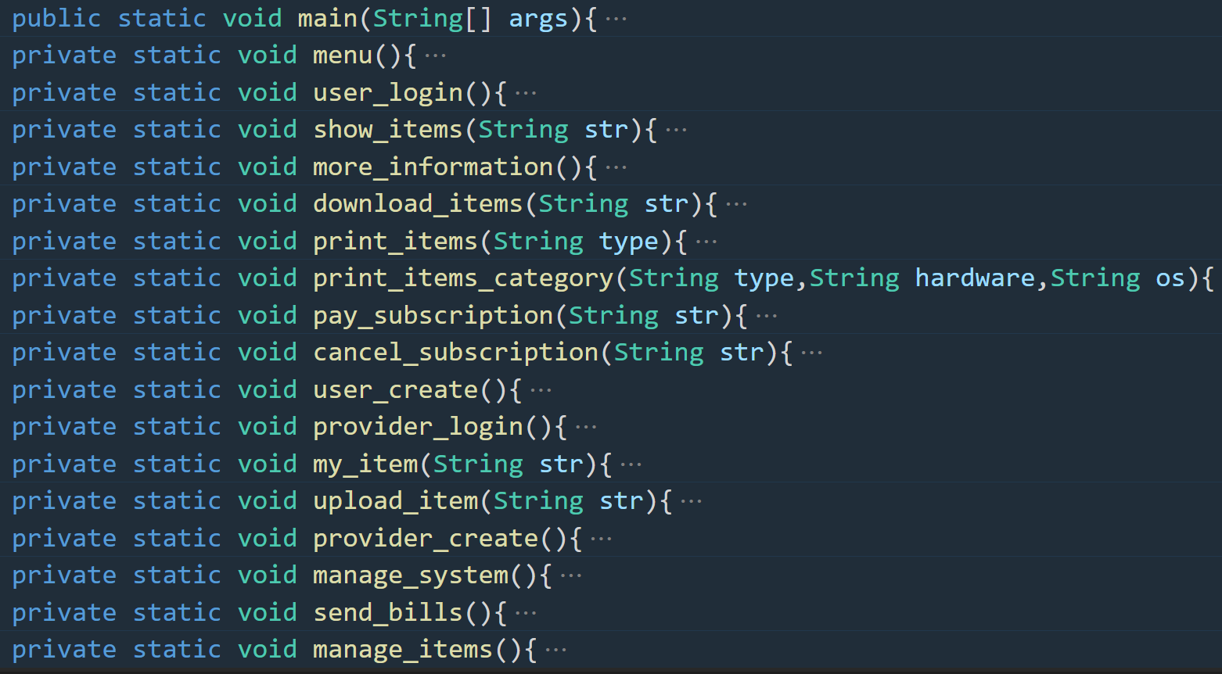

These are all functions of menu systems.

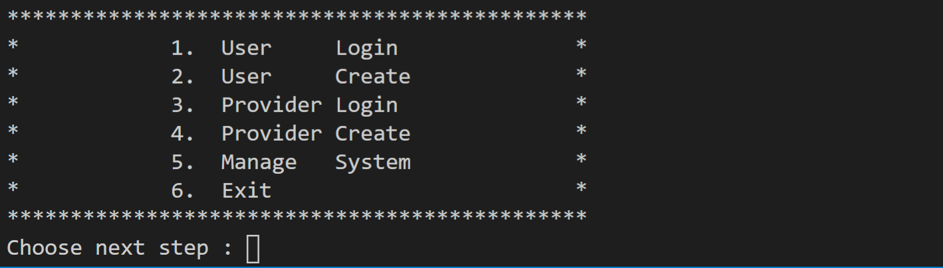 Menu – first menu function. When you first start the program., it looks like that.

When you choose step one it goes to

User login – first you can see the user lists and can input who do you want to login.

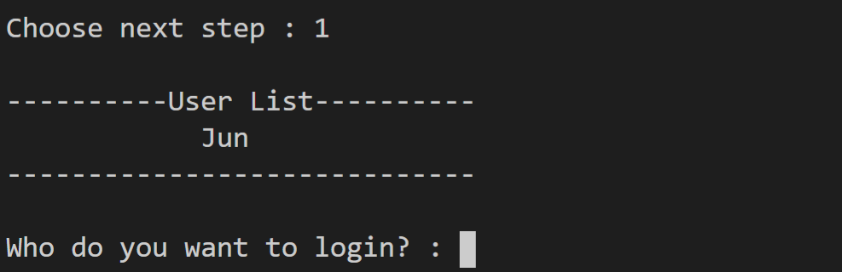

When you input you want, you can see the information of that user and can continue next step.

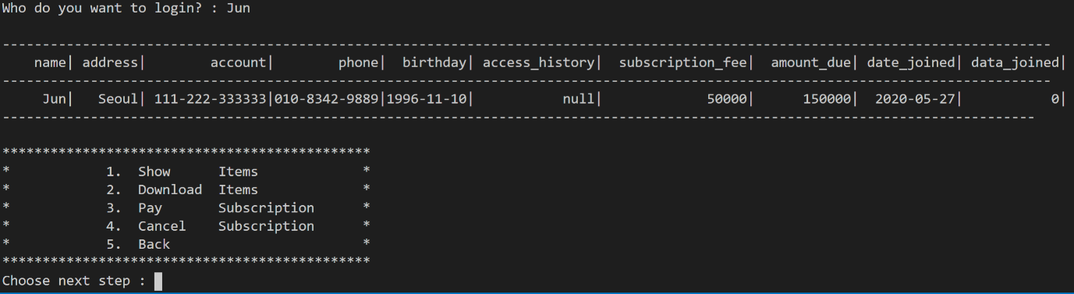

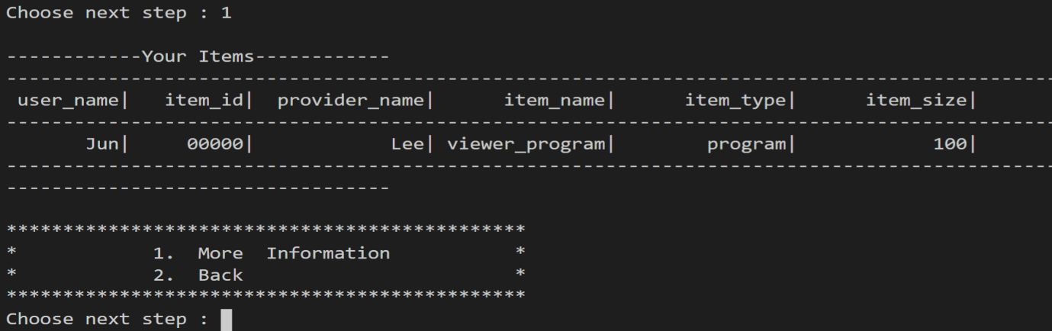If you choose Show Items, you can see your items downloaded.

If you choose More information, you can insert item name that you want to see more. Then when you input the name, you can see all attributes about that item.

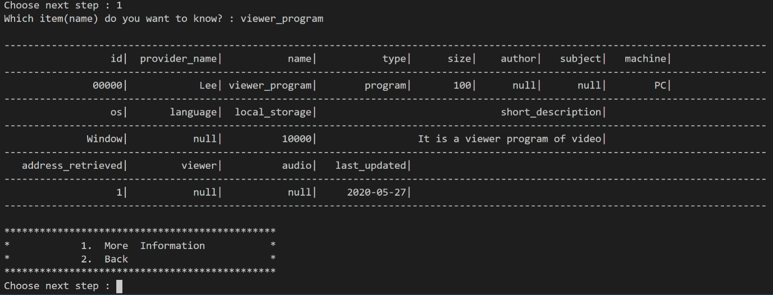

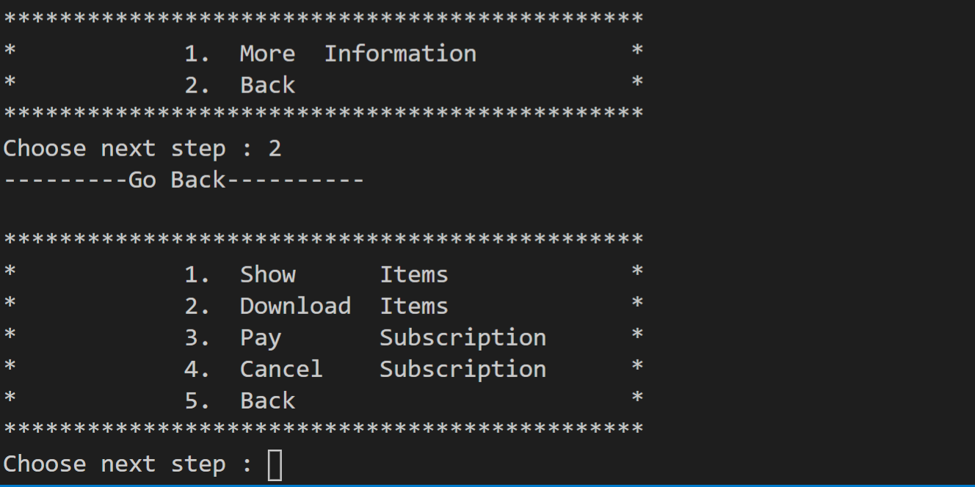If you choose to go back, you can choose other option to continue.

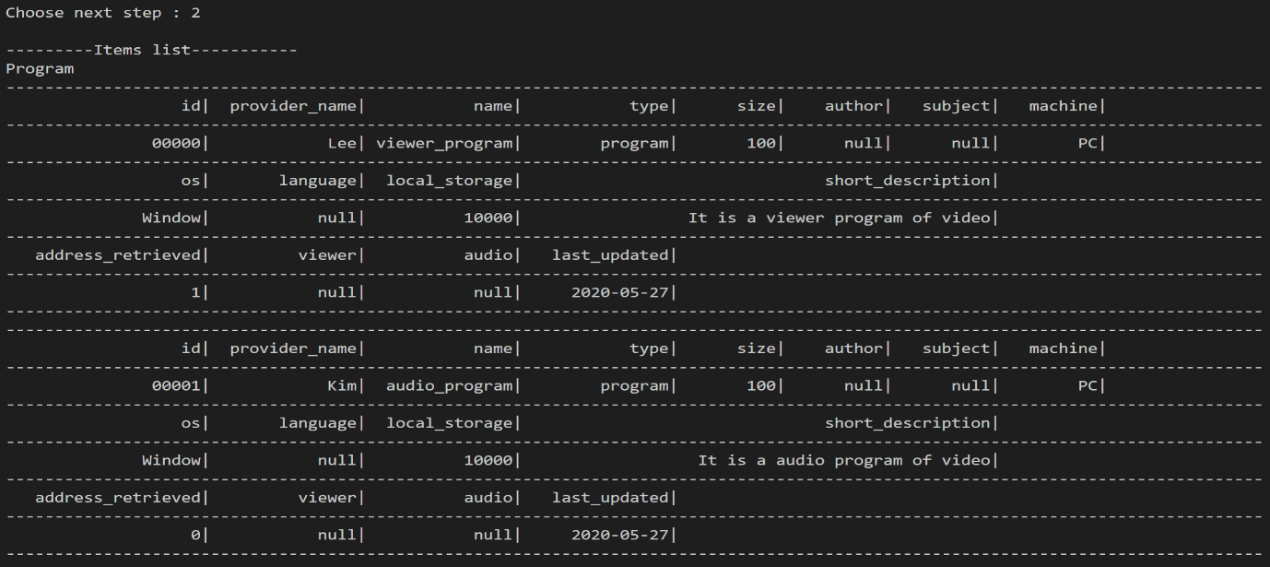If you choose Download Items, you can see all list of items by category.

* **Items are placed in an appropriate category.**

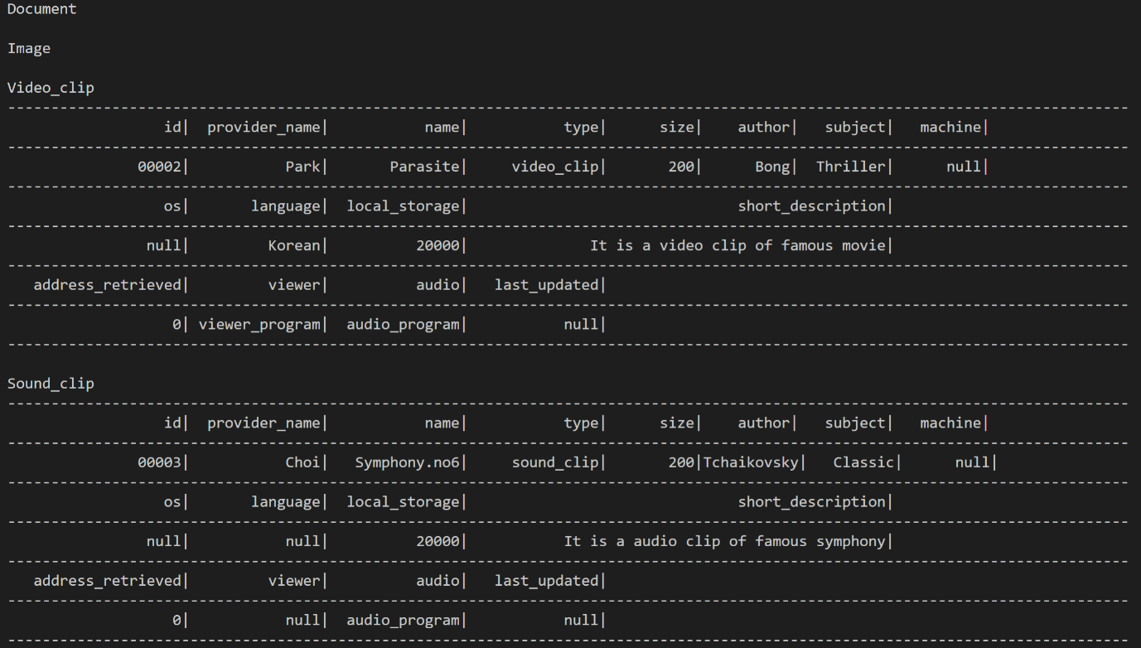

Then you can choose to see items by given category.



* **A user can request information on available programs, documents, images, video clips etc. that might be available in general or for a given hardware and operating system configuration. Information should be available based on category if so desired.**

If you insert given hardware and operation system, you can see information about items based on them.

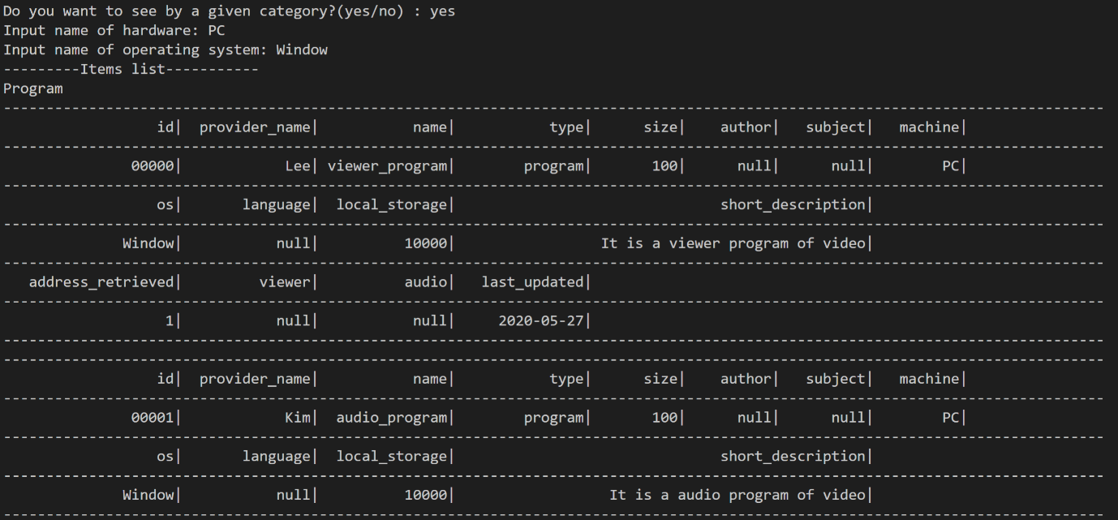

Then you can choose which item to download.

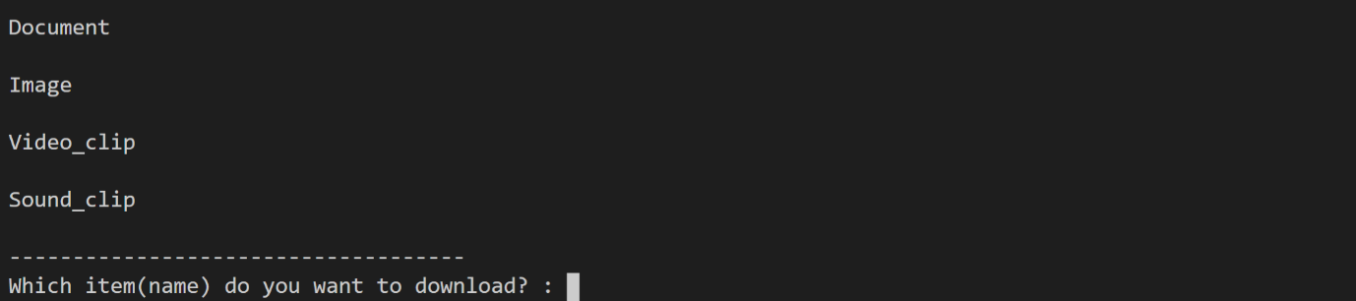

* **Access to an item should be simulated**

About video clip, viewer program and audio program are needed and should downloaded separately first.

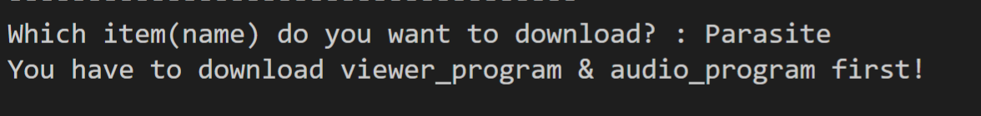

About audio clip, audio program is needed and should downloaded first.

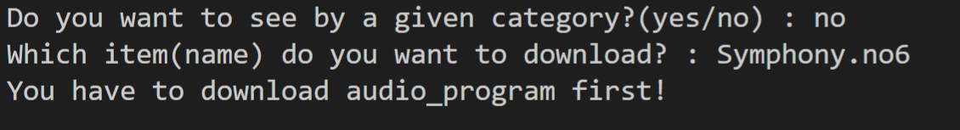

* **Some items such as a video clip, may require other items. In this case, besides the clip, a viewer program and an audio program may be needed and may be downloaded separately.**

After you download audio program.

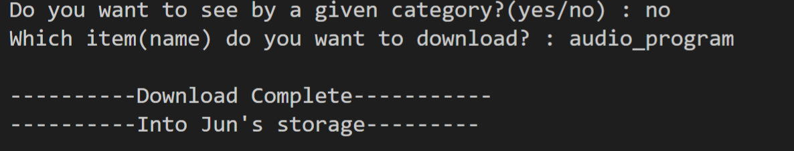

You can download sound clip. And the location from which the desired item being retrieved is printed out.

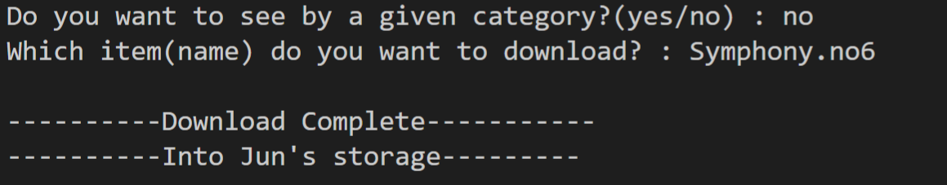

Now you can find the items are downloaded successfully.

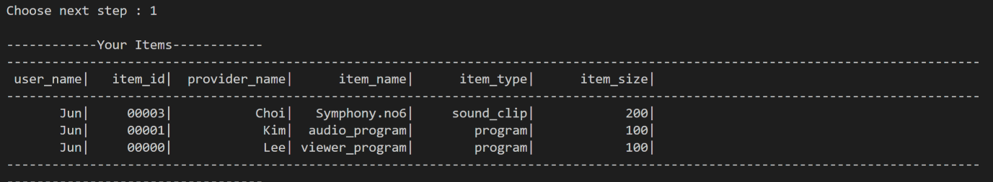

* **A user can request a download a desired item. When this is done since an actual download will not be performed, a print out of** **the locations from which the desired item or items are being retrieved should be indicated. Also appropriate statistics should be updated.**

When you choose Pay Subscription, you can know amount due to pay and can pay the fee.

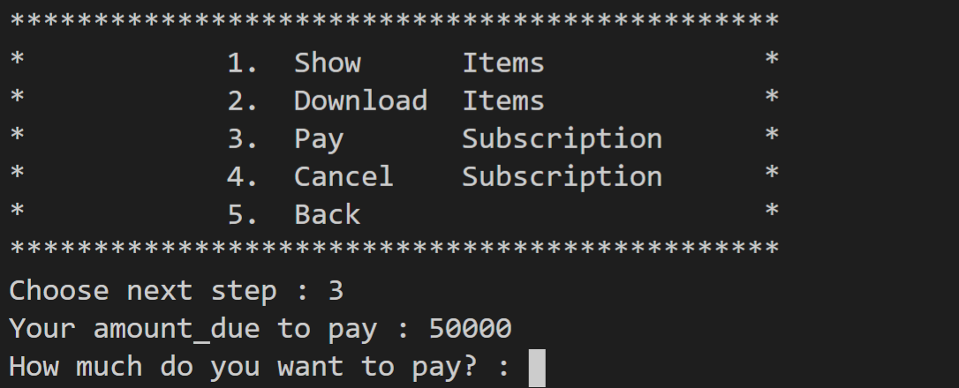

If you insert the money to pay, you can know remain amount due.

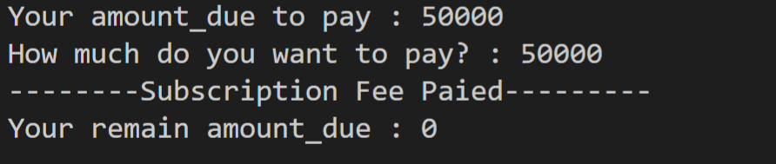

Next, if you choose Cancel Subscription, you can cancel subscription.

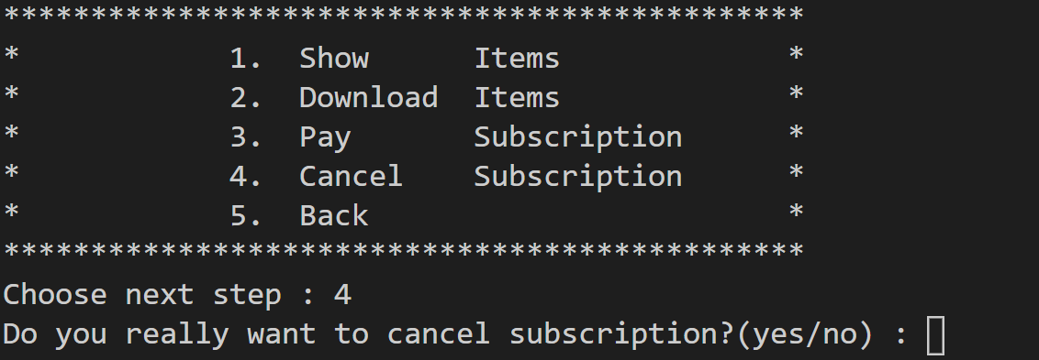

If you input yes, cancel success.

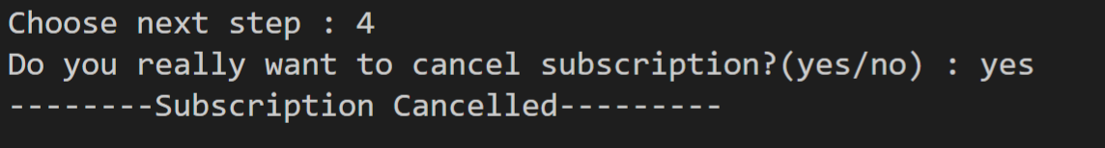

* **People may cancel their subscription on a monthly basis.**

When you select User Create, you can input user information and can create user.

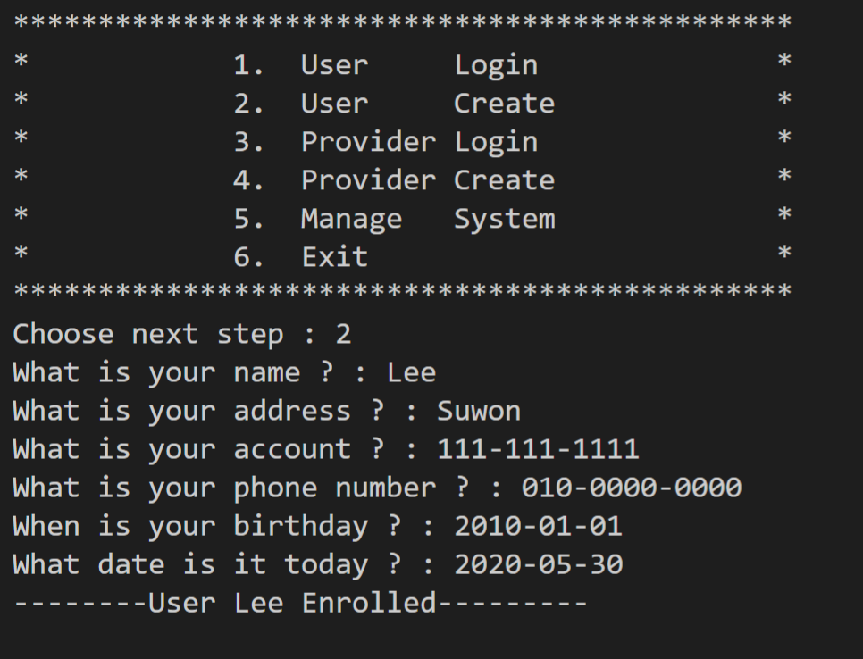

* **Both users and providers submit forms containing the appropriate data.**

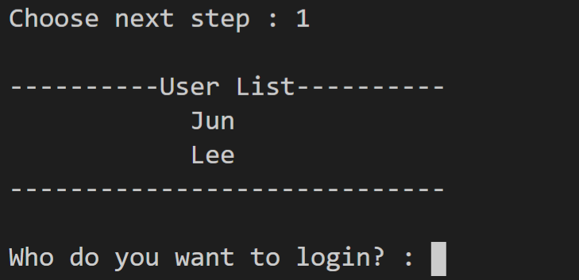

* **Providers, users and items are then entered into the database with the appropriate information.**

When you select Provider Login, you can see Provider’s list and can input whom to login.

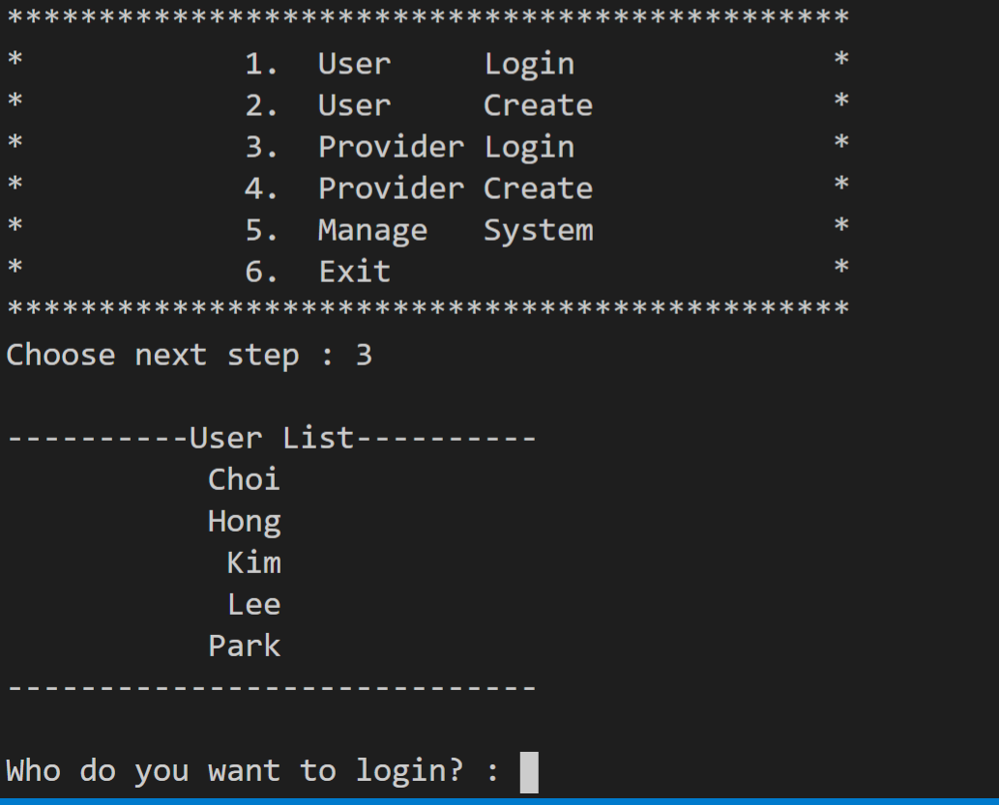

When you input, you can see information of that provider.

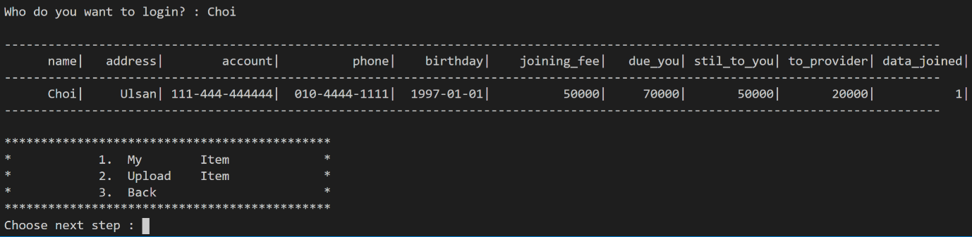

If you choose My Item, you can see items of information that provider uploaded.

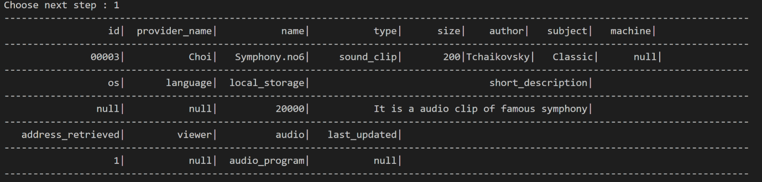

* **A provider should be allowed to view the statistics on his submitted items.**

If you select Upload Item, you can input information of item and can upload item.

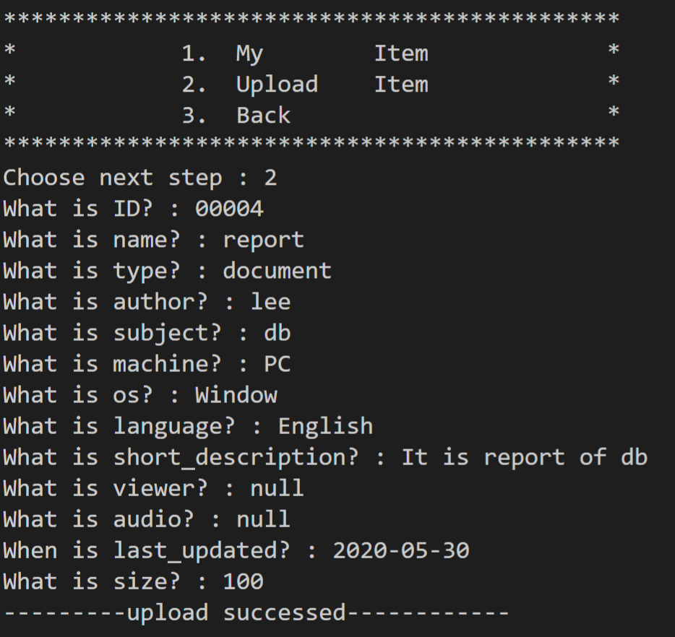

You can find that items are entered with appropriate information.

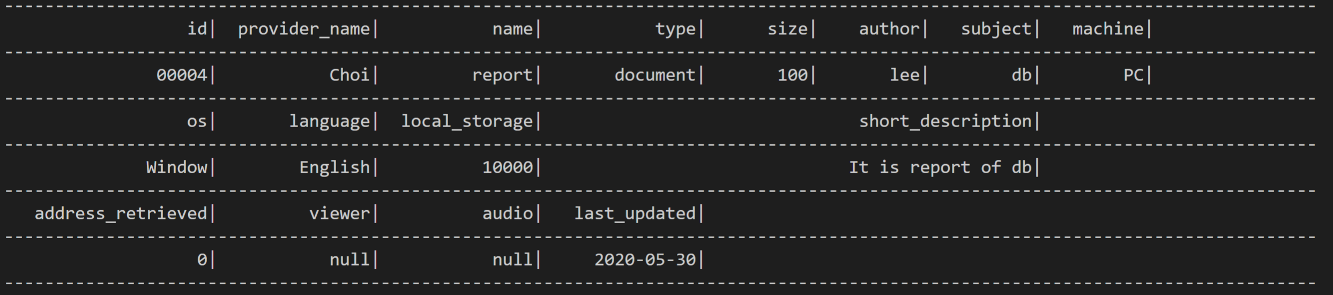

* **Providers, users and items are then entered into the database with the appropriate information.**
* **Items may be updated any time.**

If you select Provider Create, you can input provider’s information and can create provider.

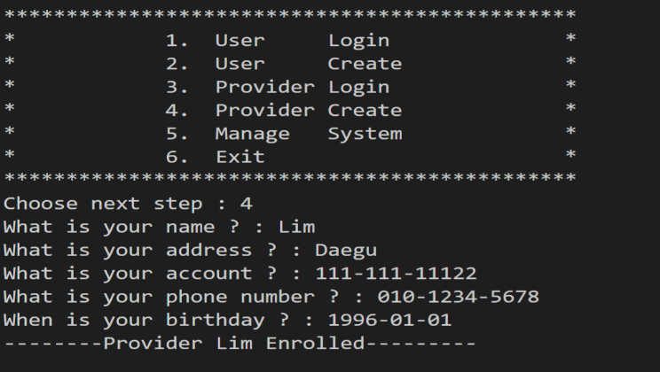

* **Both users and providers submit forms containing the appropriate data.**

If you select Manage System, you can see those menus.

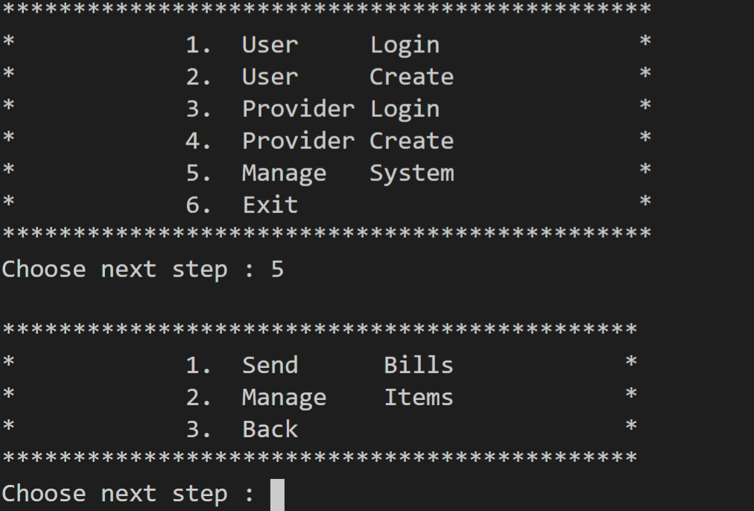

If you select Send Bills, you can immediately send bills to Users and Providers. The bills sent are same as event but you can send bills by this tab any time you want.

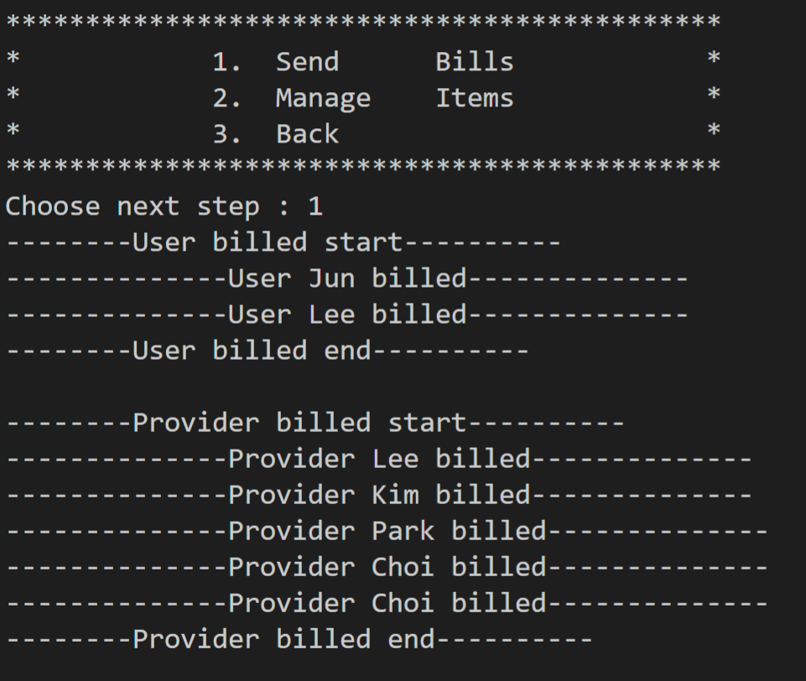

If you choose Mange Items, you can get information of Most accessed item, Least accessed item. Also, if there is items that did not pass threshold, the items are dropped by deleting Provider. And you can see the information that dropped and deleted. Then you can see the main(most) user in this program and download times, items that the main user downloaded.

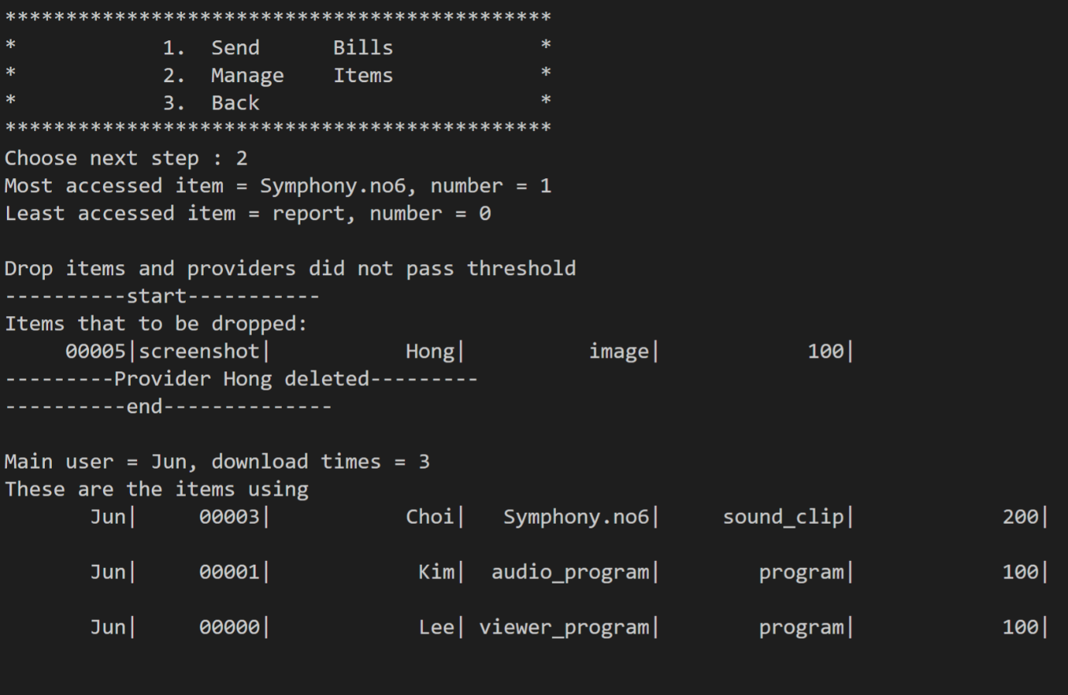

* **Items may be updated any time.**
* **Items associated with dropped providers are appropriately removed.**
* **Items that are not accessed above a given threshold amount are purged from the system with appropriate cancellation of providers account and removal of their items.**
* **Information should be retrievable as to the most accessed items and the least accessed items as well as items that have been dropped because they did not pass the monthly threshold. Also, reports that indicate the main users and those that hardly use the system should be retrievable as well as what items they are using or not using.**

Finally, if you choose Exit, you can exit program.

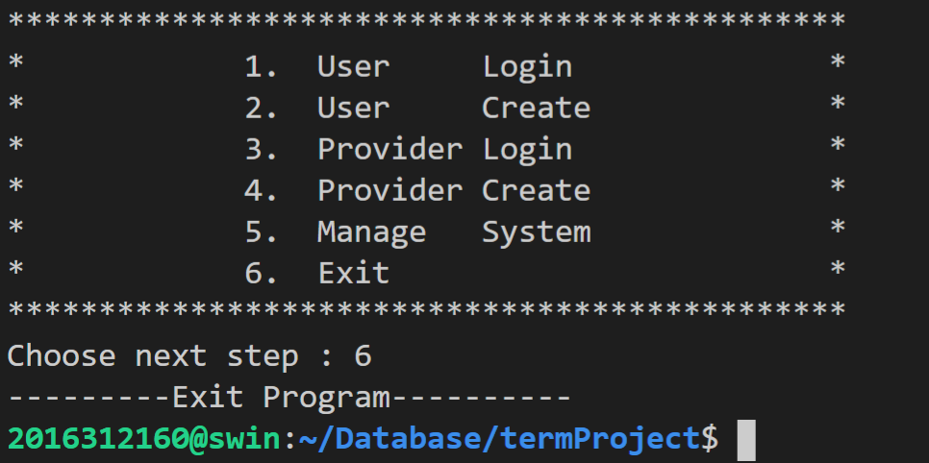

**URL of your project : http://swin.skku.edu/∼2016312160/Database/termProject**