**A PROJECT REPORT ON**

**“STUDENT FEE MANAGEMENT SYSTEM”**

ON PARTIAL COMPLETION OF

AISSCE PRACTICAL EXAMINATION- 2018-19



Submitted By--------

Name:-Sugandhita Devi

Class:-XII Section:-C

Rollno:- ----------------------------

**CERTIFICATE**

This is to certify that the project work entitled “Student Fees Management” was carried out by Sugandhita Devi, Roll no _________of XII Science for the session 2018-19.

The project has been satisfactorily completed by the student as per CBSE guidelines under my guidance and the concept and codes are original in nature and not copied from anywhere else.

External’s Signature Principal’s Signature

----------------------------------------- -------------------------------------------

Computer Teacher Signature Computer Teacher Signature

**ACKNOWLEDGEMENT**

This project entitled “STUDENT FEES MANAGEMENT” would have been impossible to complete without the support and guidance of my group members who helped me throughout the project. I am thankful to Priyam Priyadarshini my group member for her ample support.

I also offer my heartfelt gratitude to our teacher of Informatics Practices, Archana Sharma ma’am and Jeet Das Sir who gave me a chance to work on this interesting topic as our project. They guided us with full support and time.

Lastly, I would like to thank our Principal Ma’am Mrs.Panchali Roy for providing us with all the Lab and library facilities which helped me directly or indirectly in the completion of my project.

**CONTENTS**

|  |  |  |
| --- | --- | --- |
| **Serial No.** | **Topic** | **Page No.** |
| 1 | Introduction | 1 |
| 2 | System Requirement | 2 |
| 3 | Entity Relationship Diagram | 3 |
| 4 | Screenshots | 4-9 |
| 5 | Source Codes | 9-39 |
| 6 | Database Designs | 40 |
| 7 | Conclusion | 41 |
| 8 | Bibliography | 42 |

**INTRODUCTION**

This project **“Student Fees Management System”** covers functionally of different modules in the application, problems of existing system, system analysis and hardware and software requirements.

It is a software application which is useful for schools to maintain fees and other information of the students.

The school authority can get details of the student which are recorded in the “STUDENT” table in the MySQL with the netbeans. Records can be entered, updated and displayed. Details can be added, deleted, updated from the option available in the FEES INFO list of Menu Frame.

STUDENT

* + Add records
  + Delete records
  + Display records
  + Update records

Fees

* + Add records
  + Delete records
  + Display records
  + Update records

**SYSTEM REQUIREMENTS**

**Hardware**

* Computer Processer
* Hard Disk
* Ram
* Keyword
* Mouse

**Software**

* Operating System
* Windows XP Minimum
* JDK 6 or above
* NetBeans IDE 6.5.1 or higher
* MySQL 4.1 or higher

**ENTITY RELATIONSHIPDIAGRAM**

STUDENT

PAYS

FEES

**SCREENSHOTS**

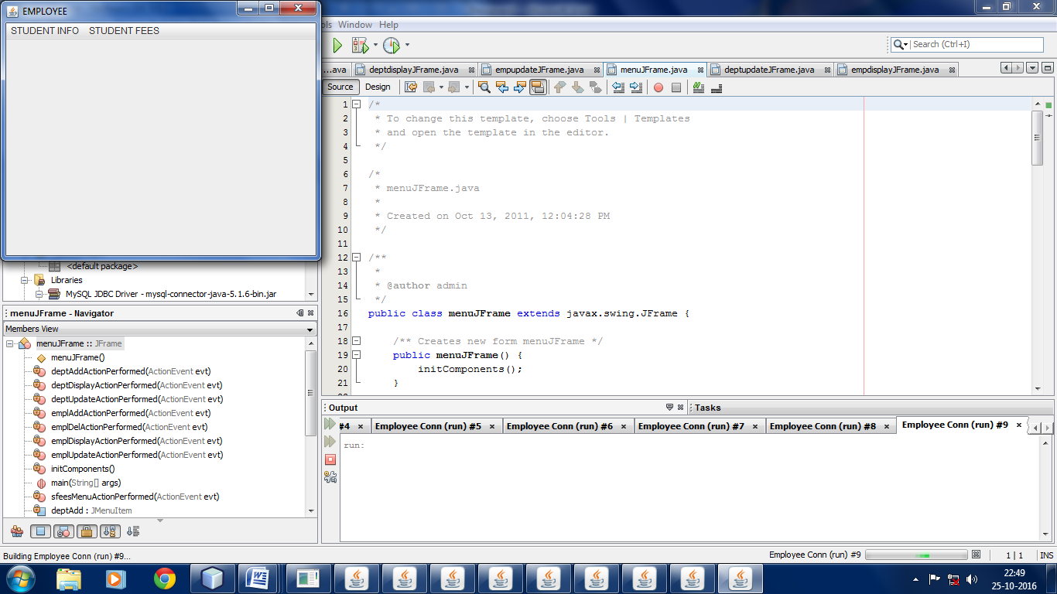**Menu Frame :**

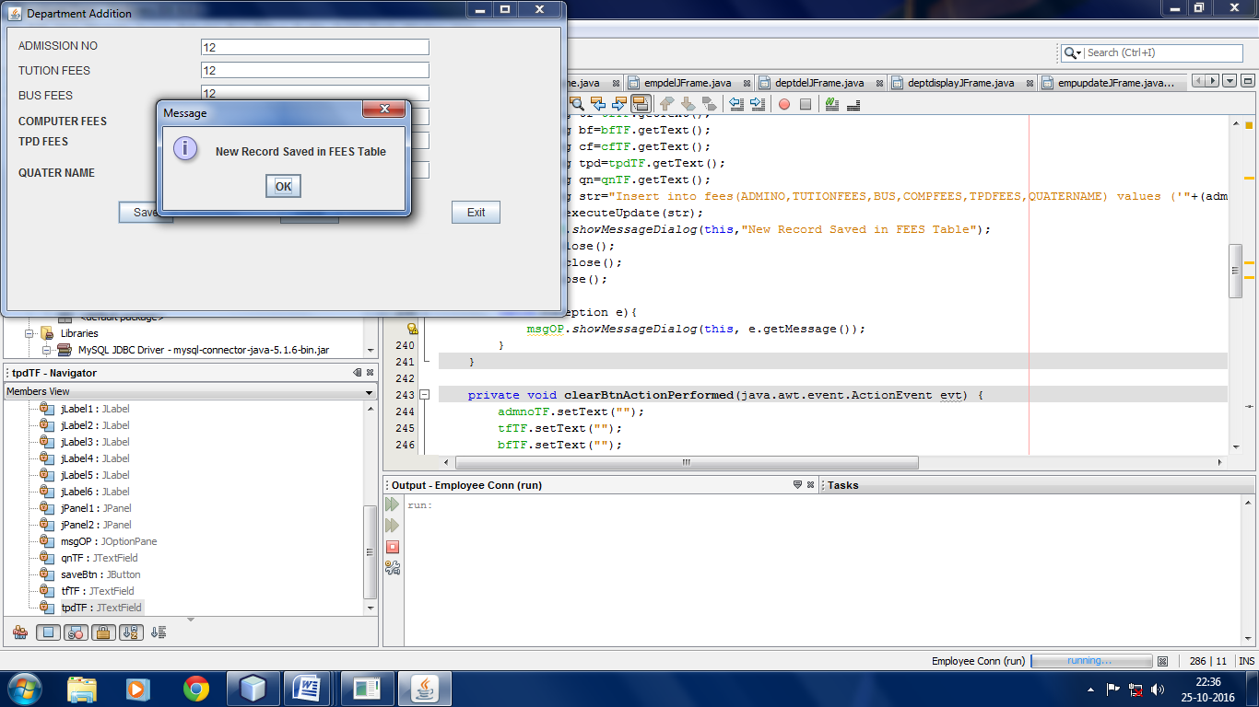

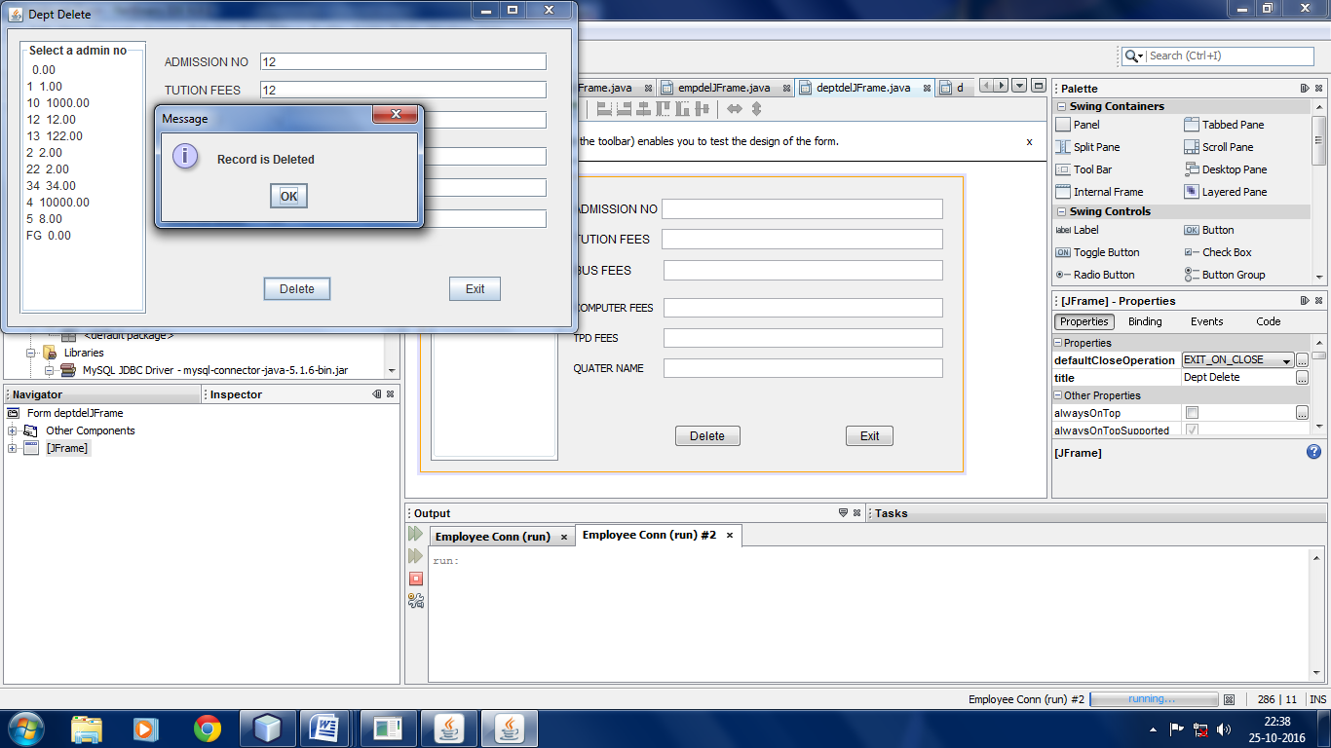

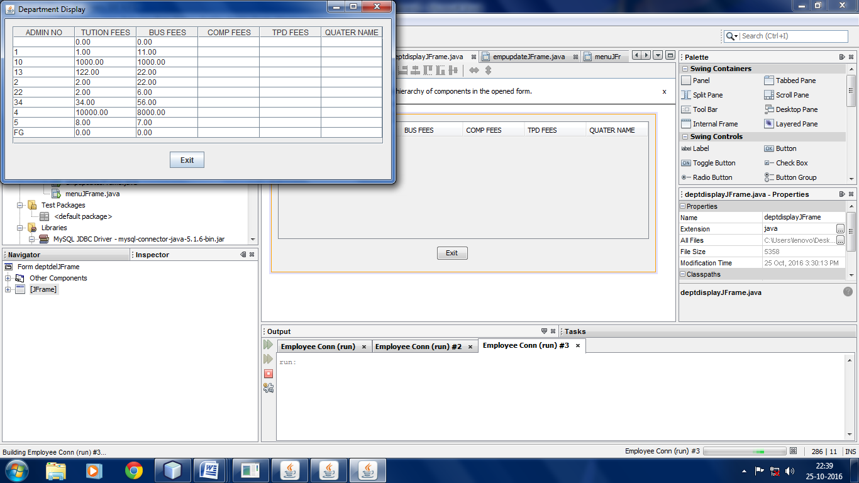

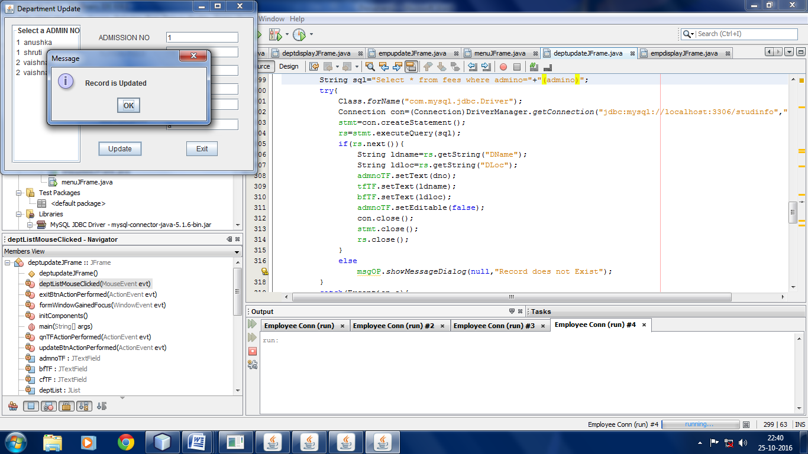

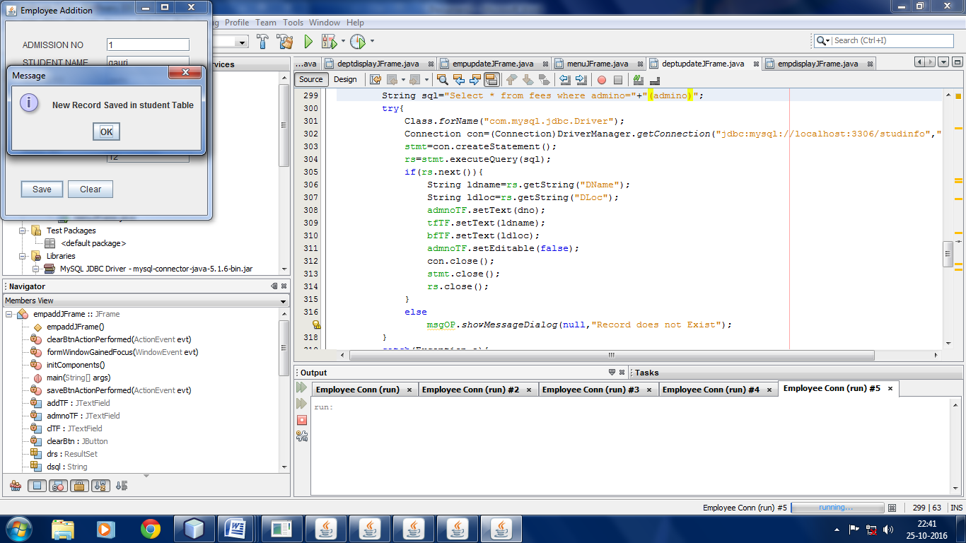

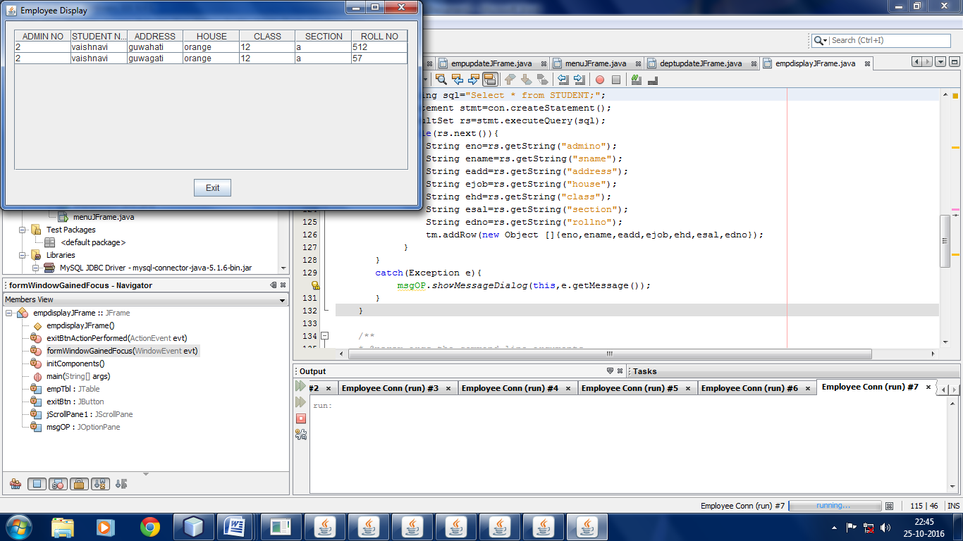

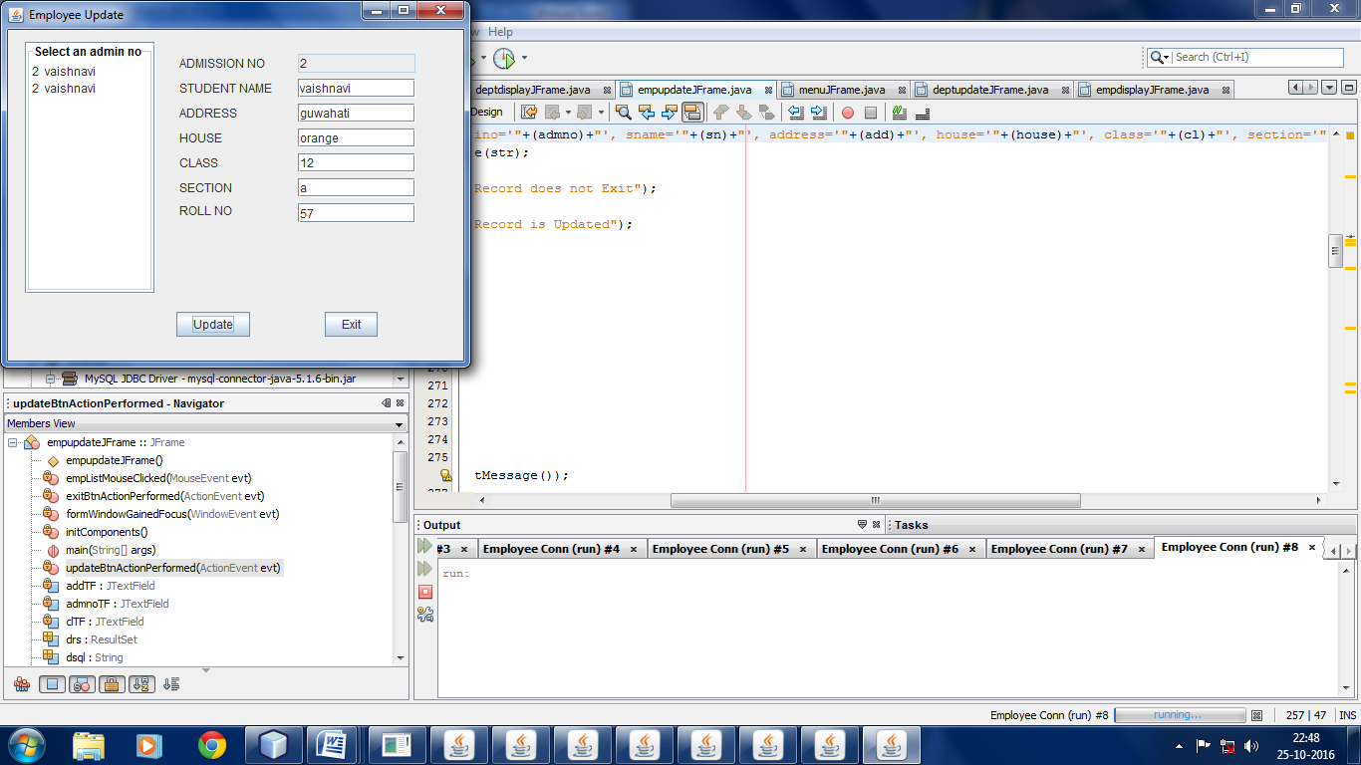

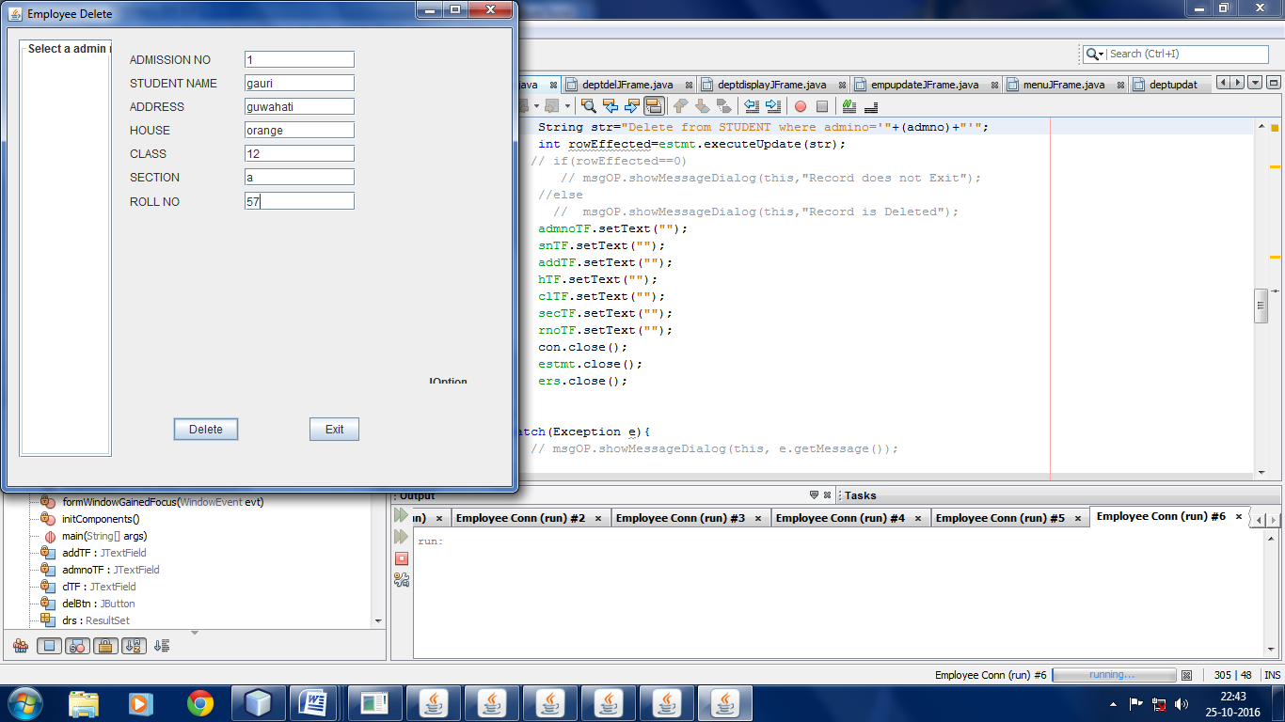

**SOURCE CODES**

**menuJFrame:**

public class menuJFrame extends javax.swing.JFrame {

publicmenuJFrame() {

initComponents();

}private void custAddActionPerformed(java.awt.event.ActionEventevt) {

newcustaddJFrame().setVisible(true);

this.setVisible(false);

} private void custlUpdateActionPerformed(java.awt.event.ActionEventevt) {

newcustupdateJFrame().setVisible(true);

this.setVisible(false);

} private void prodMenuActionPerformed(java.awt.event.ActionEventevt) { }

private void prodAddActionPerformed(java.awt.event.ActionEventevt) {

newprodaddJFrame().setVisible(true);

this.setVisible(false);

} private void prodUpdateActionPerformed(java.awt.event.ActionEventevt) {

newprodupdateJFrame().setVisible(true);

this.setVisible(false);

}private void prodDisplayActionPerformed(java.awt.event.ActionEventevt) {

newproddisplayJFrame().setVisible(true);

this.setVisible(false);

}private void custlDelActionPerformed(java.awt.event.ActionEventevt) {

this.setVisible(false);

newcustdelJFrame().setVisible(true);

}private void custDisplayActionPerformed(java.awt.event.ActionEventevt) {

this.setVisible(false);

newcustdisplayJFrame().setVisible(true);

}public static void main(String args[]) {

java.awt.EventQueue.invokeLater(new Runnable() {

public void run() {

newmenuJFrame().setVisible(true);

}});}

**custaddJFrame:**

importjava.sql.*;

importjavax.swing.JOptionPane;

importjavax.swing.DefaultComboBoxModel;

public class custaddJFrame extends javax.swing.JFrame {

publiccustaddJFrame() { initComponents();

} Statement cstmt=null;

ResultSetcrs=null;

String csql="Select * from Cust;";

Statement sstmt=null;

ResultSetsrs=null;

String ssql="Select * from Prod;";

private void clearBtnActionPerformed(java.awt.event.ActionEventevt) {

DefaultComboBoxModelcbm=(DefaultComboBoxModel)mCB.getModel();

qTF.setText("");

pnameTF.setText("");

cnameTF.setText("");

caddTA.setText("");

phTF.setText("");

pTF.setText("");

cbm.removeAllElements();

} private void exitBtnActionPerformed(java.awt.event.ActionEventevt) {

this.setVisible(false);

newmenuJFrame().setVisible(true);

} private void saveBtnActionPerformed(java.awt.event.ActionEventevt) {

try{

Class.forName("com.mysql.jdbc.Driver");

Connection con=(Connection)DriverManager.getConnection("jdbc:mysql://localhost:3306/elec","root","");

cstmt=con.createStatement();

crs=cstmt.executeQuery(csql);

String mno=(String)mCB.getSelectedItem();

String pname=pnameTF.getText();

String cname=cnameTF.getText();

String cadd=caddTA.getText();

String cph=phTF.getText();

String cprice=pTF.getText();

String quan=qTF.getText();

String str="Insert into Cust (MNo,PName,CName,CAdd,CPHno,CPrice,CQuan) values ('"+(mno)+"','"+(pname)+"','"+(cname)+"','"+(cadd)+"','"+(cph)+"','"+(cprice)+"','"+(quan)+"');";

cstmt.executeUpdate(str);

JOptionPane.showMessageDialog(this,"New Record Saved in Cust Table");

} catch(Exception e){

JOptionPane.showMessageDialog(this,e.getMessage());

}} private void formWindowGainedFocus(java.awt.event.WindowEventevt) {

DefaultComboBoxModelcbm=(DefaultComboBoxModel)mCB.getModel();

try{

Class.forName("com.mysql.jdbc.Driver");

Connection con=(Connection)DriverManager.getConnection("jdbc:mysql://localhost:3306/elec","root","");

sstmt=con.createStatement();

srs=sstmt.executeQuery(ssql);

while(srs.next()){

String mno=srs.getString("MNo");

cbm.addElement(mno);

} mCB.setModel(cbm);

} catch(Exception e){

JOptionPane.showMessageDialog(this,e.getMessage());

}} public static void main(String args[]) {

java.awt.EventQueue.invokeLater(new Runnable() {

public void run() {

newcustaddJFrame().setVisible(true);

} });}

**custdelJFrame:**

importjava.sql.*;

importjavax.swing.JOptionPane;

importjavax.swing.DefaultListModel;

importjavax.swing.DefaultComboBoxModel;

public class custdelJFrame extends javax.swing.JFrame {

private Statement pstmt;

private String psql;

privateResultSetprs;

publiccustdelJFrame() {

initComponents();

}Statementcstmt=null;

ResultSetcrs=null;

String csql="Select * from Cust;";

Statement sstmt=null;

ResultSetsrs=null;

String ssql="Select * from Prod;";

String mmno="";

private void custListMouseClicked(java.awt.event.MouseEventevt) {

String listcust=(String)custList.getSelectedValue();

mmno=listcust.trim();

String sql="Select * from Cust where mno='"+(mmno)+"';";

try{

Class.forName("com.mysql.jdbc.Driver");

Connection con=(Connection)DriverManager.getConnection("jdbc:mysql://localhost:3306/elec","root","");

cstmt=con.createStatement();

crs=cstmt.executeQuery(sql);

if(crs.next()){

String pname=crs.getString("PName");

String cname=crs.getString("CName");

String cadd=crs.getString("CAdd");

String cph=crs.getString("CPHno");

String cprice=crs.getString("CPrice");

String quan=crs.getString("CQuan");

pnameTF.setText(pname);

cnameTF.setText(cname);

caddTA.append(cadd);

phTF.setText(cph);

pTF.setText(cprice);

mTF.setText(mmno);

qTF.setText(quan);

con.close();

cstmt.close();

crs.close();

}

else

JOptionPane.showMessageDialog(null,"Record does not Exist");

}catch(Exception e){

JOptionPane.showMessageDialog(this, e.getMessage()); }

} private void delBtnActionPerformed(java.awt.event.ActionEventevt) {

try{

Class.forName("com.mysql.jdbc.Driver");

Connection con=(Connection)DriverManager.getConnection("jdbc:mysql://localhost:3306/elec","root","");

cstmt=con.createStatement();

crs=cstmt.executeQuery(csql);

String quan=qTF.getText();

String pname=pnameTF.getText();

String cname=cnameTF.getText();

String cadd=caddTA.getText();

String cph=phTF.getText();

String cprice=pTF.getText();

String str="Delete from Cust where mno='"+(mmno)+"'";

introwEffected=cstmt.executeUpdate(str);

if(rowEffected==0)

JOptionPane.showMessageDialog(this,"Record does not Exit");

else

JOptionPane.showMessageDialog(this,"Record is Deleted");

qTF.setText("");

pnameTF.setText("");

cnameTF.setText("");

caddTA.setText("");

phTF.setText("");

pTF.setText("");

con.close();

cstmt.close();

crs.close();

} catch(Exception e){

JOptionPane.showMessageDialog(this, e.getMessage());

}}private void exitBtnActionPerformed(java.awt.event.ActionEventevt) {

this.setVisible(false);

newmenuJFrame().setVisible(true);

} private void formWindowGainedFocus(java.awt.event.WindowEventevt) {

DefaultListModel lm=(DefaultListModel)custList.getModel();

lm.clear();

try{

Class.forName("com.mysql.jdbc.Driver");

Connection con=(Connection)DriverManager.getConnection("jdbc:mysql://localhost:3306/elec","root","");

cstmt=con.createStatement();

crs=cstmt.executeQuery(csql);

while(crs.next()){

String lpname=crs.getString("mno");

lm.addElement(" "+lpname);

}custList.setModel(lm);}

catch(Exception e){

JOptionPane.showMessageDialog(this, e.getMessage());

}}public static void main(String args[]) {

java.awt.EventQueue.invokeLater(new Runnable() {

public void run() {

newcustdelJFrame().setVisible(true);

}}); }

**custdisplayJFrame:**

importjava.sql.*;

importjavax.swing.JOptionPane;

importjavax.swing.table.*;

public class custdisplayJFrame extends javax.swing.JFrame {

publiccustdisplayJFrame() {

initComponents();

}private void exitBtnActionPerformed(java.awt.event.ActionEventevt) {

this.setVisible(false);

newmenuJFrame().setVisible(true);

} private void formWindowGainedFocus(java.awt.event.WindowEventevt) {

DefaultTableModel tm=(DefaultTableModel)custTb1.getModel();

try{

Class.forName("com.mysql.jdbc.Driver");

Connection con=(Connection)DriverManager.getConnection("jdbc:mysql://localhost:3306/elec","root","");

String sql="Select * from Cust;";

Statement stmt=con.createStatement();

ResultSetrs=stmt.executeQuery(sql);

while(rs.next()){

String mno=rs.getString("MNo");

String pname=rs.getString("PName");

String cname=rs.getString("CName");

String cadd=rs.getString("CAdd");

String cph=rs.getString("CPHno");

String cprice=rs.getString("CPrice");

String quan=rs.getString("CQuan");

tm.addRow(new Object []{mno,pname,cname,cadd,cph,cprice,quan});

} }

catch(Exception e){

JOptionPane.showMessageDialog(this,e.getMessage());

}}public static void main(String args[]) {

java.awt.EventQueue.invokeLater(new Runnable() {

public void run() {

newcustdisplayJFrame().setVisible(true);

}});}

**custupdateJFrame:**

importjava.sql.*;

importjavax.swing.JOptionPane;

importjavax.swing.DefaultListModel;

public class custupdateJFrame extends javax.swing.JFrame {

private String quan;

publiccustupdateJFrame() {

initComponents();

} Statement cstmt=null;

ResultSetcrs=null;

String csql="Select * from Cust;";

Statement sstmt=null;

ResultSetsrs=null;

String ssql="Select * from Prod;";

private void updateBtnActionPerformed(java.awt.event.ActionEventevt) {

try{

Class.forName("com.mysql.jdbc.Driver");

Connection con=(Connection)DriverManager.getConnection("jdbc:mysql://localhost:3306/elec","root","");

cstmt=con.createStatement();

crs=cstmt.executeQuery(csql);

mmno=mTF.getText();

String pname=pnameTF.getText();

String cname=cnameTF.getText();

String cadd=caddTA.getText();

String cph=phTF.getText();

String cprice=pTF.getText();

quan=qTF.getText();

String str="Update Cust set PName='"+(pname)+"',CName='"+(cname)+"',CAdd='"+(cadd)+"',CPHno='"+(cph)+"',CPrice='"+(cprice)+"',CQuan='"+(quan)+"' where mno='"+(mmno)+"'";

introwEffected=cstmt.executeUpdate(str);

if(rowEffected==0)

JOptionPane.showMessageDialog(this,"Record does not Exit");

else

JOptionPane.showMessageDialog(this,"Record is Updated");

qTF.setText("");

pnameTF.setText("");

cnameTF.setText("");

caddTA.setText("");

phTF.setText("");

pTF.setText("");

con.close();

cstmt.close();

crs.close();

}

catch(Exception e){

JOptionPane.showMessageDialog(this, e.getMessage());

}} private void exitBtnActionPerformed(java.awt.event.ActionEventevt) {

this.setVisible(false);

newmenuJFrame().setVisible(true);

} private void formWindowGainedFocus(java.awt.event.WindowEventevt) {

DefaultListModel lm=(DefaultListModel)custList.getModel();

lm.clear();

try{

Class.forName("com.mysql.jdbc.Driver");

Connection con=(Connection)DriverManager.getConnection("jdbc:mysql://localhost:3306/elec","root","");

cstmt=con.createStatement();

crs=cstmt.executeQuery(csql);

while(crs.next()){

String lcname=crs.getString("mno");

lm.addElement(" "+lcname);

}

custList.setModel(lm);

sstmt=con.createStatement();

srs=sstmt.executeQuery(ssql);

while(srs.next()){

mmno=srs.getString("MNo");

}}catch(Exception e){

JOptionPane.showMessageDialog(this, e.getMessage());

}} Stringmmno="";

private void custListMouseClicked(java.awt.event.MouseEventevt) {

String listeno=(String)custList.getSelectedValue();

mmno=listeno.trim();

String sql="Select * from cust where mno='"+(mmno)+"';";

try{

Class.forName("com.mysql.jdbc.Driver");

Connection con=(Connection)DriverManager.getConnection("jdbc:mysql://localhost:3306/elec","root","");

cstmt=con.createStatement();

crs=cstmt.executeQuery(sql);

if(crs.next()){

mmno=crs.getString("mno");

String pname=crs.getString("PName");

String cname=crs.getString("CName");

String cadd=crs.getString("CAdd");

String cph=crs.getString("CPHno");

String cprice=crs.getString("CPrice");

quan=crs.getString("cquan");

qTF.setText(quan);

mTF.setText(mmno);

pnameTF.setText(pname);

cnameTF.setText(cname);

caddTA.setText(cadd);

phTF.setText(cph);

pTF.setText(cprice);

con.close();

cstmt.close();

crs.close();

}

else

JOptionPane.showMessageDialog(null,"Record does not Exist");

}

catch(Exception e){

JOptionPane.showMessageDialog(this, e.getMessage());

}}

public static void main(String args[]) {

java.awt.EventQueue.invokeLater(new Runnable() {

public void run() {

newcustupdateJFrame().setVisible(true);

}});}

**prodaddJFrame:**

importjava.sql.*;

importjavax.swing.JOptionPane;

public class prodaddJFrame extends javax.swing.JFrame {

publicprodaddJFrame() {

initComponents();

} private void saveBtnActionPerformed(java.awt.event.ActionEventevt) {

try{

Class.forName("com.mysql.jdbc.Driver");

Connection con=(Connection)DriverManager.getConnection("jdbc:mysql://localhost:3306/elec","root","");

String sql="Select * from prod;";

Statement stmt=con.createStatement();

ResultSetrs=stmt.executeQuery(sql);

String pno=pnoTF.getText();

String pname=pnameTF.getText();

String pquan=qtyTF.getText();

String pprc=prcTF.getText();

String str="Insert into prod(PNo,PName,PQuan,PPrice) values ('"+(pno)+"','"+(pname)+"','"+(pquan)+"','"+(pprc)+"');";

stmt.executeUpdate(str);

JOptionPane.showMessageDialog(this,"New Record Saved in Prod Table");

con.close();

stmt.close();

rs.close();

}

catch(Exception e){

JOptionPane.showMessageDialog(this, e.getMessage());

}}private void clearBtnActionPerformed(java.awt.event.ActionEventevt) {

pnoTF.setText("");

pnameTF.setText("");

qtyTF.setText("");

prcTF.setText("");

}private void exitBtnActionPerformed(java.awt.event.ActionEventevt) {

this.setVisible(false);

newmenuJFrame().setVisible(true);

}public static void main(String args[]) {

java.awt.EventQueue.invokeLater(new Runnable() {

public void run() {

newprodaddJFrame().setVisible(true);

}});}

**proddelJFrame:**

importjavax.swing.DefaultListModel;

importjava.sql.*;

importjavax.swing.JOptionPane;

public class proddelJFrame extends javax.swing.JFrame {

private String pprc;

publicproddelJFrame() {

initComponents();

}Statementstmt=null;

ResultSetrs=null;

String q="Select * from Prod;";

private void prodListMouseClicked(java.awt.event.MouseEventevt) {

String listpno=(String)prodList.getSelectedValue();

String pno=listpno.trim();

String sql="Select * from Prod where PNo='"+(pno)+"';";

try{

Class.forName("com.mysql.jdbc.Driver");

Connection con=(Connection)DriverManager.getConnection("jdbc:mysql://localhost:3306/elec","root","");

stmt=con.createStatement();

rs=stmt.executeQuery(sql);

if(rs.next()){

String lpname=rs.getString("PName");

String lqty=rs.getString("PQuan");

String p=rs.getString("pprice");

prcTF.setText(""+p);

pnoTF.setText(pno);

pnameTF.setText(lpname);

qtyTF.setText(lqty);

pnoTF.setEditable(false);

con.close();

stmt.close();

rs.close();

} else

JOptionPane.showMessageDialog(null,"Record does not Exist");

} catch(Exception e){

JOptionPane.showMessageDialog(this, e.getMessage());

}}private void delBtnActionPerformed(java.awt.event.ActionEventevt) {

try{

Class.forName("com.mysql.jdbc.Driver");

Connection con=(Connection)DriverManager.getConnection("jdbc:mysql://localhost:3306/elec","root","");

stmt=con.createStatement();

String pno=pnoTF.getText();

String pname=pnameTF.getText();

String pquan=qtyTF.getText();

pprc=prcTF.getText();

String str="Delete from Prod where PNo='"+(pno)+"'";

introwEffected=stmt.executeUpdate(str);

if(rowEffected==0)

JOptionPane.showMessageDialog(this,"Record does not Exit");

else

JOptionPane.showMessageDialog(this,"Record is Deleted");

pnoTF.setText("");

pnameTF.setText("");

qtyTF.setText("");

prcTF.setText("");

con.close();

stmt.close();

rs.close();

} catch(Exception e){

JOptionPane.showMessageDialog(this, e.getMessage());

}}private void exitBtnActionPerformed(java.awt.event.ActionEventevt) {

this.setVisible(false);

newmenuJFrame().setVisible(true);

}private void formWindowGainedFocus(java.awt.event.WindowEventevt) {

DefaultListModel lm=(DefaultListModel)prodList.getModel();

lm.clear();

try{

Class.forName("com.mysql.jdbc.Driver");

Connection con=(Connection)DriverManager.getConnection("jdbc:mysql://localhost:3306/elec","root","");

String sql="Select * from prod;";

stmt=con.createStatement();

rs=stmt.executeQuery(sql);

while(rs.next()){

String lpname=rs.getString("pno");

lm.addElement(" "+lpname);

}prodList.setModel(lm);

con.close();

stmt.close();

rs.close();

} catch(Exception e){

JOptionPane.showMessageDialog(this, e.getMessage());

}}public static void main(String args[]) {

java.awt.EventQueue.invokeLater(new Runnable() {

public void run() {

newproddelJFrame().setVisible(true);

}});}

**proddisplayJFrame:**

importjava.sql.*;

importjavax.swing.table.*;

importjavax.swing.JOptionPane;

public class proddisplayJFrame extends javax.swing.JFrame {

publicproddisplayJFrame() {

initComponents();

} private void formWindowGainedFocus(java.awt.event.WindowEventevt) {

DefaultTableModel tm=(DefaultTableModel)prodTB1.getModel();

try{

Class.forName("com.mysql.jdbc.Driver");

Connection con=(Connection)DriverManager.getConnection("jdbc:mysql://localhost:3306/elec","root","");

String sql="Select * from prod;";

Statement stmt=con.createStatement();

ResultSetrs=stmt.executeQuery(sql);

while(rs.next()){

String pno=rs.getString("PNo");

String pname=rs.getString("PName");

String pquan=rs.getString("PQuan");

String pprc=rs.getString("PPrice");

tm.addRow(new Object []{pno,pname,pquan,pprc});

}}catch(Exception e){

JOptionPane.showMessageDialog(this,e.getMessage());

}}private void exitBtnActionPerformed(java.awt.event.ActionEventevt) {

this.setVisible(false);

newmenuJFrame().setVisible(true);

} public static void main(String args[]) {

java.awt.EventQueue.invokeLater(new Runnable() {

public void run() {

newproddisplayJFrame().setVisible(true);

}});}

**produpdateJFrame:**

importjavax.swing.DefaultListModel;

importjava.sql.*;

importjavax.swing.JOptionPane;

public class produpdateJFrame extends javax.swing.JFrame {

publicprodupdateJFrame() {

initComponents();

}Statementstmt=null;

ResultSetrs=null;

String q="Select * from Prod;";

private void exitBtnActionPerformed(java.awt.event.ActionEventevt) {

this.setVisible(false);

newmenuJFrame().setVisible(true);

}private void updateBtnActionPerformed(java.awt.event.ActionEventevt) {

try{

Class.forName("com.mysql.jdbc.Driver");

Connection con=(Connection)DriverManager.getConnection("jdbc:mysql://localhost:3306/elec","root","");

stmt=con.createStatement();

rs=stmt.executeQuery(q);

String pno=pnoTF.getText();

String pname=pnameTF.getText();

String pquan=qtyTF.getText();

String pprc=prcTF.getText();

String str="Update Prod set PName='"+(pname)+"',PQuan='"+(pquan)+"',PPrice='"+(pprc)+"' where PNo='"+(pno)+"'";

introwEffected=stmt.executeUpdate(str);

if(rowEffected==0)

JOptionPane.showMessageDialog(this,"Record does not Exit");

else

JOptionPane.showMessageDialog(this,"Record is Updated");

pnoTF.setText("");

pnameTF.setText("");

qtyTF.setText("");

prcTF.setText("");

con.close();

stmt.close();

rs.close();

}catch(Exception e){

JOptionPane.showMessageDialog(this, e.getMessage());

}}private void formWindowGainedFocus(java.awt.event.WindowEventevt) {

DefaultListModel lm=(DefaultListModel)prodList.getModel();

lm.clear();

try{

Class.forName("com.mysql.jdbc.Driver");

Connection con=(Connection)DriverManager.getConnection("jdbc:mysql://localhost:3306/elec","root","");

String sql="Select * from Prod;";

stmt=con.createStatement();

rs=stmt.executeQuery(sql);

while(rs.next()){

String lpname=rs.getString("pno");

lm.addElement(" "+lpname);

}prodList.setModel(lm);

con.close();

stmt.close();

rs.close();

}catch(Exception e){

JOptionPane.showMessageDialog(this, e.getMessage());

}}private void prodListMouseClicked(java.awt.event.MouseEventevt) {

String listpno=(String)prodList.getSelectedValue();

String pno=listpno.trim();

String sql="Select * from Prod where PNo='"+(pno)+"';";

try{

Class.forName("com.mysql.jdbc.Driver");

Connection con=(Connection)DriverManager.getConnection("jdbc:mysql://localhost:3306/elec","root","");

stmt=con.createStatement();

rs=stmt.executeQuery(sql);

if(rs.next()){

String lpname=rs.getString("PName");

String lqty=rs.getString("PQuan");

pnoTF.setText(pno);

pnameTF.setText(lpname);

qtyTF.setText(lqty);

String p=rs.getString("pprice");

prcTF.setText(""+p);

pnoTF.setEditable(false);

con.close();

stmt.close();

rs.close();

}

else

JOptionPane.showMessageDialog(null,"Record does not Exist");

}catch(Exception e){

JOptionPane.showMessageDialog(this, e.getMessage());

}} public static void main(String args[]) {

java.awt.EventQueue.invokeLater(new Runnable() {

public void run() {

newprodupdateJFrame().setVisible(true);

}}); }

**DATABASE DESIGNS**

**Table: Cust**

|  |  |  |  |  |
| --- | --- | --- | --- | --- |
| **Field** | **Type** | **Null** | **Key** | **Default** |
| MNo | varchar(10) | Yes |  | NULL |
| PName | varchar(20) | Yes |  | NULL |
| CName | varchar(20) | Yes |  | NULL |
| CAdd | varchar(50) | Yes |  | NULL |
| CPHno | varchar(21) | Yes |  | NULL |
| CPrice | double(10,2) | Yes |  | NULL |
| CQuan | int(4) | Yes |  | NULL |

**Table: Prod 12**

|  |  |  |  |  |
| --- | --- | --- | --- | --- |
| **Field** | **Type** | **Null** | **Key** | **Default** |
| PNo | varchar(10) | Yes |  | NULL |
| PName | varchar(20) | Yes |  | NULL |
|  |  |  |  |  |
| PQuan | int(4) | Yes |  | NULL |
| PPrice | double(10,2) | Yes |  | NULL |

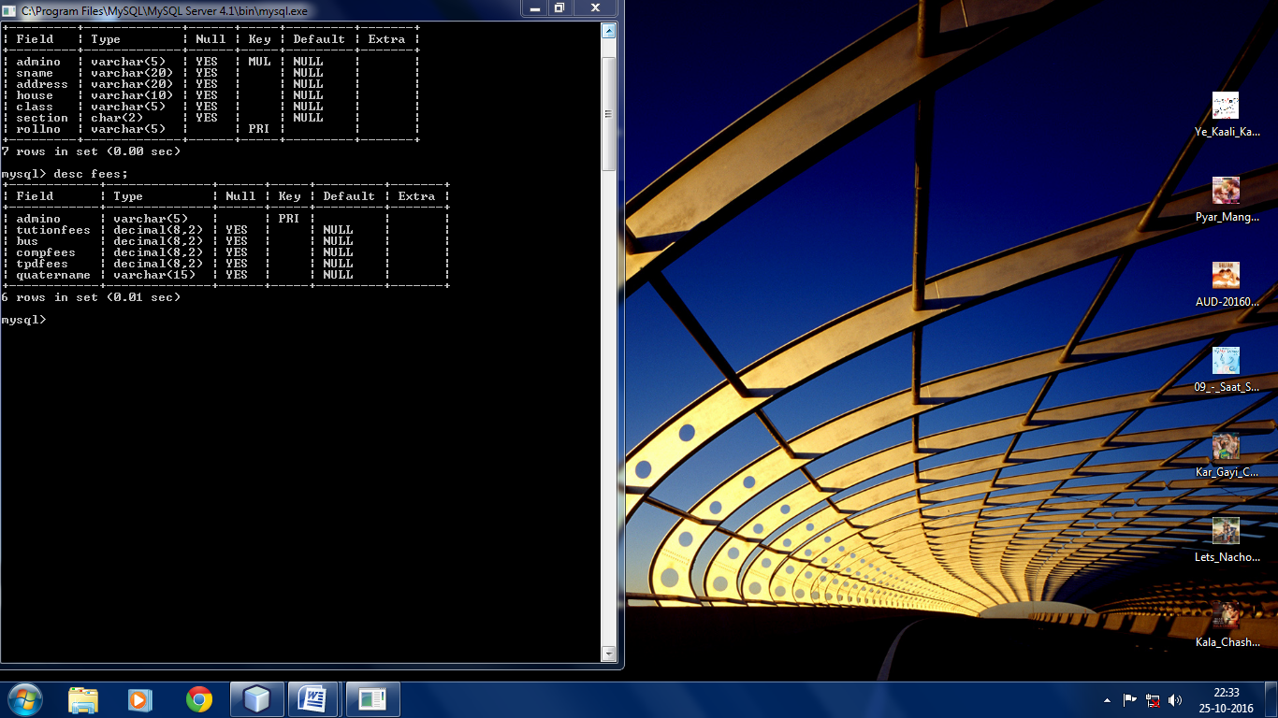

**CONCLUSION**

With this, I come to the conclusion that the project work on retail trade enriched me with software and theoretical knowledge. In process of development of the project many new problems were encountered, theoretical as well as practical which were reasonably difficult to manage. The reason was my inexperience with the process of software development.

I learnt a lot from during the making of this project. It led to the development of my software knowledge. I tried with my full effort to make it a good as well as attractive project. I was partly able to complete my project within the stipulated time. This project helped me to understand theoretical as well as practical things in software development.

The retail trade concept is itself is huge. Including every aspect of retailing in this school project is not possible. So we have basically focused on the very basic concept. But the project can be further implemented with new add-ons and can be converted to a live project.

**BIBLIOGRAPHY**

1.Informatics Practices (class XII)-SUMITA ARORA

2.Informatics Practices (class XII)-Together With IP

3. Informatics Practices(Saraswati Publications)-ReetaSahoo