Distributed Data Access Mid-Term Project

Jun Tang 2111172

Project Introduction
.

Services Overview

The solution contains three API services and one shared Contracts project:
• CustomerService.Api – owns Customer data and exposes CRUD endpoints.
• ProductService.Api – owns Product catalog and inventory (stock).
• OrderService.Api – owns Order data and creates orders.
• Contracts – shared message contracts used for asynchronous events (e.g., OrderCreated).
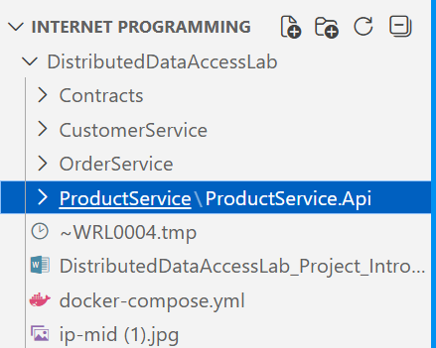

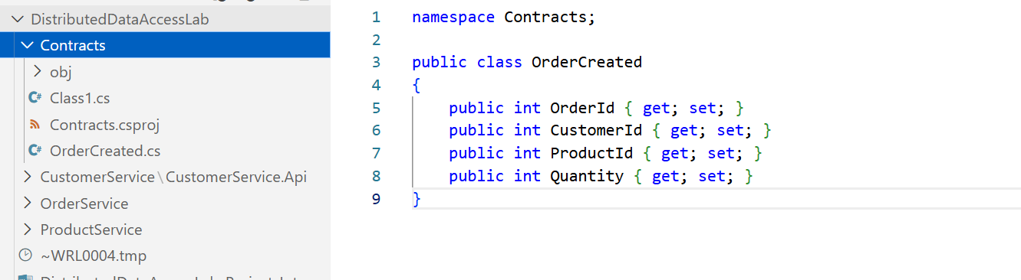

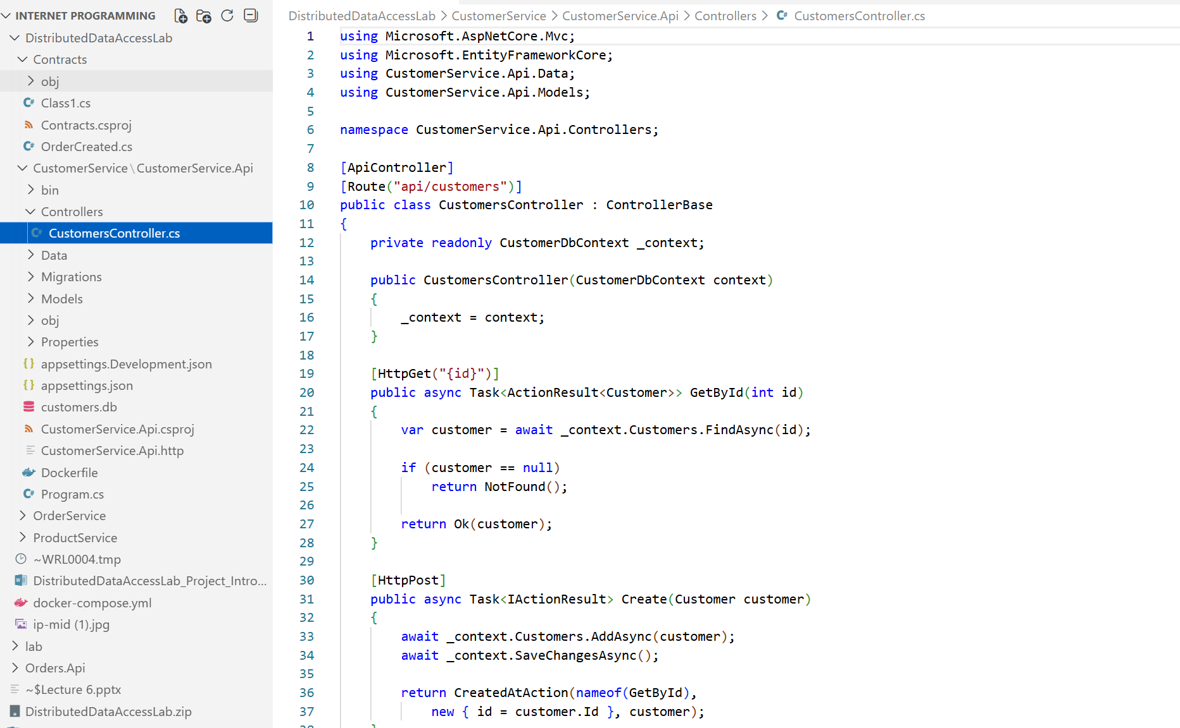

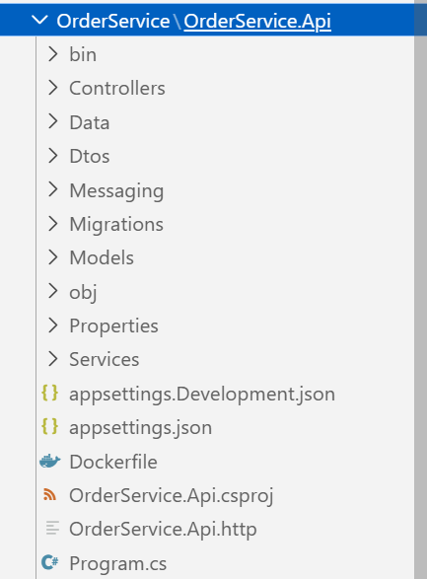

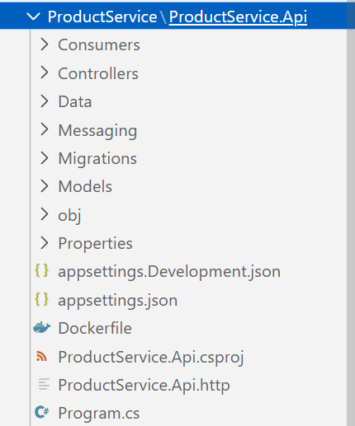

2. Architecture Diagram (Concept Description)
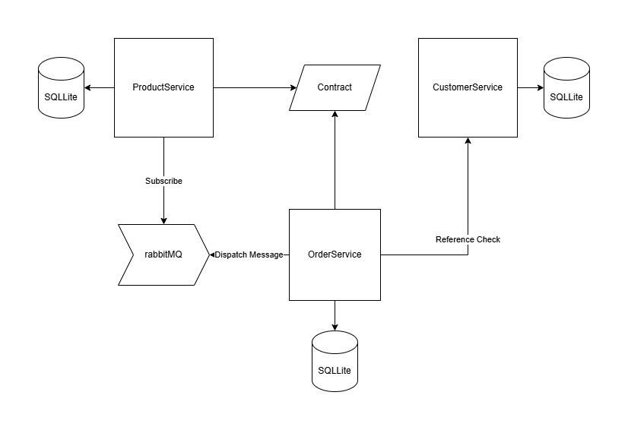
Event flow:
1) OrderService publishes an OrderCreated event to RabbitMQ queue: order_created.
2) ProductService consumes OrderCreated and updates product stock (inventory) in its own database.
No service directly reads or writes another service’s database.

3. Data Access Requirements

Database-per-service:
• Each microservice has its own DbContext and its own SQLite database file mounted into the container.
Async EF Core usage:
• Controllers use async EF Core methods (e.g., ToListAsync, FindAsync, SaveChangesAsync).
Independent migrations per service:
• Each service has its own Migrations folder and applies migrations on startup.
• Migrations are not shared across services; schema changes remain isolated.

4. Event-based Communication (RabbitMQ)
• OrderService publishes OrderCreated messages as persistent messages to queue order_created.
• ProductService runs a background consumer that retries connecting to RabbitMQ until it is ready, then consumes messages with manual ACK/NACK handling.
• If processing fails, the message is NACKed and re-queued for retry.

5. Data Ownership and Coupling Prevention
Ownership rules:
• Customer data is owned exclusively by CustomerService.
• Product catalog and inventory are owned exclusively by ProductService.
• Order data is owned exclusively by OrderService.
Coupling prevention patterns used:
• No cross-database access: services do not connect to each other’s databases.
• Integration through messages: OrderService tells other services what happened (OrderCreated) instead of calling internal DBs.
• Shared Contracts project: only message shapes are shared, not data access code or DbContexts.
• Event-driven updates: ProductService updates its own state (stock) based on events, reducing synchronous runtime coupling.

6. Docker & Compose – How to Run

Prerequisites:
• Docker Desktop / Docker Engine + Docker Compose
Run:
1) From the solution root, run:
docker compose up --build
2) RabbitMQ Management UI:
http://localhost:15672 (guest/guest)
3) Services expose HTTP on their mapped ports (see docker-compose.yml).

Reliability notes:
• docker-compose uses a RabbitMQ healthcheck and service dependency conditions.
• OrderService and ProductService implement retry logic to handle RabbitMQ readiness and transient startup timing.

7. Quick Validation Checklist

• Start all containers successfully with docker compose up.
• Create a product in ProductService, then create an order in OrderService referencing that product.
• Verify ProductService stock decreases after the OrderCreated event is processed.
• Verify each SQLite DB file is isolated per service via its own volume mount.

Containers:
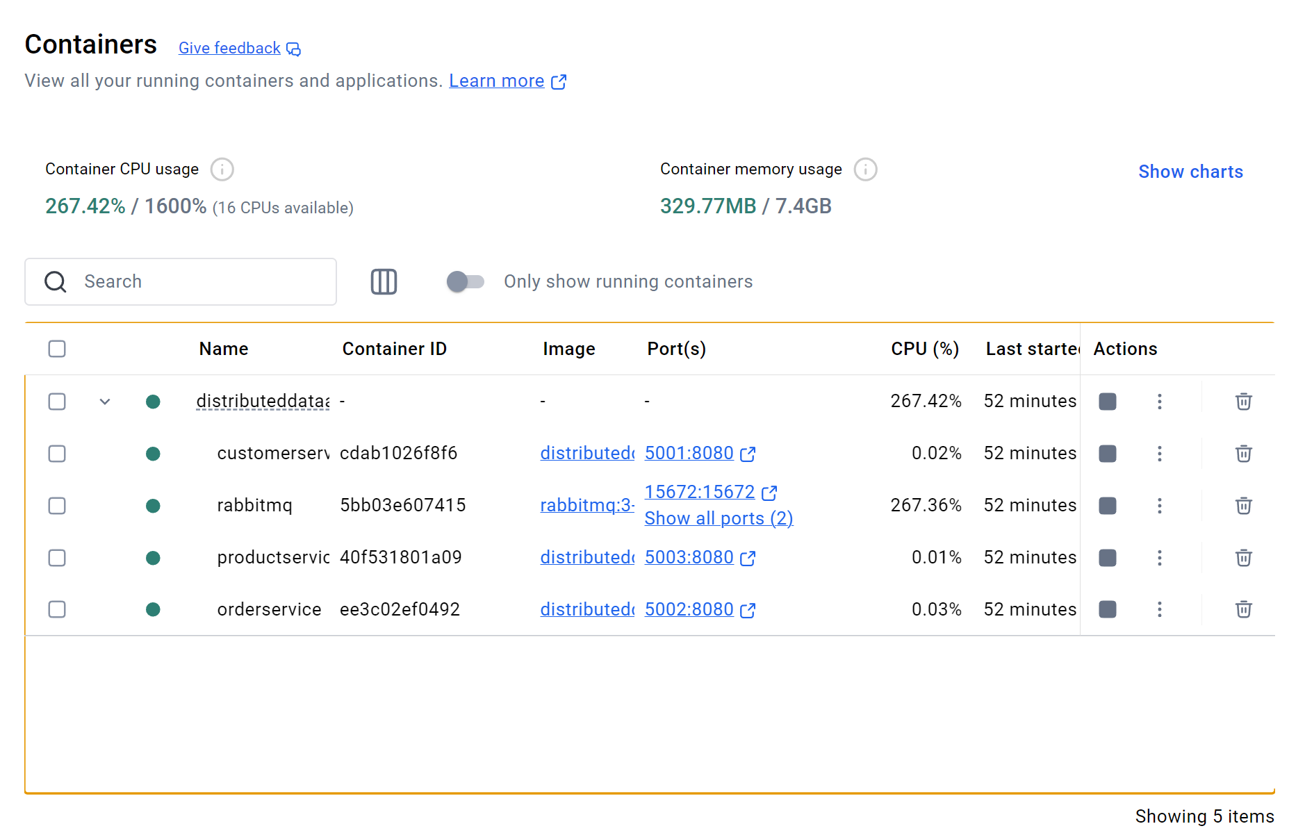
CustomerService:
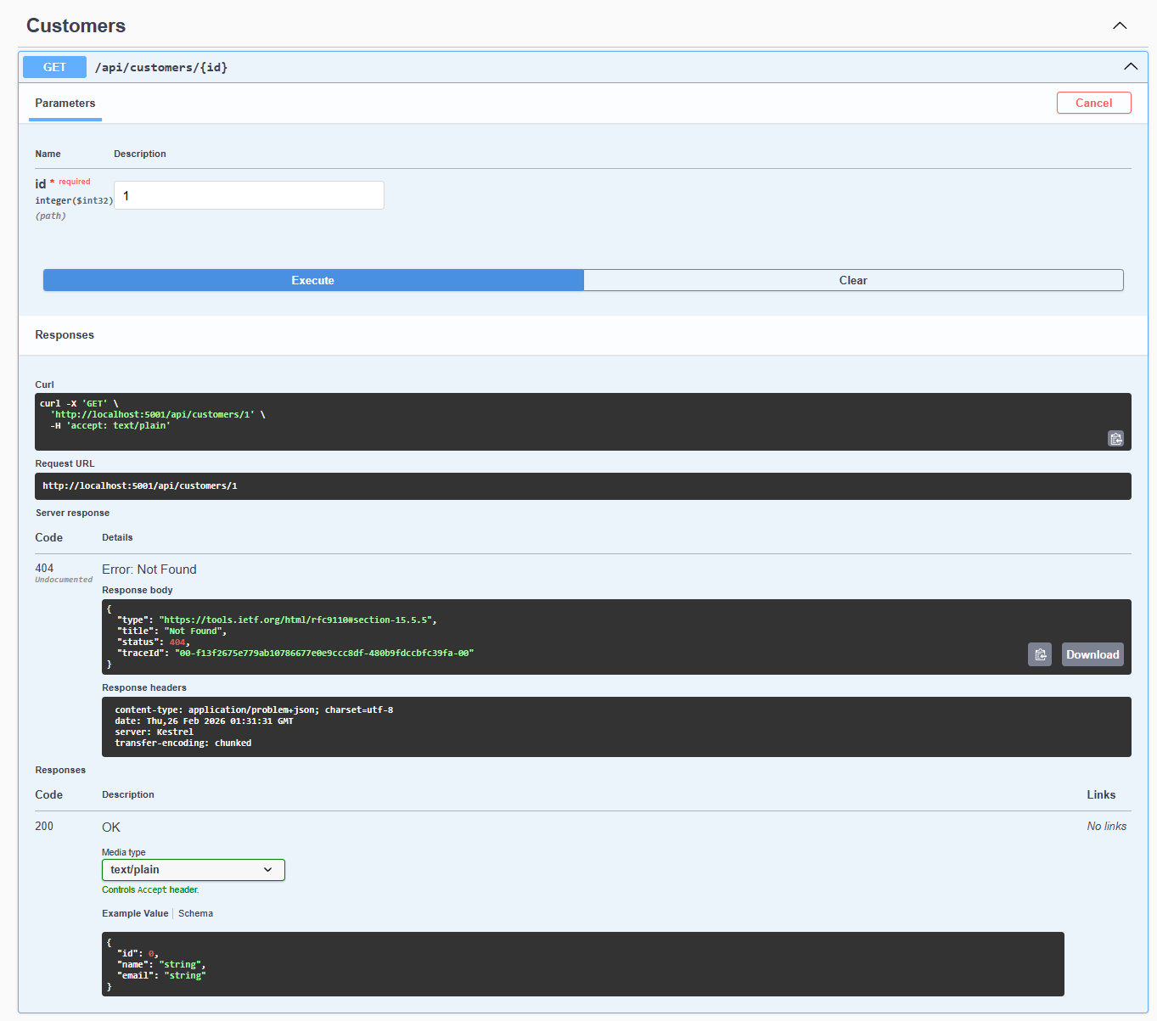

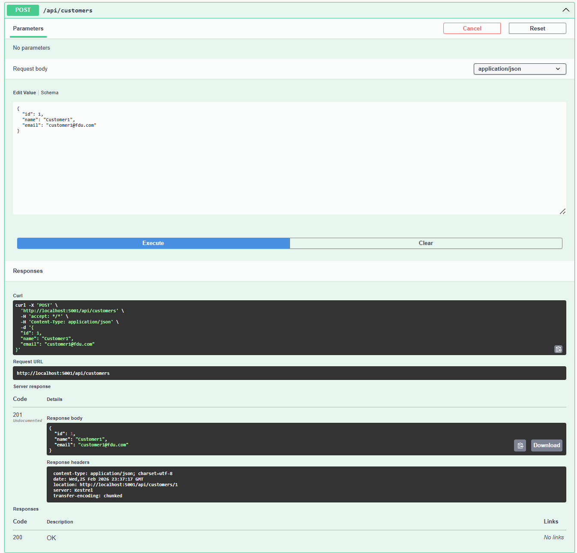

Product Service:
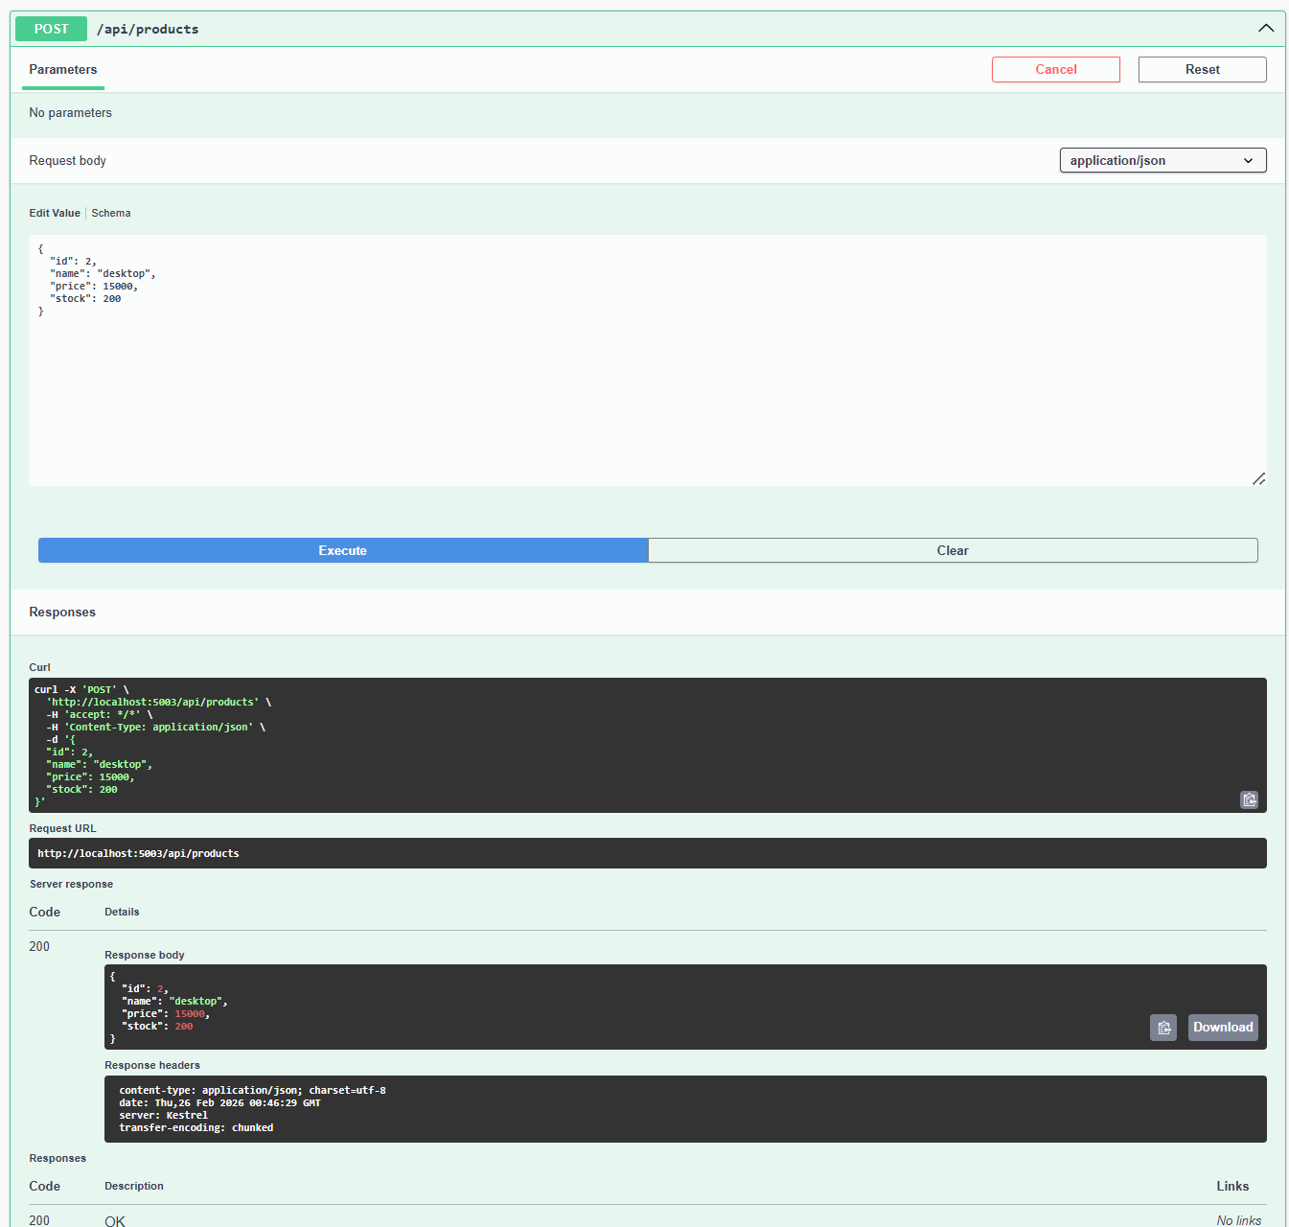
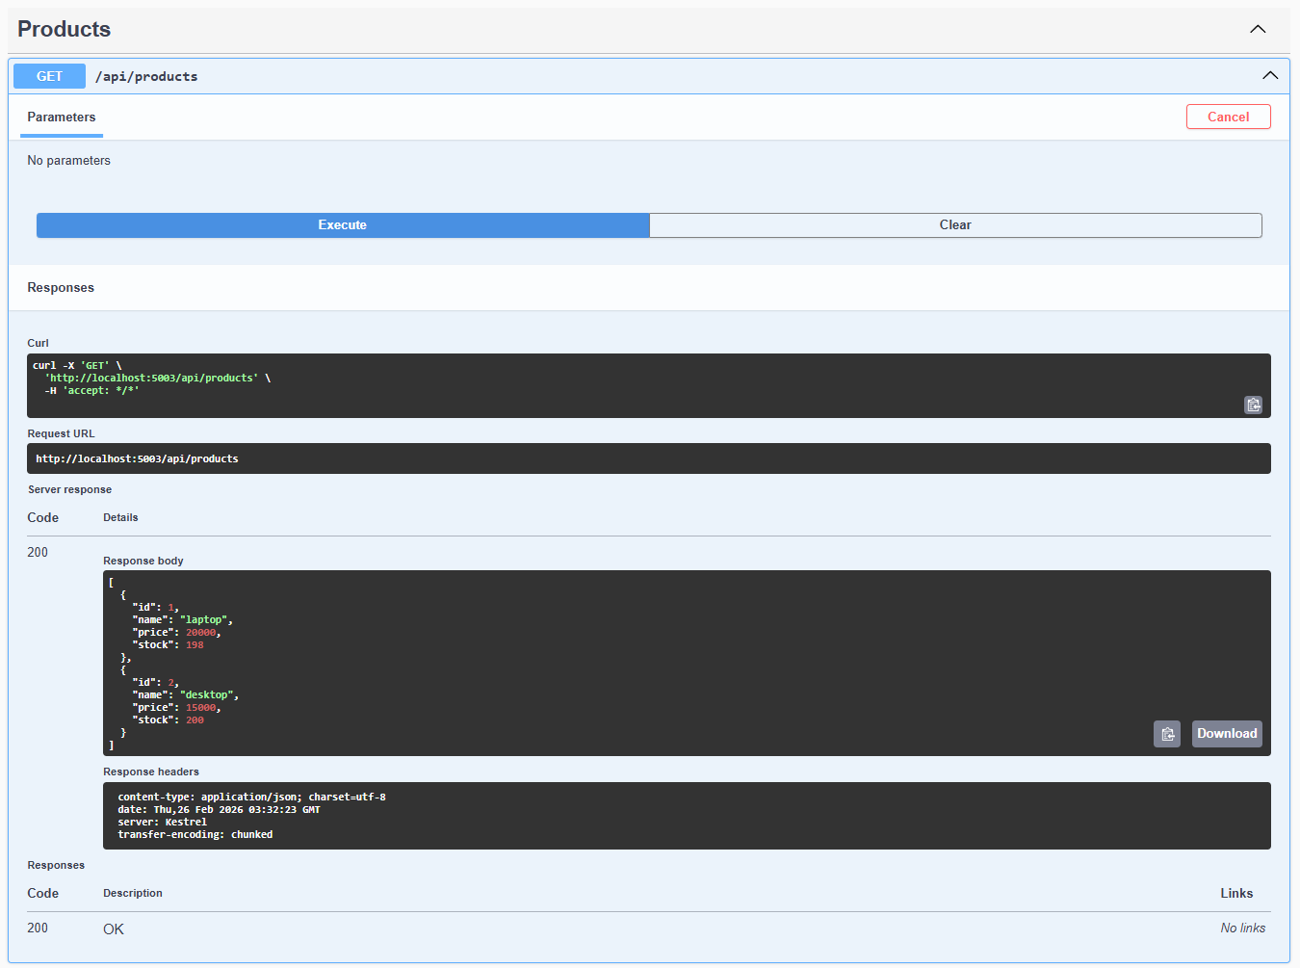

Place Order:
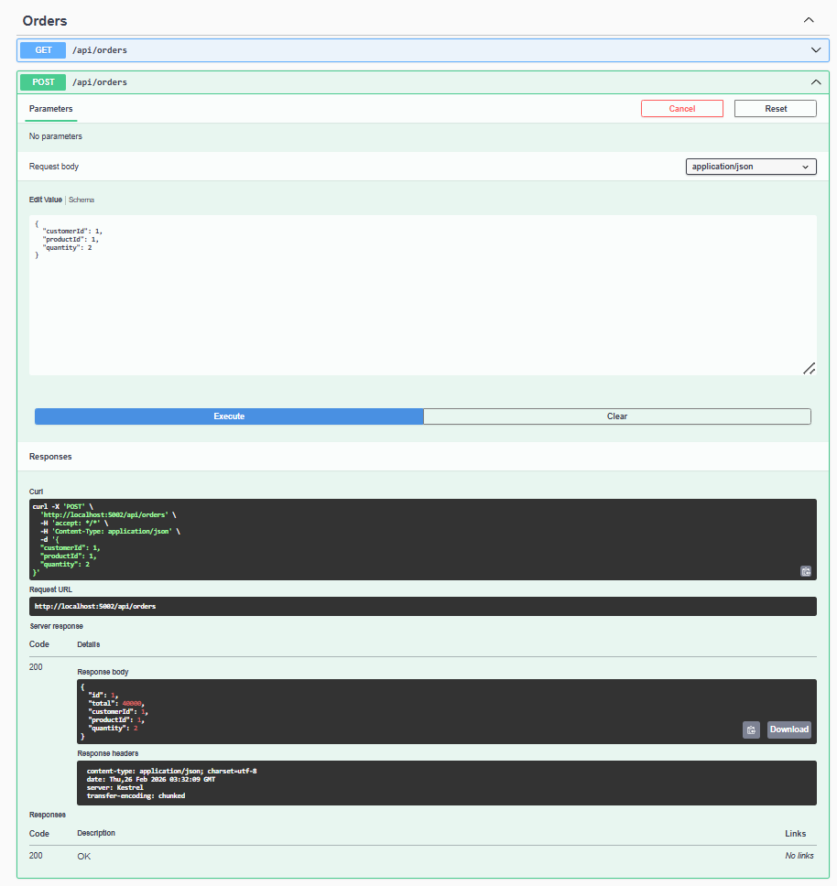

Query Orders:
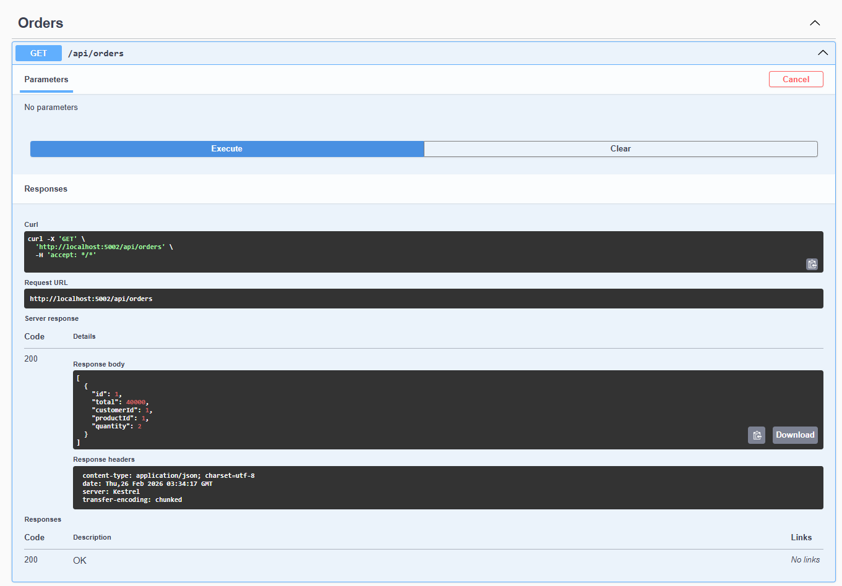
Validate Products:
Order:
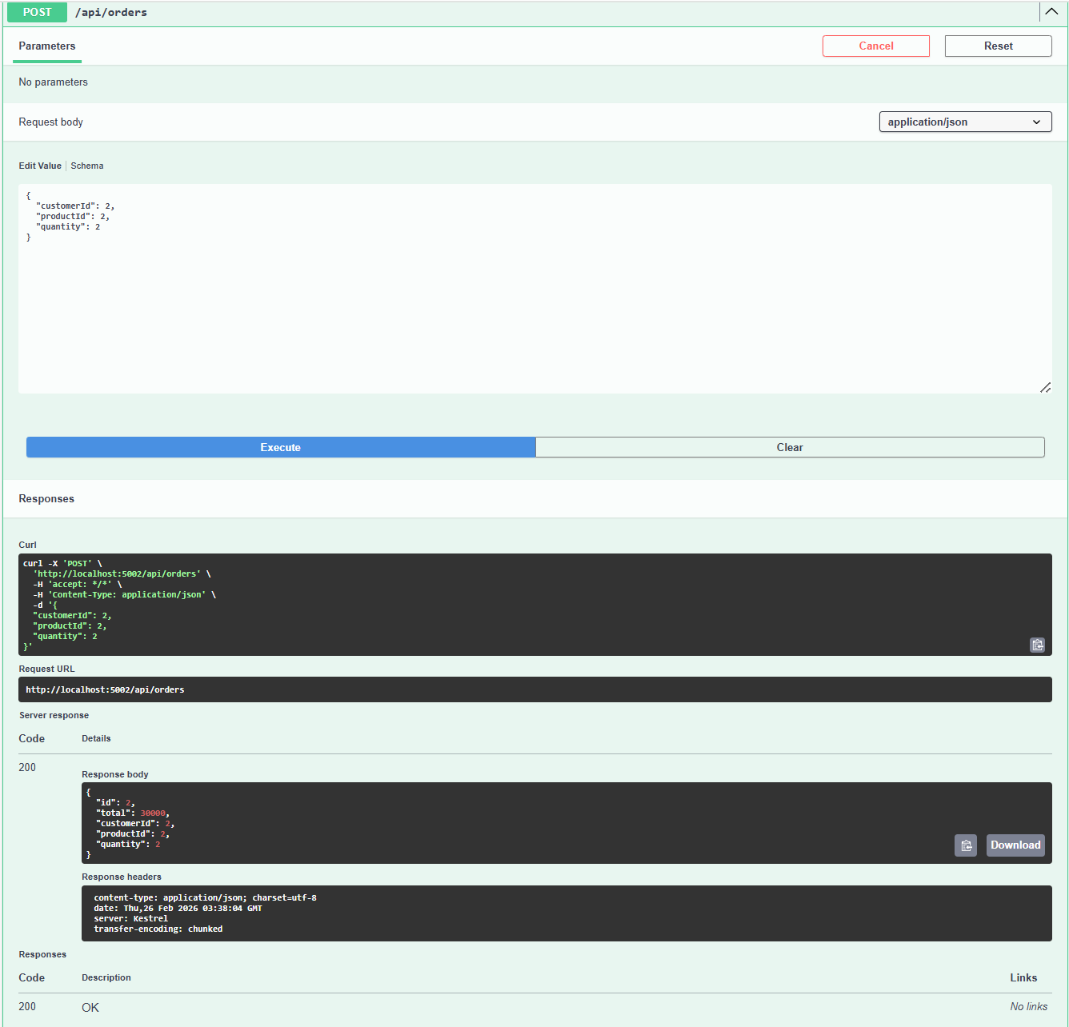
Products get the event from RabbitMQ and deduct the product 2 from storage:
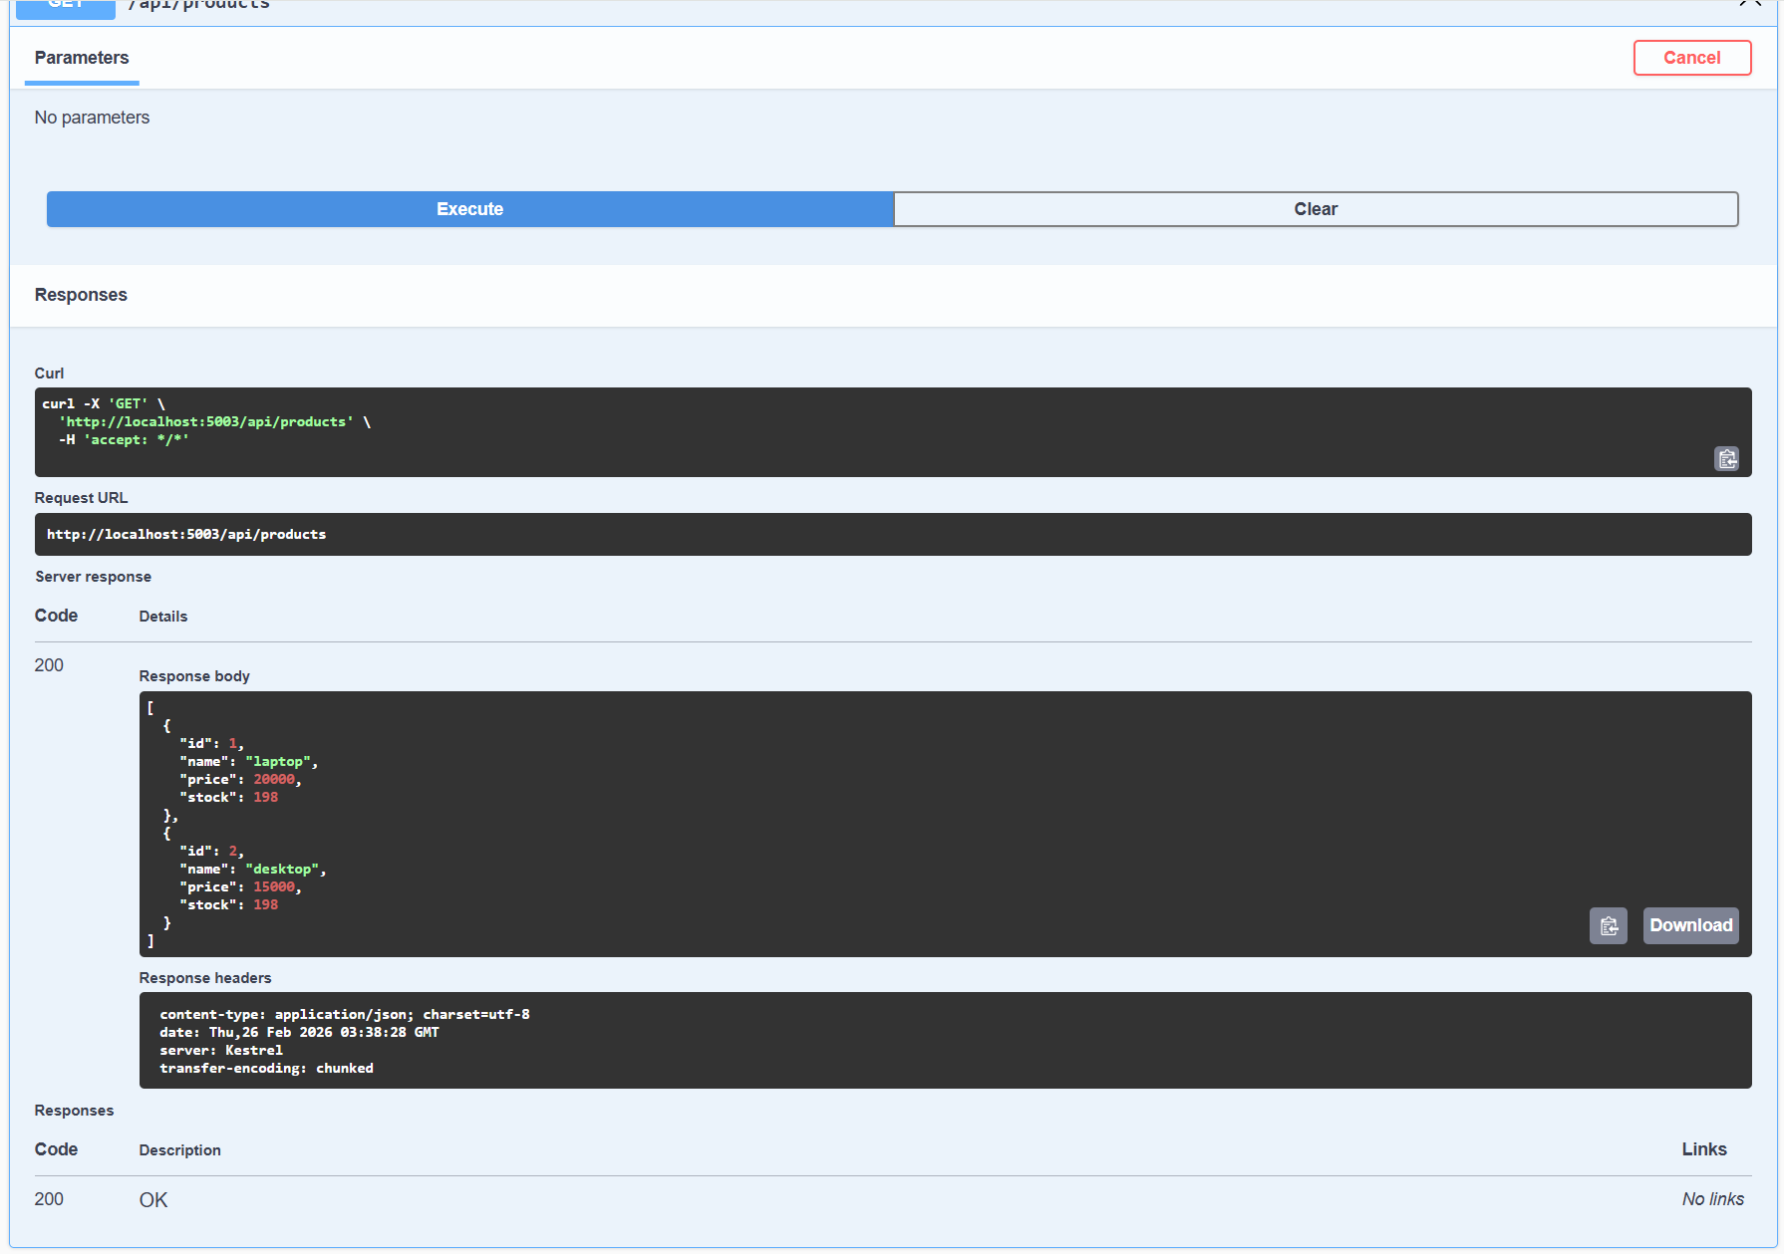

Order Validation:
Invalid customer id:
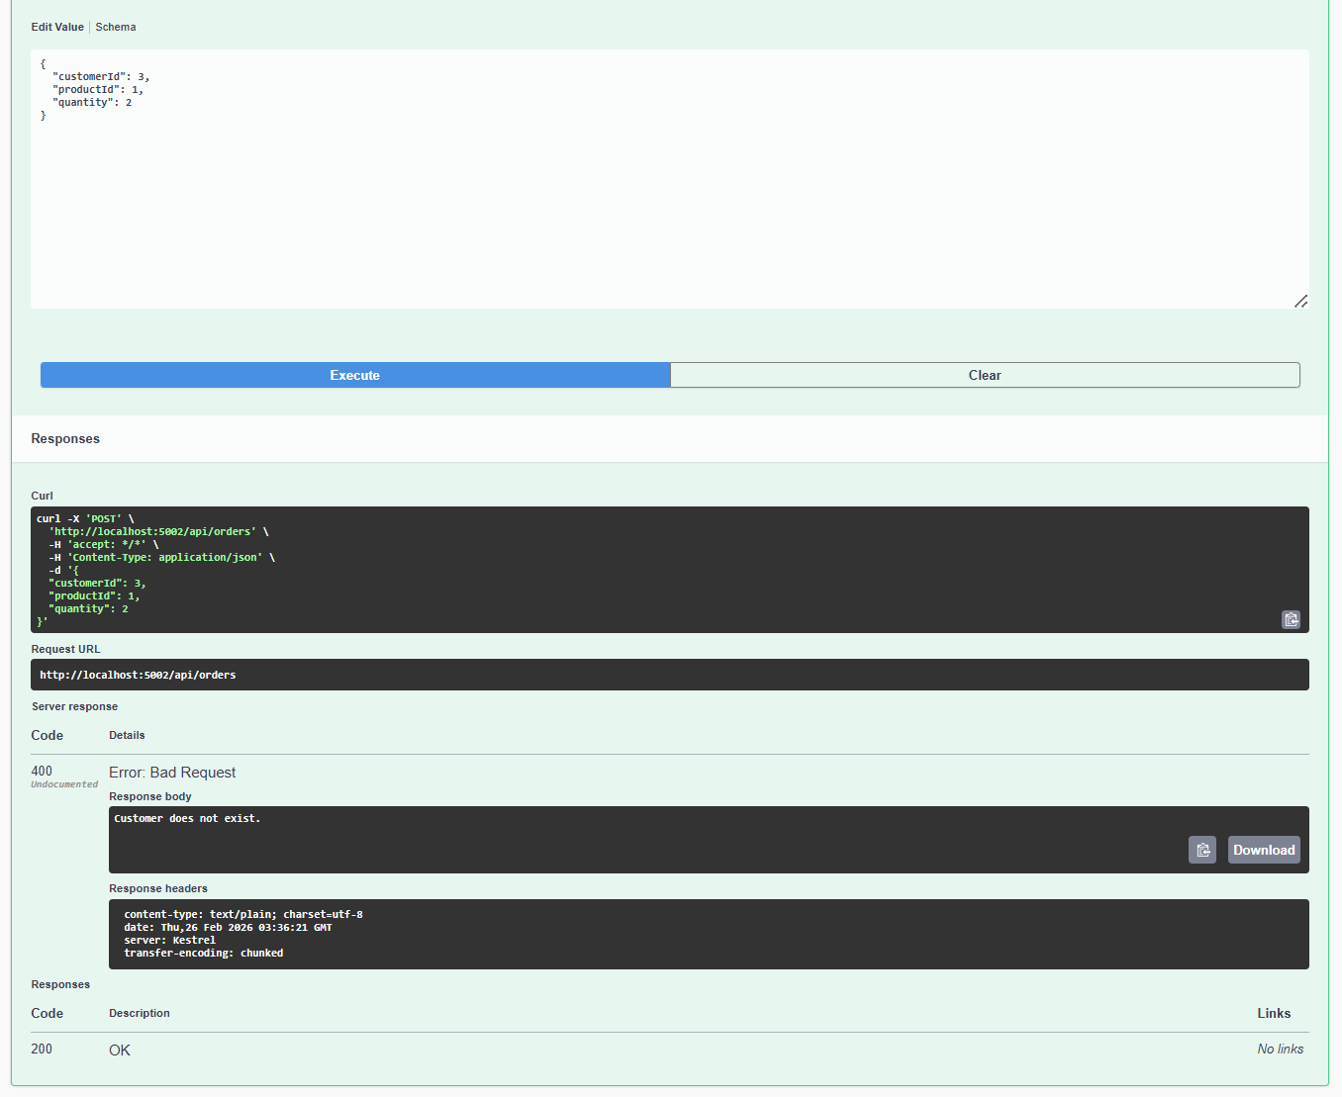
Invalid Product ID:
