A109 |  | O-ARSANILIC ACID | CAS#: 2045-00-3  MW: 217.05  MF: H2NC6H4ASO3H2 | 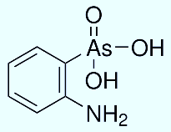
A110 |  | ARSENAZO III | CAS#: 1668-00-4  MW: 776.37  MF: (HO)2C10H2(SO3H)2(N=NC6H4ASO3H2)2 | 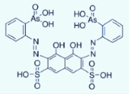
A111 |  | 2,2′-AZOBIS(2-METHYLPROPIONITRILE) | CAS#: 78-67-1  MW: 164.21  MF: (CH3)2C(CN)N=NC(CH3)2CN | 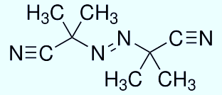
A112 |  | 4-AMINOBENZAMIDINE DIHYDROCHLORIDE | CAS # 2498-50-2  MW: 208.09  MF: H2NC6H4C(=NH)NH2·2HCL | 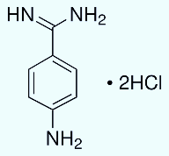
A113 |  | P-ARSANILIC ACID | CAS # 98-50-0  MW: 217.05  MF: C6H8ASNO3 | 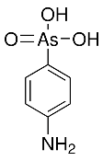
A114 |  | L-ARGININE | CAS # 74-79-3  MW: 174.20  MF: H2NC(=NH)NH(CH2)3CH(NH2)CO2H | 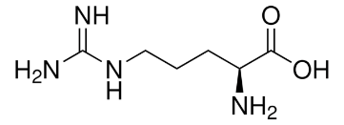
A115 |  | 4-ACETOXYSTYRENE | CAS # 2628-16-2  MW: 162.19  MF: C10H10O2 | 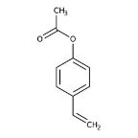
A116 |  | 2,2′-AZOBIS(2-METHYLPROPANE) | CAS # 927-83-3  MW: 142.24  MF: (CH₃)₃CN=NC(CH₃)₃ | 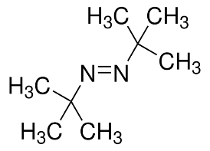
B091 |  | BROMETHALIN | CAS#: 63333-35-7  MW: 577.93  MF: C14H7BR3F3N3O4 | 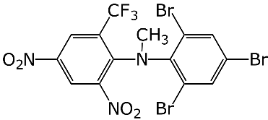
B092 |  | 1,3- BIS[ TRIS(HYDROXYMETHYL)METHYLAMINO]PROPANE | CAS#:64431-96-5  MW: 282.34  MF: C11H26N2O6 | 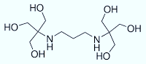
B093 |  | BARIUM THIOSULFATE | CAS#: 35112-53-9  MW: 249.46  MF: BAO3S2 | 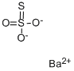
B094 |  | 1-BOC-4-HYDROXYPIPERIDINE | CAS#: 109384-19-2  MW: 201.26  MF: C10H19NO3 | 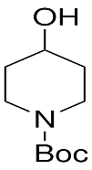
B095 |  | 4-BROMO-PHTHALIC ANHYDRIDE | CAS#: 86-90-8  MW: 227.01  MF: C8H3BRO3 | 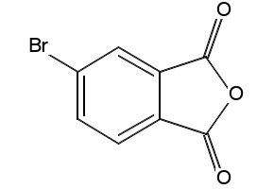
B096 |  | BENZOPHENONE | CAS#: 119-61-9  MW:  MF: | 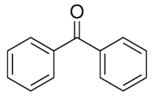
B097 |  | 2-BROMOANISOLE | CAS#: 578-57-4  MW:  MF: | 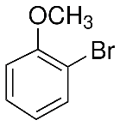
B098 |  | 4-BROMOANISOLE | CAS#: 104-92-7  MW:  MF: | 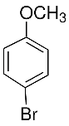
B099 |  | 1-BROMOBUTANE | CAS#: 109-65-9  MW:  MF: | 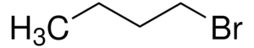
B100 |  | 1-BROMO-2-CHLOROBENZENE | CAS#: 694-80-4  MW:  MF: | 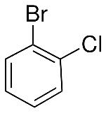
B101 |  | 1-BROMO-3-CHLOROBENZENE (3-BROMO-1-CHLOROBENZENE) | CAS#: 108-37-2  MW:  MF: | 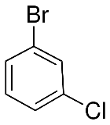
B102 |  | 1-BROMO-2-ETHYLBENZENE (CONFIRM NOT 4-ETHYL) | CAS#: 1973-22-4  MW:  MF: | 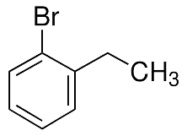
B103 |  | 1-BROMO-4-ETHYLBENZENE | CAS#: 1585-07-5  MW:  MF: | 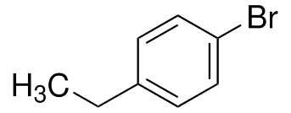
B104 |  | 1-BROMO-2-FLUOROBENZENE | CAS#: 1072-85-1  MW:  MF: | 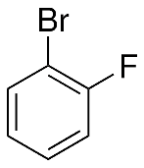
B105 |  | 1-BROMO-3-FLUOROBENZENE | CAS#: 1073-06–9  MW:  MF: | 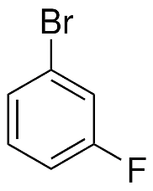
B106 |  | 3-BROMOPHENOL | CAS#: 591-20-8  MW:  MF: | 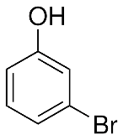
B107 |  |  | CAS#: MW:  MF: | 
B108 |  | 2-BROMOPYRIDINE | CAS#: 109-04-6  MW:  MF: | 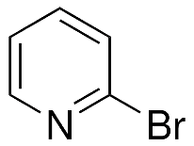
B109 |  | 2-BROMOTOLUENE | CAS#: 95-46-5  MW:  MF: | 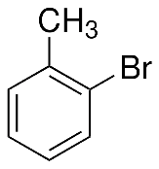
B110 |  | 3-BROMOTOLUENE | CAS#: 591-17-3  MW:  MF: | 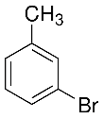
B111 |  | 4-BUTOXYPHENOL | CAS#: 122-94-1  MW:  MF: | 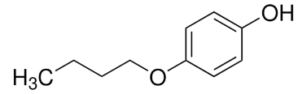
B112 |  | 2-BUTANOL | CAS#: 78-92-2  MW:  MF: | 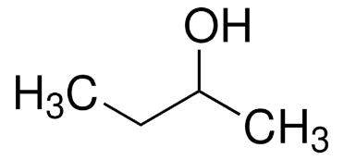
C146 | CHLOROMETHYL METHYL ETHER |  | CAS#: 107-30-2  MW: 80.51  MF: | 
C147 | CALCIUM SILICATE |  | CAS#: 10101-39-0  MW: 116.16  MF: CASIO₃ | 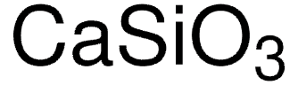
C149 | COLLAGEN |  | CAS#: 9007-34-5  MW:  MF:
C150 | CARBONYL CYANIDE 3 CHLOROPHENYLHYDRAZONE |  | CAS#: 555-60-2  MW: 204.62  MF: C₉H₅CLN₄ | 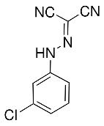
C147 | CALCIUM SILICATE |  | CAS#: 10101-39-0  MW: 116.16  MF: CAH3SI | 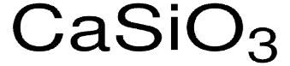
C148 | 2-CHLORO-1,3-DIMETHYLIMIDAZOLINIUM CHLORIDE |  | CAS#: 37091-73-9  MW:  MF: C5H10CL2N2 | 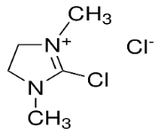
D144 | DOXEPIN HCI |  | CAS#: 1229-29-4  MW: 315.84  MF: C19H21NO · HCL | 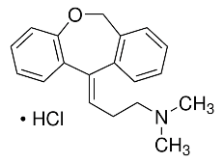
D145 | DICHLOROPHENYLBORANE |  | CAS#: 873-51-8  MW: 158.82  MF: C6H5BCI2 | 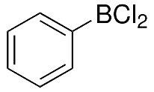
D146 | DIMETHYLPHENYLSILANE |  | CAS#: 766-77-8  MW:136.27  MF: C8H12SI | 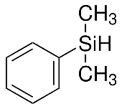
D147 | 1,3-DIBROMO-5,5-DIMETHYLHYDANTOIN |  | CAS#: 77-48-5  MW: 285.92  MF: C6H5SIH(CH3)2 | 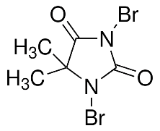
D148 | DIMETHYL-L-ARGININE, DIHYDROCHLORIDE |  | CAS#: 36589-29-4  MW: 275.18  MF: C8H18N4O2 · 2HCL | 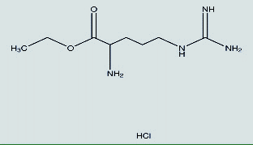
D149 | 2-SEC-BUTYL-4,5-DIMETHYL-3-THIAOLINE |  | CAS#: 65894-82-8  MW: 171.30  MF: C9H17NS | 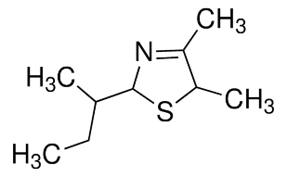
D150 | DIACETONE ALCOHOL |  | CAS#: 123-42-2  MW: 116.16  MF:  (CH₃)₂C(OH)CH₂COCH₃ | 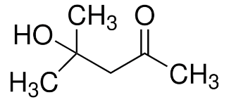
D151 | 1,3-DIBROMOBENZENE |  | CAS#: 108-36-1  MW: 235.90  MF: C₆H₄Br₂ | 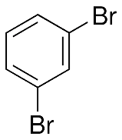
D152 | 1,4-DIBROMOBENZENE |  | CAS#: 106-37-6  MW: 235.90  MF: C₆H₄Br₂ | 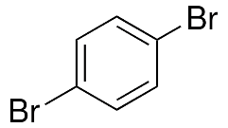
D153 | 3,5-DIBROMO-1-FLUOROBENZENE |  | CAS#: 1435-51-4  MW: 253.89  MF: Br₂C₆H₃F | 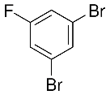
D154 | 2,2’-DICHLORODIETHYL ETHER |  | CAS#: 111-44-4  MW: 143.01  MF: (ClCH₂CH₂)₂O | 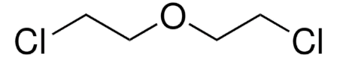
D155 | N,N-DIETHYLANILINE |  | CAS#: 91-66-7  MW: 149.23  MF: (C₂H₅)₂NC₆H₅ | 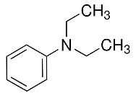
D156 | DIETHYLENE GLYCOL MONOETHYL ETHER |  | CAS#: 111-90-0  MW:  MF: | 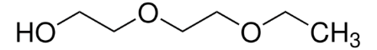
D157 | DIISOPROPANOLAMINE 99% |  | CAS#: 110-97-4  MW: 133.19  MF: NH[CH₂CH(OH)CH₃]₂ | 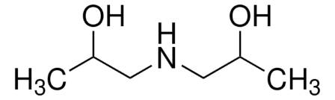
D158 | 3-DIMETHYLAMINOPROPYLAMINE |  | CAS#: 109-55-7  MW: 102.18  MF: (CH₃)₂N(CH₂)₃NH₂ | 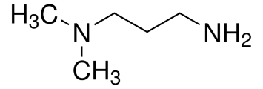
D159 | DESONIDE |  | CAS#: 638-94-8  MW: 416.51  MF: C₂₄H₃₂O₆
E014 | ETHYL VINYL KETONE, 97%, CONTAINS 0.15% BHT AS STABILIZER |  | CAS#: 1629-58-9  MW: 84.12  MF: C5H8O | 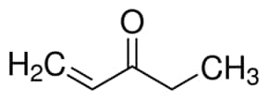
E015 | ETHYLENE GLYCOL DIETHYL ETHER |  | CAS#: 629-14-1  MW:118.17  MF: C6H14O2 | 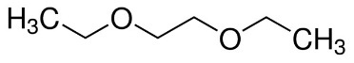
E016 | ETHYLENE GLYCOL BIS(2-MERCAPTOETHYL) ETHER |  | CAS#: 14970-87-7  MW: 182.30  MF: HSCH2CH2OCH2CH2OCH2CH2SH | 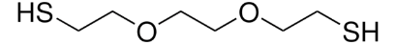
E017 | EDC HYDROCHLORIDE |  | CAS # 25952-53-8  MW: 191.70  MF: C8H17N3.HCI | 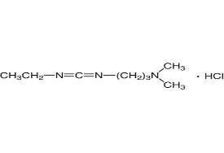
E018 | ETHYL 3-ETHOXYPROPIONATE |  | CAS # 25952-53-8  MW: 191.70  MF: C₈H₁₇N₃ · HCl | 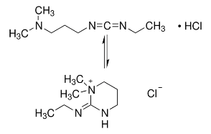
F034 | FORMAMIDINIUM BROMIDE |  | CAS#: 146958-06-7  MW: 124.97  MF: CH5BRN2 | 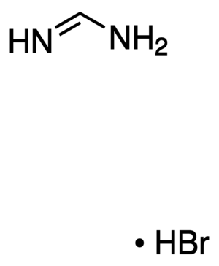
F035 | 4-[[(4-FLUOROPHENYL)IMINO]METHYL]PHENOL |  | CAS#: 3382-63-6  MW: 215.2  MF: C13H10FNO | 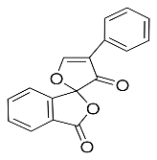
F036 | FLUORESCAMINE |  | CAS#: 38183-12-9  MW: 278.26  MF: C₁₇H₁₀O₄ | 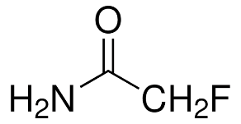
F037 | FLUOROACETAMIDE |  | CAS#: 640-19-7  MW: 77.06  MF: FCH₂CONH₂ | 

F038 | 2-FLUOROPHENOL | CAS#: 367-12-4  MW: 112.10  MF: FC₆H₄OH | 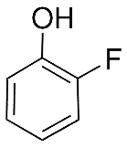
F039 | 3-FLUOROPHENOL | CAS#: 372-20-3  MW:  MF: | 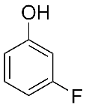
F040 | 3-FLUOROANISOLE | CAS#: 456-49-5  MW: 112.10  MF: FC₆H₄OH | 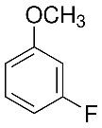
F041 | 4-FLUOROANISOLE | CAS#: 459-60-9  MW: 126.13  MF: FC₆H₄OCH₃ | 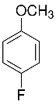
G010 | GLUTARALDEHYDE SOLUTION, GRADE I, 70% IN H2O | CAS#: 111-30-8  MW: 100.12  MF: OHC(CH₂)₃CHO | 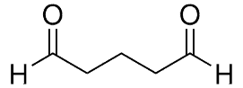
H054 | HEPES | CAS#: 7365-45-9  238.30  C₈H₁₈N₂O₄S | 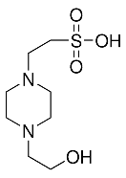
H055 | HYDROCORTISONE 17-VALERATE | CAS#: 57524-89-7  MW: 446.58  MF: C₂₆H₃₈O₆ | 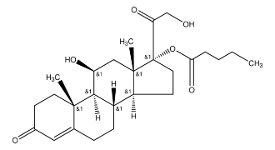
H056 | HALCINONIDE | CAS#: 3093-35-4  MW: 454.96  MF: C₂₄H₃₂ClFO₅ | 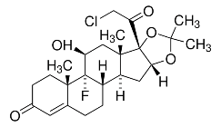
H057 | HYDROXYPROGESTERONE CAPROATE | CAS#: 630-56-8  MW: 428.60  MF: C₂₇H₄₀O₄ | 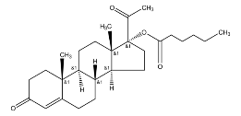
I025 | ISOSTEARIC ACID | CAS#: 2724-58-5  MW: 284.48  MF: C₁₈H₃₆O₂ | 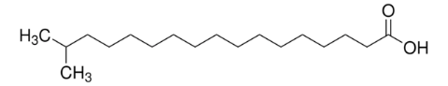
I026 | IODOQUINOL, POWDER, USP | CAS#: 83-73-8  MW: 396.95  MF: C₉H₅I₂NO | 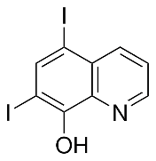
I027 | ISOPROPYL PALMITATE | CAS#: 142-91-6  MW: 298.50  MF: CH₃(CH₂)₁₄COOCH(CH₃)₂ | 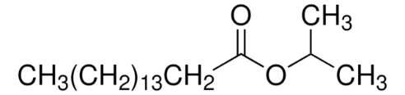
I028 | ISOVALERIC ACID | CAS#: 503-74-5  MW: 102.13  MF: (CH₃)₂CHCH₂COOH | 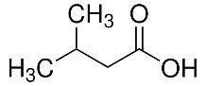
L003 | LITHIUM TRIFLUOROMETHANESULFONATE | CAS#: 33454-82-9  MW: 156.01  MF: CF₃SO₃Li | 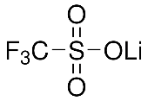

M107 | 2-METHYL-N-ETHYL-N-(2-CYANOETHYL)-4-  AMINOBENZALDEHYDE | CAS#: 119-97-1  MW: 216.28  MF: (NCCH₂CH₂)(C₂H₅)NC₆H₃(CH₃)CHO | 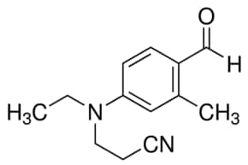
M108 | 4-METHYLPYRIDINE | CAS#: 108-89-4  MW:93.13  MF: C₆H₇N | 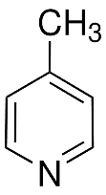
M109 | METHYL SOYATE (SOY METHYL) | CAS#: 67784-80-9  MW:  MF:
M110 | 4,5-METHYLENEDIOXY-1,2-PHENYLENEDIAMINE DIHYDROCHLORIDE | CAS#: 81864-15-5  MW: 225.07  MF: C₇H₈N₂O₂ · 2HCl | 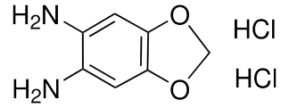
M111 | 6-MALEIMIDOHEXANOIC ACID N-HYDROXYSUCCINIMIDE ESTER | CAS#: 55750-63-5  MW:308.29  MF: C₁₄H₁₆N₂O₆ | 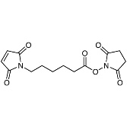
M112 | MEGESTEROL ACETATE | CAS#: 907193-65-1  MW:  MF:

N038 | NICOTINAMIDE | CAS#: 98-92-0  MW:122.12  MF: C₆H₆N₂O | 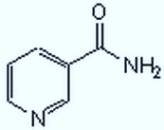
N039 | NADH, DISODIUM SALT | CAS#: 606-68-8  MW: 709.40 (anhydrous basis)  MF: C₂₁H₂₇N₇Na₂O₁₄P₂ · xH₂O | 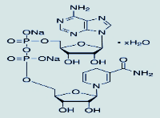
N040 | N-BUTYRIC ACID (NATURAL) | CAS#: 107-92-6  MW: 88.11  MF: CH₃CH₂CH₂COOH | 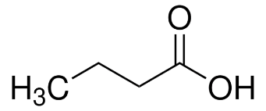
N041 | 3-NITROBENZYL BROMIDE (TECH) | CAS#: 3958-57-4  MW: 216.03  MF: C₇H₆NO₂Br | 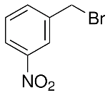

P074 | POTASSIUM DIBUTYLTHIOPHOSPHATE | CAS#: 3549-51-7  MW: 282.44  MF: C₈H₂₀KO₂PS₂ | 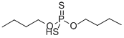
P075 | PHENOL/ CHLOROFORM/ ISOAMYL AL
P076 | EQUILIBRATION BUFFER
P077 | PHENOL, ACS | CAS#: 108-95-2  MW: 94.11  MF: C₆H₅OH | 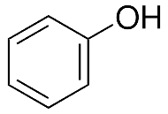
P078 | POLYQUATERNIUM-1 SOLUTION | 75345-27-6 | 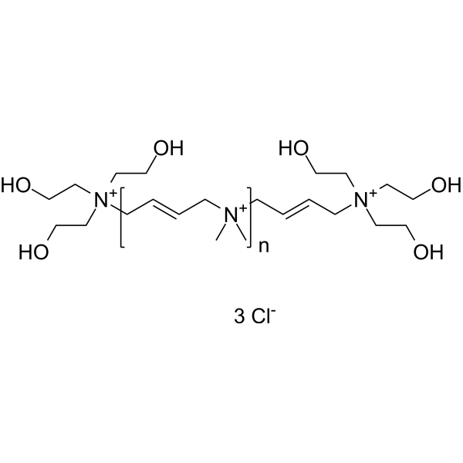
P079 | 1,3-BIS(4-PYRIDYL)PROPANE | CAS#: 17252-51-6  MW: 198.26  MF: C₁₃H₁₄N₂ | 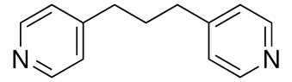

RA010 | AMMONIUM ACETATE, ACS | CAS#: 631-61-8  MW: 77.08  MF: CH₃CO₂NH₄ | 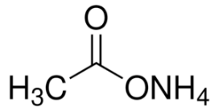

RB011 | BORIC ACID, REAGENT ACS | CAS#: 10043-35-3  MW: 61.83  MF:  H₃BO₃ | 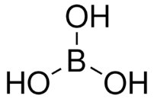
RB012 | BARIUM THIOSULFATE | CAS#: 35112-53-9  MW: 249.46  MF: BaS₂O₃ | 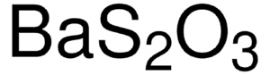

RM012 | MANGANESE CHELATE | CAS#:  MW:  MF:

RN001 | NINHYDRIN | CAS#: 485-47-2  MW: 178.14  MF: C₉H₆O₄ | 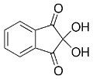

RP011 | POTASSIUM HYDROXIDE 20% SOLUTION | CAS#: 1310-58-3  MW: 56.11  MF: KOH | 
RP012 | PHENYL ACETONE | CAS#: 103-79-7  MW: 134.18  MF: C₆H₅CH₂COCH₃ | 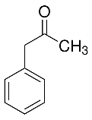

RS032 | SODIUM CITRATE, ANHYDROUS | CAS#: 68-04-2  MW: 258.07  MF: C₆H₅O₇Na₃ | 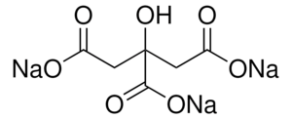

S021 | SODIUM PHOSPHATE DIBASIC | CAS#: 7558-79-4  MW: 141.96  MF: Na₂HPO₄ | 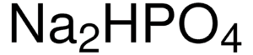
S022 | SODIUM COCOYL SARCOSINATE | CAS#: 61791-59-1  MW:  MF:  C3H7NO2·Na
S023 | SILQUEST TEOS PURE SILANE | CAS#: 78-10-4  MW: 208.33  MF: Si(OC₂H₅)₄ | 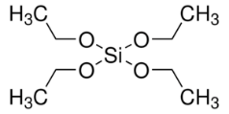

T074 | TRIAMCINOLONE ACETONIDE | CAS#: 76-25-5  MW: 434.50  MF: C₂₄H₃₁FO₆ | 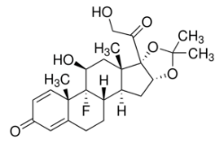
T075 | TRIS HYDROCHLORIDE | CAS#: 1185-53-1  MW: 157.60  MF: NH₂C(CH₂OH)₃ · HCl | 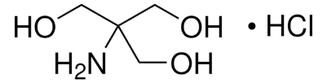
T076 | TROPOLONE | CAS#: 533-75-5  MW: 122.12  MF: C₇H₆O₂ | 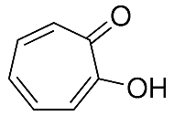
T077 | TRIMELLITIC ANHYDRIDE | CAS#: 552-30-7  MW: 192.13  MF: C₉H₄O₅ | 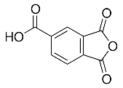
T078 | EDTA, TETRASODIUM TETRAHYDRATE SALT | CAS#: 13235-36-4  MW: 452.23  MF: C10H20O12N2Na4 | 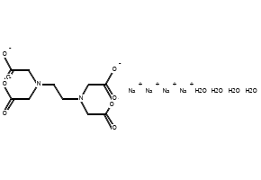
T079 | TETRAMETHYLAMMONIUM HYDROXIDE, 25 WT.  % SOLUTION IN METHANOL | CAS#: 75-59-2  MW: 91.15  MF: (CH₃)₄N(OH) | 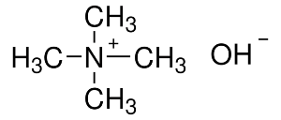
T080 | TRICHLOROETHYLENE | CAS#: 79-01-6  MW: 131.39  MF: ClCH=CCl₂ | 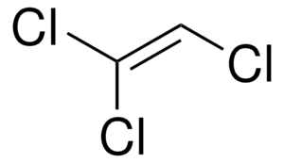
T081 | TETRA PROPYL AMMONIUM BROMIDE 50% SOLUTION | CAS#: 1941-30-6  MW: 266.26  MF: (CH₃CH₂CH₂)₄N(Br) | 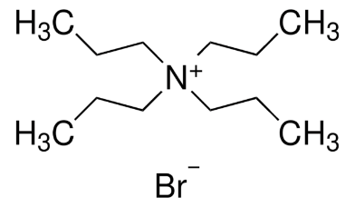
T082 | TRIAMCINOLONE ACETONIDE | CAS#: 76-25-5  MW: 434.50  MF: C₂₄H₃₁FO₆ | 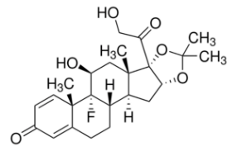

On the contact page: Please confirm with Dr. Porwal.
INTRODUCING DENTAL PRODUCTS BUSINESS DEVELOPMENT AND CONSULTANT, SPECIAL CHEMICAL -
DR. CHRISTOS ANGELATAKIS

On the first page, CIT proudly offers the Special Dental Products line of products
CD01 - GLUTARALDEHYDE CONCENTRATE + TITRATION
CD02 - POLYACRYLIC ACID DERIVATIVE (PAA-MA)
CD03 - POLYACRYLIC ACID GLYCIDYL METHACRYLATE ADDUCT (PAA-GMA) 35%
CD04 - POLYACRYLIC ACID METHACRYLATED (PAAMA)15-20%

