**Drone V3 Testing Record**

**Dronev3** is a C++ program that simulates autonomous drone deliveries under different environmental and operational conditions. It models different weather scenarios, obstacles, and random malfunctions to test the reliability and decision-making of a drone delivery system. The simulator provides real-time feedback for each delivery attempt, including route updates, success or failure messages, and remaining battery life.

This document contains a record of its testing;

**Test Case-1: Program Start and Initialization**

|  |  |
| --- | --- |
| **Description** | Verify program prompts correctly and initializes randomization and battery. |
| **Input** | Run program → press **Enter**. |
| **Expected Output** | Displays message: Press ENTER to start deliveries  Battery = 100 initialized. |
| **Pass Criteria** | Program waits for Enter and starts Delivery #1 with 100% battery. |

**Results:**

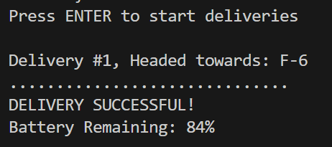

Passed✅

**Test Case-2: Successful Delivery (Normal Conditions)**

|  |  |
| --- | --- |
| **Description** | Verify that the drone completes a delivery successfully when there are no weather or obstacle issues. |
| **Input** | Start the program and observe a delivery under normal conditions. |
| **Expected Output** | The delivery is marked successful, and the battery level decreases slightly. |
| **Pass Criteria** | Delivery is successful and battery reduces as expected. |

**Results:**

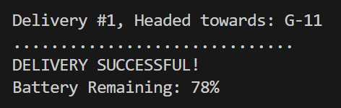

Passed✅

**Test Condition-3: Successful Delivery with Obstacle**

|  |  |
| --- | --- |
| **Description** | Ensure that the program handles an obstacle correctly and still completes the delivery. |
| **Input** | Observe a delivery where an obstacle appears during the route. |
| **Expected Output** | The drone reroutes, completes the delivery successfully, and uses extra battery power. |
| **Pass Criteria** | Delivery remains successful and the drone’s battery decreases appropriately. |

**Results:**

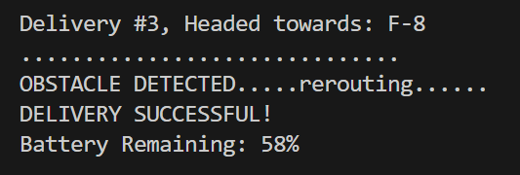

Passed✅

**Test Condition-4: Flight Delay Due to Weather**

|  |  |
| --- | --- |
| **Description** | Check how the program responds when weather conditions prevent a delivery. |
| **Input** | Observe a delivery attempt under unfavorable weather conditions. |
| **Expected Output** | The delivery is delayed, and no battery is used during this attempt. |
| **Pass Criteria** | Program clearly indicates the delay and continues to the next delivery. |

**Results:**

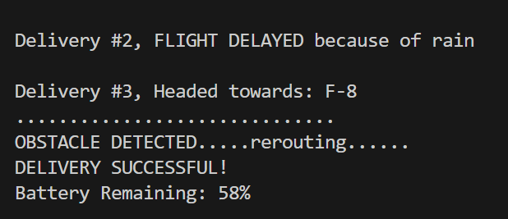

Passed✅

**Test Condition-5: Recharge When Battery < 40 %**

|  |  |
| --- | --- |
| **Description** | Confirm that the drone returns to base and recharges when operating with low battery in windy conditions. |
| **Input** | Run the program until the battery becomes low during windy weather. |
| **Expected Output** | The drone recharges slightly before retrying the delivery. |
| **Pass Criteria** | Program correctly pauses the delivery, increases the battery level, and repeats the attempt. |

**Results:**

Failed ❌

The recharge sequence only triggers when the battery of the drone is less than 40%, since the drone’s battery starts at 100 percent and the drone loses 10-25% of battery with each delivery (30 percent max with obstacle penalty), even in the worst case scenario (100-30-30 =40) the first two deliveries do not drain enough of the drones battery to trigger a recharge before the third and final delivery.

Suggested Fixes: Set recharge to trigger at less than 50% battery or tweak the battery consumption values

**Test Case-6: Delivery Failure Due to Malfunction**

|  |  |
| --- | --- |
| **Description** | Verify that the simulator displays an error and marks the delivery as failed when a malfunction occurs. |
| **Input** | Observe a delivery where a technical malfunction happens. |
| **Expected Output** | The program shows an error message and records the delivery as failed. |
| **Pass Criteria** | Delivery is marked failed without affecting the rest of the simulation. |

**Results:**

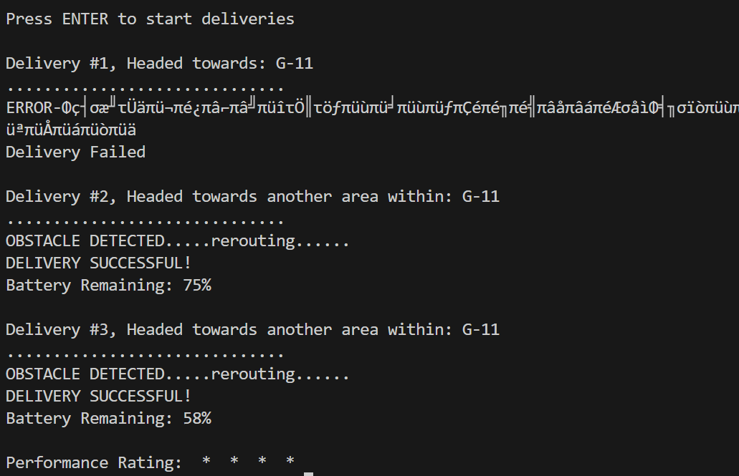

Passed✅

**Additional Notes:**

* The final summary should include; Total deliveries, Successful and Failed deliveries.
* The scoring system is currently too lenient.