**Supplementary Material**

**Maritime piracy in the Strait of Hormuz and implications for energy export security**

Jun U. Shepard[1],[2] and Lincoln Pratson

*Nicholas School of the Environment, Duke University, Durham, NC 27708 USA*

Contents

S1 Top 10 exporters and importers of main hydrocarbon products (2016) 1

S2 Traffic by GCC 2

S3 Standard errors in the second stage regression 3

S4 Vessel-linking algorithm 4

S5 Assignments of vessel types to GCC 7

S6 Randomization tests on piracy hijackings 8

S7 First stage regression results (average effect) 9

S8 First stage regression results (variable effects) 10

S10 Second stage regression: by GCC, across product 11

S11 Second stage regression: by GCC, by product 12

S12 Energy exports through the Strait of Hormuz (original coefficients) 13

S13 Test for “trade-switching” between marine- and land-based trade 14

S14 Pipeline switching regression results 15

References 16

# S1 Top 10 exporters and importers of main hydrocarbon products (2016)

|  |  |  |  |  |  |  |
| --- | --- | --- | --- | --- | --- | --- |
| **Rank** | **Crude Oil** | | **Petroleum Products** | | **LNG** | |
| **Exports** | **Imports** | **Exports** | **Imports** | **Exports** | **Imports** |
| 1 | Saudi Arabia | China | Russia | Singapore | Myanmar | China |
| (353,187,387.25) | (366,209,451.94) | (120,497,790.86) | (101,904,743.85) | (336,223,978.55) | (325,135,744.94) |
| 2 | Russia | U.S.A. | U.S.A. | U.S.A. | Qatar | Japan |
| (262,713,547.45) | (347,329,008.57) | (99,107,208.79) | (93,165,514.55) | (85,512,755.57) | (84,170,606.70) |
| 3 | Iraq | India | Netherlands | Netherlands | Australia | Thailand |
| (167,488,137.91) | (208,772,053.37) | (76,230,900.19) | (71,658,000.67) | (42,203,642.56) | (42,615,509.87) |
| 4 | Canada | Japan | Singapore | Belgium | Malaysia | South Korea |
| (127,307,479.95) | (165,899,268.79) | (75,871,958.51) | (39,588,501.57) | (24,844,374.30) | (35,060,054.97) |
| 5 | UAE | South Korea | UAE | U.K. | Indonesia | India |
| (125,792,774.35) | (147,562,016.04) | (68,035,893.62) | (36,346,542.95) | (16,291,392.66) | (19,709,865.40) |
| 6 | Kuwait | Netherlands | South Korea | Germany | Nigeria | Taiwan |
| (101,157,358.66) | (104,187,581.93) | (56,816,749.49) | (36,010,857.56) | (14,049,513.74) | (14,875,935.65) |
| 7 | Iran | Italy | India | China | Russia | Spain |
| (94,841,283.10) | (71,914,409.76) | (52,513,400.70) | (35,980,909.21) | (10,823,144.01) | (10,848,579.15) |
| 8 | Venezuela | Germany | Belgium | France | Algeria | U.K. |
| (86,252,497.73) | (70,004,374.75) | (37,865,915.37) | (32,816,928.10) | (10,800,810.09) | (7,671,355.62) |
| 9 | Nigeria | Spain | Malaysia | Malaysia | Pap. New Guinea | Egypt |
| (84,595,201.49) | (61,250,761.98) | (37,692,548.17) | (32,150,646.46) | (7,745,681.83) | (5,923,927.79) |
| 10 | Angola | France | Saudi Arabia | South Korea | Trin. & Tobago | Seychelles |
| (80,015,713.12) | (49,044,689.47) | (32,550,334.79) | (31,234,259.17) | (7,582,580.15) | (5,558,008.74) |

**Table S1.** Top 10 exporters and imports of crude oil, petroleum products, and liquefied natural gas in 2016 (tons). Data are derived from the BACI database of bilateral trade (Gaulier and Zignago, 2010), subsetted to only represent 2016 data. The label for “Other Asia, NES” is assumed to represent only Taiwan based on information from the UN Trade Statistics division (UN Trade Statistics, 2010).

# S2 Traffic by GCC

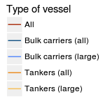

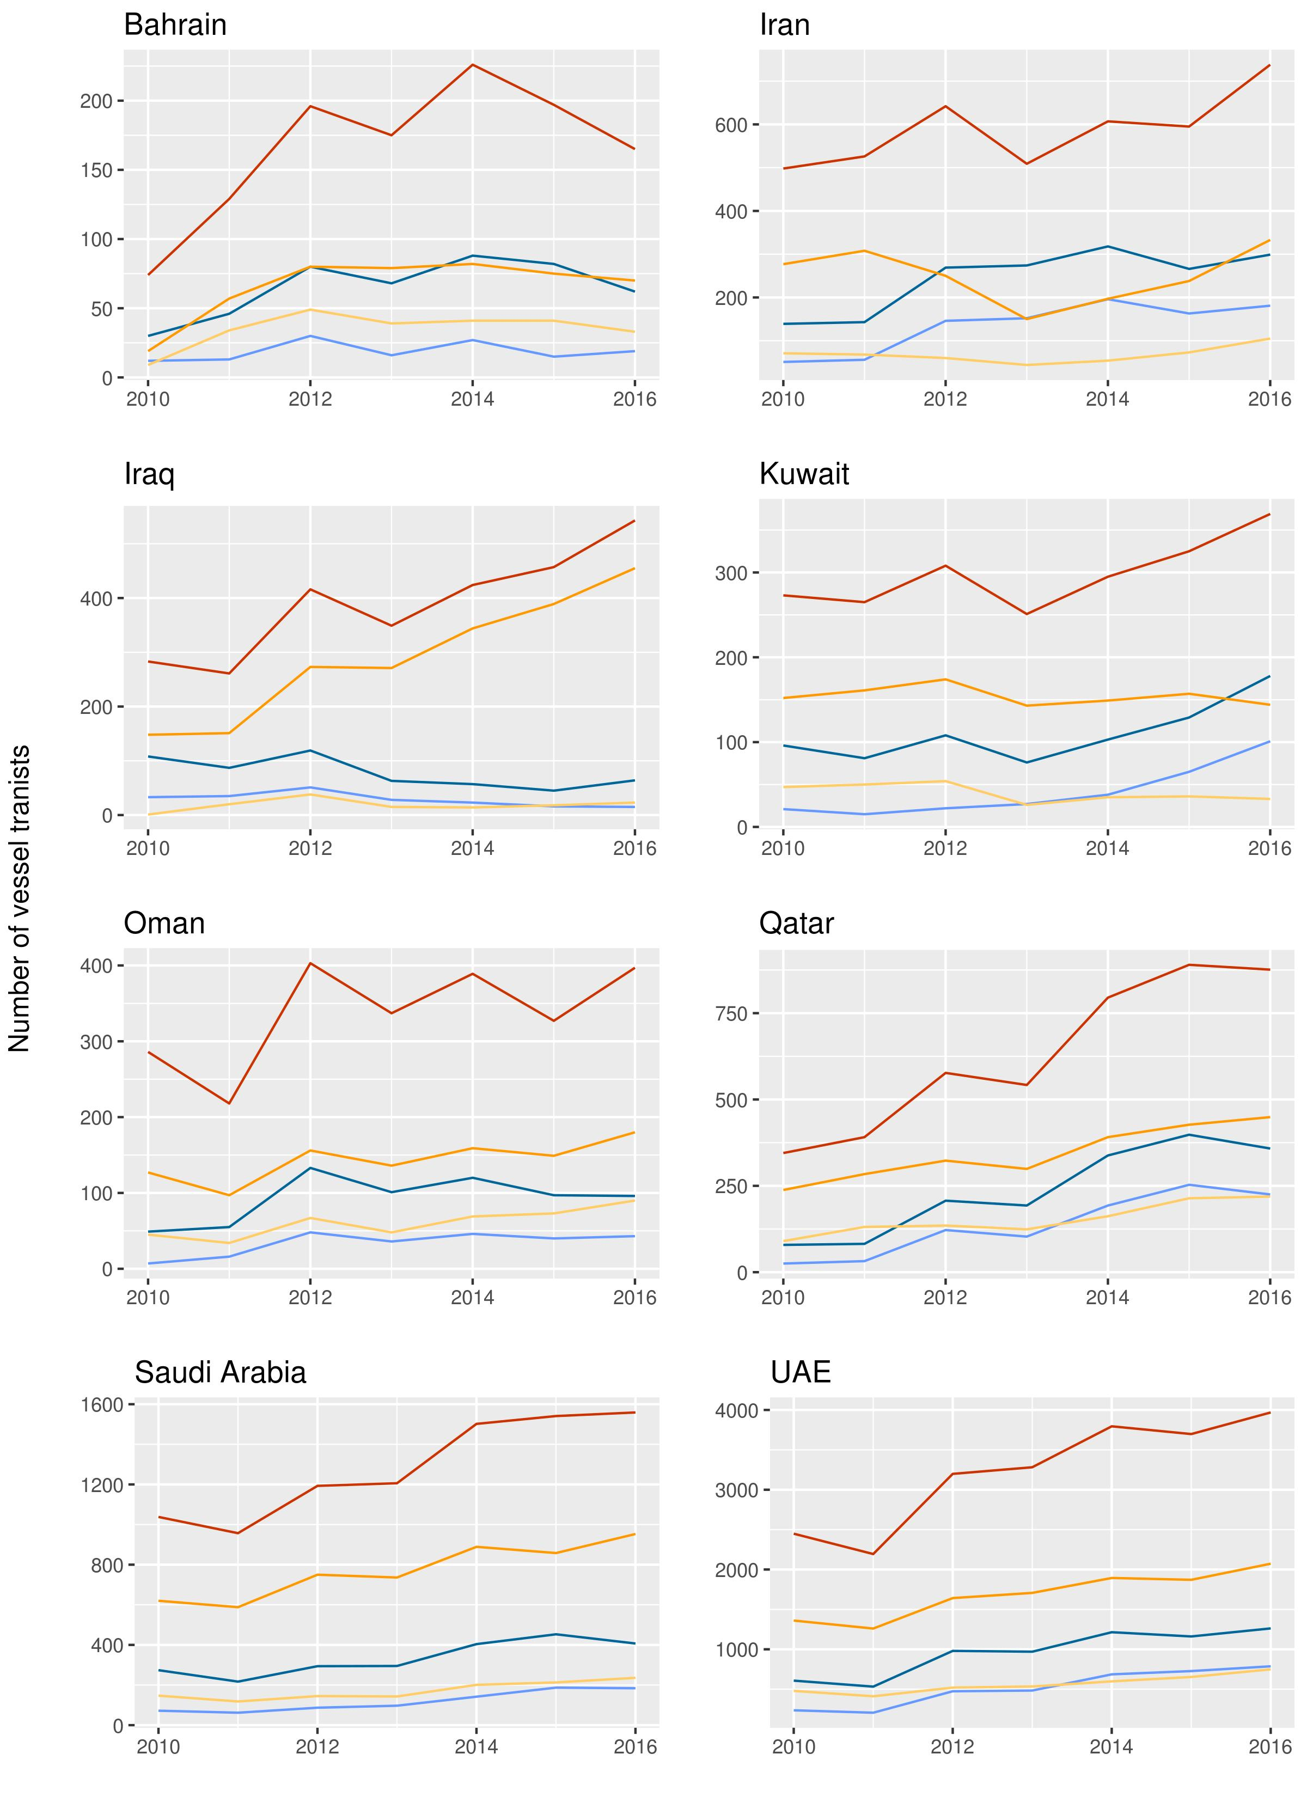

**Figure S2.** Traffic through the SOH, by GCC.

# S3 Standard errors in the second stage regression

The two-stage least squares (2SLS) regression used in this analysis is based on the following formulae:

Equation 1

$$T_{it}=α+{β_{1}Z}_{i,t-1}+β_{2}Z_{i,t-2}+β_{3,i}Γ_{i}+β_{4,i}\left(Z_{i,t-1}\right)\left(Γ_{i}\right)+β_{5,i}\left(Z_{i,t-2}\right)\left(Γ_{i}\right)+β_{6,t}Λ_{t}+ϵ_{it}$$

Equation 2

$$Y_{ijkt}=λ_{1}{\hat{T}}_{it}+λ_{4,j}Φ_{j}+λ_{5,t}Λ_{t}+μ_{ijkt}$$

The standard errors in the first stage regression (Equation 1) are clustered by year, given that traffic residuals may be correlated within each year ($t$). We do not cluster standard errors by country because while residuals may be correlated within country $i$, we cover all countries in the scope of this analysis (rather than taking a random sample of countries to represent all countries). This is based on recent literature advising on the use of clustered standard errors (McKenzie, 2017; Abadie et al., 2017).

In 2SLS regressions, the standard errors in the second stage regression must be adjusted given that the regressor is a predicted value ( ${\hat{T}}_{it}$ instead of $T_{it}$). The dataset used in the first stage is identified by country-year, which gives us predicted values for traffic ($T_{it}$) also at the country-year level. However, our dataset (and therefore our dependent variable) in the second stage is identified by country-product-importer-year ($Y_{ijkt}$). We have inflated our dataset, making it difficult to adjust standard errors analytically. We therefore bootstrap standard errors in the second stage regression using 1000 repetitions and use the mean as our standard errors on coefficients, which are also drawn from the bootstrap.

# S4 Vessel-linking algorithm

All vessels in our traffic and piracy databases have associated flags that they use when registering with the IMO. These flags are based on the home country of the company that owns the vessel and are not representative of the countries that actually use the vessels for trade. Most vessels transiting the Strait of Hormuz (SOH) fly the Panamanian flag, but it is unlikely that Panama is the country most dependent on these straits.

We develop a program that uses each vessel’s route history to link the vessel to countries that use it most. For each vessel, the program parses through Seasearcher to obtain port entries occurring six months before and after each chokepoint transit. It then aggregates the number of entries by country. Linking is based on the share of entries that each country comprises. The country with the largest share of entries is automatically linked to the vessel.[3] Each additional country is linked if it provides at least a 10% increase in the cumulative sum of the share of port entries.[4]

Figure S4 illustrates the distribution of the number of countries linked to each vessel. We can observe in this figure, as well as in Figure 3 of the main text, that the vessel-linking algorithm is necessary for any analysis involving vessel behavior as it relates to global trade.

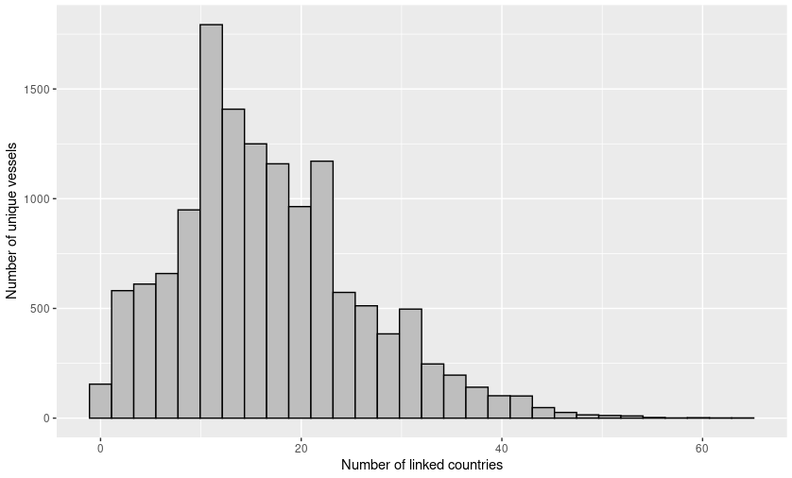

**Fig. S4.** Histogram of number of unique countries linked to each vessel.The data used in this histogram is a combination of analysis datasets for the SOH. Vessels that transit both straits will therefore be double-counted in this histogram. The dataset is identified by vessel (unless it transits both chokepoints). This means that all countries that are ever linked to a vessel over the analysis period are presented, regardless of whether the vessel stops being used by a country after a certain point.

# S5 Assignments of vessel types to GCC

**Table S5.** Vessel types linked to each GCC across all years of analysis in the SOH. The data represent years 2010-2016. The data are uniquely identified by vessel and GCC. Note that the same vessel can be (and is most likely) associated with multiple GCC. For each country, a vessel can only be represented once.

|  |  |  |  |  |  |  |  |  |
| --- | --- | --- | --- | --- | --- | --- | --- | --- |
| **Types of tankers** | **Bahrain** | **Iran** | **Iraq** | **Kuwait** | **Oman** | **Qatar** | **Saudi Arabia** | **UAE** |
| Bunkering tanker | 1 | 4 | 1 | 4 | 2 | 3 | 1 | 38 |
| Chemical tanker | 6 | 44 | 5 | 13 | 17 | 10 | 120 | 217 |
| Combined chemical and oil tanker | 33 | 113 | 48 |  | 90 | 44 | 190 | 629 |
| Combined LNG and LPG carrier |  | 1 | 1 |  |  | 1 | 6 | 7 |
| Combined ore and oil carrier |  |  | 2 |  |  | 1 | 2 | 6 |
| Crude oil tanker | 5 | 160 | 379 | 56 | 30 | 100 | 565 | 1200 |
| Edible oil tanker |  | 1 |  |  |  |  |  | 1 |
| Floating production tanker |  | 1 | 3 | 1 |  | 2 | 6 | 10 |
| Floating storage tanker |  | 2 | 3 | 1 |  |  | 3 | 7 |
| Liquefied natural gas carrier |  |  |  | 7 | 10 | 153 | 1 | 129 |
| Liquefied petroleum gas carrier | 4 | 35 | 5 | 7 | 13 | 69 | 64 | 283 |
| LNG floating storage regasification unit |  |  |  |  |  | 4 |  | 6 |
| Naval auxiliary tanker | 4 |  |  |  | 1 |  |  | 6 |
| Product tanker | 49 | 88 | 36 | 37 | 74 | 65 | 216 | 719 |
| Tanker (unspecified) | 1 | 3 | 5 | 1 | 3 | 1 |  | 15 |
| **Types of bulk carriers** | **Bahrain** | **Iran** | **Iraq** | **Kuwait** | **Oman** | **Qatar** | **Saudi Arabia** | **UAE** |
| Bulk aggregates carrier |  |  |  |  |  | 1 | 1 | 1 |
| Bulk carrier | 60 | 311 | 81 | 115 | 73 | 467 | 303 | 1643 |
| Bulk carrier with container capacity | 1 | 13 | 3 | 1 | 2 | 1 | 2 | 15 |
| Bulk cement carrier | 1 | 2 |  | 1 | 6 | 1 |  | 11 |
| Bulk ore carrier | 1 | 3 | 3 | 1 |  | 1 | 4 | 9 |
| Combined bulk and oil carrier | 1 |  |  | 1 | 1 | 1 | 3 | 6 |
| General cargo | 8 | 47 | 28 | 16 | 9 | 21 | 30 | 137 |
| General cargo with container capacity | 5 | 72 | 53 | 12 | 18 | 43 | 107 | 339 |
| Vehicle carrier | 15 |  | 8 | 22 | 10 | 12 | 93 | 158 |

# S6 Randomization tests on piracy hijackings

A critical criterion for an instrument in a 2SLS analysis is its random assignment; the residual in the first stage ($ϵ_{it}$) cannot be correlated with the predictors of interest ( $Z_{i,t-1}$ and $Z_{i,t-2}$). Therefore, for our 2SLS analysis to be valid, piracy hijackings must occur by effectively random assignment.

The matching algorithm introduced earlier allows us to more accurately link vessels to countries. Using this matching, we build a dataset (for each chokepoint) that is identified by vessel and date of transit. Onto this, we attach an indicator for whether that vessel encountered a piracy incident.[5] We then run the following Logit regression to validate the randomization of piracy hijackings:

Equation 3

$$P_{ivt}={θ_{1,i}λ}_{i}+{θ_{2,t}γ}_{t}+η_{vt}$$

Where $P_{ivt}$ is an indicator equal to one if vessel $v$ encounters a piracy incident, $λ_{i}$ are fixed effects by country, $γ_{t}$ are fixed effects by year, and $η_{ivt}$ is the regression residual. Results indicate that none of the coefficients on country fixed effects are statistically significant. This suggests that piracy incidents are indeed random by country.

# S7 First stage regression results (average effect)

Table S7 presents the results of the simplified first stage regression, which does not include interactions by country (see Equation 3 in the main text).

|  |  |  |  |  |  |  |  |  |  |
| --- | --- | --- | --- | --- | --- | --- | --- | --- | --- |
|  | **All** | **Tankers** | | | | **Bulk Carriers** | | | |
|  | **All** | **Small** | **Medium** | **Large** | **All** | **Small** | **Medium** | **Large** |
| **(Intercept)** | -0.93 | 0.66 | -1.49 | 0 | -0.01 | 0.25 | -1.06 | 0.41 | -0.43 |
|  | (16.86) | (9.38) | (8.54) | (0.01) | (0.06) | (6.29) | (3.86) | (4.72) | (6.43) |
| **Lag1.Zit** | -17.67*** | -9.06*** | -6.45*** | 0* | -0.01*** | -5.06*** | 0.13 | -4.01*** | -6.57*** |
|  | (0.92) | (0.51) | (0.47) | 0.00 | 0.00 | (0.34) | (0.21) | (0.26) | (0.35) |
| **Lag2.Zit** | -14.71*** | -7.45*** | -5.86*** | 0.01*** | 0.01*** | -3.19*** | -0.73** | -4.27*** | -5.14*** |
|  | (0.98) | (0.55) | (0.50) | 0.00 | 0.00 | (0.37) | (0.23) | (0.28) | (0.38) |
| **Year 2013** | -9.84* | -4.4 | -4.55* | 0 | 0 | -3.33 | -2.37* | -1.07 | -2.19 |
|  | (4.55) | (2.53) | (2.31) | 0.00 | (0.01) | (1.70) | (1.04) | (1.27) | (1.74) |
| **Year 2014** | 6.19 | -0.22 | 4.9* | 0 | 0 | 1.91 | 3.18** | -2.14 | 1.72 |
|  | (4.45) | (2.48) | (2.26) | 0.00 | (0.01) | (1.66) | (1.02) | (1.25) | (1.70) |
| **Year 2015** | -2.38 | -3.62 | 1.03 | 0 | 0.02 | -2.69 | 1.32 | -0.93 | -0.31 |
|  | (4.49) | (2.50) | (2.27) | 0.00 | (0.01) | (1.68) | (1.03) | (1.26) | (1.71) |
| **Year 2016** | 14.68** | 6.93** | 7.07** | 0.01 | 0.01 | 3.83* | 3.16** | 3.09* | 3.91* |
|  | (4.54) | (2.52) | (2.30) | 0.00 | (0.01) | (1.69) | (1.04) | (1.27) | (1.73) |
|  |  |  |  |  |  |  |  |  |  |
| **Observations** | 750 | 750 | 750 | 750 | 750 | 750 | 750 | 750 | 750 |
| **R-squared** | 0.99 | 0.99 | 0.99 | 0.37 | 0.53 | 0.99 | 0.99 | 0.98 | 0.98 |
| **Adj. R-squared** | 0.99 | 0.99 | 0.99 | 0.2 | 0.41 | 0.99 | 0.99 | 0.98 | 0.98 |
| **F-statistic** | 727 | 579.23 | 392.81 | 2.23 | 4.37 | 622.44 | 418.4 | 227.03 | 210.46 |
| *** *p* < 0.001, ** *p* < 0.01, * *p* < 0.05 | | |  |  |  |  |  |  |  |

**Table S7.** The average effect piracy on vessel traffic in the **Strait of Hormuz**, across countries. This regression does not include interaction terms for country fixed effects and lag-1/lag-2 piracy variables. The coefficients on Lag1.Zit and Lag2.Zit ( and $π_{2}$, respectively) therefore represent the average effect of piracy hijackings, controlling for country-level characteristics and idiosyncrasies. Country-level fixed effects are also included, but are not presented in this table for simplicity. Each column represents differing dependent variable (e.g. large tanker traffic). Standard errors are clustered by year.

# S8 First stage regression results (variable effects)

Table S8 presents the results of the actual first stage regression, including interactions for lag-1 piracy x country fixed effects and lag-2 piracy x country fixed effects. These two terms allow for the effects of piracy hijackings on the predicted value of traffic to vary by country, whereas the average effect regression (presented in S8) only allow predicted values to differ by country fixed effect. These tables represent the results of Equation 2 in the main text.

|  |  |  |  |  |  |  |  |  |  |
| --- | --- | --- | --- | --- | --- | --- | --- | --- | --- |
|  | **All** | **Tankers** | | | | **Bulk Carriers** | | | |
|  | **All** | **Small** | **Medium** | **Large** | **All** | **Small** | **Medium** | **Large** |
| **(Intercept)** | -4.78 | -1.22 | 0 | -0.75 | -0.47 | -2.58 | -0.01 | -0.77 | -1.8 |
|  | (11.91) | (7.55) | (0.01) | (5.20) | (3.93) | (5.95) | (0.05) | (2.97) | (4.33) |
| **Lag1.Zit** | -4.27 | -1.86 | 0 | -2.28 | 0.41 | -3.83 | 0 | -4.59 | 0.76 |
|  | (17.28) | (10.96) | (0.02) | (7.54) | (5.70) | (8.63) | (0.07) | (4.31) | (6.28) |
| **Lag2.Zit** | -8.95 | -7.92 | 0 | -4.14 | -3.78 | -2.28 | 0.01 | -0.39 | -1.9 |
|  | (18.47) | (11.71) | (0.02) | (8.06) | (6.10) | (9.22) | (0.08) | (4.61) | (6.71) |
| **Year 2013** | -2.87 | -2.1 | 0 | -2.25 | 0.15 | -0.77 | 0.01 | -0.98 | 0.2 |
|  | (4.10) | (2.60) | 0.00 | (1.79) | (1.36) | (2.05) | (0.02) | (1.02) | (1.49) |
| **Year 2014** | 9.15* | 1.05 | 0 | 2.53 | -1.47 | 5.17* | -0.01 | 2.68** | 2.5 |
|  | (4.01) | (2.54) | 0.00 | (1.75) | (1.32) | (2.00) | (0.02) | (1.00) | (1.46) |
| **Year 2015** | 0.41 | -1.41 | 0 | -1.11 | -0.3 | 0.69 | 0.03 | 0.22 | 0.44 |
|  | (4.02) | (2.55) | 0.00 | (1.75) | (1.33) | (2.01) | (0.02) | (1.00) | (1.46) |
| **Year 2016** | 21.22*** | 10.57*** | 0 | 5.57** | 5*** | 8.82*** | 0.02 | 1.93 | 6.86*** |
|  | (4.06) | (2.58) | 0.00 | (1.77) | (1.34) | (2.03) | (0.02) | (1.01) | (1.48) |
| **Observations** | 658 | 658 | 658 | 658 | 658 | 658 | 658 | 658 | 658 |
| **R-squared** | 1 | 1 | 0.79 | 1 | 0.99 | 1 | 0.76 | 1 | 0.99 |
| **Adj. R-squared** | 1 | 0.99 | 0.62 | 1 | 0.99 | 0.99 | 0.56 | 0.99 | 0.99 |
| **F-statistic** | 716.06 | 437.89 | 4.72 | 446.54 | 161.5 | 394.25 | 3.88 | 337.02 | 230.4 |
| *** *p* < 0.001, ** *p* < 0.01, * *p* < 0.05 | | |  |  |  |  |  |  |  |

**Table S8.** The variable effect piracy on vessel traffic in the **Strait of Hormuz**. This regression includes interaction terms for country fixed effects and piracy hijackings (both lag-1 and lag-2). It is therefore impossible to interpret the coefficient values on Lag1.Zit and Lag2.Zit without also adding the coefficient for three additional variables (the interaction term for country x Lag1.Zit, the interaction term for country x Lag2.Zit, and country fixed effect). However, by allowing the effects of the piracy hijackings to vary by country, we are allowing for and addressing heterogeneity in effects by country to be used in the second stage regression. Standard errors are clustered by year.

# S9 Second stage regression: by GCC, across product

|  |  |  |  |  |  |  |  |  |
| --- | --- | --- | --- | --- | --- | --- | --- | --- |
|  | **Bahrain** | **Iran** | **Iraq** | **Kuwait** | **Oman** | **Qatar** | **Saudi Arabia** | **UAE** |
| Effect of a vessel *decrease* | -1242.40 | 14331.73 | 1918.12 | -2041.55 | -3876.91 | -4470.60 | -4733289.93 | -3843.92 |
| Std. Error | 1991.56 | 27473.64 | 38192.12 | 18529.24 | 20126.22 | 15394.31 | 116609163.16 | 25216.01 |
| P-Value | 0.48 | 0.51 | 0.53 | 0.56 | 0.54 | 0.52 | 0.51 | 0.53 |
| Observations | 310.00 | 283.00 | 339.00 | 431.00 | 364.00 | 683.00 | 739.00 | 1029.00 |
| R2 | 0.65 | 0.55 | 0.53 | 0.53 | 0.37 | 0.52 | 0.26 | 0.41 |
| Adjusted R2 | 0.48 | 0.38 | 0.43 | 0.38 | 0.12 | 0.43 | 0.11 | 0.29 |

**Table S9.** The effect of a one vessel reduction on energy exports/grain imports moving through each Strait, by GCC and across product. The underlying model equation is presented in Equation 3 in the main text. This specification includes fixed effects by trading partner and product (e.g. crude oil, within energy exports) but not GCC, as it runs iteratively *by* GCC. Note that the “Effect of one-vessel reduction” is actually -1 multiplied by the coefficient ($λ_{1}$). Standard errors and coefficients are bootstrapped with 1000 iterations.

# S10 Second stage regression: by GCC, by product

|  |  |  |  |  |  |
| --- | --- | --- | --- | --- | --- |
| **Energy exporter** | **Fuel type** | $${-λ}_{1}$$ | **Std. Error** | **N** | **Adj. R2** |
| Bahrain | Petroleum Products | -13994.70 | 7271.26 | 364 | 0.65 |
| Iran | Petroleum Products | -2157.72 | 2105.25 | 276 | 0.28 |
| Iraq | Petroleum Products | -377.68 | 709.43 | 230 | 0.36 |
| Iraq | Crude | 8881.08 | 41099.05 | 180 | 0.90 |
| Kuwait | Propane | -7158.29 | 22882.20 | 52 | 0.86 |
| Kuwait | Petroleum Products | -15540.07 | 8416.51 | 364 | 0.84 |
| Kuwait | Butane | -2006.16 | 6306.49 | 56 | 0.89 |
| Kuwait | Crude | 18017.14 | 87788.66 | 92 | 0.92 |
| Oman | Petroleum Products | -304.11 | 3359.17 | 376 | 0.74 |
| Oman | Crude | 126314.68 | 211894.78 | 88 | 0.92 |
| Qatar | Propane | 830.26 | 3034.69 | 100 | 0.73 |
| Qatar | Petroleum Products | 608.66 | 463.30 | 445 | 0.83 |
| Qatar | Butane | 251.06 | 1529.82 | 100 | 0.79 |
| Qatar | Crude | -609.54 | 16979.77 | 140 | 0.76 |
| Qatar | LNG | 7384.29 | 8627.00 | 185 | 0.83 |
| Saudi Arabia | Propane | 810.73 | 1951.84 | 120 | 0.69 |
| Saudi Arabia | Petroleum Products | 950.42 | 1075.02 | 560 | 0.51 |
| Saudi Arabia | Butane | 1175.62 | 1009.75 | 195 | 0.91 |
| Saudi Arabia | Crude | 3225.81 | 25049.00 | 195 | 0.88 |
| UAE | Propane | 986.46 | 1149.05 | 185 | 0.67 |
| UAE | Petroleum Products | 400.02 | 211.26 | 780 | 0.90 |
| UAE | Butane | 180.87 | 364.74 | 240 | 0.78 |
| UAE | Crude | 5668.88 | 8474.41 | 245 | 0.85 |

**Table S10.** The effect of a one vessel reduction on energy exports/grain imports moving through each Strait, by GCC and product. The underlying model equation is presented in Equation 3 in the main text. Note that the “Effect of one-vessel reduction” is actually -1 multiplied by the coefficient ($λ_{1}$). Standard errors and coefficients are bootstrapped with 1000 iterations.

# S11 Energy exports through the Strait of Hormuz (original coefficients)

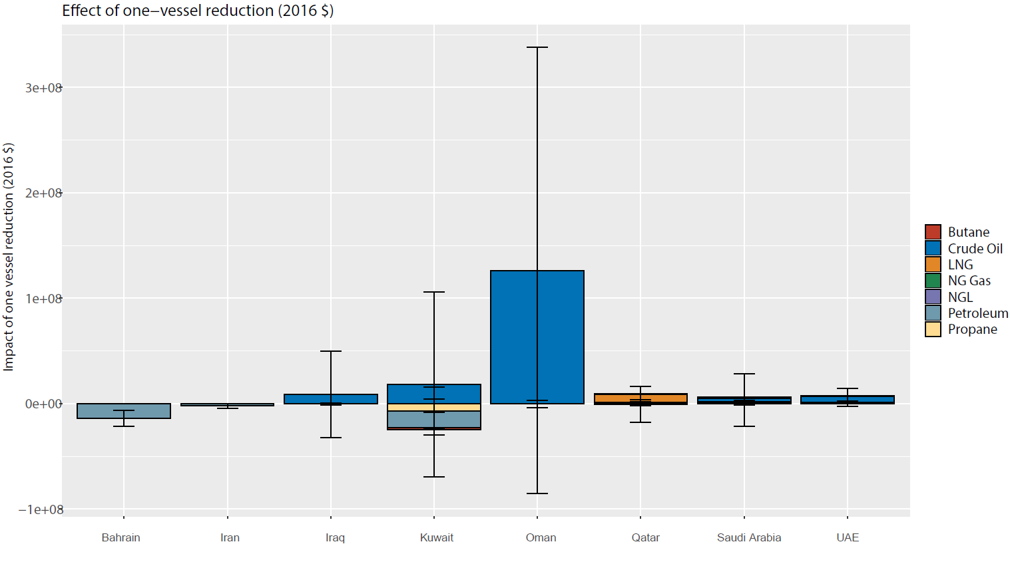Figure S12 illustrates the coefficient on the second stage regression, run on energy exports value (in current USD). This is effectively the result presented in Figure 4 in the main text, before the values are transformed to $ 2016-GDP.

**Fig. S11.** Impact of a one-vessel reduction on the value of energy exports (in current USD) moving through the SOH. Second stage regressions are run iteratively by GCC and product. Each of these products is represented by a different color in the stacked bar. Only results that are significant at the 10% level are shown in this illustration.

# S12 Test for “trade-switching” between marine- and land-based trade

|  |  |  |
| --- | --- | --- |
| **Country…** | **Shares pipeline with…** | **To transport…** |
| Iraq | Israel | Oil |
|  | Kuwait | Oil |
|  | Saudi Arabia | Oil |
|  | Syria | Oil |
|  | Turkey | Oil |
| Israel | Egypt | Gas |
|  | Iraq | Oil |
|  | Jordan | Oil, Gas |
|  | Lebanon | Oil, Gas |
|  | Saudi Arabia | Oil |
| Jordan | Egypt | Gas |
|  | Israel | Oil, Gas |
|  | Lebanon | Oil, Gas |
|  | Saudi Arabia | Oil |
|  | Syria | Gas |
| Kuwait | Iraq | Oil |
|  | Saudi Arabia | Oil |
| Oman | United Arab Emirates | Oil |
|  | Qatar | Oil |
| Qatar | Oman | Oil |
|  | Saudi Arabia | Oil |
| Saudi Arabia | Bahrain | Oil |
|  | Iraq | Oil |
|  | Israel | Oil |
|  | Jordan | Oil |
|  | Kuwait | Oil |
|  | Lebanon | Oil |
|  | Qatar | Oil |
|  | United Arab Emirates | Oil |
| United Arab Emirates | Oman | Gas |
|  | Saudi Arabia | Oil |

**Table S12.** Pipeline relations, based on maps compiled by Guan et al. (2014) and Kandiyoti (2008).

# S13 Pipeline switching regression results

|  |  |  |
| --- | --- | --- |
|  | **Exports** | **Imports** |
| Amount to/from chokepoint-requiring partners | 0.01*** | 0.04 |
|  | 0 | -0.03 |
| Oils obtained from bituminous materials, not crude | 586281.61* | -411756.89 |
|  | -237851.7 | -223294.95 |
| Liquefied Natural Gas | 113273.76 | -675971.42** |
|  | -251016.5 | -216890.54 |
| Liquefied Propane | 248439.7 | -628252.56** |
|  | -244592.41 | -205155.44 |
| Liquefied Butane | 272268.58 | -619088.41** |
|  | -244020.18 | -203995.32 |
| Other gases | 249366.7 | -588374.29* |
|  | -268710.66 | -228156.43 |
| Natural Gas | 312475.29 | -580844.3** |
|  | -260975.56 | -221941 |
| ln(Populationit) | 9.63 | 0.37 |
|  | -46.79 | -44.62 |
| ln(GDPpcit) | -0.05 | -0.02 |
|  | -0.08 | -0.08 |
| Observations | 320 | 320 |
| R2 | 0.51 | 0.15 |
| Adj. R2 | 0.47 | 0.09 |
| F-statistic | 14.02 | 2.36 |

*** *p* < 0.001, ** *p* < 0.01, * *p* < 0.05

**Table S13.** Effect of a one-ton increase in chokepoint-dependent partners on trade with pipeline-sharing partners.The regression used to generate this table includes trade partner fixed effects (for pipeline-sharing countries) as well as year fixed effects. Hydrocarbon type variables are indicators equal to one for observations pertaining to the trade of that product.

# References

Abadie, A., Athey, S., Imbens, G.W., & Wooldridge, J. (2017). *When Should You Adjust Standard Errors for Clustering?* (Working paper No. 24003). Cambridge, MA: National Bureau of Economic Research. URL: <https://ideas.repec.org/p/nbr/nberwo/24003.html>

[dataset] Gaulier, G., & Zignago, S. (2010). *BACI: International Trade Database at the Product-Level. The 1994-2007 Version* (Working paper No. 2010-23). Paris: CEPII Research Center. URL: <https://ideas.repec.org/p/cii/cepidt/2010-23.html#author-abstract>

Guan, W. W., Bol, P. K., Lewis, B. G., Bertrand, M., Berman, M. L., & Blossom, J. C. (2012). WorldMap – a geospatial framework for collaborative research. *Annals of GIS,* *18*(2), 121-134. doi:10.1080/19475683.2012.668559

McKenzie, D. (2017). *When should you cluster standard errors? New wisdom from the econometrics oracle*. Washington, DC: World Bank. URL: <https://blogs.worldbank.org/impactevaluations/when-should-you-cluster-standard-errors-new-wisdom-econometrics-oracle>

Kandiyoti, R. (2008). *Pipelines: Flowing oil and crude politics*. London: I.B. Tauris.

1. Corresponding author: Jun U. Shepard ([jun.shepard@duke.edu](mailto:jun.shepard@duke.edu))
2. Declarations of interest: None
3. Where there is a tie for largest share, the program keeps both countries.
4. Each observation of IMO identifier and chokepoint transit date is counted as one record in the program. For instance, if a vessel transits the Strait of Hormuz on January 1, 2012 and again on March 2, 2012, the program may link it to different countries if there is a change in vessel behavior in the two months difference.
5. This dataset is aggregated when compiling the analysis dataset for the first stage.