**Hybrid Input-Output Analysis of Embodied Energy Security**

Jun U. Shepard*a* and Lincoln F. Pratson*a*

*a Duke University (Nicholas School of the Environment), 9 Circuit Drive, Durham, NC 27701 USA. Corresponding email: [jun.shepard@duke.edu](mailto:jun.shepard@duke.edu).*

Contents

1 Non-energy sectors in Eora-26 2

2 IEA-Eora correspondence 3

3 Energy types in IEA-HOMIES 4

4 Regional classification of countries 5

5 Illustrative representation of HOMIES 6

6 Back-calculating primary energy 7

7 Bioenergy correspondence table 8

8 Data validation in HOMIES 9

8.1 Scaling LCOE 9

8.2 Mining shares 10

9 Losses in HOMIES 11

10 Import dependence by region 12

11 Energy security metrics of the energy importer 13

12 Energy security metrics, by exporter 16

References 19

# 1 Non-energy sectors in Eora-26

The following table contains the 26 non-energy sectors represented in the Eora-26 database [1]. We have created an additional correspondence between the Eora sector classification and the Harmonized System (HS) 2 digit codes. We include these in the table as well.

|  |  |  |
| --- | --- | --- |
| **Eora-26** | **Description** | **Corresponding HS2 codes** |
| 1 | Agriculture | 01, 02, 04, 05, 06, 07, 08, 09, 10, 11, 12, 13, 14, 15 |
| 2 | Fishing | 03 |
| 3 | Mining and Quarrying | 25, 26, 27 |
| 4 | Food and Beverages | 16, 17, 18, 19, 20, 21, 22, 23, 24 |
| 5 | Textiles and Wearing Apparel | 41, 42, 43, 50, 51, 52, 53, 54, 55, 56, 57, 58, 59, 60, 61, 62, 63 |
| 6 | Wood and Paper | 44, 45, 46, 47, 48, 49 |
| 7 | Petroleum, Chemical, Non-Metal Mineral Products | 28, 29, 30, 31, 32, 33, 34, 35, 36, 37, 38 |
| 8 | Metal Products | 72, 73, 74, 75, 76, 77, 78, 79, 80, 81, 82, 83 |
| 9 | Electrical and Machinery | 84, 85, 90, 91, 92 |
| 10 | Transport Equipment | 86, 87, 88, 89 |
| 11 | Other Manufacturing | 39, 40, 64, 65, 66, 67, 68, 69, 70, 71, 93, 94, 95, 96, 97, 98 |
| 12 | Recycling |  |
| 13 | Electricity, Gas and Water |  |
| 14 | Construction |  |
| 15 | Maintenance and Repair |  |
| 16 | Wholesale Trade |  |
| 17 | Retail Trade |  |
| 18 | Hotels and Restaurants |  |
| 19 | Transport |  |
| 20 | Post and Telecommunications |  |
| 21 | Financial Intermediaries and Business |  |
| 22 | Public Administration |  |
| 23 | Education, Health, Other Services |  |
| 24 | Private Households |  |
| 25 | Others |  |
| 26 | Re-export and Re-import |  |

# 2 IEA-Eora correspondence

The following table presents the correspondence between sectors in the International Energy Agency (IEA) World Energy Balances (WEB) and Eora-26.

|  |  |
| --- | --- |
| **Eora Sector** | **IEA Sector(s)** |
| 1 | Agriculture/Forestry |
| 2 | Fishing |
| 3 | Mining and quarrying |
| 4 | Food and tobacco |
| 5 | Textile and leather |
| 6 | Wood and wood products; Paper, pulp and print; Memo: Non-energy use in wood and wood products; Memo: Non-energy use in paper/pulp printing |
| 7 | Chemical and petrochemical; Non-metallic products |
| 8 | Iron and steel; Non-ferrous metals; Machinery; Memo: Non-energy use in non-ferrous metals; Memo: Non-energy use in iron and steel |
| 9 | Machinery |
| 10 | Transport equipment |
| 11 | Non-specified (industry) |
| 12 | Transfers |
| 13 | Main activity producer electricity plants (transf.); Main activity producers heat plants (transf.) |
| 14 | Construction |
| 15 | Commercial and public services |
| 16 | [Not specified] |
| 17 | [Not specified] |
| 18 | Commercial and public services |
| 19 | Transport |
| 20 | Commercial and public services |
| 21 | Commercial and public services |
| 22 | Commercial and public services |
| 23 | Commercial and public services |
| 24 | [Not specified] |
| 25 | [Not specified] |
| 26 | [Not specified] |

# 3 Energy types in IEA-HOMIES

|  |  |
| --- | --- |
| **HOMIES** | **IEA** |
| Coal | Coal mines (energy) |
| Crude Oil | Oil and gas extraction (energy) (scaled) |
| Bioenergy | Agriculture (scaled) |
| Natural Gas | Oil and gas extraction (energy) (scaled) |
| Uranium | Nuclear industry |
| Hydro (Water) | N/A |
| Fossil-fuel based electricity | Main activity producer electricity plants (transf.) |
| Nuclear-based electricity | Main activity producer electricity plants (transf.) |
| Hydro-based electricity | Main activity producer electricity plants (transf.) |
| Renewables-based electricity | Main activity producer electricity plants (transf.) |
| Renewables (primary) | N/A |
| Petroleum | Oil refineries (energy) |
| Losses | N/A |

# 4 Regional classification of countries

The following table presents the regional classifications used in the hybridized model.

|  |  |
| --- | --- |
| **Region** | **Countries/Territories** |
| Africa | Algeria, Angola, Benin, Botswana, Burkina Faso, Burundi, Cameroon, Cape Verde, Central African Republic, Chad, Comoros, Republic of the Congo, Democratic Republic of the Congo, Cote d’Ivoire, Djibouti, Egypt, Eritrea, Gabon, Gambia, Ghana, Guinea, Guinea-Bissau, Equatorial Guinea, Kenya, Lesotho, Liberia, Libya, Madagascar, Malawi, Mali, Mauritius, Morocco, Mozambique, Namibia, Niger, Nigeria, Reunion, Rwanda, Sao Tome and Principe, Republic of Seychelles, Sierra Leone, Somalia, Swaziland, Senegal, South Africa, South Sudan (Sudan), Tanzania, Togo, Tunisia, Uganda, Zambia, Zimbabwe |
| China | China |
| East Asia | Hong Kong, Japan, Democratic People’s Republic of Korea, South Korea, Macau, Mongolia |
| Europe | Andorra, Albania, Austria, Belarus, Belgium, Bosnia and Herzegovina, Bulgaria, Croatia, Czech Republic, Denmark, Estonia, Finland, France, Germany Gibraltar, Greece, Hungary, Ireland, Italy, Latvia, Lithuania, Luxembourg, Former Yugoslav Republic of Macedonia, Malta, Moldova, Montenegro, Netherlands, Norway, Poland, Portugal, Romania, Russia, Serbia, Slovak Republic, Slovenia, Spain, Sweden, Switzerland, Ukraine, United Kingdom |
| Latin America | Argentina, Bolivia, Brazil, Chile, Colombia, Ecuador, Guyana, Paraguay, Peru, Suriname, Uruguay, Venezuela, Bolivarian Republic of Venezuela |
| North and Central America | Belize, Bermuda, Canada, Costa Rica, El Salvador, Guatemala, Honduras, Mexico ,Nicaragua, Panama, United States |
| Oceania | American Samoa, Australia, Cook Islands, Fiji, French Polynesia, Guam, Republic of Kiribati, Marshall Islands, Federated States of Micronesia, Republic of Nauru, New Caledonia, New Zealand, Niue, Norfolk Island, Northern Mariana Islands, Palau, Papua New Guinea, Samoa, Solomon Islands, Tonga, Tuvalu, Vanuatu |
| Persian Gulf Countries | Bahrain, Iran, Iraq, Kuwait, Oman, Qatar, Saudi Arabia, United Arab Emirates |
| South Asia | Afghanistan, Bangladesh, Bhutan, Brunei Darussalam, Cambodia, India, Indonesia, Laos, Malaysia, Myanmar, Nepal, Pakistan, Philippines, Singapore, Sri Lanka, Thailand, Timor-Leste, Viet Nam |
| West and Central Asia | Armenia, Azerbaijan, Cyprus, Georgia, Israel, Jordan, Kazakhstan, Kyrgyzstan, Lebanon, Syrian Arab Republic, Tajikistan, Turkey, Turkmenistan, Uzbekistan, Yemen |

# 5 Illustrative representation of HOMIES

The following figure presents an illustrative example of what HOMIES looks like for each year of our analysis. In this example, we include three countries to demonstrate how intersectoral flows are mapped. However, note that HOMIES includes the transactions among 136 countries, 26 non-energy sectors, and 13 energy sectors.



**Fig. 1. Illustrative example of HOMIES for three countries.** Red cells represent energy to energy flows (TJ to TJ), green cells represent non-energy to energy flows (USD to TJ), orange cells represent energy to non-energy flows (TJ to USD), and blue cells represent non-energy to non-energy flows (USD to USD).

In this figure, the colored submatrices correspond to the submatrices $E_{θ}$, $E_{τ}$, $Z_{π}$, and $Z_{ϕ}$, as defined in Section 2.3 of the main text. The red submatrix of energy transactions corresponds to $E_{θ}$; the green submatrix corresponds to $Z_{π}$; the orange submatrix corresponds to $E_{τ}$, and the blue submatrix corresponds to $Z_{ϕ}$.

# 6 Back-calculating primary energy

To back-calculate the primary energy input required for secondary energy, we apply standard efficiencies by electricity-generating technology. This is particularly important for electricity generated by renewable resources (e.g. solar, wind) and uranium. In the latter case, we use the value that we back-calculate to constraint uranium trade flows between countries. This teases out the energy component of uranium trading.

The following table lists the notational efficiencies we use in HOMIES. We back-calculate by taking the magnitude of energy flow (TJ) coming out of a secondary energy source and dividing it by the technology’s notational efficiency. For instance, the average notational efficiency of solar power is listed as 0.17. If a country produces 20% of its 100TJ of electricity from solar, then the amount of solar primary energy required would be: 0.20(100TJ)/0.17 = 118TJ. Of course, this energy is not tangible or attributable to any given country. For the purposes of this analysis, we assign solar, geothermal, wind, and hydro as domestic resources.

|  |  |
| --- | --- |
| **Technology** | **Notational efficiency [2,3]** |
| Geothermal | 0.16 |
| Conventional hydroelectric | 0.90 |
| Solar photovoltaic | 0.12 |
| Solar thermal power | 0.21 |
| Wind | 0.26 |
| Nuclear | 0.36 |

Uranium, the fuel used to generate nuclear electricity, can be mined, stored, and traded. We therefore include a further procedure to compile bilateral and domestic uranium flows. We assume in this analysis that all uranium that is imported is used toward electricity generation. We first identify the amount of uranium (primary energy) that is used to generate nuclear electricity (secondary energy). This information is found in the IEA World Energy Balances database (WEB). WEB includes values on nuclear based electricity generation by country and year. We assume the average efficiency of 36% for nuclear power plants. This gives us how many TJ of uranium (primary energy) is input to meet electricity demand. We divide this input value into uranium (primary energy) that is (a) mined domestically, (b) stored domestically, and (c) imported. Domestic mining activity is derived using the World Mining Database, which includes mining activity for each country, by resource and year. We multiply the mass units (tonne) by a global constant specific energy for uranium (500TJ/tonne). Similarly, we derive imported uranium (primary energy) by multiplying mass units in the BACI bilateral trade database by the specific energy. The remainder of the uranium is attributed to domestic uranium storage.

The following table lists the heat values/energy contents for fuels used in HOMIES. These values are taken from the World Nuclear Association, United States Energy Information Administration, and the Food and Agriculture Organization of the United Nations.

|  |  |
| --- | --- |
| **Energy Resource** | **Heating values/energy content (TJ/tonne)** |
| Bioenergy | 0.037 (biodiesel); 0.02 (peat) |
| Coal | 0.015 (lignite); 0.018 (sub-bituminous); 0.025 (coke) |
| Crude oil | 0.045 |
| Natural gas | 0.048 |
| Uranium | 500 |

# 7 Bioenergy correspondence table

In order to derive monetary and energy flows that are used to produce bioenergy (a primary energy type), we must first divide out the energy component of the Agriculture sector in the Eora database. To do this, we rely on a correspondence between the FAO Crop Production Database and the IEA Renewables and Waste Database [4,5]. We outline the procedure for deriving these flows in the main text. Below, we present a table with the heat content and conversion factors for the bioenergy products represented in HOMIES. The conversion efficiencies are largely based on Huang and Zhang (2011) [6]

|  |  |  |  |
| --- | --- | --- | --- |
| **Biofuel** | **Units** | **Energy Content** | **Conversion Efficiency** |
| Biodiesel | kt |  | FT-Diesel: 41.4% [7], 52.0% [8] Ester Micro-Diesel: 7.2% [9], 36.5% [10] |
| Biogases | TJ-net | Manure: 6.2-7GJ/dry tonne Ley crops: 10.6GJ/dry tonne Sugar beet: 10.6GJ/dry tonne Straw: 7.1GJ/dry tonne [11] |  |
| Biogasoline | kt |  | Corn Ethanol: 46.4% [12], 49.4% [13], 50.1% [14] Cellulosic Ethanol: 48.4% [15], 55.6% [16] Methanol: 50.9% [17], 54.9% [18] |
| Charcoal | kt |  | 33-42% [19] |
| Other liquid biofuels | kt |  | Use average of biodiesel and biogasoline |
| Solid biofuel excluding charcoal | TJ-net | 9.14TJ-net/1000m3 [20] 0.50-0.79t/m3 [21] |  |

# 8 Data validation in HOMIES

Throughout our data compilation for HOMIES, we implemented checks on our data to ensure that flows remain realistic and reflect existing reports. We illustrate our data checks using the following figures as snapshots of our process.

## 8.1 Scaling LCOE

A key part of compiling HOMIES was to scale both energy and monetary flows into the generation of electricity. Electricity in HOMIES is differentiated by combustion-based (ELEC_COM), hydro (ELEC_HY), nuclear (ELEC_NU), and renewables based (ELEC_RE). We use LCOE to proxy for the labor and capital costs required to generate each type of electricity. The following figure illustrates the scale we use to differentiate energy and monetary flows into electricity generation. It is based on LCOE patterns in the United States, and is therefore reflects a highly developed energy system. However, our assumption is that even if LCOE is higher/lower in other countries, the LCOE of the different generation types are proportional.

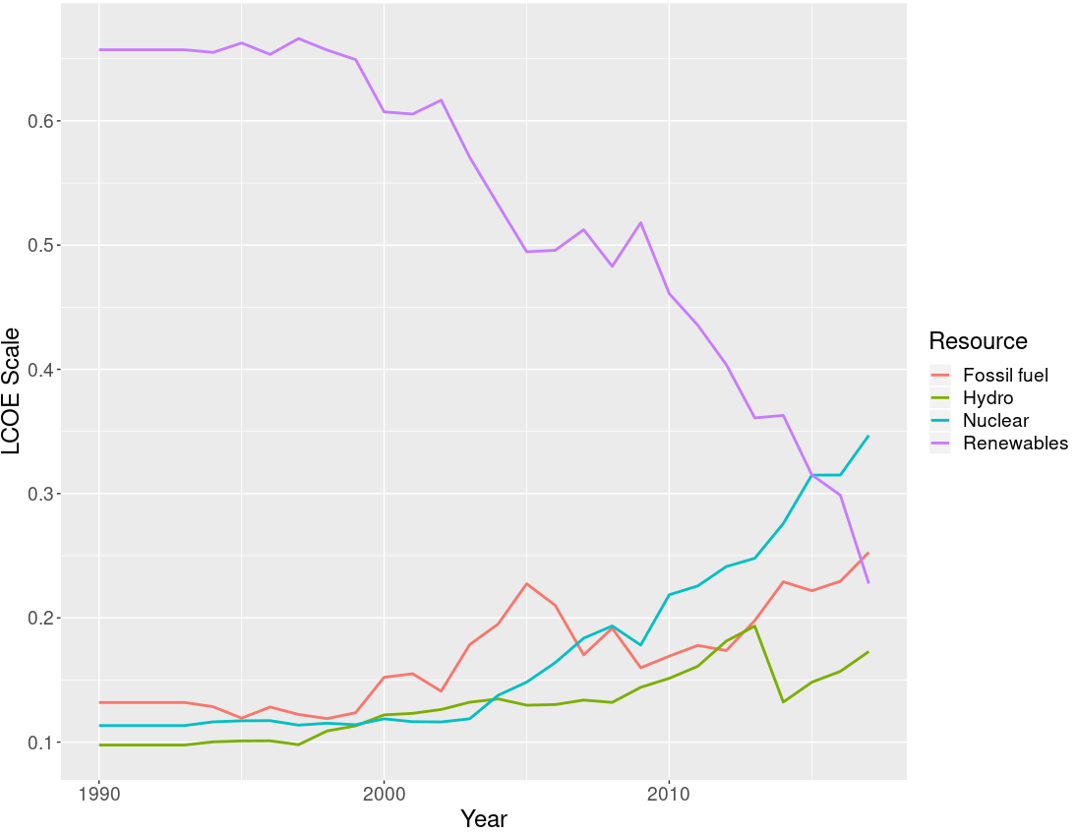

**Fig. 1. LCOE scale by year.** The scale represents the share of a monetary/energy flow that is destined for the given type of electricity.

## 8.2 Mining shares

Data on mining are taken from the World Mining Database and combined with the International Energy Agency’s World Energy Balances. When joining these datasets, we conducted a check on each country’s breakdown of mining activity. The following figure breaks down the mining activity of the ten most mining-intensive countries in the world in 2015.

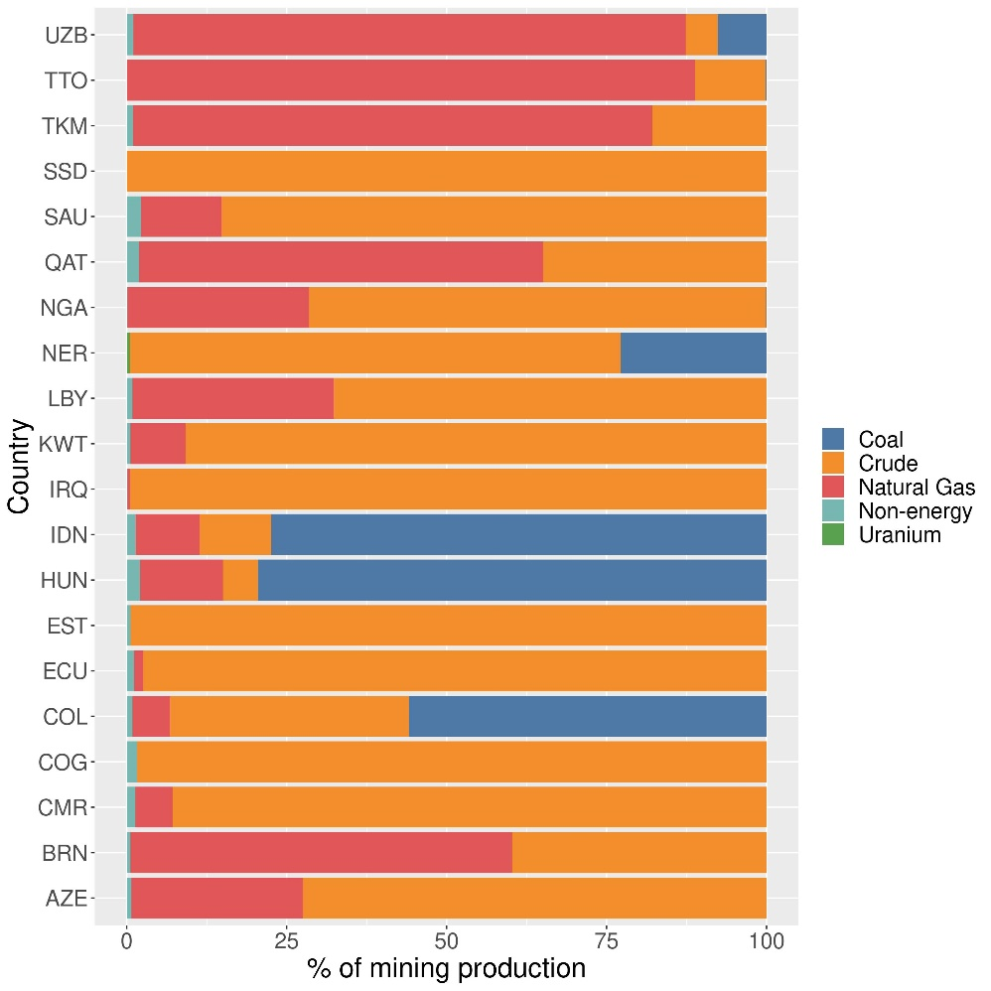

**Fig. 2. Mining production for the ten most mining-intensive countries in the world (2015).** Each bar represents a country in 2016, with bars differentiated by the commodity mined. Country codes are as follow: Uzbekistan (UZB), Trinidad and Tobago (TTO), Turkmenistan (TKM), South Sudan (SSD), Saudi Arabia (SAU), Qatar (QAT), Nigeria (NGA), Niger (NER), Libya (LBY), Kuwait (KWT), Iraq (IRQ), Indonesia (IDN), Hungary (HUN), Estonia (EST), Ecuador (ECU), Colombia (COL), Congo (COG), Cameroon (CMR), Brunei (BRN), Azerbaijan (AZE).

# 9 Losses in HOMIES

As mentioned in the main text of this study, losses are categorized as a separate energy sink in HOMIES. Once an energy flow goes into the losses column, it cannot be used by another sector to produce goods and services. The following schematic illustrates how losses are calculated throughout HOMIES in a hypothetical country with three primary energy resources (crude oil, coal, renewables), two secondary energy resources (petroleum and electricity) and two non-energy sectors.

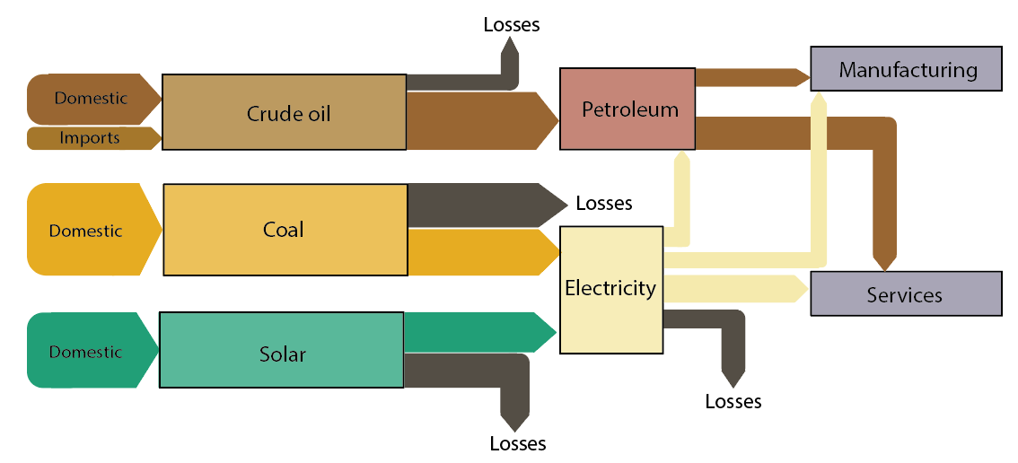

# 10 Import dependence by region

The following table includes the import dependence of direct and indirect energy at the regional level. Standard deviations are in parentheses. The global mean is listed at the bottom of the table.

|  |  |  |  |  |  |  |  |  |
| --- | --- | --- | --- | --- | --- | --- | --- | --- |
|  | **2000** | | **2005** | | **2010** | | **2015** | |
|  | **Direct** | **Embodied** | **Direct** | **Embodied** | **Direct** | **Embodied** | **Direct** | **Embodied** |
| **Africa** | 0.38 | 0.60 | 0.42 | 0.63 | 0.43 | 0.65 | 0.41 | 0.65 |
| (0.29) | (0.25) | (0.29) | (0.25) | (0.29) | (0.23) | (0.26) | (0.21) |
| **China** | 0.08 | 0.22 | 0.12 | 0.29 | 0.23 | 0.40 | 0.25 | 0.41 |
| (.) | (.) | (.) | (.) | (.) | (.) | (.) | (.) |
| **East Asia** | 0.61 | 0.84 | 0.67 | 0.82 | 0.68 | 0.83 | 0.75 | 0.88 |
| (0.27) | (0.13) | (0.26) | (0.13) | (0.23) | (0.11) | (0.20) | (0.09) |
| **Europe** | 0.51 | 0.68 | 0.53 | 0.72 | 0.53 | 0.74 | 0.51 | 0.73 |
| (0.25) | (0.23) | (0.23) | (0.18) | (0.23) | (0.17) | (0.22) | (0.18) |
| **Latin America** | 0.28 | 0.48 | 0.32 | 0.52 | 0.29 | 0.56 | 0.29 | 0.55 |
| (0.28) | (0.22) | (0.28) | (0.24) | (0.16) | (0.20) | (0.15) | (0.16) |
| **North and Central America** | 0.43 | 0.71 | 0.50 | 0.71 | 0.46 | 0.68 | 0.44 | 0.64 |
| (0.25) | (0.19) | (0.27) | (0.23) | (0.28) | (0.23) | (0.29) | (0.25) |
| **Oceania** | 0.15 | 0.46 | 0.22 | 0.55 | 0.20 | 0.52 | 0.24 | 0.56 |
| (0.04) | (0.01) | (0.02) | (0.01) | (0.11) | (0.09) | (0.18) | (0.17) |
| **Persian Gulf Countries** | 0.08 | 0.25 | 0.11 | 0.34 | 0.13 | 0.35 | 0.13 | 0.36 |
| (0.03) | (0.13) | (0.05) | (0.12) | (0.10) | (0.16) | (0.09) | (0.14) |
| **South Asia** | 0.32 | 0.64 | 0.35 | 0.65 | 0.36 | 0.66 | 0.40 | 0.71 |
| (0.23) | (0.23) | (0.22) | (0.20) | (0.24) | (0.21) | (0.22) | (0.15) |
| **West and Central Asia** | 0.36 | 0.55 | 0.47 | 0.63 | 0.45 | 0.61 | 0.45 | 0.63 |
| (0.29) | (0.32) | (0.31) | (0.29) | (0.32) | (0.29) | (0.30) | (0.27) |
| **World** | 0.39 | 0.61 | 0.44 | 0.64 | 0.43 | 0.65 | 0.43 | 0.66 |
| (0.28) | (0.26) | (0.27) | (0.24) | (0.27) | (0.23) | (0.25) | (0.22) |

# 11 Energy security metrics of the energy importer

The attached tables include the direct vs. embodied HHI trade linkages for all energy import portfolios resolved by HOMIES. Sheet 1 presents metrics for 2015, Sheet 3 presents metrics for 2010. The countries are in order of decreasing embodied import sink.

# 12 Energy security metrics, by exporter

The attached tables include the direct vs. embodied HHI trade linkages for all energy export portfolios resolved by HOMIES. Sheet 2 presents metrics for 2015, Sheet 4 presents metrics for 2010. The countries are in order of decreasing embodied export source.

# References

[1] Lenzen M, Moran D, Kanemoto K, Geschke A. BUILDING EORA: A GLOBAL MULTI-REGION INPUT-OUTPUT DATABASE AT HIGH COUNTRY AND SECTOR RESOLUTION. Econ Syst Res 2013. https://doi.org/10.1080/09535314.2013.769938.

[2] U.S. Energy Information Administration. Annual Energy Review: Table F.1, Conversion Efficiencies of Non-combustible Renewable Energy Resources. Washington, DC: 2011.

[3] U.S. Energy Information Administration. Average Operating Heat Rate for Selected Energy Sources (Table 8.1). Power Plant Oper Rep 2018. https://www.eia.gov/electricity/annual/html/epa_08_01.html.

[4] FAO. FAOSTAT Data. Food Agric Organ United Nations Rome 2018. https://doi.org/10.1016/j.jad.2018.09.064.

[5] International Energy Agency. Renewables and Waste Database 2017. https://doi.org/https://doi.org/10.1787/data-00549-en.

[6] Huang WD, Zhang YHP. Energy efficiency analysis: Biomass-to-wheel efficiency related with biofuels production, fuel distribution, and powertrain systems. PLoS One 2011. https://doi.org/10.1371/journal.pone.0022113.

[7] Hamelinck CN, Faaij APC. Outlook for advanced biofuels. Energy Policy 2006. https://doi.org/10.1016/j.enpol.2005.06.012.

[8] van Vliet OPR, Faaij APC, Turkenburg WC. Fischer-Tropsch diesel production in a well-to-wheel perspective: A carbon, energy flow and cost analysis. Energy Convers Manag 2009. https://doi.org/10.1016/j.enconman.2009.01.008.

[9] Steen EJ, Kang Y, Bokinsky G, Hu Z, Schirmer A, McClure A, et al. Microbial production of fatty-acid-derived fuels and chemicals from plant biomass. Nature 2010. https://doi.org/10.1038/nature08721.

[10] Huang WD, Percival Zhang YH. Analysis of biofuels production from sugar based on three criteria: Thermodynamics, bioenergetics, and product separation. Energy Environ Sci 2011. https://doi.org/10.1039/c0ee00069h.

[11] Berglund M, Börjesson P. Assessment of energy performance in the life-cycle of biogas production. Biomass and Bioenergy 2006. https://doi.org/10.1016/j.biombioe.2005.11.011.

[12] Pimentel D, Patzek TW. Ethanol production using corn, switchgrass, and wood; Biodiesel production using soybean and sunflower. Nat Resour Res 2005. https://doi.org/10.1007/s11053-005-4679-8.

[13] Farrell AE, Plevin RJ, Turner BT, Jones AD, O’Hare M, Kammen DM. Ethanol can contribute to energy and environmental goals. Science (80- ) 2006. https://doi.org/10.1126/science.1121416.

[14] DIAS DE OLIVEIRA ME, VAUGHAN BE, RYKIEL EJ. Ethanol as Fuel: Energy, Carbon Dioxide Balances, and Ecological Footprint. Bioscience 2005. https://doi.org/10.1641/0006-3568(2005)055[0593:eafecd]2.0.co;2.

[15] Sheehan J, Aden A, Paustian K, Killian K, Brenner J, Walsh M, et al. Energy and environmental aspects of using corn stover for fuel ethanol. J Ind Ecol 2003. https://doi.org/10.1162/108819803323059433.

[16] Hamelinck CN, Van Hooijdonk G, Faaij APC. Ethanol from lignocellulosic biomass: Techno-economic performance in short-, middle- and long-term. Biomass and Bioenergy 2005. https://doi.org/10.1016/j.biombioe.2004.09.002.

[17] Kumabe K, Fujimoto S, Yanagida T, Ogata M, Fukuda T, Yabe A, et al. Environmental and economic analysis of methanol production process via biomass gasification. Fuel 2008. https://doi.org/10.1016/j.fuel.2007.06.008.

[18] Hamelinck CN, Faaij APC. Future prospects for production of methanol and hydrogen from biomass. J Power Sources 2002. https://doi.org/10.1016/S0378-7753(02)00220-3.

[19] Food and Agriculture Organization. Chapter 2. Wood carbonisation and the products it yields. Ind Charcoal Mak 1985. http://www.fao.org/3/x5555e/x5555e03.htm.

[20] UN Statistics Division. Conversion Factors. 2014.

[21] Food and Agriculture Organization. Methods for estimating biomass density from existing data. Estim Biomass Biomass Chang Trop For A Prim 1997. fao.org/3/w4095e06.htm.