**The Dependence of the Global Transport Equipment Sector on Maritime Chokepoints: A hybrid-input output approach**

Jun U. Shepard*a* and Lincoln F. Pratson*a*

*a Duke University (Nicholas School of the Environment), 9 Circuit Drive, Durham, NC 27701 USA. Corresponding email: [jun.shepard@duke.edu](mailto:jun.shepard@duke.edu).*

# 1 Countries represented in this analysis

The following table presents the regional classifications used in the hybridized model.

|  |  |
| --- | --- |
| **Region** | **Countries/Territories** |
| Africa | Algeria, Angola, Benin, Botswana, Burkina Faso, Burundi, Cameroon, Cape Verde, Central African Republic, Chad, Comoros, Republic of the Congo, Democratic Republic of the Congo, Cote d’Ivoire, Djibouti, Egypt, Eritrea, Gabon, Gambia, Ghana, Guinea, Guinea-Bissau, Equatorial Guinea, Kenya, Lesotho, Liberia, Libya, Madagascar, Malawi, Mali, Mauritius, Morocco, Mozambique, Namibia, Niger, Nigeria, Reunion, Rwanda, Sao Tome and Principe, Republic of Seychelles, Sierra Leone, Somalia, Swaziland, Senegal, South Africa, South Sudan (Sudan), Tanzania, Togo, Tunisia, Uganda, Zambia, Zimbabwe |
| China | China |
| East Asia | Hong Kong, Japan, Democratic People’s Republic of Korea, South Korea, Macau, Mongolia |
| Europe | Andorra, Albania, Austria, Belarus, Belgium, Bosnia and Herzegovina, Bulgaria, Croatia, Czech Republic, Denmark, Estonia, Finland, France, Germany Gibraltar, Greece, Hungary, Ireland, Italy, Latvia, Lithuania, Luxembourg, Former Yugoslav Republic of Macedonia, Malta, Moldova, Montenegro, Netherlands, Norway, Poland, Portugal, Romania, Russia, Serbia, Slovak Republic, Slovenia, Spain, Sweden, Switzerland, Ukraine, United Kingdom |
| Latin America | Argentina, Bolivia, Brazil, Chile, Colombia, Ecuador, Guyana, Paraguay, Peru, Suriname, Uruguay, Venezuela, Bolivarian Republic of Venezuela |
| North and Central America | Belize, Bermuda, Canada, Costa Rica, El Salvador, Guatemala, Honduras, Mexico ,Nicaragua, Panama, United States |
| Oceania | American Samoa, Australia, Cook Islands, Fiji, French Polynesia, Guam, Republic of Kiribati, Marshall Islands, Federated States of Micronesia, Republic of Nauru, New Caledonia, New Zealand, Niue, Norfolk Island, Northern Mariana Islands, Palau, Papua New Guinea, Samoa, Solomon Islands, Tonga, Tuvalu, Vanuatu |
| Persian Gulf Countries | Bahrain, Iran, Iraq, Kuwait, Oman, Qatar, Saudi Arabia, United Arab Emirates |
| South Asia | Afghanistan, Bangladesh, Bhutan, Brunei Darussalam, Cambodia, India, Indonesia, Laos, Malaysia, Myanmar, Nepal, Pakistan, Philippines, Singapore, Sri Lanka, Thailand, Timor-Leste, Viet Nam |
| West and Central Asia | Armenia, Azerbaijan, Cyprus, Georgia, Israel, Jordan, Kazakhstan, Kyrgyzstan, Lebanon, Syrian Arab Republic, Tajikistan, Turkey, Turkmenistan, Uzbekistan, Yemen |

# 2 Ports in shortest path algorithm

The ports identified for each country are illustrated in the map below and listed in the table underneath.

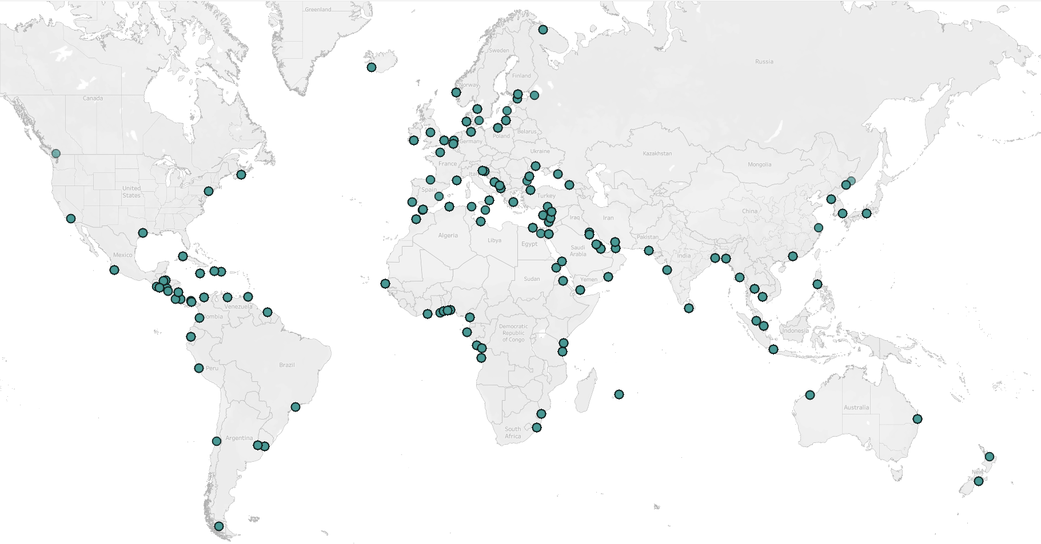

|  |  |  |  |
| --- | --- | --- | --- |
| **Country** | **Port latitude** | **Port longitude** | **Closest city/landmark** |
| Albania | 41.32 | 19.45 | Durres |
| Algeria | 36.77 | 3.07 | Djasr Kasentina |
| Angola | -8.80 | 13.25 | Luanda |
| Argentina | -34.60 | -58.37 | Buenos Aires |
| Australia | -27.47 | 153.03 | Queensland |
| Australia | -20.32 | 118.58 | Port Hedland |
| Bahrain | 26.25 | 50.75 | Galali |
| Bangladesh | 22.32 | 91.82 | Dangar Char |
| Belgium | 51.22 | 4.40 | Antwerp |
| Benin | 6.35 | 2.43 | Cotonou |
| Bosnia and Herzegovina | 42.92 | 17.60 | Neum |
| Brazil | -23.95 | -46.30 | Sao Paolo |
| Bulgaria | 43.18 | 27.97 | Varma |
| Cameroon | 4.05 | 9.68 | Douala |
| Canada | 44.65 | -63.58 | Nova Scotia |
| Canada | 49.28 | -123.12 | Vancouver |
| Chile | -33.58 | -71.62 | San Antonio |
| Chile | -53.17 | -70.90 | Punta Arenas |
| China | 23.12 | 113.23 | Guangdong |
| China | 31.22 | 121.50 | Shanghai |
| Colombia | 3.88 | -77.07 | Valle del Cauca |
| Colombia | 10.42 | -75.53 | Bolivar |
| Congo | -4.78 | 11.83 | Pointe Noire |
| Costa Rica | 9.92 | -84.72 | Puntarenas Province |
| Costa Rica | 9.98 | -83.02 | Limon |
| Cote d'Ivoire | 5.25 | -4.02 | Port Bouet |
| Croatia | 45.33 | 14.43 | Rijeka |
| Cuba | 23.13 | -82.37 | Havana |
| Cyprus | 34.67 | 33.05 | Akrotiri |
| Denmark | 55.70 | 12.62 | Copenhagen |
| Denmark | 55.47 | 8.45 | Fano |
| Dominican Republic | 18.42 | -70.02 | Santo Domingo |
| Ecuador | -2.20 | -79.88 | Duran |
| Egypt | 31.17 | 29.83 | Dekhela |
| Egypt | 29.68 | 32.37 | Attaka |
| Eritrea | 15.62 | 39.47 | Mitsiwa |
| Estonia | 59.45 | 24.77 | Talinn |
| Finland | 60.17 | 24.97 | Helsinki |
| France | 43.32 | 5.37 | Marseille |
| France | 49.48 | 0.12 | Le Havre |
| Gabon | -0.70 | 8.80 | Port Gentil |
| Georgia | 42.15 | 41.58 | Poti |
| Germany | 53.55 | 9.93 | Hamburg |
| Ghana | 5.62 | 0.02 | Accra |
| Gibraltar | 36.13 | -5.35 | Gibraltar |
| Greece | 37.93 | 23.65 | Pireas |
| Guatemala | 15.73 | -88.60 | Puerto Barrios |
| Guatemala | 13.92 | -90.80 | Port of San Jose |
| Haiti | 18.55 | -72.35 | Port au Prince |
| Honduras | 15.83 | -87.95 | Puerto Cortes |
| Honduras | 13.40 | -87.45 | San Lorenzo |
| Iceland | 64.15 | -21.93 | Reykjavik |
| India | 22.55 | 88.33 | Kolkata |
| India | 18.97 | 72.87 | Mumbai |
| Indonesia | -6.10 | 106.88 | Jakarta |
| Iran | 27.15 | 56.20 | Bandar Abbas |
| Iraq | 30.02 | 47.95 | Abdali |
| Ireland | 51.85 | -8.27 | County Cork |
| Israel | 29.55 | 34.95 | Eilat |
| Israel | 32.82 | 35.00 | Haifa |
| Italy | 38.42 | 15.90 | Vibo Marina |
| Jamaica | 17.97 | -76.78 | Port Royal |
| Japan | 35.07 | 136.87 | Nagoya |
| Jordan | 29.52 | 35.00 | Aqaba |
| Kenya | -4.07 | 39.67 | Mombasa |
| Khmer | 10.63 | 103.50 | Puy Kamphen |
| Kuwait | 29.35 | 47.93 | Al Hishan |
| Latvia | 57.40 | 21.53 | Ventspils |
| Lebanon | 33.90 | 35.50 | Beirut |
| Libya | 32.90 | 13.18 | Tripoli |
| Lithuania | 55.72 | 21.12 | Klaipeda |
| Malaysia | 3.00 | 101.40 | Selangor |
| Malta | 35.90 | 14.52 | Valetta |
| Mauritius | -20.15 | 57.50 | Port Louis |
| Mexico | 19.05 | -104.32 | Colima |
| Montenegro | 42.08 | 19.08 | Polje |
| Morocco | 33.60 | -7.62 | Casablanca |
| Morocco | 35.90 | -5.52 | Eddalya |
| Mozambique | -25.97 | 32.58 | Maputo |
| Myanmar | 16.77 | 96.17 | Yangon |
| Netherlands | 51.90 | 4.48 | Rotterdam |
| New Zealand | -43.60 | 172.72 | Bankside |
| New Zealand | -37.63 | 176.17 | Tauranga |
| Nicaragua | 12.02 | -83.75 | El Bluff |
| Nicaragua | 12.48 | -87.17 | Punta Hawai |
| Nigeria | 6.40 | 3.40 | Lagos |
| North Korea | 42.23 | 130.30 | Rason |
| North Korea | 38.72 | 125.40 | Nampo |
| Norway | 60.40 | 5.32 | Bergen |
| Oman | 16.93 | 54.02 | Raysut |
| Pakistan | 24.78 | 66.98 | Karachi |
| Panama | 8.95 | -79.57 | Panama Bay |
| Panama | 9.37 | -79.88 | Puerto Pilon |
| Peru | -12.05 | -77.15 | Callao District |
| Philippines | 14.58 | 120.97 | Manila |
| Poland | 54.35 | 18.67 | Gdansk |
| Portugal | 37.95 | -8.87 | Sines |
| Qatar | 25.28 | 51.53 | Doha |
| Republic of the Congo | -5.82 | 13.45 | Matadi |
| Romania | 44.17 | 28.65 | Constanta |
| Russia | 68.98 | 33.05 | Murmansk |
| Russia | 44.72 | 37.78 | Novorossiysk |
| Russia | 59.93 | 30.30 | Saint Petersburg |
| Russia | 43.12 | 131.90 | Vladivostok |
| Saudi Arabia | 26.50 | 50.20 | Dammam |
| Saudi Arabia | 21.48 | 39.18 | Jeddah |
| Senegal | 14.68 | -17.43 | Dakar |
| Singapore | 1.28 | 103.85 | Queenstown |
| Slovenia | 13.58 | -89.83 | Los Cobanos |
| Slovenia | 45.55 | 13.73 | Capodistria |
| South Africa | -29.87 | 31.07 | Durban North |
| South Korea | 35.10 | 129.03 | Busan |
| Spain | 36.13 | -5.43 | Gibraltar |
| Spain | 43.35 | -3.05 | Santurtzi |
| Spain | 39.45 | -0.32 | Valencia |
| Sri Lanka | 6.95 | 79.85 | Colombo |
| Sudan | 19.60 | 37.23 | Port Sudan |
| Suriname | 5.83 | -55.17 | Jagtlust |
| Sweden | 57.70 | 11.97 | Goteberg |
| Syria | 35.53 | 35.77 | Latakia |
| Tanzania | -6.82 | 39.30 | Dar es Salaam |
| Thailand | 13.08 | 100.88 | Chon Buri |
| Togo | 6.13 | 1.28 | Lome |
| Trinidad and Tobago | 10.65 | -61.52 | Port of Spain |
| Tunisia | 36.80 | 10.25 | Tunis |
| Turkey | 41.00 | 29.02 | Istanbul |
| Turkey | 36.80 | 34.63 | Mersin |
| United Kingdom | 51.95 | 1.32 | Felixstowe |
| Ukraine | 46.48 | 30.73 | Odessa Oblast |
| United Arab Emirates | 25.35 | 56.38 | Sharjah |
| United Kingdom | 51.95 | 1.32 | Felixstowe |
| United Kingdom | 53.42 | -3.00 | Liverpool |
| United States | 29.75 | -95.28 | Houston |
| United States | 33.75 | -118.25 | Los Angeles |
| United States | 40.70 | -74.15 | New York |
| Uruguay | -34.90 | -56.22 | Montevideo |
| Venezuela | 10.48 | -68.00 | Puerto Cabello |
| Yemen | 12.78 | 44.95 | Al Buraiqeh |

# 3 Representations of chokepoint dependence

The purposes of this analysis can be summarized into two questions. First, how dependent are the major TE exports on transit through maritime chokepoints? Dependence here can be measured in two ways: (i) through the inputs to TE manufacturing and (ii) through the exports of TE output. The former is represented in Figure 1a below. In this figure, a hypothetical country’s TE sector (the middle bar) requires inputs from countries A-F and ships TE output to meet final demand in countries G-J. These numbers are completely hypothetical and are not based on empirical data.

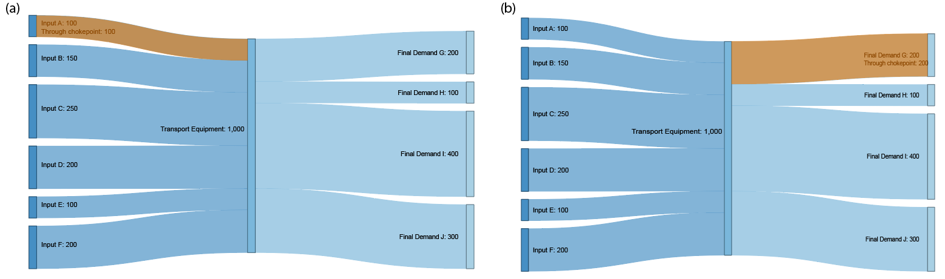

Figure 1. Schematic of chokepoint transits and dependences for TE exporters.

The left panel (a) represents how TE exporters can be dependent on chokepoints via their manufacturing inputs. The right panel (b) represents how TE exporters can be dependent based on whether their TE exports transit a chokepoint. The TE-manufacturing country requires 1,000 units of input and produces 1,000 units of output. If one of its inputs (Input A) requires chokepoint transit, the TE sector would directly depend on the chokepoint for 10% of its inputs. The dependence of TE output on the chokepoint is represented in Figure 1b. In this illustration, the TE sector delivers 200 units of TE output to meet final demand in country G. 20% of its outputs (200/1,000) are therefore directly dependent on the chokepoint.

The second question we ask is, how dependent are major TE importers on transit through maritime chokepoints? Similar to the first question, this can be answered in two ways: (i) through the direct imports of TE and (ii) through the inputs required to produce the TE that is imported. We represent these two types of flows in Figure 2a and Figure 2b, below:

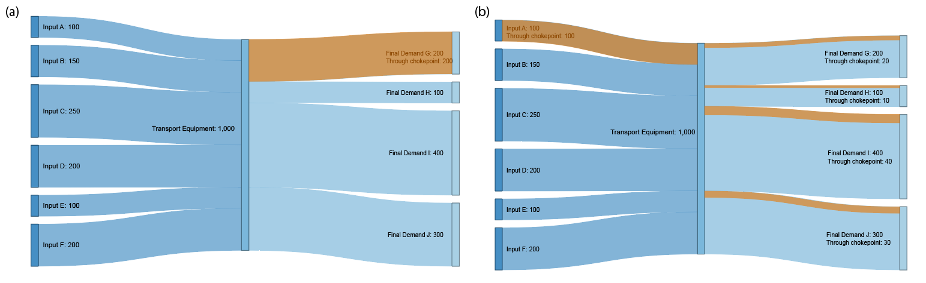

Figure 2. Schematic of chokepoint transits and dependences for TE importers.

The left panel (a) represents how TE importers can be dependent on chokepoints via their direct imports of TE output. The right panel (b) represents how importers can also be chokepoint dependent based on whether the inputs to TE manufacturing transits a chokepoint themselves. In this example, 200 units of TE imports to country G requires chokepoint transit. Country G’s TE demand (which again can act as a proxy for transportation demand) would be 25% dependent on chokepoints if this comprised 25% of the country’s total TE imports. If, as in Figure 1b, 100 units of input to the TE sector depends on chokepoint transit, each of the final demand countries would also be dependent on the chokepoint for their TE imports. Here, because the chokepoint-dependent inputs comprise 10% of the total inputs to the TE sector, 10% of the TE output that goes to the final demand countries would also be dependent on the chokepoint. The direct chokepoint dependence of TE importers is therefore the sum of (i) and (ii).

Figure 2a represents the first flow, or the direct imports of TE by the final demand country. On the other hand, Figure 2b represents each final demand country’s chokepoint dependence based on the inputs to TE manufacturing.