**A representation of transportation and trade networks in global energy models**

Jun Ukita Shepard, Duke University

*Email: jun.shepard@duke.edu*

IIASA Supervisors: Bas van Ruijven (ENE) and Behnam Zakeri (ENE)

**Introduction.**

Regional energy systems are inextricably tied to international trade and shipping networks. However, current energy models generally do not address the dynamics of these networks. These dynamics are particularly important in the context of technological transitions; shifts in regional demand will break existing trade linkages while forming new ones. This project explores the effects of short-term trade policies on long-term energy trade networks. These long-term trade networks do not only impact energy security but also have consequences for meeting emissions targets.

**Methodology.**

The MESSAGE energy model represents the global energy economy using 14 representative regions. It assumes a “global pool” trade schema, in which each region exports into/imports from a global resource pool. We transition MESSAGE to a bilateral schema by specifying bilateral trade flows for five energy commodities. We also introduce shipping networks, thereby exploring the effects of trade trajectories on investment into new shipping technologies specified by cargo and fuel. We analyse 12 scenarios, exploring the effects of tariffs, sanctions, technological advancements in shipping, and emissions taxes on energy trade networks from 2020-2110. Each scenario is represented in importer or exporter variable costs.

**Results.**

Results suggest that tariff policies may change the composition of trade flows by 2060. For instance, under a low-tariff scenario light oil exports from the Middle East to Southern Asia are substituted by crude oil exports and crude oil exports from Latin America to Pacific OECD increase substantially. Results also suggest that sanctions between regions can have a lasting effect on energy trade networks and the overall cost of the global energy system. Most notably, sanctions between North America and the Middle East can increase the global system cost by 24% from the baseline. Trade policies have heterogenous impacts on regional emissions, though increased trade friction generally reduces regional emissions. The effects of policies on global emissions are marginal. Emissions taxes significantly alter the trajectory of global energy trade networks. This is driven by rapid reductions in crude oil trade and increases in fuel oil and coal trade flows (see figure below).

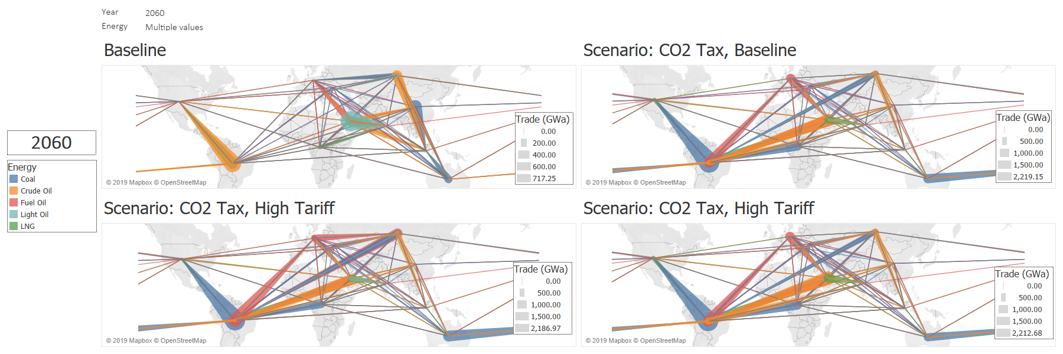

**Conclusions.**

The results of this project suggest that short-term policies, such as sanctions and tariffs, can shape long-term energy trade networks. They also underscore the indirect effect of trade policies on emissions; increased trade friction can lead to regional reductions in emissions but has little impact on global trajectories. Trade diversity, an index for measuring energy security, appears to generally decrease across energy commodities over time. These results have significant implications for decisionmakers who must balance energy security with climate change mitigation.