TimeWise

# STAKEHOLDERS

* User: A person who has access to a board and is able to view, edit and delete it fully or partially, in order to utilize the application.
* Administrator: A person who has full access to the functionality of the app, as well as the servers, and is responsible to manage the correct operation of the project.

# TERMINOLOGY.

* Card: the entity that represents a specific task that the user wants to complete.
* List: the unit that combines ‘Cards’ into different groups (e.g. TODO, Doing, Done). A list can contain multiple cards.
* Board: the canvas where ‘Lists’ are displayed. A board can contain multiple lists.

# MUST REQUIREMENTS

## EPIC 1: Core functionality

*These basic features are needed, so that the app can function in its simplest form.*

As a user, I want…

* to be able to use the application anonymously, so that I can divide my tasks into cards quickly, without providing any personal information.
  + Acceptance Criteria:
    - The user can access and edit the board without registration.
* to create new lists within a board, so that I can organize and structure my cards.
  + Acceptance Criteria:
    - The user can create multiple lists within a single board.
    - The user can give the list a name.
* to create new cards with different titles within my lists, so that I can represent my tasks.
  + Acceptance Criteria:
    - The user can create a card within a list.
    - The user can give the card a title.
    - The user can see the title of the card in the board overview, within a list.
* to move between different screens in a maximum of three clicks, so that I can easily switch between functionalities.
* the interface to be clearly labeled and accessible, so that I have a pleasant user experience.
  + Acceptance Criteria:
    - The layout should include icons and explanatory text when you hover over a button.
    - The design will be minimalistic, making it easy for the user to find what they need.
    - The application should be responsive and have smooth transitions that load within less than 1 second.
* to be able to share and work on the same board, so that I can collaborate with other users.
  + Acceptance Criteria:
    - There is support for multiple users to be connected to the application at the same time.
    - Multiple users can make changes simultaneously to the same board and the lists and cards within it.

## EPIC 2: Client-Server Application

*These features ensure that the integrity of the data is preserved indefinitely and accessible from different devices.*

As a user, I want…

* my data to be stored in a reliable database, so that I can use the app continuously without losing my information.
  + Acceptance Criteria:
    - When I make changes to my boards, lists, and cards, the changes are automatically saved to the database.
* the overview of a board and actual data to be synchronized automatically across different devices, so that changes are visible from anywhere.
  + Acceptance Criteria:
    - The application should synchronize the board overview as soon as it is updated, across all devices.
    - The synchronization should be seamless and automatic, without requiring the user to manually trigger it by pressing a button.

As an administrator, I want…

* to be able to monitor usage and performance of the application so that I can make improvements as necessary.
  + Acceptance Criteria:
    - There is a dashboard or other interface where administrators can view usage and performance metrics.
    - Metrics include things like server logs, number of active users, frequency of use, and any error or performance issues.
* to be able to restart the server without losing data, so that I can ensure that the app operates correctly and fix problems in functionality.
* to be able to delete boards, so that I can remove information that has not been used for an extended period of time.

## EPIC 3: Flexibility

*These features allow the user to reorganize and modify their workspace.*

As a user, I want…

* to be able to delete lists, and/or cards so that I can remove redundant information.
  + Acceptance Criteria:
    - The user should be able to delete a list by clicking on the delete icon next to the list name.
    - The user should be able to delete a card by clicking on the delete icon next to the card name.
    - When a list or card is deleted, it should be permanently removed from the user’s workspace and cannot be restored.
    - The user should be prompted to confirm the deletion action before the list or card is permanently deleted to prevent accidental deletion.
* to be able to drag and drop cards between lists so that I can easily change their placement.
  + Acceptance Criteria:
    - The user can select a card by clicking on it, and then drag and drop it into another list.
    - The card is visually moved from the original list to the destination list upon release of the mouse click.
    - If the user drags a card outside of the board area, the card should not be lost and should be able to be retrieved easily.
* to be able to drag and drop lists within the board so that I can structure them in a clear manner depending on their priority at the time.
  + Acceptance Criteria:
    - The user can select a list by clicking on its title and then drag and drop it into the selected position on the board.
    - After moving a list, its contents should remain unchanged.

# SHOULD REQUIREMENTS

## EPIC 4: Enhancements to Basic Functionality

*These features build up on the existing functionality, allowing the user to create multiple boards and add details to cards.*

As a user, I want…

* to create a new board, so that I can divide my cards more efficiently.
  + Acceptance Criteria:
    - The board is saved in the database and can be accessed later using a unique key.
    - The board can be given a name upon creation.
* to be able to access a homepage from all pages, so that I can create a new board or search for an existing one.
  + Acceptance Criteria:
    - There is a page that has a “create a new board” button and a search bar.
    - Clicking on the homepage button - which is visible from all pages - will lead the user back to the homepage.
* to be able to join boards by entering a key, so that I can collaborate with other users on specific boards.
  + Acceptance Criteria:
    - There is a textbox where keys can be entered.
    - Upon entering the valid key and pressing the ‘search’ button, the application will display the corresponding board.
* to be able to delete boards, so that I can discard unnecessary information.
  + Acceptance Criteria:
    - There is a “delete board” option available.
    - Clicking on the “delete board” option prompts a confirmation message to ensure that the user wants to delete the board.
    - If the user confirms the deletion, the board and all of its contents (lists and cards) are permanently deleted.
    - After the board is deleted, it cannot be accessed anymore by searching for its key.
* to be able to add a description to my cards so that I can provide additional information about the card.
  + Acceptance Criteria
    - The user should be able to access the card details by clicking on the card.
    - There should be a text box where the user can enter the description of the card.
    - The user should be able to save the description by clicking on a “Save” button.
    - The saved description should be displayed on the card for future reference.
* to be able to edit or delete the description of my card, so that I can modify it if necessary.
* to be able to create subcards in the form of checklists within cards, so that I can break down large tasks into smaller sub-tasks.
  + Acceptance Criteria:
    - The user should be able to easily create new checklists within a card.
    - The user should be able to add items to a checklist.
    - The user should be able to edit or delete items from a checklist.
    - The user should be able to mark items within a checklist as complete or incomplete.
* to be able to view the progress of a checklist in the overview of the board, so that I can keep track of my progress without having to open the detailed view of the card.
  + Acceptance Criteria:
    - The user can see the number of completed items of a checklist out of its total number of items.

## EPIC 5: Customization

*These features provide options for personalization, allowing for a better user experience.*

As a user, I want…

* to be able to create and manage tags for all cards, so that I can relate different cards to one another.
  + Acceptance Criteria:
    - There will be a button on the board overview, that when clicked, will drop down a tag management window.
    - After opening the window, the user can create new tags, edit, and delete existing ones.
    - The changes will affect all cards within a board (and not only a specific card).
* to be able to manage the tags of a specific card, so that I can categorize cards.
  + Acceptance Criteria:
    - There is a plus button in the detailed view of the card that allows the user to add a new tag to it.
    - There is a delete button next to every tag applied to a card that allows the user to remove it.
* to be able to customize the background and color of my boards, lists, and cards, so that I can personalize them.

# COULD REQUIREMENTS

## EPIC 6: Keyboard Shortcuts

*These features suggest alternative options to conventional navigation of the application to perform repetitive actions more efficiently.*

As a user, I want …

* to be able to use keyboard shortcuts, so that I can quickly navigate and perform actions.
  + Acceptance Criteria:
    - The keyboard shortcuts should work consistently across different pages and features of the application.
    - The keyboard shortcuts should be compatible with commonly used keyboard layouts.
* to create a new card by pressing CTRL + M, so that I can save time.
* to open the detailed view of a selected card by pressing CTRL + O, so that I can perform common actions faster.
* to be able to exit the detailed view of a card by pressing ESC, so that I can quickly return to the board overview.
* to be able to save changes in the description of a card by pressing CTRL + S, so that I can update the description more efficiently.

## EPIC 7: Security

*These features ensure that the user’s data is protected at all times.*

As a user, I want…

* to be able to password-protect boards, so that I can keep sensitive information secure and control who can access them.
  + Acceptance Criteria:
    - The board creator can set a password for the board.
    - The board can only be accessed with the correct password.
* to be able to set different access levels for board members, such as read-only or write.
  + Acceptance Criteria:
    - When creating the board, a user can set two different passwords, one that gives read-only access and one that gives write access.
    - A user can set access levels for board members by sending the password to other users.
* to be able to view a board when given read-only access, so that I can see its contents
* to be able to view and edit a board when given write access, so that I can make changes to its contents.

As an administrator, I want…

* to be able to reset passwords, so that I can provide support to users who have forgotten them and enable them to access their boards again.

# MOCKUPS

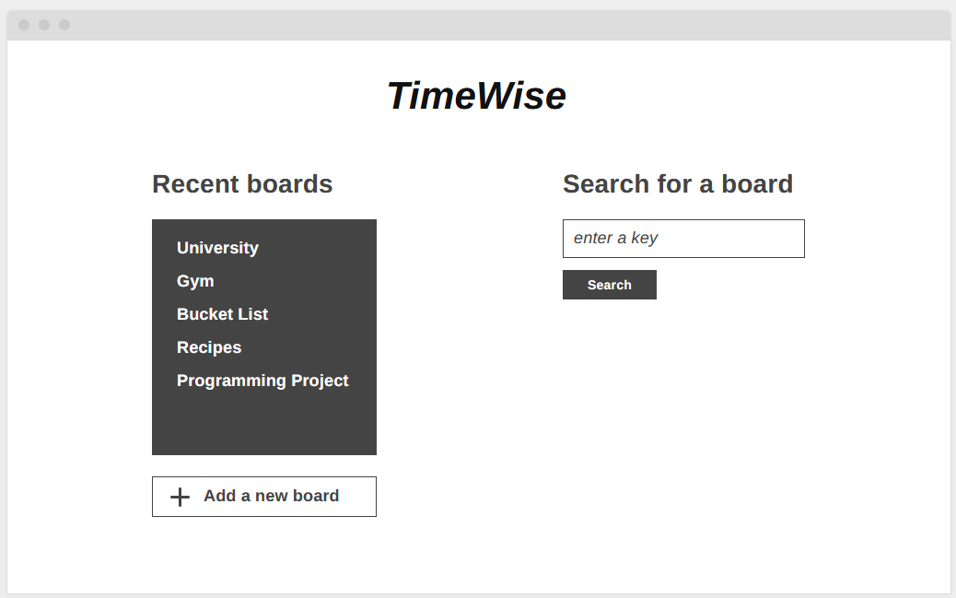

*Start Screen of the application*

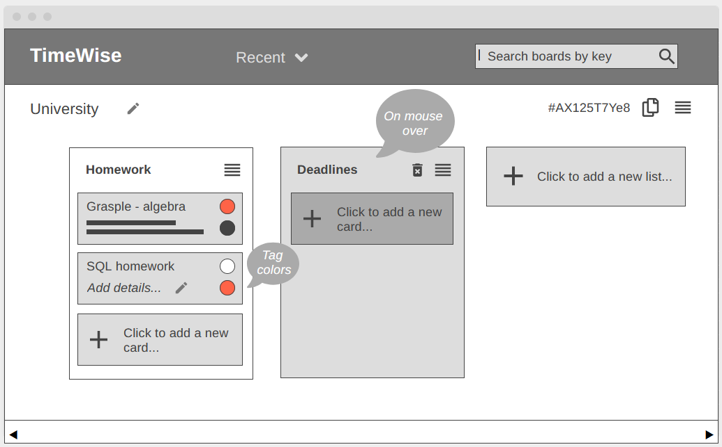

*Board overview of the lists and cards in a particular instance of a Board named ‘University’*

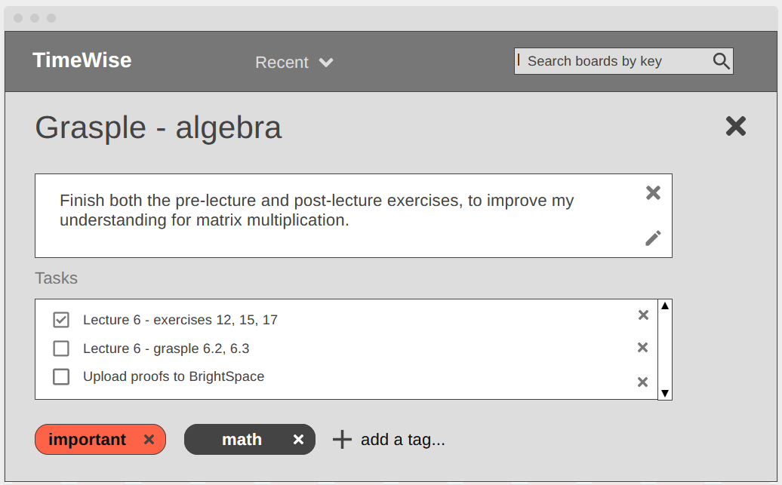

*Detailed view of the card named ‘Grasple - algebra’ that includes a description, a checklist and two tags*