# Path following guidance logic

<<TEMPLATE START>>

**Title**: Title of paper

**Authors**: Authors of paper

**Link:** Link to paper

**Summary:** Paper summary in one sentence

**Key Points:**

* Problem Solved: What problem did they try to solve?
* Main Contributions: What were the main contributions?
* Conditions: Under what conditions is the method applicable?
* What can be improved: What could I improve on top of this paper?
* Stylistic comments:
  + **Good**:
  + **Bad**:

**Notes:**

* More notes

<<TEMPLATE END>>

### Hybrid VTOL PF Papers

**Title**: Incremental nonlinear dynamic inversion based path-following control for a hybrid quad-plane unmanned aerial vehicle

**Authors**: Li Zhou, et al.

**Link:** <https://onlinelibrary.wiley.com/doi/10.1002/rnc.6503>

**Summary:** INDI controller architecture for achieving path following for both hover & fixed-wing regime flight of the Hybrid Quadplane VTOL

**Key Points:**

* Problem Solved: Robust controller that can handle both hover & fixed-wing regime behavior of a Hybrid Quad-plane VTOL for **path following**. Better than active disturbance rejection control & PID control.
* Main Contributions: Unified control method that can take the VF Path Following commands and apply it robustly to 2 distinct flight regime of a Hybrid Quad-plane VTOL
* Conditions: Applies to **Hybrid Quad-plane VTOL vehicle type** only
* What can be improved:
  + **MC: Constant speed of 2m/s is assumed**, with no lateral body frame velocity component. Which limits the capability significantly.
  + **Wind isn’t considered natively inside the PF algorithm**, and is considered as a ‘disturbance’ that INDI can handle.
* Stylistic comments:
  + **Good**:
  + **Bad**:

**Notes:**

* The Path Following Algorithm itself wasn’t the essence of the paper, however it used the **Vector Field method** from “Overview (Quadrotor): A Survey of Path Following Control Strategies for UAVs Focused on Quadrotors” paper.
* Output of the PF algorithm INDI is capable of tracking: Speed, Course over Ground, Height.

### PF Survey Papers

**Title**: A Survey and Analysis of Algorithms for Fixed-Wing Unmanned Aerial Vehicles

**Authors**: P.B. Sujit, Srikanth SariPalli, and joão BorgeS SouSa

**Link:** <https://ieeexplore.ieee.org/document/6712082?reload=true>

**Summary notes:** Summary of existing path following algorithms and performance analysis using simulated environment

**Key Points:**

* Problem Solved: Provide a guideline on how different path following algorithms behave for the UAV Practitioners
* Main Contributions: Path following performance evaluation under a controlled simulation environment
* Conditions: Simulation was done with a 2D-path
* Stylistic comments:
  + Good: Very intuitive diagrams showing the algorithm’s internal calculations. Nice diagrams showing different simulated results in an intuitive manner. Lots of nice color schemes to make the paper more ‘enjoyable’
  + Bad: Some diagrams were not well made (e.g. angle representations seems hand drawn: Fig 6). No algorithmic formulation diagram was supplied for LQR and Vector-Field method (only vague vectors)

**Notes:**

* The algorithm formulations were quite confusing. Why do they have to be so complicated? E.g. compared to the TJ NPFG paper, the formulations involve so many symbols (e.g. Vector-Field: ‘Algorithm 8’)
* Also, **wind estimation wasn’t considered at all** (due to assumption that autopilot’s computational power isn’t enough for it), so the algorithms have no notion of wind.
* **Nice quantitative result comparison. But the ‘weight’ for the control effort vs path divergence is just not balanced,** and control effort wasn’t really taken into account on penalty in my opinion (due to it’s order of magnitude)
* PF algorithms are divided into two categories:
  + Geometric methods: Uses **Virtual Target Point to follow**. NLGL, LOS, Vector Field, etc.
  + Control techniques : PID, Backstepping, etc

**Title**: A Survey of Path Following Control Strategies for UAVs Focused on Quadrotors

**Authors**: Bartomeu Rubı, et.al

**Link:** <http://link.springer.com/10.1007/s10846-019-01085-z>

**Summary notes:** Selection of 4 (Backstepping, Feedback linearlization, NLGL, Carrot Chasing) PF methods, and evaluating against a spiral-up path with Quadcopter dynamics.

* *Focus on Quadrotor, and not on fixed-wings!*

**Key Points:**

* Problem Solved: Evaluate 4 major PF schemes on a **quadcopter** dynamics model
* Main Contributions: **Quantitative** evaluation on PF ability of 4 different schemas on a Quadcopter dynamics in a Simulation, with reasonings behind the result
* Conditions:
  + **Wind** interference is limited (randomly- varied, only applying certain ‘force’ to the bearing)
  + Quadrotor dynamics has a altitude & attitude controller that can ‘fairly well’ track the target setpoint
* Stylistic comments:
  + Good: Nice **overview** & discussion on necessity of the paper (focus on ‘quadrotor’, and different PF algorithm schemas)
  + Bad: Evaluation was done only on spiral-up path, which doesn’t represent the range of paths a quadrotor would be expected to follow.
    - Wind was limited to affecting vehicle (~1kg mass) with 1 Newtons of force max.

**Notes:**

* **2D NLGL was extended to 3D NLGL, but with simply adding yaw-setpoint & altitude setpoint & reducing the 2D velocity setpoint vector size**, which doesn’t really utilize the full quadrotor dynamics (or does it?). So height is controlled by absolute reference & 2D planer is controlled by velocity reference (like TJ NPFG)

**Title**: A review of path following control strategies for autonomous robotic vehicles: theory, simulations, and experiments / Unified Submarine

**Authors**: Nguyen Hung, Francisco Rego, et.al

**Link:** <http://arxiv.org/abs/2204.07319>

**Summary notes:** Overview on existing path-following algorithms, deriving a vehicle-type agnostic formulation and comparing the performances.

**Key Points:**

* Problem Solved: Instead of assuming specific vehicle type, emphasize a unified common principle & formulate them
* Main Contributions: Open source [Matlab](https://github.com/hungrepo/path-following-Matlab/tree/master/PF-toolbox) / [Gazebo simulation](https://github.com/dsor-isr/Paper-PathFollowingSurvey) environments, formulation in generic terms (vehicle-agnostic)
* Conditions: Only ‘constant’ external disturbance (e.g. wind) is considered.
* Stylistic comments:
  + Good: Lots of nice diagrams (some are a bit childish? E.g. Fig 2.6, like PPT)
  + Bad: The ‘citation’ is horrible, it’s quite hard to read (e.g. “Gho21”, “Map09”)

**Notes:**

* However, **‘quantitative’ comparison result wasn’t delivered in the end.** This leaves the paper tasting a bit blend, as that’s what was promised in the beginning.
* Also, it focuses on underwater submarine platform ‘medusa’ for testing, therefore the simulation isn’t really vehicle-type agnostic!

### 🀄 Vector Field Methods

**Title**: Vector Field Based Sliding Mode Control of Curved Path Following for Miniature Unmanned Aerial Vehicles in Winds

**Authors**: Want, et al.

**Link:** <https://link.springer.com/article/10.1007/s11424-018-8006-y>

**Summary:** df

**Key Points:**

* Problem Solved: What problem did they try to solve?
* Main Contributions: What were the main contributions?
* Conditions: Under what conditions is the method applicable?
* What can be improved: What could I improve on top of this paper?
* Stylistic comments:
  + **Good**:
  + **Bad**:

**Notes:**

**Title**: Singularity-free Guiding Vector Field for Robot Navigation

**Authors**: Yao, et.al

**Link:** <http://arxiv.org/abs/2012.01826>

**Summary:** Higher dimensional VF to remove singularity (VF diminishing) problem

**Key Points:**

* Problem Solved: What problem did they try to solve?
* Main Contributions: Idea of higher dimensional VF without singularity
* Conditions: Under what conditions is the method applicable?
* What can be improved: What could I improve on top of this paper?
* Stylistic comments:
  + **Good**:
  + **Bad**:

**Notes:**

* Quite rigorous!

**Title**: Vector Field Based Path Following for UAVs using Incremental Nonlinear Dynamic Inversion

**Authors**: Sharma

**Link:** Link to paper

**Summary:** VF based PF for Multirotor with low level controller

**Key Points:**

* Problem Solved: What problem did they try to solve?
* Main Contributions: What were the main contributions?
* Conditions: Under what conditions is the method applicable?
* What can be improved: What could I improve on top of this paper?
* Stylistic comments:
  + **Good**: Interesting to include journal paper in the thesis as well
  + **Bad**: The spacing / blank pages are a bit too much. Too much quantity!

**Notes:**

* Doesn’t respect the acceleration limit in the VF formulation stage
* 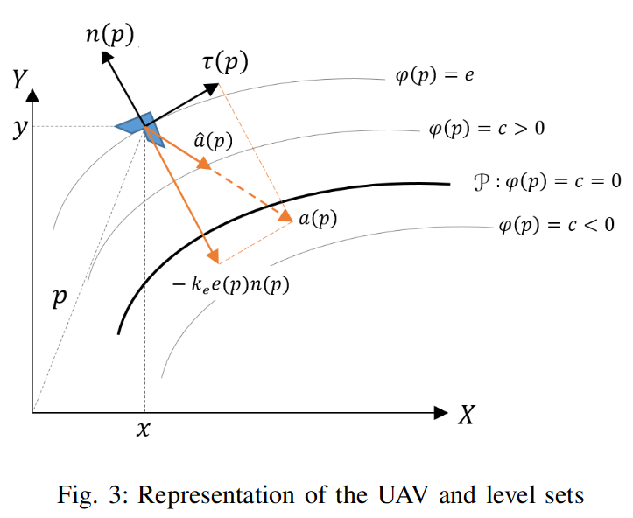
  + This can be represented in look-ahead angle as:
    - * Which is: 0 at infinite track error & PI/2 when on-track.
    - **This creates a very different look ahead angle diagram:**
      * 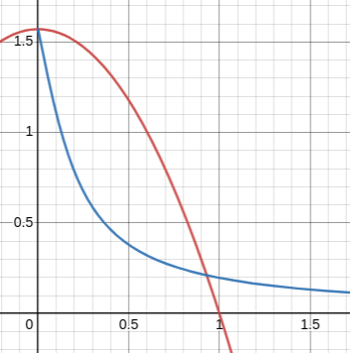
        + [Source](https://www.desmos.com/calculator/crmmc0iesc)
* 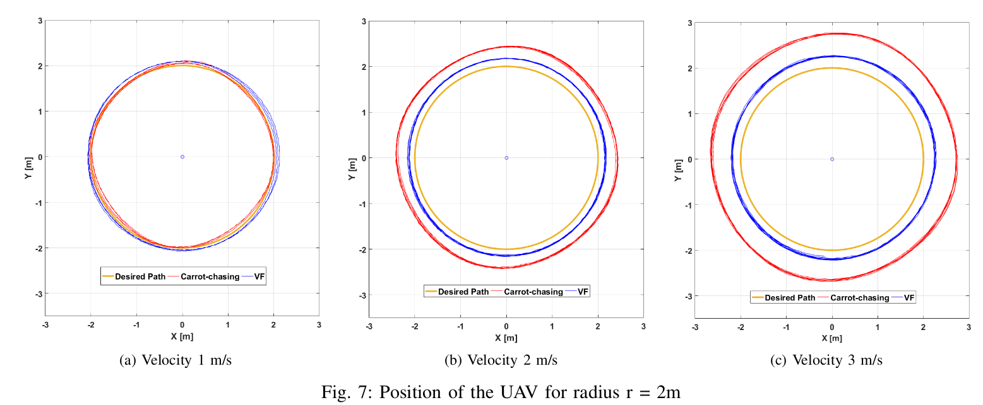
  + Quite horrible constant position error btw

**Title**: Vector field path following for small unmanned air vehicles

**Authors**: Nelson, et.al

**Link:** <http://ieeexplore.ieee.org/document/1657648/>

**Summary:** Classical Vector field based path following for straight line & orbit following

**Key Points:**

* Problem Solved: VF based path following for UAVs
* Main Contributions: Perhaps just the earliest paper implementing this method?
* Conditions: 2D plane, constant airspeed, no excess wind
* What can be improved: Consideration for maximum lateral acceleration, consideration for wind
* Stylistic comments:
  + **Good**: Table 1 for laying out variables in algorithm was helpful for understanding
  + **Bad**:

**Notes:**

* It’s nice to have ‘optimistic’ stability analysis (non excess wind), but it’s quite simple and only guarantees that vehicle will converge to path without excess wind
* Vector Fields ‘switch’ when we follow a *different path shape
  + Ah, this is the limitation of geometric classification in VF, which TJ NPFG tackled, making the path more generic (not just straight line & arcs)
* It’s interesting that even with wind, tracking error isn’t that big, since the bearings were all truly feasible. Control was in the ground ‘course’.

**Title**: On Flying Backwards: Preventing Run-away of Small, Low-speed, Fixed-wing UAVs in Strong Winds 🌬️

**Authors**: Thomas Stastny and Roland Siegwart

**Link:** <http://arxiv.org/abs/1908.01381>

**Summary notes:** Wind aware path following algorithm that can handle excess wind over the flying speed of the flying wing platform

**Notes:**

* Problem Solved: Consider excess wind (wind speed > forward flying speed) condition for NPFG path following algorithm
* Main Contributions: Relaxed Buffer zone &
* Conditions: The parameters need to be tuned properly? (E.g. ramp-in constants)
* Stylistic comments:
  + Good
    - Fig 2 was very intuitive & explained the basic assumptions / notations very precisely
    - Fig 4 was very good as well for understanding
    - Fig 8 with real flight experiment data is always cool to include, to show that it actually works in real life 😉
  + Bad
    - It was quite hard to understand Fig 3, as the plot, although showing information concisely, wasn’t so intuitive to understand (especially the beta + / - boundaries)

**Title**: 3D NPFG: Three-Dimensional Nonlinear Differential Geometric Path-Following Guidance Law

**Authors**: Namhoon Cho∗ and Youdan Kim†

**Link:** <https://arc.aiaa.org/doi/10.2514/1.G001060>

**Summary notes:** Improved NPFG with stability proof for tracking path curvature, on a generic smooth 3D-path

**Key Points:**

* Problem Solved: Limitation of pre-existing PF with only 2D paths -> 3D
* Main Contributions: Improved NPFG (L- distance based version) that is stability-proofed & simple to implement (Geometric based)
* Conditions:
  + Wind-less environment (Wind isn’t considered in Simulation at all)
  + Vehicle is in-line with the path (seems like it’s generic assumption (e.g. between Eq 26 & 27)
* What can be improved:
  + Incorporating Wind information
  + Constraint on only applying a ‘lateral’ acceleration to the inertial velocity
    - Key Question: Is ‘lateral acceleration’ to inertial velocity always feasible?
    - Even if so, is that the optimal solution for PF?
  + Airspeed setpoint manipulation (vehicle is assumed to move at a somewhat *constant speed)
* Stylistic comments:
  + **Good**: The structure is quite nice
  + **Bad**: Quite theory heavy, could have had few more diagrams for better understanding 🤔

**Notes:**

* It was super nice to come back to this paper after ~2 months, as now I had more context & overview on PF algorithms, to be able to understand the core concept behind the idea! - Jan 8, 2023
* ~~I just found it very hard to understand (although figures were nice), maybe I just need more background information!~~

### Other PF Algorithms

**~~Title~~**~~: L1 Adaptive Path-Following of Small Fixed-wing Unmanned Aerial Vehicles in Wind~~

**~~Authors~~**~~: Toufik Souanef~~

**~~Link:~~**[~~https://ieeexplore.ieee.org/document/9721593/~~](https://ieeexplore.ieee.org/document/9721593/)

**~~Summary notes:~~** ~~Paper summary in one sentence~~

**~~Notes:~~**

* ~~This was a reference for the “P.B. Sujit, et.al; Unmanned Aerial Vehicle Path Following …” paper, regarding ‘adaptive control’~~
* ~~Problem Solved: What problem did they try to solve?~~
* ~~Main Contributions: What were the main contributions?~~
* ~~Conditions: Under what conditions is the method applicable?~~
* ~~Stylistic comments: (Optional) Stylistic comments for writing your own papers (e.g. nice way to present this data in a figure, good use of algorithms, bad structure, etc. )~~

**Title**: L2+, an Improved Line of Sight Guidance Law for UAVs 🎟️

**Authors**: Renwick Curry1, Mariano Lizarraga, et al

**Link:** <https://ieeexplore.ieee.org/document/6579804>

**Summary notes:** Improved L1 distance manipulation based on ground speed &

**Notes:**

* Problem Solved: Improve the shortcomings of the pre-existing L1 guidance logic
* What were the main contributions?
* Personal summary - rewrite the abstract for yourself, ideally in a way that you think is simple and precise
* Under what conditions is the method applicable?
* Style
  + Good: Contrast to the original L1 guidance logic’s behavior made it intuitive to compare the path following behavior
  + Bad: Wind directions in the figures aren’t so clear, would have been nice to have a graphical representation, instead of explaining in the text.

**Title**: L1: A New Nonlinear Guidance Logic for Trajectory Tracking 🕊️

**Authors**: Sanghyuk Park,∗ John Deyst,† and Jonathan P. How‡

**Link:** <https://arc.aiaa.org/doi/10.2514/6.2004-4900>

**Summary notes:** Simplistic look-ahead vector based path following guidance using lateral acceleration command | L1 guidance!

**Notes:**

* What problem did they try to solve?
* Main Contributions: Simple and intuitive guidance logic that is easily applicable for fixed-wing vehicles (lateral acceleration)
  + Analysis of the guidance law’s similarity in Circular / Linear trajectory to a pre-existing missile guidance logic & PD controller
* Conditions: No wind?
* Stylistic comments:

# VTOL Control

**Title**: Title of paper

**Authors**: Authors of paper

**Link:** Link to paper

**Summary notes:** Paper summary in one sentence

**Notes:**

* What problem did they try to solve?
* What were the main contributions?
* Under what conditions is the method applicable?
* (Optional) Stylistic comments for writing your own papers (e.g. nice way to present this data in a figure, good use of algorithms, bad structure, etc. )