UNIVERSITI MALAYSIA SARAWAK
Faculty of Computer Science and Information Technology
TMA3084 Software Engineering Laboratory | Semester 1, 2026/2027
PROJECT PROPOSAL
(Product Requirements Document)
<Mobile App Development (HOLLYBIZ)>
Group Number / Name | Group 01_T15 – TeamNEWBEE
Lab Group / Demonstrator | Group 1 Aminul Islam Rakib
Client / Organisation | Kellt Then, Owner, Holly Burger
Lecturer | Mdm. Nurfauza Jali
GitHub Repository | https://github.com/junxiang2004/Project-TMA3084-App-Develop-For-Burger.git
Version / Date | v1.0 (original) –17/10/2026

Team Members
No. | Name | Matric No. | TSPi Role | Signature
1 | Jong Jun Xiang | 104582 | Project Manager | 
2 | Ling Han Lun | 104773 | Quality Assurance & CI/CD Engineer | 
3 | Tang Yong Sheng | 102992 | Lead Mobile Architect (Flutter/Dart) | 
4 | Khiew Jung Huat | 104669 | Lead Systems Analyst & Requirements Engineer | 
5 | Sii Jong Ming | 106335 | Backend & AI Integration Specialist | 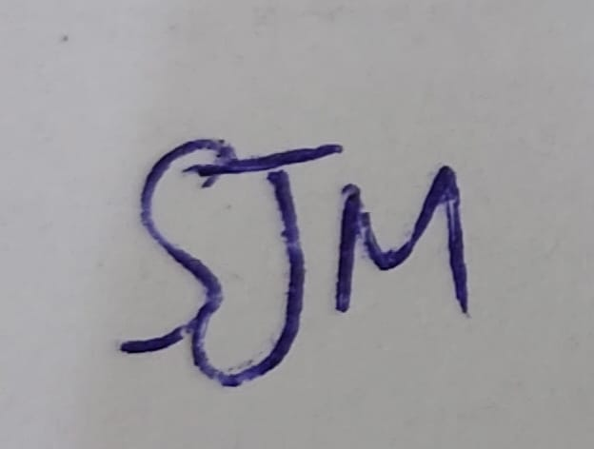

Declaration
By signing above, we certify that this proposal is our own work, that all external sources, libraries, APIs and AI-assisted content are acknowledged, and that we have not engaged in plagiarism or unauthorized collusion (Peraturan Akademik UNIMAS, Etika Akademik). AI tool usage is recorded in LOGAI.
Table of Contents
Abstract 4
1. Introduction 4
1.1 Client Background 4
1.2 Team Background 4
2. Problem Statement 4
3. Project Objectives & Success Metrics 4
4. Project Perspective 5
4.1 Target Users 5
4.2 System Context and Architecture 5
5. Project Scope 5
5.1 In Scope / Out of Scope 5
5.2 Features and User Stories 5
5.3 AI Feature 6
5.4 Non-Functional Requirements and Constraints 6
5.5 System Environment 6
6. Task Allocation & Team Contribution 7
7. Team Goals 7
8. Expected Results 7
8.1 Working System 7
8.2 Documentation and Artefacts 7
9. Project Planning 8
9.1 Methodology 8
9.2 Submission Schedule 8
9.3 Development Milestones (GitHub) 8
9.4 Risks and Assumptions 9
10. References 9
Appendix A: Client Meeting Evidence 10
Appendix B: Revision History 10

List Of Figure
Figure 1:Logo of Holly Burger 4
Figure 2: Logo For NEWBEE 4
Figure 3:High Level Architecture Diagram 7
Figure 4: Gantt Chart 13

List of Tables
Table 1 Summary of client problems 6
Table 2 Project objectives and success metrics 7
Table 3 Target users 7
Table 4 Scope boundary 8
Table 5 Features and user stories 9
Table 6 AI feature summary 10
Table 7 Non-functional requirements and constraints 10
Table 8 System environment 10
Table 9 Task allocation and contribution 11
Table 10 Team goals 12
Table 11 Deliverables 12
Table 12 Submission schedule 13
Table 13 Development milestones 13
Table 14 Risks and assumptions 14

Abstract
PRD section: Executive Summary / TL;DR Rubric link: Clarity & presentation
This project aims to develop a Flutter-based mobile application for Holly Burger to improve inventory management, daily sales recording, product costing, and event-based financial tracking. Currently, the business owner faces several challenges, including difficulties in calculating daily sales, identifying best-selling products, monitoring stock quantities and expiration dates, and determining individual product costs and profits. In addition, calculating total income and expenses after each event can take several days, while large amounts of financial data and missing historical records make business performance analysis and comparison more challenging. To address these issues, the proposed application will provide features for inventory tracking, automated sales and profit calculations, product cost estimation, and event-based financial management. The system will also generate charts to visualise business performance and allow comparisons between current and previous event records. Furthermore, a cloud-based Generative AI feature will analyse financial data, identify changes in revenue, expenses, and profit, and provide possible explanations and recommendations for improvement. The expected outcome is a user-friendly mobile application that reduces manual calculation effort, improves record organisation, and supports more informed pricing and business decisions for Holly Burger.

1. Introduction
PRD section: Background & Context Rubric link: Background (Section A)
Managing daily operations and financial records is an important part of running a food business. For businesses such as Holly Burger, keeping track of inventory, sales, and expenses is necessary to maintain smooth operations and understand business performance. This becomes particularly important when participating in different events, as each event involves different sales results and operating expenses. Without well-organised records, reviewing financial information and evaluating business performance can become challenging.

To support Holly Burger's business operations, this project proposes the development of a mobile application that provides a more organised and accessible way to manage business information. A mobile-based solution is suitable for the owner as it allows business records to be accessed and updated using a smartphone, including during events. Through this project, the development team aims to apply software engineering principles to design a practical system that meets the client's business needs.

1.1 Client Background
Holly Burger is a food and beverage (F&B) business established in 2023. The business mainly operates by participating in food-related events and festivals, such as Kuching Festival and Oktoberfest, where it sells its products to customers. The client contact person is Kelly Then, one of the business owners, who manages the business together with another partner. Both owners are the intended users of the proposed mobile application, which is designed to support their daily business operations and management activities.
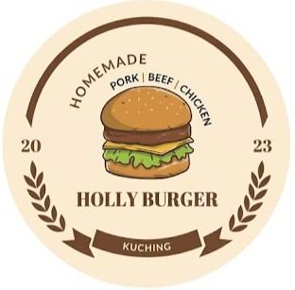
Figure 1:Logo of Holly Burger

1.2 Team Background
Our team, NEWBEE, is a group of students from the Faculty of Computer Science and Information Technology at Universiti Malaysia Sarawak (UNIMAS). Our team motto is "Ctrl+C, Ctrl+Bee!", reflecting our playful team spirit and enthusiasm for learning. We have foundational knowledge in programming, system analysis, database management, and software engineering, which we aim to apply throughout this project.
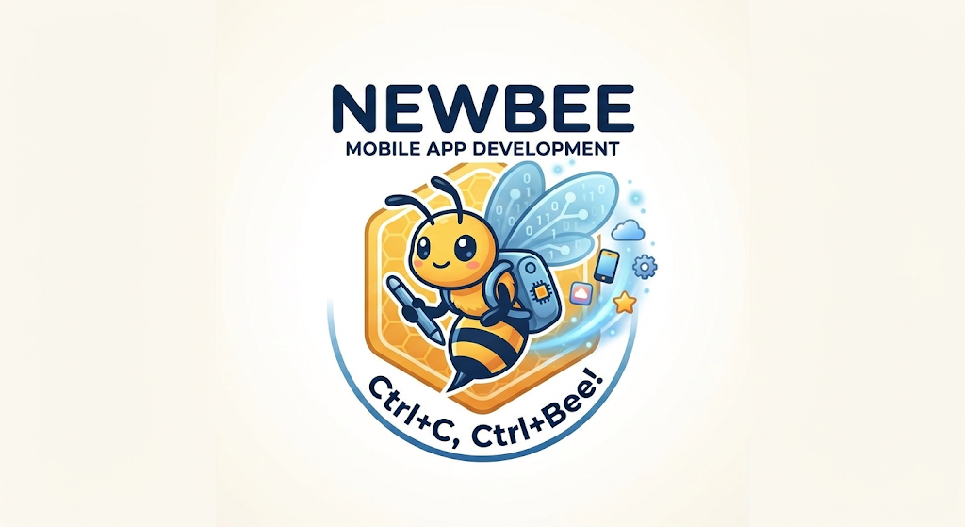
Figure 2: Logo For NEWBEE

2. Problem Statement
PRD section: Problem & Opportunity Rubric link: Objectives / constraints analysed
ID | Current process / problem | Impact on client | Evidence (source)
P1 | Orders recorded on paper. | Difficult to calculate sales and identify best-sellers. | Client interview, 10/10
P2 | Stock quantities and expiry dates are easily overlooked. | Difficulty managing inventory. | Client interview, 10/10
P3 | Difficult to calculate individual product costs. | Difficulty estimating profits and setting prices. | Client interview, 10/10
P4 | Event financial calculations take several days. | Delayed profit calculation. | Client interview, 10/10
P5 | Only one person handles accounting and large amounts of data. | Heavy workload and difficulty analysing business performance. | Client interview, 10/10
P6 | Previous sales records may be lost. | Difficulty comparing event performance. | Client interview, 10/10
Table 1 Summary of client problems
Proposed Solution:
A Flutter-based mobile application is proposed to help Holly Burger manage inventory, track daily sales, calculate product costs and event profits, and visualise business performance. The system will also integrate AI-powered analysis to compare financial records and provide recommendations for business improvement.

3. Project Objectives & Success Metrics
PRD section: Goals & Success Metrics Rubric link: Objectives well defined and prioritised
No. | Objective | Solves | Success metric (how we measure) | Priority
O1 | To study and analyse Holly Burger's current business operations and financial management processes. | All | Client-reviewed and approved software requirements documented in the SRS. | High
O2 | To design and develop a Flutter mobile application for inventory, sales, product costing, and event financial management. | P1-P4 | All Must-have FRs pass acceptance tests | High
O3 | To integrate an AI feature that analyses business performance and provides recommendations based on historical financial records. | P5 | e.g. ≥80% correct classification on test set | High
O4 | To test and evaluate the application's functionality, usability, and reliability with the client. | All | ≥50 test cases, ≥60% coverage, UAT sign-off | Medium
Table 2 Project objectives and success metrics

4. Project Perspective
PRD section: Target Users & System Context Rubric link: Information obtained and analysed

4.1 Target Users
User type | Description | Main needs / goals | Device / tech level
Accountant(owner) | One of the business owners is responsible for recording and managing Holly Burger's financial transactions. | Efficiently record business income and expenses, access previous financial records, and reduce the risk of data loss. | Android phone, basic
Business Owner | The other owner involved in managing daily business operations. | Monitor inventory, track sales, review financial records, and view business performance. | Android phone, basic
Table 3 Target users

4.2 System Context and Architecture
This app will replace the client’s current method of managing the business which mainly uses paper to record.
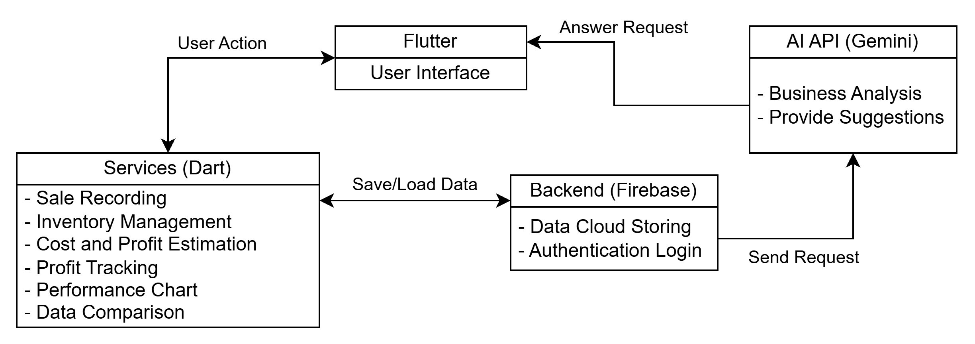
Figure 3:High Level Architecture Diagram
Flutter will be used as to make the front end part for the system, which is the user interface. Dart will be the programming language used for the backend design which are the services in the apps. Firebase is used for the backend design to store the data: sales, inventories, cost, and profit. Using these data can then create performance chart and compare the data. The AI will be using the data stored to do the business analysis and provide suggestions based on the data to let the client know what can be done to improve the business.

5. Project Scope
PRD section: Scope, Features & Requirements Rubric link: Design recommendations supported

5.1 In Scope / Out of Scope
In scope (will deliver this semester) | Out of scope (will not deliver)
Inventory management, including stock quantities and expiry dates. | Barcode scanning and automatic stock counting.
Daily sales recording and best-selling product tracking. | Automatic sales recording through a POS system.
Product cost calculation and estimated profit based on selling price. | Automatic updates of ingredient prices from suppliers.
Event income, expense, and profit tracking. | Automatic import of expenses from bank transactions or receipts.
Business performance charts and historical record comparison. | Automatic recovery of lost paper records.
AI-powered financial analysis and business recommendations. | AI prediction of future sales and profits.
Table 4 Scope boundary

5.2 Features and User Stories
FR-ID | Module | User story (As a … I want … so that …) | Priority
FR-01 | Inventory Management | As an owner, I want to record stock quantities and expiry dates so that I can manage inventory effectively. | Must
FR-02 | Sales Management | As an owner, I want to record daily sales by product type so that I can track sales and identify best-selling products. | Must
FR-03 | Product Costing | As an owner, I want to calculate production costs based on ingredients so that I can determine the cost of each product. | Must
FR-04 | Profit Estimation | As an owner, I want to calculate estimated profits based on selling prices so that I can make better pricing decisions. | Must
FR-05 | Event Financial Management | As an accountant, I want to record income and expenses for each event so that I can calculate the total event profit. | Must
FR-06 | Financial Records | As an accountant, I want to access previous financial records so that I can review past transactions without losing important information. | Must
FR-07 | Business Dashboard | As an owner, I want to view charts of revenue, expenses, and profits so that I can understand business performance easily. | Should
FR-08 | Performance Comparison | As an owner, I want to compare financial records between events so that I can identify changes in business performance. | Should
FR-AI-01 | AI Business Analysis | As an owner, I want AI to analyse financial trends and provide recommendations so that I can make better business decisions. | Must
Table 5 Features and user stories

5.3 AI Feature
The proposed system will integrate a cloud-based Generative AI feature to analyse Holly Burger's financial performance. The AI will compare financial records from different events, identify changes in revenue, expenses, and profit, and provide possible explanations for these changes based on the available data. It will also generate recommendations to help the owner understand business performance and make better financial decisions.
Item | Description
AI capability | Financial data analysis and business recommendations.
User value | Helps the owner understand business performance and compare previous event records (P5, P6).
Input → Output | Event revenue, expenses, and profit records → AI-generated analysis, explanations, and recommendations.
AI service / API | Gemini
Constraints | API costs, internet connection, response time, data privacy, and API key protection.
Table 6 AI feature summary

5.4 Non-Functional Requirements and Constraints
NFR-ID | Category | Requirement / constraint | Target
NFR-01 | Performance | Main screens load quickly | Within 3 s
NFR-02 | Security | API keys never stored in source code | 0 secrets in repo
NFR-03 | Usability | User easy to use | Users can complete key tasks without assistant
NFR-04 | Data Reliability | Store data securely and retrieve it correctly when needed. | 100% save the input data and can be retrieve without data loss
NFR-05 | Compatibility | Support user device | Works on agree target device.
Table 7 Non-functional requirements and constraints

5.5 System Environment,
Layer | Technology / tool | Justification
Mobile app | Flutter (Dart 3), Material 3 | Course requirement; cross-platform
State management | Provider | Easier to use
Backend / database | Firebase Auth + Cloud Firestore | Store and retrieve business records.
AI service | Gemini | Analyse financial data and provide recommendations.
Version control & CI | GitHub, GitHub Actions | Easier teamwork
Target devices | Android 8.0+ phones | Support user device
Table 8 System environment

6. Task Allocation & Team Contribution
PRD section: Team & Stakeholders (RACI) Rubric link: Project breakdown; team work
Member | TSPi role | Owned features (FR-IDs) | Other responsibilities / contribution
Jong Jun Xiang | Team Leader | FR-AI-01 | Host weekly meetings, manage the member
Tang Yong Sheng | Development Manager | FR-01, FR-02 | architecture, code review
Khiew Jung Huat | Planning Manager | FR-03, FR-04 | TASK / SCHEDULE, GitHub board
Ling Han Lun | Quality/Process Manager | FR-07, FR-08 | LOGTEST, CI, coverage
Sii Jong Ming | Support Manager | FR-05, FR-06 | repo setup, LOGAI, tools
Jong Jun Xiang | Client Liaison / Developer | FR-AI-01 | client meetings, UAT
Table 9 Task allocation and contribution

7. Team Goals
PRD section: Team Working Agreement Rubric link: Team work
No. | Team goal | Measure
G1 | Develop an application meets client requirement | All features pass the acceptance test
G2 | Complete project tasks on schedule, well manage project develop process. | Every milestone delivered on time
G3 | To ensure effective teamwork and collaboration among all team members. | All members attend 90% of group meeting and complete the asigned task.
G4 | Keep the client engaged with the team | Hold client meetings at least once every two weeks.
Table 10 Team goals

8. Expected Results
PRD section: Release Criteria / Deliverables Rubric link: Decisions supported by information

8.1 Working System

The expected outcome of this project is a functional Flutter-based mobile application designed for Holly Burger's business owners. The system will allow users to manage inventory, record daily sales, calculate product costs and estimated profits, and track income and expenses from different events. It will also provide financial charts and historical record comparisons. An AI-powered analysis feature will help users understand business performance and provide recommendations based on financial data. The final release will include an Android APK (v1.0.0) and client UAT sign-off.

8.2 Documentation and Artefacts
Deliverable | Submitted with
Project Proposal (original) | Proposal Submission (Week 4)
Revised Proposal and Software Requirements Specification (SRS) | Initial Report (Week 9)
Runnable prototype (4–5 screens), tagged release | Demo 1 (Week 9)
Software Design Specification (SDS), test plan and results (LOGTEST), user manual, maintenance plan, client acceptance form | Final Report (Week 13)
Release APK, demo video (5–10 min), presentation slides | Final Demo 2 (Week 14)
GitHub repository and complete project file | e-Archive (Week 15)
TSPi forms (LOGT, LOGD, LOGAI, SCHEDULE, SUMP, SUMQ, SUMS, SUMTASK, WEEK, PEER) and meeting minutes | Ongoing; compiled in Final Report
Table 11 Deliverables

9. Project Planning
PRD section: Milestones, Timeline & Risks Rubric link: Methodology to be followed

9.1 Methodology

The NEWBEE team will adopt the Agile Scrum methodology to develop the Holly Burger mobile application through two-week sprints. Each sprint will focus on developing and testing assigned features, allowing the team to review progress and make improvements based on client feedback. Team members will follow their assigned TSPi roles to ensure clear responsibilities and effective collaboration. GitHub will be used to manage tasks through Issues, feature branches, Pull Requests (PRs), peer reviews, and automated testing using GitHub Actions.

9.2 Submission Schedule
Phase | Deliverable | Week | Due
Phase 1: Planning & Development | Proposal Submission | 4 | 16 Oct 2026
 | Proposal Presentation | 5 | 16 – 25 Oct 2026
 | Initial Report | 9 | 16 Nov 2026
 | Demo 1 | 9 | 16 – 20 Nov 2026
Phase 2: Finalisation & Closure | Final Report | 13 | 24 Dec 2026
 | Final Demo 2 | 14 | 28 – 31 Dec 2026
 | e-Archive | 15 | Before 10 Jan 2027
Table 12 Submission schedule

9.3 Development Milestones (GitHub)
Milestone | Week | Key output | Status
M1 – Scope & Requirements | 4 – 5 | GitHub repo, issue board, CI file; proposal and initial SRS in /docs | In Progress
M2 – Design & Prototype | 9 | SDS draft, 4–5 screen prototype, green CI, v0.2.0 tag | Not started
M3 – Product & Verification | 13 | ≥50 tests, ≥60% coverage, AI feature working | Not stared
M4 – Final Release & Acceptance | 15 | Release APK v1.0.0, client sign-off, e-Archive | Not started
Table 13 Development milestones

Figure 4: Gantt Chart

9.4 Risks and Assumptions
ID | Risk / assumption | Likelihood | Impact | Mitigation
R1 | Client unavailable for meetings | Medium | High | Arrange meetings in advance and communicate online when necessary.
R2 | AI API usage limits or unexpected costs. | Medium | Medium | Monitor API usage and minimise the unnecessary use
R3 | Lack of proffesional ability skill e.g. flutter and dart. | High | High | Follow toturial make more practice and guide by lucture
R4 | Delay in completing task | Medium | High | Track progress using Github and having a group meeting once a week for task progress tracking
Table 14 Risks and assumptions

10. References
GeeksforGeeks. (2024, July 15). How to draw high level design diagram? GeeksforGeeks. https://www.geeksforgeeks.org/system-design/how-to-draw-high-level-design-diagram/
Holly Burger [@hollyburger_kch]. (n.d.). Posts [Instagram profile]. Instagram. https://www.instagram.com/hollyburger_kch/

Appendix A: Client Meeting Evidence
The Project Manager met with the representative of Holly Burger to introduce the TMA3084 Software Engineering Laboratory project and discuss the possibility of developing a mobile application for the business. The main purpose of the meeting was to confirm the client's willingness to participate in the project and cooperate with the development team.
In this meeting client agreed to participate in the project. The development team will arrange a follow-up interview to gather detailed business requirements. And further discussions will be conducted to understand the client's business operations and expectations.
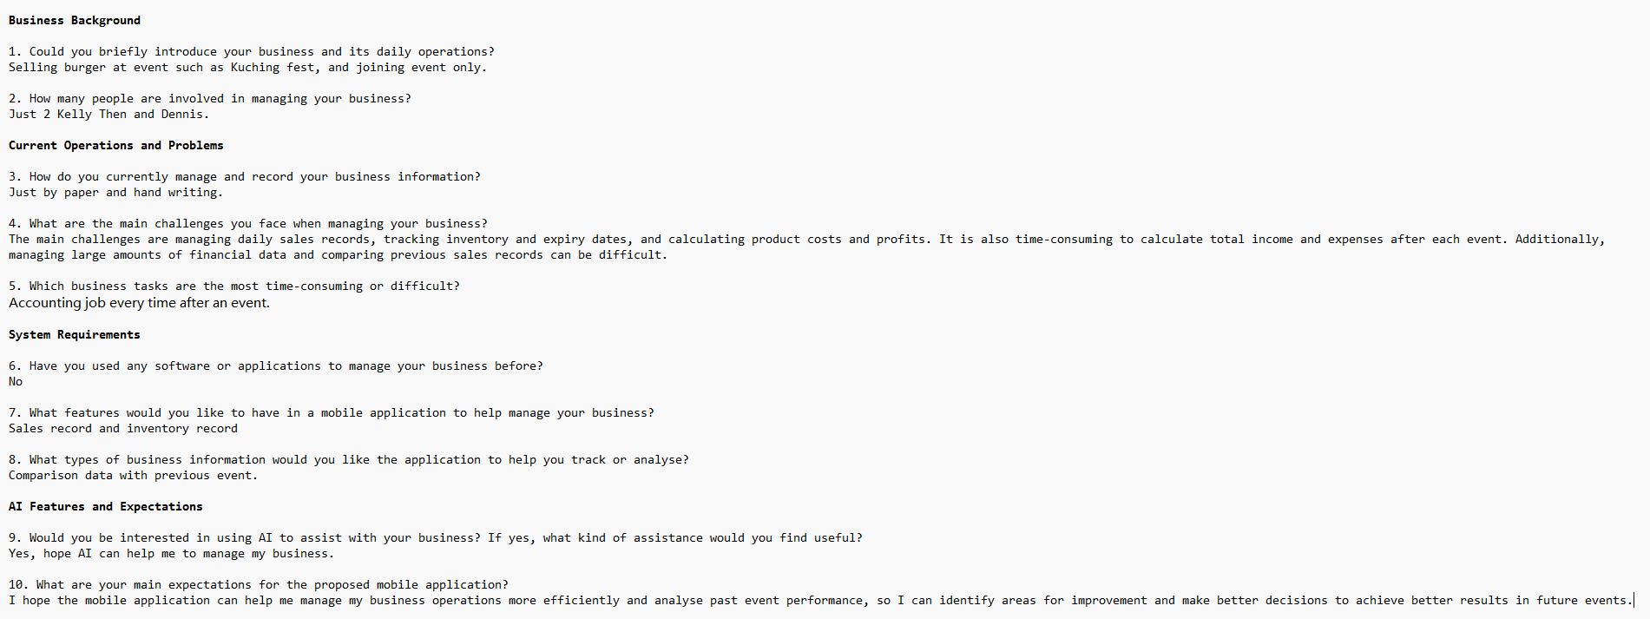

Appendix B: Revision History
Version | Date | Changes (e.g. after proposal presentation feedback) | By
1.0 | 17 Oct 2026 | Original submission | Jong Jun Xiang & Ling Han Lun
1.1

