Impact of Heart Disease Indicators on Machine Learning Predictions
Tan Jun Xian

Master of Science in Artificial Intelligence

The University of Texas at Austin

Abstract
Cardiovascular disease, or heart disease, has been the leading cause of deaths worldwide [1]. This has led to several organizations doing research into early assessments or detections of heart disease, so that early treatment can be done. This in turn can potentially reduce the mortality rate [2][3]. This study will investigate the effects of different heart disease indicators, which will be used with machine learning methodologies to perform early prediction of heart disease. In addition, a Large Language Model will be integrated with the heart prediction model, to assist in explaining the symptoms, giving additional insights, or recommendations to reduce heart disease based on the symptoms. The code repository is private and access can be granted upon request at https://github.com/junxiant/Heart-Disease-Screening

Introduction
Heart disease is the leading cause of mortality globally. In central and eastern europe, and central asia, heart disease contributes to the high levels of mortality rate globally [4]. Early detection of heart disease is crucial for patients to start their treatments early, which can potentially reduce the mortality rate [27].

In recent years, machine learning, and artificial intelligence has gained popularity and interest around the world. Several researchers have taken the task of using machine learning techniques to analyze medical data for prediction of diseases [5][28].

The purpose of this study is to investigate the effects of different heart disease indicators, and the performance of machine learning methodologies used to predict heart disease. The goal is to find the best performing machine learning algorithm, and to perform data analysis of the heart disease indicators, to find the important features. This will include machine learning algorithms such as:
- Logistic Regression
- Decision Tree
- Random Forest
- K-Nearest Neighbors
- XGBoost

Additionally, Large Language Models (LLMs) such as GPT-3 [31] have been trending due to the increased usage of conversational chatbots. A trained LLM, Me llama [36] will be used in this study to assist in explaining the input features, or the symptoms of heart disease, and to generate recommendations based on the heart disease risk, as predicted by our machine learning model.

Background
There has been much research and studies using machine learning and artificial intelligence in the medical industry. For example, Ramesh et al. (2022) [5] conducted a predictive analysis of using machine learning algorithms for heart disease. This includes using decision trees, informative gain value, naive bayes, random forest, k-nearest neighbor, support vector machine, logistic regression to do heart disease prediction. This includes using an online public dataset provided by UCI machine learning repository [6]. This study has proved to produce a comparable result with an area under curve (AUC) between 0.799 to 0.898.

Another study, Fahd et al. (2019) [7], also aimed to use different machine learning algorithms, such as decision tree, logistic regression, random forest, naive bayes, and support vector machine. The dataset used was the same provided by UCI [6], it produced results between accuracy of 0.8736 to 0.9319.

In recent studies, LLMs have been used for applications in healthcare settings. A research was done to review the application of LLMs in medicine [33], which includes generating medical documents, and increasing the efficiency of medical workflows. One such specific example would be using LLM to do a radiology report generation task [34], which does a multi-modal task of combining visual and text embeddings.

Methodology

3.1. Data
The datasets used were obtained from the UCI data repository [6], and the CDC annual data collection [8][9]. The CDC annual data has been preprocessed and filtered, provided in a kaggle repository [10]. Both of these datasets contain features, or indicators for heart disease. As data analysis is a crucial part of the machine learning process [29], it will be performed on these datasets to help us understand the features and its distribution.

3.1.1. 2020 CDC Annual Data
From the age distribution, we can see that the majority is between the ages of 60 to 70. The BMI distribution also suggests that the average of the people in this dataset are obese. Then, a simple feature correlation analysis with respect to heart disease is done, which tells us that age, difficulty walking, stroke, diabetic features have strong correlation with heart disease. And by leveraging Random Forest, the classifier also picked out the BMI feature to be strongly correlated with heart attack. As with the data distribution, it is very imbalanced as seen on the bar plot.

Table 1. Data Exploration for 2020 CDC Data
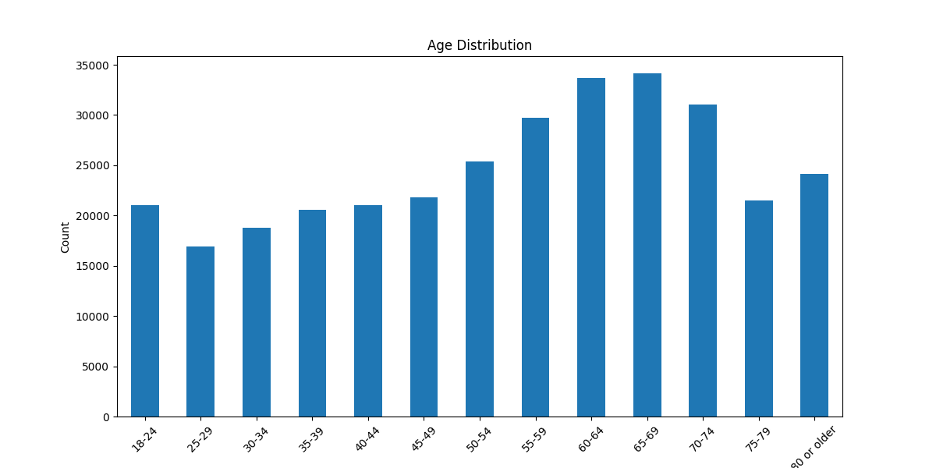 | 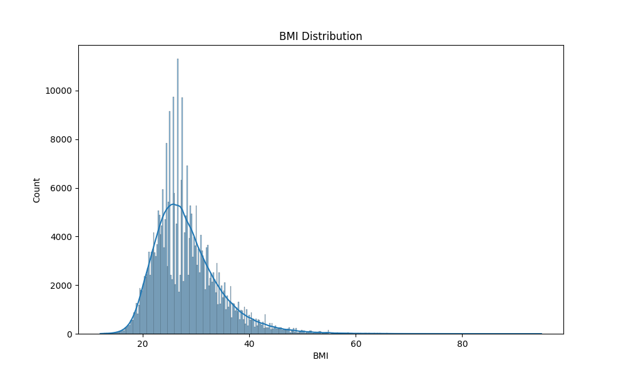
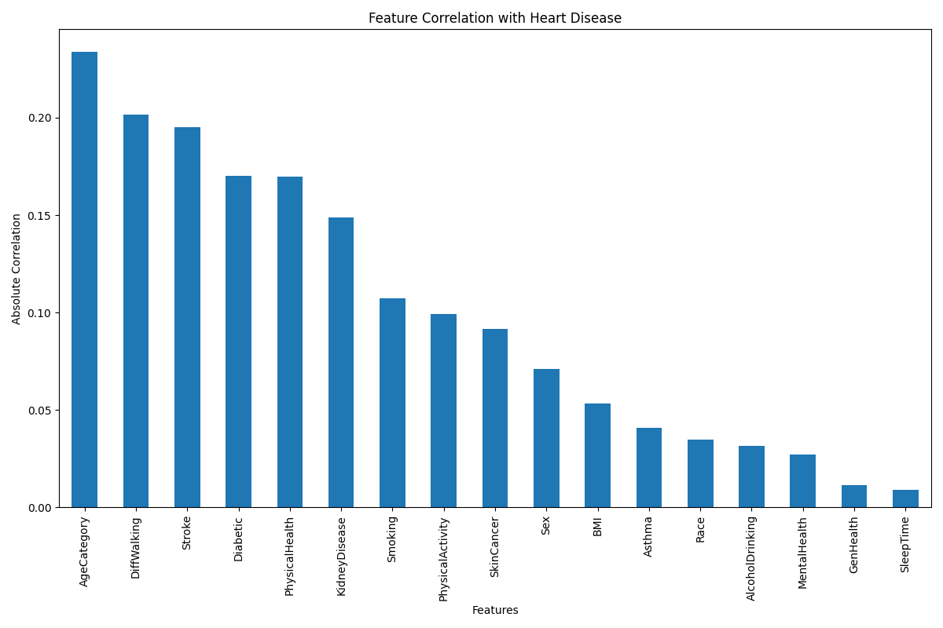 | 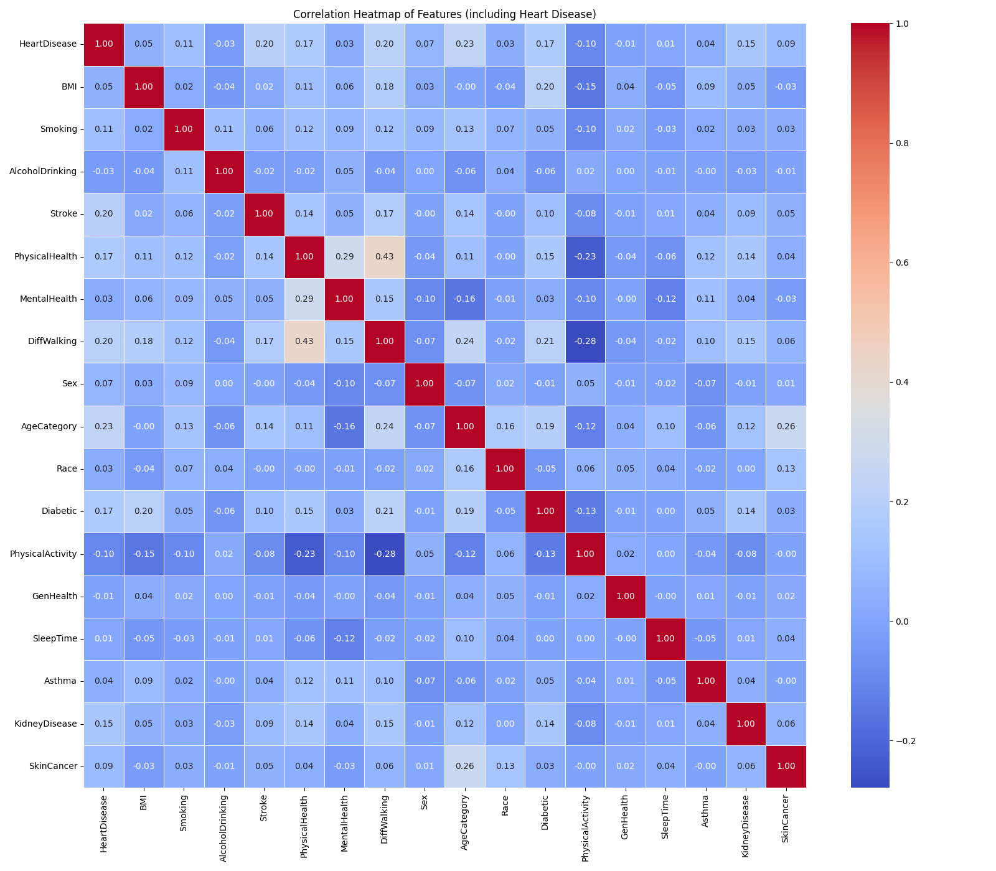
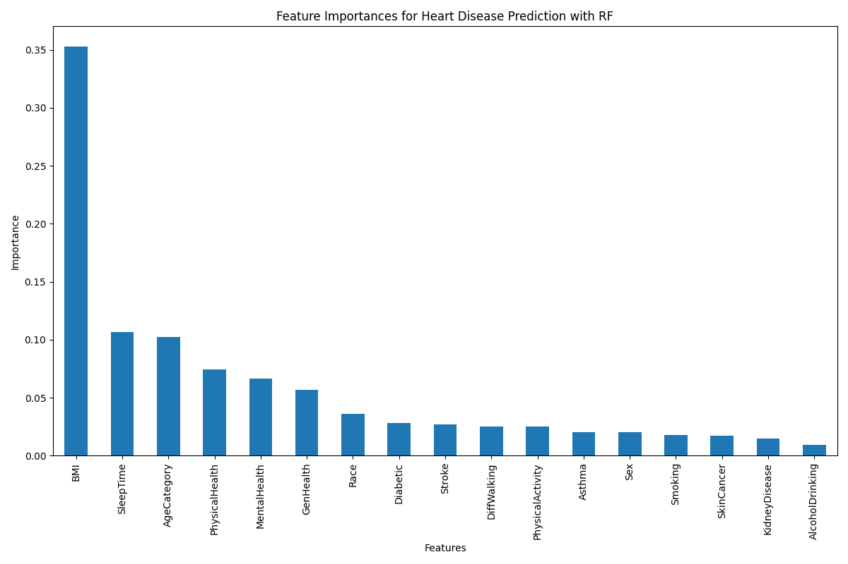 | 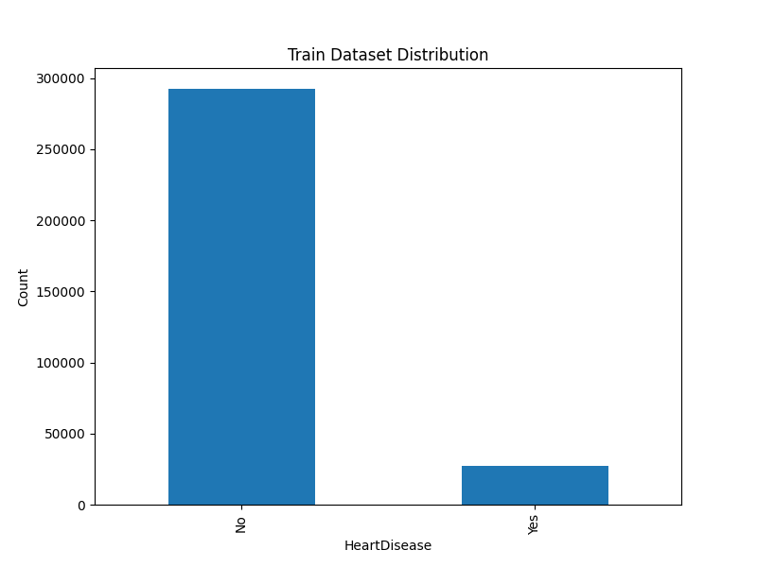

3.1.2. 2022 CDC Annual Data
For the 2022 CDC data, it can also be seen that the majority of the age is also between 60 to 70. The average BMI is also around 30, which is obese. From the feature correlation, the presence of angina has the highest correlation, followed by stroke, age. With Random Forest’s feature importance, the presence of angina is also the highest, followed by BMI, weight. The dataset is also very imbalanced as seen from the chart.

Table 2. Data Exploration for 2022 CDC Data
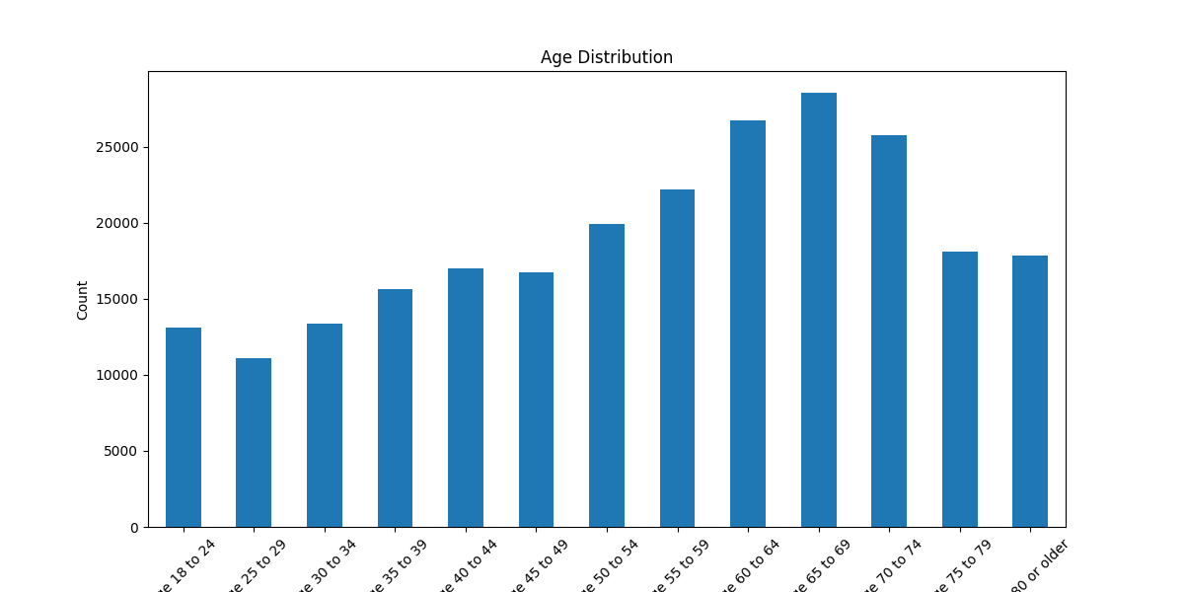 | 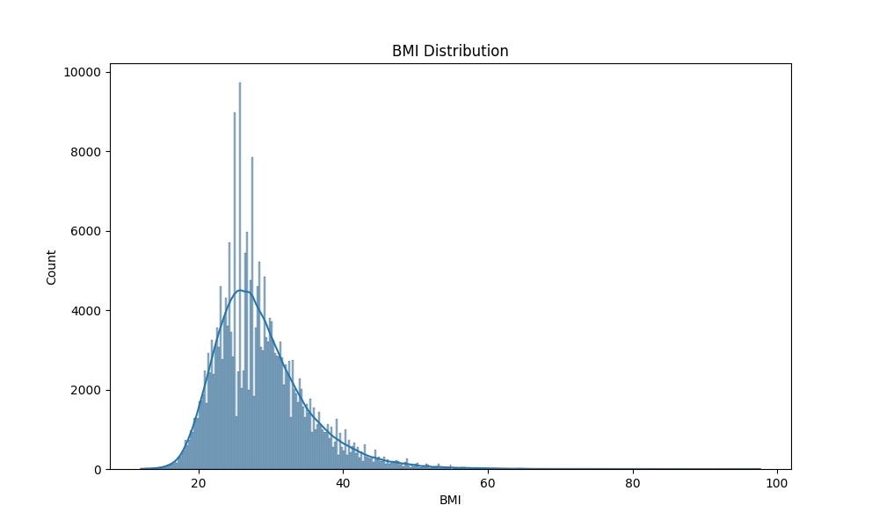
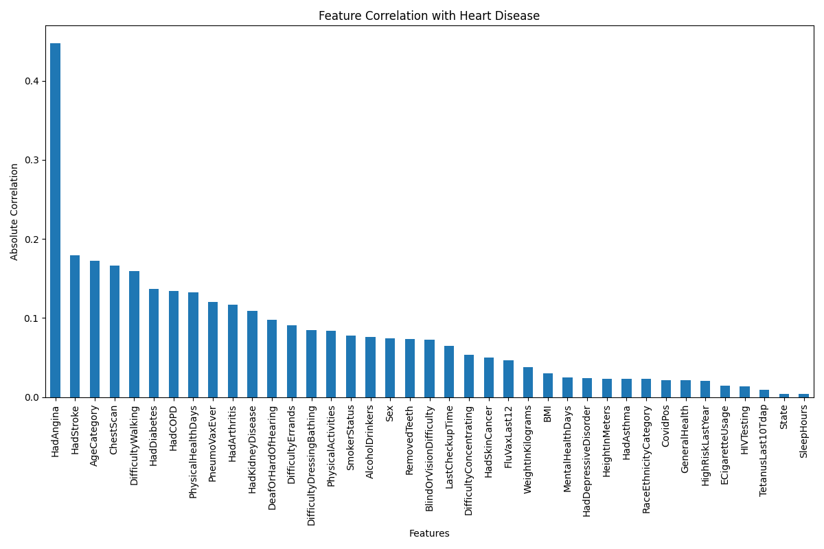 | 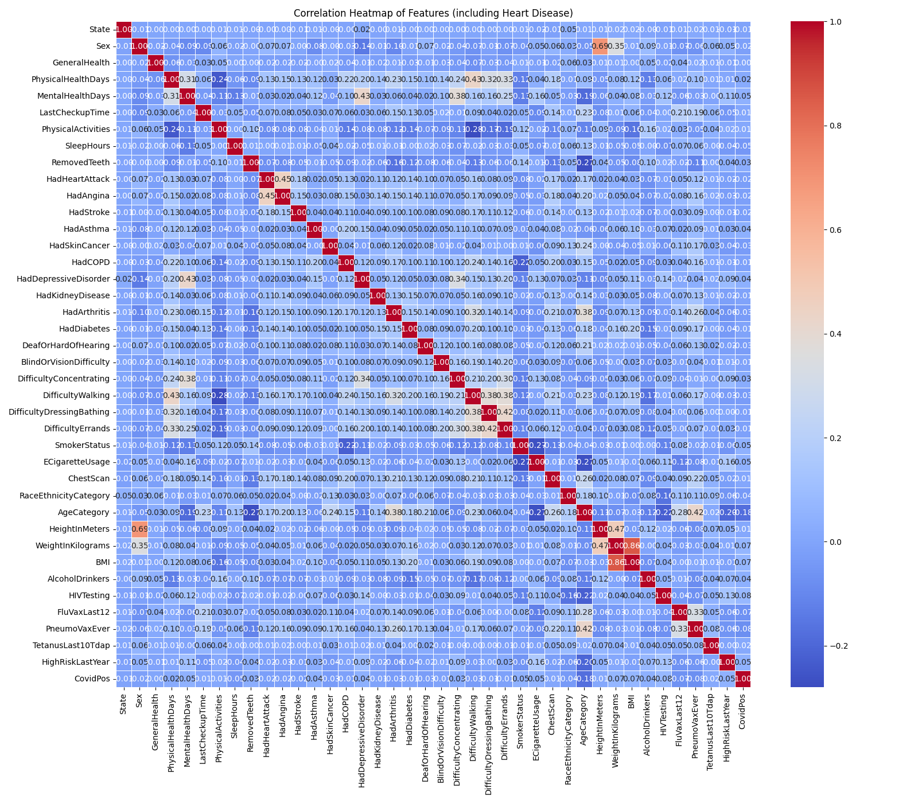
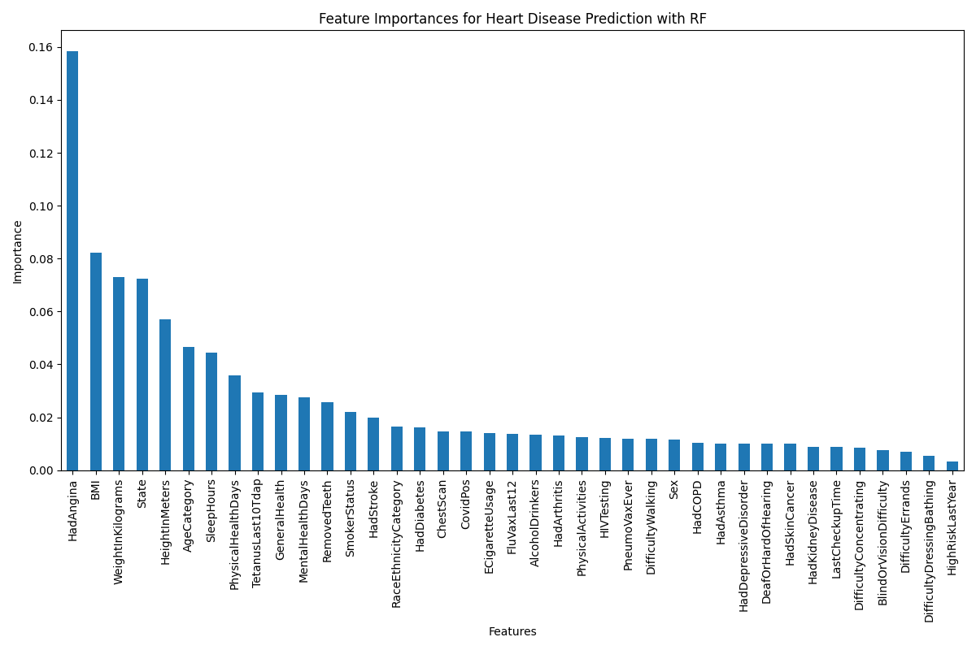 | 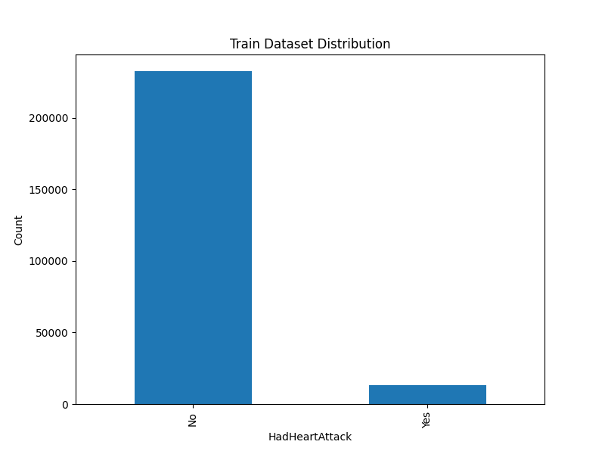

3.1.3 UCI Data
The UCI dataset is much smaller than the CDC annual data, the features are also different, as it contains more technical heart related data such as fbs (fasting blood sugar), restecg (resting electrocardiographic), cp (chest pain type), chol (cholesterol), trestbps (resting blood pressure), thalach (maximum heart rate achieved), exang (exercise induced angina), thal (thalassemia blood disorder), slope (slope of the ecg during exercise).

From the age distribution, the average age is between 52 to 60. The average cholesterol is also high, although BMI is not provided, we can infer that this could be due to obesity. The correlation plot also shows that the exang, cp, slope, age, sex, fbs, all gave a strong correlation with respect to heart disease. With Random Forest’s feature importance ranking, it showed that the age, cp showed strong correlation. This dataset is much more balanced although it contained more positive than negative heart disease.

Table 3. Data Exploration for UCI Data
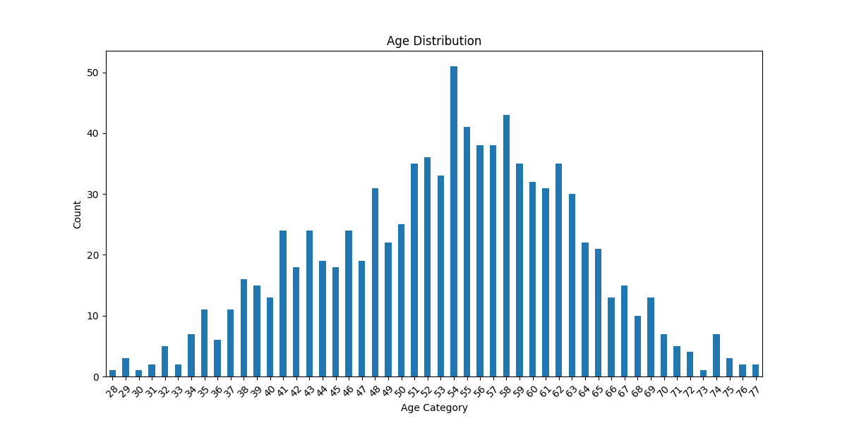 | 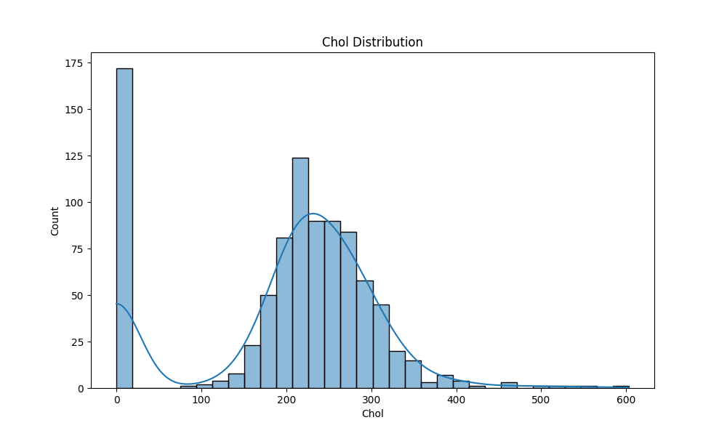
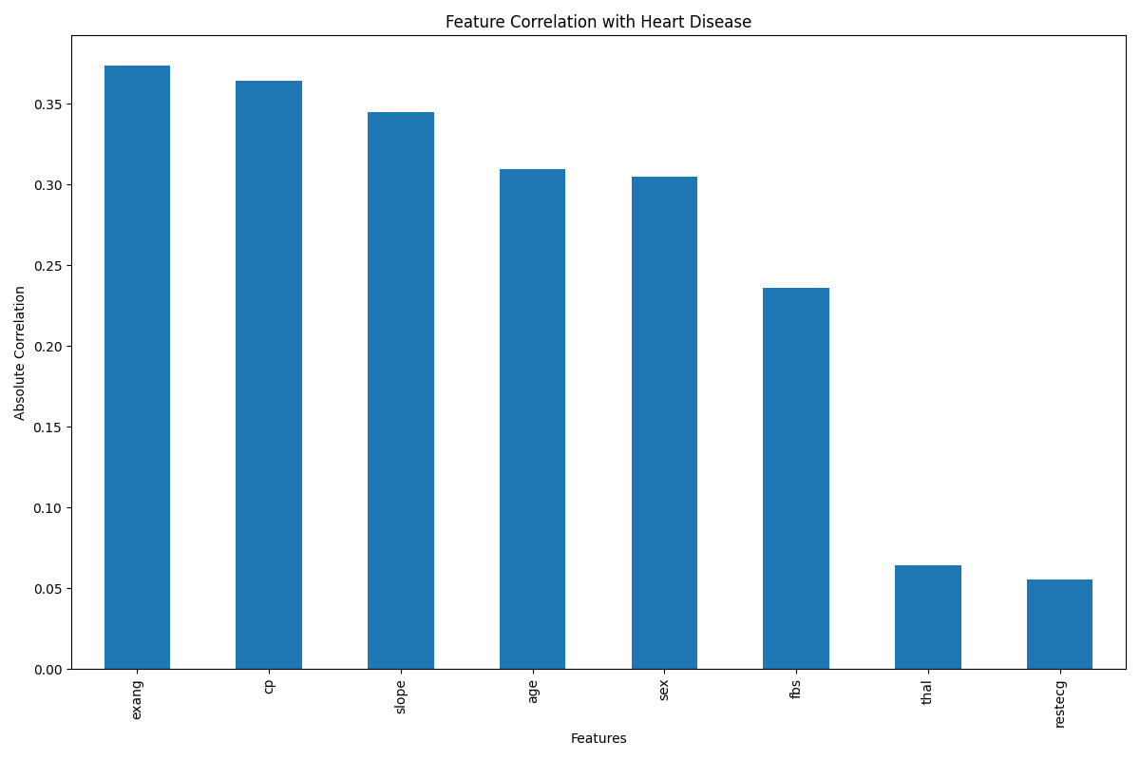 | 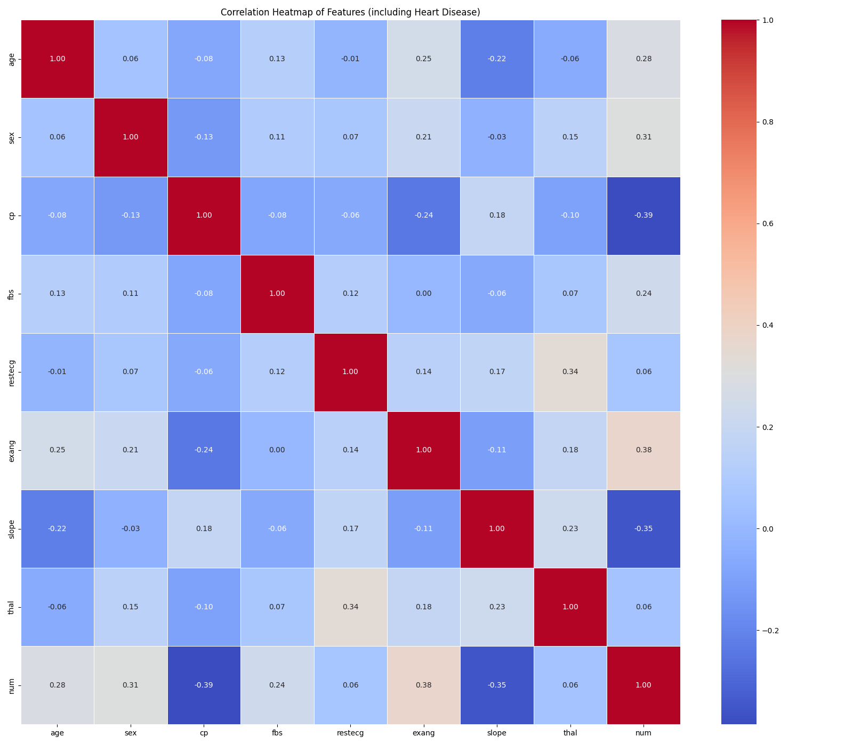
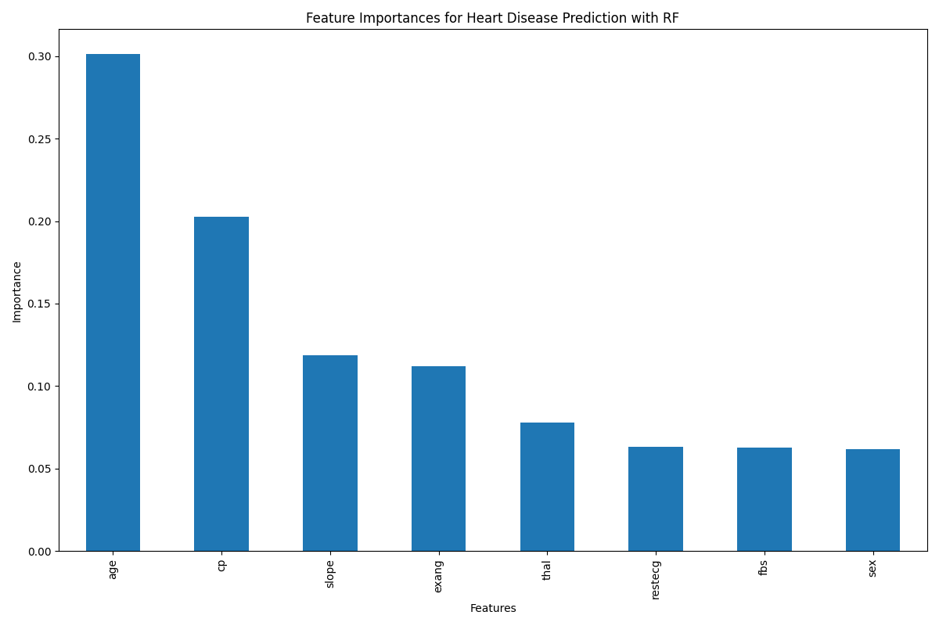 | 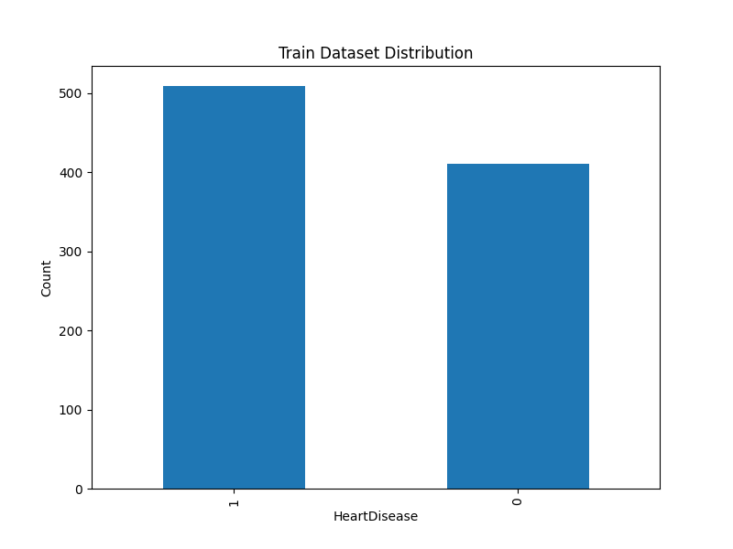

3.2. Machine Learning Methods
The machine learning algorithms used were Logistic Regression, Decision Tree, Random Forest, K-Nearest Neighbor, XGBoost. The rationale for multiple algorithms used were to pick the best performing model for each dataset. This will give us a general idea of how well each machine learning algorithm performs.

Logistic Regression is fairly common as it has been used in many experiments [30], for example one of the research which uses logistic regression for heart disease prediction [11]. In our setting, a binary logistic regression classifier will also be used as all three of the datasets have binary target labels. Maximum iteration of 5000 was set, with the l2 penalty, and a set of regularization values of 0.1, 1 and 100.

Decision Trees, another machine learning algorithm which can also be used for binary classification. There are three different types of criterion, gini, entropy and log loss, which can be used to measure the quality of the split. In another research [12], decision tree was also used for the binary classification of heart disease. In our setting, we use the default criterion of gini, with a set of depth at 10, 20, 30, and a minimum sampling split values of 2, 5 and 10.

Random Forest, which is an ensemble of decision trees, have been known as a reliable supervised machine learning algorithm, it is also popular in data science experiments [13]. It has also been used in one of the experiments for predicting heart disease [14], but parameter tuning is also crucial for it to work effectively. In our experiments, the number of estimators have been set to 100 and 200, with the max depth set to 10, 20 and the minimum sampling split values to be 2,5 and 10.

Gradient Boosting, introduced by Friedman (1999) [15], has been one of the most successful machine learning algorithms for regression and classification supervised learning tasks [16]. This algorithm serves as a baseline for many other variants of boosting, which we will also explore later. In a separate research done by Theerthagiri et al. [17], they explored the usage of gradient boosting combined with recursive feature elimination. In their study they were able to use the combined method to achieve high accuracy scores compared to just using other machine learning methods such as decision tree, naive bayes, k-nearest neighbors.

The other variation of gradient boosting, known as XGBoost was introduced by Tianchi et al. [18]. XGBoost is efficient in handling sparse data, or missing values in the dataset, which is one of its major advantages, and it also reduces the computation complexity for finding the best split [19]. In a separate research done by Kartik et al. (2022) [20], XGBoost was used and optimized for a diagnostic system to predict heart disease. There were comparisons done with other tree based methods, and XGBoost performed the best out of all. In our setting, the number of estimators were set to 100, 200, with learning rate of 0.01 and 0.1, with max depth set to 3, 5, and the evaluation metric used was log loss.

K-nearest neighbor, although it is not as popular or widely used for heart disease, there has been some experiments that used it. For example, Akhil et al. (2013) [21] used k-nearest neighbor with genetic algorithm to do heart disease prediction. In our experiments, we will just use k-nearest neighbor with a set of number of neighbors as 3, 5, 7 and weights of uniform and distance as parameters.

The parameters for all the algorithms used have been summarized in the table below.

Table 4. Hyper-parameters settings for grid search
Machine Learning Algorithms | Parameters
Logistic Regression | C=0.1, 1, 10  Penalty = L2
Decision Trees | Max depth = 10, 20, 30  Min samples = 2, 5, 10
Random Forest | Estimators = 100, 200  Max depth = 10, 20  Min samples = 2, 5, 10
XGBoost | Estimators = 100, 200  Learning rate = 0.01, 0.1  Max depth = 3, 5
K-nearest neighbor | Number of neighbors = 3, 5, 7  Weights = uniform, distance

3.3. Training details
The datasets have been cleaned and any empty cells or values will be dropped to ensure that the model trained consistently. Categorical labels will be converted using label encoding, and the data will be split using a consistent seed of 42, with a 80% train and 20% test split.
Data normalization was applied as it has shown to be important in data preprocessing stages [22].

Optimizing hyperparameters is a crucial part of any machine learning training process [23][26]. To optimize hyperparameters and to enhance the accuracy, a 5 fold cross validation grid search was performed for each of the classifiers, and then the best hyperparameters were selected to be trained and evaluated on the test set.

Since the CDC annual data is quite imbalanced, it is wise to use methods to balance it out, such as data imputation, or using weighted approaches in the machine learning algorithms [24][25]. In our experiment, we will just calculate the class weights with respect to the heart disease target label, and then perform training and evaluation of the algorithms both with class weights and without class weights.

3.4. LLM Integration
Me llama [36], short for Medical LLAMA, a LLM that was fine-tuned on medical data, will be used to generate explanations of the features and recommendations to reduce heart disease risk. We will be leveraging LM Studio [35], to download and host the model locally. The 8b parameter and quantized model will be downloaded to be used. The process of the integration is shown in the figure below.

Figure 1. Machine Learning Model with Me LLAMA
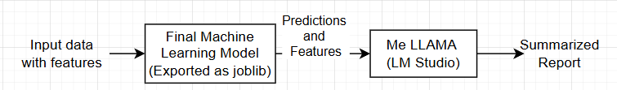

To ensure consistent outputs from the LLM, a set of rules was defined in the prompt for it to follow.

Prompt is defined as:
“A patient has the following characteristics:
{input_features}

The heart disease prediction model returned:
Prediction: {"High risk" if prediction == 1 else "Low risk"}
Confidence: {probs}

Please provide:
1. Only explain if the prediction is "High risk", else generate a "Low risk, nothing to explain".
2. An explanation of what these features mean in the context of heart disease.
3. Recommendations for reducing heart disease risk based on these features.
4. Any additional insights or concerns based on this data.

Keep the explanation short but informative. “

The LLM has been given the role of “You are a medical AI assistant helping to interpret heart disease risk predictions.”

The temperature has been set to 0.1 as we want to keep the generated information factual. The token limit has been set to 1000 to ensure that sufficient information has been generated.

Results
Results of the machine learning algorithms are reported in the tables below. Since the CDC annual data is extremely imbalanced, accuracy is not the best way to evaluate the model, so we will look at the F1 metric instead.

For 2020 CDC annual data, Random Forest, followed by the XGBoost performed the best out of all the other algorithms. Both have comparable results with small margins.
As for the 2022 CDC annual data, the Random Forest performed the best. However, we can also see that XGBoost performed quite well.

For the UCI data, the Random Forest algorithm achieved the best out of all the others, followed by XGBoost. We then compared our best results with other related works.

Table 5. Test results for 2020 CDC Data
Models | Precision | Recall | F1 | AUC
Logistic Regression | 0.2145 | 0.7634 | 0.3350 | 0.8263
Decision Tree | 0.2113 | 0.7749 | 0.3320 | 0.8175
Random Forest | 0.2681 | 0.5375 | 0.3577 | 0.8177
K-Nearest Neighbor | 0.2877 | 0.1857 | 0.2257 | 0.6638
XGBoost | 0.2172 | 0.7961 | 0.3413 | 0.8406

Table 6. Test results for 2022 CDC Data
Models | Precision | Recall | F1 | AUC
Logistic Regression | 0.2128 | 0.7606 | 0.3326 | 0.8822
Decision Tree | 0.2076 | 0.5351 | 0.2992 | 0.7040
Random Forest | 0.4588 | 0.4692 | 0.4640 | 0.8792
K-Nearest Neighbor | 0.4692 | 0.2184 | 0.2981 | 0.7551
XGBoost | 0.2593 | 0.6624 | 0.3727 | 0.8715

Table 7. Test results for UCI Data
Models | Precision | Recall | F1 | AUC
Logistic Regression | 0.8645 | 0.8137 | 0.8383 | 0.9024
Decision Tree | 0.7889 | 0.8431 | 0.8151 | 0.7621
Random Forest | 0.8584 | 0.8921 | 0.8750 | 0.9230
K-Nearest Neighbor | 0.8484 | 0.8235 | 0.8358 | 0.8879
XGBoost | 0.8653 | 0.8823 | 0.8737 | 0.9352

Table 8. Comparing related works results
Dataset | Method | Precision | Recall | F1 | AUC
UCI Data | Random Forest (Ours) | 0.8584 | 0.8921 | 0.8750 | 0.9230
 | KNN [5] | 0.917 | 0.948 | 0.908 | 0.799
 | Logistic Regression + Random Forest [12] | 0.72 | 0.75 | 0.71 | -
 | XGBoost with Bayesian Optimization [20] | - | 0.8571 | 0.9056 | -

We take a look at the generated explanations from Me LLAMA. For this purpose, we will take a sample of NEGATIVE and POSITIVE heart disease from the UCI dataset.

Based on the positive results given to the LLM, it was able to generate a comprehensive summary of the features which contributed to the prediction, and also a recommendation to reduce the risk.

Table 9. Me LLAMA Outputs
Negative Example

Inputs:
'age': 63,
'sex': 1, #Male
'cp': 'typical angina',
'trestbps': 145,
'chol': 233,
'fbs': 1,
'restecg': 'lv hypertrophy',
'thalch': 150,
'exang': 0,
'oldpeak': 2.3,
'slope': 'downsloping',
'ca': 0,
'thal': 'fixed defect'

Outputs:
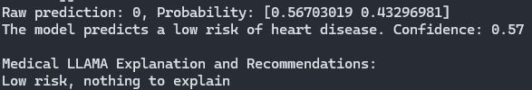
Positive Example

Inputs:
'age': 77,
'sex': 1, # Male
'cp': 'asymptomatic',
'trestbps': 300,
'chol': 304,
'fbs': 0,
'restecg': 'lv hypertrophy',
'thalch': 162,
'exang': 0,
'oldpeak': 0,
'slope': 'upsloping',
'ca': 3,
'thal': 'fixed defect'

Outputs:
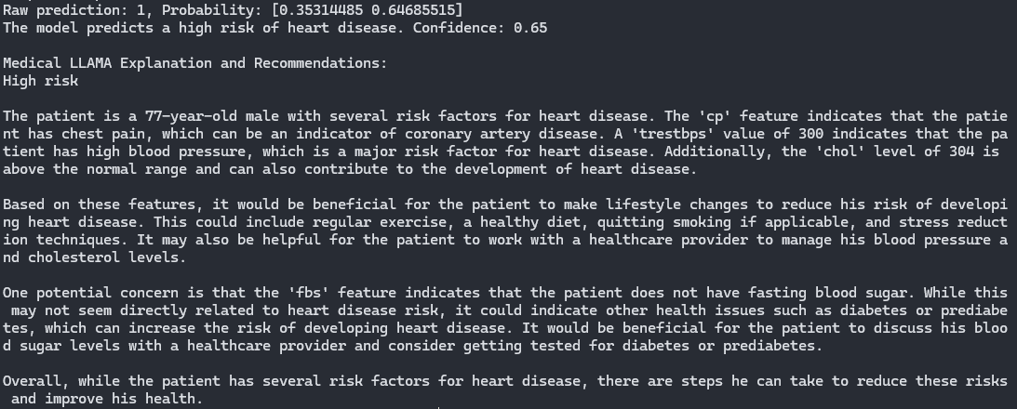

Conclusion
Based on our experiments, it has been shown that the ensemble methods, such as XGBoost and Gradient Boosting, have consistently outperformed the other machine learning algorithms. Data analysis is also important as it helps us understand the data that is being used to train these machine learning models.

Key features such as age, bmi, difficulty walking, chest pain problems, were also significant in these datasets. To address the data imbalance, class weights were calculated and applied while training the algorithms, especially when using the CDC annual data.

The data imbalance was a significant issue, as in the real world scenario, data will not always be balanced, and chances are there will always be more negatives than positives.

The usage of LLM is also extremely helpful, in a way that it allows patients to understand what symptoms or features contributed to their heart disease risk prediction. Having the LLM generate some recommendations is helpful, although this should also be fact checked by the doctors first, before releasing the information to the patients, to prevent any misunderstanding

References
[1] McNamara, K., Alzubaidi, H., & Jackson, J. K. (2019). Cardiovascular disease as a leading cause of death: How are pharmacists getting involved? Integrated Pharmacy Research and Practice, 8, 1-11. https://doi.org/10.2147/iprp.s133088

[2] National Heart Foundation of Australia. (2011). Guidelines for the prevention, detection and management of chronic heart failure in Australia.

[3] Nashif, S., Raihan, M. R., Islam, M. R., & Imam, M. H. (2018). Heart disease detection by using machine learning algorithms and a real-time cardiovascular health monitoring system. World Journal of Engineering and Technology, 6(4), 854-873. https://doi.org/10.4236/wjet.2018.64057

[4] Di Cesare, M., Perel, P., Taylor, S., Kabudula, C., Bixby, H., Gaziano, T. A., McGhie, D. V., Mwangi, J., Pervan, B., Narula, J., Pineiro, D., & Pinto, F. J. (2024). The heart of the world. Global Heart, 19(1). https://doi.org/10.5334/gh.1288

[5] Tr, R., Lilhore, U. K., M, P., Simaiya, S., Kaur, A., & Hamdi, M. (2022). PREDICTIVE ANALYSIS OF HEART DISEASES WITH MACHINE LEARNING APPROACHES. Malaysian Journal of Computer Science, 132–148. https://doi.org/10.22452/mjcs.sp2022no1.10

[6] Janosi, A., Steinbrunn, W., Pfisterer, M., & Detrano, R. (1989). Heart Disease [Dataset]. UCI Machine Learning Repository. https://doi.org/10.24432/C52P4X

[7] Alotaibi, F. S. (2019). Implementation of machine learning model to predict heart failure disease. International Journal of Advanced Computer Science and Applications, 10(6). https://doi.org/10.14569/ijacsa.2019.0100637

[8] Centers for Disease Control and Prevention. (2020). 2020 BRFSS survey data and documentation. https://www.cdc.gov/brfss/annual_data/annual_2020.html

[9] Centers for Disease Control and Prevention. (2022). 2022 BRFSS survey data and documentation. https://www.cdc.gov/brfss/annual_data/annual_2022.html

[10] Pytlak, K. (2023, October 12). Indicators of heart disease [Dataset]. Kaggle. https://www.kaggle.com/datasets/kamilpytlak/personal-key-indicators-of-heart-disease/data

[11] Logabiraman, G., Ganesh, D., Kumar, M. S., Kumar, A. V., & Bhardwaj, N. (2024). Heart disease prediction using machine learning algorithms. MATEC Web of Conferences, 392, 01122. https://doi.org/10.1051/matecconf/202439201122

[12] Kibria, H. B., & Matin, A. (2022). The severity prediction of the binary and multi-class cardiovascular disease − A machine learning-based fusion approach. Computational Biology and Chemistry, 98, 107672. https://doi.org/10.1016/j.compbiolchem.2022.107672

[13] Curth, A., Jeffares, A., & van der Schaar, M. (2024). Why do random forests work? Understanding tree ensembles as self-regularizing adaptive smoothers. arXiv preprint arXiv:2402.01502.

[14] Alariyibi, A., El-Jarai, M., & Maatuk, A. (2023). Evaluating The Accuracy of Classification Algorithms for Detecting Heart Disease Risk. arXiv preprint arXiv:2312.04595.

[15] Friedman, J. H. (2001). Greedy function approximation: A gradient boosting machine. The Annals of Statistics, 29(5), 1189-1232. https://www.jstor.org/stable/2699986

[16] Florek, P., & Zagdański, A. (2023). Benchmarking state-of-the-art gradient boosting algorithms for classification. arXiv preprint arXiv:2305.17094.

[17] Theerthagiri, P., & Vidya, J. (2022). Cardiovascular disease prediction using recursive feature elimination and gradient boosting classification techniques. Expert Systems, 39(9), Article e13064. https://doi.org/10.1111/exsy.13064

[18] Chen, T., & Guestrin, C. (2016). XGBoost: A scalable tree boosting system. In Proceedings of the 22nd ACM SIGKDD International Conference on Knowledge Discovery and Data Mining (pp. 785-794). Association for Computing Machinery. https://doi.org/10.1145/2939672.2939785

[19] Bentéjac, C., Csörgő, A., & Martínez-Muñoz, G. (2021). A comparative analysis of gradient boosting algorithms. Artificial Intelligence Review, 54, 1937-1967. https://doi.org/10.1007/s10462-020-09896-5

[20] Budholiya, K., Shrivastava, S. K., & Sharma, V. (2020). An optimized XGBoost based diagnostic system for effective prediction of heart disease. Journal of King Saud University - Computer and Information Sciences, 34(7), 4514–4523. https://doi.org/10.1016/j.jksuci.2020.10.013

[21] Jabbar, M. A., Deekshatulu, B., & Chandra, P. (2013). Classification of heart disease using K- nearest neighbor and genetic algorithm. Procedia Technology, 10, 85–94. https://doi.org/10.1016/j.protcy.2013.12.340

[22] Patro, S. (2015). Normalization: A preprocessing stage. arXiv preprint arXiv:1503.06462.

[23] Rasheed, S., Kumar, G. K., Rani, D. M., Kantipudi, M. V. V. P., & M, A. (2024). Heart disease prediction using GridSearchCV and Random Forest. EAI Endorsed Transactions on Pervasive Health and Technology, 10. https://doi.org/10.4108/eetpht.10.5523

[24] Rawat, S. S., & Mishra, A. K. (2022). Review of methods for handling class imbalance in classification problems. In International Conference on Data, Engineering and Applications (pp. 3-14). Springer. https://doi.org/10.1007/978-981-19-3089-8_1

[25] Kulkarni, A., Chong, D., & Batarseh, F. A. (2020). Foundations of data imbalance and solutions for a data democracy. In F. A. Batarseh & R. Yang (Eds.), Data Democracy (pp. 83-106). Academic Press. https://doi.org/10.1016/B978-0-12-818366-3.00005-8

[26] Amazon Web Services. (n.d.). What is hyperparameter tuning? - Hyperparameter tuning methods explained. Retrieved November 4, 2024, from https://aws.amazon.com/what-is/hyperparameter-tuning/

[27] Almansouri, N. E., Awe, M., Rajavelu, S., Jahnavi, K., Shastry, R., Hasan, A., Hasan, H., Lakkimsetti, M., AlAbbasi, R. K., Gutiérrez, B. C., & Haider, A. (2024). Early Diagnosis of Cardiovascular Diseases in the Era of Artificial Intelligence: An In-Depth Review. Cureus, 16(3), e55869. https://doi.org/10.7759/cureus.55869

[28] Ahsan, M. M., Luna, S. A., & Siddique, Z. (2022). Machine-Learning-Based Disease Diagnosis: A Comprehensive Review. Healthcare (Basel, Switzerland), 10(3), 541. https://doi.org/10.3390/healthcare10030541

[29] MarkovML. (n.d.). Importance of data analysis in machine learning. Retrieved November 4, 2024, from https://www.markovml.com/blog/data-analysis-importance#role-of-data-analysis-in-ml

[30] Schober, P., & Vetter, T. R. (2021, February 1). Logistic regression in medical research. Anesthesia and analgesia. https://www.ncbi.nlm.nih.gov/pmc/articles/PMC7785709/

[31] Brown, T. B. et al. (2020). Language models are few-shot learners. arXiv preprint arXiv:2005.14165.

[32] Han, T., Adams, L. C., Papaioannou, J. M., Grundmann, P., Oberhauser, T., Löser, A., ... & Bressem, K. K. (2023). MedAlpaca--an open-source collection of medical conversational AI models and training data. arXiv preprint arXiv:2304.08247.

[33] Meng, X., Yan, X., Zhang, K., Liu, D., Cui, X., Yang, Y., Zhang, M., Cao, C., Wang, J., Wang, X., Gao, J., Wang, Y. G., Ji, J. M., Qiu, Z., Li, M., Qian, C., Guo, T., Ma, S., Wang, Z., Guo, Z., … Tang, Y. D. (2024). The application of large language models in medicine: A scoping review. iScience, 27(5), 109713. https://doi.org/10.1016/j.isci.2024.109713

[34] Wang, Z., Liu, L., Wang, L., & Zhou, L. (2023). R2GenGPT: Radiology report generation with frozen LLMs. Meta-Radiology, 1(3), Article 100033. https://doi.org/10.1016/j.metrad.2023.100033

[35] LM Studio. (n.d.). LM Studio - Experiment with local LLMs. Retrieved November 4, 2024, from https://lmstudio.ai/

[36] Xie, Q., Chen, Q., Chen, A., Peng, C., Hu, Y., Lin, F., ... & Bian, J. (2024). Me llama: Foundation large language models for medical applications. arXiv preprint arXiv:2402.12749.

