# **ER Diagram**

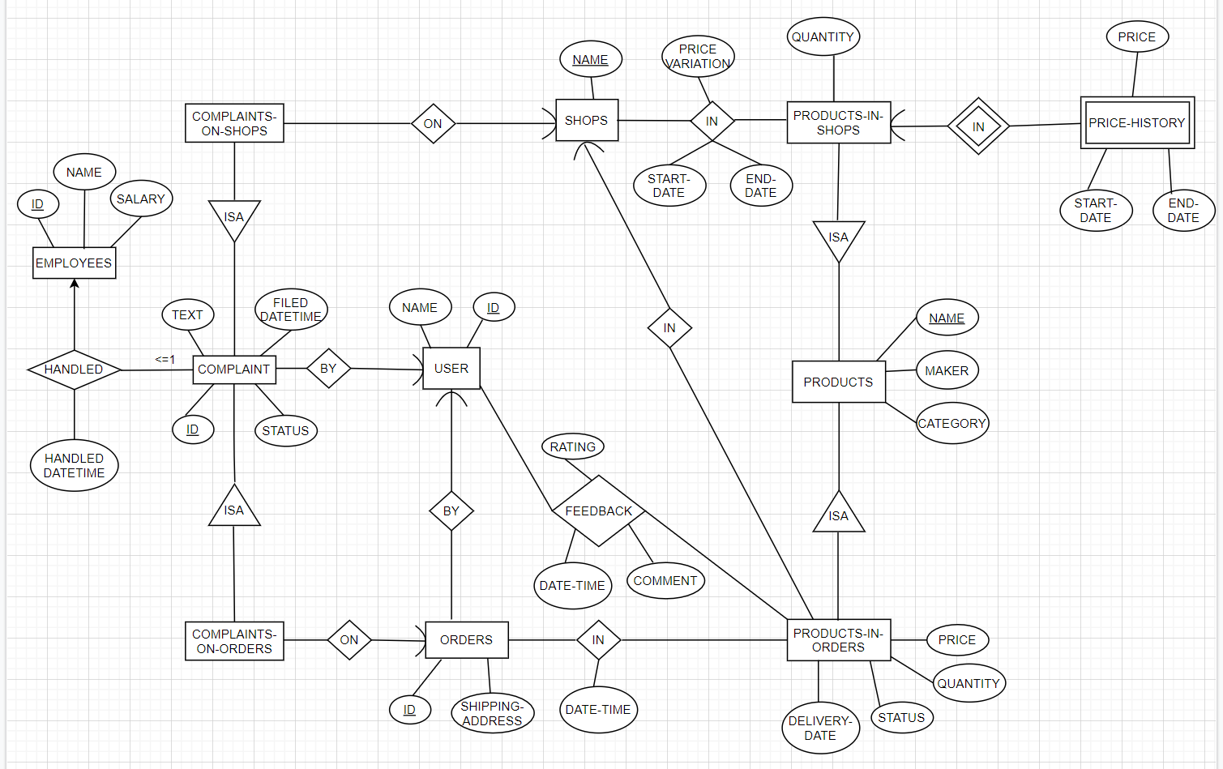

# **List of Relations**

**1** Employees

**2** Complaint

**3** Complaints-on-Shops

**4** Complaints-on-Orders

**5** Orders

**6** User

**7** Feedback

**8** Product

**9** Product-in-Orders

**10** Product-in-Shops

**11** Shops

**12** Price_History

**13**  Ordered_Products

**14** Shops_Products_PriceVar

# **1. Employee**

**Employee** (EmployeeID, Name, Salary)

**Keys:** EmployeeID

**Primary Key:** EmployeeID

**FDs:**

1. EmployeeID → Name, Salary

# Prove: If relation is in 3NF

* FD (1) is OK, since EmployeeID is a key of **Employee**
* So **Employee** is in 3NF

# **2. Complaint**

**Complaint** (ComplaintID, Text, Status, Filled-date-time, Handled-date-time, EmployeeID, UserID)

**Keys:** ComplaintID, UserID, EmployeeID

**Primary Key:** ComplaintID

**FDs:**

1. ComplaintID → Text, Status, Filled-date-time, Handled-date-time, EmployeeID, UserID

# Prove: If relation is in 3NF

* FD (1): LHS = Key.
* So **Complaint** is in 3NF

# **3. Complaints-on-Shops**

**Complaints-on-Shops** (ComplaintID, ShopName)

**Keys:** ComplaintID

**Primary Key:** ComplaintID

**FDs:**

1. ComplaintID → ShopName

# Prove: If relation is in 3NF

* Every 2 attribute relation is in BCNF.
* So **Complaints-on-Shops** is in 3NF.

# **4. Complaints-on-Orders**

**Complaints-on-Orders** (ComplaintID, OrderID)

**Keys:** ComplaintID

**Primary Key:** ComplaintID

**FDs:**

1. ComplaintID → OrderID

# Prove: If relation is in 3NF

* Every 2 attribute relation is in BCNF.
* So **Complaints-on-Orders** is in 3NF.

# **5. Orders**

**Orders** (OrderID, Shipping-address, UserID, Date-time)

**Keys:** OrderID, UserID

**Primary Key:** {OrderID, UserID}

**FDs:**

1. {OrderID, UserID} → Shipping-address

# Prove: If relation is in 3NF

* Since both keys are on the left hand side, FD(1) is ok. Table does not need to be decomposed.

# **6. User**

**User** (UserID, Name)

**Keys:** UserID

**Primary Key:** UserID

**FDs:**

1. UserID → Name

# Prove: If relation is in 3NF

* Since the key is on the left hand side, FD(1) is ok. Table does not need to be decomposed.

# **7. Feedback**

**Feedback** (UserID, Rating, Date-time, Comment, ProductName)

**Keys:** {UserID, ProductName}

**Primary Key:** {UserID, ProductName}

**FDs:**

1. {UserID, ProductName} → Rating, Date-time, Comment

# Prove: If relation is in 3NF

* Since both keys are on the left hand side, FD(1) is ok. Table does not need to be decomposed.

# **8. Product**

**Products** (ProductName, Maker, Category)

**Keys:** ProductName

**Primary Key:** ProductName

**FDs:**

1. ProductName → Maker, Category

# Prove: If relation is in 3NF

* Since the key is on the left hand side, FD(1) is ok. Table does not need to be decomposed.

# **9. Product-in-Orders**

**Product-in-Orders** (ProductName, Price, Quantity, Delivery-date, Status ShopName, OrderID)

**Keys:** ProductName, ShopName, OrderID

**Primary Key:** {ProductName, OrderID, ShopName}

**FDs:**

1. {ProductName, OrderID, ShopName} → Price, Quantity, Deliver-date, Status, ShopName

# Prove: If relation is in 3NF

* Since the key is on the left hand side, FD(1) is ok. Table does not need to be decomposed.

# **10. Product-in-Shops**

**Product-in-Shops** (ProductName, Price, Quantity, ShopName)

**Keys:** ProductName, ShopName

**Primary Key:** {ProductName, ShopName}

**FDs:**

1. {ProductName, ShopName} → Price, Quantity

# Prove: If relation is in 3NF

* Since the key is on the left hand side, FD(1) is ok. Table does not need to be decomposed.

# **11. Shops**

**Shops** (ShopName)

**Keys:** ShopName

**Primary Key:** ShopName

**FDs:**

NIL

# **12. Price_History**

**Price_History** (Product Name, Price, Start-date, End-date, ShopName)

**Keys:** ProductName, ShopName

**Primary Key:** {ProductName, ShopName, Start-date}

**FDs:**

1. {ProductName, ShopName, Start-date} → Price, Start-date, End-date

# Prove: If relation is in 3NF

* Since the key is on the left hand side, FD(1) is ok. Table does not need to be decomposed.

# **~~13. Ordered_Products~~**

**~~Ordered_Products~~** ~~(OrderID, ProductName, Date-time)~~

**~~Keys:~~** ~~{OrderID, ProductName}~~

**~~Primary Key:~~** ~~{OrderID, ProductName}~~

**~~FDs:~~**

1. ~~{OrderID, ProductName} → Date-time~~

# ~~Prove: If relation is in 3NF~~

* ~~Since the key is on the left hand side, FD(1) is ok. Table does not need to be decomposed.~~

# **14. Shops_Products_PriceVar**

**Shops_Products_PriceVar** (ShopName, ProductName, Start-date, End-date, Price-variation)

**Keys:** {ShopName, ProductName}

**Primary Key:** {ShopName, ProductName}

**FDs:**

1. {ShopName, ProductName} → Start-date, End-date, Price-variation

# Prove: If relation is in 3NF

* Since the key is on the left hand side, FD(1) is ok. Table does not need to be decomposed.