**Group Assignment**

**AAPP007-4-2-SYAD**

**Systems Analysis and Design**

**HAND OUT DATE: 19 Oct 2023**

**HAND IN DATE: 22 Dec 2023**

**WEIGHTAGE: 70%**

**__________________________________________________**

**Instructions to Candidates:**

1. **Submit your assignment via Moodle.**
2. **Students are advised to underpin their answers with the use of references (cited using the 7th edition of APA Referencing Style).**
3. **Late submission will be awarded zero (0) unless Extenuating Circumstances (EC) are upheld.**
4. **Cases of plagiarism will be penalized.**
5. **You must obtain 50% overall to pass this module.**

Table of Contents

1.0 Introduction 4

1.1 Discovering Melaka’s Heritage 4

1.2 Our Mission and Aspirations 4

2.0 Problem Identification and Proposed Solutions 6

2.1 Problem 1 6

2.1.1 Cause 6

2.1.2 Effect 6

2.1.3 Proposed solution for rectification 6

2.2 Problem 2 7

2.2.1 Cause 7

2.1.2 Effect 7

2.2.3 Proposed solution for rectification 7

2.3 Aim of project 7

2.4 Objective of report 8

3.0 Project Planning 9

3.1 SDLC 9

3.2 Gantt Chart 12

3.3 Workload Matrix 12

4.0 Feasibility Study 13

4.1 Operational Feasibility (PIECES) 13

4.2 Technical Feasibility 15

4.3 Economical Feasibility 16

4.3.1 Cost-Benefit Analysis 17

4.3.2 Cost Benefit Ratio Analysis 18

4.4 Schedule Feasibility 19

4.4.1 Breakdown of System Development Schedule 19

4.4.2 Summarized System Development Schedule 20

5.0 System Analysis 21

Functional Requirements 21

Customer Functions 21

River Cruise System Functions: 21

Non-Functional Requirements: 22

6.0 Design Diagrams of Proposed System 24

6.1 System Context Diagram 24

6.2 Level 0 Data Flow Diagram 25

6.3 Entity Relationship Diagram 26

7.0 Interface Design 27

7.1 Prototype 27

7.1.1 Home Page 27

8.0 References 29

# 1.0 Introduction

Tucked away in the busy centre of Melaka Marina, Paradise River Cruise aims to provide a tasteful fusion of the past and the present. Through this endeavour, tourists can fully immerse themselves in Melaka's historical allure and experience its rich cultural legacy. River Cruise is more than just a relaxing excursion; it's a well-planned tour of the city's most famous sites and lesser-known attractions.

## 1.1 Discovering Melaka’s Heritage

A selection of Melaka's noteworthy sites such as the sturdy Bastion Middleburg to the graceful pre-war architecture, are featured in our cruise itinerary. The tour continues while stopping at the visually stunning Eye of Melaka, the serene atmosphere of Kampung Hulu Mosque, and the colourful hallways of the Shore Shopping Gallery. The trip concludes at Bakau Road as the cruise heads to the rhythmic water fountain, which casts a peaceful aura over the river as the night falls.

## 1.2 Our Mission and Aspirations

With the motto, "Navigating Dreams, Creating Memories," River Cruise aims to provide its guests with more than just a picturesque journey; instead, it seeks to leave a lasting imprint and significant experiences. The tagline, "Experience Paradise, One Wave at a Time," perfectly captures the spirit of living in the present and recognizes the elegance in simplicity. The vision statement of River Cruise, "Elevating River Cruises Beyond Expectations," highlights the company's dedication to raising the bar for the industry, improving client happiness, and completely transforming river cruise travel.

1.3 What we provide

In the heart of the Paradise River Cruise experience lies a fully functional system that seamlessly integrates advanced navigation and a fully functional payment system, ensuring the utmost convenience for passengers. The system extends its benefits into an online booking platform designed to provide guests with effortless reservations and cruise package confirmations.

Paradise River Cruise prioritizes user-friendly design, featuring intuitive interfaces on both online platforms and onboard systems. Multilingual support caters to guests from diverse linguistic backgrounds. With all that, the cruise provides we can ensure that our system will support passengers from all over the world with convenience.

# 2.0 Problem Identification and Proposed Solutions

## 2.1 Problem 1

The current reservation system, which consists of a loose-leaf binder and Microsoft Access database has its limitations. DESC NMORE

### 2.1.1 Cause

River Cruise is a small company with slight budget constraints. Microsoft Access and a loose-leaf binder is a cost-effective database management solution. GIVE MORE CAUSE

### 2.1.2 Effect

Paper can take up a lot of space, and the amount of paper produced just increases every day (Melo, 2019). In addition, it is often necessary to store documents nearby to ensure that they are retrieved as quickly as possible. The scalability and restricted functionality of Microsoft Access is one of its major drawbacks. Access can work well with small to medium sized databases, but when working with large and complex data sets, it can run into performance and scalability issues. Access can show decreased overall performance and slower response times as database size and data volume expand (Roberts, 2023). This can have an impact on how quickly data is received, processed, and analyzed. MORE EFFECT

### 2.1.3 Proposed solution for rectification

Invest in a complete system installation that communicates seamlessly with policy, avoids conflicts, and gives you detailed insight into rental policy and customer data (Funky, 2023). Allocate a portion of the budget for research and implementation of the reservation system in accordance with the specific requirements of the RC.

## 2.2 Problem 2

Owners Tiffany and James aren’t sure how effective their social media advertising is at attracting new business. DESC MORE. MORE DETAIL

### 2.2.1 Cause

They may not have used the proper tracking methods or analytics tools to measure the success of their social media campaigns. Furthermore, customer feedback and engagement on these platforms may not have been thoroughly researched. MORE

### 2.1.2 Effect

The lack of debate about the effectiveness of social media advertising makes it difficult to allocate optimal resources for RC. It hampers their ability to tailor marketing strategies and target the right audience. This lack of clarity can lead to poor use of advertising budgets and missed opportunities for business growth. MORE

### 2.2.3 Proposed solution for rectification

Use tools like HubSpot, Sprout Social, or other social media analytics tools to track the performance of social media campaigns. This will provide insights into user engagement, click-through rates, and conversion metrics. (Baker, 2023) MORE

Gather feedback from existing customers to understand how they found out about RC. Include questions related to the effectiveness of social media channels. This can be done through surveys, emails, or follow-up calls. MR

## 2.3 Aim of project

The main objective of this report is to provide a comprehensive framework to address River Cruises (RC)’s business challenges and generate growth opportunities. Founded by environmentalists Tiffany and James, RC has been offering guided ecotours, sailing and kayaking rentals along the scenic Fair River for three years past and the company’s commitment to environment and customer satisfaction has positioned it as a unique and promising business in the region.

## 2.4 Objective of report

Reservation System Optimization:

Analyze and recommend improvements to existing system installations to eliminate system conflicts, increase user friendliness, and ensure integration with other business systems which is not difficult.

Data-Driven Decision Making:

To propose methods for collecting and analyzing comprehensive information about rental programs, customer information, and effective advertising to enable informed decision making and targeted efforts about trade.

Extensions that can be analyzed:

To assess the feasibility and potential impact of introducing a selection of books and videos on kayaking and ecotourism into RC offerings, considering consumer needs and market trends.

Streamlining business workflows:

Identify opportunities to streamline business processes by better allocating responsibilities to staff, especially during peak periods, and using technology to improve efficiency.

# 3.0 Project Planning

## 3.1 SDLC

Software Development Life Cycle (SDLC) is a process that developers use to plan ahead and create high-quality software while reducing the risk. This process can help developers to fulfill the expectations of the client during and after production (AWS, N.D.). There are a total of 6 processes in SDLC.

1. System planning

In system planning, client business is identified. Our client is a River Cruise company in Melaka River that provides guided eco-tours, cruises, and kayak rentals. There are several problems that the business is now facing.

One of them is that they must handle data collection manually. The data collected is stored in a Microsoft Access Database manually, resulting in a higher chance of getting an error. For example, they mentioned that the reservation for guided tours or instruction sessions sometimes conflicts with their availability. They also display the status of kayak availability with a color-coded magnet. Besides, they are not able to analyze their data, resulting in poor effectiveness in attracting new business.

There are a few solutions that we proposed to help solve this issue. A system for managing orders, inventory, and billing can be created. The system will be responsible for taking customers’ orders for guided tours or kayak rented. This can help reduce the chances of order conflict. Furthermore, the system can also process customers’ payments. For instance, when a customer rents a kayak via the system, the payment made will automatically loaded into the accounting software, making it more efficient and effective compared to manually keying into an accounting software. The system will also collect customer details like email addresses, booking history, and search history within the system so that they can understand more about their customers’ wants and hence employ a better marketing strategy to attract new business.

The estimated cost and timeline to create this system will be around RM60,000 and will take around four months to complete.

1. System Analysis

In System Analysis, the understanding of a client’s requirements is very important. The project team will have to conduct a market survey, internet survey or interview to understand the specific requirements and preferences of the client. This is very important as it can ensure that the proposed River Cruise system is aligned with their goals and visions.

Besides, the core functional and non-functional features that the clients want in their new system should be identified. The project team should work closely with the client so that misunderstandings or unclear needs can be prevented, as well as different opinions on the information obtained in terms of assumptions.

After understanding the requirements needed, the finalization of the identified requirements will be made. The identified requirement will also be documented in detail in a document file. This file will serve as a formal agreement between both parties, providing a clear and detailed description of what the system will be.

1. System Design

System Design is the third stage of an SDLC process. In this phase, a user interface of the system will be designed. This phase aims to convert the system requirements into a comprehensive design to guide and showcase the developers and clients to ensure a systematic and well-organized approach to building the system.

A flowchart, data flow diagram, and a system context diagram of the system will be created. These charts and diagrams are important as they illustrate the flow of activities within the system. For instance, the flowchart includes processes like user registration, order placement, and payment processing in the system. The Data Flow Diagram is used to show how data moves through the system, while the System Context Diagram displays the interaction between the system and external entities. These diagrams will play a crucial role in identifying the outputs, inputs, processes of the system, and the management and user involvement.

In this phase, a user interface using wireframes and a mockup of this system will also be created. In addition to creating the user interface, the System Design phase will also involve the development of prototypes with the approver of the wireframe, allowing clients to interact with the prototype of the system and gather valuable feedback.

The detailed design specifications are documented in a System Design Document (SDD), which will contain the overall data flow and serve as a reference for developers throughout the next implementation stage.

1. System Implementation

In the fourth phase of SDLC, a new system is constructed. Programs and code will be written based on the detailed outline of the System Design Document. The code will be written based on the chosen programming language and coding standard and practice development outlines of the company.

After the system is constructed, the system will undergo a series of testing. This testing is used to validate the functionality and performance of the system. For instance, user registration, user login, and booking all will be tested to make sure that the system is bug-free and reaches the client's expectations. In addition to checking for bugs, the testing will assess how well the system manages a lot of data and concurrent user engagement.

1. System Security and Support

In the fifth and final phase of SDLC, the system will be published, making it accessible to the public. The performance of the system will be closely monitored, and regular security assessments will be made to identify potential bugs and vulnerabilities in the system. If a bug or an issue is detected, the system will undergo maintenance to enhance security and stability.

Besides, the system will also be updated with new technology or new features that are aligned with the evolving goals of the organization. For instance, with the increasing volume of demand, the functionality of the system will be upgraded so that it can maintain the sustainability of the system.

## A diagram with multiple colored squares Description automatically generated with medium confidence3.2 Gantt Chart

## 3.3 Workload Matrix

|  |  |  |
| --- | --- | --- |
| **Name** | **Task / Description / Responsibility** | **Signature** |
| Celeste Chiong Sze Jie (TP068754) | Introduction  Project Planning | **celeste** |
| Chong Pin Jun (TP069755) | Project Planning  Design Diagram  Interface Design | pinjun |
| Lim Hao Foong | Problems Identification and Proposed Solutions  Design Diagram | **howard** |
| Nigel Shenjiat Kinsuan (TP070330) | Feasibility Study  Design Diagram  Interface Design | **nigel** |
| Yap Wei Xing (TP070519) | Introduction  System Analysis | **yapwx** |

# 4.0 Feasibility Study

In response to the challenges faced by Paradise River Cruise, an initiative to implement a new comprehensive River Cruice Management system. This proposed system, designed to optimize business operations, represents a pivotal step towards heightening the operational efficiency of Paradise River Cruise. The overall feasibility of proposed system is discussed below:

## 4.1 Operational Feasibility (PIECES)

Paradise River Cruise’s current database system (Microsoft Access) has proven to be ineffective for the business’s use case, evident as the business owners noticed schedule conflicts while carrying out their day-to-day operations. In addition, the current system used does not offer business insights. On the other hand, the accounting system currently used by Paradise River Cruise is adequate for the business’s needs. The proposed system will retain and improve on existing functions, while adding new features, all in one system package. Its performance will exceed the previous solutions in both speed and efficiency.

As stated by the business, the existing database system has caused numerous schedule conflicts. With that, the two problems in the information department that have been found in the existing system are: (a) does not provide the business with reliable reservation and scheduling data, and (b) does not provide the business with key business insights. The proposed system will eliminate data inaccuracies and automatically generate key business insights under an intuitive user interface. The focus will be to provide the business with a system that is reliable while being easy to use.

While the accounting solution employed by Paradise River Cruise is adequate for the business’s financial needs, the proposed system introduces an opportunity for economic optimization. Due to the current system’s data conflicts, potential economic inefficiencies may happen. Hence, the proposed system aims to increase revenue and cost savings by providing increased business operation efficiency and stability.

In terms of control, it has been identified that the current system does not guarantee the security and accuracy of the business’s data. A leaf binder can be easily compromised by anyone with physical access to the item, while the manual nature of the Microsoft Access database leaves room for discrepancies and lacks real-time updates. Furthermore, the business does not possess a backup of these separate systems. The proposed system will provide enhanced control over all business operations while improving data security and accuracy.

Operational inefficiencies in the current system, including manual workflows and potential conflicts contribute to a lack of efficiency. This can potentially reduce the overall revenue generated by the business. The proposed system aims to overcome these inefficiencies by reducing conflicts and providing quick access to information. Also, the business would have to hire personnel to undergo system maintenance, which was previously done by the business owners, to reduce their workload as well as ensuring peak efficiency of business operations.

The current system does not provide reliable service to customers of Paradise River Cruise. Under the current system, customer experience may be compromised due to the schedule conflicts caused by the database system. Also, the current systems are not flexible (not interconnected) and cannot be expanded with business growth. The proposed system is positioned to elevate the overall service quality provided to customers by Paradise River Cruise by offering better data accuracy (accurate schedule) and personalized services.

## 4.2 Technical Feasibility

The proposed system aims to provide Paradise River Cruise with a reliable scheduling platform, and a financial management interface while providing the business with key data insights to further improve their services. Scheduling systems such as: Calendly, and Acuity Scheduling; while financial management systems like: Sage One, and Xero are commonly used in most modern businesses (YH TAN & ASSOCIATES PLT, n.d.). For smaller to mid-sized businesses with straightforward functional needs, opting for an in-house scheduling and financial system is considered practical and may result in cost savings by eliminating software licensing fees.

On the software aspect, it is recommended to host the proposed system using the Linux Apache MySQL PHP (LAMP) stack. This web stack is both free and open source to prevent any future complications.

From a technological standpoint, Paradise River Cruise does not currently possess any hardware infrastructure to host the proposed system. The business is suggested to purchase/rent either (a) local machine or (b) a Virtual Private Server (VPS). A high availability (HA) secondary server with identical configuration to the primary hosting server should also be configured to prevent downtime in the event of a hardware failure. Additionally, the business is highly suggested to make regular backups (preferably off-site) of the system database.

In concern to technical expertise, Paradise River Cruise lacks employees with the necessary skills to perform routine maintenance and upkeep works. It is recommended that the business consider hiring at least one part-time system administrator to fulfill this responsibility.

As a conclusion, the proposed system’s technical feasibility hinges upon the business’s commitment in acquiring hardware and hiring personnel with adequate technical expertise.

## 4.3 Economical Feasibility

While the systems currently employed by Paradise River Cruise suffices to fulfill the business’s demands, the proposed system introduces an opportunity for economic optimization. Potential economic inefficiencies are a result of the current database system's identification of schedule conflicts and human processes. The proposed system, with its automation features, aims to streamline processes, reduce errors, and, in the long term, contribute to cost savings. As seen in the Cost-Benefit Analysis in Section 4.3.1 below, there is a potential for increased benefits, albeit at a higher operating cost than the current systems.

4.3.1 Cost-Benefit Analysis

|  |  |  |  |  |  |  |
| --- | --- | --- | --- | --- | --- | --- |
| Cost-Benefit Analysis – Paradise River Cruise System | | | | | | |
|  | **Year** | | | | | |
|  | **0** | **1** | **2** | **3** | **4** | **5** |
| Costs | | | | | | |
| Development Cost | -60,000 |  |  |  |  |  |
| Operating Cost |  | -24,000 | -25,200 | -26,460 | -27,783 | -29,173 |
| Total Cost | **-60,000** | **-24,000** | **-25,200** | **-26,460** | **-27,783** | **-29,173** |
| Discount Factor  (6% p.a.) | 1.00 | 0.94 | 0.89 | 0.84 | 0.79 | 0.75 |
| Present Value of Costs | -60,000 | -22,560 | -22,428 | -22,226 | -21,948 | -21,880 |
| Cumulative Present Value of Costs | -60,000 | -88,560 | -110,988 | -133,214 | -155,162 | -177,042 |
| Benefits | | | | | | |
| Tangible Benefits |  | 70,000 | 77,000 | 84,700 | 93,170 | 102,487 |
| Intangible Benefits |  | 5,000 | 5,500 | 6,050 | 6,655 | 7,321 |
| Total Benefits |  | **75,000** | **82,500** | **90,750** | **99,825** | **109,808** |
| Discount Factor  (6% p.a.) | 1.00 | 0.94 | 0.89 | 0.84 | 0.79 | 0.75 |
| Present Value of Benefits |  | 70,500 | 73,425 | 76,230 | 78,862 | 82,356 |
| Cumulative Present Value of Benefits |  | 70,500 | 143,925 | 220,155 | 299,017 | 381,373 |
| Cumulative Benefits  + Costs | -60,000 | -18,060 | 32,937 | 86,941 | 143,855 | 204,331 |

### 4.3.2 Cost Benefit Ratio Analysis

|  |  |  |
| --- | --- | --- |
| Cost-Benefit Ratio Analysis – Paradise River Cruise System | | |
|  | **Off-the-shelf system** | **In-house system (Proposed)** |
| Costs | | |
| Consultation Fees | 0 | 600 |
| Licensing Fees | 10,000 | 0 |
| Hardware and Software | 4,000 | 8,000 |
| Maintenance | 3,000 | 1,000 |
| Personnel | 0 | 2,000 |
| Implementation | 1,000 | 1,500 |
| Total Cost | **18,000** | **13,100** |
| Benefits | | |
| Increased Profits | 70,000 | 20,000 |
| Total Benefit | **70,000** | **20,000** |
| Cost-Benefit Ratio | **3.89** | **1.52** |

## 4.4 Schedule Feasibility

Based on the proposed schedule of four months, the proposed system appears to be feasible schedule-wise. The timeline includes buffer time to account for unforeseen schedule setbacks. The Gantt chart and timeline for the system development phases (as seen in section 3.2) is as follows:

### 4.4.1 Breakdown of System Development Schedule

1. System planning

* Problem Identification (Nov 1 – Nov 10)
* Solution for Proposed System (Nov 13 – Nov 27)
* Identify Aim and Objective (Nov 13 – Nov 27)

Under the system planning phase, the project’s aim and objectives are defined. Then, communication channels are established. A project plan was then drafted.

1. System analysis

* Understand client’s Requirements (Nov 30 – Dec 6)
* Identify Functional and Non-functional Features (Dec 7 – Dec 15)
* Finalize (Dec 18 – Dec 22)

While conducting the system analysis, a requirement analysis was conducted. Based on the business’s requirements, the features needed were determined.

1. System design

* Flowchart (Dec 25 – Dec 29)
* Prototype (Jan 1 – Jan 10)
* Wireframe (Jan 11 – Jan 18)

On to the system design process, a system flowchart was designed. Promptly, the prototype was developed, while receiving feedback from the business. Adjustments were made based on the feedback to refine the system design.

1. System implementation

* Coding (Jan 19 – Jan 31)
* System Testing (Feb 1 – Feb 14)

After the business was satisfied with the final wireframe, the coding and implementation process were set into motion. Regular code reviews and security testing were done alongside the coding process, so that issues and bugs were addressed promptly. Collaboration with the business was also done to obtain further feedback. After the system was internally completed, the system was subject to User Acceptance Testing (UAT).

1. System security and support

* Regular Security Assessment (Feb 15 – Feb 21)
* New Tech and Features (Feb 22 – Feb 29)

Regular monitoring and security assessments were done after the system was implemented. A post-implementation review was also conducted to gather feedback for new features to be added in the future.

### 4.4.2 Summarized System Development Schedule

|  |  |
| --- | --- |
| **Phase** | **Duration (days)** |
| System Planning | 27 |
| System Analysis | 23 |
| System Design | 24 |
| System Implementation | 31 |
| System Security and Support | 14 |

# 5.0 System Analysis

## Functional Requirements

### Customer Functions

Registration:

* Users should be able to create and register an account with the necessary personal information from our website.

Multilanguage support:

* Be able to support multiple languages for different cultures of people.

User Login:

* The system should provide registered users with a secure login system to  
  book the cruise.

Easily check the availability of the cruise:

* Users should be able to view available cruise options, select, and book them by the user.

The system should make payments easier for the users:

* Having implemented a secure payment system for users' online transactions.

Generate Receipt:

* Generate and provide users with a digital receipt for their booked services.

### River Cruise System Functions:

System login:

* Secure login for cruise staff with different roles such as admin and staff.

Cruise Updates and Inventory Information:

* Enable staff to update information about the cruise, available inventory, and total people on board

Add Reservation Information:

* Allow staff to input and manage customer reservations.

Process Payment:

* Facilitate the processing of payments for booked services.

Generate Receipt:

* Automatically generate and store digital receipts for each transaction.

## Non-Functional Requirements:

Performance:

* Response Time  
  The system should respond to user actions within 2 seconds.
* Scalability   
  The system should handle increasing users and transactions without significant performance degradation.

Reliability:

* System Uptime  
  Aim for at least 99% system uptime, ensuring accessibility to users at all times.
* Data Integrity  
  Implement measures to ensure the integrity of user data and transaction records.

Security:

* User Authentication  
  Implement a system that secures user authentication information.
* Data Encryption  
  Ensure that sensitive user data, especially payment information, is encrypted during transmission and storage.

Usability:

* User-Friendly Interface  
  Design a user-friendly interface for both customers and staff.

Scalability:

* System Scalability  
  Design the system to accommodate an increase in the number of users, bookings, and inventory items.

Regulatory Compliance:

* Data Protection  
  have a system that complies with data protection regulations to protect internal user privacy.
* Payment Security  
  have the industry standards for secure online payment processing.

# 6.0 Design Diagrams of Proposed System

## 6.1 System Context Diagram

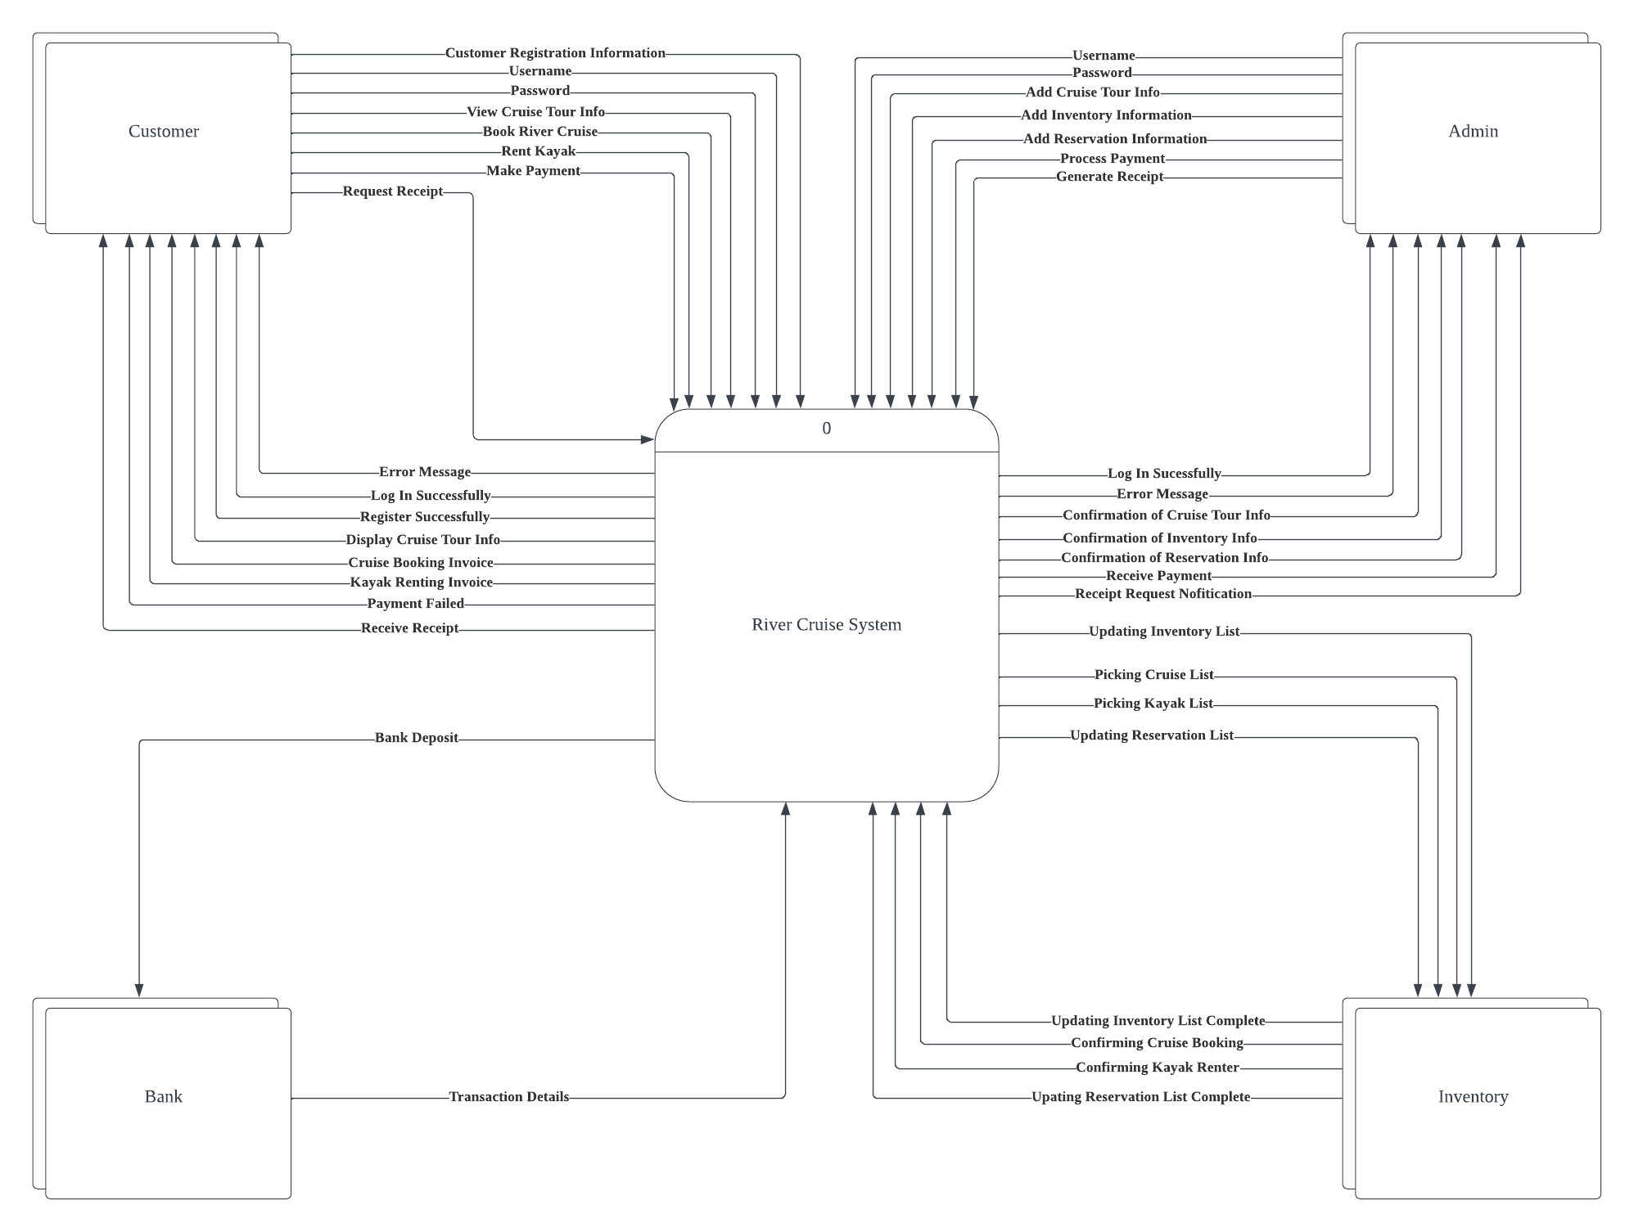

## 6.2 Level 0 Data Flow Diagram

## 6.3 Entity Relationship Diagram

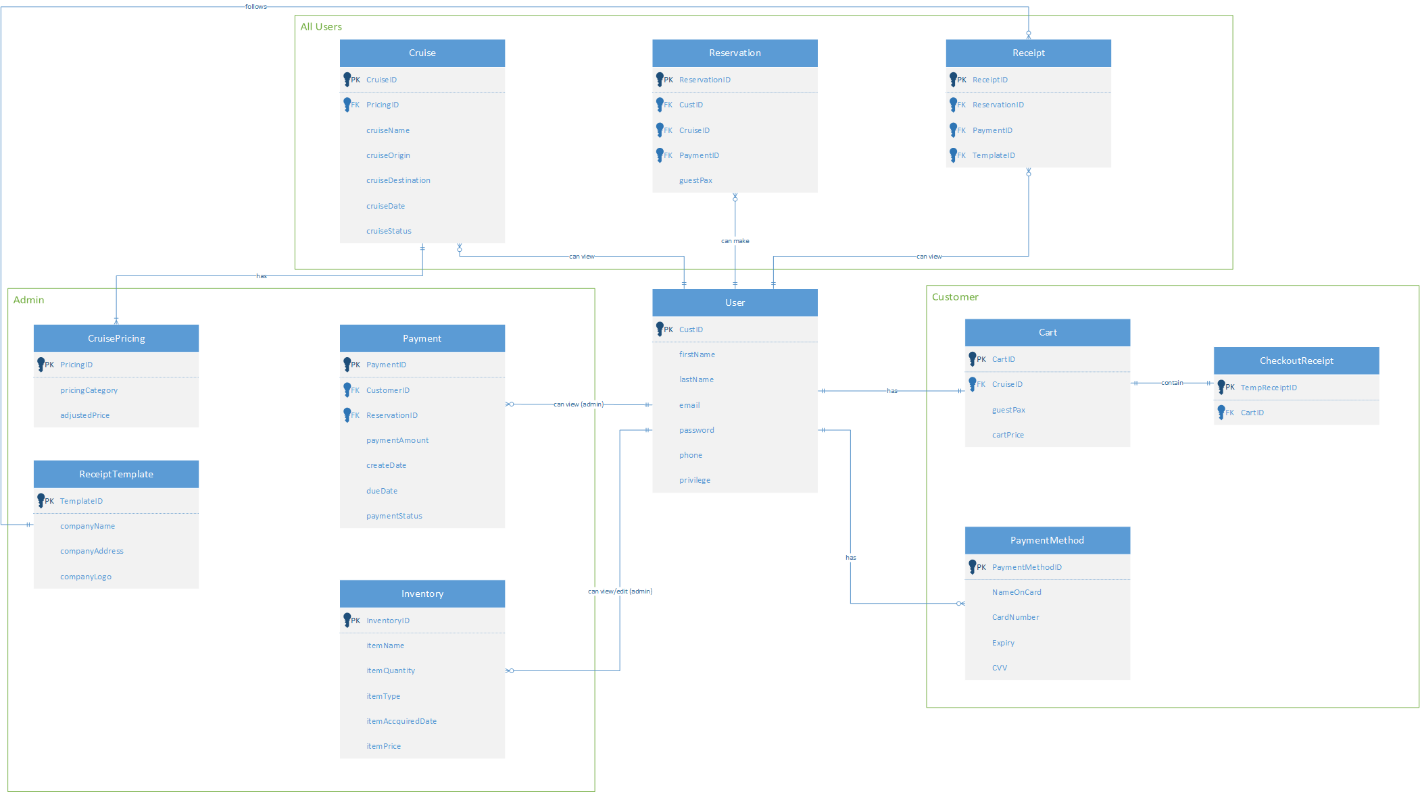

# 7.0 Interface Design

## 7.1 Prototype

### 7.1.1 Home Page

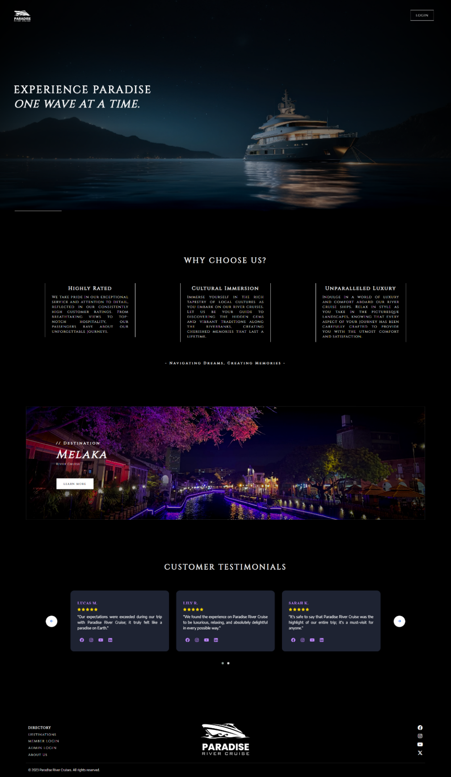

# 8.0 References

AWS. (N.D.). *What is SDLC?* Retrieved from AWS: https://aws.amazon.com/what-is/sdlc/#:~:text=The%20software%20development%20lifecycle%20(SDLC,expectations%20during%20production%20and%20beyond.

Baker, K. (2023, April 21). *HubSpot*. Retrieved from The 15 Best Social Media Analytics Tools for Marketers in 2023: https://blog.hubspot.com/marketing/social-media-analytics-tools

Funky. (2023, March 21). *4 Types Of Reservation Systems*. Retrieved from iMark Guru: https://imarkguru.com/4-types-of-reservation-systems/

Melo, S. (2019, November 12). *8 Disadvantages of paper document management system*. Retrieved from Data Scope: https://datascope.io/en/blog/8-disadvantages-of-paper-document-management-system/

Roberts, S. (2023, July 13). *Advantages and Disadvantages of Microsoft Access*. Retrieved from The Knowledge Academy: https://www.theknowledgeacademy.com/blog/advantages-and-disadvantages-of-microsoft-access/

YH TAN & ASSOCIATES PLT. (n.d.). *Top 10 Accounting Softwares in Malaysia*. Retrieved from YH TAN & ASSOCIATES PLT: https://www.yhtanmy.com/blog/top-10-accounting-softwares-in-malaysia/

[11 Must-Have Features of an Online Booking System (rezdy.com)](https://rezdy.com/blog/online-booking-system-must-have-features/)

[12 Most Important Features Your Online Booking System Should Have | Bookinglayer](https://www.bookinglayer.com/article/the-12-most-important-features-your-online-booking-system-should-have)

[The Key Features That Your Online Booking System Should Have (getomnify.com)](https://www.getomnify.com/blog/key-features-that-an-online-booking-system-should-have)

[How To Implement An Effective Booking System: Tips & Tools (marketsplash.com)](https://marketsplash.com/booking-system/)