Olist E Commerce Customer Experience and Retention Analysis

1 Project Background and Objectives
Olist is a Brazilian e-commerce marketplace connecting consumers, sellers, and e-commerce platforms. As its order volume grows, business performance depends not only on sales and order growth, but also on the shopping experience, fulfillment efficiency, and long-term customer value.
This project develops an analytical framework using Olist transaction data across orders, customers, products, sellers, payments, logistics, and reviews. Initial exploration reveals customer experience and retention issues worth investigating: late orders receive substantially lower ratings than on-time orders, and relatively few customers make repeat purchases. Sales volume alone therefore cannot fully explain long-term growth. The analysis examines factors associated with customer satisfaction and combines customer value and retention analysis to support operational and customer management decisions.
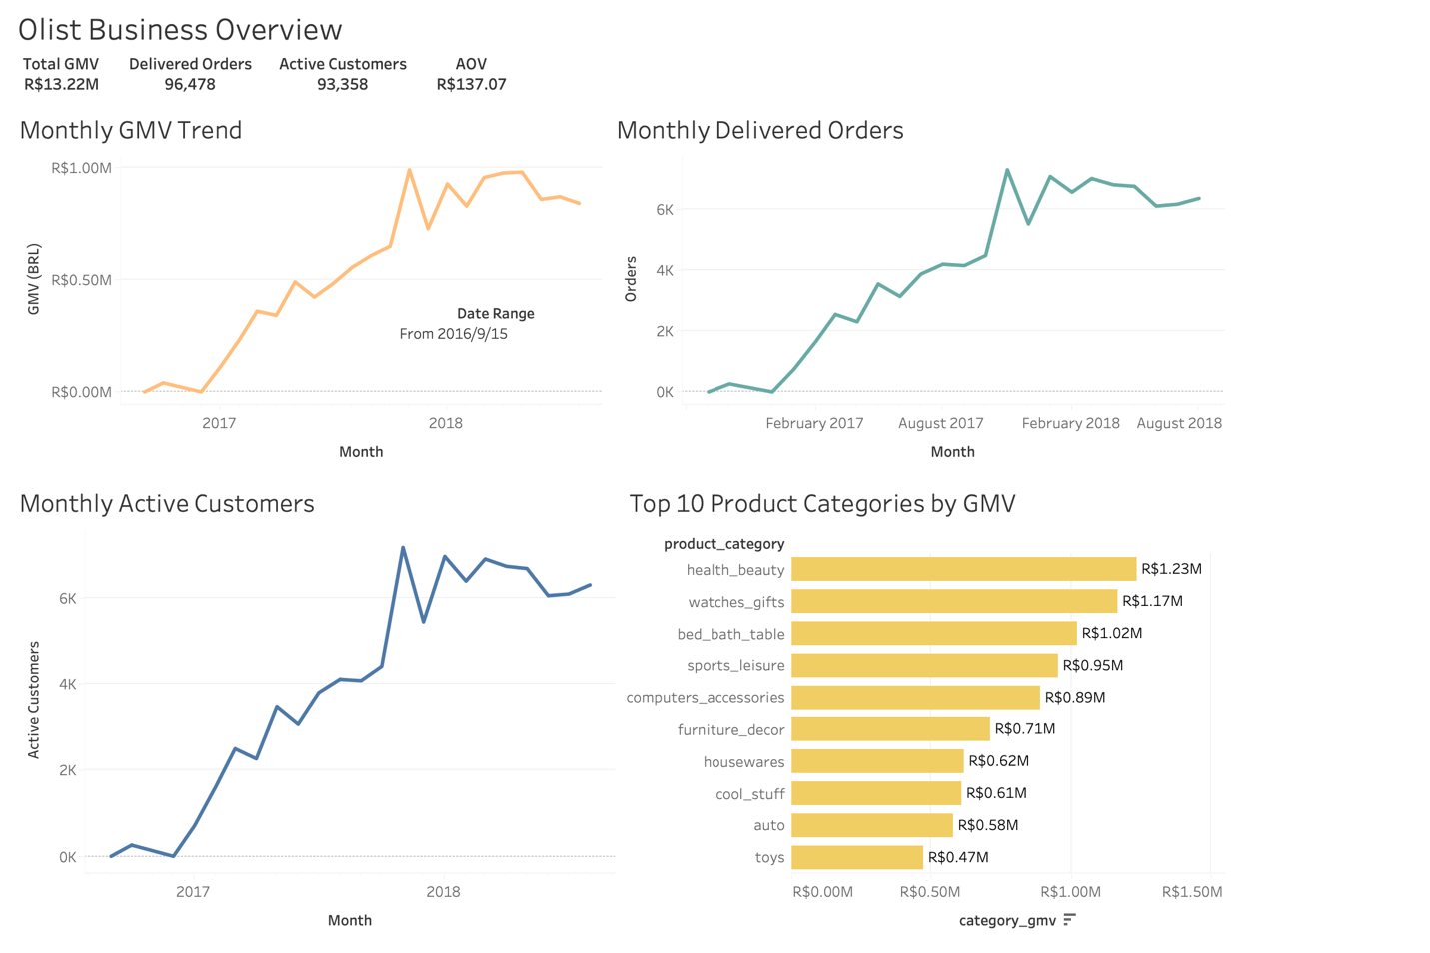
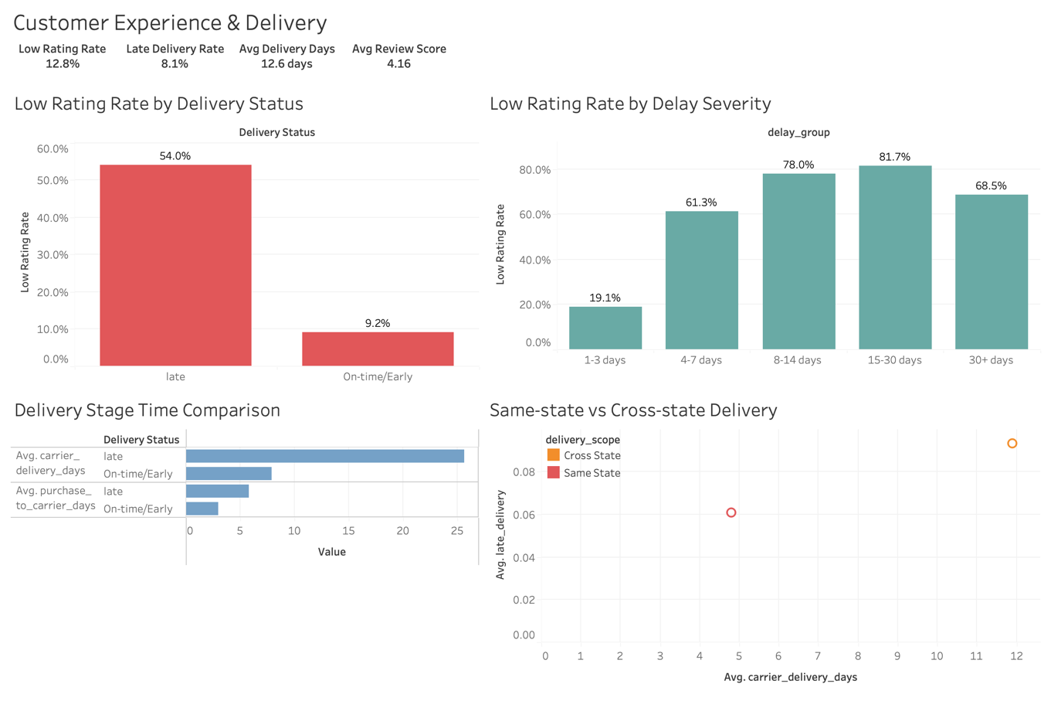
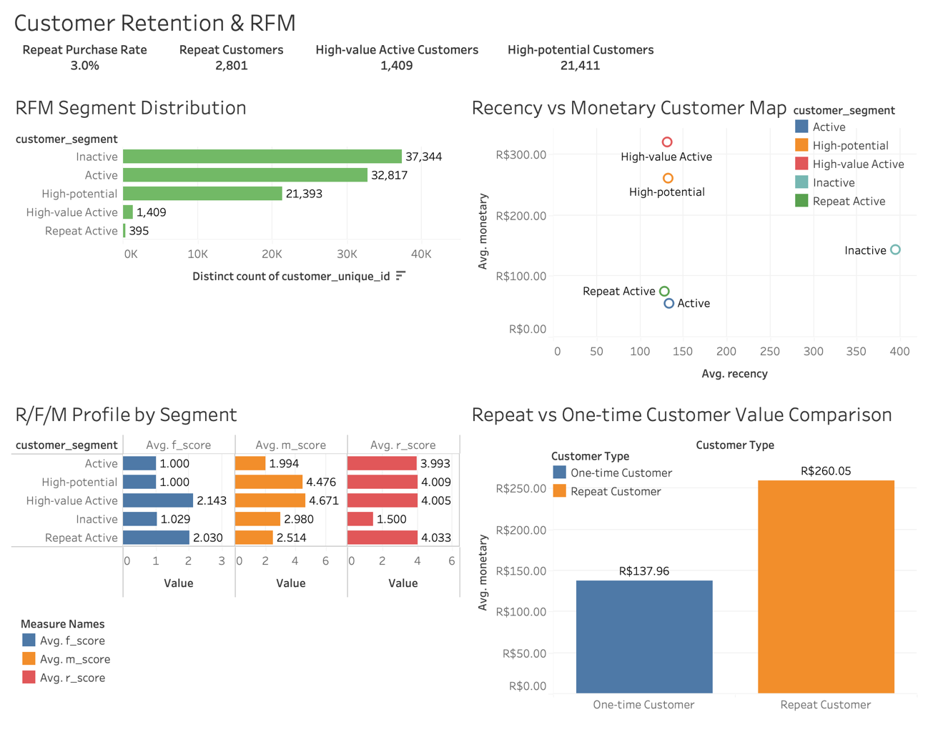
Data Source
The project uses publicly available historical transaction data from Olist, covering September 2016 to September 2018. Customer, order, product, seller, payment, logistics, and review information provides the basis for examining business performance, fulfillment, purchasing behavior, and customer value.
The source data was filtered and integrated for the project objectives. The review dataset retains fields such as Review Score but excludes review titles and review text; no text sentiment analysis is performed. These are anonymized historical observational records. Advertising exposure, marketing campaigns, browsing behavior, and traffic acquisition sources are not included.
Source Tables
olist_customers_dataset — Customer information
olist_orders_dataset — Order master records
olist_order_items_dataset — Order item details
olist_order_payments_dataset — Payment records
olist_order_reviews_dataset — Review scores, excluding review text
olist_products_dataset — Product information
olist_sellers_dataset — Seller information
product_category_name_translation — Product category translations

2 Analytical Framework

Data preparation: Acquire, clean, and integrate the source tables.

Exploratory analysis: Examine GMV, order volume, AOV, active customers, category sales and GMV, review scores, delivery duration, delays, repeat-purchase rates, and purchase frequency.

Customer experience analysis: Investigate delivery delays and low ratings, delay severity, fulfillment stages, interstate shipping, product weight and volume, and the experience of on-time orders. Develop customer experience recommendations.

Customer retention analysis: Examine first-purchase experience and subsequent purchasing; use RFM segmentation to develop differentiated customer engagement strategies.

Synthesis: Supplement the analysis with payment preferences, then consolidate the key findings and operational recommendations.

3 Dataset Overview
Dataset | Records | Description
Olist_​orders_​dataset.csv | 99000+ | Order status, purchase dates, and fulfillment timestamps
olist_​customers_​dataset | 99000+ | Customer IDs, cities, and geographic codes
olist_​order_​reviews_​dataset | 99000+ | Order review scores; review text excluded
olist_​order_​payments_​dataset | 103000+ | Payment methods, amounts, and installments
olist_​order_​items_​dataset | 112000+ | Item details and product/seller links
olist_​products_​dataset | 32951 | Categories, weight, dimensions, and photo counts
olist_​sellers_​dataset | 3095 | Seller IDs, cities, and geographic codes
product_​category_​name_​translation | 71 | Portuguese-to-English product category labels

Relationships Between the Source Tables

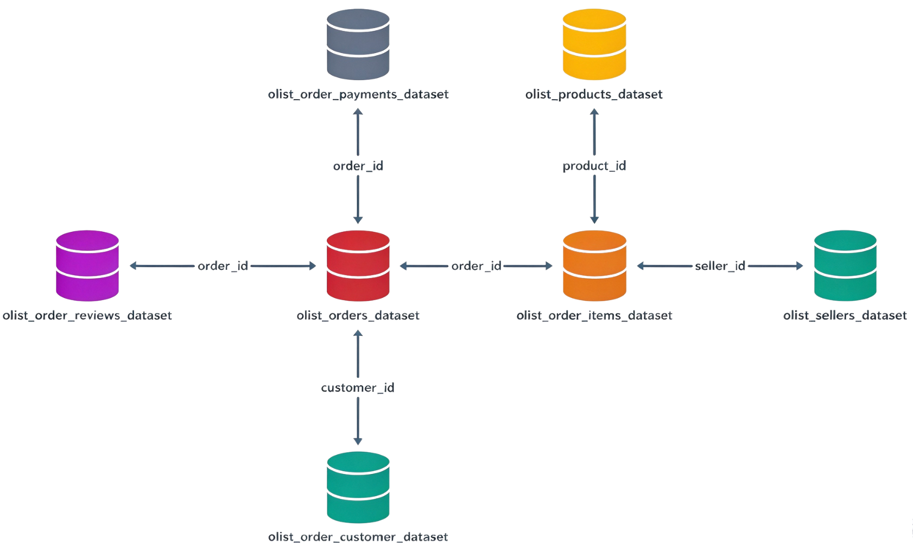

4 Exploratory Data Analysis

4.1 Business Performance

4.1.1 Order Status

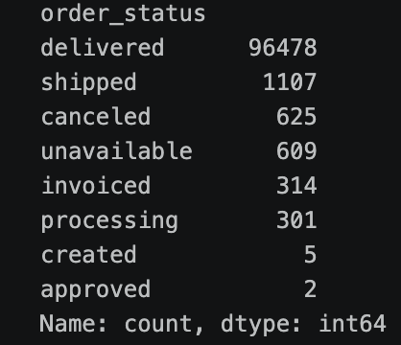

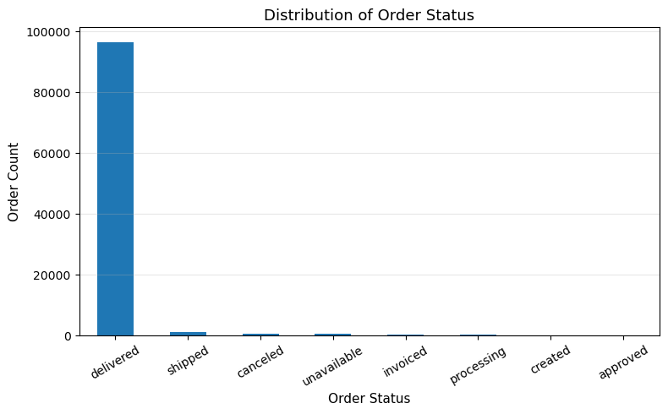

Most orders in the sample are delivered: 96,478 orders, representing more than 97% of the total. The remaining orders have statuses such as shipped, canceled, and unavailable.

4.1.2 Monthly GMV Order Volume and Average Order Value

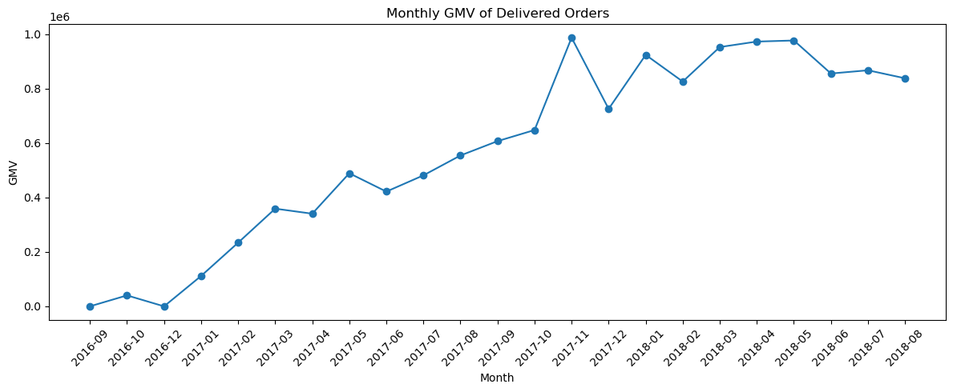

Monthly GMV for delivered orders increased overall from September 2016, peaked in November 2017, and subsequently fluctuated within a relatively high range. This suggests that transaction volume stabilized at a higher level after the initial expansion.

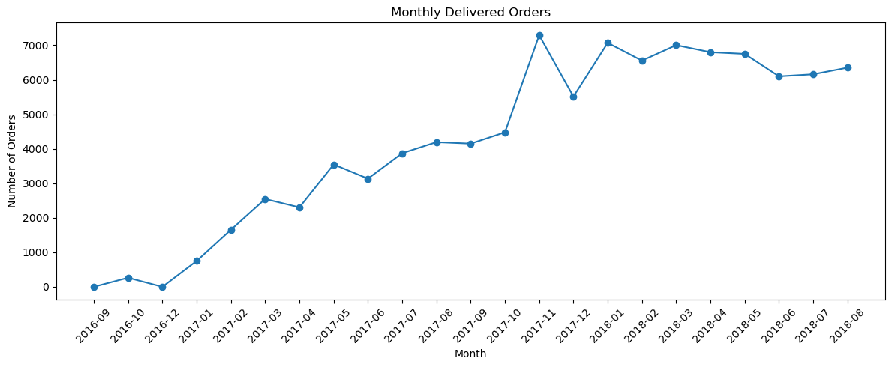
Monthly delivered-order volume followed a similar pattern: growth from September 2016, a peak in November 2017, and subsequent fluctuations at an elevated level. GMV and order volume moved closely together, particularly during 2017. Their similar trajectories suggest that growth may have been driven primarily by more orders rather than higher spending per order. Monthly average order value (AOV) is examined next to assess this interpretation.
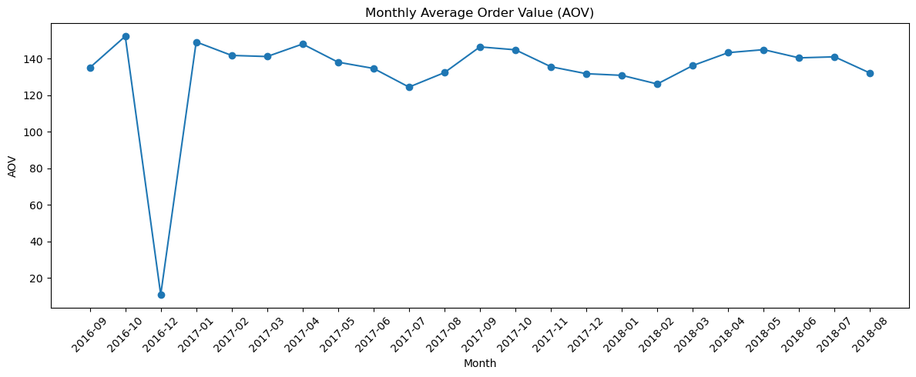
Monthly AOV was relatively stable, generally around R$125–150, with no sustained upward trend. December 2016 was an exception: only one delivered order, worth R$10.90, produced an unusually low monthly AOV. Taken together, the stable AOV and parallel GMV and order-volume trends indicate that growth during the study period was primarily associated with expanding order volume rather than sustained increases in basket value.

4.1.3 Monthly Active Customers

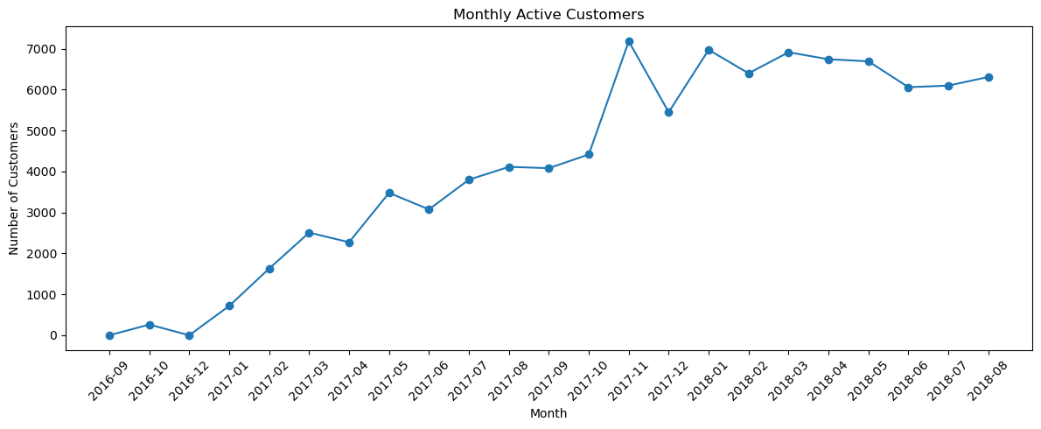

Monthly active purchasing customers increased substantially and closely tracked delivered-order volume. The customer base expanded throughout 2017 and reached a local peak in November. In 2018, monthly active customers generally remained around 6,000–7,000. Combined with stable AOV, these patterns suggest that customer and order expansion were the main contributors to observed GMV growth.

4.1.4 Sales Volume by Product Category

Category analyses focus on delivered orders. The category translation table was missing entries for pc_gamer and portateis_cozinha_e_preparadores_de_alimentos. These two translations were added before category sales were analyzed.
product_​category_​name | product_​category_​name_​english
pc_​gamer | pc_​gamer
portateis_​cozinha_​e_​preparadores_​de_​alimentos | portable_​kitchen_​and_​food_​preparers
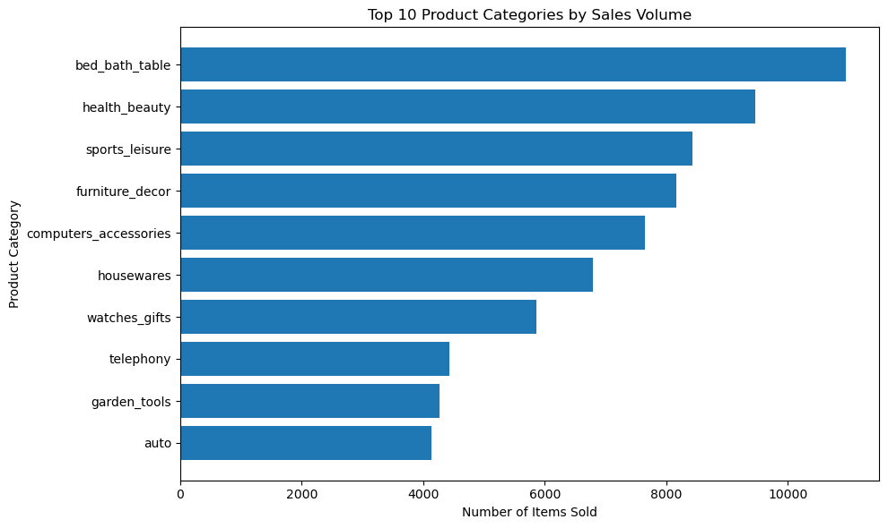

By item sales volume, bed_bath_table ranked first, followed by health_beauty, sports_leisure, and furniture_decor. Leading categories spanned home goods, health and beauty, sports and leisure, and electronic accessories, rather than being concentrated in a single category.

4.1.5 GMV by Product Category
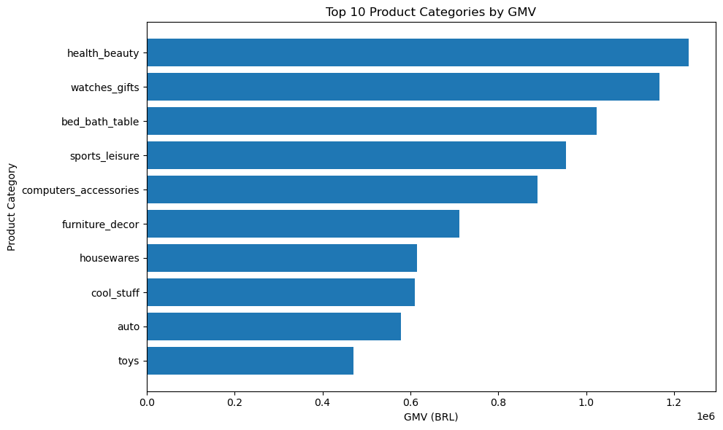

Category rankings by GMV differed from rankings by sales volume. Although bed_bath_table had the highest item volume, it ranked third in GMV, indicating a volume-driven contribution. watches_gifts ranked second in GMV despite a lower sales-volume ranking, suggesting higher average product prices. health_beauty combined strong sales volume with the highest GMV and was a major contributor to platform transactions.

4.2 Customer Experience

4.2.1 Distribution of Review Scores

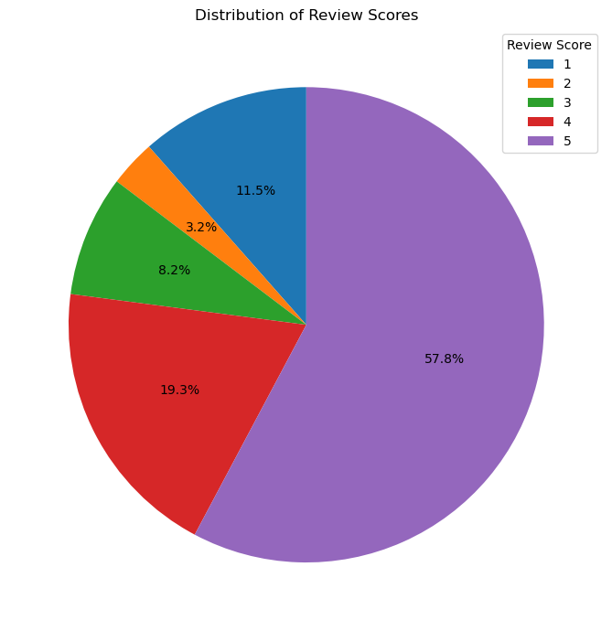

Ratings were generally favorable: 57.8% of reviews gave five stars and 19.3% gave four stars, for a combined 77.1%. Low ratings of one or two stars accounted for approximately 14.7%. Scores of one to three together represented 22.9%, indicating a meaningful group of customers with less favorable experiences. Subsequent analysis examines the order and fulfillment characteristics associated with low ratings.

4.2.2 Distribution of Delivery Duration

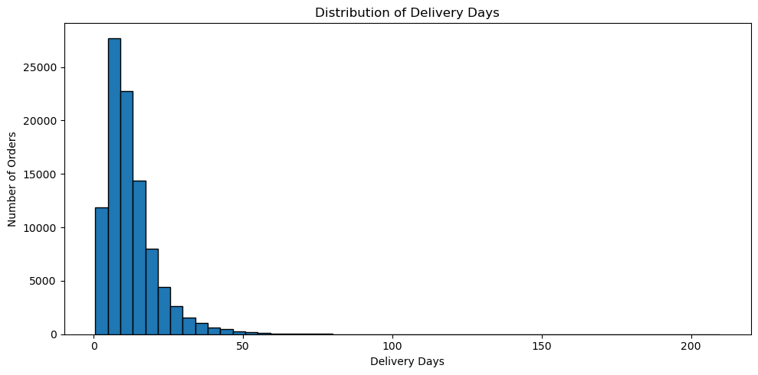

Delivery duration for delivered orders was strongly right-skewed. Most orders arrived within relatively short periods, while a small number took much longer. Mean delivery duration was approximately 12.56 days and the median was 10.22 days; the middle 50% ranged from about 6.77 to 15.72 days. The maximum was approximately 209.63 days. Long-duration outliers raised the mean above the median. Actual delivery dates are next compared with estimated delivery dates to assess lateness and delay severity.

4.2.3 Delivery Delays

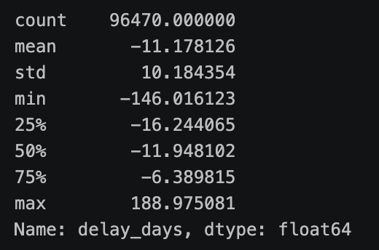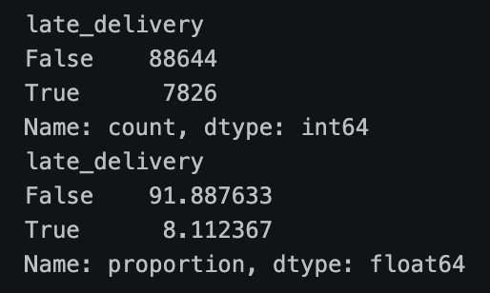
Delivery status | Orders | Share
On time / early | 88644 | 91.89%
Late | 7826 | 8.11%

Among 96,470 delivered orders with complete actual delivery timestamps, 88,644 orders (91.89%) arrived on or before the estimated delivery date, while 7,826 (8.11%) arrived afterward. Most orders therefore met or beat their delivery promise, but approximately 8.1% were late. The next stage examines the relationship between lateness and ratings and investigates factors associated with poor delivery experiences.

4.3 Customer Purchasing Behavior

4.3.1 Purchase Frequency

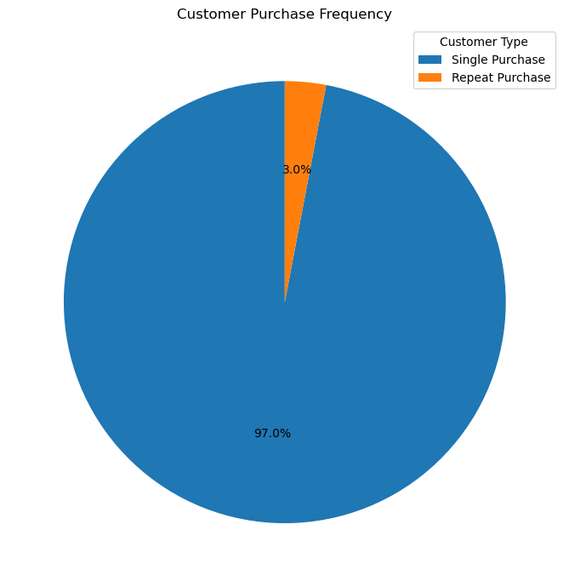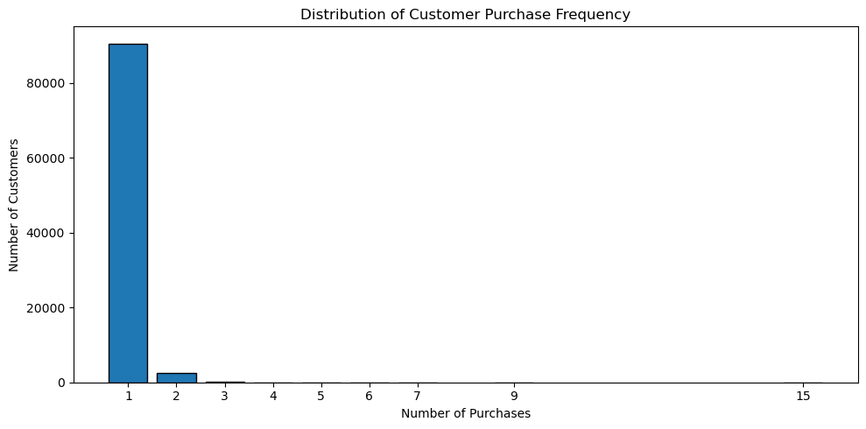

A total of 90,557 customers purchased only once, accounting for 97.0% of customers. Only 2,801 customers made two or more purchases, a repeat-purchaser share of approximately 3.0%. Of these, 2,573 purchased exactly twice, with substantially fewer purchasing three or more times. High-frequency purchasers were therefore uncommon during the observation period. Customer value segmentation is used later to identify groups that may benefit from different engagement and retention strategies.

5 Factors Associated with Customer Experience

The exploratory results suggest that longer delivery times, particularly late delivery, may be associated with poorer customer experiences. The analysis therefore investigates late deliveries and separately examines less favorable ratings among orders that arrived on time.

5.1 Late Deliveries

5.1.1 Delivery Status and Review Scores

The analysis compares the proportion of low-rated orders within the late and on-time delivery groups.

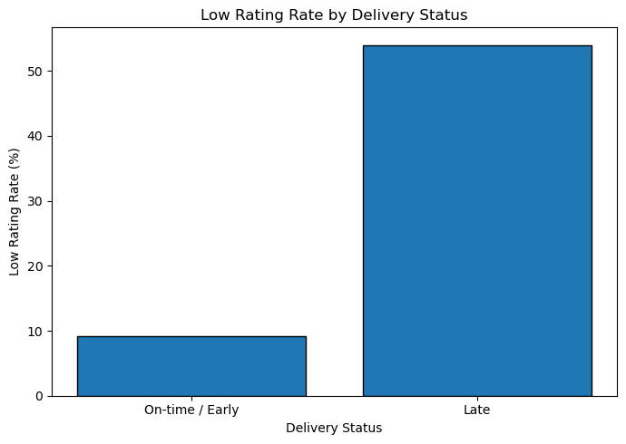

The low-rating rate was 53.99% for late deliveries, compared with 9.19% for orders delivered on time or early. This large descriptive difference indicates a strong association between delivery delays and poor ratings, suggesting that fulfillment performance is an important dimension of the customer experience.

5.1.2 Delay Severity and Low Ratings

To examine whether more severe delays are associated with worse ratings, late orders were divided into five groups: 1–3 days, 4–7 days, 8–14 days, 15–30 days, and more than 30 days. The low-rating share was calculated within each group.

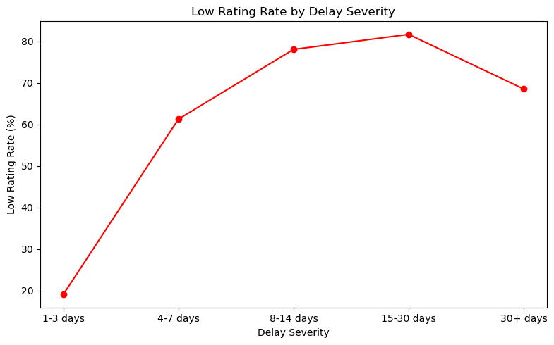

The low-rating rate was 19.1% for delays of 1–3 days, rose sharply to 61.3% for 4–7 days, and reached approximately 78–82% for delays of 8–30 days. For delays exceeding 30 days, it fell to 68.5%; this group contained only 343 orders. Overall, more severe delays were generally associated with higher low-rating rates, with a particularly marked increase after three days.

5.1.3 Factors Associated with Delivery Delays

The preceding comparisons show a close association between delivery delays and low ratings. Fulfillment stages and shipment characteristics are examined next to identify potential priorities for reducing delays.
Delivery status | Purchase to handoff (days) | Carrier transit (days)
On time / early | 3.00 | 7.88
Late | 5.82 | 25.56
Late orders spent longer in both the pre-handoff and carrier transit stages, but the larger difference occurred after the shipment was handed to the carrier. Average carrier transit time was approximately 25.56 days for late orders, compared with 7.88 days for on-time or early orders. The purchase-to-handoff difference was smaller, making carrier transit the more prominent descriptive distinction.
Given this difference in carrier transit time, the analysis examines shipping geography, shipment weight, and shipment volume. Shipping geography is considered first.
Shipping scope | Mean carrier transit (days) | Delay rate (%)
Same state | 4.79 | 6.03%
Interstate | 11.86 | 9.16%
Interstate orders had an average carrier transit time of 11.86 days, compared with 4.79 days for shipments within the same state. Their delay rate was also higher: 9.16% versus 6.03%. Interstate shipping was therefore associated with both longer transit and a higher likelihood of lateness, making geographic scope an important fulfillment consideration.
Shipment Weight
Weight group | Mean carrier transit (days) | Delay rate (%)
Q1 Light | 8.71 | 7.50%
Q2 | 9.32 | 7.96%
Q3 | 9.50 | 8.00%
Q4 Heavy | 9.69 | 8.55%
Shipment Volume
Volume group | Mean carrier transit (days) | Delay rate (%)
Q1 Small | 9.03 | 7.98%
Q2 | 9.17 | 7.98%
Q3 | 9.44 | 7.65%
Q4 Large | 9.54 | 8.37%
Weight and volume showed relatively weak descriptive relationships with delivery performance. From the lightest to the heaviest weight group, average carrier transit time increased modestly from 8.71 to 9.69 days, while the delay rate increased from 7.50% to 8.55%. Transit time also rose slightly with volume, but delay rates did not increase consistently. Differences by interstate versus same-state shipping were more pronounced than those associated with weight or volume.

5.2 On Time and Early Deliveries

5.2.1 Delivery Duration and Review Scores
On time / early | Orders | Mean delivery duration (days) | Median delivery duration (days)
Non-low rating | 80063 | 10.73 | 9.5
Low rating | 8100 | 12.36 | 10.96
Among on-time or early deliveries, low-rated orders had a mean delivery duration of 12.36 days, compared with 10.73 days for other rated orders. Median durations were also higher: 10.96 versus 9.50 days. Even when orders met the estimated delivery date, longer actual waiting times were associated with somewhat less favorable ratings, although the difference was relatively modest.

5.2.2 Freight Burden and Review Scores
On time / early | Orders | Mean freight share (%) | Median freight share (%)
Non-low rating | 80063 | 20.82% | 18.31%
Low rating | 8100 | 21.38% | 19.02%

Among on-time or early deliveries, the mean freight share was 21.38% for low-rated orders and 20.82% for other rated orders. The corresponding medians were 19.02% and 18.31%. These small differences suggest no strong descriptive association between relative freight burden and low ratings in this subset.

5.3 Recommendations for Customer Experience

Fulfillment performance is closely associated with customer ratings. Delivery delays are linked to substantially higher low-rating rates, and the largest time difference for late orders occurs during carrier transit.

An early-warning process could flag undelivered orders approaching their estimated delivery dates, trigger carrier follow-up and exception handling, and proactively communicate progress to customers. For interstate orders, which have longer transit times and higher delay rates, historical delivery performance could inform more realistic delivery estimates and monitoring of high-risk routes and carrier stages. Long-duration orders that are not yet late could also benefit from shorter transit times and clearer progress updates.

Because weight, volume, and relative freight burden show weaker relationships with delivery performance or ratings, operational resources should initially prioritize delivery timeliness, interstate transportation, and exception management.

6 Customer Retention and Value Analysis

6.1 First Purchase Experience and Subsequent Purchasing

6.1.1 First Order Rating and Repeat Purchasing

The exploratory analysis identified a repeat-purchaser share of only about 3%. Given the relationship between delivery experiences and ratings, the next question is whether customers’ first-order ratings are associated with later purchasing.
First-order rating | Customers | Subsequent repeat purchasers | Repeat-purchase rate (%)
Non-low rating | 80845 | 2450 | 3.03%
Low rating | 11896 | 328 | 2.76%
Customers whose first order received a low rating had a subsequent repeat-purchase rate of 2.76%, compared with 3.03% for those whose first order did not receive a low rating: a difference of approximately 0.27 percentage points. This is a small descriptive difference, and repeat purchasing was low in both groups. First-order ratings alone therefore appear insufficient to explain the overall low level of repeat purchasing.

6.1.2 First Order Delivery Status and Repeat Purchasing

First-order delivery status provides an additional, operational perspective on subsequent purchasing.
First-order delivery status | Customers | Subsequent repeat purchasers | Repeat-purchase rate (%)
On time / early | 85285 | 2591 | 3.04%
Late | 7448 | 187 | 2.51%
Customers whose first order arrived on time or early had a subsequent repeat-purchase rate of 3.04%, compared with 2.51% for those whose first order was late: a difference of approximately 0.53 percentage points. This difference was larger than the rating-based comparison of 3.03% versus 2.76%, but repeat purchasing remained low in both groups. The ability of first-order experience to explain overall retention patterns is therefore limited.

6.2 RFM Customer Value Segmentation

Neither first-order ratings nor first-order delivery status fully explains the low repeat-purchase rate. The analysis therefore shifts from examining possible explanations to identifying customer value. Recency, Frequency, and Monetary (RFM) scores are used to segment customers and inform differentiated engagement and retention strategies.

6.2.1 Construction of RFM Measures
Statistic | Recency (days) | Frequency (purchases) | Monetary（R$）
Customers | 93,358 | 93,358 | 93,358
Mean | 237.94 | 1.03 | 141.62
Standard deviation | 152.59 | 0.21 | 215.69
Minimum | 1 | 1 | 0.85
25% | 114 | 1 | 47.65
Median (50%) | 219 | 1 | 89.73
75% | 346 | 1 | 154.74
Median Recency was 219 days. Frequency was heavily concentrated at one purchase, indicating that most customers had purchased only once. Median Monetary value was R$89.73, while the maximum reached R$13,440, indicating strong right skew. Scoring should reflect these distributions, particularly the concentration of Frequency at one purchase.

6.2.2 RFM Scoring and Customer Segments

Recency and Monetary values were divided into five distribution-based score groups, with higher scores assigned to more recent purchasing and higher spending. Because approximately 97% of customers purchased only once, Frequency was scored directly from purchase counts: one to four purchases received scores of 1–4, and five or more received a score of 5.

Five customer segments were defined using the three scores. An R score of at least 3 indicates relatively recent purchasing, while an R score of 2 or below indicates a longer period without purchasing. An M score of at least 4 indicates higher spending, while a score of 3 or below indicates moderate or lower spending.
Customer segment | Score rules | Customer characteristics
High-value Active | R ≥ 3，F ≥ 2，M ≥ 4 | Recent repeat purchasers with higher cumulative spending
Repeat Active | R ≥ 3，F ≥ 2，M ≤ 3 | Recent repeat purchasers with lower cumulative spending
High-potential | R ≥ 3，F = 1，M ≥ 4 | Recent higher-spending customers without a second purchase
Active | R ≥ 3，F = 1，M ≤ 3 | Recent single-purchase customers with lower spending
Inactive | R ≤ 2 | Customers with less recent purchases and signs of inactivity

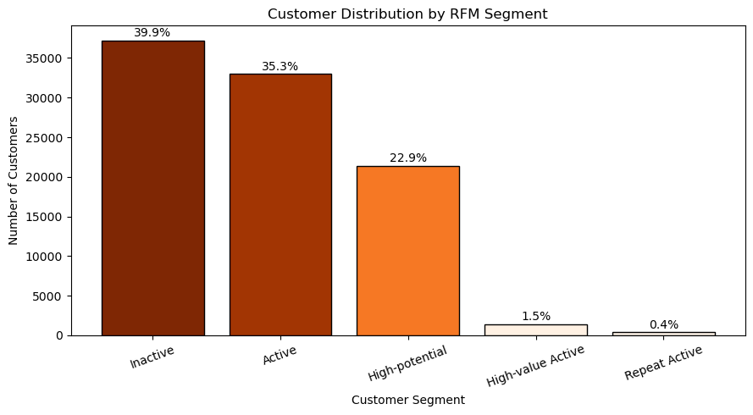

The segment distribution was dominated by single-purchase customers. Inactive customers represented 39.9%, Active customers 35.3%, and High-potential customers 22.9%. High-value Active and Repeat Active customers—recently active repeat purchasers—together accounted for less than 2%. This is consistent with the low overall repeat-purchase rate. The High-potential group is particularly relevant: these customers purchased recently and spent relatively more but had not yet made a second purchase, making them a potential audience for second-purchase initiatives.
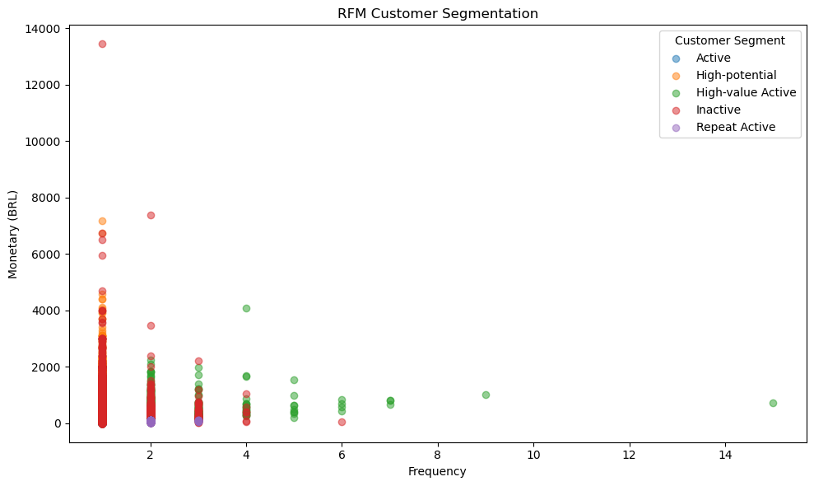
Frequency and Monetary distributions also showed that most customers had purchased only once. High-potential customers had higher spending than general Active customers despite not having repurchased. High-value Active customers combined higher purchase frequency with greater spending. Some Inactive customers had substantial historical spending, suggesting that selected previously valuable customers could be prioritized for reactivation.

6.3 Customer Engagement Strategies by Segment
Engagement should vary by customer value and activity. For High-value Active customers, prioritize loyalty and long-term value through VIP or membership benefits such as exclusive discounts, cashback or points, coupons, prize draws, and early access to new products. For Repeat Active customers, consider spending thresholds, bundles, and complementary product recommendations to increase order value and cumulative spending.
For High-potential customers, prioritize the second purchase through time-limited coupons, spending-threshold offers, points, and recommendations related to the first purchase. For Active customers, use lower-cost email, in-platform messages, personalized recommendations, and modest incentives to encourage a second purchase while controlling marketing costs. For Inactive customers, consider limited-time return offers, reactivation emails, and category-relevant promotions. Use historical Frequency and Monetary values to prioritize outreach, concentrating resources on previously more frequent or higher-spending customers rather than treating all dormant customers equally.

7 Customer Payment Preferences
Payment methods are examined as a supplementary analysis to better understand transaction preferences, inform the payment experience, and support customer engagement alongside the experience and RFM analyses.
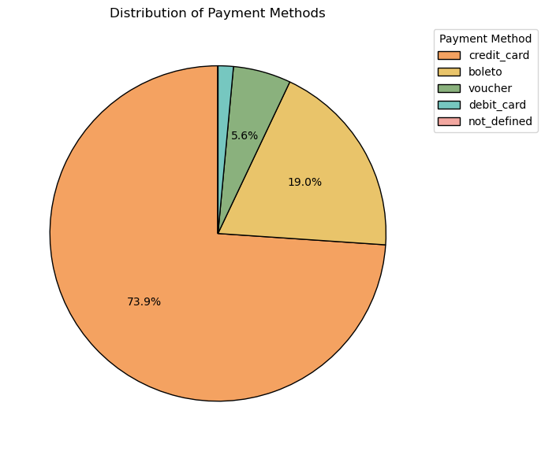
Credit cards accounted for 73.9% of all payment records, making them the dominant payment method. Boleto and vouchers represented 19.0% and 5.6%, respectively, while other methods accounted for small shares.
The platform could prioritize credit-card checkout and explore partnerships with card issuers or payment providers offering cashback, points, exclusive coupons, or payment credits. Boleto and voucher options should remain available to accommodate different payment preferences and avoid unnecessary transaction barriers.

8 Summary of Findings and Business Recommendations

8.1 Key Findings
Growth drivers: GMV and order volume increased together while AOV remained relatively stable. Growth during the study period was mainly associated with more orders and purchasing customers rather than sustained increases in order value.
Delivery experience: Late deliveries were strongly associated with low ratings. The low-rating rate was 53.99% for late orders versus 9.19% for on-time or early orders, and increased sharply for delays exceeding three days.
Fulfillment priorities: Time differences for late orders were concentrated in carrier transit. Interstate orders had longer transit times and higher delay rates than same-state orders, while relationships with product weight and volume were weaker.
Customer retention: Approximately 97% of customers purchased only once, and the repeat-purchaser share was about 3%. Customers with low-rated or late first orders had slightly lower subsequent repeat-purchase rates, but the differences were limited. First-order experience alone does not fully explain the overall pattern.
Customer value: Recently active repeat purchasers formed a small group. High-potential customers represented 22.9%: recent, higher-spending single-purchase customers who may be suitable targets for second-purchase initiatives.
Payment preferences: Credit cards accounted for 73.9% of payment records, substantially exceeding other payment methods.

8.2 Operational Recommendations
Delivery management: Establish early warnings for undelivered orders approaching their estimated delivery dates; follow up with carriers, handle exceptions, and proactively communicate shipment progress.
Fulfillment optimization: Prioritize carrier transit and interstate transportation. Use historical performance to identify high-risk routes, improve delivery estimates, and allocate carrier resources, rather than focusing primarily on weight or volume.
Second-purchase conversion: Prioritize High-potential customers for time-limited second-purchase coupons, spending-threshold offers, points, and relevant product recommendations.
High-value customer engagement: Evaluate VIP or membership benefits for High-value Active customers, including exclusive discounts, points, cashback, coupons, prize draws, and early access to new products.
Segmented engagement: Use bundles and spending-threshold offers for Repeat Active customers, lower-cost personalized outreach for Active customers, and value-based reactivation priorities for Inactive customers.
Payment optimization: Improve credit-card checkout and evaluate payment-provider partnerships for cashback, points, coupons, or credits, while retaining boleto and vouchers for customers with different preferences.

