Huishoubao Valuation Experience Optimization
Product Design Using AI Assisted Condition Assessment and Inspection Transparency
English translation. Original Chinese app screenshots, research graphics, and prototype visuals are retained as source evidence; the surrounding English text explains their content. This is an independent portfolio proposal and has not been developed or launched.

1 Project Overview

1.1 Project Introduction
This project proposes an AI assistant embedded in Huishoubao’s existing valuation process. Guided photography, assessment of visible device condition, user confirmation, and automatic form completion are intended to reduce the effort required of inexperienced users. Pre-order photographs and condition records are retained so that, after professional inspection, users can compare discrepancies against their confirmed descriptions and understand the associated price changes. The goal is greater transparency and trust.

1.2 Background and Core Problems

1.2.1 Project Background
Huishoubao’s online valuation process requires users to select a device model and manually report its appearance, functionality, and repair history. The system generates an estimated price, while the final transaction price depends on professional inspection. Users with limited inspection knowledge or recycling experience may struggle to match their device to the condition options and understand differences between their descriptions and the inspection findings.

1.2.2 Core User Problems
Core Problem Statement
For users unfamiliar with online device recycling and inspection, technical condition options, disconnected pre-order and post-inspection records, and unclear links between inspection findings and price changes can increase task and decision effort. These barriers may lead users to delay ordering, abandon a transaction, or switch platforms.
1. Difficulty assessing and reporting condition: Users struggle to map their device’s actual condition to technical assessment options.
2. Limited ability to verify valuation evidence: Users cannot easily compare their pre-order selections with subsequent professional inspection findings.
3. Uncertainty about the final payout: Inspection discrepancies and their price implications are not sufficiently intuitive, potentially raising doubts about quote adjustments.

1.3 Target Users
User group | Definition
Primary users | First-time users with a clear need to recycle a phone but limited online recycling and inspection knowledge
Secondary users | Infrequent users with some experience who find repeated condition assessment and form completion inconvenient
Non-priority users | Experienced frequent comparers who mainly seek the highest quote across platforms

1.4 Objectives and Core Metric
User objective: Reduce the expertise and effort required to assess and report device condition through AI assistance. Retained records, visual inspection comparisons, and explanations of price changes are intended to reduce information asymmetry, uncertainty, and distrust.
Business objective: Reduce cancellations and abandonment associated with reporting errors or unclear valuations, and improve conversion from completed valuation to completed transaction.
Core metric: Valuation-to-transaction conversion rate—the proportion of completed online valuation sessions that ultimately lead to a completed transaction. Valuation sessions are linked to subsequent orders, and each session is counted once.

1.5 Scope and Boundaries
The project focuses on smartphone valuation and inspection at Huishoubao. AI-assisted condition assessment, user confirmation, retained valuation records, and inspection discrepancy explanations support efficiency and transparency. AI assists rather than replacing pricing rules or professional inspection. The MVP excludes internal-fault detection, other device categories, and cross-platform price comparisons.

1.6 Individual Role and Responsibilities
Role: Independent project designer performing product management responsibilities.
Responsibilities: User research, competitor analysis, requirements definition, feature planning, business process design, prototyping, metric and event design, and iteration planning.

2 Current Business Process and Initial Hypotheses

2.1 Current Business Process
Business Context
Used smartphones are non-standardized goods. Devices of the same model can have different values because of cosmetic condition, functionality, and repair history.
Huishoubao follows a process of online user assessment, system-generated estimate, professional inspection, and transaction confirmation. The online estimate reflects user-supplied information; the final offer reflects the inspected device condition.
User assessment and professional inspection rely on different standards and information sources, so estimated and final prices may differ. This characteristic underpins the research hypotheses.
Existing User Journey
Users select their device configuration and condition to receive an estimated price. After the device is submitted, professional inspection determines the final offer. If the final offer is lower, users can accept it or request the device’s return. At the valuation stage, users mainly compare their devices with reference images and make manual selections. Differences from professional inspection create an opportunity for further research.

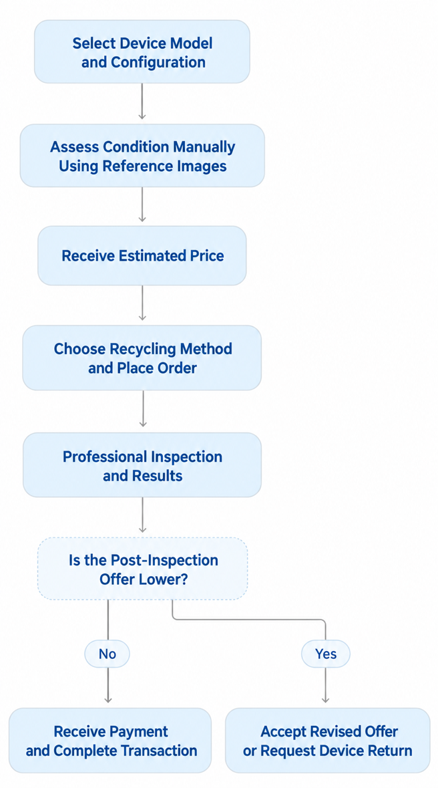

2.2 Initial Problem Hypotheses
An initial review of the existing workflow produced the following hypotheses for validation through interviews and public feedback:
Condition assessment and option matching are difficult. Scratches and dents are typical examples. Reference images still require users to make comparisons under different viewing angles, lighting conditions, and interpretations of standards. Self-assessment may therefore differ from inspection and create a gap between estimated and final prices.
Pre-inspection and post-inspection records are difficult to reconcile. Without standardized device photographs and condition records, users may struggle to verify discrepancies or determine whether damage existed before shipping or occurred during transport or inspection.
Inspection discrepancies lack linked price explanations. Users may not understand technical inspection terminology, identify which findings differ from their original assessment, or see how those differences affect the final offer.
These problems may increase task and decision effort, undermine perceived fairness, and contribute to delayed orders, rejected offers, return requests, or complaints.

3 User Research

3.1 Research Objectives and Methods
Research Objectives
The research tests the initial hypotheses by examining:
1. Difficulties assessing condition and matching valuation options.
2. Whether differences between self-assessment and professional standards create price-expectation gaps.
3. Demand for comparable pre-inspection records and explanations of price changes.
4. Factors influencing acceptance of the final offer or abandonment.
Research Methods
The project combines analysis of public feedback with semi-structured user interviews.
Method | Research plan | Purpose
Public feedback analysis | Select approximately 60 usable entries from complaint and social platforms, mainly about Huishoubao with Aihuishou and Zhuanzhuan as comparators | Identify shared issues in valuation, inspection, price changes, and trust
Semi-structured interviews | Interview 6–10 people with recent valuation, recycling, or resale experience, or a current need to sell; 30–45 minutes each | Understand behavior, expectations, decisions, and underlying problems

3.2 Research Execution and Findings
Public feedback identifies recurring disputes around valuation and inspection. Interviews explore users’ experience of condition reporting, price interpretation, transaction decisions, and acceptance of the proposed AI features.
Research Overview
Method | Sample | Purpose
Public feedback analysis | 60 entries: Huishoubao 40, Aihuishou 10, Zhuanzhuan 10 | Identify recurring valuation, inspection, and explanation issues
Semi-structured interviews | 8 participants: 6 completed valuations, 3 experienced inspection, 2 completed transactions | Assess condition difficulties, decision factors, and acceptance of the AI concept

3.2.1 Findings from Public Feedback
Sources include Black Cat Complaints, Zhihu, Baidu Tieba, and public experience articles. Forty Huishoubao entries form the main sample. ATRenew/Aihuishou and Zhuanzhuan entries provide context on whether similar issues appear across platforms.
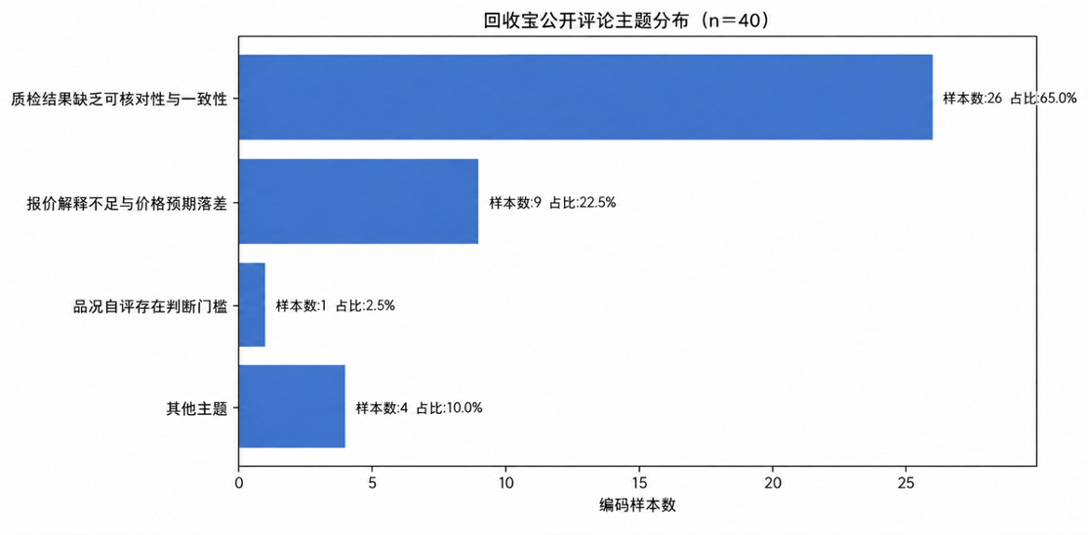
1. Verifiability of inspection findings was the most prominent issue
Some users reported that scratches, dents, or functional issues in inspection reports did not match the device condition they recalled before shipping, but they lacked complete, clear photographs or videos to verify the findings.
Differences between inspection findings or assessment standards can increase users’ doubts about the results.
2. Price changes lacked intuitive explanations
Some users were less concerned that the offer changed than with whether the platform explained newly identified issues and their price implications. Large unexplained gaps between estimated and final prices could lead to rejected offers, returns, or complaints.
3. Public feedback did not fully reveal form-completion difficulties
Few entries explicitly discussed uncertainty about scratch severity or condition options. Because complaints tend to focus on inspection, price reductions, and after-sales issues, interviews were needed to investigate barriers at the earlier valuation stage.

3.2.2 Interview Findings
Interviewees included users who had completed online valuations, experienced professional inspection, completed transactions, or had a current need to sell a device without having used a professional recycling platform.
Experience | Participants
Completed online valuation | 6
Experienced professional inspection | 3
Completed a transaction | 2
No platform experience but current selling need | 2
1. Self-assessment presents practical difficulties
All eight interviewees described some difficulty identifying fine scratches, paint loss, screen burn-in, or differences in damage severity. Six based their feedback on actual valuation or transaction experience. Static reference images do not cover every device, lighting condition, angle, and damage pattern, leaving users to rely on subjective judgment.
2. Self-assessment can differ from professional inspection
All three participants with actual inspection experience encountered cosmetic issues identified during inspection that they had not noticed online. Such differences can create overly optimistic expectations from the initial estimate and disappointment when the final offer changes.
3. Price gaps evidence and return effort jointly influence decisions
U02 canceled after a RMB220 reduction and wanted retained issue photographs. U03 accepted an RMB80 reduction because the gap was relatively small and return shipping was inconvenient. U06 accepted a RMB120 reduction that was within expectations. Some users prioritized photographic evidence; others prioritized payout and convenience.
4. Transparency reduces uncertainty but cannot replace competitive prices
When price differences were small, most users preferred an option that retained records and explained adjustments. When another offer was substantially higher, some still prioritized price. Transparency can build trust but may not offset a large price disadvantage.
5. AI should assist while preserving user control
Participants generally saw value in using AI to identify subtle cosmetic issues and reduce comprehension and form-filling effort. They also worried about errors caused by lighting, camera angle, and image quality, making confirmation, editing, and manual entry essential.

3.2.3 Combined Research Conclusions
Public feedback and interviews provide complementary evidence:
Public feedback highlights difficulties verifying inspection findings and understanding price changes. Interviews additionally reveal practical difficulties reporting condition and recognizing minor damage.
Differences between self-assessment and professional inspection can create price-expectation gaps. Transaction decisions also depend on the size of the price difference, the available evidence, and the effort of returning the device.
An assisted workflow—AI assessment, user confirmation or editing, and automatic form completion—may reduce effort. Retained records, inspection comparisons, and price explanations can support transparency.
Research Limitations
The interview sample is small, and only three participants had actual inspection experience. Public feedback drawn mainly from complaint platforms is subject to negative selection bias. Findings are used to identify potential problems and form product hypotheses, not to represent all Huishoubao users or estimate population-level incidence. Responses to the AI proposal are concept feedback rather than evidence from a deployed product.

3.3 User Segmentation and Persona

3.3.1 Segmentation Criteria
Two dimensions guide segmentation:
Online recycling experience: Familiarity with valuation options, inspection workflows, and price adjustments.
Need for transaction certainty: Importance placed on convenience, verifiable records, and explainable price changes.
Segment | Experience | Need for certainty | Characteristics | Priority
Cautious novice | Low | High | Limited assessment experience; concerns about incorrect reporting, inspection reductions, and loss of control after shipping; may stop after valuation | Primary
Price-focused novice | Low | Lower | Inexperienced but prioritizes the highest quote and tolerates some uncertainty | Non-priority
Infrequent convenience seeker | Moderate | High | Some experience; wants less repeated assessment, form-filling, and communication effort | Secondary
Experienced price comparer | High | Lower | Understands prices and workflows; assesses condition independently and prioritizes the highest cross-platform quote | Non-priority
The primary audience is the cautious novice: a user with a clear need to sell a smartphone who may hesitate because of condition-assessment difficulty, uncertain post-inspection prices, and limited verification evidence. AI assistance and transparent inspection directly address these concerns. Infrequent convenience seekers form the secondary audience and may benefit from automatic assessment and form completion.
Price-focused novices lack experience but mainly prioritize the highest offer. Serving them would require further segmentation of selling intent and price expectations, beyond this project’s scope. Experienced price comparers also prioritize the best offer. Because AI does not change platform pricing rules, neither group is an MVP priority.

3.3.2 Core Persona
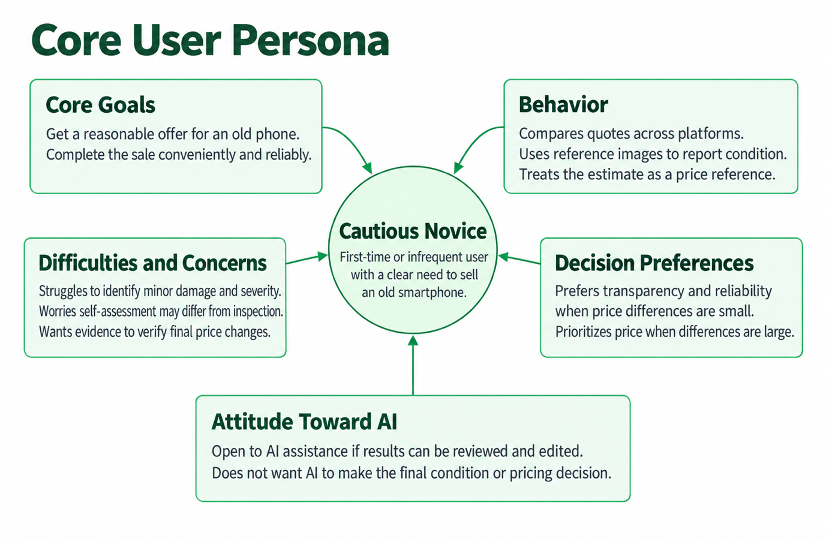
Cautious Novice
Age 26 | Corporate employee | First-time user of a professional recycling platform
Recently upgraded their phone and wants to sell the old device to offset the cost. Values a reasonable payout, a simple process, and reliable results. Has completed an online valuation but has not ordered because of concerns about post-inspection price reductions and insufficient evidence for checking them.

3.3.3 Typical Scenarios
Scenario 1: After upgrading, a user wants to sell the old phone. They select the model and complete the condition form but cannot confidently distinguish minor scratches or dent severity, relying on reference images and subjective choices.
Scenario 2: The estimated price seems acceptable, but negative online reviews raise concerns about opaque reductions after shipping. Without standardized pre-order photographs or clarity on future inspection explanations, the user stays on the valuation results page rather than ordering.
Scenario 3: Guided photography, AI-assisted visible-condition assessment, user confirmation, automatic form completion, and retained records could help establish more realistic expectations. Subsequent comparisons and price explanations may increase willingness to order and accept a reasonable offer.

3.4 Pain Points and Root Causes
Core problem | User behavior | Root cause | Potential impact
Condition assessment and reporting | Repeatedly compares damage grades or makes subjective choices | Static examples cannot cover all models, lighting, angles, and damage; limited expertise | Greater effort and price expectations that may differ from inspection
Inspection verification | Cannot determine whether newly reported issues existed before shipping | No standardized photographs or confirmed records; weak item-level correspondence | Doubts about findings, lower trust, and reduced willingness to accept
Understanding price changes | Sees an adjusted offer without understanding its drivers | Unclear link from discrepancy to price impact to final offer; technical language | Concerns about opaque reductions, rejected offers, returns, or complaints
The opportunity extends beyond the offer amount: valuation, inspection, and final pricing lack a continuous, understandable, and verifiable information trail. AI assistance can reduce early assessment effort, while standardized records and discrepancy explanations can improve later transparency.

4 Competitor Analysis

4.1 Competitor Selection and Method
Huishoubao is the target for improvement. Aihuishou and Zhuanzhuan are direct comparators. Aihuishou offers reference points in professional recycling, offline inspection, and structured reports. Zhuanzhuan’s photo-based AI valuation and detailed inspection reports provide examples of existing AI applications and their boundaries.
The review combines app walkthroughs, public official materials, and public user feedback. It compares condition reporting, AI photo recognition, pre-order records, inspection reports, and price explanations. Walkthroughs were conducted in October 2026; the observations are version-specific and features may change.

4.2 Core Feature Comparison
Dimension | Huishoubao | Aihuishou | Zhuanzhuan
Condition entry | Supported: manual selection of appearance, screen, functionality, and repairs | Supported: manual device-condition entry | Supported: conventional valuation requires manual device and condition information
Reference images and guidance | Supported: descriptions and images for damage levels | Supported: reference images for frames, back panels, and screens | Supported: examples, damage grades, and device proportions for those conditions
AI photo recognition | Not observed: mainly reference images and self-assessment | Not observed: AI focused on recommendations and recycling inquiries | Partial: categories and model candidates from photographs; no specific scratch/dent recognition observed
Confirming and editing AI results | Not observed: no structured AI condition results | Not observed: no AI condition-confirmation flow | Partial: model correction and storage entry; no item-level cosmetic-result editing
Pre-order photo and condition records | Not observed: standardized actual-device photography was not required | Not observed: no retained pre-order photos used for later verification identified | Partial: AI requires photographs, but linkage to formal orders and reports was not identified
Inspection photos and reports | Partial: inspection findings and a full report page | Supported: photographs, inspector, matching items, discrepancies | Supported: photographs, normal findings, defects, and some quantitative standards
Before/after comparison | Not observed: no item-level comparison with pre-order records | Partial: self-reported versus inspected items; no item-level photo comparison identified | Partial: findings shown without direct comparison to pre-order photographs and AI results
Price explanations and questions | Not observed: warning of possible changes without item-level price linkage | Partial: discrepancies shown; specific monetary impacts and interactive explanations not identified | Partial: price factors and defect standards shown, but not linked item by item to final adjustments

4.3 Detailed Competitor Findings
Huishoubao uses reference images but relies on subjective assessment
Text and reference photographs explain condition grades, but users must compare their own devices with the examples and manually choose the closest option. Device differences, lighting, angles, and damage patterns may increase uncertainty and produce differences from professional assessment.
The results page shows the device estimate, promotional additions, and recycling methods, and warns that discrepancies found during inspection can change the payout. However, the reviewed valuation flow did not require photographs of the actual device or create standardized photographic records for subsequent verification.
Screenshots: Condition reference images and valuation results. Original Chinese interface retained.
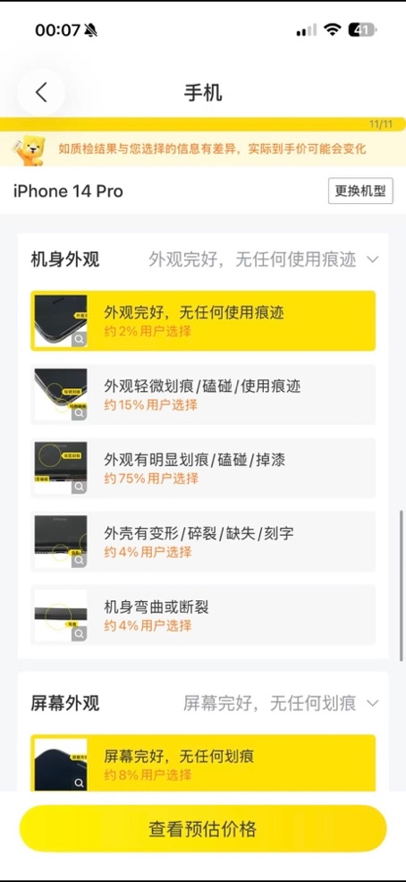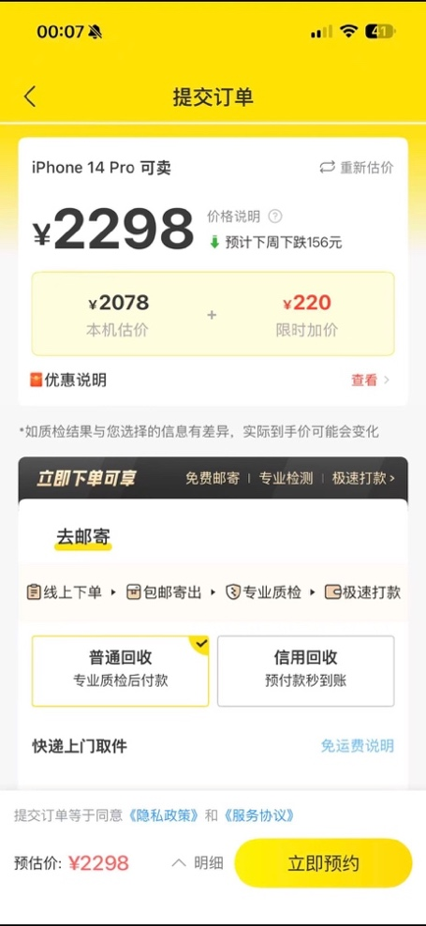
Aihuishou provides structured inspection but mainly manual valuation
The reviewed valuation flow used reference images and manual selections. Its AI assistant mainly supported product recommendations, budget-based device selection, and recycling inquiries. The walkthrough did not identify a function that assessed scratches or dents in actual user photographs and automatically completed condition fields.
Inspection reports displayed device photographs, inspectors, matching items, and discrepancies, enabling comparisons with self-reported condition. Public materials also described quote rationale and settlement details. However, the walkthrough did not obtain a page showing the monetary deduction for each discrepancy, so item-level price impact was not treated as verified.
Screenshots: Manual condition entry, the AI assistant, and matching/discrepant inspection items. Original Chinese interface retained.
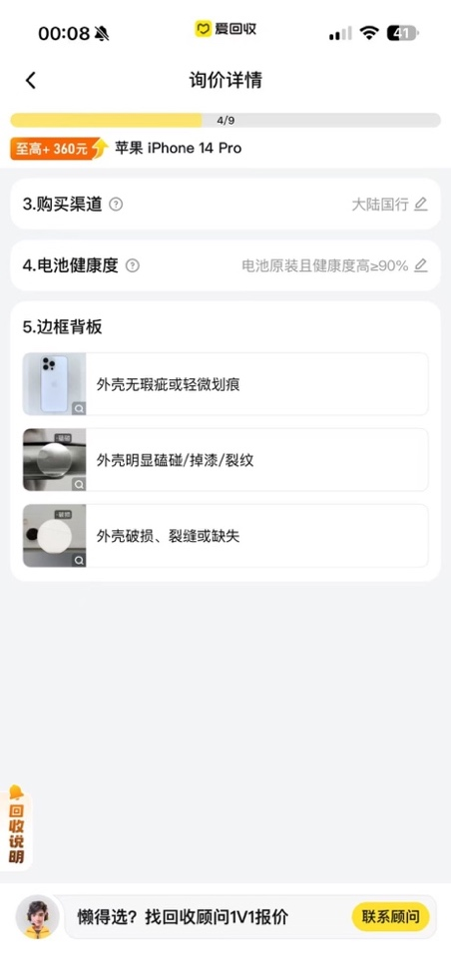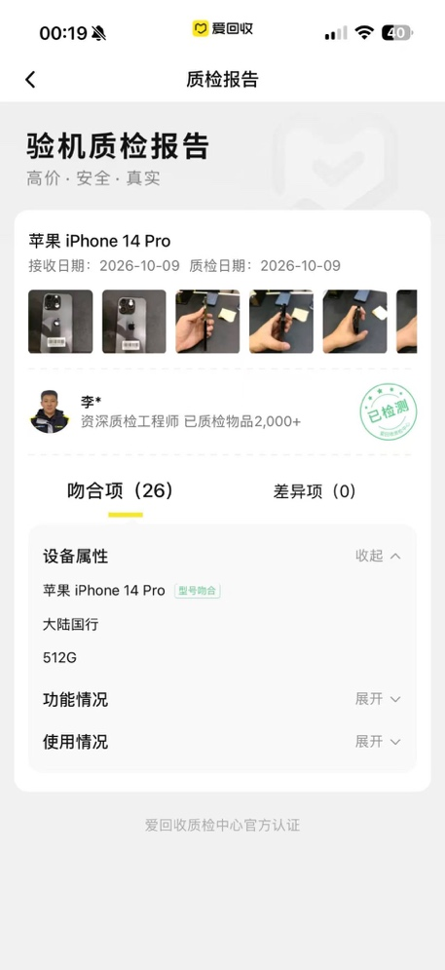
Zhuanzhuan offers photo based AI valuation with an incomplete condition workflow
The Xiao Z AI assistant accepted product photographs and suggested categories and candidate models. In this walkthrough it did not correctly identify the specific model; the user corrected it and supplied information such as storage capacity. It then provided reference price ranges for different cosmetic conditions, without structured recognition of actual scratches or dents.
Inspection reports displayed device photographs, normal findings, defects, and some quantified standards such as scratch length and count. However, the reviewed reports did not directly connect AI-valuation photographs and user confirmation records to professional findings, or explain each discrepancy’s contribution to the final offer.
Screenshots: AI photo entry, model correction, price ranges, and inspection defects. Original Chinese interface retained.
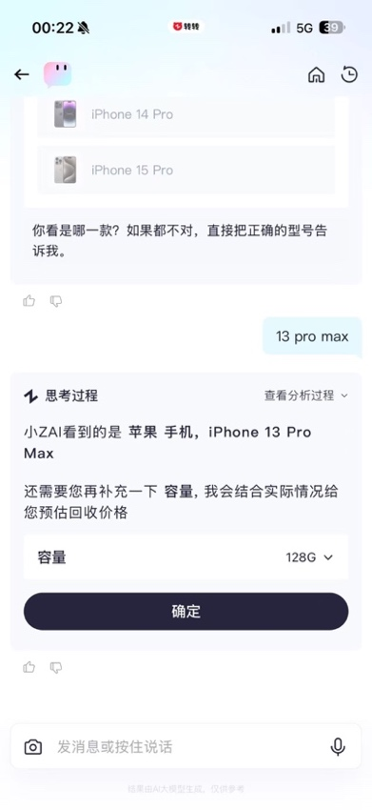
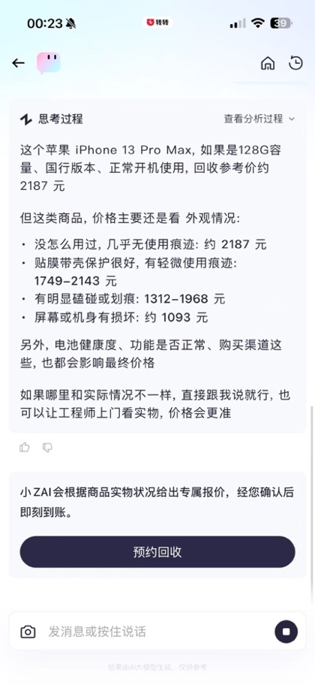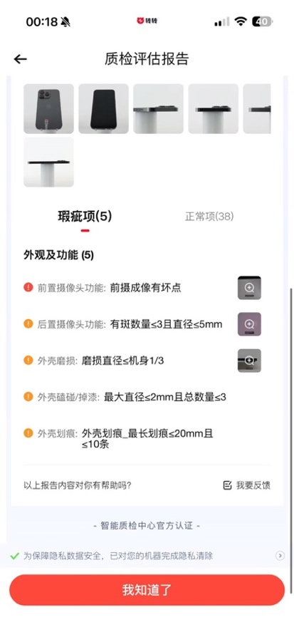

5 Requirements Analysis

5.1 Core Requirements and User Stories
User problem | Core requirement | User story
Difficulty grading cosmetic damage | AI assessment and automatic entry | As an inexperienced user, I want photo-based assistance and automatic entry to reduce assessment and form-filling effort.
Concern about recognition errors | Confirmation and editing | I want to review and edit AI findings so I retain control over submitted condition information.
Difficulty verifying inspection differences | Record retention and comparison | I want pre-order photographs and confirmed records retained and compared item by item after inspection.
Difficulty understanding findings and price changes | Discrepancy and price explanations | I want understandable explanations for individual discrepancies so I can judge the final price change.
AI assists with visible cosmetic assessment and organizes explanations using inspection findings and pricing rules. Users can confirm or edit condition information and request manual review of disputed inspection items.

5.2 MoSCoW Prioritization and Value Cost Assessment
Requirements are assessed qualitatively across user value, business value, and implementation cost/risk, informed by research findings and business objectives.
Feature | User value | Business value | Cost / risk | MoSCoW
Guided photography and visible-condition assessment | High | High | High | Must-have
User confirmation, editing, and automatic entry | High | High | Medium | Must-have
Pre-order photo and confirmed-record retention | High | High | Medium | Must-have
Inspection comparisons and price explanations | High | High | High | Must-have
AI follow-up on specific discrepancies | Medium | High | High | Should-have
Quick human-service handoff when AI cannot explain | Medium | High | Medium | Should-have
Anonymous inspection-report sharing | Medium | Medium | Medium | Could-have
AI submission without confirmation or autonomous final pricing | Low | Low | High | Won’t-have
Cross-platform quote comparison | High | Low | High | Won’t-have
AI assessment, confirmation, retained records, and discrepancy explanations form the core workflow and are Must-haves. Follow-up questions and customer-service handoff may improve explanations but require conversation logic and service-system integration, making them Should-haves. Anonymous report sharing is a Could-have. AI submission without confirmation or autonomous pricing poses excessive error risk; cross-platform comparison conflicts with the platform objective. Neither is included in this release.

5.3 MVP Scope
Smartphones are the initial category. The MVP follows assessment, confirmation, record retention, and comparison/explanation to test whether assistance reduces assessment effort and improves understanding of inspection findings and price changes.
Included in the MVP
Guide photographs of the screen, back panel, and frame; identify visible scratches, dents, cracks, and similar cosmetic issues.
Allow users to confirm or edit results before corresponding condition fields are automatically completed.
Retain uploaded photographs, recognition results, and user confirmation records.
Compare pre-order records with professional inspection findings.
Explain final price changes using actual inspection findings and platform pricing rules.
Prompt users to retake failed images; allow a return to manual entry if recognition repeatedly fails.
Excluded from the MVP
Multi-turn AI follow-up on individual discrepancies.
A streamlined AI-to-human customer-service handoff.
Anonymous inspection-report sharing.
Other device categories such as computers and tablets.
Inferring internal faults, functional problems, or repair history from images.
AI determination of final device condition or price.
Cross-platform quote comparisons.

6 Product Solution

6.1 Solution Overview
During valuation, AI assists with visible cosmetic assessment and users confirm the results. After professional inspection, the system compares pre-order records with actual findings and explains discrepancies and their price impact. AI supports assessment and explanation; users retain confirmation rights, and professional inspectors make the final condition determination.


6.2 Core Business Workflow
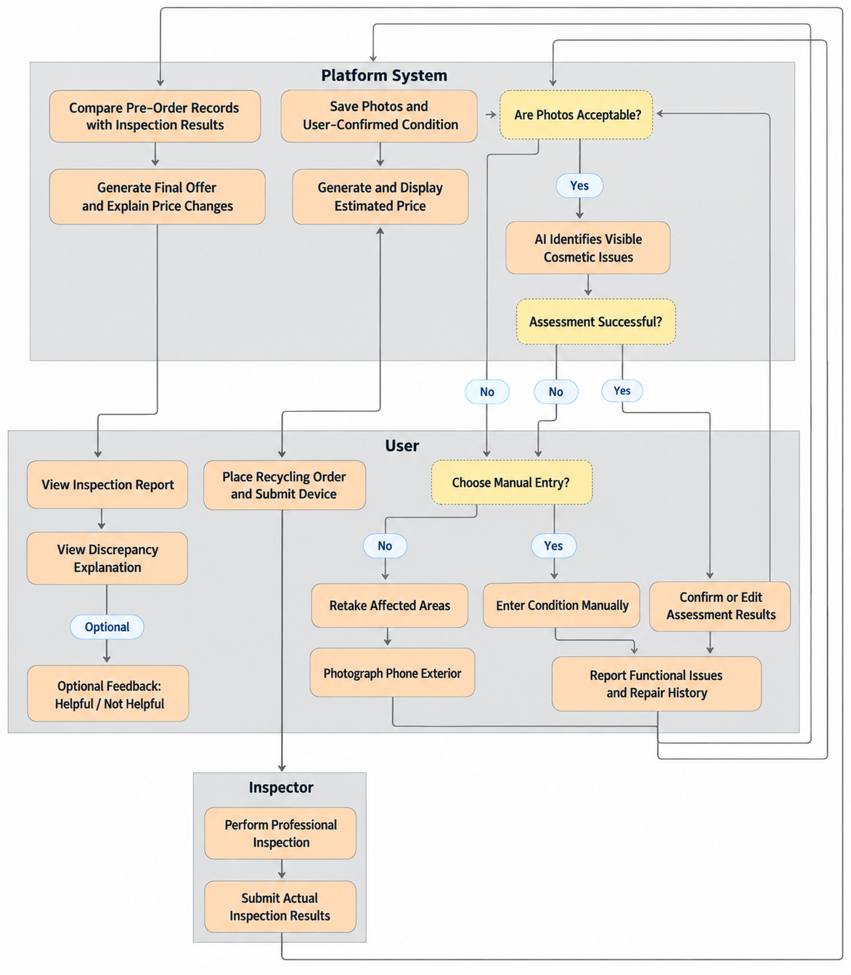
Users photograph the phone, review or edit visible-condition results, and supply functional issues and repair history. The platform retains photographs and confirmed records for inspection comparison. After inspection, pricing rules determine the final offer and item-level impacts. Users can open discrepancy explanations and optionally rate their helpfulness. If recognition fails, users can retake the relevant photographs or return to manual entry to complete valuation.

6.3 Core Screen Designs
Three screens support the MVP workflow: guided capture, recognition confirmation, and inspection comparison with price explanations.

1 Guided Photo Capture
Show three upload areas for the screen, back panel, and frame, each with an illustration and brief guidance. Display thumbnails after upload and allow viewing or replacement. Once all three areas are supplied, “Start assessment” opens the results confirmation screen.
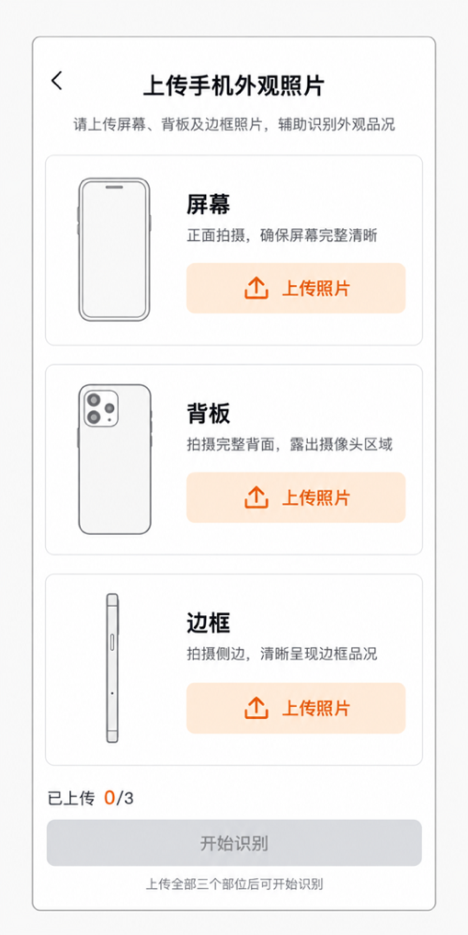

2 Recognition Results Confirmation
Display photographs and AI findings for each area, with issue locations marked and explained. Users can edit condition selections or add missed issues before selecting “Confirm and continue.” Photographs, recognition results, and user confirmation records support later inspection comparison.
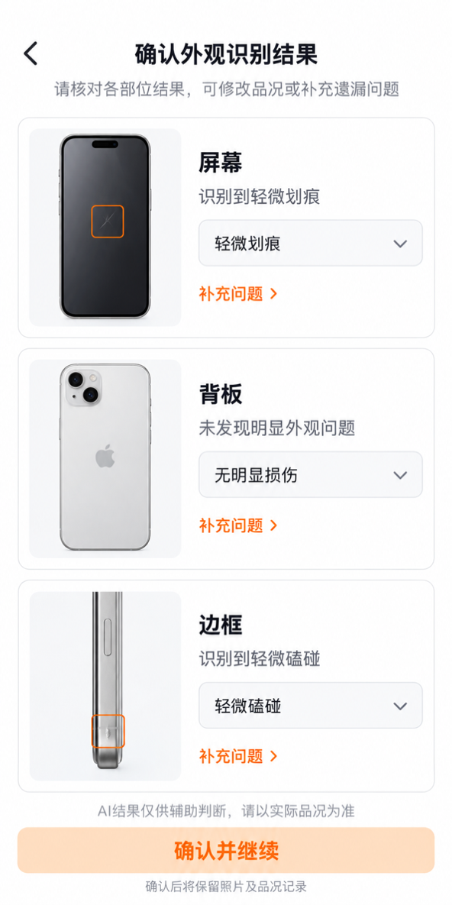

3 Inspection Discrepancies and Price Explanations
Show the estimate, final offer, and difference at the top. Display discrepant items by default, comparing confirmed pre-order condition with actual inspection results and supporting photographs. “View discrepancy explanation” expands the rationale; users may optionally mark it helpful or unhelpful. Provide access to the complete report and an item-level “Question this finding” entry for manual review linked to relevant records.
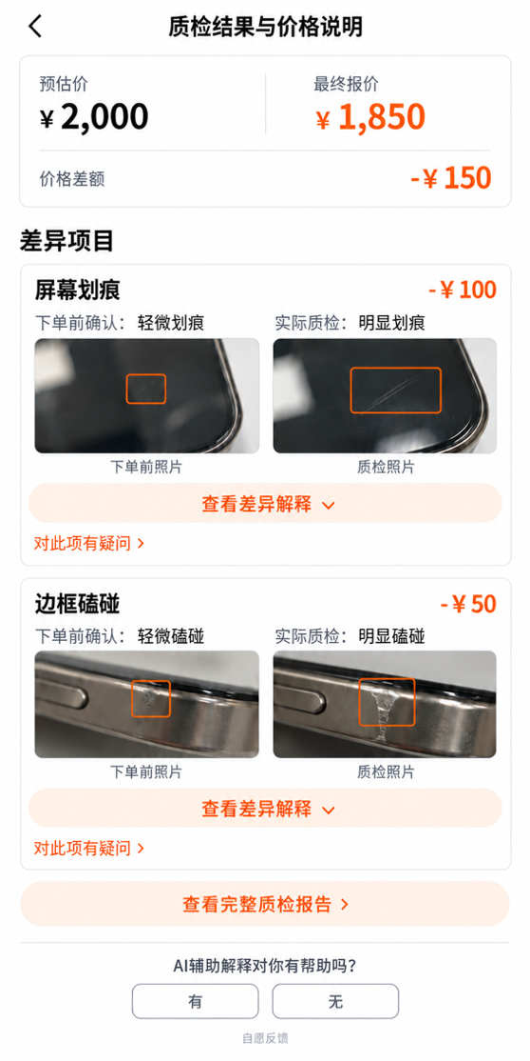

6.4 Functional and Interaction Rules
The rules below specify triggers, processing, and exceptions for photo assessment, confirmation/retention, and inspection explanations, enabling valuation completion and item-level review requests.
Feature | Trigger | Processing rules | Exceptions
Photo upload and assessment | All three areas uploaded; “Start assessment” selected | Check photographs; display findings and issue locations by area | Retake only failed/unsuitable areas; retain completed work. Manual entry is available without a minimum retake count.
Condition confirmation and retention | “Confirm and continue” selected after review/editing | Allow edits and additions; retain photographs and final confirmed condition, without separately storing the original AI assessment | Request missing information and retain completed fields
Inspection discrepancies and price explanations | Inspector submits findings | Compare confirmed and inspected condition. Show offer, difference, photographs, reasons, and item-level impacts that reconcile with the total. Expand explanations on click; allow optional helpful/unhelpful feedback and full-report access. | Allow item-specific manual review requests with linked photographs/records and communicate the outcome

7 Metrics and Event Tracking

7.1 Metric Design
Valuation-to-transaction conversion is the North Star metric. Secondary metrics identify funnel losses, while diagnostic metrics assess explanations. Link valuation sessions to subsequent orders, deduplicate by session or order as appropriate, and apply a consistent conversion observation window.
Level | Metric | Calculation | Purpose
North Star | Valuation-to-transaction conversion | Completed valuation sessions leading to a completed transaction / Completed valuation sessions × 100% | Overall conversion from completed valuation to sale
Secondary core | Valuation completion | Sessions displaying an estimated quote / Sessions starting valuation × 100% | Flow completion across both AI and manual paths
Secondary core | Valuation-to-order conversion | Completed valuation sessions leading to an order / Completed valuation sessions × 100% | Willingness to enter the physical inspection process
Secondary core | Post-inspection transaction conversion | Completed orders / Orders displaying a final quote × 100% | Acceptance and completion after inspection and final pricing
Diagnostic | Discrepancy explanation click rate | Orders with explanation clicks / Orders with report views and discrepancies × 100% | Active interest in understanding differences and adjustments
Diagnostic | Explanation helpfulness rate | Orders with “helpful” feedback / Orders submitting helpful/unhelpful feedback × 100% | Subjective usefulness among voluntary respondents; excludes nonresponses

7.2 Event Tracking Design
Two event sequences support measurement: the conversion funnel records valuation-to-transaction milestones; the explanation funnel records report viewing, explanation clicks, and feedback.

1 Conversion Funnel
Valuation started → Estimated quote displayed → Order created → Final quote displayed → Transaction completed.
Record the start when the user enters valuation after selecting “Start valuation,” and completion when the estimate is successfully displayed. Ordering requires successful order creation; transaction completion requires the corresponding completed order status.
Event | Trigger | Key properties | Metric
Valuation started | User selects “Start valuation” and enters the flow | Session ID | Valuation completion
Valuation completed | Estimated quote successfully displayed | Session ID | Completion; valuation-to-order and valuation-to-transaction conversion
Order created | Recycling order successfully created | Session ID; Order ID | Valuation-to-order conversion
Final quote displayed | Post-inspection final quote successfully displayed | Order ID | Post-inspection transaction conversion
Transaction completed | Order status becomes completed | Order ID | Post-inspection and valuation-to-transaction conversion

2 Explanation Funnel
Inspection report viewed → Discrepancy explanation clicked → Optional helpful/unhelpful feedback submitted.
On report opening, record whether discrepancies exist. Log the explanation entry click and any helpful/unhelpful response. Unanswered feedback is excluded from the helpfulness-rate denominator.
Event | Trigger | Key properties | Metric
Inspection report viewed | Report opened | Order ID; discrepancy indicator | Explanation click rate
Discrepancy explanation clicked | User selects “View discrepancy explanation” | Order ID | Explanation click rate
Explanation feedback submitted | Optional helpful/unhelpful response submitted | Order ID; response | Explanation helpfulness rate
Use the valuation session ID to link the valuation journey, then bind the order ID to subsequent inspection and transaction events. Retain event timestamps, deduplicate at the relevant level, and apply a consistent observation window.

8 Feasibility Assessment

8.1 Risks and Mitigations
Recognition accuracy: Image quality and viewing angle may cause errors or omissions. AI is advisory; users can check and edit results or choose manual entry without a minimum number of retakes.
Explanation credibility: AI may generate unsupported reasons for price changes. Platform pricing rules calculate amounts; AI organizes explanations only from inspection records and photographs. Users may request manual review.

8.2 Costs and Expected Benefits
AI integration and inference: Integration, adaptation, and model-call costs. Expected benefit: less assessment and form-filling effort and improved valuation completion.
Screen development and image storage: Capture, confirmation, and comparison screens, plus photograph and confirmed-record storage. Expected benefit: a verifiable basis for comparing inspection findings.
Inspection and pricing integration: Development to link orders, findings, and pricing rules. Expected benefit: accurate presentation of discrepancies and monetary impacts, clearer explanations, and improved post-inspection conversion.

9 Project Summary and Future Iterations

9.1 Project Summary
The proposal addresses difficulty assessing condition and understanding inspection-related price changes through an AI-assisted assessment, confirmation, retention, and comparison/explanation workflow. Before ordering, photographs support condition reporting with editing and manual-entry options. After inspection, photographs, confirmed records, and item-level price impacts help users understand differences and request review.
Completed work includes requirements and prioritization, business workflows, prototypes, functional rules, metrics, and event tracking. The intended benefits are lower valuation effort, clearer inspection and price explanations, and stronger conversion. This is a portfolio product-design proposal, not a developed or launched service. Recognition performance, usability, and conversion outcomes remain unvalidated.

9.2 Future Iterations
The smartphone MVP demonstrates the complete workflow from cosmetic assessment to inspection explanations. Later versions could expand to tablets, laptops, and other devices using the same assessment, confirmation, retention, and comparison mechanisms.
Expansion requires category-specific adaptations: tablet guidance for larger screens and frames, or laptop records covering screens, cases, and keyboards. Condition standards, inspection items, and pricing rules must also be adapted. AI remains advisory for visible condition and explanations; users report functional issues, which professional inspection verifies.

10 Appendices

Appendix A Public Feedback Research Materials
Comment Selection Notes
The sample contains 60 usable public entries: 40 about Huishoubao, 10 about Aihuishou, and 10 about Zhuanzhuan. Entries were summarized without changing their intended meaning and coded by platform, channel, transaction stage, sentiment, topic, and user behavior.
Some entries originate from complaint platforms and represent unverified individual accounts. Complaint sampling can overrepresent negative feedback. The analysis is used to identify issues and form hypotheses, not to estimate population-level incidence.
Sample Entries and Coding
ID | Platform and source | Publication date | Summary
R001 | Huishoubao — Black Cat Complaints | 2026-05-31 | The user stated that after an at-home inspection, the quote was reduced for scratches, color differences, and dead pixels without corresponding photographs or video, leading them to dispute the findings.
R037 | Huishoubao — Zhihu Q&A | 2018 | The user reported a higher quote than nearby recycling channels and satisfactory customer-service communication, and completed the sale.
Continued in the following table.
Transaction stage | Topic | Behavior or impact | Source
At-home inspection | Difficult to verify inspection discrepancies | Disputed the findings and requested an explanation | View source
Completed transaction | Positive experience | Completed the sale | View source

Appendix B Interview Recruitment Screener
What is your age group?
18–24 / 25–34 / 35–44 / 45–54 / 55 or older
What is your current employment status?
Student / Corporate employee / Freelancer / Self-employed / Retired / Other
In the past two years have you valued or sold an old smartphone?
Completed a sale / Obtained a valuation but did not sell / No experience but currently need to sell / None of these
Which sales channels have you used or considered? Select all that apply.
Professional recycling platforms / Peer-to-peer marketplaces such as Xianyu / Official brand trade-in / Offline stores or dealers / Personal contacts / Other
Which professional recycling platforms have you used? Select all that apply.
Huishoubao / Aihuishou / Zhuanzhuan / Other / None
What stage did you reach on a professional recycling platform?
Browsing / Online valuation completed / Order submitted / Inspection completed / Transaction completed / Canceled or returned after inspection / Never used one
How many times have you valued or sold an old smartphone in the past two years?
0 / 1 / 2–3 / 4 or more
Would you participate in an interview lasting approximately 30–45 minutes?
Yes / No
Do you consent to recording for anonymous research documentation only?
Yes / No

Appendix C Semi Structured Interview Guide

1 Interview Information

Participants: People who valued or sold an old phone within the past two years, or currently need to sell one.

Duration: Approximately 30–45 minutes.

Format: Semi-structured interview.

Purpose: Understand experiences of condition assessment, online valuation, inspection verification, price interpretation, and transaction decisions.

Recording: With consent, use recordings and field notes. Without consent, use field notes only. Anonymize all research materials.

Anonymity: Records are used only for this project. Remove names, contact details, employers, and other identifying information, and use participant codes such as U01 and U02.

2 Opening Script

Thank you for participating. We would like to understand your actual experience of handling or selling an old smartphone. There are no right or wrong answers; please answer based on your experience.

With your permission, we will record the interview only to support research documentation. Names, contact details, and other identifiers will be removed from reported findings and replaced with participant codes. You may decline any question or stop the recording or interview at any time.

3 Questions for All Participants

Background and Selling Experience

1. Tell me about the last time you handled an old smartphone. Why did you want to sell or recycle it?

2. Which channels or platforms did you consider? Why did you select or reject a particular option?

3. What mattered most when deciding to sell?
Possible prompts: Price, convenience, speed, platform reputation, data security, inspection transparency.

Condition Assessment and Online Valuation

4. Before valuation or sale, how do you assess appearance, functionality, and repair history?

5. Have you been unsure which condition option to select? Please describe a specific example.

6. How do you use platform descriptions or reference images? What remains difficult to assess?

7. After seeing an online estimate, how do you judge whether it is reasonable? Do you form a specific price expectation?

4 Branch Questions

A Participants with Professional Recycling Platform Experience

8. Which stage did you reach, and did you complete the transaction? Please describe the process.

9. Did inspection match your pre-submission assessment? If not, what differed?

10. If the final offer differed from the estimate, how did the platform explain it? Did you understand and accept the explanation?

11. When questioning a finding, could you locate photographs, inspection records, or other evidence? What information did you most want?

12. What ultimately led you to accept, reject, or abandon the offer?

B Participants without Professional Recycling Platform Experience
These participants skip Question 12 and proceed from Question 11 to the shared Question 13.

8. Why have you not used a professional recycling platform? What are your main concerns?

9. If you used one, where would you expect to encounter difficulties?

10. If the inspected offer were below the estimate, what information would help you judge the adjustment as reasonable?

11. What would increase or decrease your willingness to submit the device and complete the transaction?

5 Tradeoffs Between Price and Transparency

13. Have you abandoned a transaction because of price, inspection findings, or explanations? What was the main reason?

14. Imagine two platforms with different offers:

Platform A offers less but retains pre-order records and explains inspection discrepancies and price changes.

Platform B offers more but shows only the final inspection result and offer.

Which would you prefer and why? How large would the price difference need to be to change your choice?

6 Reactions to the Proposed Valuation Feature
I will describe a new smartphone valuation approach. Please explain whether it would help and what concerns you might have.
The platform guides users to photograph the device. AI identifies visible condition and helps complete relevant fields. After inspection, the system compares records and explains discrepancies and price changes. AI assists; it does not set the offer.
15. Which feature would help most, and which would help least? Why?
16. Would you use AI condition findings as a reference? Why or why not?
Possible prompts: When would you distrust it? Which results should users confirm?
17. What concerns would you have?
Possible prompts: Recognition errors, photography effort, image privacy. Would the feature affect your willingness to order or accept the final offer?

7 Closing Question

Are there other aspects of valuation, inspection, or final pricing that cause inconvenience, concern, or distrust that we have not discussed?

Appendix D Interview Records

