温州大学瓯江学院理工分院
《python爬虫项目》 实验报告
实验名称：
班 级： | 16计算机2班 | 姓 名： | 欧阳王军 | 学 号： | 16219111215
实验地点： |  | 日 期： | 2019年4月22日

一、实验目的：
[实验目的和要求]
1．静态与动态爬虫
2．DJANGO
3. 12306验证码识别登陆

二、实验环境：
1、python,pychram,mysql
三、实验内容和要求：
1.静态爬虫
2.动态爬虫
3.制作DJANGO网站

四、实验步骤与结果：
（对实验步骤的说明应该能够保证根据该说明即可重复完整的实验内容，得到正确结果。）
1．
步骤：
- 确认要爬取的网站，确认URL
- 使用requests与beautifiulsoup库获取网页源代码
- 使用浏览器查看源码，分析需要爬取的标题等的特征
- 获取数据存入列表中
- 将得到的数据存入数据库
截图：
静态爬虫 （网易云热歌榜）
爬虫代码：
import requests
import re
from bs4 import BeautifulSoup
import pymysql
singer=[]
zhuanji=[]
dict={
'歌名':'',
'专辑':'',
'歌手':''
}
def get_html(url):
header = {
'User-Agent': 'Mozilla/5.0 (Windows NT 10.0; WOW64) AppleWebKit/537.36 (KHTML, like Gecko) Chrome/73.0.3683.86 Safari/537.36'}
try:
response=requests.get(url,headers=header)
if response.status_code==200:
html = response.text.encode(response.encoding).decode('utf-8', 'ignore')
return html
if response.status_code==302:
print('302')
except ConnectionError:
return get_html(url)
def get_info():
html=get_html("http://music.163.com/discover/toplist?id=3778678")
soup=BeautifulSoup(html,'lxml')
tag=soup.find_all('ul',attrs=('class','f-hide'))
singname=re.findall(r'<li><a href="/song.*?id=\d+">(.*?)</a></li>',str(tag))
singid=re.findall(r'<li><a href="/song.*?id=(.*?)">.*?</a></li>',str(tag))
for i in range(len(singid)):
newhtml=get_html("https://music.163.com/song?id="+singid[i])
newsoup=BeautifulSoup(newhtml,'lxml')
tag2=newsoup.find_all("p",attrs=('class','des s-fc4'))
singer.append(re.findall(r'<span title="(.*?)">',str(tag2)))
zhuanji.append(re.findall(r'<a class="s-fc7" href="/album\?id=\d+">(.*?)</a>',str(tag2)))
dict['专辑']=zhuanji[i]
dict['歌手']=singer[i]
s="".join(singname[i].split())
dict['歌名'] =s
get_db()
def get_db():
conn = pymysql.connect(
host='localhost',
port=3306,
user='root',
passwd='123456',
db='sy',
)
cur = conn.cursor()
# 插入一条数据
sql = "INSERT INTO `bbb_yinyue`(singname,singer,zhuanji) values (%s,%s,%s)"
cur.execute(sql, [dict["歌名"], dict['歌手'], dict['专辑']])
conn.commit()
cur.close()
conn.close()
def main():
get_info()
main()
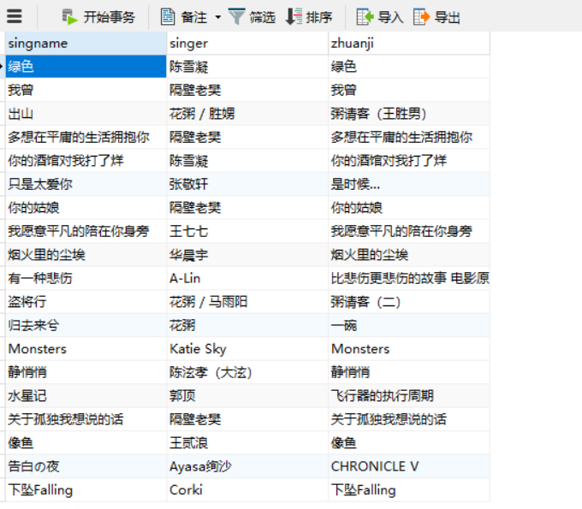
2.动态网页：
动态爬虫 （nike自动下单）
爬虫代码：
import os
import sys
import six
import pause
import argparse
import logging.config
from selenium import webdriver
from dateutil import parser as date_parser
from selenium.webdriver.common.by import By
from selenium.webdriver.support.ui import WebDriverWait
from selenium.common.exceptions import TimeoutException
from selenium.webdriver.support import expected_conditions as EC
import time
logging.config.dictConfig({
"version": 1,
'images': 2, # 不加载图片
"disable_existing_loggers": False,
"formatters": {
"default": {
"format": "%(asctime)s [PID %(process)d] [Thread %(thread)d] [%(levelname)s] [%(name)s] %(message)s"
}
},
"handlers": {
"console": {
"class": "logging.StreamHandler",
"level": "INFO",
"formatter": "default",
"stream": "ext://sys.stdout"
}
},
"root": {
"level": "INFO",
"handlers": [
"console"
]
}
})
NIKE_HOME_URL ="https://www.nike.com/cn/" #"https://www.nike.com/us/en_us/"
LOGGER = logging.getLogger()
def run(driver, username, password, url, shoe_size, login_time=None, release_time=None,
page_load_timeout=None, screenshot_path=None, html_path=None, select_payment=False, purchase=False,
num_retries=None):
driver.maximize_window()
driver.set_page_load_timeout(page_load_timeout)
if login_time:
LOGGER.info("Waiting until login time: " + login_time)
pause.until(date_parser.parse(login_time))
try:
login(driver=driver, username=username, password=password)
except Exception as e:
LOGGER.exception("Failed to login: " + str(e))
six.reraise(Exception, e, sys.exc_info()[2])
if release_time:
LOGGER.info("Waiting until release time: " + release_time)
pause.until(date_parser.parse(release_time))
num_retries_attempted = 0
while True:
try:
try:
LOGGER.info("Requesting page: " + url)
driver.get(url)
except TimeoutException:
LOGGER.info("Page load timed out but continuing anyway")
try:
select_shoe_size(driver=driver, shoe_size=shoe_size)
except Exception as e:
# If we fail to select shoe size, try to buy anyway
LOGGER.exception("Failed to select shoe size: " + str(e))
try:
click_buy_button(driver=driver)
except Exception as e:
LOGGER.exception("Failed to click buy button: " + str(e))
six.reraise(Exception, e, sys.exc_info()[2])
if select_payment:
try:
select_payment_option(driver=driver)
except Exception as e:
LOGGER.exception("Failed to select payment option: " + str(e))
six.reraise(Exception, e, sys.exc_info()[2])
try:
click_save_button(driver=driver)
except Exception as e:
LOGGER.exception("Failed to click save button: " + str(e))
six.reraise(Exception, e, sys.exc_info()[2])
if purchase:
try:
click_submit_button(driver=driver)
except Exception as e:
LOGGER.exception("Failed to click submit button: " + str(e))
six.reraise(Exception, e, sys.exc_info()[2])
LOGGER.info("Purchased shoe")
break
except Exception:
if num_retries and num_retries_attempted < num_retries:
num_retries_attempted += 1
continue
else:
break
if screenshot_path:
LOGGER.info("Saving screenshot")
driver.save_screenshot(screenshot_path)
if html_path:
LOGGER.info("Saving HTML source")
with open(html_path, "w") as f:
f.write(driver.page_source)
driver.quit()
def login(driver, username, password):
try:
LOGGER.info("Requesting page: " + NIKE_HOME_URL)
driver.get(NIKE_HOME_URL)
except TimeoutException:
driver.refresh();
LOGGER.info("Page load timed out but continuing anyway")
#time.sleep(5)
LOGGER.info("Waiting for login button to become clickable")
#time.sleep(5)
# wait_until_clickable(driver=driver, xpath="//li[@js-hook='exp-join-login']/button")
while True:
try:
wait_until_clickable(driver=driver, xpath="//div[@id='AccountNavigationContainer']/button", duration=2)
break
except TimeoutException:
driver.refresh()
LOGGER.info("Clicking login button")
driver.find_element_by_xpath("//div[@id='AccountNavigationContainer']/button").click()
LOGGER.info("Waiting for login fields to become visible")
#wait_until_visible(driver=driver, xpath="//input[@name='emailAddress']")
wait_until_visible(driver=driver, xpath="//input[@name='verifyMobileNumber']")
LOGGER.info("Entering username and password")
email_input = driver.find_element_by_xpath("//input[@name='verifyMobileNumber']")
email_input.clear()
email_input.send_keys(username)
password_input = driver.find_element_by_xpath("//input[@name='password']")
password_input.clear()
password_input.send_keys(password)
LOGGER.info("Logging in")
driver.find_element_by_xpath("//input[@value='登录']").click()
#wait_until_visible(driver=driver, xpath="//a[text()='我的帐户']")
wait_until_visible(driver=driver, xpath="//span[text()='我的帐户']")
LOGGER.info("Successfully logged in")
def select_shoe_size(driver, shoe_size):
#LOGGER.info("Waiting for size dropdown button to become clickable")
#wait_until_clickable(driver, class_name="size-dropdown-button-css", duration=10)
#LOGGER.info("Clicking size dropdown button")
#driver.find_element_by_class_name("size-dropdown-button-css").click()
LOGGER.info("Waiting for size dropdown to appear")
wait_until_visible(driver, xpath="//div[@name='skuAndSize']", duration=10)
LOGGER.info("Selecting size from dropdown")
#driver.find_element_by_class_name("skuAndSize").find_element_by_xpath(
# "//label[text()='{}']".format(shoe_size)).click()
driver.find_element_by_xpath("//div[@name='skuAndSize']").find_element_by_xpath(
"//label[text()='{}']".format(shoe_size)).click()
def click_buy_button(driver):
xpath = "//button[contains(@class,'addToCartBtn')]"#"//button[@data-qa='feed-buy-cta']"
LOGGER.info("Waiting for buy button to become clickable")
wait_until_clickable(driver, xpath=xpath, duration=10)
LOGGER.info("Clicking buy button")
driver.find_element_by_xpath(xpath).click()
time.sleep(5)
def select_payment_option(driver):
xpath = "//input[@data-qa='payment-radio']"
LOGGER.info("Waiting for payment checkbox to become clickable")
wait_until_clickable(driver, xpath=xpath, duration=10)
LOGGER.info("Checking payment checkbox")
driver.find_element_by_xpath(xpath).click()
def click_save_button(driver):
xpath = "//button[text()='Save &amp; Continue']"
LOGGER.info("Waiting for save button to become clickable")
wait_until_clickable(driver, xpath=xpath, duration=10)
LOGGER.info("Clicking save button")
driver.find_element_by_xpath(xpath).click()
def click_submit_button(driver):
xpath = "//button[text()='Submit Order']"
LOGGER.info("Waiting for submit button to become clickable")
wait_until_clickable(driver, xpath=xpath, duration=10)
LOGGER.info("Clicking submit button")
driver.find_element_by_xpath(xpath).click()
def wait_until_clickable(driver, xpath=None, class_name=None, duration=10000, frequency=0.01):
if xpath:
WebDriverWait(driver, duration, frequency).until(EC.element_to_be_clickable((By.XPATH, xpath)))
elif class_name:
WebDriverWait(driver, duration, frequency).until(EC.element_to_be_clickable((By.CLASS_NAME, class_name)))
def wait_until_visible(driver, xpath=None, class_name=None, duration=10000, frequency=0.01):
if xpath:
WebDriverWait(driver, duration, frequency).until(EC.visibility_of_element_located((By.XPATH, xpath)))
elif class_name:
WebDriverWait(driver, duration, frequency).until(EC.visibility_of_element_located((By.CLASS_NAME, class_name)))
def myrun(driver,args):
run(driver=driver, username=args.username, password=args.password, url=args.url, shoe_size=args.shoe_size,
login_time=args.login_time, release_time=args.release_time, page_load_timeout=args.page_load_timeout,
screenshot_path=args.screenshot_path, html_path=args.html_path, select_payment=args.select_payment,
purchase=args.purchase, num_retries=args.num_retries)
if __name__ == "__main__":
parser = argparse.ArgumentParser()
parser.add_argument("--username", required=True)
parser.add_argument("--password", required=True)
parser.add_argument("--url", required=True)
parser.add_argument("--shoe-size", required=True)
parser.add_argument("--login-time", default=None)
parser.add_argument("--release-time", default=None)
parser.add_argument("--screenshot-path", default=None)
parser.add_argument("--html-path", default=None)
parser.add_argument("--page-load-timeout", type=int, default=15)
parser.add_argument("--driver-type", default="chrome", choices=("firefox", "chrome"))
parser.add_argument("--headless", action="store_true",default=True)
parser.add_argument("--select-payment", action="store_true")
parser.add_argument("--purchase", action="store_true")
parser.add_argument("--num-retries", type=int, default=1)
args = parser.parse_args()
driver = None
if args.driver_type == "firefox":
options = webdriver.FirefoxOptions()
if args.headless:
options.add_argument("--headless")
if sys.platform == "darwin":
executable_path = "./bin/geckodriver_mac"
elif "linux" in sys.platform:
executable_path = "./bin/geckodriver_linux"
else:
raise Exception("Unsupported operating system. Please add your own Selenium driver for it.")
driver = webdriver.Firefox(executable_path=executable_path, firefox_options=options, log_path=os.devnull)
elif args.driver_type == "chrome":
options = webdriver.ChromeOptions()
options.add_argument('--log-level=3')
prefs = {"profile.managed_default_content_settings.images": 2,"plugins.plugins_disabled": ['Adobe Flash Player']}
options.add_experimental_option("prefs", prefs)
if args.headless:
options.add_argument("headless")
if sys.platform == "darwin":
executable_path = "./bin/chromedriver_mac"
elif "linux" in sys.platform:
executable_path = "./bin/chromedriver_linux"
elif sys.platform == 'win32':
executable_path = "./bin/chromedriver.exe"
else:
raise Exception("Unsupported operating system. Please add your own Selenium driver for it.")
driver = webdriver.Chrome(executable_path=executable_path, chrome_options=options)
myrun(driver,args)

3.django
步骤：
- 使用pycharm创建项目
- 在setting.py文件中通过DATABASES选项进行数据库配置，在_init_.py中配置
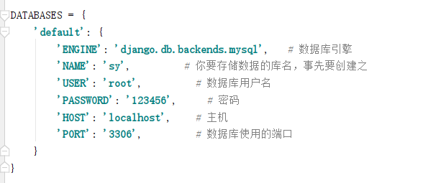
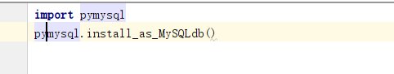
- 在urls.py中写两个PATH一个跳转到网易云，一个跳转到淘宝
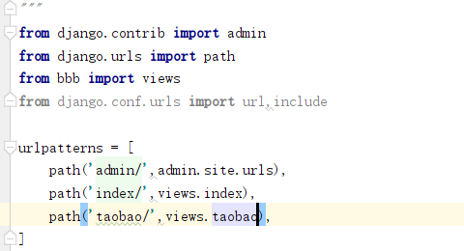

- 在models.py中建立两张表
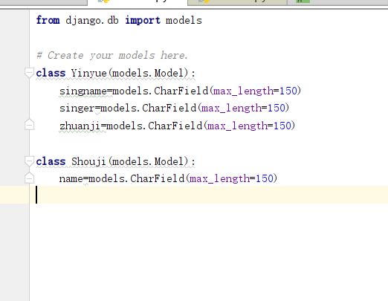
然后在数据库中生成数据表，进行数据迁移
Python manage.py makemigrations
Python manage.py migrate

- 编写views.py
Views.py
from django.shortcuts import render
import pymysql
from bbb.models import Yinyue
from bbb.models import Shouji
from django.shortcuts import HttpResponse
from django.core.paginator import Paginator,PageNotAnInteger,EmptyPage
def index(request):
yinyue_list = Yinyue.objects.all().order_by("id") # 一定要排序
paginator = Paginator(yinyue_list, 12) # 每页15条记录
page = request.GET.get('page') # 获取第一页数据，从1开始
try:
customer=paginator.page(page)
except PageNotAnInteger:
customer=paginator.page(1)
except EmptyPage:
customer=paginator.page(paginator.num_pages)
return render(request, 'index.html',{"yinyue_list":customer} )
def taobao(request):
shouji_list = Shouji.objects.all().order_by("id") # 一定要排序
paginator = Paginator(shouji_list, 12) # 每页15条记录
page = request.GET.get('page') # 获取第一页数据，从1开始
try:
customer = paginator.page(page)
except PageNotAnInteger:
customer = paginator.page(1)
except EmptyPage:
customer = paginator.page(paginator.num_pages)
return render(request, 'taobao.html', {"shouji_list": customer})
- 再详细页中使用获取的字典，显示数据
html文件
index.html(网易云)
{% load staticfiles %}
<!DOCTYPE html>
<html lang="en">
<head>
<meta charset="UTF-8">
<title>Title</title>
<link href="{% static 'css/bootstrap.min.css' %}" rel="stylesheet">
<link href="{% static 'css/style.css' %}" rel="stylesheet">
</head>
<body>
<div class="container" style="margin-top:50px;">
<h1 align="center"><b>云音乐热歌榜</b></h1>
<table class="table">
<thead class="thead-dark">
<tr>
<th scope="col">排名</th>
<th scope="col">歌曲名称</th>
<th scope="col">歌手</th>
<th scope="col">专辑</th>
</tr>
</thead>
{% for music in yinyue_list %}
<tr>
<td scope="row">{{music.id}}</td>
<td>{{music.singname}}</td>
<td>{{music.singer}}</td>
<td>{{music.zhuanji}}</td>
</tr>
{% endfor %}
</table>
<div class="row justify-content-center">
<ul class="pagination">
{% for pg in yinyue_list.paginator.page_range %}
{% if yinyue_list.number == pg %}
<li class="page-item"><a class="page-link" href="?page={{ pg }}">{{ pg }}</a></li>
{% else %}
<li><a class="page-link" href="?page={{ pg }}">{{ pg }}</a></li>
{% endif %}
{% endfor %}
</ul>
</div>
</div>
<link href="{% static 'js/jquery-3.3.1.min.js' %}" rel="stylesheet">
<link href="{% static 'js/bootstrap.min.js' %}" rel="stylesheet">
</body>
</html>
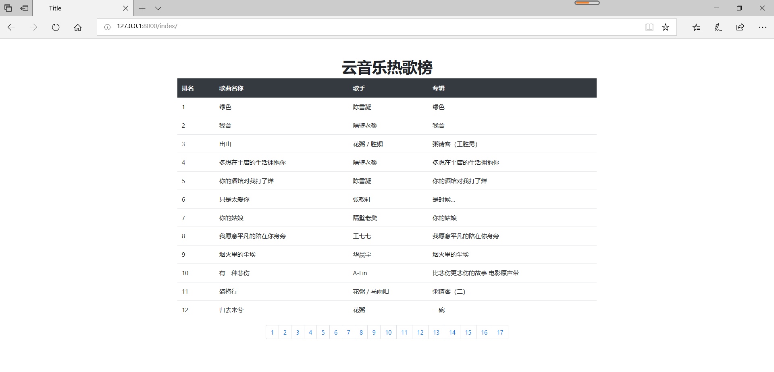
taobao.html（淘宝界面）
{% load staticfiles %}
<!DOCTYPE html>
<html lang="en">
<head>
<meta charset="UTF-8">
<meta name="viewport" content="width=device-width, initial-scale=1, shrink-to-fit=no">
<title>taobao</title>
<link href="{% static 'css/bootstrap.min.css' %}" rel="stylesheet">
<link href="{% static 'css/style.css' %}" rel="stylesheet">
</head>
<body>
<div class="container" style="margin-top:50px;">
<h1 align="center"><b>手机销量店铺排名</b></h1>
<table class="table">
<thead class="thead-dark">
<tr>
<th scope="col">排名</th>
<th scope="col">店铺名</th>
</tr>
</thead>
{% for i in shouji_list %}
<tr>
<td scope="row">{{i.id}}</td>
<td>{{i.name}}</td>
</tr>
{% endfor %}
</table>
<div class="row justify-content-center">
<ul class="pagination">
{% for pg in shouji_list.paginator.page_range %}
{% if shouji_list.number == pg %}
<li class="page-item"><a class="page-link" href="?page={{ pg }}">{{ pg }}</a></li>
{% else %}
<li><a class="page-link" href="?page={{ pg }}">{{ pg }}</a></li>
{% endif %}
{% endfor %}
</ul>
</div>
</div>
<link href="{% static 'js/jquery-3.3.1.min.js' %}" rel="stylesheet">
<link href="{% static 'js/bootstrap.min.js' %}" rel="stylesheet">
</body>
</html>
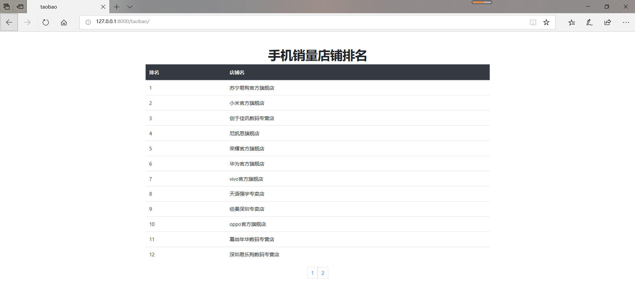

12306验证码识别登陆
代码
from selenium import webdriver
from selenium.webdriver.common.keys import Keys
from selenium.webdriver.common.by import By
from selenium.webdriver.support.ui import WebDriverWait
from selenium.webdriver.support import expected_conditions as EC
from selenium.webdriver.common.action_chains import ActionChains
import requests
import base64
import re
import time
class Demo():
def __init__(self,username,password):
self.coordinate=[[-105,-20],[-35,-20],[40,-20],[110,-20],[-105,50],[-35,50],[40,50],[110,50]]
self.username=username
self.password=password
def login(self):
login_url="https://kyfw.12306.cn/otn/resources/login.html"
driver = webdriver.Chrome()
driver.set_window_size(1200, 900)
driver.get(login_url)
account=driver.find_element_by_class_name("login-hd-account")
account.click()
userName=driver.find_element_by_id("J-userName")
userName.send_keys(self.username)
password=driver.find_element_by_id("J-password")
password.send_keys(self.password)
self.driver=driver
def getVerifyImage(self):
try:
img_element =WebDriverWait(self.driver, 100).until(
EC.presence_of_element_located((By.ID, "J-loginImg"))
)
except Exception as e:
print(u"网络开小差,请稍后尝试")
base64_str=img_element.get_attribute("src").split(",")[-1]
imgdata=base64.b64decode(base64_str)
with open('verify.jpg','wb') as file:
file.write(imgdata)
self.img_element=img_element
def getVerifyResult(self):
url="http://littlebigluo.qicp.net:47720/"
response=requests.request("POST",url,data={"type":"1"},files={'pic_xxfile':open('verify.jpg','rb')})
result=[]
print(response.text)
for i in re.findall("<B>(.*)</B>",response.text)[0].split(" "):
result.append(int(i)-1)
self.result=result
print(result)
def moveAndClick(self):
try:
Action=ActionChains(self.driver)
for i in self.result:
Action.move_to_element(self.img_element).move_by_offset(self.coordinate[i][0],self.coordinate[i][1]).click()
Action.perform()
except Exception as e:
print(e.message())
def submit(self):
self.driver.find_element_by_id("J-login").click()
def __call__(self):
self.login()
time.sleep(3)
self.getVerifyImage()
time.sleep(1)
self.getVerifyResult()
time.sleep(1)
self.moveAndClick()
time.sleep(1)
self.submit()
time.sleep(10000)
Demo('11111','222222')()

