IE4727 Web Application Design - Project Report

Design project group number: <your group number, e.g. F32-DG05>

Team members: <Member 1 Name (Matric No.)>, <Member 2 Name (Matric No.)>

Project Title: CineBook — A Web Portal for Booking Cinema Tickets (Theme 5)

Summary of Project:
- CineBook is a cinema ticket-booking web portal that lets movie-goers browse now-showing and upcoming films, search and filter by title or cinema, view film details, and reserve seats online. Registered users log in to book tickets through an interactive seat map that greys out already-reserved seats, choose a payment method, and receive a confirmation e-ticket. Users can review their past bookings, update their seats, and manage their account profile. The application is built with the traditional stack (HTML, CSS, JavaScript, PHP and MySQL) and models managers, branches, cinemas, movies, customers, reservations and transactions in a normalised relational database. It demonstrates server-side form processing with SELECT, INSERT and UPDATE queries, client- and server-side validation, and session-based authentication, delivering a smooth end-to-end booking experience that mirrors a real cinema website.

This page should show the table of content. For example:

- Application Requirements and Specifications
- Functional Requirements and Specifications
- Design of the web application
Site Map Story Board Wireframe Database
- 4. Implementation
Summary of Implementation
Coding of ONE to TWO Functional Requirements
- 5. Testing of the web application
- 6. Summary of Modern Enhancements with Justification
- 7. Conclusion
Appendix 1: Source Codes
Appendix 2: Contribution to the project by each team member
Appendix 3: Contribution to the report by each team member

Application Requirements and Specifications
CineBook must satisfy the following overall quality requirements:
R1 — Usability: consistent header navigation and search on every page; a visual seat picker with a live ticket total; forms pre-filled for logged-in users; and clear inline validation messages.
R2 — Responsiveness: built with CSS Grid/Flexbox and media queries; the hero, movie grid and 3-column booking layout reflow to a single column on tablet and phone, and wide tables scroll horizontally.
R3 — Security: all database access uses prepared statements (SQL-injection safe); passwords are hashed with password_hash(); CSRF tokens protect every form; the session id is regenerated on login; output is escaped to prevent XSS; and booking is gated behind login.
R4 — Scalability: a normalised schema (manager → branch → cinema → movie; customer → reservation → transaction) and fully data-driven pages, so new movies or cinemas are added as database rows with no code changes.
R5 — Maintainability: shared includes (header, footer, db_connect, functions), a single external stylesheet using CSS variables, reusable helper functions, and commented code.
R6 — Accessibility: semantic HTML5 landmarks, a label for every input, aria-labels on navigation, search and each seat, alt text on images, keyboard-focusable controls, and high contrast (gold on near-black).

Functional Requirements and Specifications
The system supports the following functions:
F1 — Browse movies: the home page shows an auto-scrolling hero carousel plus Now Showing and Coming Soon listings from the database.
F2 — Search & filter: users search movies by title (SQL LIKE) and filter by cinema on the Movies page.
F3 — View movie details: a dynamic page shows synopsis, star rating, certificate, duration, cinema and showtimes.
F4 — Register: new users create an account with client- and server-side validation.
F5 — Login / Logout: registered users authenticate; sessions manage state; logout requires confirmation.
F6 — Book tickets (login required): users pick seats on a visual seat map (reserved seats disabled per showtime) and submit a booking; the server records a reservation and a transaction.
F7 — Booking confirmation: a server-generated e-ticket page shows the booking with poster, seats, total and reference.
F8 — Manage bookings: users view their bookings and update seats (SQL UPDATE).
F9 — View theatres: the Theatres page lists cinema branches in a table.
F10 — Manage profile: logged-in users update their personal details and password (SQL UPDATE), with email-uniqueness checking.

Design of the web application
The site follows a browse → details → book → confirm flow for guests, plus an account area (login/register → session → your tickets / profile → logout). The storyboard below shows the navigation between all pages; booking is gated behind login and returns the user to their chosen showtime after signing in.
3.1 Site Map / Storyboard
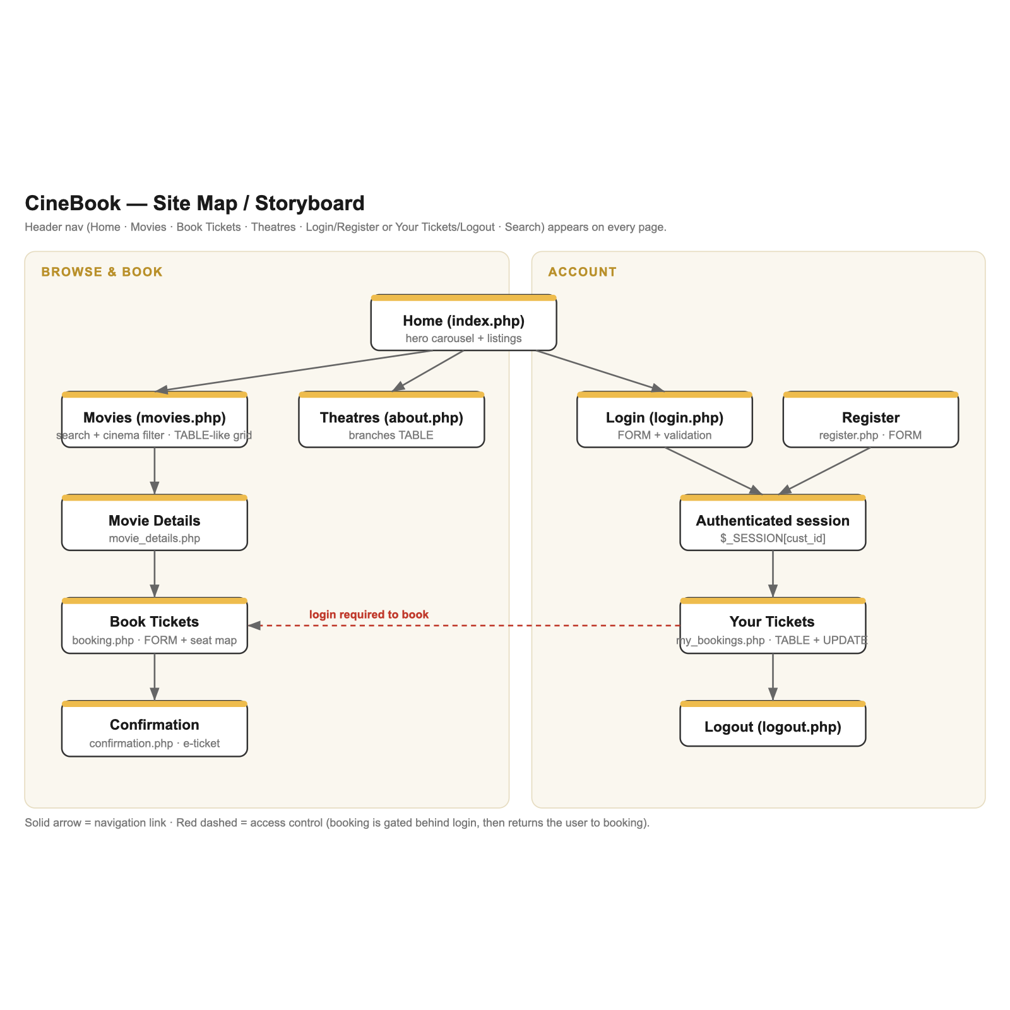
Figure 1. CineBook site map / storyboard.
3.2 Wireframes
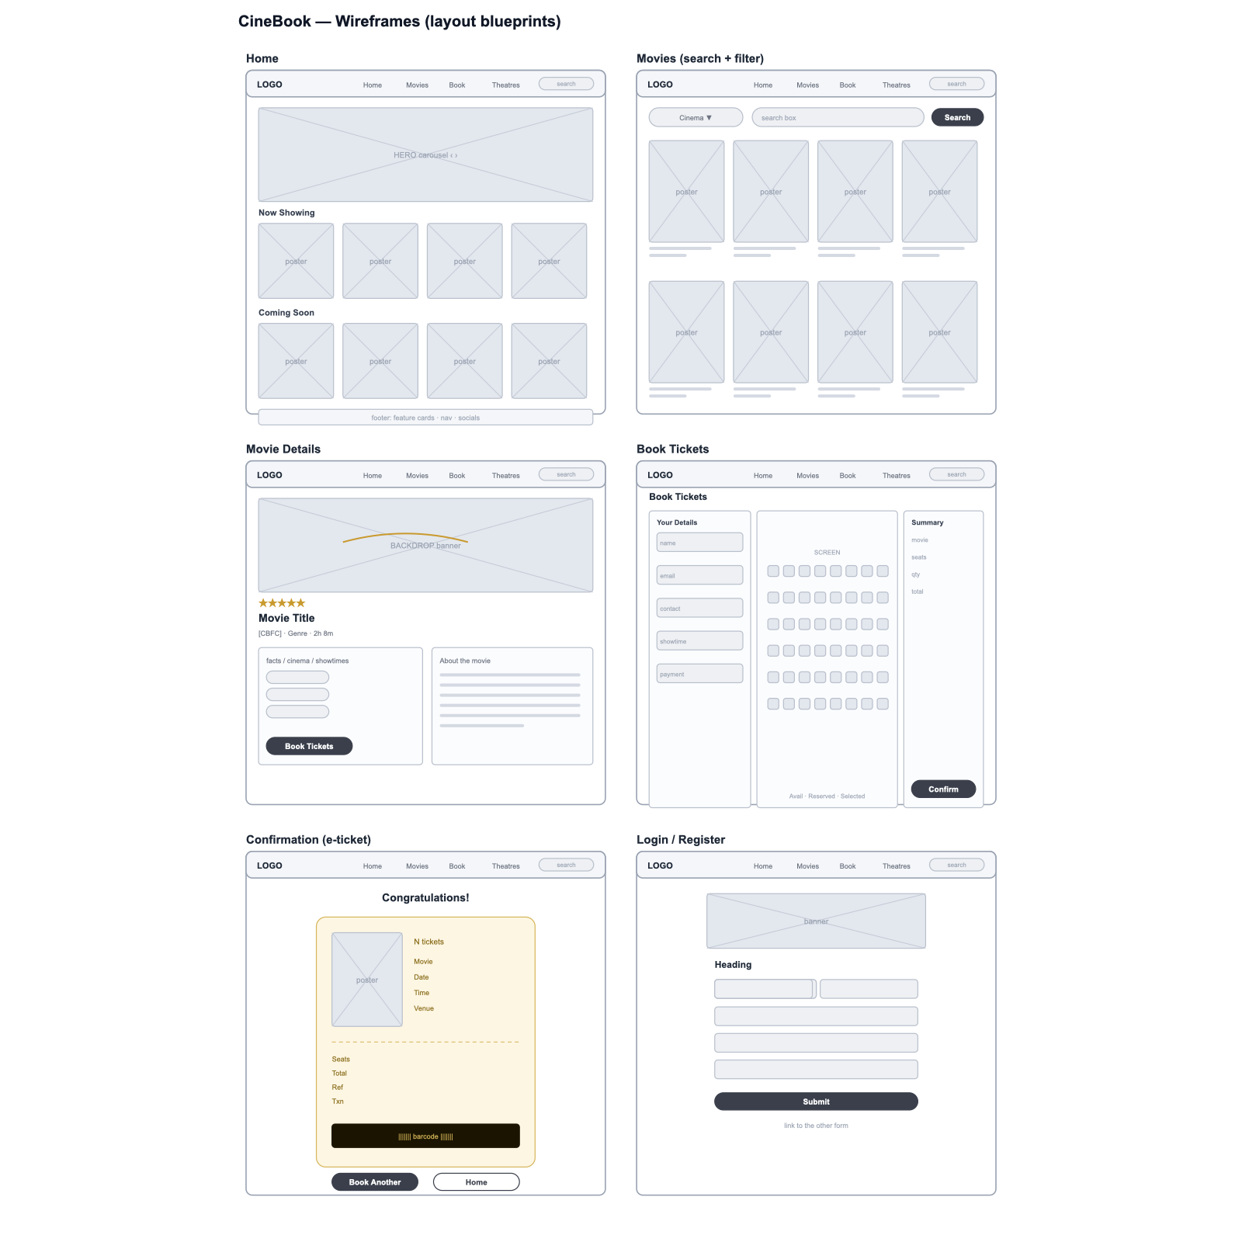
Figure 2. Wireframes (layout blueprints) for the key pages.
3.3 Database Design
The database (cinebook_db) uses eight normalised tables with foreign-key relationships: manager, branch, cinema, movie, customer, reservation, payment_type and transaction.
Catalogue side: a manager runs a branch; a branch hosts cinemas; a cinema screens movies (each movie row is a dated showtime with poster, backdrop, genre, certificate, star rating and status).
Booking side: a customer makes reservations for a movie; each reservation has a matching transaction that records the total and payment type. See Appendix 2, Table A2.2 for the full table list.

Implementation:

CineBook is implemented as server-rendered PHP pages that query a MySQL database via mysqli prepared statements and generate HTML. Shared includes provide the header, footer, database connection and helper functions (authentication, CSRF, formatting and image helpers). A single external stylesheet (css/style.css) with CSS variables styles the whole site, and one small vanilla-JavaScript file powers the hero carousel. Transactions with the database use SELECT (listings, search, details), INSERT (registration, reservation, transaction) and UPDATE (seat changes, profile edits).

Highlighted feature — F6 Book Tickets (seat selection & booking):
booking.php is gated with require_login(). It first queries all existing reservations and parses their seat strings into a per-movie list, which PHP writes directly into a JavaScript object (no AJAX/JSON libraries are used, per the Base-Version rules).
Client side: a vanilla-JS seat grid renders seats A1–H10; seats already reserved for the chosen showtime are disabled, and selecting seats updates hidden form fields and a live ticket total.
Server side: on submit, the CSRF token is verified, every field is validated, and the booking is saved with two prepared-statement INSERTs — one into reservation and one into transaction — before redirecting to a confirmation e-ticket.
Secondary feature — F2 Search: movies.php builds a prepared SELECT with a title LIKE clause and an optional cinema filter, demonstrating safe, parameterised querying.

Testing of web application
The table below lists representative test cases per functional requirement, with inputs, method (manual UI and/or database/code check) and results.

Functional Requirement | Description of Test Case | Result (If a visual needs to be shown, place the figure below this table and label with a figure number)
F1 | Open the home page | Pass — hero carousel auto-advances; Now Showing & Coming Soon load from the DB
F2 | Search title = 'mid' | Pass — only 'Midnight Protocol' is listed
F2 | Filter by cinema 'Silver Village Orchard' | Pass — only that cinema's movies are shown
F3 | Click a movie poster/title | Pass — details page shows synopsis, rating, certificate and showtimes
F4 | Register with valid details | Pass — account created and auto-logged in
F4 | Register with mismatched passwords | Pass — 'Passwords do not match'; no record inserted
F4 | Register with an existing email | Pass — 'An account with this email already exists'
F5 | Login with correct credentials | Pass — session created; redirected
F5 | Login with wrong password | Pass — 'Incorrect email or password'
F5 | Login attempt with ' OR '1'='1 in email | Pass — login fails safely (prepared statements)
F5 | Click Logout then Cancel / Yes | Pass — session kept on Cancel, destroyed on Yes
F6 | Open Book Tickets while logged out | Pass — redirected to login, then returned to booking
F6 | Select an already-reserved seat | Pass — reserved seats are disabled and un-clickable
F6 | Submit booking with no seats selected | Pass — 'Please select at least one seat'
F6 | Submit a valid booking (3 seats) | Pass — reservation + transaction inserted; confirmation shown
F6 | Submit a booking with a tampered CSRF token | Pass — rejected ('session expired')
F7 | View the confirmation page | Pass — e-ticket shows poster, seats, total and booking reference
F8 | Update a booking's seats to 'B4, B5' | Pass — row updated via SQL UPDATE; 'Seats updated'
F8 | Update seats with an invalid format | Pass — validation error; no update
F10 | Update profile details and email | Pass — customer row updated; duplicate email blocked
R2 | Resize the browser to 375px width | Pass — layout stacks to one column; no horizontal scroll

Summary of Modern Enhancements (optional)
React.js single-page movie browser (Additional Version). A separate React 18 app (in /react) renders a dynamic movie browser that fetches data from a JSON API (/api/movies.php) over the same MySQL database, with instant client-side search, status tabs, genre filters and sorting.
Justification: it goes beyond the traditional server-rendered stack by adding a modern, component-based, reactive UI. Search/filter/sort update instantly with no page reload, and consuming a JSON API over the existing database demonstrates a clean front-end/back-end (API) separation while reusing the base data layer. AJAX and JSON — permitted only in the Additional Version — are used here and nowhere in the Base Version.

Conclusion
CineBook delivers a complete, functional cinema-booking portal that meets all Base-Version requirements: a home page plus content pages with text and images, tables, a validated booking form with server-side processing, SELECT/INSERT/UPDATE database transactions, client- and server-side validation, and a single external stylesheet — with no disallowed technologies.
Security (prepared statements, hashing, CSRF, session handling) and usability (interactive seat map, auto-scrolling hero, account management) were emphasised. A React additional version was also implemented. Future work could add real online payment, email e-tickets, and an admin dashboard for managing movies and showtimes through the site.

Appendices:
Appendix 1: Source Codes with proper comments for evaluation
Appendix 2 (To be printed for DEMO evaluation): Contribution to the project by each team member shown in a table (see Table A2.1 and A2.2).
Appendix 3: Contribution to the report by each team member shown in a table (see Table A3).

Table A2.1. Contribution to the Project by each team member

Note: create more rows if needed, but DO NOT change the column size of “Remarks by Tutor”

Functional Requirement | Filename(s) and line numbers created for this requirement | Remarks by Tutor | Contributed by which member
F1 — Browse movies | index.php; js/script.js
F2 — Search & filter | movies.php; includes/header.php
F3 — Movie details | movie_details.php
F4 — Register | register.php
F5 — Login / Logout | login.php; logout.php
F6 — Book tickets | booking.php; css/style.css (seat map)
F7 — Confirmation | confirmation.php
F8 — Manage bookings | my_bookings.php
F9 — View theatres | about.php
F10 — Manage profile | profile.php
Shared / infrastructure | includes/db_connect.php; includes/functions.php; includes/header.php; includes/footer.php

Table A2.2. Database Tables created

Table Name | Purpose/Usage of this Table | Remarks by Tutor | Contributed by which member
manager | Cinema managers (manager details)
branch | Cinema branches; location and its manager
cinema | Cinemas belonging to a branch; name and contact
movie | Movies / dated showtimes: title, poster, backdrop, genre, duration, certificate, star rating, status
customer | Registered users: name, age, address, contact, email, hashed password
reservation | Seat reservations: name, date, time, seats, number of tickets, linked to customer and movie
payment_type | Available payment methods (Credit Card, Debit Card, PayNow)
transaction | Payment records: totals and dates, linked to customer, reservation and payment type

Table A3. Contribution to the Report by each team member

Chapter | Contributed by which member
Summary; Ch.1 Application Requirements; Ch.2 Functional Requirements | <member>
Ch.3 Design (site map, wireframes, database) | <member>
Ch.4 Implementation; Ch.5 Testing | <member>
Ch.6 Modern Enhancements; Ch.7 Conclusion; Appendices | <member>

If possible, state Percentage Contribution (out of 100%) by each member to the project and report. If it is equal contribution, state 50% for each member:

Member 1 (Name: xxx ) - Percentage: 50%
Member 2 (Name: yyy ) - Percentage: 50%

