Table of Contents

CineBook — IE4727 Web Application Design Project

Theme 5: A Web Portal for Booking Cinema Tickets
This document contains the report deliverables for the Base Version of CineBook. Diagrams: docs/sitemap.svg (storyboard). Wireframes are sketched in Section 5 and can be redrawn in any diagramming tool.

1. Application Requirements
(Overall system behaviour and quality — not just features.)
Quality | Requirement | How CineBook meets it
Usability | Users can find showtimes and book seats with minimal effort. | Consistent header/nav and search on every page; visual seat picker with a running total; forms pre-filled from the logged-in account; clear inline validation messages; breadcrumb-free, short booking flow.
Responsiveness | Layout must adapt to desktop, tablet and phone. | Pure CSS Grid/Flexbox with media queries at 1000/820/620 px. The hero, movie grid, and 3-column booking layout reflow to single column; tables scroll horizontally on small screens.
Security | Protect user data and prevent common attacks. | Prepared statements everywhere (SQL-injection safe); passwords hashed with password_hash(); CSRF tokens on all POST forms; session_regenerate_id() on login/register (session-fixation defence); output escaped with htmlspecialchars() (XSS); booking gated behind login; open-redirect protection on ?redirect=; identical login error message (no user enumeration).
Scalability | Handle growth in movies, cinemas and bookings. | Normalised relational schema (manager → branch → cinema → movie; customer → reservation → transaction). Pages are fully data-driven, so adding movies/cinemas needs only database rows, no code changes.
Maintainability | Easy to extend and modify. | Shared includes (header.php, footer.php, functions.php, db_connect.php); one external stylesheet using CSS variables (design tokens); reusable helper functions (starRating, formatDuration, poster/backdrop helpers, CSRF, auth); commented code.
Accessibility | Usable with assistive technology. | Semantic HTML5 landmarks (<header>, <nav>, <main>, <footer>); a <label> for every input; aria-label on nav, search and each seat; alt text on images; keyboard-focusable controls; high contrast (gold on near-black).

2. Functional Requirements
(What the system does.)
FR1 – Browse movies. Home page shows a hero carousel plus “Now Showing” and “Coming Soon” listings sourced from the database. FR2 – Search & filter. Users can search movies by title (SQL LIKE) and filter by cinema on the Movies page. FR3 – View movie details. A dynamic details page shows synopsis, rating, certificate, duration, cinema, and showtimes. FR4 – Register. New users create an account (first/last name, age, contact, address, email, password + confirmation) with client- and server-side validation. FR5 – Login / Logout. Registered users authenticate; sessions manage state; logout destroys the session. FR6 – Book tickets (auth-gated). Logged-in users select a showtime, pick seats on a visual seat map (already-booked seats are disabled per showtime), and submit a booking form; the server records a reservation and a transaction. FR7 – Booking confirmation. A server-generated e-ticket page shows the booking with poster, seats, total and a booking reference. FR8 – Manage bookings. “Your Tickets” lists the user’s bookings and allows updating seats (SQL UPDATE). FR9 – View theatres. The About/Theatres page lists cinema branches in a table.

3. Storyboard / Site Map
See the visual flowchart below.
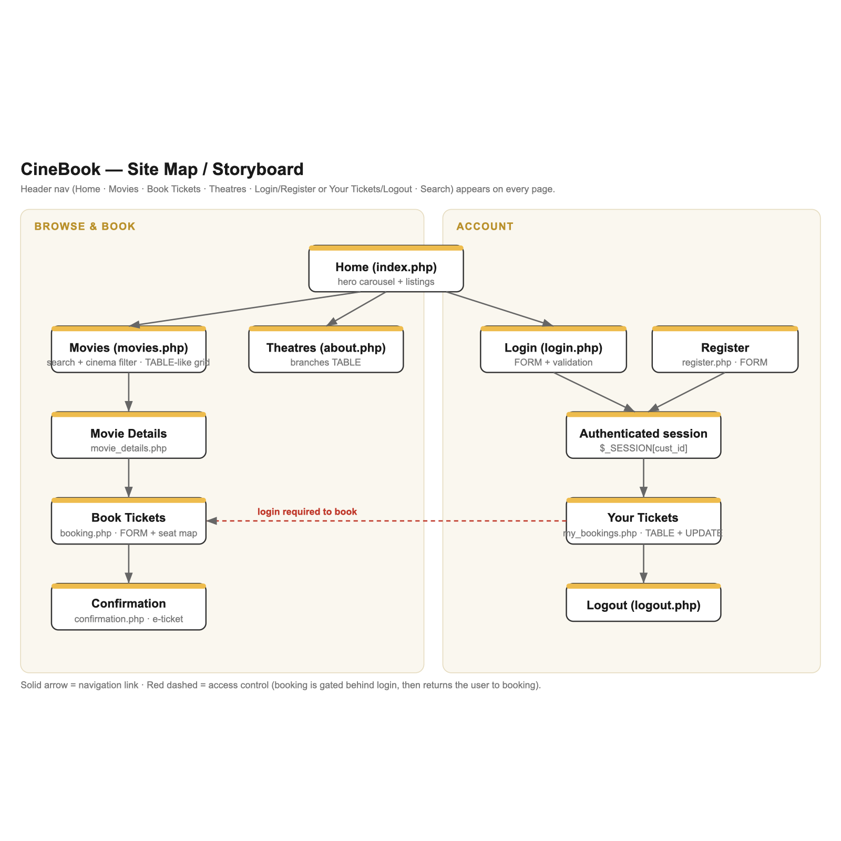
CineBook site map
Navigation summary:
Home (index.php)
├── Movies (movies.php) ── search + cinema filter
│ └── Movie Details (movie_details.php)
│ └── Book Tickets (booking.php) [requires login]
│ └── Confirmation (confirmation.php)
├── Theatres / About (about.php) branches table
├── Login (login.php) ─┐
├── Register (register.php) ─┘→ Authenticated session
│ ├── Your Tickets (my_bookings.php) update seats
│ └── Logout (logout.php)
└── Search box (header) → Movies results
Access control: any attempt to reach booking.php while logged out redirects to Login and, after a successful login/registration, returns the user to the booking page they wanted.

4. Wireframes (layout blueprints)
Polished blueprint wireframes of all key pages are shown below; ASCII sketches follow for quick reference.
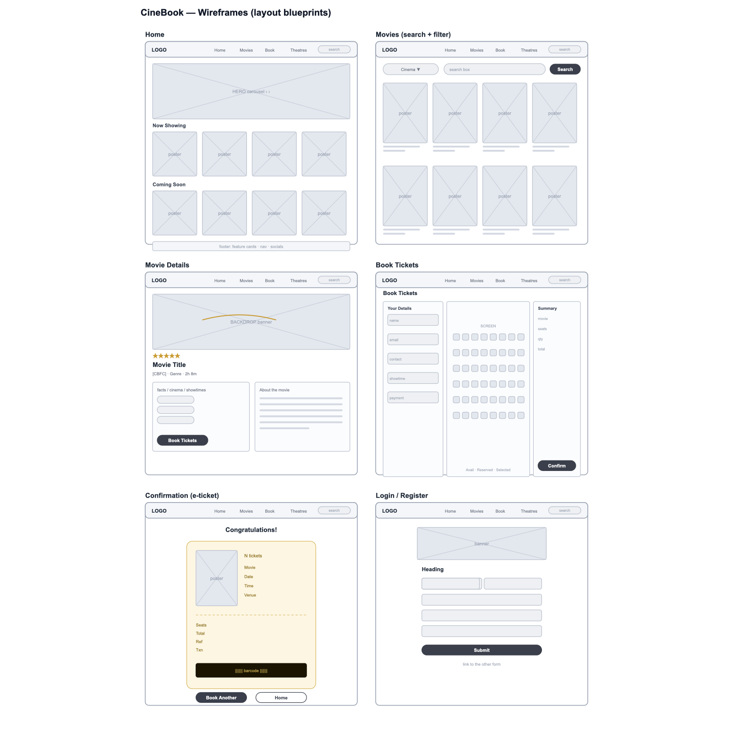
CineBook wireframes
Home
+------------------------------------------------------+
| LOGO Home Movies Book Theatres Login [Search] |
+------------------------------------------------------+
| < HERO CAROUSEL (backdrop, title, stars, > |
| buttons: View Details / Book Tickets) o o o o |
+------------------------------------------------------+
| Now Showing [View all] |
| [poster][poster][poster][poster] |
| Coming Soon [View all] |
| [poster][poster][poster][poster] |
+------------------------------------------------------+
| FOOTER: feature cards · logo · nav · socials |
+------------------------------------------------------+
Movies (search + filter, card grid)
[ Cinema: v ] [ search box ][Search]
[poster card][poster card][poster card][poster card]
title/cert/Book …
Movie Details
+---------------- BACKDROP BANNER ---------------------+
★★★★★ Title
[CBFC] · Genre · 2h 8m
+---------------------+ +---------------------------+
| facts / showtimes | | About the movie (synopsis)|
| [Book Tickets] | | |
+---------------------+ +---------------------------+
Book Tickets (3 columns)
+-----------+ +--------- SCREEN (curve) ---------+ +-----------+
| Your | | A [][][] .. [][][] | | Booking |
| Details | | B [][][] .. [][][] | | Summary |
| name | | ... seat icons ... | | movie |
| email | | legend: Avail/Reserved/Selected| | seats |
| contact | +----------------------------------+ | qty/total |
| showtime | | [Confirm] |
| payment | +-----------+
+-----------+
Confirmation (golden e-ticket)
Congratulations!
+------------------------------------------+
| [poster] N tickets |
| Movie Date Time |
| Venue Seats Total Ref Payment Txn |
| - - - - - - perforation - - - - - - - |
| ||||||| barcode ||||||| |
+------------------------------------------+
[Book Another] [Back to Home]
Login / Register
+----------- banner -----------+
| Heading |
| [ field ] [ field ] |
| [ field ] |
| [ Submit (full width) ] |
| link to the other form |
+------------------------------+

5. Implementation Details
Stack: HTML5, CSS3 (one external stylesheet, CSS variables), vanilla JavaScript, PHP (procedural + mysqli), MySQL/MariaDB. No frameworks, no AJAX/JSON (Base-Version compliant).
Project structure
cinebook/
├── index.php, movies.php, movie_details.php, booking.php,
│ confirmation.php, my_bookings.php, about.php,
│ login.php, register.php, logout.php
├── includes/ db_connect.php · functions.php · header.php · footer.php
├── css/style.css (external stylesheet, 4+ styles)
├── js/script.js (hero carousel — plain JS)
├── images/posters, images/backdrops, images/ui
└── database.sql (schema + sample data)
Key techniques - Server-side rendering: each PHP page queries MySQL and generates HTML (e.g. confirmation.php). - Database transactions: SELECT (listings/search), INSERT (registration, reservation, transaction), UPDATE (seat change in my_bookings.php). - Prepared statements (bind_param) for every query using user input — prevents SQL injection. - Sessions & auth: functions.php provides require_login(), is_logged_in(), current_user_id(); booking is gated and returns the user after login. - CSRF protection: csrf_field() injects a per-session token; csrf_verify() checks it on every POST. - Validation: HTML5 (required, pattern, type), JavaScript (instant feedback), and authoritative PHP checks (email format, phone digits, password length/match, seat format). - Interactive seat map (pure JS): occupied seats are written into JavaScript by PHP (no AJAX); selecting seats updates hidden fields and a live price total. - Images: poster/backdrop file names stored in the DB; helper functions build the image or fall back to a genre-coloured placeholder.

6. Base-Version Requirements — Compliance Checklist
Requirement | Status
1 home + 4–10 content pages, each with title, text & images | ✅ Home + 8 content pages, all with images
1 table displaying content | ✅ about.php, my_bookings.php
1 form (4+ fields) + server-side processing + DB | ✅ booking.php (6 fields), register.php
SQL Select / Insert / Update | ✅ all three present
1 server-side generated page | ✅ all PHP pages; confirmation.php
Client-side validation (HTML5 + JS) | ✅
Server-side validation (PHP) | ✅
Form on project site (no external form) | ✅
1 external CSS with 4+ styles | ✅ css/style.css
No iframe/frames/mailto/jQuery/JSON/AJAX/Bootstrap | ✅ verified
No external/social links | ✅ decorative only

7. Test Cases
# | Feature | Input Data | Expected Output | Test Method | Result
T1 | Registration – valid | fname=Jane, lname=Tan, age=22, phone=91234567, email=jane@test.com, pw=secret1 (x2) | Account created, auto-logged-in, redirected | Manual UI | Pass
T2 | Registration – password mismatch | pw=secret1, confirm=secret2 | Error “Passwords do not match”; no insert | Manual UI | Pass
T3 | Registration – duplicate email | email already in DB | Error “account with this email already exists” | Manual UI | Pass
T4 | Registration – invalid age | age=5 | Error “Age must be between 12 and 120” | Manual UI | Pass
T5 | Login – valid | correct email + password | Session created, redirected to intended page | Manual UI | Pass
T6 | Login – wrong password | correct email, wrong pw | Error “Incorrect email or password” | Manual UI | Pass
T7 | Auth gate | open booking.php while logged out | Redirect to login; after login, return to booking | Manual UI | Pass
T8 | Booking – missing seats | fill form, select 0 seats | Error “Please select at least one seat” | Manual UI + PHP | Pass
T9 | Booking – invalid contact | contact=abc | Error “Contact number must be 7-15 digits” | JS + PHP | Pass
T10 | Booking – too many seats | select 11 seats | Blocked at 10 (alert) | JS | Pass
T11 | Seat occupancy | choose showtime with booked seats | Booked seats shown “Reserved” and un-clickable | Manual UI | Pass
T12 | Booking – success | valid form + 3 seats | Reservation + transaction inserted; redirect to confirmation | Manual UI + DB check | Pass
T13 | Confirmation | valid res_id | E-ticket shows poster, seats, total, reference | Manual UI | Pass
T14 | Update seats | new_seats=B4, B5 | Row updated (SQL UPDATE); “Seats updated” | Manual UI + DB | Pass
T15 | Update seats – bad format | new_seats=zzz | Error “Please enter valid seat(s)”; no update | Manual UI | Pass
T16 | Search | q=mid | Only “Midnight Protocol” listed | Manual UI | Pass
T17 | Cinema filter | select a cinema | Only that cinema’s movies listed | Manual UI | Pass
T18 | SQL injection attempt | email=' OR '1'='1 at login | Login fails safely (prepared statement) | Manual + code review | Pass
T19 | CSRF | submit POST with wrong/missing token | Rejected “session expired” | Manual (edit token) | Pass
T20 | Responsiveness | resize to 375 px width | Layout stacks to one column, no horizontal scroll | Browser devtools | Pass
T21 | Page titles | visit each page | Correct <title> in the browser tab | Manual UI | Pass
(Fill the “Result” column with your own run and add screenshots as evidence in the final report.)

8. (Optional) Modern Enhancement — Additional Version
Not included in the current Base Version. A separate React.js single-page movie browser consuming a PHP JSON API over the same MySQL database can be added for the 15% component, with justification (modern, reactive, component-based UI beyond the traditional stack).

