**SUMMARY**

## USC ID/s:

Junye Li - 2760190786

|  |  |  |  |  |
| --- | --- | --- | --- | --- |
| M+N | Time in MS (Basic) | Time in MS (Efficient) | Memory in KB (Basic) | Memory in KB (Efficient) |
| 16 | 0 | 0 | 14580 | 14968 |
| 64 | 34.91282 | 1.02472 | 21048 | 15836 |
| 128 | 1.99747 | 3.98731 | 21076 | 15836 |
| 256 | 7.97606 | 13.98563 | 21168 | 15836 |
| 384 | 15.95998 | 29.89817 | 21420 | 15836 |
| 512 | 28.94759 | 54.15034 | 21952 | 15836 |
| 768 | 69.83995 | 120.99433 | 23396 | 15836 |
| 1024 | 128.2382 | 218.41574 | 31856 | 15836 |
| 1280 | 199.49102 | 346.09795 | 35692 | 15836 |
| 1536 | 293.66732 | 530.65252 | 37940 | 15452 |
| 2048 | 576.45059 | 965.09862 | 58600 | 15564 |
| 2560 | 892.16256 | 1528.09334 | 82828 | 15656 |
| 3072 | 1207.67736 | 2168.57266 | 111560 | 15736 |
| 3584 | 1683.01892 | 2803.12419 | 144964 | 15820 |
| 3968 | 2136.81364 | 3636.65628 | 177076 | 15836 |

## Datapoints

## Insights

### Graph1 – Memory vs Problem Size (M+N)

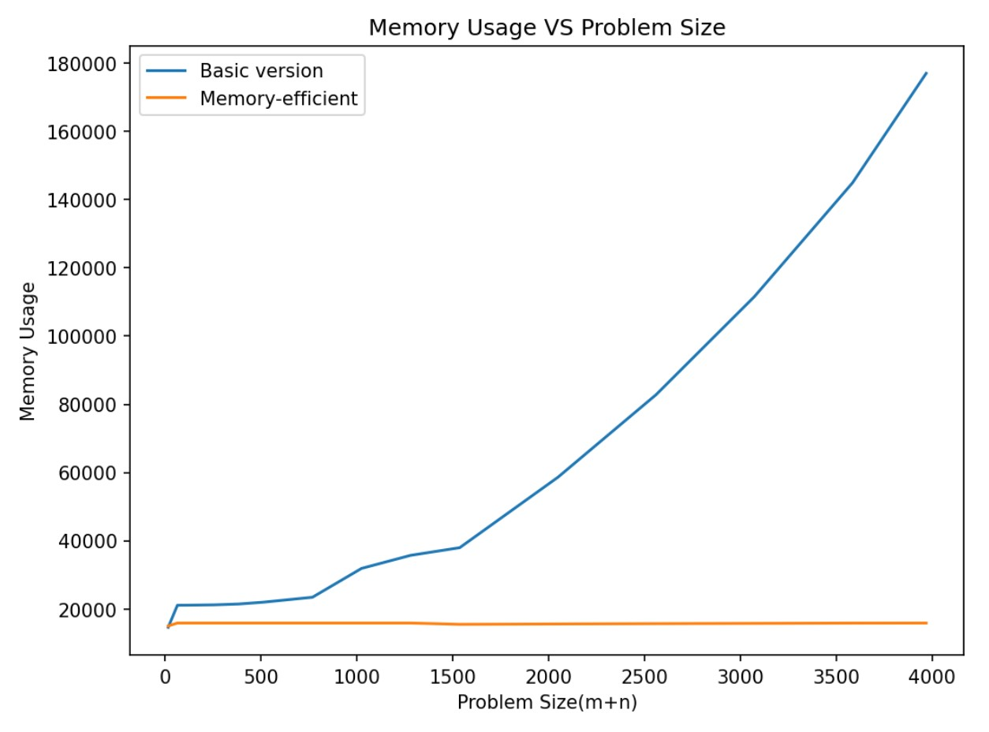

#### Nature of the Graph (Logarithmic/ Linear/ Polynomial/ Exponential)

Basic: Polynomial

Efficient: Linear

#### Explanation:

For the basic version, we need to build an OPT array which has O(mn) entries to store all the subproblem answers. Therefore, the complexity is polynomial.

For the Efficient version, by reusing one of the dimensions of the OPT array, we only need O(m+n) space to store values.

### Graph2 – Time vs Problem Size (M+N)

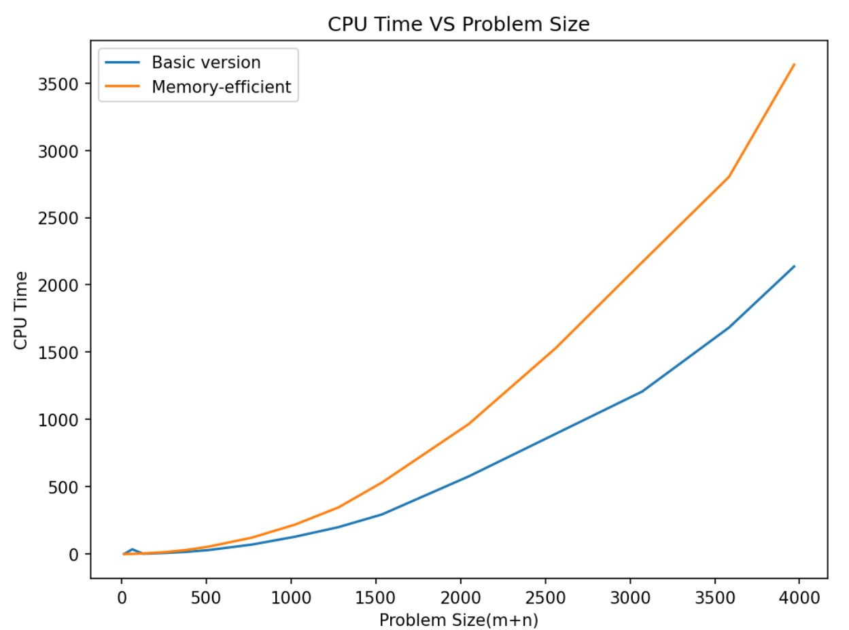

#### Nature of the Graph (Logarithmic/ Linear/ Polynomial/ Exponential)

Basic: Polynomial

Efficient: Polynomial

#### Explanation:

Both basic and memory-efficient version have the complexity of O(mn) so they are polynomial.

## Contribution

(Please mention what each member did if you think everyone in the group does not have an equal contribution, otherwise, write “Equal Contribution”)

<USC ID/s>: <Equal Contribution>