***Coliseum - High Level Requirements***

Jun Yen Leung - junyenle@usc.edu

Ethan Barker - esbarker@usc.edu

Jake Leventhal - jglevent@usc.edu

Uri Rahimi - urahimi@usc.edu

Dylan Appleton - dappleto@usc.edu

**Overview:**

Coliseum will be a side-scrolling platformer-style boss-rush game. The core gameplay will involve controlling a character capable of basic movement and attacks to fight a single non-player agent per level.

**Section 1: Title Screen, Log In, Registration**

Upon loading the game, players should be shown a title screen with game art and be given the option to log in, register, continue as a guest, or view high scores.. Choosing to register will allow them to choose a unique username and supply a password for logging in in the future. After registration, the player should be redirected to the log in screen. Choosing to log in will allow the player to enter their username and password. These particulars will be checked against the database and the player will be allowed to log in only if a match is found. Viewing high scores queries the database for the top 10 worldwide scores achieved and displays those scores.

**Section 2: Agents**

**2a: Player Character (PC)**

The PC should be able to move left and right, as well as be able to perform two layers of jump (short jump and long jump). The PC will attack with a sword and can attack either forwards or upwards while standing and in all directions while jumping. In addition, the PC should be able to dash a short distance and be invulnerable during said dash.

The PC should be animated using a sprite sheet at 6-12 frames per second (utilizing tripling / quadrupling to achieve 24/36 frames per second, depending on other animations). The PC should be equipped with an attack animation, a flinch animation, a death animation, a jump animation, a dash animation, and a movement animation. Each animation should be accompanied by an appropriate sound effect.

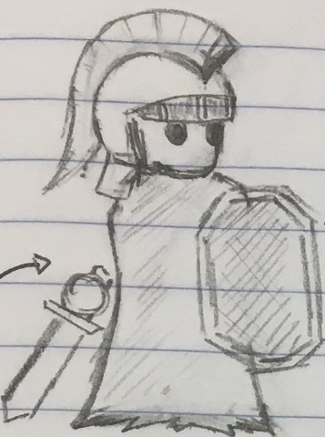The PCs hitbox should be set frame by frame according to each animation’s frames. Taking hits from hostile agents should decrease the life points of the PC. The PC should take three hits before death, with no healing mechanism. The PC’s life points should be visible.

PC concept sketch 🡺

**2b: Hostile Agent (BOSS)**

There should be one BOSS per level. The BOSS’ movement and attacks, as well as corresponding animations and sound effects, should depend on the particular design of said boss. BOSS hitboxes should, like PC hitboxes, be determined by their animation frames. BOSS animations should be either 6-12 or 24 frames per second, depending on the complexity of the BOSS’ movements. The BOSS should lose life points when it is hit by the PC. The BOSS’ life points should not be visible.

In addition to movement and attack animations, the BOSS should have additional “flare” animations to make it seem more life-like. For example, it may taunt the PC upon entering the fight.

Each BOSS should have its own music track. This track should fit the “personality” of the BOSS and make it feel more awesome.

BOSS AI should be simple and employ good use of anticipation (that is, BOSS attacks should be clearly telegraphed). The intention here is for the BOSS to feel cool by giving it cool attacks, but for it to still be beatable by a player who is paying attention to its animations.

**Section 3: Environment**

**3a: Player-acting environment**

By player-acting, we mean environment features that the PC can interact with. This will be limited to platforms and drops. The fight between the PC and the BOSS should take place on a single long platform on which the PC and BOSS can walk. The BOSS may create additional secondary platforms depending on its design. On either end (left/right) of the main platform, there should be a drop. Falling down this drop will result in the PC’s death. The BOSS should not be able to fall off the platform.

**3b: Non-player-acting environment**

By this we mean environment factors that are purely aesthetic.

There should be foreground, midground, and background art. These three elements should move at different speeds in relation to the camera, offering the illusion of depth. That is, as the camera moves across the screen, the background should move the least while the foreground should move the most. The non-player-acting environment elements should also include small looping animations such as moving clouds or audience members.

**3c: Player / environment bridging**

By this we mean the elements that help connect the player on the other side of the screen to the environment we have created.

The camera should center on the PC and move as the PC moves. The background art width should be at least (main platform width + 2000) pixels so that the world seems continuous to the player.

**3d: Concept sketch**

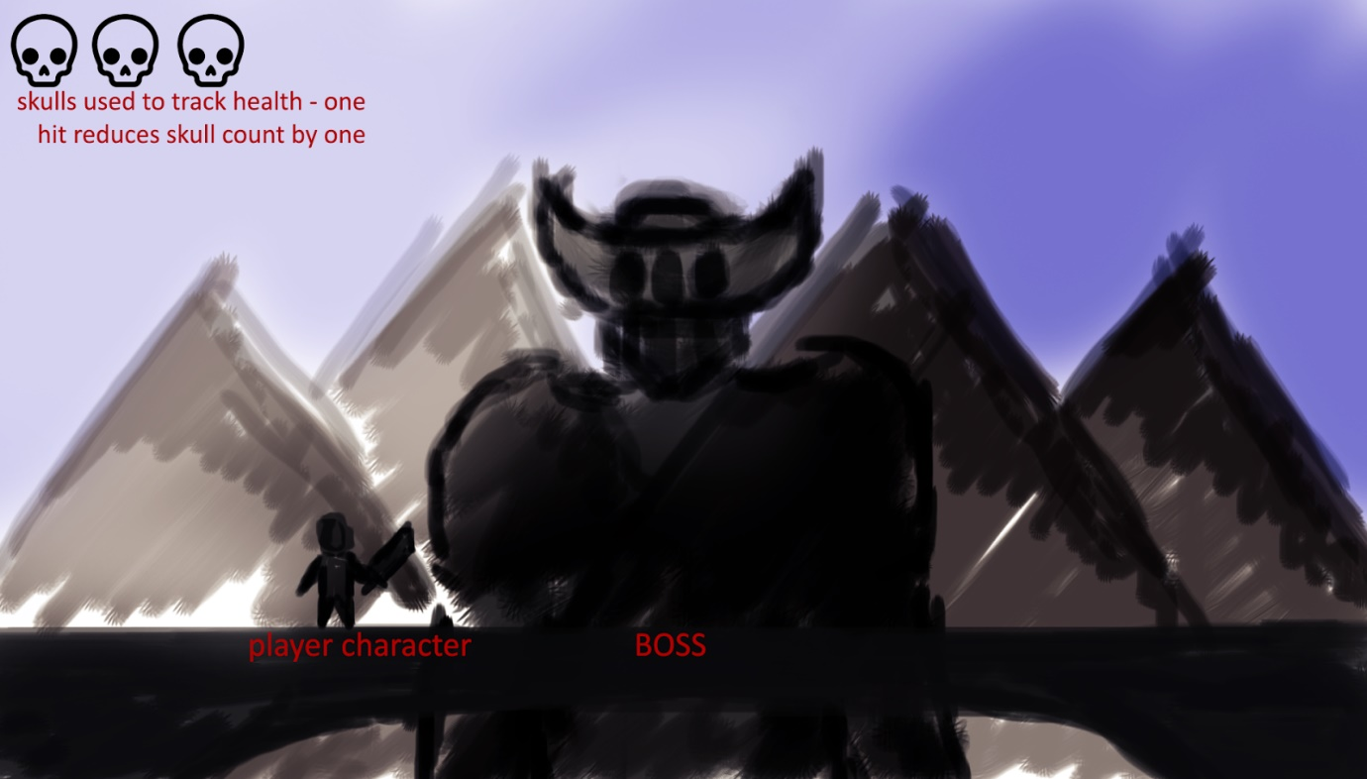

**Section 4: Additional features**

**4a: High scores**

Logged-in players who beat the BOSS should be scored based on the amount of time spent and whether or not they were able to beat the BOSS without taking any hits. The highest 10 scores across all players should be saved to a high score list and be accessible to any player from the game’s title screen. Players who are playing as guests will not be able to save high scores.

**4b: GAME OVER**

GAME OVER can occur in two ways:

1. The PC dies, in which case a GAME OVER screen should be displayed and the player will be redirected to the title screen.
2. The BOSS dies, in which case a score screen showing “VICTORY” and the player’s score should be displayed. The high score list should also be displayed.