ROS Spin Professor Handoff
Corrected Doxorubicin Semiquinone Oxygen Spin Chemistry Model

Repository commit 05834d40de6e
Generated 2026-09-09T11:48:19.673422+00:00
Professor-facing final computational report

All quantitative figures and tables in this document were generated directly from the ROS_Spin computational workflow or from values stored in its machine-readable parameter and provenance files. No figures were reproduced from external publications. Figure 1 is an author-created conceptual workflow and contains no independent quantitative data.
NON-PREDICTIVE DIMENSIONLESS SENSITIVITY ANALYSIS

Purpose of This Handoff
This report hands off the completed corrected ROS_Spin implementation, its generated scientific results, numerical validation, evidence record, and reproduction package. It is written to support technical review and manuscript revision without requiring the reader to reconstruct the repository history.
All quantitative figures and tables in this document were generated directly from the ROS_Spin computational workflow or from values stored in its machine-readable parameter and provenance files. No figures were reproduced from external publications. Figure 1 is an author-created conceptual workflow and contains no independent quantitative data.

Executive Summary
Across the five baseline initial-state benchmarks, the computed primary-superoxide yield per encounter spans 0.140445 to 0.445496. Across the selected sensitivity grids it spans 0.000594884 to 1; these extrema describe only the executed grid. The simulations demonstrate how primary superoxide yield would depend on the competition among spin-selective electron transfer, doublet-quartet mixing, relaxation, and encounter escape under specified dimensionless scenarios. They do not establish that the assumed spin preparation, mixing magnitude, or state-selective rates occur in the doxorubicin semiquinone-oxygen system.
Computed structural results include projector algebra, six-state dimensions, valid density matrices, probability accounting, solver agreement, and coherent-embedding consistency. Conditional sensitivity results cover mixing, relaxation, escape, initial state, and kQ/kD. Literature-derived calculations remain confined to condition-specific bulk rates, downstream aqueous kinetics, and provenance-qualified experimental context.
The worst absolute discrepancy between the reference matrix exponential and the separately constructed adaptive Dormand-Prince solver is 1.044e-12. The maximum encounter probability-balance error is 1.318e-13, and the maximum downstream radical-equivalent balance error is 1.694e-21 M. These checks validate numerical consistency rather than physical parameterization.
Circuit status for the recorded run is qiskit_executed. The three-qubit calculation embeds the six physical states within an eight-state space, checks the two unused states for leakage, and compares statevectors and doublet/quartet observables. It validates coherent encoding consistency only; it does not demonstrate quantum advantage or independently validate the chemistry.

Connection to the Original ROS Spin Project
ROS_Spin originally asked whether electron-spin dynamics could influence reactive oxygen species formation during anthracycline redox cycling while retaining a quantum-circuit component for computational comparison. The completed workflow preserves that objective but replaces the original two-qubit chemical interpretation with the correct spin space for doxorubicin semiquinone and molecular oxygen.
The prior implementation used singlet/triplet and Bell-state ideas for a system whose oxygen partner has spin one. It also risked treating computational-basis parity and repeated circuit gates as chemical dynamics, carrying semiconductor relaxation data into an unrelated molecular encounter, and mapping spin outcomes directly to ROS products. Those choices could not support the proposed chemistry.
The corrected workflow keeps the biological motivation at the level supported by current evidence: anthracycline semiquinone chemistry can transfer an electron to oxygen, and downstream superoxide chemistry can form H2O2. The present encounter model does not bridge its illustrative per-encounter yields to organelle, cell, animal, or patient exposure without missing formation, association, residence, competing-sink, transport, and compartment parameters.

Table 1 Original versus Corrected Implementation
Table 1 connects the corrected implementation to the original project and identifies why each change matters scientifically.
Model element | Original implementation | Corrected implementation | Consequence
Physical species | Generic two-spin or semiconductor shuttling model | Doxorubicin/adriamycin semiquinone with S=1/2 and ground-state O2 with S=1 | The chemistry is tied to the stated redox pair.
Spin dimensions | Two qubits; dimension 4 | Spin-1/2 x spin-1 electronic space; dimension 6 | All physical electronic states are retained.
Manifold classification | Singlet/triplet or basis-parity labels | Doublet (dimension 2) and quartet (dimension 4) projectors | Projectors follow angular-momentum addition.
Initial states | Bell states or computational-basis preparations | I6/6, PD/2, PQ/4, and bounded pD mixtures | All cases are computational benchmarks; no chemical preparation is asserted.
Hamiltonian | Repeated CZ or identity gates used as chemical dynamics | Zeeman, exchange, dipolar, O2 ZFS, and local-field terms in the six-state space | Unavailable interactions remain disabled or sensitivity-only.
Relaxation | Semiconductor dephasing parameters | Local isotropic Lindblad sensitivity model with exact-system rates unavailable | No semiconductor relaxation parameter enters active chemistry.
Electron transfer | Mapped from state counts or parity | Integrated kD Tr(PD rho) and kQ Tr(PQ rho) loss fluxes | Reaction yield is a time-integrated kinetic quantity.
Encounter escape | Absent or not separated from circuit depth | Independent first-order escape channel kescape Tr(rho) | Reaction, escape, and unresolved survival close the probability balance.
Primary superoxide | Assigned from singlet/triplet or basis outcomes | YD + YQ from integrated electron-transfer flux | One primary radical equivalent is assigned per reacted encounter.
Hydrogen peroxide | Mapped directly from a spin population | Separate HO2/O2-minus speciation and dismutation with two radicals per H2O2 | Spin populations are not treated as H2O2.
Rate units | Bulk and encounter rates could be conflated | Bulk M^-1 s^-1 constants remain separate from encounter s^-1 rates | No unsupported dimensional conversion is made.
Quantum-circuit role | Circuit outcomes interpreted as chemistry | Three-qubit coherent embedding consistency check | The circuit does not validate open-system chemistry or quantum advantage.
Interpretation | Risk of direct biological or cardiotoxicity extrapolation | Conditional dimensionless sensitivity analysis with evidence-gated inputs | Cellular ROS and clinical outcomes remain outside scope.

Generated CSV source /Users/arjunlingala/Downloads/ROS_Spin/results/paper/tables/table01_original_versus_corrected_model.csv

Corrected Model and Equations
Doxorubicin or adriamycin semiquinone has electron spin S=1/2, whereas ground-state O2 has S=1. Their product space therefore contains 2 x 3 = 6 electronic states. This change determines the correct state dimension and invalidates a two-qubit singlet/triplet description of the encounter.
Angular-momentum addition splits the six-state space into a doublet subspace of dimension two and a quartet subspace of dimension four. Exact projectors define the manifold observables. I6/6, PD/2, PQ/4, and bounded pD mixtures are computational benchmarks, not evidence of chemical state preparation.
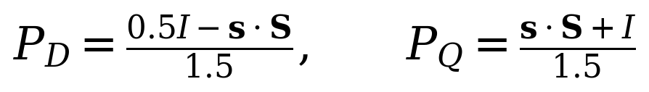
The active model propagates a six-by-six density matrix with a constant-generator matrix exponential. Zeeman, exchange, dipolar, oxygen zero-field-splitting, and local-field structures are implemented, but unavailable exact-system terms remain disabled or are activated only as named sensitivity coordinates. Local isotropic Lindblad terms supply an explicitly phenomenological relaxation sensitivity model.
Electron transfer is represented by separate first-order loss operators in the doublet and quartet manifolds, while encounter escape removes population independently. The model integrates these fluxes through time and retains unresolved survival so that reaction, escape, and survival close to unity.
Primary superoxide is calculated only as the sum of integrated doublet and quartet electron-transfer yields. One reacted encounter contributes one primary superoxide-family radical equivalent. A final spin population is never re-labeled as chemical product.
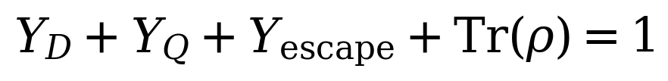
A distinct fixed-pH model partitions the radical pool between HO2 and O2-minus, applies spontaneous and SOD-mediated dismutation, consumes two radical equivalents per H2O2, and tracks an optional H2O2 loss channel. This stage does not feed an encounter spin population directly into H2O2.

Figure 1 Conceptual Model Overview
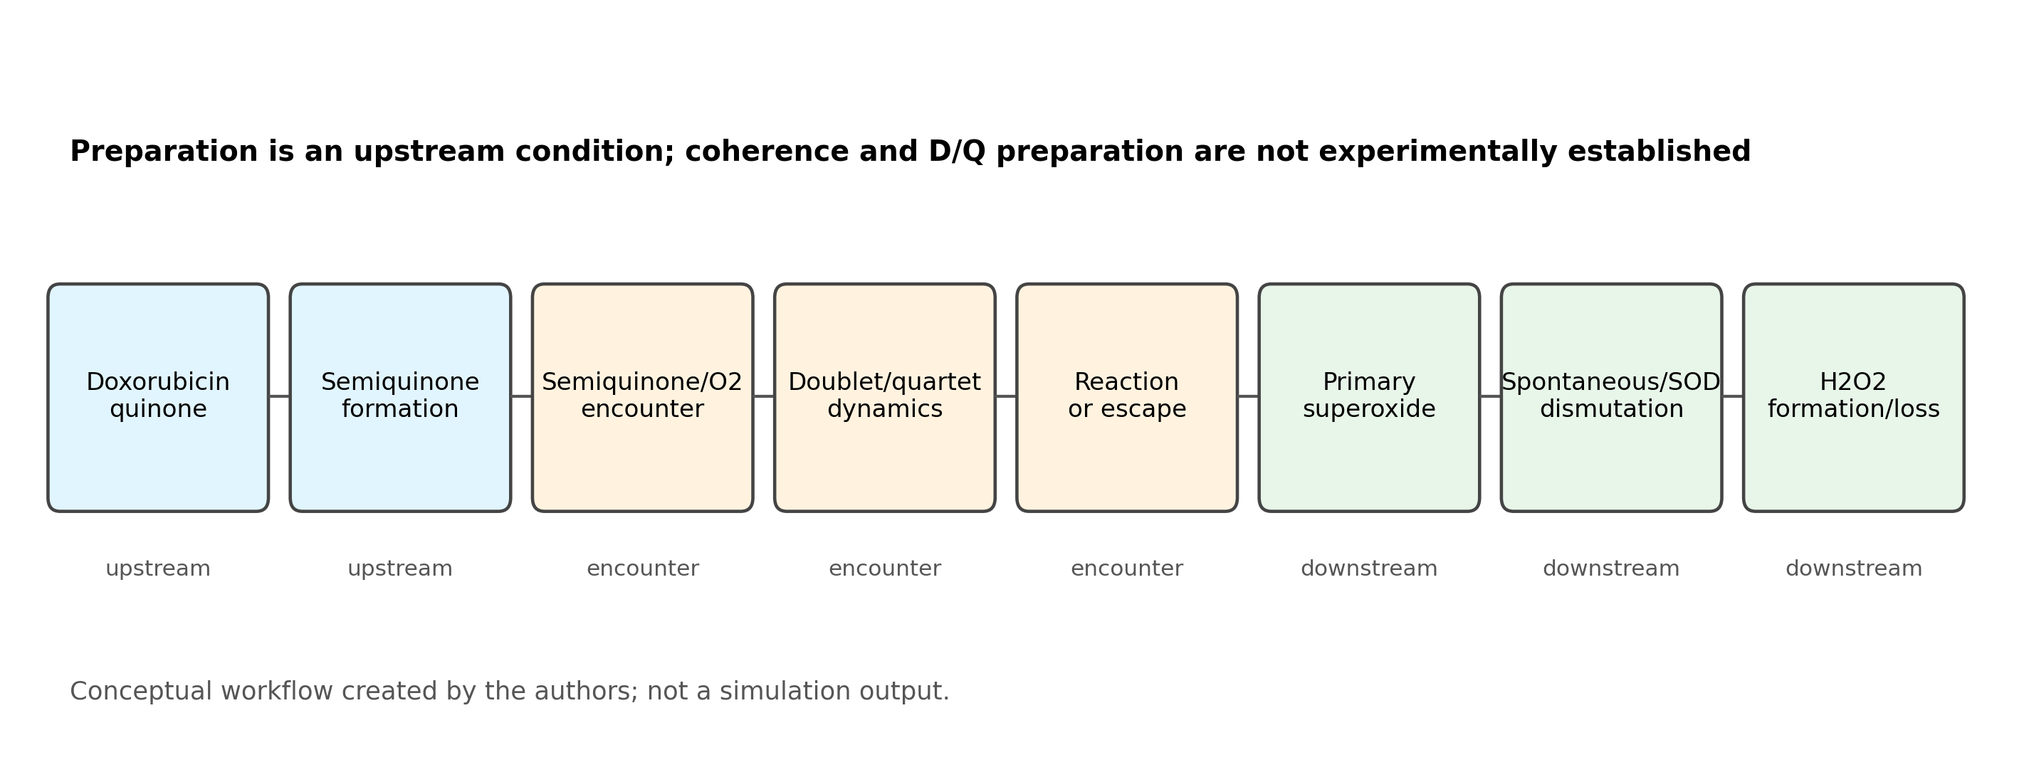
Figure 1 Corrected Model Overview. Corrected model overview. Doxorubicin reduction and semiquinone formation are classical upstream stages. A semiquinone-triplet-O2 encounter enters the six-state doublet/quartet quantum spin-evolution stage, followed by competing spin-selective electron transfer or escape. Integrated reaction flux forms primary superoxide; fixed-pH HO2/O2-minus speciation and dismutation subsequently form H2O2, which may be lost through a separate sink. Conceptual workflow created by the authors; not a simulation output. The diagram is non-quantitative and does not assert coherent preparation or a measured encounter.
Source data /Users/arjunlingala/Downloads/ROS_Spin/results/paper/data/figure01_model_overview.csv Caption /Users/arjunlingala/Downloads/ROS_Spin/results/paper/captions/figure01_model_overview_caption.txt

Computational Methods and Script Mapping
The active workflow separates model equations, command-line policy, sensitivity design, plotting, evidence, and tests so that each generated claim can be traced to code and source data.
spin_chemistry.py Defines spin operators and projectors, six-state Hamiltonians, reference and independent propagators, staged ROS chemistry, evidence gates, and coherent embedding checks.
ROS.py Provides the guarded command line for a single evidence-backed bulk calculation or an explicitly opted-in encounter sensitivity case.
sensitivity_analysis.py Defines normalized one- and two-dimensional sweeps, benchmark initial states, probability outputs, and the non-predictive labeling policy.
paper_analysis.py Runs the deterministic paper workflow, writes Figure 1-11 source data, renders all figures, generates Tables 1-9, and records run metadata.
plotting.py Renders each figure from its saved source CSV using one visual style and the required sensitivity warning.
configs/doxorubicin_parameters.json Stores active, disabled, sensitivity-only, downstream, bulk-rate, and experimental-evidence records.
configs/parameter_provenance.csv Provides the machine-readable source ledger, conditions, uncertainty, suitability, and exact code paths.
tests Checks spin algebra, dynamics, evidence policy, independent validation, downstream balances, circuit behavior, legacy boundaries, and the paper and handoff pipelines.
The JSON configuration and provenance CSV distinguish measured or literature-derived bulk quantities from missing encounter quantities. Bulk constants in M^-1 s^-1 remain separate from kD, kQ, relaxation, and escape in s^-1. Missing geometry, tensors, relaxation times, state preparation, and state-resolved rates are not assigned invented values.
All encounter results are conditional, dimensionless sensitivity results. Mixing, relaxation, escape, initial doublet fraction, and kQ/kD are varied over declared computational coordinates. The equality kQ/kD=1 is the spin-independent null; the displayed axes are not measured ranges, probability distributions, priors, or confidence intervals.

Figure 2 Benchmark Trajectories
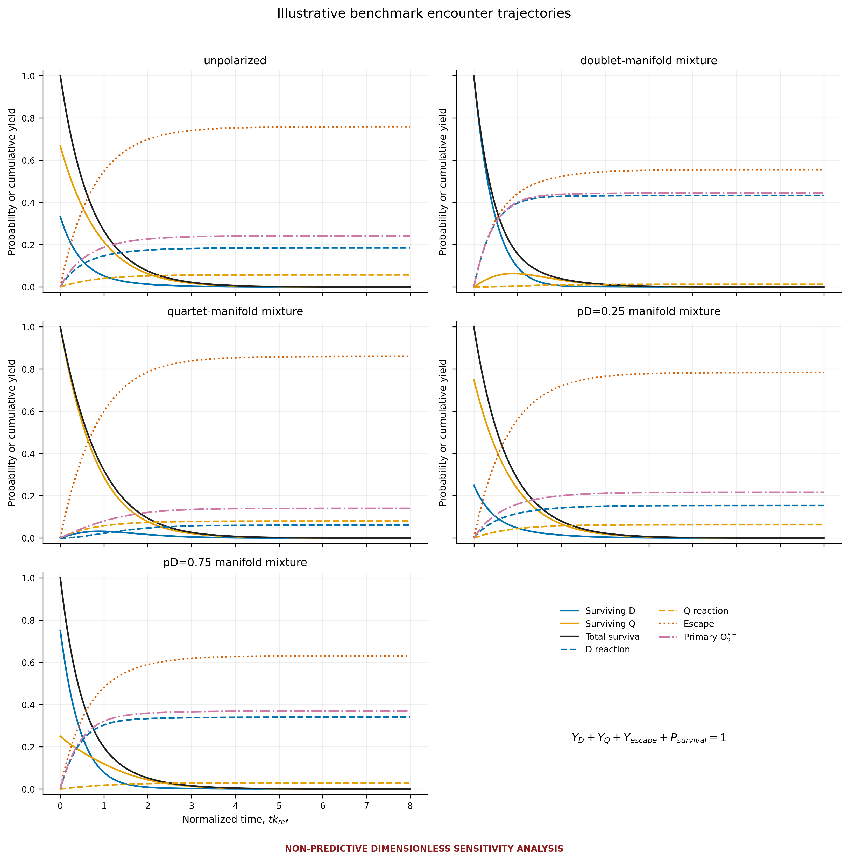
Figure 2 Benchmark Encounter Trajectories. Benchmark encounter trajectories. Surviving doublet and quartet populations, total survival, cumulative doublet and quartet reaction yields, primary-superoxide yield, and escape yield are shown against normalized time for five benchmark mixtures. At every sampled time, YD + YQ + Yescape + Psurvival = 1 within numerical tolerance. The settings kD/kref=1, kQ/kD=0.1, kescape/kref=1, omega_local/kref=1, and gammaR/kref=gammaO/kref=0.1 are illustrative sensitivity coordinates, not measured parameters.
Source data /Users/arjunlingala/Downloads/ROS_Spin/results/paper/data/figure02_benchmark_trajectories.csv Caption /Users/arjunlingala/Downloads/ROS_Spin/results/paper/captions/figure02_benchmark_trajectories_caption.txt

Figure 3 Initial State Comparison
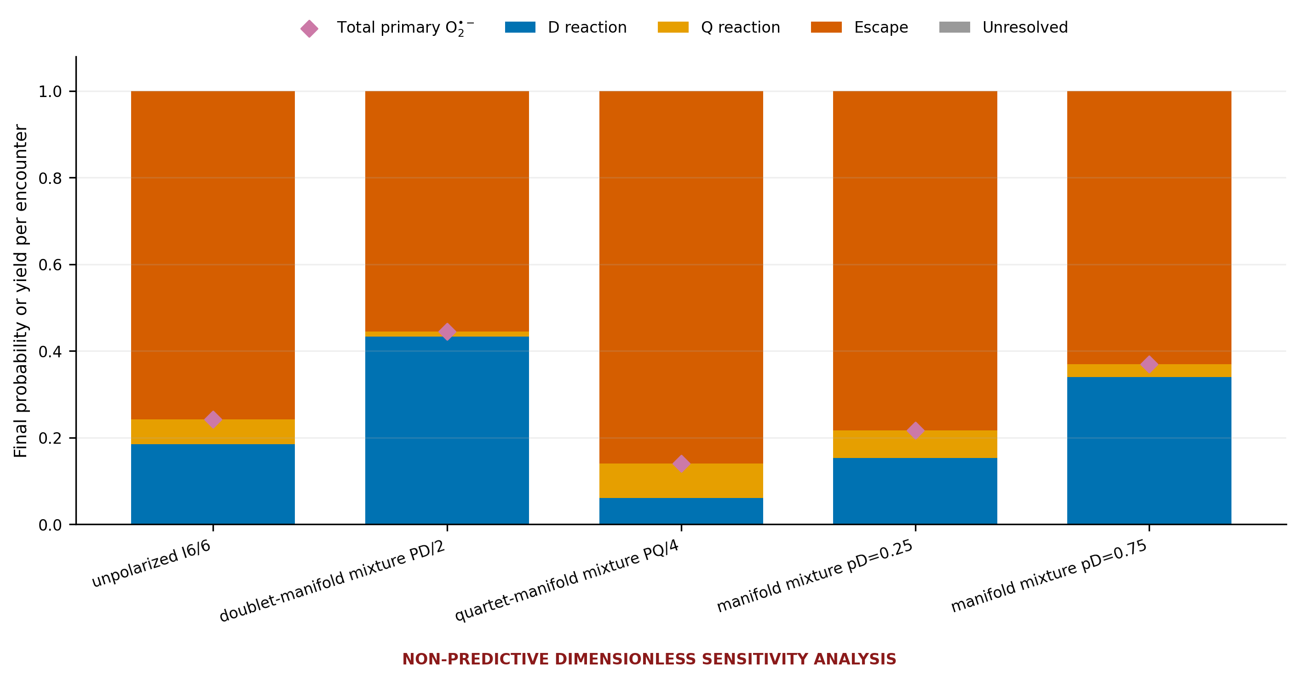
Figure 3 Initial State Comparison. Initial-state comparison. Final reaction, escape, and unresolved survival outcomes are compared for the unpolarized encounter, doublet-manifold benchmark, quartet-manifold benchmark, and pD=0.25 and pD=0.75 mixtures. The doublet and quartet cases are computational limiting benchmarks rather than demonstrated chemically prepared states. Primary superoxide is the sum of integrated D and Q reaction yields, not a final spin population.
Source data /Users/arjunlingala/Downloads/ROS_Spin/results/paper/data/figure03_initial_state_comparison.csv Caption /Users/arjunlingala/Downloads/ROS_Spin/results/paper/captions/figure03_initial_state_comparison_caption.txt

Figures 4 and 5 Timescale Competition
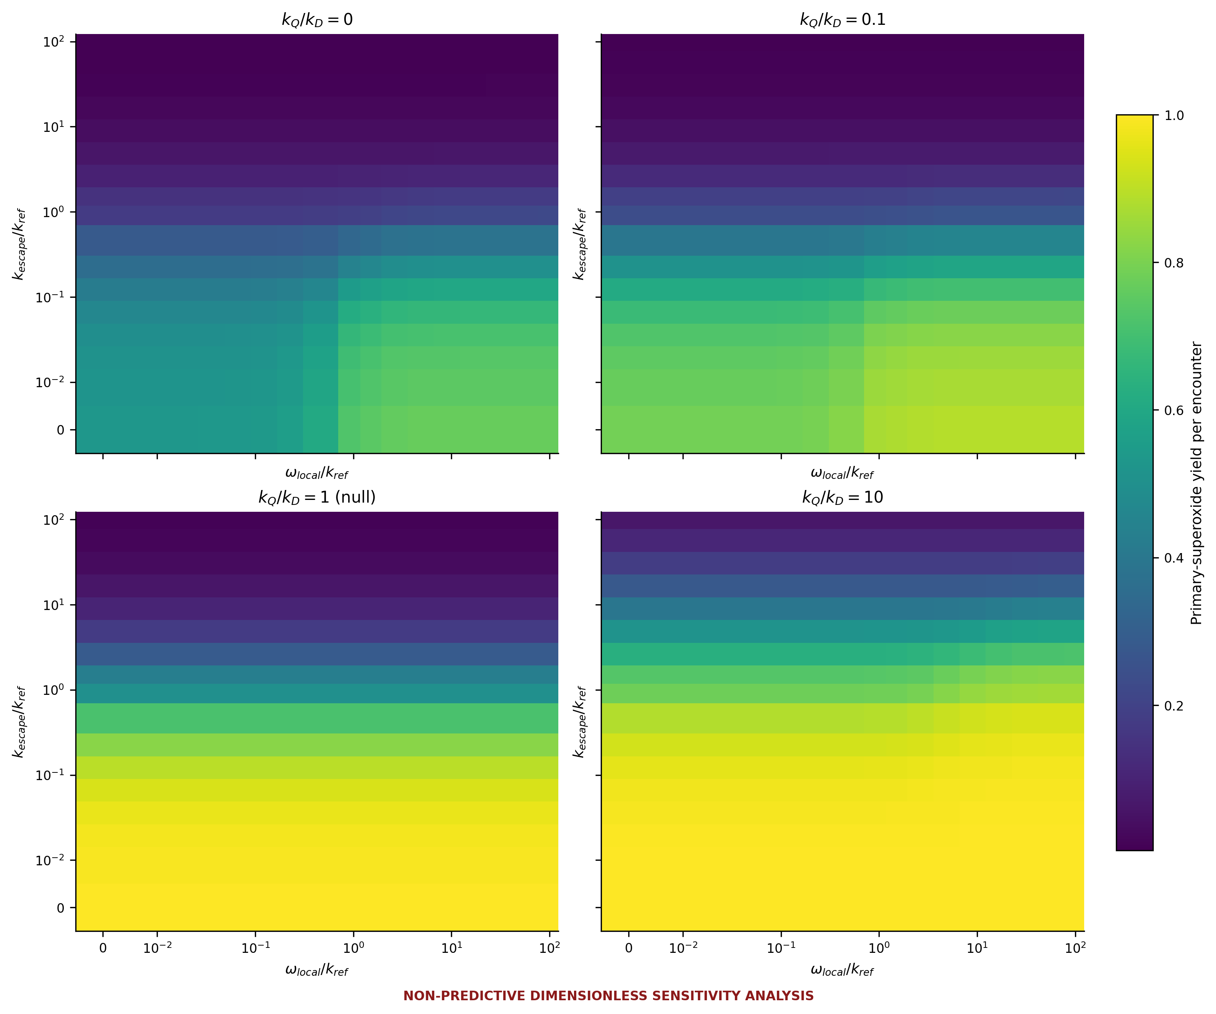
Figure 4 Mixing versus Escape Heatmaps. Mixing-versus-escape heatmaps. Primary-superoxide yield per encounter is calculated over normalized local D/Q mixing and escape rates for kQ/kD=0, 0.1, 1, and 10. The kQ/kD=1 panel is the spin-independent null condition. Zero and logarithmic nonzero coordinates are illustrative; no displayed range is experimentally established.
Source data /Users/arjunlingala/Downloads/ROS_Spin/results/paper/data/figure04_mixing_escape_heatmaps.csv Caption /Users/arjunlingala/Downloads/ROS_Spin/results/paper/captions/figure04_mixing_escape_heatmaps_caption.txt

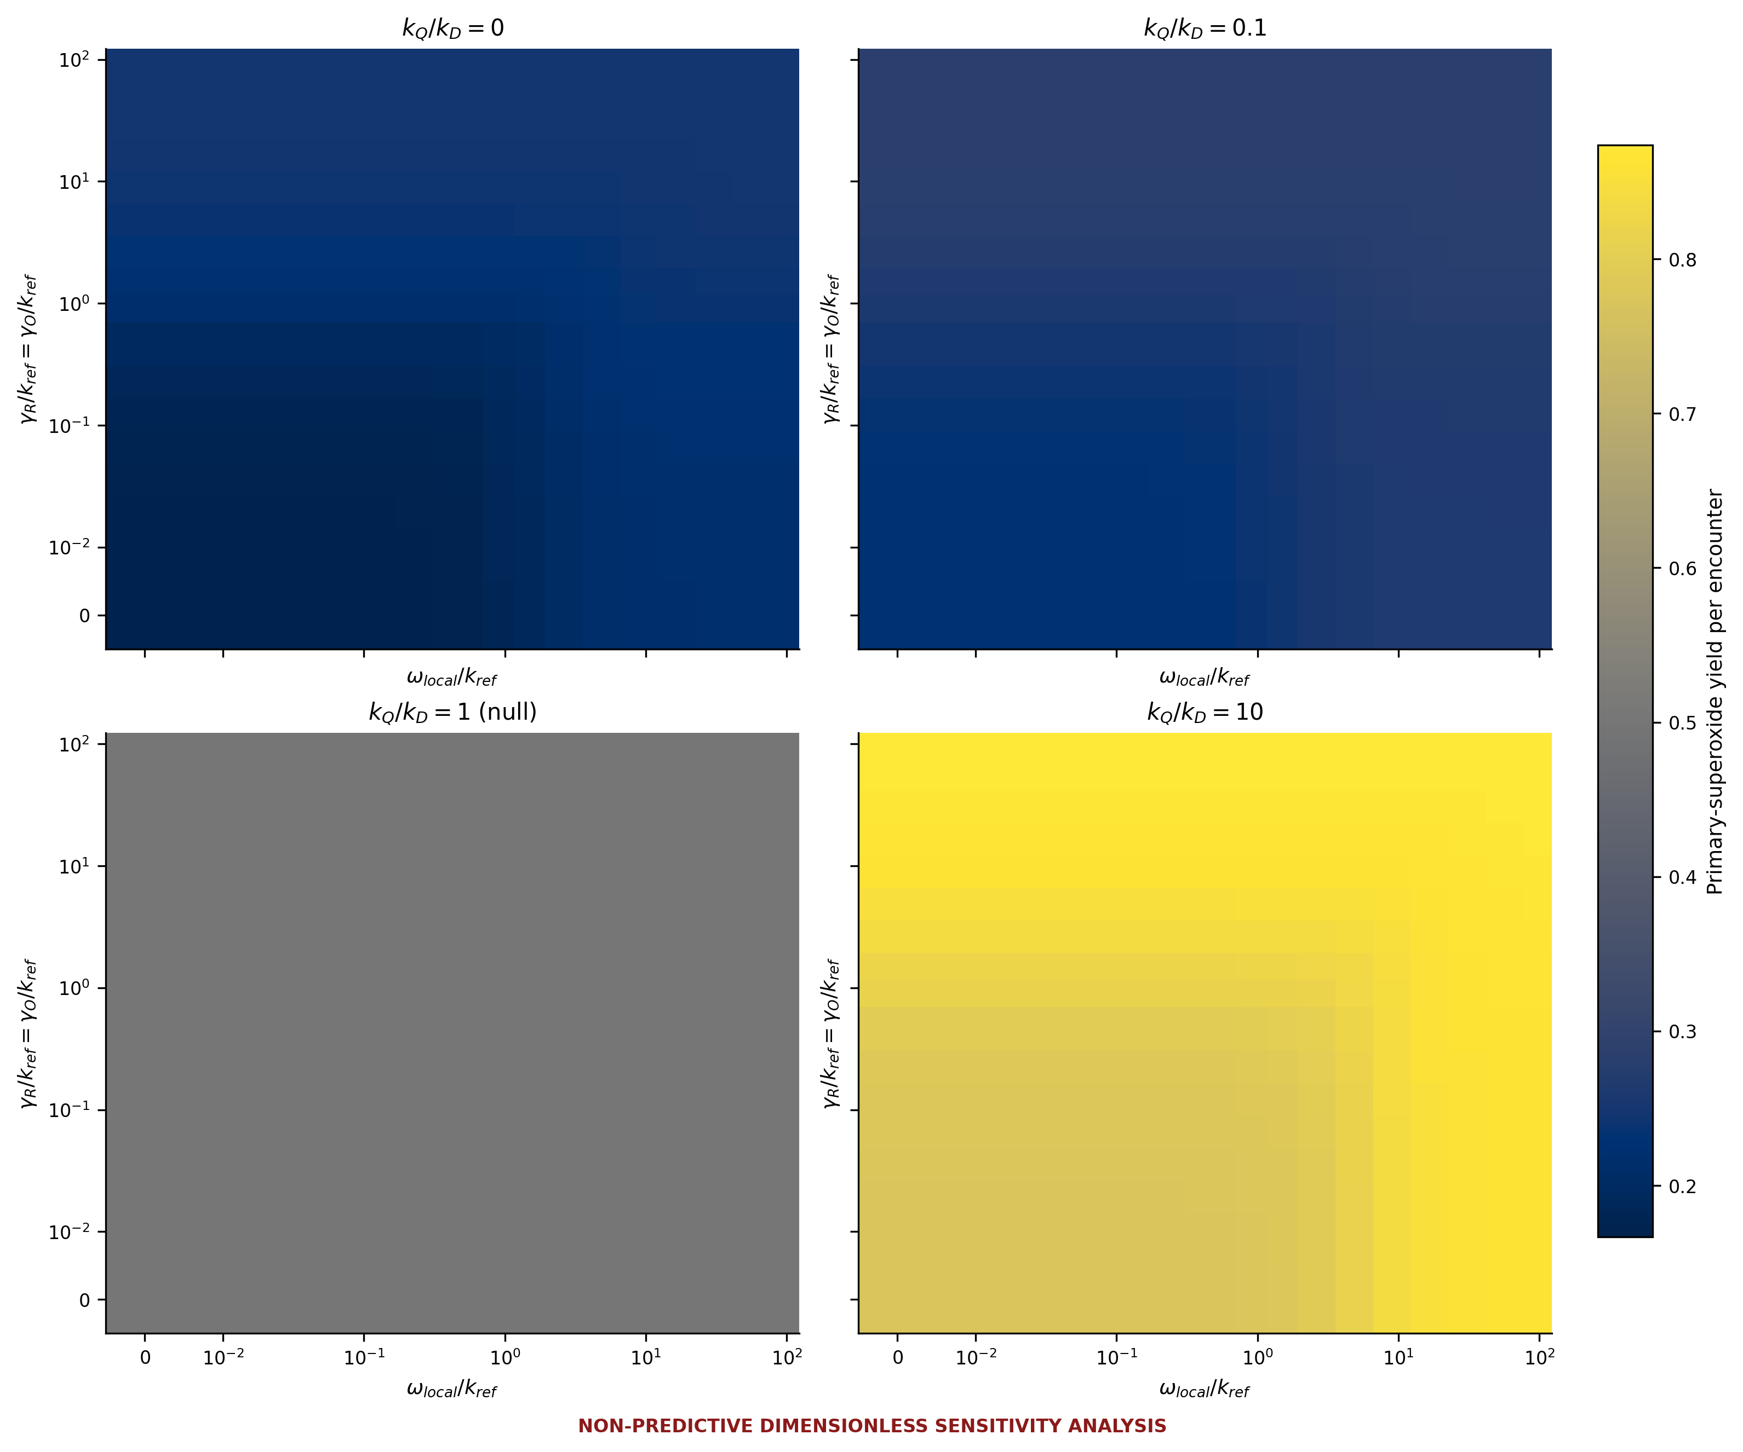
Figure 5 Mixing versus Relaxation Heatmaps. Mixing-versus-relaxation heatmaps. Primary-superoxide yield is calculated for an unpolarized benchmark over normalized local mixing and equal radical/O2 relaxation rates. The fixed settings are kD/kref=1, kescape/kref=1, and duration=8/kref; panels show kQ/kD=0, 0.1, 1, and 10, with equality marked as the spin-independent null. All coordinates are illustrative and non-predictive.
Source data /Users/arjunlingala/Downloads/ROS_Spin/results/paper/data/figure05_mixing_relaxation_heatmaps.csv Caption /Users/arjunlingala/Downloads/ROS_Spin/results/paper/captions/figure05_mixing_relaxation_heatmaps_caption.txt

Figure 6 Reaction Selectivity Sensitivity
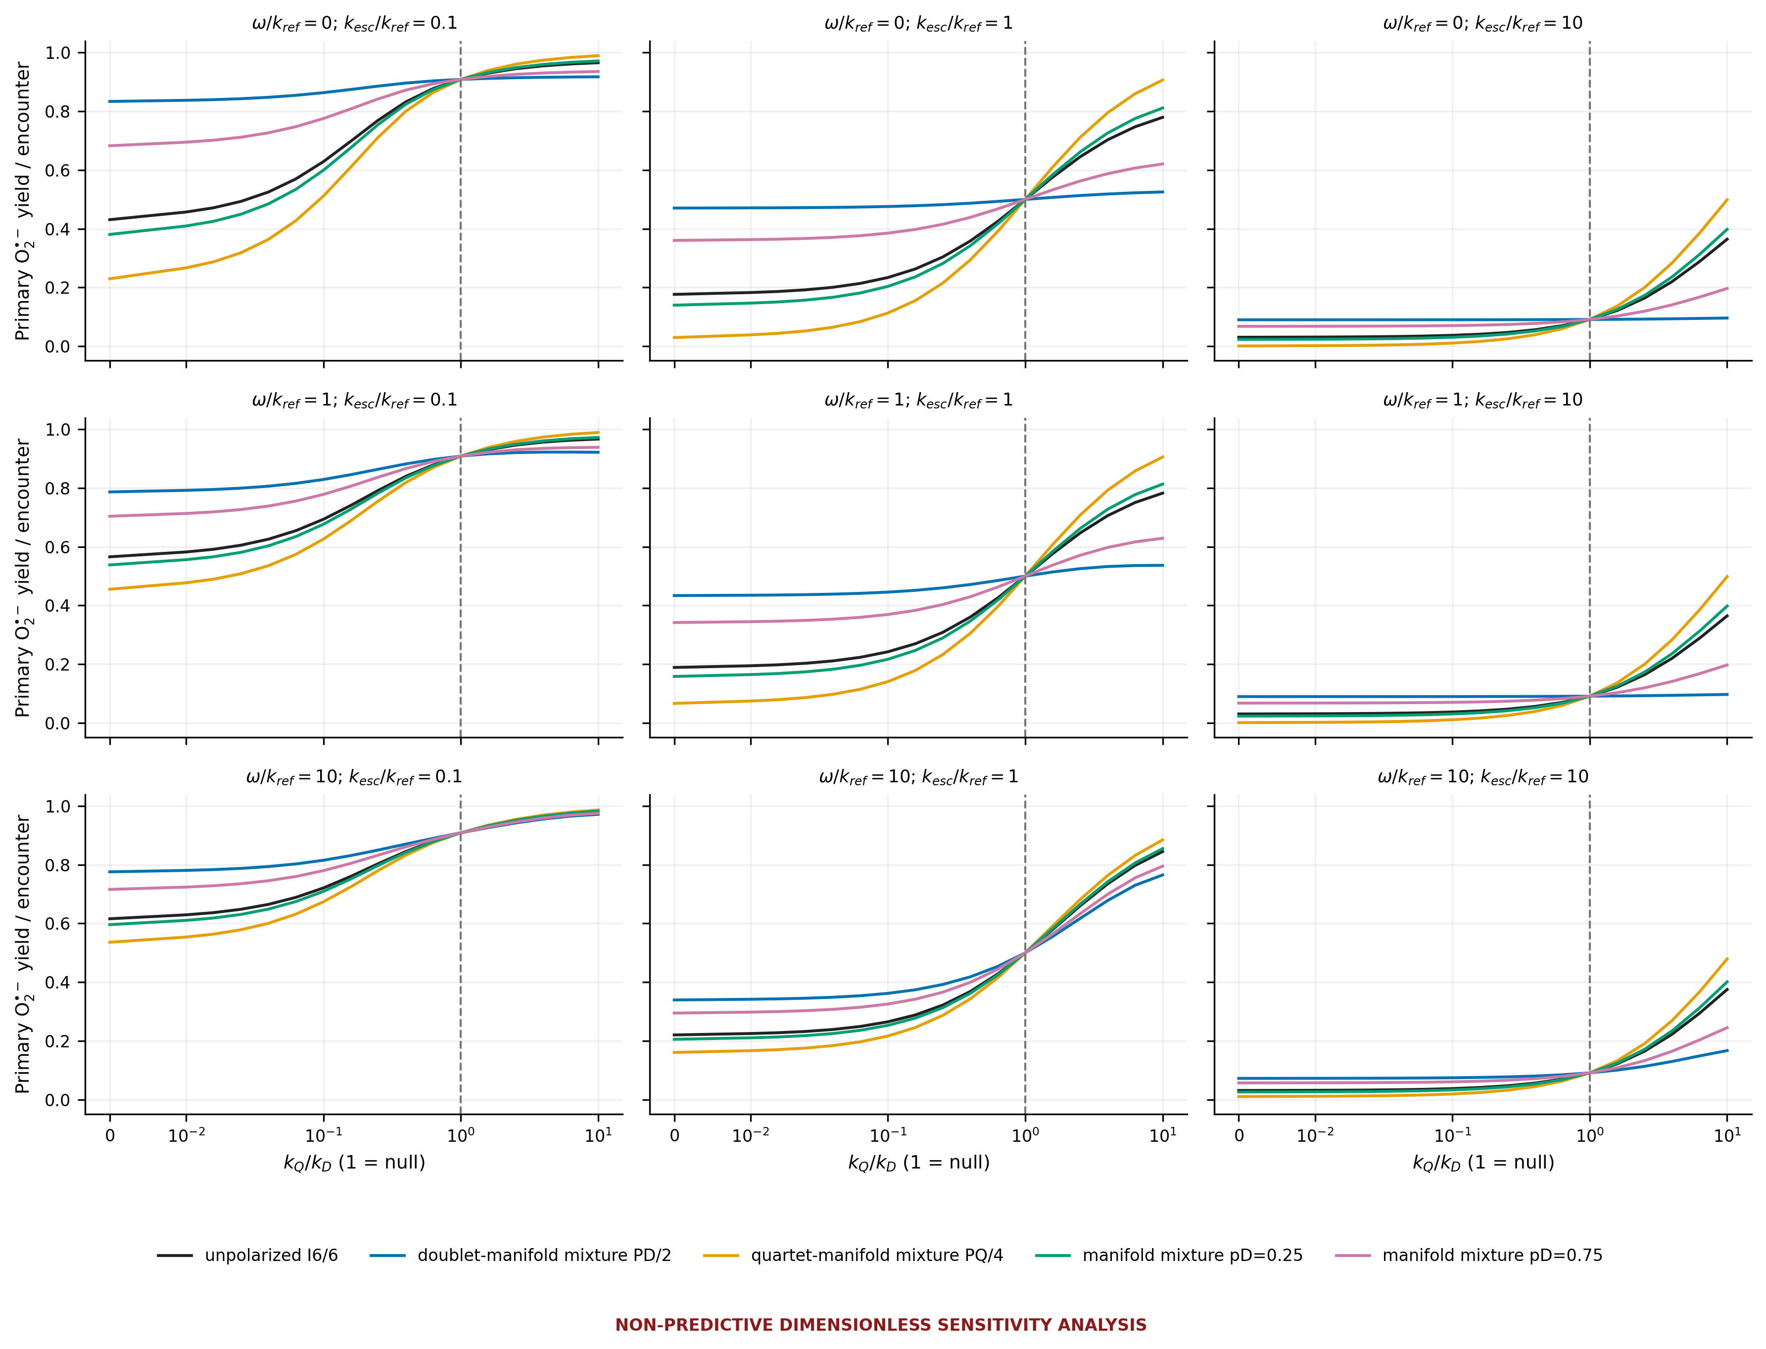
Figure 6 Reaction Selectivity Sensitivity. Reaction-selectivity sensitivity. Primary-superoxide yield is plotted against kQ/kD for unpolarized, doublet, quartet, pD=0.25, and pD=0.75 benchmarks across three mixing and escape settings. The vertical line marks kQ/kD=1 as the spin-independent null. The kQ/kD axis is a sensitivity coordinate, not a measured or chemically defensible probability distribution or physical range.
Source data /Users/arjunlingala/Downloads/ROS_Spin/results/paper/data/figure06_reaction_selectivity.csv Caption /Users/arjunlingala/Downloads/ROS_Spin/results/paper/captions/figure06_reaction_selectivity_caption.txt

Figure 7 Controls
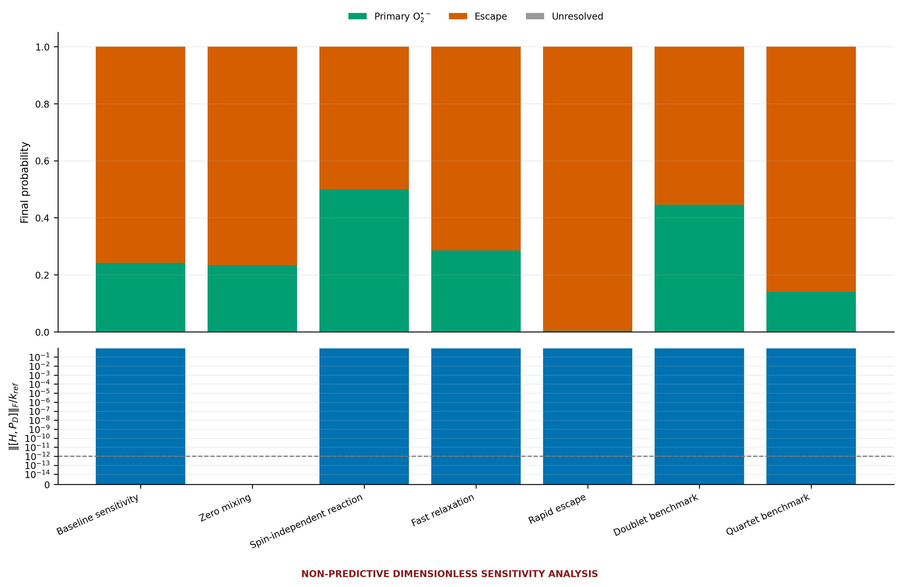
Figure 7 Controls and Limiting Cases. Controls and limiting cases. Baseline sensitivity, zero mixing, kQ=kD spin-independent reaction, fast relaxation, rapid escape, doublet benchmark, and quartet benchmark cases show primary reaction, escape, and unresolved survival. Stacked outcomes make probability accounting visible. All rates and initial-state restrictions are computational controls, not established encounter parameters or preparations.
Source data /Users/arjunlingala/Downloads/ROS_Spin/results/paper/data/figure07_controls.csv Caption /Users/arjunlingala/Downloads/ROS_Spin/results/paper/captions/figure07_controls_caption.txt

Figure 8 Independent Solver Validation
The worst absolute discrepancy between the reference matrix exponential and the separately constructed adaptive Dormand-Prince solver is 1.044e-12. The maximum encounter probability-balance error is 1.318e-13, and the maximum downstream radical-equivalent balance error is 1.694e-21 M. These checks validate numerical consistency rather than physical parameterization.
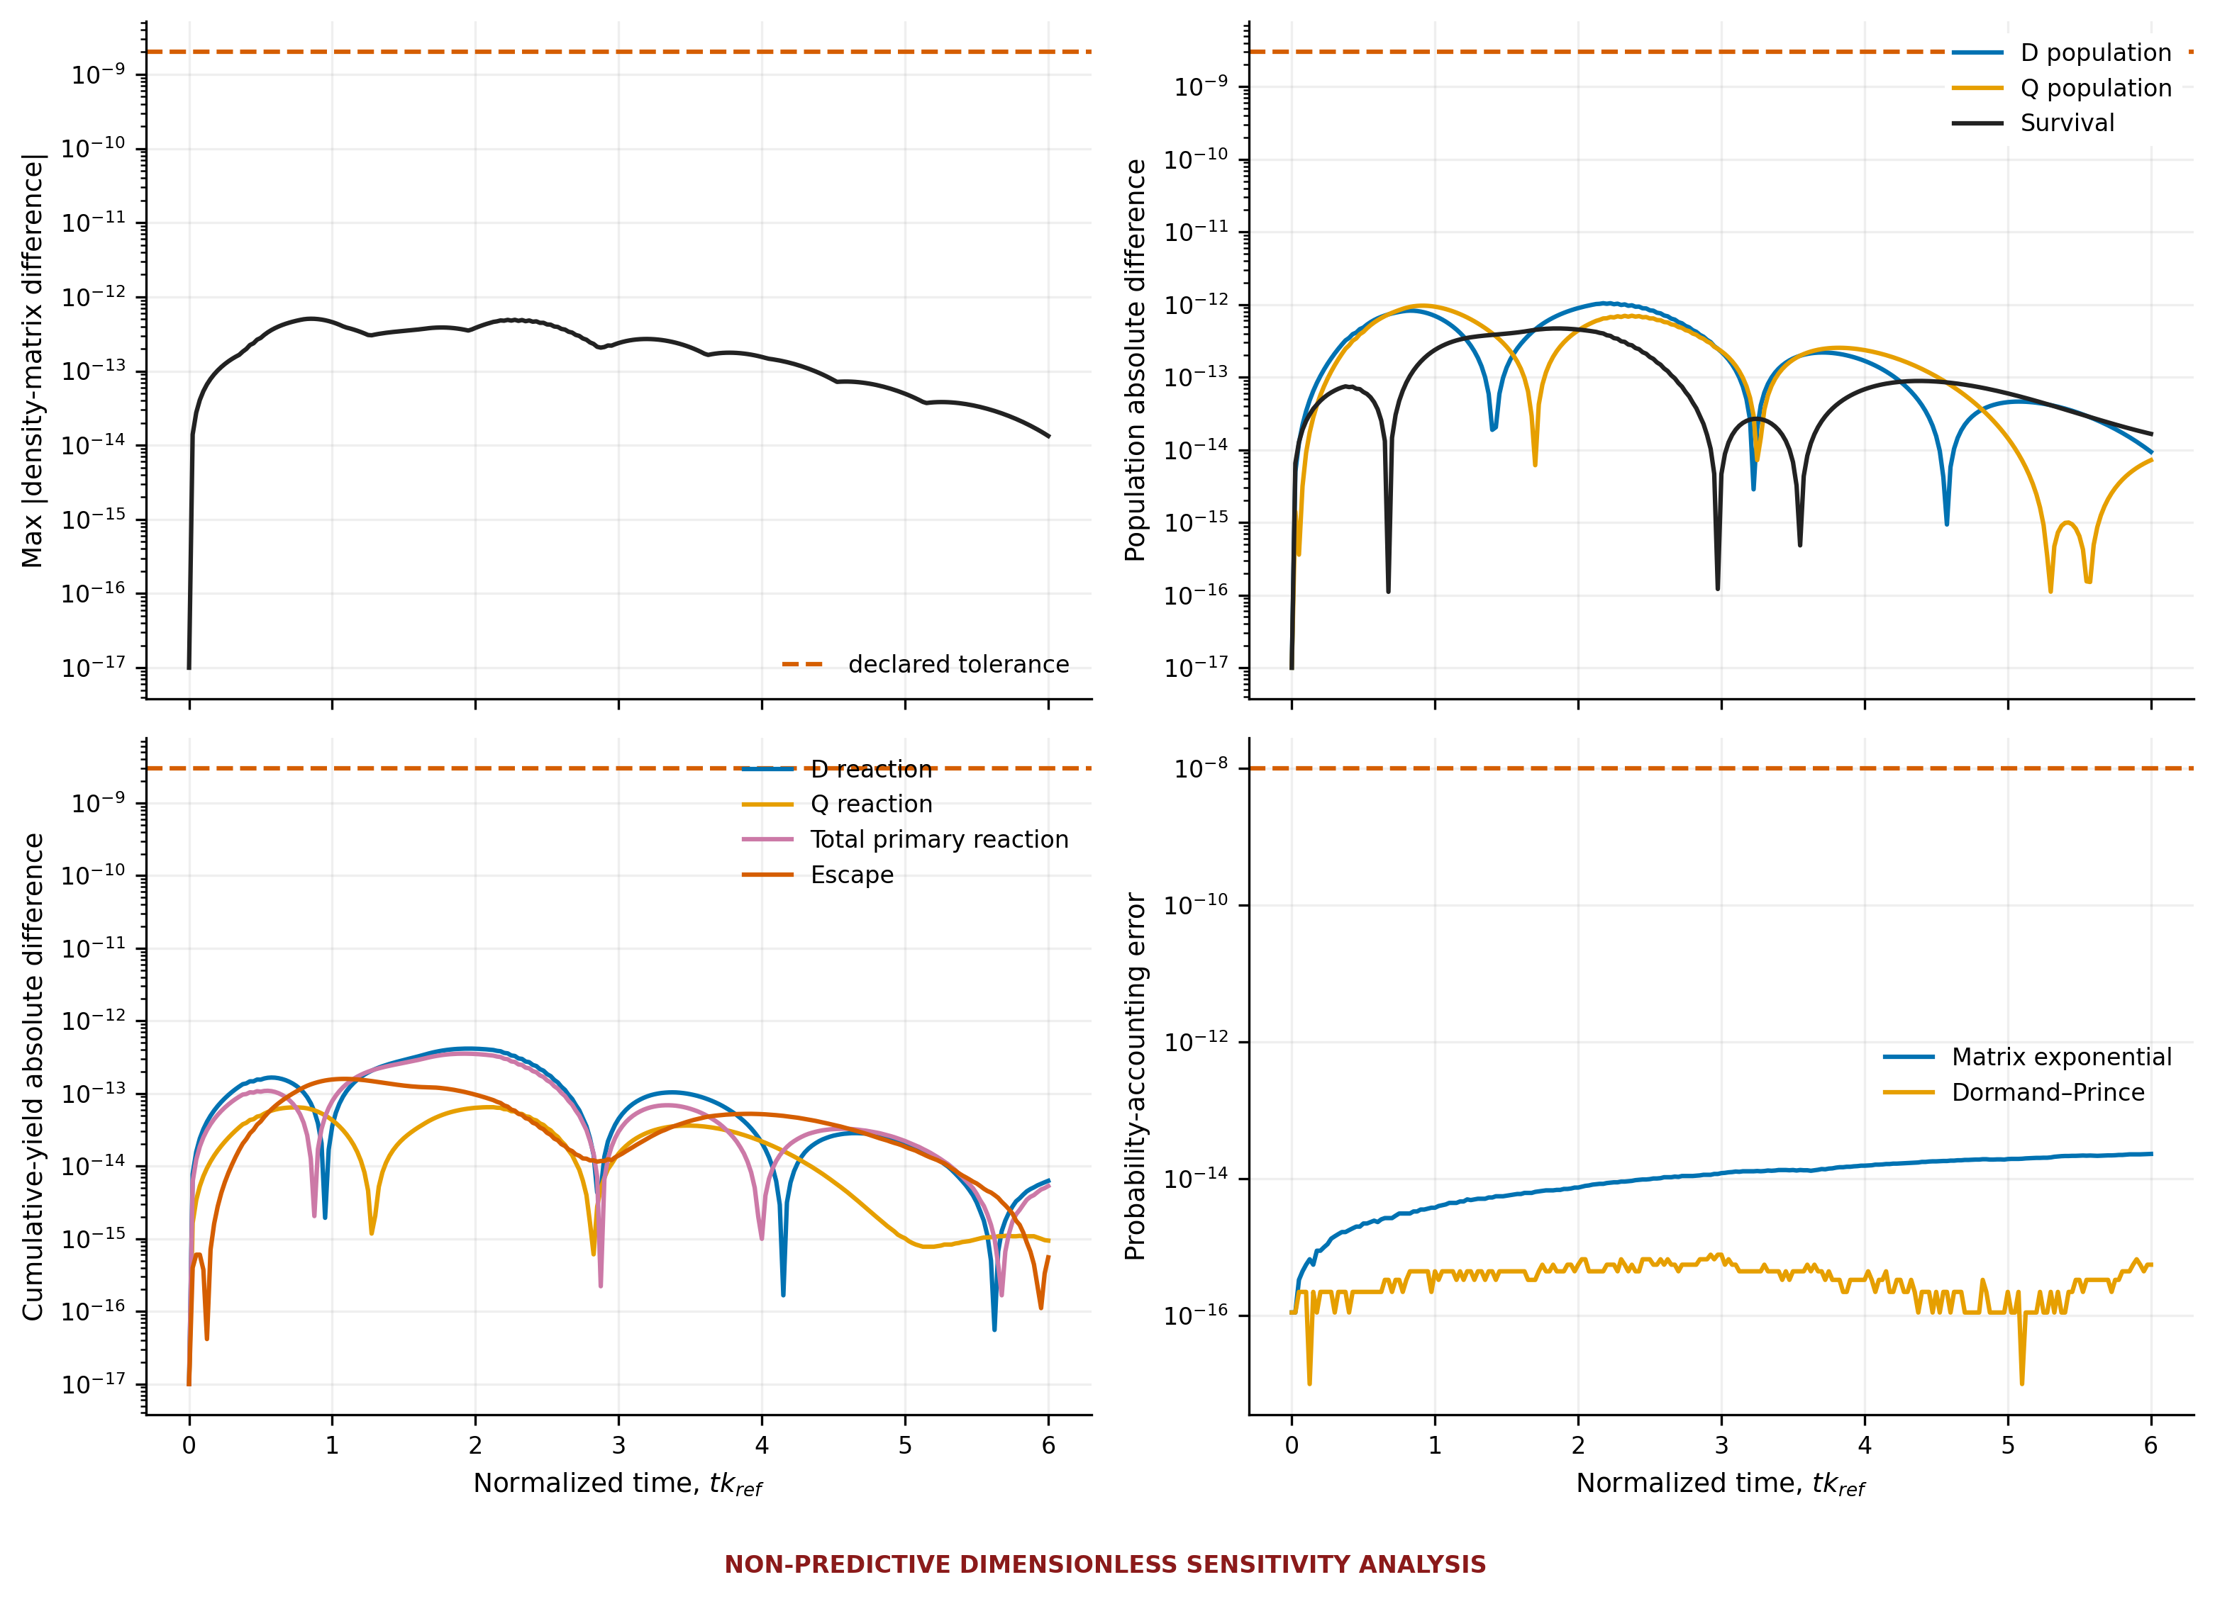
Figure 8 Independent Numerical Validation. Independent numerical validation. A separately constructed adaptive Dormand-Prince 5(4) solver is compared with the constant-generator matrix-exponential reference for full density matrices, doublet and quartet populations, survival, reaction yields, escape yield, and probability balance. Dashed lines show declared tolerances. Agreement validates numerical implementation only, not physical encounter inputs.
Source data /Users/arjunlingala/Downloads/ROS_Spin/results/paper/data/figure08_solver_validation.csv Caption /Users/arjunlingala/Downloads/ROS_Spin/results/paper/captions/figure08_solver_validation_caption.txt

Figure 9 Downstream ROS Kinetics
A distinct fixed-pH model partitions the radical pool between HO2 and O2-minus, applies spontaneous and SOD-mediated dismutation, consumes two radical equivalents per H2O2, and tracks an optional H2O2 loss channel. This stage does not feed an encounter spin population directly into H2O2.
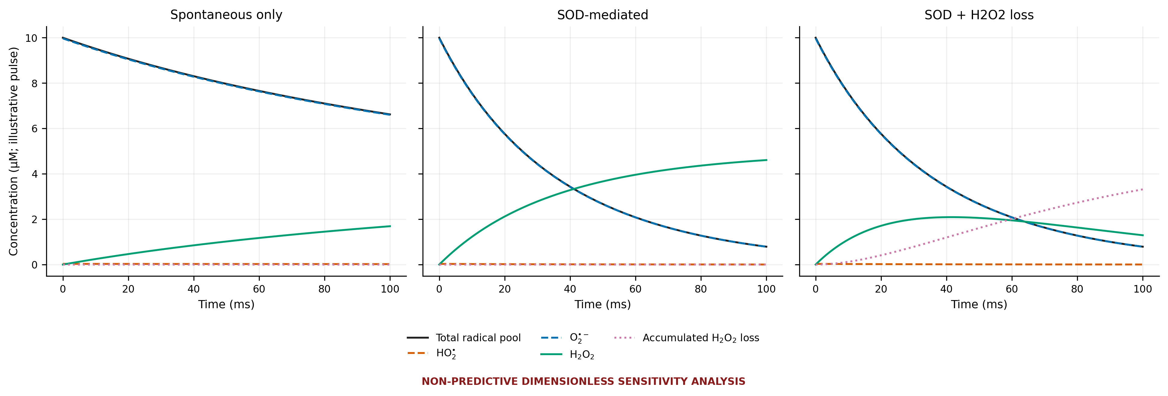
Figure 9 Downstream ROS Kinetics. Downstream ROS kinetics. Total superoxide-family radical pool, HO2, O2-minus, accumulated H2O2, and accumulated H2O2 loss are shown for spontaneous dismutation, SOD-mediated dismutation, and SOD plus H2O2 loss. The calculation starts from an illustrative 10 micromolar single radical pulse at fixed pH 7.4, assumes rapid acid-base equilibrium and constant rates/SOD, and consumes two radical equivalents per H2O2. No spin population is mapped directly to H2O2, and the trajectories are not cellular predictions.
Source data /Users/arjunlingala/Downloads/ROS_Spin/results/paper/data/figure09_downstream_kinetics.csv Caption /Users/arjunlingala/Downloads/ROS_Spin/results/paper/captions/figure09_downstream_kinetics_caption.txt

Figure 10 Primary Source Bulk Rate Context
The plotted literature values remain condition-specific bulk kinetic records. Their units and incomplete conditions prevent their use as encounter-level state-resolved reaction rates.
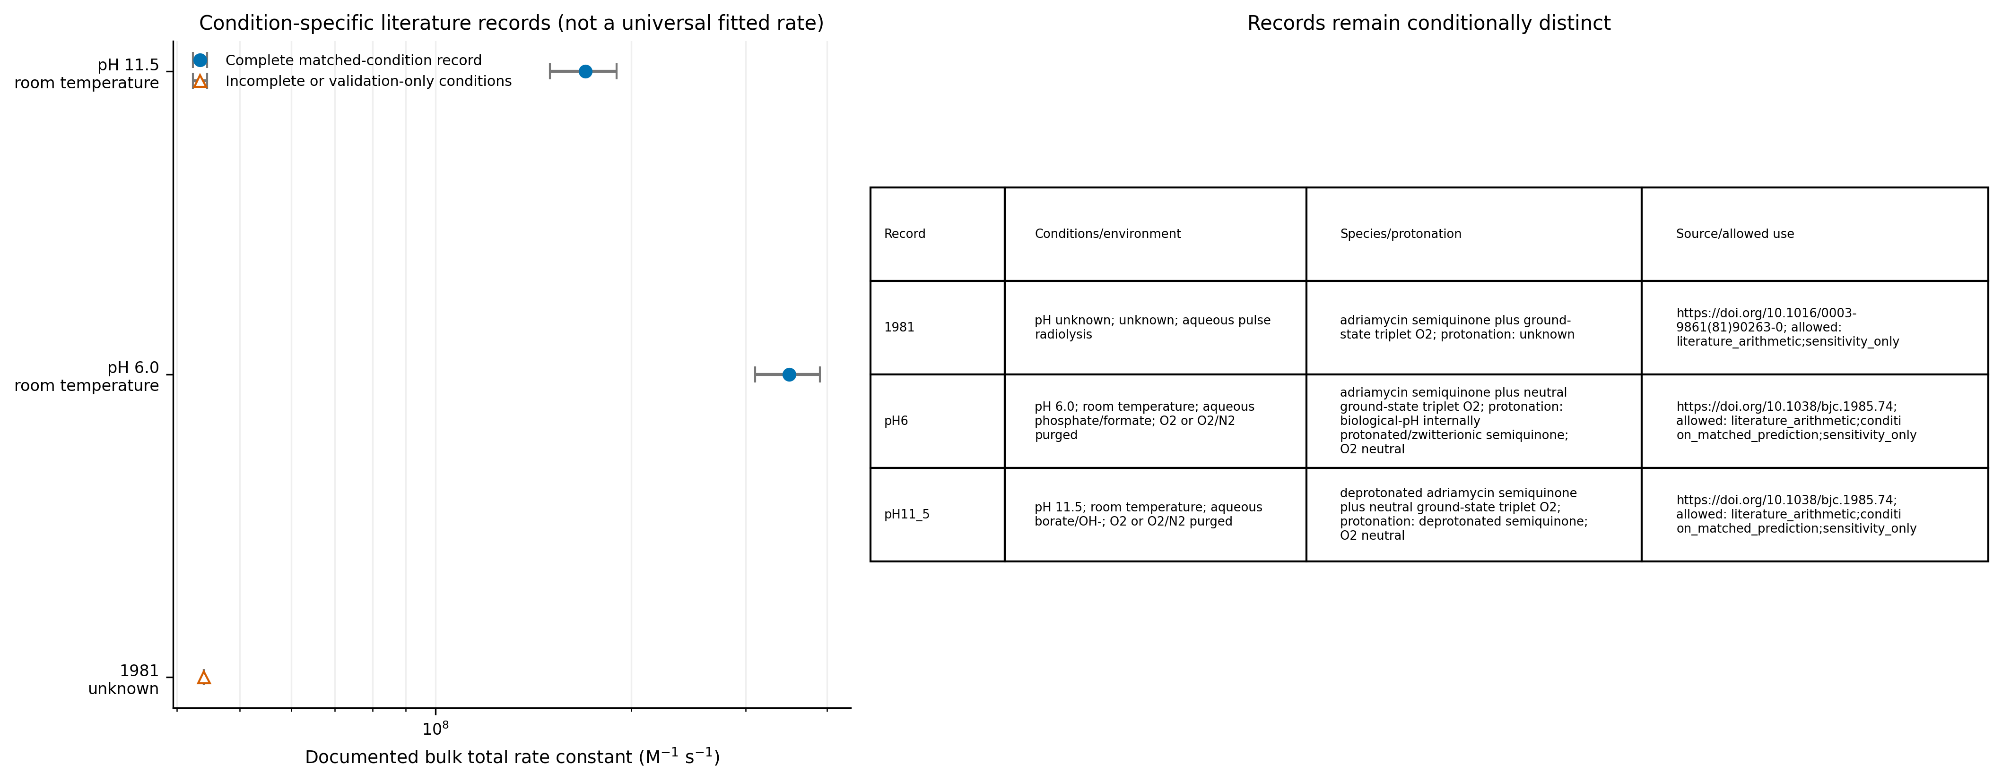
Figure 10 Literature Bulk Rate Comparison. Literature bulk-rate comparison. Actual numerical values stored in the configuration JSON and matched provenance CSV are plotted with reported uncertainty, pH, temperature, environment, species/protonation, method, and source identifiers. Missing conditions remain visibly marked and records are not combined into a universal rate. These M^-1 s^-1 bulk total constants are not encounter-level kD or kQ in s^-1.
Source data /Users/arjunlingala/Downloads/ROS_Spin/results/paper/data/figure10_bulk_rate_comparison.csv Caption /Users/arjunlingala/Downloads/ROS_Spin/results/paper/captions/figure10_bulk_rate_comparison_caption.txt

Figure 11 Circuit Embedding Validation
Circuit status for the recorded run is qiskit_executed. The three-qubit calculation embeds the six physical states within an eight-state space, checks the two unused states for leakage, and compares statevectors and doublet/quartet observables. It validates coherent encoding consistency only; it does not demonstrate quantum advantage or independently validate the chemistry.
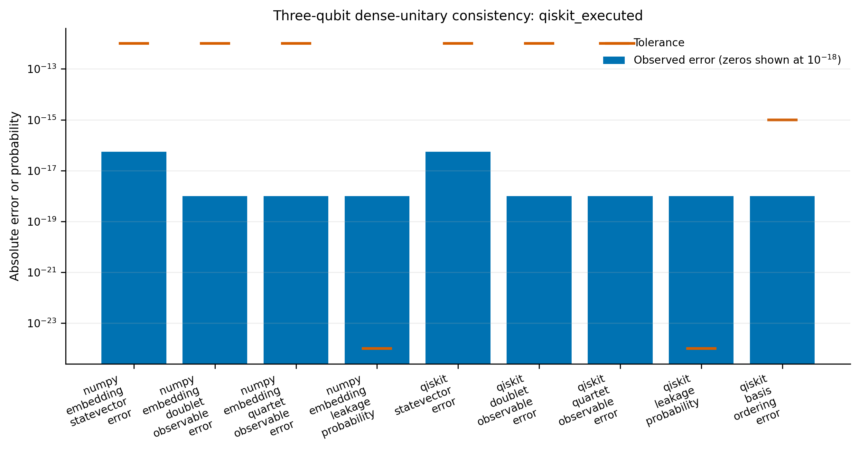
Figure 11 Three Qubit Coherent Embedding Validation. Three-qubit coherent-embedding validation. The six-state coherent reference unitary is compared with its eight-state three-qubit embedding and, when requested and available, actual Qiskit statevector execution. Statevector, doublet and quartet observable, basis-ordering, and unused-state leakage errors are compared with declared tolerances. This validates coherent simulator and encoding consistency only; it does not validate reaction, relaxation, escape, downstream chemistry, hardware performance, or quantum advantage.
Source data /Users/arjunlingala/Downloads/ROS_Spin/results/paper/data/figure11_circuit_validation.csv Caption /Users/arjunlingala/Downloads/ROS_Spin/results/paper/captions/figure11_circuit_validation_caption.txt

Baseline and Control Tables
Tables 4-7 report the generated baseline, controls, independent-solver errors, and coherent-embedding metrics. All numeric cells are populated from their CSV sources.

Table 4 Baseline Results
Initial state | Initial pD | D reaction | Q reaction | Primary superoxide | Escape | Survival | Balance
unpolarized I6/6 | 0.33333333333333337 | 0.1848290544320762 | 0.05729985974754856 | 0.24212891417962476 | 0.757827651907562 | 4.343391281261024e-05 | 0.9999999999999993
doublet-manifold mixture PD/2 | 0.9999999999999999 | 0.4333861334320349 | 0.012110102986419376 | 0.4454962364184543 | 0.5544871632962286 | 1.6600285316311623e-05 | 0.9999999999999993
quartet-manifold mixture PQ/4 | -1.008102552748629e-17 | 0.060550514932096816 | 0.07989473812811315 | 0.14044525306020997 | 0.8594978962132286 | 5.685072656075954e-05 | 0.9999999999999993
manifold mixture pD=0.25 | 0.24999999999999994 | 0.15375941955708133 | 0.06294857934268971 | 0.21670799889977105 | 0.7832452129839784 | 4.678811624964756e-05 | 0.9999999999999992
manifold mixture pD=0.75 | 0.7499999999999999 | 0.34017722880705037 | 0.029056261771842826 | 0.3692334905788932 | 0.6307398465254785 | 2.6662895627423608e-05 | 0.9999999999999992

Generated CSV source /Users/arjunlingala/Downloads/ROS_Spin/results/paper/tables/table04_baseline_results.csv

Table 5 Controls and Extrema
Type | Source | Control | Initial state | Mixing/kref | Relaxation/kref | Escape/kref | kQ/kD | Primary superoxide | Escape yield | Survival
control | figure07_controls | Baseline sensitivity |  |  |  |  |  | 0.24212891417962476 | 0.757827651907562 | 4.343391281261024e-05
control | figure07_controls | Zero mixing |  |  |  |  |  | 0.2338612039677051 | 0.7660670883725904 | 7.170765970365598e-05
control | figure07_controls | Spin-independent reaction |  |  |  |  |  | 0.4999999437324118 | 0.49999994373241186 | 1.1253517471925926e-07
control | figure07_controls | Fast relaxation |  |  |  |  |  | 0.285254760496954 | 0.714731466709809 | 1.3772793160686254e-05
control | figure07_controls | Rapid escape |  |  |  |  |  | 0.003966367009909883 | 0.9960336329900332 | 0.0
control | figure07_controls | Doublet benchmark |  |  |  |  |  | 0.4454962364184543 | 0.5544871632962286 | 1.6600285316311623e-05
control | figure07_controls | Quartet benchmark |  |  |  |  |  | 0.14044525306020997 | 0.8594978962132286 | 5.685072656075954e-05
selected_grid_minimum | figure04_mixing_escape_heatmaps |  | unpolarized I6/6 | 0.0 | 0.1 | 100.0 | 0.0 | 0.0033003735153258 | 0.9966996264846175 | 0.0
selected_grid_maximum | figure04_mixing_escape_heatmaps |  | unpolarized I6/6 | 15.848931924611142 | 0.1 | 0.0 | 10.0 | 0.9999999999999905 | 0.0 | 2.513571360957245e-15
selected_grid_minimum | figure05_mixing_relaxation_heatmaps |  | unpolarized I6/6 | 0.0 | 0.0 | 1.0 | 0.0 | 0.1666666479108041 | 0.8331096728255349 | 0.000223679263659914
selected_grid_maximum | figure05_mixing_relaxation_heatmaps |  | unpolarized I6/6 | 100.0 | 100.0 | 1.0 | 10.0 | 0.8737914889921969 | 0.1262085110076903 | 3.014601656113909e-28
selected_grid_minimum | figure06_reaction_selectivity |  | quartet-manifold mixture PQ/4 | 0.0 | 0.1 | 10.0 | 0.0 | 0.0005948839976204568 | 0.9994051160023725 | 1.1921979225581182e-35
selected_grid_maximum | figure06_reaction_selectivity |  | quartet-manifold mixture PQ/4 | 0.0 | 0.1 | 0.1 | 10.0 | 0.9896245364115824 | 0.01037506762991176 | 3.959585024229424e-07

Generated CSV source /Users/arjunlingala/Downloads/ROS_Spin/results/paper/tables/table05_controls_and_extrema.csv

Table 6 Independent Solver Validation
Observable | Worst absolute error | Worst relative error | Tolerance | Pass | Reference solver | Independent solver | Scope
density_matrix | 5.07316411303867e-13 | 1.8731682878912015e-12 | 2e-09 | True | constant-generator matrix exponential Pade(13) | independent adaptive Dormand-Prince RK5(4) | numerical implementation agreement, not physical validation
doublet_population | 1.044438840969164e-12 | 1.044438840969164e-12 | 3e-09 | True | constant-generator matrix exponential Pade(13) | independent adaptive Dormand-Prince RK5(4) | numerical implementation agreement, not physical validation
quartet_population | 9.652834087603424e-13 | 9.652834087603424e-13 | 3e-09 | True | constant-generator matrix exponential Pade(13) | independent adaptive Dormand-Prince RK5(4) | numerical implementation agreement, not physical validation
survival | 4.69416172599324e-13 | 4.694161725993241e-13 | 3e-09 | True | constant-generator matrix exponential Pade(13) | independent adaptive Dormand-Prince RK5(4) | numerical implementation agreement, not physical validation
doublet_reaction_yield | 4.1511238890734603e-13 | 4.1511238890734603e-13 | 3e-09 | True | constant-generator matrix exponential Pade(13) | independent adaptive Dormand-Prince RK5(4) | numerical implementation agreement, not physical validation
quartet_reaction_yield | 6.47953912746857e-14 | 6.47953912746857e-14 | 3e-09 | True | constant-generator matrix exponential Pade(13) | independent adaptive Dormand-Prince RK5(4) | numerical implementation agreement, not physical validation
primary_superoxide_yield | 3.536615444943436e-13 | 3.536615444943436e-13 | 3e-09 | True | constant-generator matrix exponential Pade(13) | independent adaptive Dormand-Prince RK5(4) | numerical implementation agreement, not physical validation
escape_yield | 1.5892842597509116e-13 | 1.5892842597509116e-13 | 3e-09 | True | constant-generator matrix exponential Pade(13) | independent adaptive Dormand-Prince RK5(4) | numerical implementation agreement, not physical validation
reference_probability_accounting | 2.3092638912203256e-14 | 2.3092638912203256e-14 | 1e-08 | True | constant-generator matrix exponential Pade(13) | independent adaptive Dormand-Prince RK5(4) | numerical implementation agreement, not physical validation
independent_probability_accounting | 7.771561172376096e-16 | 7.771561172376096e-16 | 1e-08 | True | constant-generator matrix exponential Pade(13) | independent adaptive Dormand-Prince RK5(4) | numerical implementation agreement, not physical validation

Generated CSV source /Users/arjunlingala/Downloads/ROS_Spin/results/paper/tables/table06_independent_solver_validation.csv

Table 7 Circuit Validation

Table 7A Numerical metrics
Metric | Layer | Value | Tolerance | Pass
numpy_embedding_statevector_error | NumPy embedding | 5.551115123125783e-17 | 1e-12 | True
numpy_embedding_doublet_observable_error | NumPy embedding | 0.0 | 1e-12 | True
numpy_embedding_quartet_observable_error | NumPy embedding | 0.0 | 1e-12 | True
numpy_embedding_leakage_probability | NumPy embedding | 0.0 | 1e-24 | True
qiskit_statevector_error | Qiskit | 5.551115123125783e-17 | 1e-12 | True
qiskit_doublet_observable_error | Qiskit | 0.0 | 1e-12 | True
qiskit_quartet_observable_error | Qiskit | 0.0 | 1e-12 | True
qiskit_leakage_probability | Qiskit | 0.0 | 1e-24 | True
qiskit_basis_ordering_error | Qiskit | 0.0 | 1e-15 | True

Table 7B Execution status and scope
Metric | Qiskit available | Execution | Implementation | Scope | Reason
numpy_embedding_statevector_error | True | executed | one inserted dense 8x8 UnitaryGate; not decomposed gates | closed coherent simulator and encoding consistency only
numpy_embedding_doublet_observable_error | True | executed | one inserted dense 8x8 UnitaryGate; not decomposed gates | closed coherent simulator and encoding consistency only
numpy_embedding_quartet_observable_error | True | executed | one inserted dense 8x8 UnitaryGate; not decomposed gates | closed coherent simulator and encoding consistency only
numpy_embedding_leakage_probability | True | executed | one inserted dense 8x8 UnitaryGate; not decomposed gates | closed coherent simulator and encoding consistency only
qiskit_statevector_error | True | executed | one inserted dense 8x8 UnitaryGate; not decomposed gates | closed coherent simulator and encoding consistency only
qiskit_doublet_observable_error | True | executed | one inserted dense 8x8 UnitaryGate; not decomposed gates | closed coherent simulator and encoding consistency only
qiskit_quartet_observable_error | True | executed | one inserted dense 8x8 UnitaryGate; not decomposed gates | closed coherent simulator and encoding consistency only
qiskit_leakage_probability | True | executed | one inserted dense 8x8 UnitaryGate; not decomposed gates | closed coherent simulator and encoding consistency only
qiskit_basis_ordering_error | True | executed | one inserted dense 8x8 UnitaryGate; not decomposed gates | closed coherent simulator and encoding consistency only

Generated CSV source /Users/arjunlingala/Downloads/ROS_Spin/results/paper/tables/table07_circuit_validation.csv

Table 2 Parameter Provenance
The table is split into two aligned panels for print legibility. The symbol column links the panels; the generated CSV preserves the complete row schema.

Table 2A Identity conditions and value
Symbol | Definition | Value or range | Unit | Exact species | Charge or protonation | Environment | Temperature | pH
g_SQ | isotropic doxorubicin semiquinone g value | 2.0035 | dimensionless | doxorubicin semiquinone | protonation/formal charge not assigned | N2-purged 100 mM phosphate; 100 uM doxorubicin; 400 uM xanthine; 0.2 U xanthine oxidase in 2 mL | not reported | 7.5
deltaHpp_SQ | peak-to-peak aqueous one-line width | 3.25 | G | doxorubicin semiquinone | protonation/formal charge not assigned | N2-purged 100 mM phosphate; 100 uM doxorubicin; 400 uM xanthine; 0.2 U xanthine oxidase in 2 mL | not reported | 7.5
deltaHpp_SQ_replication | independent aqueous one-line width | 3.2 | G | doxorubicin semiquinone | protonation/formal charge not assigned | hypoxic 50 mM Tris; 1 mM doxorubicin; 400 uM hypoxanthine; 0.1 U/mL xanthine oxidase | 310 K | 7.4
A_SQ | resolved doxorubicin/adriamycin semiquinone hyperfine values | numeric extraction unavailable | not available | adriamycin semiquinone | not reported in accessible abstract | not reported in accessible abstract | not reported in accessible abstract | not reported in accessible abstract
lambda_0 | gas-phase O2 spin-spin fine-structure constant | 1.9847530 | cm^-1 | 16O2 X3Sigma_g- v=0 | neutral | gas phase | not extracted | pH not applicable
gamma_0 | gas-phase O2 spin-rotation constant | -8.42930e-3 | cm^-1 | 16O2 X3Sigma_g- v=0 | neutral | gas phase | not extracted | pH not applicable
D_O2_gas | axial D from D=2 lambda convention conversion | 3.969506 | cm^-1 | 16O2 X3Sigma_g- v=0 | neutral | gas phase | not extracted | pH not applicable
D_O2_solid_air | axial matrix O2 zero-field splitting | 3.572(3) | cm^-1 | ground-state O2 | neutral | solid air condensed in waveguide | 5 K | pH not applicable
D_O2_N2_matrix | O2 zero-field splitting in solid nitrogen | 3.497 | cm^-1 | ground-state O2 | neutral | O2 diluted in solid N2 | 15 K | pH not applicable
T1_O2_solution | bulk dissolved oxygen electron spin-lattice relaxation | approximately 7.5 | ps | ground-state O2 | neutral | water; 1:1 water/glycerol; cyclohexane; methanol; benzene; acetone; acetonitrile; DMSO | room temperature | not reported/not applicable
K_O2_T4L | O2 association constant in T4 lysozyme L99A cavities | 48 | M^-1 | ground-state O2 | neutral | T4 lysozyme L99A; 50 mM phosphate; 25 mM NaCl | 298 K | 5.5
tau_rot_O2_T4L | O2 rotational correlation components | 0.164;1.41 | ps | ground-state O2 | neutral | T4 lysozyme L99A cavities; 50 mM phosphate; 25 mM NaCl | 298 K | 5.5
g_D_E_O2_encounter | O2 g and ZFS tensors in transient doxorubicin-semiquinone/O2 encounter | unavailable | not available | ground-state O2 | neutral | doxorubicin-semiquinone solution encounter | unavailable | unavailable
T1_T2_Tm_SQ | doxorubicin or close anthracycline semiquinone electron-spin relaxation/dephasing | unavailable | s | doxorubicin semiquinone | unresolved | chemically relevant solution | unavailable | unavailable
k_O2_total_pH6 | total bulk semiquinone oxidation by O2 | 3.5e8 | M^-1 s^-1 | adriamycin semiquinone plus ground-state O2 | biological-pH semiquinone described as internally protonated/zwitterionic; O2 neutral | aqueous phosphate/formate system; O2 or O2/N2 purge at least 30 min | room temperature | 6.0
k_O2_total_pH11_5 | total bulk semiquinone oxidation by O2 | 1.7e8 | M^-1 s^-1 | adriamycin semiquinone plus ground-state O2 | deprotonated semiquinone form; O2 neutral | aqueous borate/OH- system; O2 or O2/N2 purge at least 30 min | room temperature | 11.5
k_O2_total_1981 | earlier total bulk semiquinone oxidation by O2 | 4.4e7 | M^-1 s^-1 | adriamycin semiquinone plus O2 | not reported in accessible source | aqueous buffer | not reported in accessible source | not reported in accessible source
t_half_SQ_anaerobic | semiquinone chemical half-life | 50 | us | adriamycin semiquinone | not reported in accessible source | anaerobic aqueous medium | not reported in accessible source | not reported in accessible source
diffusion_distance_SQ | author-calculated bulk travel bounds | <0.6 anaerobic;<0.1 air-saturated | um | adriamycin semiquinone | not reported in accessible source | aqueous buffer | not reported in accessible source | not reported in accessible source
encounter_geometry_J_D_kassoc_ksep | separation; orientation; exchange; dipolar; association/separation; cage duration | unavailable | not available | doxorubicin-semiquinone/O2 encounter | unresolved | chemically relevant solution | unavailable | unavailable
DQ_coherence | direct spin-correlated coherent D/Q encounter evidence | unavailable | not available | doxorubicin-semiquinone/O2 encounter | unresolved | chemically relevant solution | unavailable | unavailable
k_D | doublet encounter electron-transfer rate | unavailable | s^-1 | doublet doxorubicin-semiquinone/O2 encounter | unresolved | chemically relevant solution | unavailable | unavailable
k_Q | quartet encounter electron-transfer rate | unavailable | s^-1 | quartet doxorubicin-semiquinone/O2 encounter | unresolved | chemically relevant solution | unavailable | unavailable
k_Q_over_k_D | quartet/doublet rate ratio | unavailable | dimensionless | doxorubicin-semiquinone/O2 encounter | unresolved | chemically relevant solution | unavailable | unavailable
pKa_HO2 | hydroperoxyl acid dissociation constant | 4.88 | dimensionless | HO2 radical to O2 radical anion | neutral to -1 | oxygen-saturated formic acid/sodium formate aqueous buffer | not reported | 0-13 investigated
k_HH | elementary HO2 plus HO2 dismutation rate | 0.76e6 | M^-1 s^-1 | HO2 radical plus HO2 radical | neutral plus neutral | oxygen-saturated formic acid/sodium formate aqueous buffer | not reported | 0-13 mechanism study
k_HA | elementary HO2 plus O2 radical-anion dismutation rate | 8.5e7 | M^-1 s^-1 | HO2 radical plus superoxide | neutral plus -1 | oxygen-saturated formic acid/sodium formate aqueous buffer | not reported | 0-13 mechanism study
k_AA | direct superoxide plus superoxide disproportionation upper bound | <100 | M^-1 s^-1 | superoxide plus superoxide | -1 plus -1 | oxygen-saturated formic acid/sodium formate aqueous buffer | not reported | 0-13 mechanism study
k_SOD_oxidation | bovine CuZnSOD oxidized-enzyme half-reaction | 1.2e9 | M^-1 s^-1 | bovine CuZnSOD plus superoxide | enzyme state E0 plus -1 | aqueous O2; EDTA; formate | not reported | not reported in accessible record
k_SOD_reduction | bovine CuZnSOD reduced-enzyme half-reaction | 2.2e9 | M^-1 s^-1 | bovine CuZnSOD plus superoxide | enzyme state E- plus -1 | aqueous O2; EDTA; formate | not reported | not reported in accessible record
k_SOD_overall | overall bovine CuZnSOD-superoxide rate | 2.37e9 | M^-1 s^-1 | native bovine CuZnSOD plus superoxide | enzyme plus -1 | aqueous | 298 K | not reported in accessible abstract
v_O2minus_heart_SMP | superoxide formation rate | control 1.6+/-0.2;doxorubicin 69.6+/-2.7 | nmol min^-1 mg^-1 | bovine-heart submitochondrial particles plus doxorubicin | doxorubicin HCl microspecies not reported | isolated submitochondrial particles | not reported in accessible abstract | not reported in accessible abstract
v_H2O2_heart_SMP | hydrogen peroxide formation rate | control undetectable;doxorubicin 2.2+/-0.3 | nmol min^-1 mg^-1 | bovine-heart submitochondrial particles plus doxorubicin | doxorubicin HCl microspecies not reported | isolated submitochondrial particles | not reported in accessible abstract | not reported in accessible abstract
v_O2minus_Ehrlich_microsomes | SOD-inhibitable superoxide proxy rate; control vs drug | 0.51+/-0.26 n=3;14.71+/-1.43 n=6 | nmol min^-1 mg^-1 | Ehrlich-Lettre tumor microsomes plus doxorubicin | doxorubicin HCl microspecies not reported | 200 ug protein in 1 mL; 150 mM potassium phosphate; 100 uM EDTA; 1 mM NADPH | 310 K | 7.4
v_O2minus_Ehrlich_mitochondria | SOD-inhibitable superoxide proxy rate; control vs drug | 1.12+/-0.15 n=7;7.29+/-0.61 n=10 | nmol min^-1 mg^-1 | Ehrlich tumor mitochondria plus doxorubicin | doxorubicin HCl microspecies not reported | 100 ug protein/mL; sucrose/20 mM HEPES/100 uM EDTA; 100 uM NADH; 4 uM rotenone; 5 min preincubation | 310 K | 8.2
v_O2minus_Ehrlich_nuclei | SOD-inhibitable superoxide proxy rate; control vs drug | 0.36+/-0.05 n=7;3.29+/-0.33 n=12 | nmol min^-1 mg^-1 | Ehrlich tumor nuclear fraction plus doxorubicin | doxorubicin HCl microspecies not reported | 200 ug nuclear protein; sucrose/20 mM HEPES/100 uM EDTA; 1 mM NADPH | 310 K | 7.4
v_H2O2_Ehrlich | H2O2 formation in microsomes; mitochondria; intact cells | 3.42+/-0.48 n=4;2.6+/-0.6 n=3;0.64+/-0.04 n=3 | nmol min^-1 mg^-1; nmol min^-1 per 1e7 cells | Ehrlich tumor fractions or intact cells plus doxorubicin | doxorubicin HCl microspecies not reported | fraction buffers as above; intact 1.5e7 cells/3 mL Chelex-treated PBS | 310 K | 7.4 microsomes;8.2 mitochondria;cell PBS pH not reported
H2O2_PC3 | apparent intracellular steady-state hydrogen peroxide | basal 13+/-4;1 uM doxorubicin 51+/-13 | pM | PC3 human prostate cancer cells plus doxorubicin | doxorubicin microspecies not reported | cell culture | 310 K | not reported for intracellular measurement
MitoSOX_H9c2 | relative mitochondrial oxidant fluorescence | 1.40+/-0.04;1.80+/-0.08;2.80+/-0.08 | fold control | rat H9c2 cardiomyoblasts plus doxorubicin | doxorubicin microspecies not reported | HBSS with Ca/Mg and 1% BSA; 5 uM MitoSOX | 310 K | not reported
negative_5_imino | quinone-disabled anthracycline negative control | doxorubicin 14.71+/-1.43;5-iminodaunorubicin 0.45+/-0.15 | nmol min^-1 mg^-1 | Ehrlich microsomes plus anthracycline | dissolved microspecies not reported | microsomal system above | 310 K | 7.4

Table 2B Method provenance and suitability
Symbol | Method | DOI or direct source | Status | Uncertainty | Limitations | Suitability | Code location
g_SQ | CW EPR; 1 G modulation; 40 G scan; 1 mW | https://doi.org/10.1016/0003-9861(91)90023-C | measured | not reported | isotropic one-line signal; no g tensor | sensitivity_and_initialization | active_model.encounter.g_radical
deltaHpp_SQ | CW EPR | https://doi.org/10.1016/0003-9861(91)90023-C | measured | not reported | unresolved hyperfine and homogeneous/inhomogeneous broadening; cannot uniquely convert to T2 | validation_only | reference_evidence.hyperfine.aqueous_linewidth_pH7_5
deltaHpp_SQ_replication | CW EPR | https://doi.org/10.1124/mol.115.098798 | measured | not reported | unresolved line; not a hyperfine tensor or T2 measurement | validation_only | reference_evidence.hyperfine.aqueous_linewidth_replication
A_SQ | EPR; ENDOR; TRIPLE resonance; partial deuteration | https://doi.org/10.1002/mrc.1260260812 | measured_source_identified | not reported in accessible abstract | resolved assignments were investigated; numeric table/tensors/signs/isotope mapping and conditions were not accessible; do not say not investigated | unavailable_for_parameterization | reference_evidence.hyperfine.exact_study
lambda_0 | microwave/optical spectral fit | https://hitran.org/media/refs/HITRAN-1973.pdf | fitted | not available in accessible table | gas rovibronic Hamiltonian and convention; never transfer into solution encounter | context_only | reference_evidence.oxygen.gas.lambda_0
gamma_0 | microwave/optical spectral fit | https://hitran.org/media/refs/HITRAN-1973.pdf | fitted | not available in accessible table | gas rovibronic Hamiltonian; never transfer into solution encounter | context_only | reference_evidence.oxygen.gas.gamma_0
D_O2_gas | derived convention conversion | https://hitran.org/media/refs/HITRAN-1973.pdf | calculated | not propagated | not a new measurement; sign and normalization depend on Hamiltonian convention | context_only | reference_evidence.oxygen.gas.derived_D
D_O2_solid_air | 94-550 GHz multifrequency EPR | https://doi.org/10.1006/jmre.2000.2175 | measured_fitted | 0.003 cm^-1 | frozen solid only; prohibited as solution surrogate | context_only | reference_evidence.oxygen.matrix_solid_air
D_O2_N2_matrix | high-field high-frequency EPR | https://doi.org/10.1016/S0921-4526(00)00615-3 | measured_fitted | not reported | temperature dependent; signal disappears above 25 K; g=2/no rhombicity fit | context_only | reference_evidence.oxygen.matrix_nitrogen
T1_O2_solution | proton magnetic relaxation dispersion | https://doi.org/10.1006/jmre.2000.2219 | indirectly_fitted | not reported in abstract | bulk fluid scale; no direct time-domain O2 T1; not encounter-specific and not a static g/D/E tensor | sensitivity_context | reference_evidence.oxygen.bulk_solution
K_O2_T4L | gas-pressure NMR plus MD | https://doi.org/10.1038/srep20534 | measured_fitted | 7 M^-1 | protein-cavity association; not doxorubicin/O2 and not a spin-Hamiltonian value | context_only | reference_evidence.oxygen.protein_cavity.association
tau_rot_O2_T4L | molecular dynamics fit | https://doi.org/10.1038/srep20534 | calculated_fitted | 0.006;0.02 ps | rapid orientation averaging; not doxorubicin encounter dynamics | context_only | reference_evidence.oxygen.protein_cavity.rotational_correlation
g_D_E_O2_encounter | targeted primary-literature search | NA | unavailable | NA | not found; gas/matrix/liquid/protein values are not substitutes | sensitivity_only | reference_evidence.oxygen.doxorubicin_semiquinone_encounter
T1_T2_Tm_SQ | pulse-EPR and linewidth search | NA | unavailable | NA | only unresolved CW linewidths found; chemical half-life is not spin relaxation | sensitivity_only | reference_evidence.hyperfine.spin_relaxation
k_O2_total_pH6 | electron pulse radiolysis transient absorption | https://doi.org/10.1038/bjc.1985.74 | measured | 0.4e8 M^-1 s^-1 | total channel only; homogeneous solution; no encounter geometry or spin resolution | quantitative_bulk_validation | parameter_records.doxorubicin_semiquinone_plus_oxygen_pH6
k_O2_total_pH11_5 | electron pulse radiolysis transient absorption | https://doi.org/10.1038/bjc.1985.74 | measured | 0.2e8 M^-1 s^-1 | total channel only; alkaline; no encounter geometry or spin resolution | quantitative_bulk_validation | parameter_records.doxorubicin_semiquinone_plus_oxygen_pH11_5
k_O2_total_1981 | pulse radiolysis | https://doi.org/10.1016/0003-9861(81)90263-0 | measured | not reported | differs from 1985 values; missing conditions prevent reconciliation; never k_D | validation_only | parameter_records.doxorubicin_semiquinone_plus_oxygen_1981
t_half_SQ_anaerobic | pulse radiolysis | https://doi.org/10.1016/0003-9861(81)90263-0 | measured | not reported | chemical loss not spin T1/T2 or encounter duration | context_only | reference_evidence.encounter.chemical_lifetime_context
diffusion_distance_SQ | calculated from chemical lifetime/diffusion | https://doi.org/10.1016/0003-9861(81)90263-0 | calculated | not reported | not pair separation or encounter radius; 8 us air-saturated chemical lifetime is not cage time | context_only | reference_evidence.encounter.diffusion_distance_context
encounter_geometry_J_D_kassoc_ksep | targeted structure/EPR/kinetics search | NA | unavailable | NA | not reported in inspected exact-system papers and not found elsewhere | sensitivity_only | reference_evidence.encounter.geometry_exchange_dipolar_association_separation_duration
DQ_coherence | targeted transient-EPR; CIDEP/CIDNP; magnetic-field; product-branching search | NA | unavailable | NA | retrieved exact-system studies did not investigate D/Q observables; no separate direct paper found | sensitivity_only | reference_evidence.encounter.coherence
k_D | spin-resolved kinetics search | NA | unavailable | NA | bulk M^-1 s^-1 total rates cannot be converted or decomposed | illustrative_only | reference_evidence.encounter.k_D
k_Q | spin-resolved kinetics search | NA | unavailable | NA | no state-resolved rate or channel yield | illustrative_only | reference_evidence.encounter.k_Q
k_Q_over_k_D | spin-resolved kinetics search | NA | unavailable | NA | no defensible physical range or ordering; 0/0.01/0.1/1 are inactive illustrative benchmarks only | illustrative_only | reference_evidence.encounter.k_Q_over_k_D
pKa_HO2 | pulse radiolysis | https://doi.org/10.1021/j100711a009 | measured | 0.10 | buffer absence explains disagreement with earlier values; not a membrane/protein pKa | quantitative_aqueous | reference_evidence.downstream.HO2_pKa
k_HH | pulse-radiolysis decay | https://doi.org/10.1021/j100711a009 | measured | not reported | species-resolved; do not call an O2- plus O2- rate | quantitative_aqueous | reference_evidence.downstream.k_HO2_HO2
k_HA | pulse-radiolysis decay | https://doi.org/10.1021/j100711a009 | measured | not reported | requires explicit acid-base speciation | quantitative_aqueous | reference_evidence.downstream.k_HO2_O2minus
k_AA | pulse-radiolysis bound | https://doi.org/10.1021/j100711a009 | measured_upper_bound | not reported | 2026 reevaluation gives tighter <0.3 M^-1 s^-1; common neutral-pH effective rates are not this elementary step | quantitative_aqueous | reference_evidence.downstream.k_O2minus_O2minus
k_SOD_oxidation | pulse radiolysis optical 650/300 nm | https://doi.org/10.1021/ja00790a007 | measured | 0.2e9 M^-1 s^-1 | exact enzyme/preparation only; surrogate for human or mitochondrial SOD | sensitivity_benchmark | reference_evidence.downstream.k_CuZnSOD_oxidation
k_SOD_reduction | pulse radiolysis optical 650/300 nm | https://doi.org/10.1021/ja00790a007 | measured | 0.4e9 M^-1 s^-1 | exact enzyme/preparation only; surrogate otherwise | sensitivity_benchmark | reference_evidence.downstream.k_CuZnSOD_reduction
k_SOD_overall | pulse radiolysis plus optical/EPR | https://doi.org/10.1042/bj1390049 | measured | 0.18e9 M^-1 s^-1 | not a universal intracellular SOD1/SOD2 constant | sensitivity_benchmark | reference_evidence.downstream.k_CuZnSOD_overall
v_O2minus_heart_SMP | SOD-inhibitable cytochrome-c reduction | https://doi.org/10.1016/S0021-9258(17)35747-2 | measured_mean_SE | 0.2;2.7 | 90 uM dose; exact buffer oxygen and timing unavailable in accessible abstract | quantitative_matched_validation | validation_datasets.beef_heart_submitochondrial_superoxide
v_H2O2_heart_SMP | catalase-released oxygen | https://doi.org/10.1016/S0021-9258(17)35747-2 | measured_mean_SE | 0.3 | 200 uM dose; detection limit and exact conditions not reported in accessible abstract | quantitative_matched_validation | validation_datasets.beef_heart_submitochondrial_H2O2
v_O2minus_Ehrlich_microsomes | acetylated cytochrome-c reduction at 550 nm | https://doi.org/10.1155/2019/9474823 | measured_mean_SE | 0.26;1.43 | 135 uM dose; initial linear rate; oxygenation not separately reported | quantitative_matched_validation | validation_datasets.Ehrlich_microsome_superoxide
v_O2minus_Ehrlich_mitochondria | acetylated cytochrome-c reduction at 550 nm | https://doi.org/10.1155/2019/9474823 | measured_mean_SE | 0.15;0.61 | 135 uM dose; alkaline and rotenone-blocked; oxygenation not separately reported | quantitative_matched_validation | validation_datasets.Ehrlich_mitochondrial_superoxide
v_O2minus_Ehrlich_nuclei | acetylated cytochrome-c reduction at 550 nm | https://doi.org/10.1155/2019/9474823 | measured_mean_SE | 0.05;0.33 | 135 uM dose; isolated fraction; oxygenation not separately reported | quantitative_matched_validation | validation_datasets.Ehrlich_nuclear_superoxide
v_H2O2_Ehrlich | catalase-released oxygen; linear 10-30 min interval | https://doi.org/10.1155/2019/9474823 | measured_mean_SE | 0.48;0.6;0.04 | 135 uM fractions;400 uM cells; controls undetectable with detection limits not reported; PBS air-bubbled 30 min | quantitative_matched_validation | validation_datasets.Ehrlich_H2O2
H2O2_PC3 | catalase-aminotriazole kinetic assay | https://doi.org/10.1016/j.abb.2005.06.015 | measured_derived | 4;13 pM | 30 min exposure; oxygen fraction not reported; extracellular Amplex Red did not increase; catalase overexpression did not improve resistance | quantitative_matched_validation | validation_datasets.PC3_intracellular_H2O2
MitoSOX_H9c2 | 1 h fluorescence | https://doi.org/10.1016/j.bbrc.2007.04.106 | measured_mean_SD | 0.04;0.08;0.08 | 10/20/50 uM doses; n=3; oxygen not reported; doxorubicin autofluorescence and nonspecific probe products prohibit absolute calibration | sensitivity_only | validation_datasets.H9c2_MitoSOX
negative_5_imino | acetylated cytochrome-c reduction | https://doi.org/10.1155/2019/9474823 | measured_mean_SE | 1.43;0.15 | both 135 uM; supports quinone dependence but not D/Q selectivity | qualitative_disconfirming | validation_datasets.quinone_disabled_negative_control

Generated CSV source /Users/arjunlingala/Downloads/ROS_Spin/results/paper/tables/table02_parameter_provenance.csv

Table 3 Unavailable Parameters and Consequences
Unavailable parameter | Why needed | Sensitivity allowed | Range status | Allowed treatment | Prohibited conclusion
accessible numerical doxorubicin semiquinone hyperfine tensor | Defines nuclear-spin-driven electron-spin mixing in the exact radical. | yes, with explicit opt-in | illustrative only; no defensible physical range | bounded illustrative sensitivity coordinate only | Prohibits an exact-system hyperfine Hamiltonian or mixing rate.
encounter k_doublet_s | Sets doublet-resolved electron-transfer flux. | yes, with explicit opt-in | illustrative only; no defensible physical range | bounded illustrative sensitivity coordinate only | Prohibits a quantitative D-channel reaction yield.
encounter k_quartet_s | Sets quartet-resolved electron-transfer flux. | yes, with explicit opt-in | illustrative only; no defensible physical range | bounded illustrative sensitivity coordinate only | Prohibits a quantitative Q-channel reaction yield.
physical k_quartet_s/k_doublet_s range | Determines reaction selectivity between the two manifolds. | yes, with explicit opt-in | illustrative only; no defensible physical range | bounded illustrative sensitivity coordinate only | Prohibits assigning a preferred manifold or physical selectivity range.
encounter escape rate | Sets competition between reaction and encounter separation. | yes, with explicit opt-in | illustrative only; no defensible physical range | bounded illustrative sensitivity coordinate only | Prohibits a quantitative reaction-versus-escape branching ratio.
encounter duration | Sets a physical observation endpoint or residence time. | yes, with explicit opt-in | illustrative only; no defensible physical range | bounded illustrative sensitivity coordinate only | Prohibits a physical encounter time axis and endpoint.
semiquinone T1 | Defines longitudinal relaxation within the encounter. | yes, with explicit opt-in | illustrative only; no defensible physical range | bounded illustrative sensitivity coordinate only | Prohibits an encounter-specific relaxation rate.
semiquinone T2/Tm | Defines coherence decay under a physically matched model. | yes, with explicit opt-in | illustrative only; no defensible physical range | bounded illustrative sensitivity coordinate only | Prohibits quantitative dephasing or coherence-lifetime claims.
exchange coupling | Sets the isotropic electron-electron coupling magnitude. | yes, with explicit opt-in | illustrative only; no defensible physical range | bounded illustrative sensitivity coordinate only | Prohibits a quantitative exchange Hamiltonian.
dipolar coupling and geometry | Sets anisotropic coupling and requires geometry/orientation. | yes, with explicit opt-in | illustrative only; no defensible physical range | bounded illustrative sensitivity coordinate only | Prohibits a quantitative dipolar Hamiltonian and orientation average.
solution encounter O2 g and ZFS tensors | Defines encounter-specific oxygen Zeeman/ZFS evolution. | yes, with explicit opt-in | illustrative only; no defensible physical range | bounded illustrative sensitivity coordinate only | Prohibits transfer of gas, matrix, or protein O2 tensors into solution.
encounter-specific O2 relaxation | Defines spin relaxation of O2 within the solution encounter. | yes, with explicit opt-in | illustrative only; no defensible physical range | bounded illustrative sensitivity coordinate only | Prohibits assigning a solution-encounter O2 relaxation rate.
compartment-specific H2O2 loss rate | Defines compartment-specific removal of downstream H2O2. | yes, with explicit opt-in | illustrative only; no defensible physical range | bounded illustrative sensitivity coordinate only | Prohibits compartment-level H2O2 prediction.
encounter association rate | Connects bulk semiquinone and oxygen concentrations to encounter formation. | yes, with explicit opt-in | illustrative only; no defensible physical range | bounded illustrative sensitivity coordinate only | Prohibits a quantitative encounter-formation flux.
encounter geometry separated from dipolar coupling | Defines separation, orientation, association, and residence physics. | yes, with explicit opt-in | illustrative only; no defensible physical range | illustrative geometry scenarios only; none used in the baseline | Prohibits a physical association or encounter model.
chemically prepared initial D/Q population | Defines the encounter birth density matrix. | yes, as benchmark mixtures only | illustrative only; no measured preparation distribution | unpolarized and manifold-mixture benchmarks only | Prohibits choosing a chemically prepared initial D/Q state.

Generated CSV source /Users/arjunlingala/Downloads/ROS_Spin/results/paper/tables/table03_unavailable_parameters_and_consequences.csv

Table 8 Experimental Validation Evidence

Table 8A System conditions and reported result
Record | Exact system | Observable | Conditions | Reported result | Unit
beef_heart_submitochondrial_superoxide | beef_heart_submitochondrial_superoxide | beef | dose=90 uM doxorubicin; oxygen=not reported in accessible abstract | {"control": 1.6, "doxorubicin": 69.6, "uncertainty_SE": [0.2, 2.7]} | nmol min^-1 mg^-1
beef_heart_submitochondrial_H2O2 | beef_heart_submitochondrial_H2O2 | beef | dose=200 uM doxorubicin; oxygen=not reported in accessible abstract | {"control": "undetectable", "doxorubicin": 2.2, "uncertainty_SE": 0.3} | nmol min^-1 mg^-1
Ehrlich_microsome_superoxide | 200 ug microsomal protein in 1 mL; 150 mM potassium phosphate; 100 uM EDTA; 1 mM NADPH | Ehrlich | dose=135 uM; environment=200 ug microsomal protein in 1 mL; 150 mM potassium phosphate; 100 uM EDTA; 1 mM NADPH; temperature=310 K; pH=7.4; oxygen=not separately reported | {"control": 0.51, "doxorubicin": 14.71, "n": [3, 6], "uncertainty_SE": [0.26, 1.43]} | nmol min^-1 mg^-1
Ehrlich_mitochondrial_superoxide | 100 ug protein/mL; 250 mM sucrose; 20 mM HEPES; 100 uM EDTA; NADH; 4 uM rotenone; 5 min preincubation | Ehrlich | dose=135 uM; environment=100 ug protein/mL; 250 mM sucrose; 20 mM HEPES; 100 uM EDTA; NADH; 4 uM rotenone; 5 min preincubation; temperature=310 K; pH=8.2; oxygen=not separately reported | {"control": 1.12, "doxorubicin": 7.29, "n": [7, 10], "uncertainty_SE": [0.15, 0.61]} | nmol min^-1 mg^-1
Ehrlich_nuclear_superoxide | 200 ug nuclear protein; sucrose/20 mM HEPES/100 uM EDTA; 1 mM NADPH | Ehrlich | dose=135 uM; environment=200 ug nuclear protein; sucrose/20 mM HEPES/100 uM EDTA; 1 mM NADPH; temperature=310 K; pH=7.4; oxygen=not separately reported | {"control": 0.36, "doxorubicin": 3.29, "n": [7, 12], "uncertainty_SE": [0.05, 0.33]} | nmol min^-1 mg^-1
Ehrlich_H2O2 | fraction buffers as separately reported; cells in Chelex-treated PBS | Ehrlich | dose=135 uM fractions; 400 uM cells; environment=fraction buffers as separately reported; cells in Chelex-treated PBS; temperature=310 K; pH=7.4 microsomes;8.2 mitochondria;cell PBS pH not reported; oxygen=cells air-bubbled 30 min | {"uncertainty_SE": [0.48, 0.6, 0.04], "values": [3.42, 2.6, 0.64]} | nmol min^-1 mg^-1; nmol min^-1 per 1e7 cells
PC3_intracellular_H2O2 | PC3 human prostate cancer cells | PC3 | dose=1 uM doxorubicin; environment=PC3 human prostate cancer cells; temperature=310 K; oxygen=not reported | {"basal": 13, "doxorubicin": 51, "time": "30 min", "uncertainty": [4, 13]} | pM
H9c2_MitoSOX | HBSS with Ca/Mg and 1% BSA; 5 uM MitoSOX | H9c2 | dose=10/20/50 uM doxorubicin; environment=HBSS with Ca/Mg and 1% BSA; 5 uM MitoSOX; temperature=310 K; oxygen=not reported | {"uncertainty": [0.04, 0.08, 0.08], "values": [1.4, 1.8, 2.8]} | fold control
quinone_disabled_negative_control | Ehrlich microsomal system | quinone | dose=135 uM both compounds; environment=Ehrlich microsomal system; temperature=310 K; pH=7.4; oxygen=not separately reported | {"doxorubicin": 14.71, "five_iminodaunorubicin": 0.45, "uncertainty_SE": [1.43, 0.15]} | nmol min^-1 mg^-1

Table 8B Evidence method and limitation
Record | Method | Source | Direct validation | Limitation
beef_heart_submitochondrial_superoxide | SOD-inhibitable cytochrome-c reduction | doi:10.1016/S0021-9258(17)35747-2 | no | Conditions and normalization differ; do not pool or fit.
beef_heart_submitochondrial_H2O2 | catalase-released oxygen | doi:10.1016/S0021-9258(17)35747-2 | no | Detection limit and exact conditions not reported in accessible abstract.
Ehrlich_microsome_superoxide | SOD-inhibitable acetylated cytochrome-c reduction | doi:10.1155/2019/9474823 | no | Conditions and normalization differ; do not pool or fit.
Ehrlich_mitochondrial_superoxide | SOD-inhibitable acetylated cytochrome-c reduction | doi:10.1155/2019/9474823 | no | Conditions and normalization differ; do not pool or fit.
Ehrlich_nuclear_superoxide | SOD-inhibitable acetylated cytochrome-c reduction | doi:10.1155/2019/9474823 | no | Conditions and normalization differ; do not pool or fit.
Ehrlich_H2O2 | catalase-released oxygen; linear 10-30 min interval | doi:10.1155/2019/9474823 | no | Conditions and normalization differ; do not pool or fit.
PC3_intracellular_H2O2 | catalase-aminotriazole kinetic assay | doi:10.1016/j.abb.2005.06.015 | no | Apparent intracellular H2O2; medium Amplex Red did not increase and catalase overexpression did not increase resistance.
H9c2_MitoSOX | 1 h fluorescence | doi:10.1016/j.bbrc.2007.04.106 | no | Sensitivity only; autofluorescence and nonspecific probe products prohibit absolute calibration.
quinone_disabled_negative_control | acetylated cytochrome-c reduction | doi:10.1155/2019/9474823 | no | Supports quinone dependence but not D/Q selectivity.

Generated CSV source /Users/arjunlingala/Downloads/ROS_Spin/results/paper/tables/table08_experimental_validation_evidence.csv

Table 9 Requirements Traceability

Table 9A Requirement to implementation mapping
Requirement | Topic or output | Exact file | Exact code object | Figure or table
Topic 1 | Semiquinone g and hyperfine | configs/doxorubicin_parameters.json; spin_chemistry.py | hamiltonian; validate_authority_bundle | Figure 7; Table 2
Topic 2 | O2 electronic parameters | configs/doxorubicin_parameters.json | active_model.encounter.g_oxygen; oxygen_zfs_d_rad_s; oxygen_zfs_e_rad_s | Tables 2-3
Topic 3 | Spin relaxation | spin_chemistry.py | _lindblad; propagate_encounter_reference; propagate_encounter_independent | Figures 5, 7, 8
Topic 4 | Bulk SQ/O2 kinetics | spin_chemistry.py; configs/parameter_provenance.csv | evaluate_bulk_superoxide_rate | Figure 10; Table 2
Topic 5 | Encounter coherence | spin_chemistry.py | hamiltonian; propagate_encounter_reference | Figures 1-2
Topic 6 | D/Q reaction selectivity | spin_chemistry.py; sensitivity_analysis.py | P_DOUBLET; P_QUARTET; run_selectivity_sweep | Figures 3, 4, 6
Topic 7 | Escape and encounter lifetime | spin_chemistry.py; sensitivity_analysis.py | EncounterParameters.k_escape_s; run_mixing_escape_sweep | Figures 4, 7; Table 5
Topic 8 | Exchange dipolar and geometry | spin_chemistry.py | EncounterParameters; hamiltonian | Figure 7; Table 3
Topic 9 | Downstream speciation and dismutation | spin_chemistry.py | downstream_ros_species_resolved | Figure 9
Topic 10 | Experimental ROS validation | configs/doxorubicin_parameters.json | validation_datasets | Table 8
Topic 11 | Independent numerical behavior | spin_chemistry.py | propagate_encounter_reference; propagate_encounter_independent | Figure 8; Table 6
Topic 12 | Circuit consistency | spin_chemistry.py | execute_three_qubit_unitary_circuit | Figure 11; Table 7
Output A | parameter provenance | configs/parameter_provenance.csv | _provenance_rows | Table 2
Output B | Hamiltonian and spin algebra | spin_chemistry.py | hamiltonian; P_DOUBLET; P_QUARTET | Figure 1; Table 1
Output C | initial-state benchmarks | spin_chemistry.py | initial_density | Figures 2-3; Table 4
Output D | kQ/kD analysis | sensitivity_analysis.py | run_mixing_escape_sweep; run_selectivity_sweep | Figures 4 and 6
Output E | reaction network | spin_chemistry.py | primary_superoxide_formation; downstream_ros_species_resolved | Figures 1 and 9
Output F | supported claims | deliverables/ROS_Spin_professor_summary.md | SUPPORTED_CLAIMS | Professor summary
Output G | unsupported claims | deliverables/ROS_Spin_professor_summary.md | PROHIBITED_CLAIMS | Professor summary
Output H | configuration JSON | configs/doxorubicin_parameters.json | validate_authority_bundle | Table 2
Output I | machine-readable outputs | paper_analysis.py | write_csv; run_manifest.json | Figures 1-11; Tables 1-9
Output J | existing repository and legacy mapping | README.md; legacy_entrypoint.py | retired_entrypoint | Table 9

Table 9B Test evidence and remaining limitation
Requirement | Test | Evidence status | Remaining limitation
Topic 1 | InitialStateAndHamiltonianTests; AuthorityAndModeTests | bounded_complete | isotropic g only; hyperfine tensors unavailable
Topic 2 | AuthorityAndModeTests | evidence_review_complete | encounter tensors unavailable
Topic 3 | EncounterDynamicsTests; IndependentEncounterValidationTests | framework_complete | T1 and T2 unavailable
Topic 4 | AuthorityAndModeTests; PaperPipelineTests | condition_specific_complete | not encounter kD or kQ
Topic 5 | EncounterDynamicsTests | evidence_unavailable | no measured coherent encounter
Topic 6 | SpinAlgebraTests; PaperPipelineTests | sensitivity_complete | no physical ordering known
Topic 7 | EncounterDynamicsTests | sensitivity_complete | physical value unavailable
Topic 8 | InitialStateAndHamiltonianTests | framework_complete | magnitudes and geometry unavailable
Topic 9 | StagedChemistryTests | bounded_complete | fixed pH and constant SOD
Topic 10 | AuthorityAndModeTests | catalog_complete | datasets incomparable for fitting
Topic 11 | IndependentEncounterValidationTests | complete | numerical, not physical validation
Topic 12 | CoherentValidationTests | conditional_complete | coherent simulator and embedding only
Output A | AuthorityAndModeTests | complete | Interpret only within the stated evidence and sensitivity scope.
Output B | SpinAlgebraTests; InitialStateAndHamiltonianTests | complete | Interpret only within the stated evidence and sensitivity scope.
Output C | InitialStateAndHamiltonianTests | complete | Interpret only within the stated evidence and sensitivity scope.
Output D | PaperPipelineTests | complete | Interpret only within the stated evidence and sensitivity scope.
Output E | StagedChemistryTests | complete | Interpret only within the stated evidence and sensitivity scope.
Output F | test_professor_handoff.py | complete | Interpret only within the stated evidence and sensitivity scope.
Output G | test_professor_handoff.py | complete | Interpret only within the stated evidence and sensitivity scope.
Output H | AuthorityAndModeTests | complete | Interpret only within the stated evidence and sensitivity scope.
Output I | PaperPipelineTests | complete | Interpret only within the stated evidence and sensitivity scope.
Output J | PaperPipelineTests | complete | Interpret only within the stated evidence and sensitivity scope.

Generated CSV source /Users/arjunlingala/Downloads/ROS_Spin/results/paper/tables/table09_requirements_traceability.csv

Supported Claims
- The spin-1/2 semiquinone and spin-1 ground-state oxygen electronic space has dimension six and decomposes into doublet and quartet manifolds of dimensions two and four.
- The implemented projectors, density matrices, Hamiltonian construction, trace-decreasing evolution, and probability accounting satisfy the repository's algebraic and numerical tests.
- Under declared dimensionless scenarios, primary-superoxide yield depends on competition among spin-selective electron transfer, doublet-quartet mixing, relaxation, and encounter escape.
- The adaptive Dormand-Prince implementation agrees with the constant-generator matrix-exponential reference within the declared numerical tolerances.
- The three-qubit calculation checks coherent six-state-to-eight-state encoding and simulator consistency when Qiskit executes.
- Condition-specific literature bulk rates and downstream aqueous kinetics can provide bounded context when their units, species, and experimental conditions remain explicit.

Unsupported and Prohibited Claims
- Absolute cellular superoxide or absolute in-vivo H2O2 concentration
- Cardiotoxicity or therapeutic response
- A measured kQ/kD value, ordering, probability distribution, or physical range
- A confirmed coherent or spin-correlated semiquinone-oxygen encounter
- A demonstrated doublet, quartet, entangled, or otherwise prepared encounter state
- A quantitative magnetic-field effect
- Transfer of bulk M^-1 s^-1 rates into encounter-level kD or kQ in s^-1
- Quantum advantage, hardware performance, or independent validation of the chemistry

Recommended Manuscript Framing
Frame the work as an evidence-gated computational framework and conditional sensitivity study connected to the original anthracycline ROS question. Lead with the physical correction, present computed structural validation separately from sensitivity results and literature-derived calculations, and state the missing measurements as requirements for future quantitative chemistry rather than filling them with analogues.
Recommended manuscript language: The simulations demonstrate how primary superoxide yield would depend on the competition among spin-selective electron transfer, doublet-quartet mixing, relaxation, and encounter escape under specified dimensionless scenarios. They do not establish that the assumed spin preparation, mixing magnitude, or state-selective rates occur in the doxorubicin semiquinone-oxygen system.

Exact Reproduction Instructions
From the repository root, run the following commands after installing the pinned requirements and ensuring LibreOffice is available:
.venv/bin/python paper_analysis.py --mode full --output-dir results/paper --execute-circuit --overwrite
.venv/bin/python render_equations.py assets/equations
python3 professor_handoff.py --results-dir results/paper --deliverables-dir deliverables --overwrite
The exact numerical invocation, dependency versions, source hashes, assumptions, tolerances, Qiskit status, and limitations are recorded in results/paper/metadata/run_manifest.json.

References and DOI List
- Arroyo, C. M.; Carmichael, A. J. Free Radic. Biol. Med. 9 (1990) 191–197. [doi:10.1016/0891-5849(90)90027-G](https://doi.org/10.1016/0891-5849(90)90027-G).
- Behar, D. et al. J. Phys. Chem. 74 (1970) 3209–3213. [doi:10.1021/j100711a009](https://doi.org/10.1021/j100711a009).
- Bielski, B. H. J. et al. J. Phys. Chem. Ref. Data 14 (1985) 1041–1100. [doi:10.1063/1.555739](https://doi.org/10.1063/1.555739).
- Doroshow, J. H. Oxid. Med. Cell. Longev. 2019, 9474823. [doi:10.1155/2019/9474823](https://doi.org/10.1155/2019/9474823).
- Doroshow, J. H.; Davies, K. J. A. J. Biol. Chem. 261 (1986) 3068–3074. [doi:10.1016/S0021-9258(17)35747-2](https://doi.org/10.1016/S0021-9258(17)35747-2).
- Fielden, E. M. et al. Biochem. J. 139 (1974) 49–60. [doi:10.1042/bj1390049](https://doi.org/10.1042/bj1390049).
- Forman, H. J.; Fridovich, I. Arch. Biochem. Biophys. 158 (1973) 396–400. [doi:10.1016/0003-9861(73)90636-X](https://doi.org/10.1016/0003-9861(73)90636-X).
- Hasinoff, B. B. et al. Mol. Pharmacol. (2015). [doi:10.1124/mol.115.098798](https://doi.org/10.1124/mol.115.098798).
- Jülich, T. et al. Magn. Reson. Chem. 26 (1988) 701–706. [doi:10.1002/mrc.1260260812](https://doi.org/10.1002/mrc.1260260812).
- Kalyanaraman, B. et al. Arch. Biochem. Biophys. (1991). [doi:10.1016/0003-9861(91)90023-C](https://doi.org/10.1016/0003-9861(91)90023-C).
- Kitahara, R. et al. Sci. Rep. 6 (2016) 20534. [doi:10.1038/srep20534](https://doi.org/10.1038/srep20534).
- Klug-Roth, D. et al. J. Am. Chem. Soc. 95 (1973) 2786–2790. [doi:10.1021/ja00790a007](https://doi.org/10.1021/ja00790a007).
- Land, E. J. et al. Br. J. Cancer 51 (1985) 515–523. [doi:10.1038/bjc.1985.74](https://doi.org/10.1038/bjc.1985.74); [full text](https://pmc.ncbi.nlm.nih.gov/articles/PMC1977136/).
- Mukhopadhyay, P. et al. Biochem. Biophys. Res. Commun. 358 (2007) 203–208. [doi:10.1016/j.bbrc.2007.04.106](https://doi.org/10.1016/j.bbrc.2007.04.106).
- Pardi, L. A. et al. J. Magn. Reson. 146 (2000) 375–378. [doi:10.1006/jmre.2000.2175](https://doi.org/10.1006/jmre.2000.2175).
- Stanbury, D. M. J. Phys. Chem. B 130 (2026) 6654–6659. [doi:10.1021/acs.jpcb.6c01603](https://doi.org/10.1021/acs.jpcb.6c01603).
- Svingen, B. A.; Powis, G. Arch. Biochem. Biophys. 209 (1981) 119–126. [doi:10.1016/0003-9861(81)90263-0](https://doi.org/10.1016/0003-9861(81)90263-0).
- Teng, C. L. et al. J. Magn. Reson. 148 (2001) 31–34. [doi:10.1006/jmre.2000.2219](https://doi.org/10.1006/jmre.2000.2219).
- van der Horst, E.; van Bentum, P. J. M. Physica B 294–295 (2001) 87–90. [doi:10.1016/S0921-4526(00)00615-3](https://doi.org/10.1016/S0921-4526(00)00615-3).
- Wagner, B. A. et al. Arch. Biochem. Biophys. 440 (2005) 181–190. [doi:10.1016/j.abb.2005.06.015](https://doi.org/10.1016/j.abb.2005.06.015).
- Zielonka, J. et al. Free Radic. Biol. Med. 46 (2009) 329–338. [doi:10.1016/j.freeradbiomed.2008.10.031](https://doi.org/10.1016/j.freeradbiomed.2008.10.031).

Appendix Figure Captions and Table Notes
Each figure caption below is copied from the generated caption file that accompanies the plotted source data.

Figure 1 Corrected Model Overview
Figure 1. Corrected model overview. Doxorubicin reduction and semiquinone formation are classical upstream stages. A semiquinone-triplet-O2 encounter enters the six-state doublet/quartet quantum spin-evolution stage, followed by competing spin-selective electron transfer or escape. Integrated reaction flux forms primary superoxide; fixed-pH HO2/O2-minus speciation and dismutation subsequently form H2O2, which may be lost through a separate sink. Conceptual workflow created by the authors; not a simulation output. The diagram is non-quantitative and does not assert coherent preparation or a measured encounter.
Figure source /Users/arjunlingala/Downloads/ROS_Spin/results/paper/data/figure01_model_overview.csv

Figure 2 Benchmark Encounter Trajectories
Figure 2. Benchmark encounter trajectories. Surviving doublet and quartet populations, total survival, cumulative doublet and quartet reaction yields, primary-superoxide yield, and escape yield are shown against normalized time for five benchmark mixtures. At every sampled time, YD + YQ + Yescape + Psurvival = 1 within numerical tolerance. The settings kD/kref=1, kQ/kD=0.1, kescape/kref=1, omega_local/kref=1, and gammaR/kref=gammaO/kref=0.1 are illustrative sensitivity coordinates, not measured parameters.
Figure source /Users/arjunlingala/Downloads/ROS_Spin/results/paper/data/figure02_benchmark_trajectories.csv

Figure 3 Initial State Comparison
Figure 3. Initial-state comparison. Final reaction, escape, and unresolved survival outcomes are compared for the unpolarized encounter, doublet-manifold benchmark, quartet-manifold benchmark, and pD=0.25 and pD=0.75 mixtures. The doublet and quartet cases are computational limiting benchmarks rather than demonstrated chemically prepared states. Primary superoxide is the sum of integrated D and Q reaction yields, not a final spin population.
Figure source /Users/arjunlingala/Downloads/ROS_Spin/results/paper/data/figure03_initial_state_comparison.csv

Figure 4 Mixing versus Escape Heatmaps
Figure 4. Mixing-versus-escape heatmaps. Primary-superoxide yield per encounter is calculated over normalized local D/Q mixing and escape rates for kQ/kD=0, 0.1, 1, and 10. The kQ/kD=1 panel is the spin-independent null condition. Zero and logarithmic nonzero coordinates are illustrative; no displayed range is experimentally established.
Figure source /Users/arjunlingala/Downloads/ROS_Spin/results/paper/data/figure04_mixing_escape_heatmaps.csv

Figure 5 Mixing versus Relaxation Heatmaps
Figure 5. Mixing-versus-relaxation heatmaps. Primary-superoxide yield is calculated for an unpolarized benchmark over normalized local mixing and equal radical/O2 relaxation rates. The fixed settings are kD/kref=1, kescape/kref=1, and duration=8/kref; panels show kQ/kD=0, 0.1, 1, and 10, with equality marked as the spin-independent null. All coordinates are illustrative and non-predictive.
Figure source /Users/arjunlingala/Downloads/ROS_Spin/results/paper/data/figure05_mixing_relaxation_heatmaps.csv

Figure 6 Reaction Selectivity Sensitivity
Figure 6. Reaction-selectivity sensitivity. Primary-superoxide yield is plotted against kQ/kD for unpolarized, doublet, quartet, pD=0.25, and pD=0.75 benchmarks across three mixing and escape settings. The vertical line marks kQ/kD=1 as the spin-independent null. The kQ/kD axis is a sensitivity coordinate, not a measured or chemically defensible probability distribution or physical range.
Figure source /Users/arjunlingala/Downloads/ROS_Spin/results/paper/data/figure06_reaction_selectivity.csv

Figure 7 Controls and Limiting Cases
Figure 7. Controls and limiting cases. Baseline sensitivity, zero mixing, kQ=kD spin-independent reaction, fast relaxation, rapid escape, doublet benchmark, and quartet benchmark cases show primary reaction, escape, and unresolved survival. Stacked outcomes make probability accounting visible. All rates and initial-state restrictions are computational controls, not established encounter parameters or preparations.
Figure source /Users/arjunlingala/Downloads/ROS_Spin/results/paper/data/figure07_controls.csv

Figure 8 Independent Numerical Validation
Figure 8. Independent numerical validation. A separately constructed adaptive Dormand-Prince 5(4) solver is compared with the constant-generator matrix-exponential reference for full density matrices, doublet and quartet populations, survival, reaction yields, escape yield, and probability balance. Dashed lines show declared tolerances. Agreement validates numerical implementation only, not physical encounter inputs.
Figure source /Users/arjunlingala/Downloads/ROS_Spin/results/paper/data/figure08_solver_validation.csv

Figure 9 Downstream ROS Kinetics
Figure 9. Downstream ROS kinetics. Total superoxide-family radical pool, HO2, O2-minus, accumulated H2O2, and accumulated H2O2 loss are shown for spontaneous dismutation, SOD-mediated dismutation, and SOD plus H2O2 loss. The calculation starts from an illustrative 10 micromolar single radical pulse at fixed pH 7.4, assumes rapid acid-base equilibrium and constant rates/SOD, and consumes two radical equivalents per H2O2. No spin population is mapped directly to H2O2, and the trajectories are not cellular predictions.
Figure source /Users/arjunlingala/Downloads/ROS_Spin/results/paper/data/figure09_downstream_kinetics.csv

Figure 10 Literature Bulk Rate Comparison
Figure 10. Literature bulk-rate comparison. Actual numerical values stored in the configuration JSON and matched provenance CSV are plotted with reported uncertainty, pH, temperature, environment, species/protonation, method, and source identifiers. Missing conditions remain visibly marked and records are not combined into a universal rate. These M^-1 s^-1 bulk total constants are not encounter-level kD or kQ in s^-1.
Figure source /Users/arjunlingala/Downloads/ROS_Spin/results/paper/data/figure10_bulk_rate_comparison.csv

Figure 11 Three Qubit Coherent Embedding Validation
Figure 11. Three-qubit coherent-embedding validation. The six-state coherent reference unitary is compared with its eight-state three-qubit embedding and, when requested and available, actual Qiskit statevector execution. Statevector, doublet and quartet observable, basis-ordering, and unused-state leakage errors are compared with declared tolerances. This validates coherent simulator and encoding consistency only; it does not validate reaction, relaxation, escape, downstream chemistry, hardware performance, or quantum advantage.
Figure source /Users/arjunlingala/Downloads/ROS_Spin/results/paper/data/figure11_circuit_validation.csv

Table 1 Original versus Corrected ROS Spin Model
Generated programmatically from repository code or machine-readable evidence. Interpret all values within the status, conditions, suitability, and limitations columns.
Generated CSV source /Users/arjunlingala/Downloads/ROS_Spin/results/paper/tables/table01_original_versus_corrected_model.csv

Table 2 Parameter Provenance
Generated programmatically from repository code or machine-readable evidence. Interpret all values within the status, conditions, suitability, and limitations columns.
Generated CSV source /Users/arjunlingala/Downloads/ROS_Spin/results/paper/tables/table02_parameter_provenance.csv

Table 3 Unavailable Parameters and Consequences
Generated programmatically from repository code or machine-readable evidence. Interpret all values within the status, conditions, suitability, and limitations columns.
Generated CSV source /Users/arjunlingala/Downloads/ROS_Spin/results/paper/tables/table03_unavailable_parameters_and_consequences.csv

Table 4 Baseline Results
Generated programmatically from repository code or machine-readable evidence. Interpret all values within the status, conditions, suitability, and limitations columns.
Generated CSV source /Users/arjunlingala/Downloads/ROS_Spin/results/paper/tables/table04_baseline_results.csv

Table 5 Controls and Extrema
Generated programmatically from repository code or machine-readable evidence. Interpret all values within the status, conditions, suitability, and limitations columns.
Generated CSV source /Users/arjunlingala/Downloads/ROS_Spin/results/paper/tables/table05_controls_and_extrema.csv

Table 6 Independent Solver Validation
Generated programmatically from repository code or machine-readable evidence. Interpret all values within the status, conditions, suitability, and limitations columns.
Generated CSV source /Users/arjunlingala/Downloads/ROS_Spin/results/paper/tables/table06_independent_solver_validation.csv

Table 7 Circuit Validation
Generated programmatically from repository code or machine-readable evidence. Interpret all values within the status, conditions, suitability, and limitations columns.
Generated CSV source /Users/arjunlingala/Downloads/ROS_Spin/results/paper/tables/table07_circuit_validation.csv

Table 8 Experimental Validation Evidence
Generated programmatically from repository code or machine-readable evidence. Interpret all values within the status, conditions, suitability, and limitations columns.
Generated CSV source /Users/arjunlingala/Downloads/ROS_Spin/results/paper/tables/table08_experimental_validation_evidence.csv

Table 9 Requirements Traceability
Generated programmatically from repository code or machine-readable evidence. Interpret all values within the status, conditions, suitability, and limitations columns.
Generated CSV source /Users/arjunlingala/Downloads/ROS_Spin/results/paper/tables/table09_requirements_traceability.csv

