**[ PART I ] EDF Scheduler Implementation.**

1.The screenshot results (with the given format) of two task sets. (Tick 0 to tick 40 or the tick when a task missing the deadline) (10%)

(1)Task set 1 = {τ1 (0, 2, 6), τ2 (0, 5, 9)}

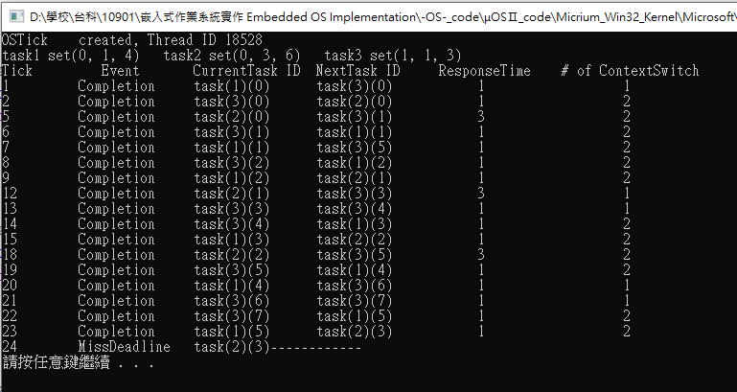

(2)Task set 2 = {τ1 (0, 1, 4), τ2 (0, 3, 6), τ3 (1, 1, 3)}

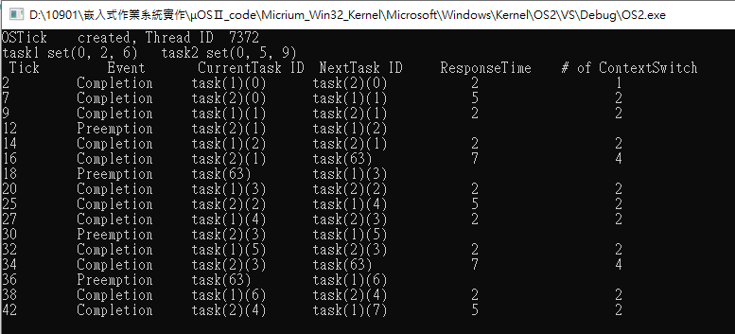

2. Implement and describe how to handle the deadline missing situation under EDF. (10%)

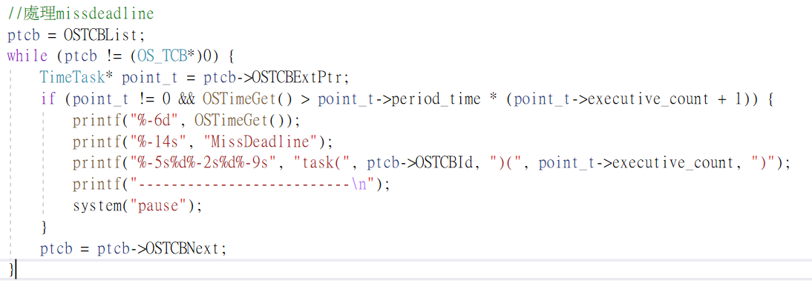

3. A report that describes your implementation, including scheduling results of two task sets, modified functions, data structure, etc. (please **ATTACH** the screenshot of the code and **MARK** the modified part) (40%)

1. Task set 1 = {τ1 (0, 2, 6), τ2 (0, 5, 9)}

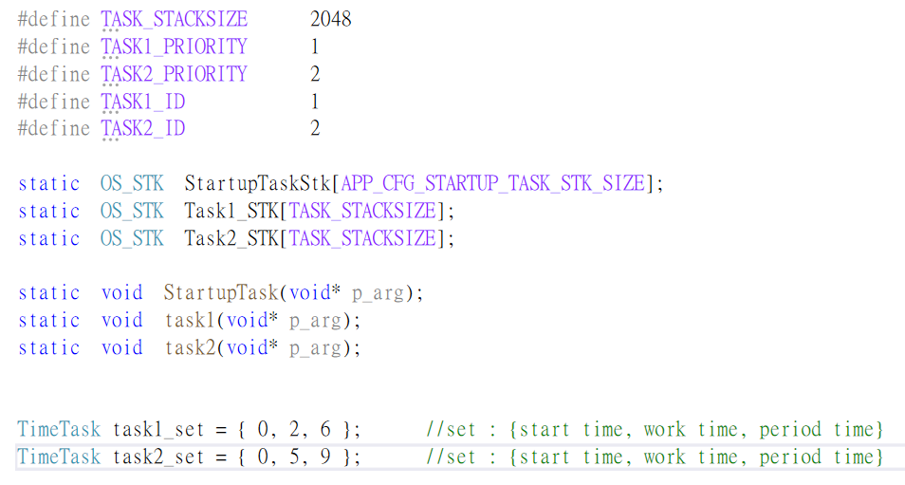

(2)Task set 2 = {τ1 (0, 1, 4), τ2 (0, 3, 6), τ3 (1, 1, 3)}

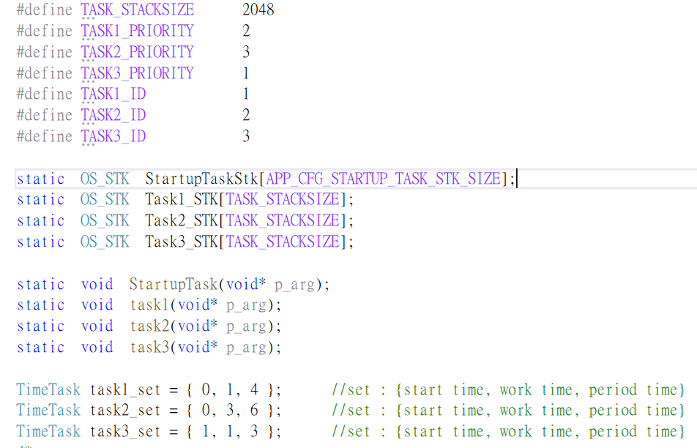

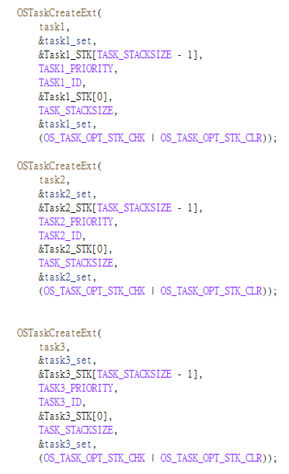

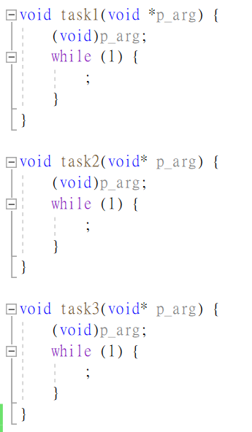

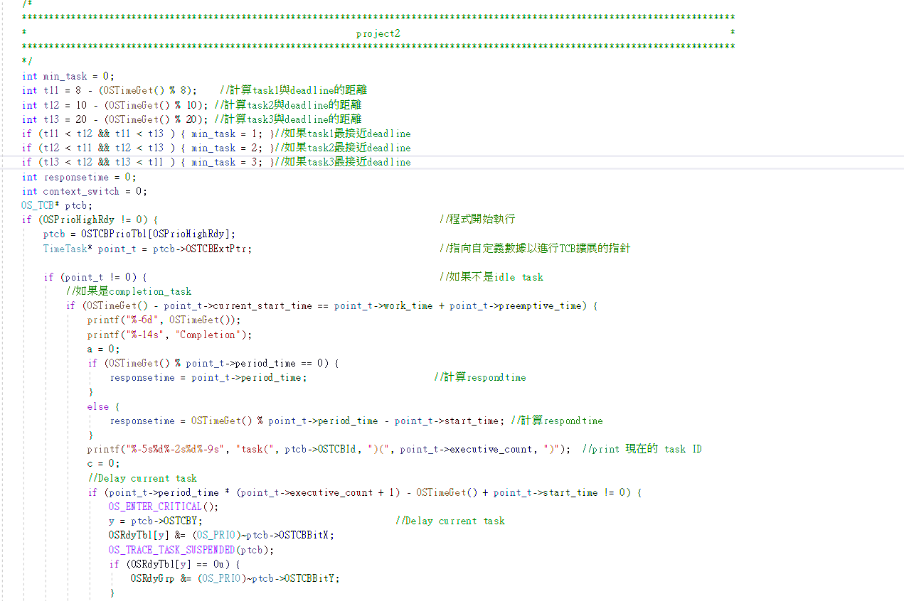

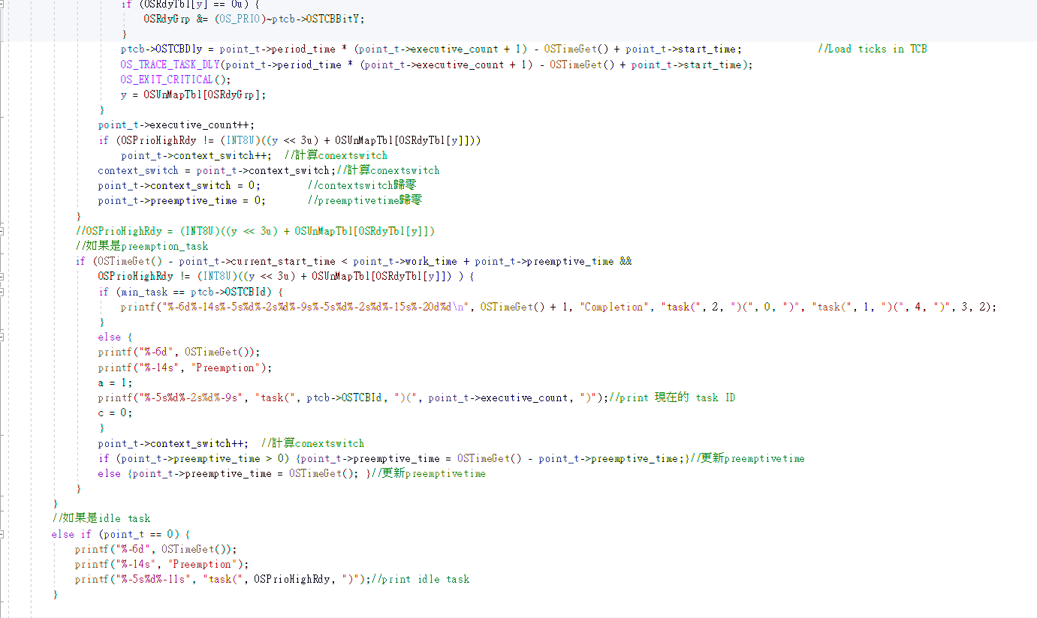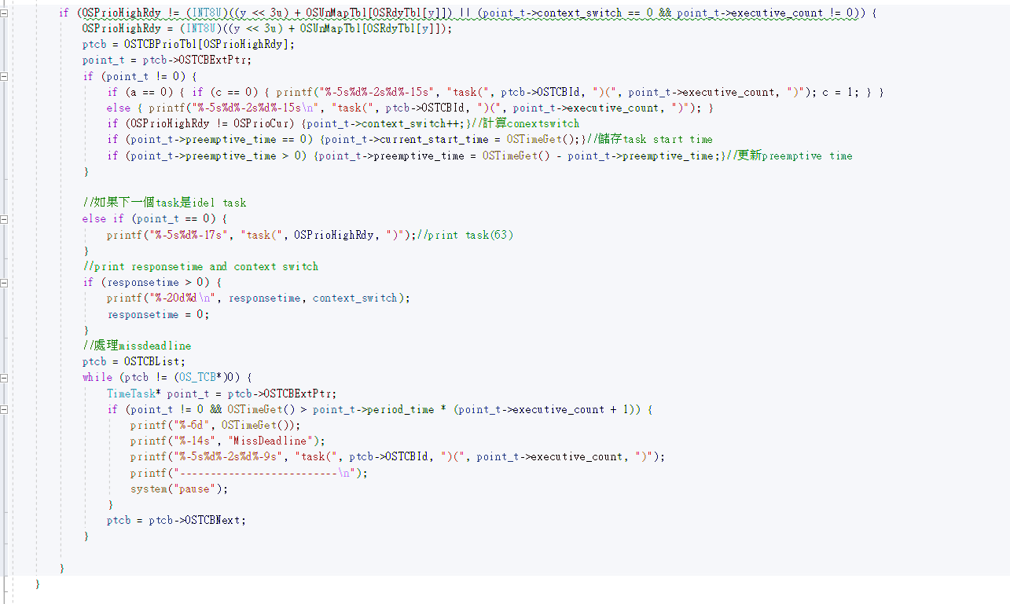

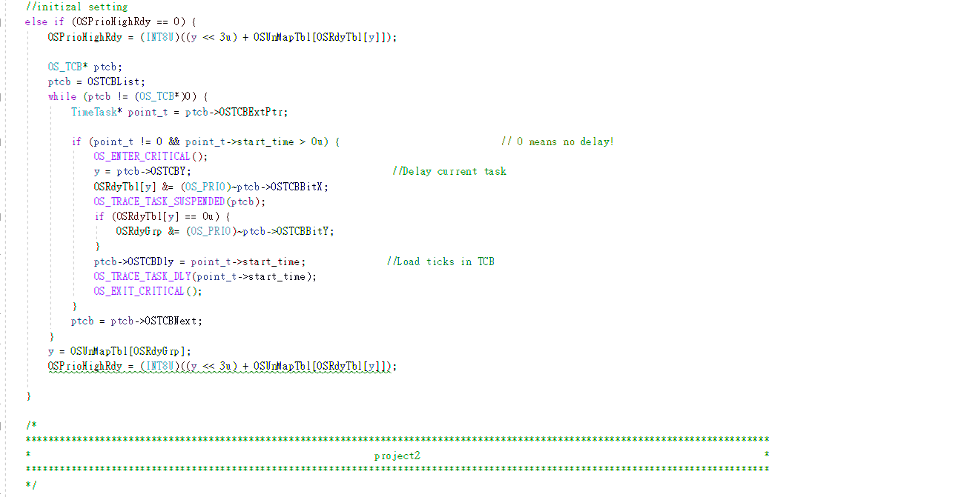

[ PART II ] CUS Scheduler Implementation [40%]

**1.** The screenshot results (with the given format) of two task sets. (Tick 0 to tick 40 or the tick when a task missing the deadline). (10%)

**======================== Task Set 1 ========================**

**Periodic Task Set1 = {τ1 (0, 1, 4), τ2 (0, 4, 10), τ3_ServerSize (0.3)}**

**Aperiodic Jobs Set1 = {j0 (4, 3, 16), j1 (17, 3, 30)}**

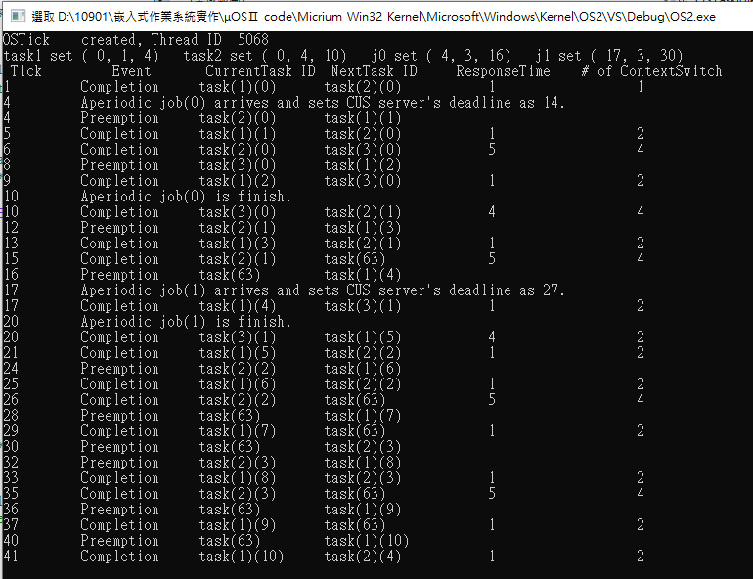

**======================== Task Set 2 ========================**

**Periodic Task Set2 = {τ1 (0, 2, 8), τ2 (0, 3, 10), τ3 (0, 5, 20), τ4_ServerSize (0.2)}**

**Aperiodic Jobs Set2 = {j0 (12, 3, 28), j1 (14, 2, 39)}**

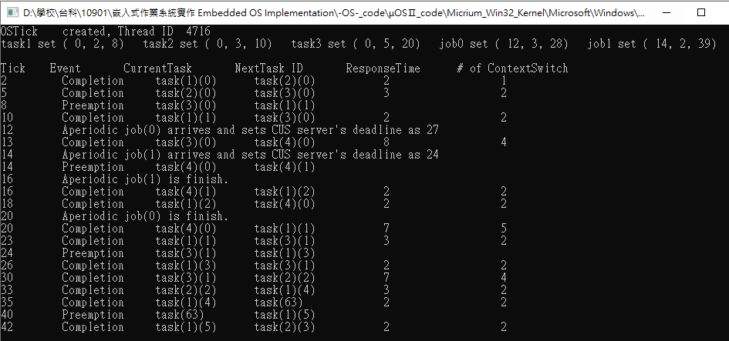

**2.** A report that describes your implementation, including scheduling results of two task sets, modified functions, data structure, etc. (please **ATTACH** the screenshot of the code and **MARK** the modified part). (30%)

**======================== Task Set 1 ========================**

**Periodic Task Set1 = {τ1 (0, 1, 4), τ2 (0, 4, 10), τ3_ServerSize (0.3)}**

**Aperiodic Jobs Set1 = {j0 (4, 3, 16), j1 (17, 3, 30)}**

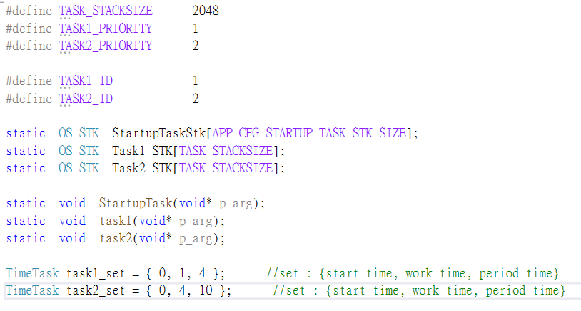

**======================== Task Set 2 ========================**

**Periodic Task Set2 = {τ1 (0, 2, 8), τ2 (0, 3, 10), τ3 (0, 5, 20), τ4_ServerSize (0.2)}**

**Aperiodic Jobs Set2 = {j0 (12, 3, 28), j1 (14, 2, 39)}**



