MULTIMEDIA SIGNAL PROCESSING HOMEWORK 1

M10907324吳俊逸

Language Choose MATLAB

Q1Q2 _Ref：<https://github.com/Chen-XueWen/Half-Toning-Matlab-Implementation>

AddQ1_Ref：<https://ww2.mathworks.cn/matlabcentral/fileexchange/25302-image-halftoning-by-floyd-s-method>

AddQ2_Ref：<http://imageprocessing-sankarsrin.blogspot.com/2019/05/direct-binary-search-halftoning-dbs.html>

CODE：<https://github.com/junyi1997/MULTIMEDIA_SIGNAL_PROCESSING>

**Problem 1:**

Topic: Point Process-Ordered Dithering using the Classical-4 & Bayer-5 Dither Array

Write an algorithm to convert the Gray Scale Image (0-255 Range) to Binary Image (0-1 Range)using the mentioned dither array.

1. Code：<https://github.com/junyi1997/MULTIMEDIA_SIGNAL_PROCESSING/tree/main/HW01/Ordered%20Dithering>
2. Results：

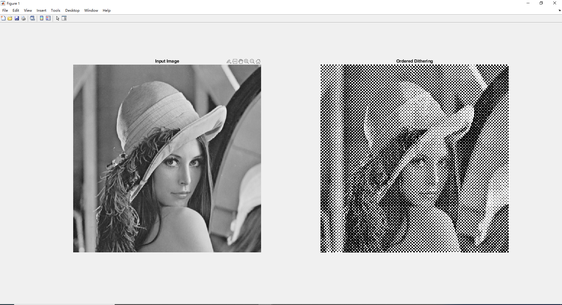

1. Inference/Discussion on results：

Ordered Dither Technique is an ancient method that uses black and white to display multi-level grayscale images. Because this method is very simple, it is still widely used. It is not only in display, but also in issues such as compression and data security.

The dither table is a small matrix, usually 4X4 or 8X8, which stores the threshold value. The sequence dither method is to compare the value of the gray-scale image with the critical value. If the value of the gray-scale image is greater than or equal to the critical value, the white point is output, otherwise the black point is output. Usually the size of the grayscale image is much larger than the dither table, so the grayscale image is cut into small images the same as the dither table, and each small image uses the same dither table for comparison.

**Problem 2:**

Topic: Neighborhood Process – Error Diffusion

In error diffusion three kernels are widely used Stucki (1981), Jarvis (1976), Floyd-Steinberg(1975)Write an algorithm to convert the Gray Scale Image (0-255 Range) to Binary Image (0-1 Range)based on the mentioned error diffusion kernels.

1. Code：<https://github.com/junyi1997/MULTIMEDIA_SIGNAL_PROCESSING/tree/main/HW01/Error%20Diffusion>
2. Results：

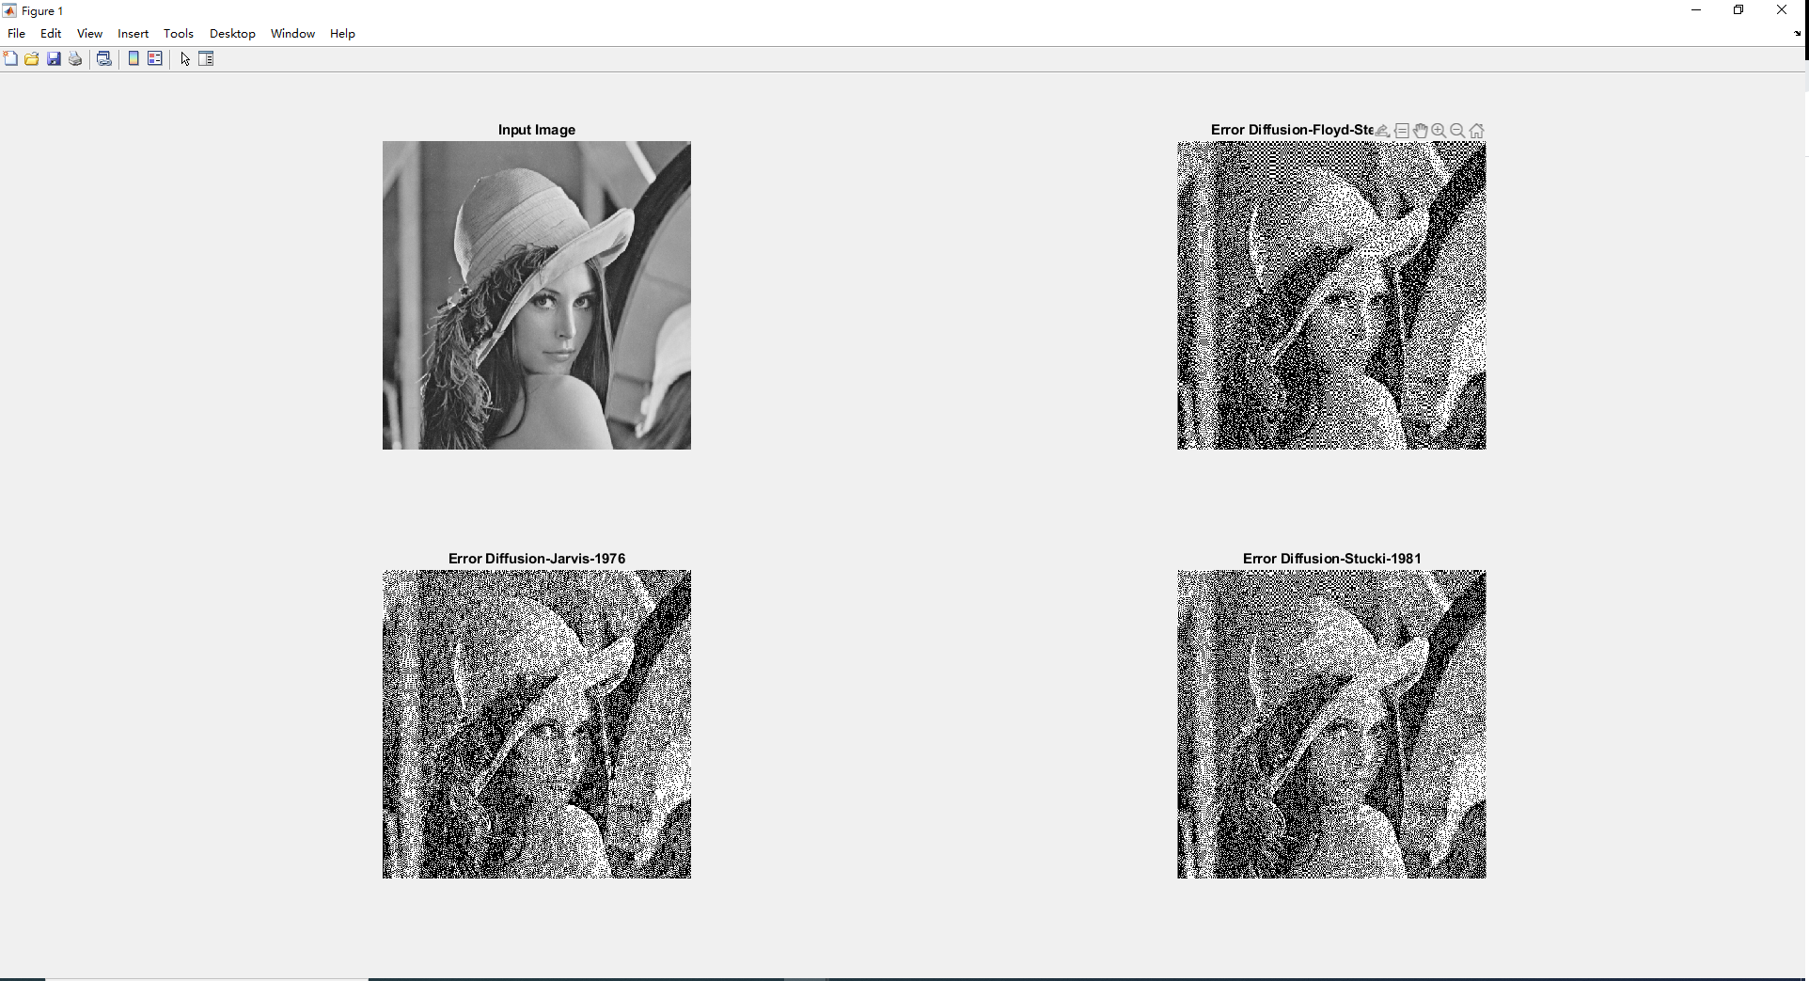

1. Inference/Discussion on results：

It is called error diffusion because the result of one point will affect the next point and can correct some problems in the middle brightness judgment error. There are currently three algorithms that can be used: Floyd-Steinberg, Jarvis-Judice-Ninke and Stucki. The effect is actually similar, but there are still subtle differences.

My feeling is Floyd-Steinburg: the finest particles

Jarvis-Judice-Ninke: the densest particles

Stucki: compromise

**Additional Bonus_1: Dot-diffusion halftones**

1. Code：<https://github.com/junyi1997/MULTIMEDIA_SIGNAL_PROCESSING/tree/main/HW01/Dot-diffusion>
2. Results：

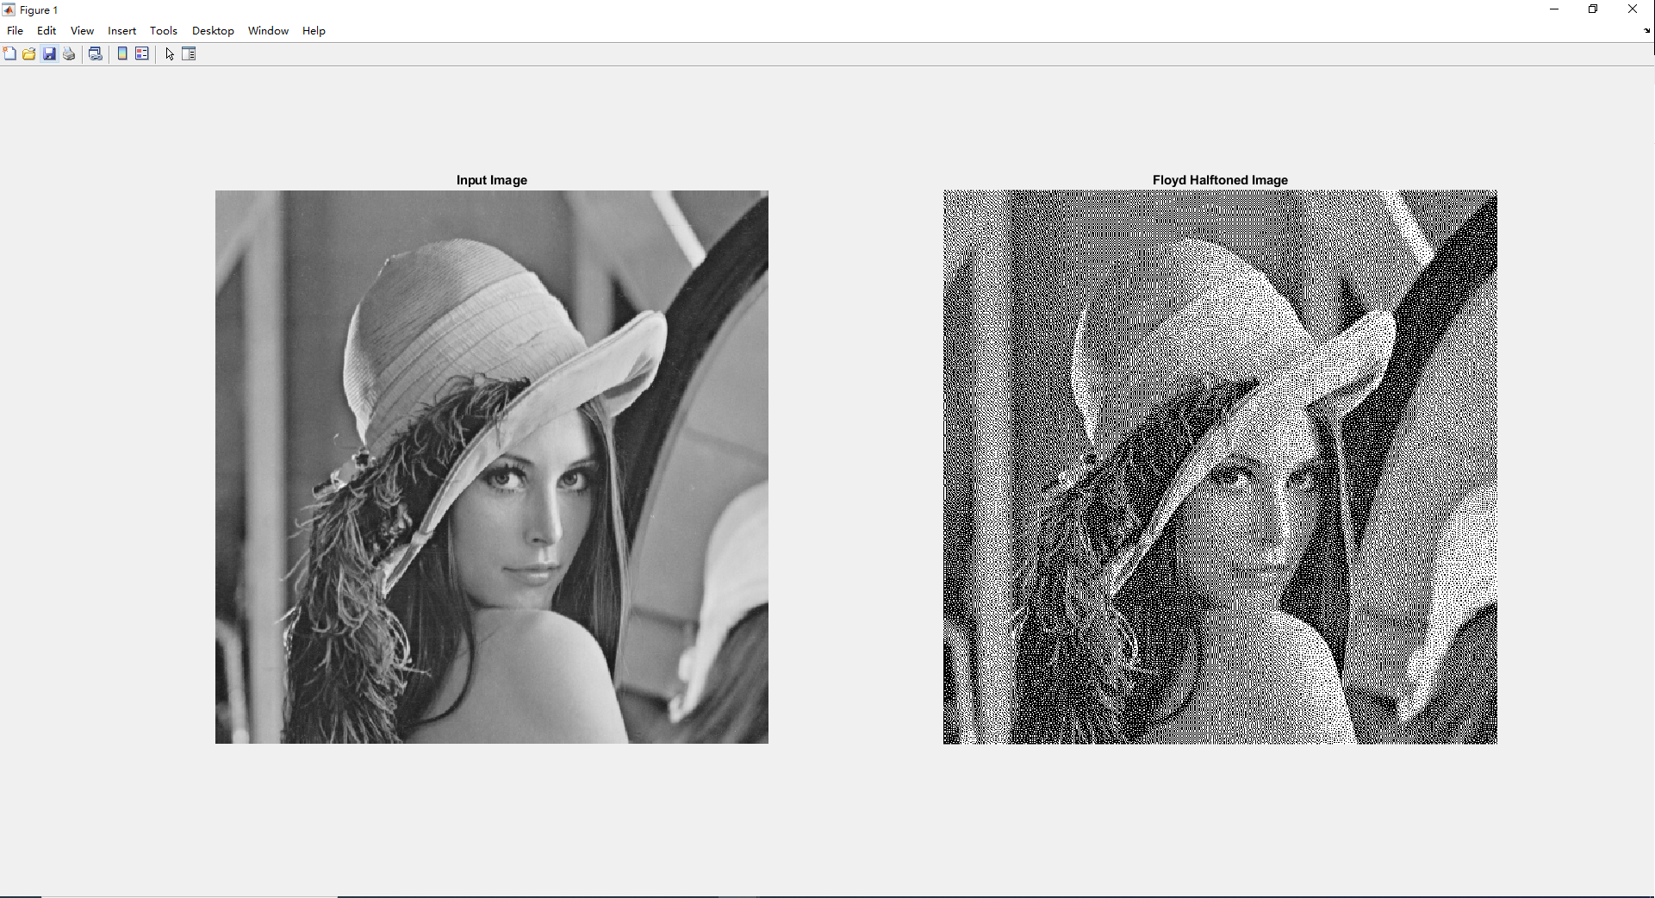

1. Inference/Discussion on results：

Dot Diffusion techniques is an improvisation of error diffusion with parallel processing feature of Ordered dithering. Basically it consist of two matrix such as Class and Diffusion Matrix.Class Matrix (CM) - Determines the order in which the pixels are processed in a block. (in other techniques raster or serpentine scan order is adopted). Note: All the blocks will be processed in parallel.

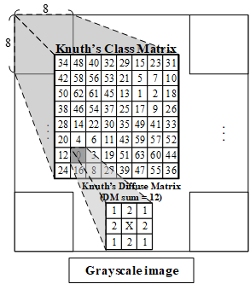

**Additional Bonus_2: Direct binary search halftone**

1. Code：<https://github.com/junyi1997/MULTIMEDIA_SIGNAL_PROCESSING/tree/main/HW01/Direct%20binary%20search>
2. Results：

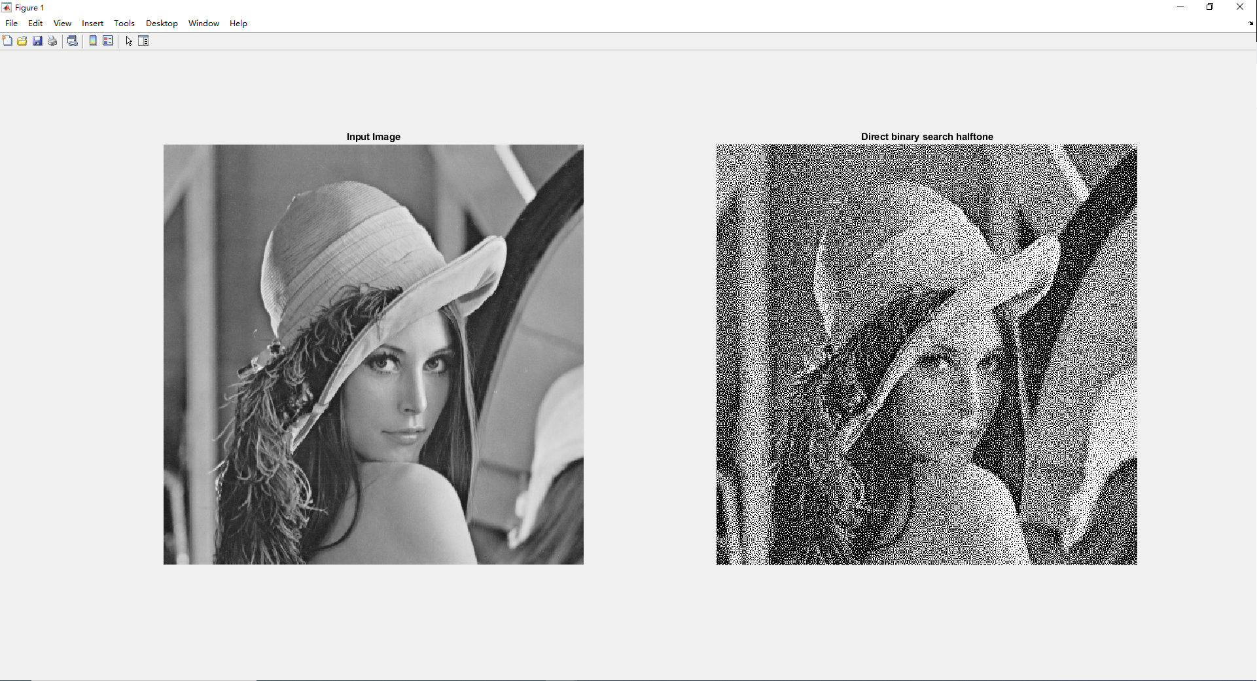

1. Inference/Discussion on results：

Direct binary approach is a heuristic optimization method and is proven to be very powerful to obtain optimized binary patterns. The approach achieves the least minimum square error between the perceived halftone and original image, though swap and toggle operation. The swap operation consists of switching the current pixel with eight of its neighborhood pixels. Toggle operation is about switching the values between 0 to 1 or vice versa (as shown in Fig. below)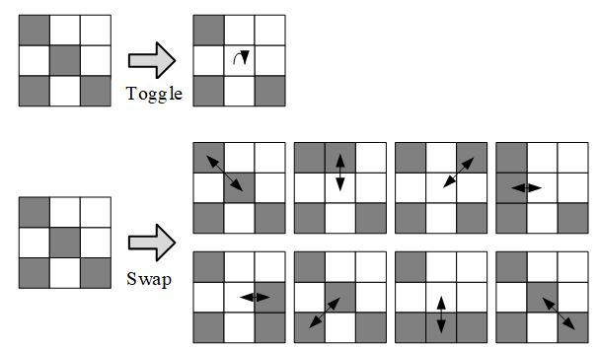

With each iteration, the perceived error starts to reduce and in finally a superior halftone quality is achieved. The method is computationally very expensive and difficult to implement in hardware.