1、所需安装包

#linux4.9.38

wget https://www.kernel.org/pub/linux/kernel/v4.x/linux-4.9.38.tar.gz

#xenomai3.1

wget https://xenomai.org/downloads/xenomai/stable/xenomai-3.1.tar.bz2

#igh1.52

git clone https://github.com/ribalda/ethercat.git

wget http://etherlab.org/download/ethercat/ethercat-1.5.2.tar.bz2

sudo apt install gcc libc6-dev libncurses5-dev libssl-dev build-essential bison flex

sudo tar xf linux-4.9.38.tar.gz

sudo tar xf xenomai-3.1.tar.bz2

1. 给ubuntu内核打上xenomai补丁，建立一个x86_64位内核

cd xenomai-3.1

sudo wget https://xenomai.org/downloads/ipipe/v4.x/x86/ipipe-core-4.9.38-x86-4.patch

sudo ./scripts/prepare-kernel.sh --linux=/home/wx/linux-4.9.38 --ipipe=ipipe-core-4.9.38-x86-4.patch --arch=x86_64

3、核心配置

cd linux-4.9.38

sudo make menuconfig

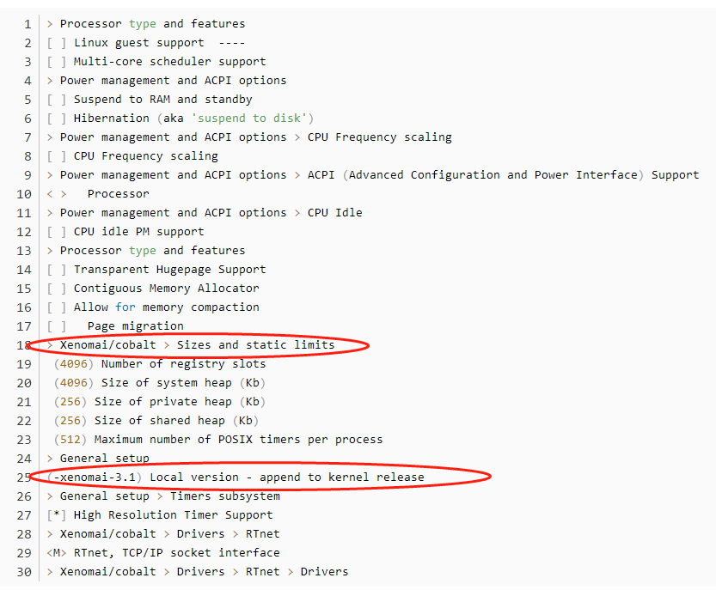

4、编译，安装内核

sudo apt install kernel-package

sudo CONCURRENCY_LEVEL=$(nproc) make-kpkg --initrd kernel_image kernel_headers

5、安装生成的系统文件

cd ..

sudo dpkg -i linux-headers-4.9.38-xenomai-3.1_4.9.38-xenomai-3.1-10.00.Custom_amd64.deb linux-image-4.9.38-xenomai-3.1_4.9.38-xenomai-3.1-10.00.Custom_amd64.deb

6、允许非root用户

sudo addgroup xenomai --gid 1234

sudo addgroup root xenomai

sudo usermod -a -G xenomai $USER

7、编辑Grub

sudo gedit /etc/default/grub

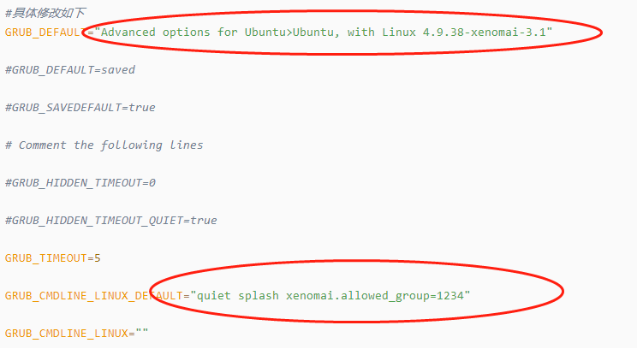

#更新GRUB并重新启动

sudo update-grub

#重启电脑

sudo reboot

#重新开机后选择Ubuntu高级内核

8、安装xenomai

cd xenomai-3.1

./configure --with-pic --with-core=cobalt --enable-smp --disable-tls --enable-dlopen-libs --disable-clock-monotonic-raw

make -j`nproc`

sudo make install

更新环境变量

echo '

### Xenomai

export XENOMAI_ROOT_DIR=/usr/xenomai

export XENOMAI_PATH=/usr/xenomai

export PATH=$PATH:$XENOMAI_PATH/bin:$XENOMAI_PATH/sbin

export PKG_CONFIG_PATH=$PKG_CONFIG_PATH:$XENOMAI_PATH/lib/pkgconfig

export LD_LIBRARY_PATH=$LD_LIBRARY_PATH:$XENOMAI_PATH/lib

export OROCOS_TARGET=xenomai

' >> ~/.xenomai_rc

echo 'source ~/.xenomai_rc' >> ~/.bashrc

source ~/.bashrc

测试：

cd /usr/xenomai/bin

sudo ./latency

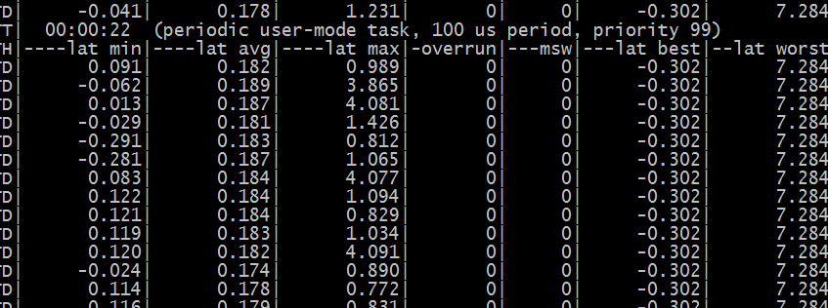

9、编译和安装igh

./bootstrap

./configure --with-linux-dir=/usr/src/linux-headers-4.9.38-xenomai-3.1 --with-module-dir=/lib/modules/4.9.38-xenomai-3.1 --enable-generic=yes --enable-8139too=no --enable-e1000=yes --enable-e1000e=yes --enable-r8169=no --enable-rtdm=yes --enable-cycles=yes --enable-hrtimer=yes --with-xenomai-dir=/usr/xenomai --prefix=/opt/etherlab

make

make modules

sudo make install

sudo make modules_install

ethercat主站配置

