Extinction of New World mega-frugivores disrupts the fruit size-body size relationship in palms and mammals
Bastian Göldel¹*, W. Daniel Kissling², Søren Faurby^{3,4} and Jens-Christian Svenning¹
¹Section for Ecoinformatics and Biodiversity, Department of Bioscience, Aarhus University, Ny Munkegade 114, 8000 Aarhus C, Denmark
²Institute for Biodiversity and Ecosystem Dynamics (IBED), University of Amsterdam, P.O. Box 94248, 1090 GE Amsterdam, The Netherlands
³Department of Biogeography and Global Change, Museo Nacional de Ciencias Naturales, CSIC, Calle José Gutiérrez Abascal 2, 28006 Madrid, Spain
⁴Department of Biological and Environmental Sciences, University of Gothenburg, SE 40530 Gothenburg, Sweden
E-mails: wdkissling@gmail.com (WDK); soren.faurby@bios.au.dk (SF); svenning@bios.au.dk (JCS)
*Correspondence: Bastian Göldel; Department of Bioscience, Aarhus University, Ny Munkegade 114, 8000 Aarhus C, Denmark. E-mail: bastian.goeldel@bios.au.dk
Keywords: Arecaceae, evolutionary co-variation, functional diversity, megafauna extinction, plant-animal interaction, plant functional traits, Quaternary climate change, seed dispersal
Running title: Megafaunal frugivores and palms
Number of words in Abstract: 300
Number of words in main body: 5825 (through Biosketch)
Number of references: 50
ABSTRACT
Aim: Megafauna extinctions can have cascading consequences for food webs and plant-animal interactions, but detailed knowledge at biogeographical scales is scarce. Here, we quantify the relationship between palm (Arecaceae) fruit sizes and body sizes of frugivorous mammals while simultaneously controlling for environmental conditions, and highlight biogeographic differences in the potential impacts of lost frugivores.
Location: Global
Methods: We combined palm distributions with palm fruit sizes, and distributions of frugivorous mammals with body sizes, to quantify geographic trait variation at global and biogeographical scales. Furthermore, we added estimated range losses of present and extinct mammals during the late Quaternary. We then used structural equation models and spatial regressions to assess the relationships between average mammal body sizes and average palm fruit sizes while accounting for differences in environment (current climate, soil texture, net primary productivity, and Quaternary glacial–interglacial climate change).
Results: Positive associations between palm fruit sizes and current mammal body sizes were found globally and in the Old World, but not in the New World (i.e. the Americas including the Caribbean islands). A positive relationship between fruit size and present and extinct mammalian body sizes was found in global, Old World and New World analyses.
Main conclusions: In the New World, the spatial pattern of palm fruit size distributions has been largely preserved despite the Late Pleistocene and Holocene loss of megafaunal mammals. Hence, the current geographic co-variation in functional traits of New World palms and mammalian frugivores does not reflect any co-variation over deep time scales. We suggest that the continued presence of large-fruited palms in areas with lost megafauna could result from abiotic and biotic seed dispersal services of substitute dispersers (e.g. scatter-hoarding rodents, introduced livestock, and humans) which might allow short-distance dispersal and survival of megafauna-dependent fruit species despite the extinction of the major seed dispersers.
INTRODUCTION
Consistent with the arrival of the ancestors of the Native Americans in the New World ~10.000 years ago, a very large number of species of the Pleistocene megafauna —such as gomphotheres, giant sloths and toxodonts— were lost to extinction (Barnosky et al., 2004; Bakker et al., 2015). In both North and South America every member of the formerly highly diverse guild of herbivores >1000 kg went extinct even though both continents used to house even more such species than currently occur in Africa (Sandom et al., 2014; Faurby & Svenning, 2015). Recent studies suggest that these megafauna extinctions might have caused strong shifts and changes in the geographic distributions of other species and ecosystems (Janzen & Martin, 1982; Guimarães et al., 2008). For instance, large herbivores can control the abundance of woody plants, and their absence might therefore result in shifts of woody cover and landscape structure as well as changes in plant species composition, soil fertility and biogeochemical cycling (Bakker et al., 2015; Doughty et al., 2015b; Svenning et al., 2015). Moreover, the loss of megafauna also represents a loss of large-bodied seed dispersers which might have strong effects on seed dispersal distances and the spatial and genetic structure of large-fruited trees (Barnosky et al., 2004; Donatti et al., 2007; Guimarães et al., 2008; Beaune et al., 2013). However, recent studies suggest that seed dispersal of megafaunal fruits might to some extent be substituted by other dispersers, including scatter-hoarding rodents and humans (Guimarães et al., 2008; Jansen et al., 2012). Whether these substitute dispersers can compensate for the loss of megafauna remains doubtful (Beaune et al., 2013).
Vertebrate frugivory is a key plant-animal interaction, especially in tropical ecosystems (Fleming & Kress, 2013). Morphological and functional traits of both plants and frugivores play a key role in this plant-animal interaction (Guimarães et al., 2008). Of particular importance is the relationship between fruit size and frugivore body size (Jordano, 2000; Lord, 2004) because only large-bodied frugivores are able to fully ingest and disperse large fruits (Guimarães et al., 2008). The loss of large-bodied frugivores can therefore result in negative consequences for plant recruitment, population structure and geographic range dynamics (Guimarães et al., 2008; Galetti et al., 2013). In areas where large-seeded or large-fruited plants occur without present-day dispersers, the presence of large-fruited plant lineages might represent disrupted or anachronistic mutualisms with megafaunal species that have disappeared or have gone at least functionally (Janzen & Martin, 1982; Guimarães et al., 2008; Galetti et al., 2013; Federman et al., 2016). For instance, the strong decline of elephants in Congo’s tropical lowland forests has been shown to disrupt the seed dispersal of most megafauna-dispersed trees (Beaune et al., 2013). Similarly, the elimination of the largest mammalian herbivores (elephants and rhinoceroses) from forests in tropical Asia has strongly reduced dispersal of megafauna-dispersed plants (Campos-Arceiz & Blake, 2011). Nevertheless, the consequences of megafauna disperser loss at large geographical scales are still little explored.
Palms (Arecaceae) are a key component of tropical and subtropical ecosystems (Henderson, 2002; Dransfield et al., 2008; Kissling et al., 2012b; Couvreur & Baker, 2013) and a model system for the ecology and evolution of tropical rainforests (Couvreur & Baker, 2013). They represent an important food source for a variety of frugivores (Zona & Henderson, 1989; Galetti et al., 2006), especially frugivorous vertebrates such as birds and mammals (Fleming & Kress, 2013). Dispersal of palm seeds therefore almost exclusively depends on avian and mammalian frugivores (Zona & Henderson, 1989). For instance, several species of large-gaped toucans and cotingas are successful seed dispersers of the palm Euterpe edulis (Galetti et al., 2013) whereas tapirs are key dispersers of the palms Mauritia flexuosa (Fragoso & Huffman, 2000) and Astrocaryum aculeatissimum (Galetti et al., 2006). Palm fruits vary widely in shape, surface texture and size (Dransfield et al., 2008), but on average they are located at the upper limit of the seed and fruit size space of flowering plants (Tomlinson, 1990). Most palm species are 1-seeded (Tomlinson, 1990; Dransfield et al., 2008) and fruit size can therefore be taken as a proxy for seed size (Tomlinson, 1990; Henderson, 2002). Diameters of palm fruits often vary between 0.5 and 2.5 cm, but many palms also have larger fruits that can be classified as megafaunal fruits, i.e., at least 4 cm in length (Guimarães et al., 2008). Overall, the relationship between palm fruit sizes and geographic distributions of animal dispersers remains little explored (Zona & Henderson, 1989; Kissling et al., 2012a).
Besides biotic interactions among frugivores and their food plants, various environmental and historical drivers are likely to have shaped the distribution of functional traits of fleshy-fruited plants across broad spatial scales (Donatti et al., 2007). For instance, contemporary temperature and precipitation (Swenson & Weiser, 2010), seasonality (Göldel et al., 2015) and soil conditions (Tautenhahn et al., 2008) can show a strong relationship with plant trait distributions at macro-ecological scales. Such environmental effects might also be indirect (Kissling et al., 2008), e.g. if present-day climate affects consumer and resource diversity via productivity and human impact (Sandom et al., 2013). Moreover, historical factors such as past climate change may also affect the spatial distribution of fruit and seed sizes. For instance, Quaternary glacial-interglacial climate oscillations can explain a large proportion of the palm fruit size distributions in the New World (Göldel et al., 2015). Moreover, compared to the New World the Old World tends to harbor fewer small-fruited plant species (Mack, 1993). This might be related to Cenozoic drying, as large seed masses enable seedlings to better survive hazards such as drought (Kissling et al., 2012a). Alternatively, this might also be caused by differences in body sizes of frugivorous dispersers (Mack, 1993). A key challenge is therefore to disentangle the direct and indirect biotic and abiotic effects on functional trait distributions across broad spatial extents.
Here, we focus on the relationship between palm fruit sizes and body sizes of mammalian frugivores at global and biogeographic scales. We quantify this relationship and simultaneously control for present and historical environmental predictor variables, incl. current climate, soil conditions, net primary productivity, and Quaternary glacial-interglacial climate change. Specifically, we test whether the geographic distribution of palm fruit sizes is related to the current distribution of mammal body sizes, and to what extent megafaunal extinctions and range contractions in the Late Pleistocene and early Holocene might have disrupted this relationship (Barnosky et al., 2004). To our knowledge, no study has yet quantified the relationship between fruit sizes of a tropical plant lineage and current and extinct frugivores across such broad spatial extents. In detail, we test following predictions:
1) Fruit sizes of palm assemblages at a global scale are positively related to body sizes of current mammal assemblages, with large average fruit sizes coinciding with large mammal body sizes, even when accounting for contemporary and Quaternary environmental conditions.
2) Within major biogeographic realms (e.g. New World, Western Old World, Eastern World), we expect a positive relationship between palm fruit sizes and body sizes of current mammal assemblages, but only in regions where large-bodied megafauna is still abundant today (e.g. Africa).
3) When adjusting for megafauna range losses and extinctions, a positive relationship between palm fruit sizes and body sizes of mammal assemblages should be evident in all regions.
METHODS
Palm data
Presence-absence data for all palm species (n = 2467) were obtained from the world checklist of palms (Govaerts & Dransfield, 2005; downloaded May 2012). The coconut Cocos nucifera and the coco de mer Lodoicea maldivica have fruits that are not dispersed by animals (Tomlinson, 1990; Henderson, 2002) and were therefore deleted from the dataset. The presence-absence data are recorded at a spatial resolution of so-called ‘botanical countries’ (level 3 units) as defined by the International Working Group on Taxonomic Databases (TDWG). These TDWG units correspond mainly to political countries, but also divide large countries (e.g. Australia, Brazil, China, United States) into smaller regions. They also occasionally combine political divided areas (e.g. Borneo and New Guinea) or ignore tiny political states with minor geographic importance (e.g. Vatican City). Out of a total of 368 TDWG units, we included the 187 units in which at least one palm species occurred. We also run analyses by including only units with species richness ≥2 (n = 153), but results were qualitatively similar and we therefore present the analyses for the full dataset (n = 187 units).
Data on fruit sizes of palm species were extracted from the primary literature, monographs, species descriptions, and herbaria, including the Aarhus University Herbarium the herbarium of the Royal Botanic Gardens Kew and the e-monocot database from Royal Botanic Gardens Kew (http://e-monocot.org/). To quantify fruit size for each species, we used reported measurements of average fruit length (rather than width or diameter) as this was the most consistently recorded fruit size trait in the literature. Out of the 2467 species, a total of 1800 species had data on average fruit sizes available from the literature sources. Table S1 in Appendix S1 provides information on the literature used to record fruit size values for each of the species. In case of missing trait values, we used the mean of congeners to estimate the value for the missing species. This was done for 669 species. A detailed overview of the mean trait values per genus as well as the number of species with estimated traits in each genus is provided in Table S2 (Appendix S1). Based on all species-level fruit sizes, we computed mean fruit sizes across all species that are present in each of the 187 TDWG units (see Fig. 1). These assemblage-level means of palm fruit sizes in TDWG units were then used as response variables in the statistical analyses (see below).
Mammal data
To determine the effect of Pleistocene extinctions on present-day macroecological relationships between palm fruit size and mammal body size, we consider separately “current” as well as, “present-natural” mammal distributions (Faurby et al 2016). The latter refer to the geographic ranges of all late Quaternary mammalian species as they would have been under present climate in the absence of strong anthropogenic impact, including the Pleistocene extinction of megafauna (refref).
“Current” and “present-natural” spatial distributions of both extant and extinct frugivorous mammals were based on the taxonomy and geographic range maps as compiled in the PHYLACINE v1.2 dataset (cite). Range maps were provided as Behrmann cylindrical equal area rasters, which we then converted into presence/absence in TDWG level 3 units so as to be comparable with the palm occurrence dataset.
Current range maps of extant mammals in the PHYLACINE dataset were based on IUCN range maps (http://www.iucnredlist.org/) with minimal modification (e.g., reprojection). However, the present-natural geographic ranges of extant taxa were systematically evaluated and modifications accordingly made to their current ranges if there is strong evidence of anthropogenic impact (see supplementary in Faurby & Svenning 2015; Faurby et al 2018). This also included human-mediated range expansion, which IUCN range maps for some taxa do not correct for. For extinct taxa, present-natural ranges were estimated based on fossil occurrences or the distribution of extant taxa that the extinct taxa frequently co-occurred with in fossil assemblages (Faurby & Svenning 2015; Faurby et al 2018). Range maps with zero occupied grid cells (e.g., species whose ranges have not been mapped by the IUCN) were excluded from our analysis.
To identify species with a frugivorous or at least a fruit-containing diet, we used the MammalDIET dataset (Kissling et al 2014). Synonyms of binomial names in the MammalDIET dataset were corrected using IUCN taxon lists (last downloaded: Oct 2018) as a reference. Species names that could not be reconciled with the taxonomy in the PHYLACINE dataset were omitted. In total, out of the 1,950 extant frugivorous (obligate and facultative) taxa in the MammalDIET dataset, we analyzed the current and present-natural ranges of 1,861 and 1,894 taxa respectively. The diet of extinct mammals was determined using the PHYLACINE dataset, which was in turn derived from other sources such as the EltonTraits dataset (REF). While there is limited direct evidence of frugivory in extinct taxa, we assumed herbivores to be the most likely candidate frugivores of palms. In total, we analyzed the present-natural ranges for 178 extinct potential frugivores.
Body size information was obtained from the PHYLACINE dataset, which in turn was based on a variety of sources, majority of which from the Mass of Mammals database v4.1 (Smith et al 2003). We calculated the mean body size within each TDWG unit.

We quantified the spatial distribution of current frugivorous mammals using the taxonomy and geographic range maps compiled by the IUCN Global Mammal Assessment 2012 (http://www.iucnredlist.org/). Diet preferences for current mammals were obtained from the MammalDiet dataset (Kissling et al. (2014). Out of a total of 5364 terrestrial mammal species, 1950 are frugivorous, i.e. species which have fleshy fruits as a preferred diet (Kissling et al., 2014). We then intersected the range maps of the frugivorous mammals with the TDWG level 3 units and retained the 1806 frugivorous mammals which occurred within the botanical countries where palms are present. To quantify historical mammal distributions we used the dataset from Faurby and Svenning (2015), which estimates the geographic ranges of all late Quaternary mammalian species as they would have been under present climate in the absence of past or present impacts by Homo sapiens. We refer to these geographic ranges as ‘present-natural ranges’ (following Faurby and Svenning (2015)). We acknowledge that other non-flying dispersers like tortoises and ratite birds could potentially be functionally analogous to mammalian dispersers, but data on their present-natural distribution is not available and we therefore did not include these groups. In detail, we estimated the present-natural ranges from 691 current and 93 extinct frugivorous species at the resolution of TDWG level 3 units. Combined with current frugivoous mammals, this included a total of 1899 mammal species in the dataset of the present-natural mammal distributions. For diet information of extinct mammals we assessed that the groups of herbivores and omnivores are most likely represent (palm) fruit and seed dispersers. We then added information on current and present-natural mammal body sizes (Faurby & Svenning, 2016) and calculated the mean body size over all frugivorous mammal species within each palm TDWG units (Table 1). We chose the mean over the median because the richness of extinct megafauna was rather low (Sandom et al., 2013; Faurby & Svenning, 2015) and we aimed to emphasize the effect of large mammalian frugivores.
Additionally, to assess whether there are differences among all current frugivores (n = 1806), fruit specialists (n = 1578), partial frugivores (n = 194) and opportunists (n = 34) we re-did the global and biogeographical analyses for these groups separately as a sensitivity-analysis.
Environmental data
To account for environmental variation at the level of TDWG units we included data on current climate (three predictor variables), paleoclimate (two variables), soil (one variable) and net primary productivity (one variable) (Table 1). All environmental variables were calculated in ArcGIS (version 10.1, ESRI, Redlands, CA, USA).
Current climate
To represent current climate we used six climate variables from the WORLDCLIM database (version 1.4; http:// www.worldclim.org), a set of global climate layers with a spatial resolution of c. 1 km² (Hijmans et al., 2005). We chose mean annual precipitation, precipitation seasonality, mean annual temperature, temperature seasonality, temperature of the coldest quarter, and precipitation of the driest quarter. These variables have been shown to be important drivers of functional trait distributions in palms and other plant families (Swenson & Weiser, 2010; Göldel et al., 2015). We performed a Principal Component Analysis (PCA) to reduce collinearity among these climatic variables. PCAs were done separately for the global and the analyses of the biogeographic realms. We retained the first three PCA axes (PC-PREC, PC-TEMP, PC-SEAS) in all analyses (Table 1), which together each time explained >90% of the variability within the data.
Soil
To quantify soil conditions, we used data from the ISRIC - World Soil Information (http://soilgrids.org/ page), a soil dataset with a resolution of 1 km (Hengl et al., 2014). We chose the percentage of sand in 45 cm soil depth as a predictor variable (SOIL) because palms often form short roots (Dransfield et al., 2008) and water availability strongly depends on the fraction of sand (Ritchie, 1981). We calculated the mean value for sand fraction for each TGWD unit.
Net primary productivity
As a measure of productivity, we used net primary productivity (NPP, measured in gC/m²/yr) as provided by the Moderate Resolution Imaging Spectral radiometer (MODIS) data at 1-km resolution (Zhao et al., 2005) and calculated mean values were calculated per TDWG.
Paleoclimate
We calculated the differences in temperature and precipitation (anomalies) between the Last Glacial Maximum (LGM; c. 21,000 years ago) and the present to represent Quaternary climate change. For temperature, these anomalies cover the full glacial-interglacial climate cycle with a geographic pattern that is consistent with these orbitally-driven climatic oscillations over at least the 10–100 thousand years (Jansson, 2003). We used mean annual temperature and annual precipitation to compute the anomaly of temperature (LGM TEMP, in °C) and the anomaly of precipitation (LGM PREC, in mm year^{–1}), respectively. We used two climate simulations for the LGM (the Community Climate System Model version 3, CCSM3, and the Model for Interdisciplinary Research on Climate version 3.2, MIROC3.2) from the Paleoclimate Modeling Intercomparison Project (PMIP2; http://pmip2.lsce.ipsl.fr/) to quantify these paleoclimatic changes (Braconnot et al., 2007), and used the mean values across both simulations. LGM data were resampled with a bilinear interpolation from the original 2.5″ resolution to the resolution of the contemporary climate data. Higher temperature and precipitation in the past than in the present is reflected by small (temperature) or negative (precipitation) anomaly values, whereas high anomaly values represent a higher temperature and precipitation in the present than in the past.
Statistical analysis
We used Structural Equation Models (SEMs) to test our hypotheses. The procedure followed general guidelines and previous studies using SEMs (Grace et al., 2012; Sandom et al., 2013). In our first hypothesis, we expected fruit sizes of palm assemblages at a global scale to be positively related to current mammal body sizes, with large average fruit sizes coinciding with large mammal body sizes. We started our modeling processes with an a priori SEM which included all hypothesized pathways among all predictor variables. Hence, we examined direct and indirect effects of biotic and abiotic drivers (PC-PREC, PC-TEMP, PC-SEAS, SOIL, LGM TEMP and LGM PREC) on our three response variables (palm fruit size, mammal body size and NPP). In the next step, we evaluated model modification indices, model fits and residual correlations. We used the chi-square test, the root mean square error of approximation (RMSEA), and the comparative fit index (CFI) to measure model fit. To ensure an adequate fit of SEMs we used the following criteria: P-values of chi-square tests > 0.05, CFI > 0.90 and confidence intervals of RMSEA < 0.05 (Grace et al., 2012). Missing paths within the model were identified from large residuals and high modification indices and deleted from the SEM. The path with the least statistical significance was deleted from the model. Afterwards we developed a new model without the deleted path and identified again the least statistically significant path. We repeated these steps until our final model only consisted of statistically significant pathways (at P < 0.05). For the first hypothesis the final SEM is shown in Fig. 2.
Based on our second hypothesis we expected a positive relationship between palm fruit sizes and current mammal body sizes in regions where large-bodied megafauna is still abundant today (e.g. Africa), but not where it is mainly extinct (e.g. New World). To test this hypothesis we built separate SEMs for each of the biogeographical realms as defined by TDWG: New World (Americas: n = 61 TDWG units), Eastern Old World (e.g. Australasia, Indomalay: n = 62) and Western Old World (Africa, Europe: n = 64) (see map in Appendix S2, Fig. S1). These realms are characterized by a unique species composition due to long-term geographic isolation and dispersal limitation. A finer subdivision into more biogeographic regions was not sensible because sample sizes (i.e. number of TDWG units) of several regions became too small for statistical analysis. To analyze our third hypothesis we included geographic range losses and megafauna extinctions of mammals and built SEMs on a global scale and for each biogeographical realm. We hypothesized a positive relationship between palm fruit sizes and body sizes of mammal assemblages within all biogeographical realms. For all the biogeographically divided SEMs (current and present-natural), climate PCA axes were calculated separately for each biogeographical realm. The analysis of these SEMs was performed as described above for the global SEM of current mammals.
As spatial autocorrelation can affect significance tests and coefficients estimates of statistical models (Legendre & Legendre, 1998; Kissling & Carl, 2008), we assessed the extent of spatial autocorrelation by calculating Moran’s I values on the residuals of non-spatial multiple regression models (ordinary least squares, OLS). As standardized coefficients from the OLS models are equivalent to the path coefficients of the SEMs, they enable a direct comparison of the spatial autocorrelation between the spatial and non-spatial models (Kissling et al., 2008). We used the same variables as in the SEMs and computed correlograms of the OLS model residuals (Kissling & Carl, 2008; Kissling et al., 2008). We further fitted simultaneous autoregressive (SAR) models of the error type to allow the inclusion of the residual spatial autocorrelation of OLS model (Kissling & Carl, 2008). The spatial weights matrix was defined using the minimum distance that linked each occupied TDWG unit to at least one other occupied unit (2072 km). To identify the extent of spatial autocorrelation we used correlograms and quantified the spatial autocorrelation in the raw data response variables, the residuals of the non-spatial OLS and the SAR models. The standardized coefficients from the SAR models were similar to those of the OLS models. We therefore focus on the spatial path coefficients from the SARs throughout the manuscript.
For all analyses with current and present-natural frugivores the predictor variables were checked for normal distribution, both globally and separately for each biogeographical realm. Furthermore, univariate relationships of both mean mammal body size and palm fruit size with all predictor variables were tested to check for non-linear responses. The response and predictor variables for palm fruit size, mammal body size and LGM PREC were log₁₀ transformed. All statistical analyses were conducted with R version 3.0.1 (R Core Team, 2013). The SEMs were calculated using the package ‘lavaan’ version 0.5-18 (2015, Y. Rosseel). The correlograms were calculated using the ncf package. The spatial weight matrices of the SARs and the Moran’s I values were calculated using the R package ’spdep’ version 0.5-71 (2014, R. Bivand).
RESULTS
Overall, the highest assemblage-mean values for palm fruit sizes were found in Africa, while intermediate sizes were found for South America and Asia, and low values for Australasia, Northern and Central America (Fig. 1). Consistent with large fruit sizes, current mammal body sizes were highest in Africa, followed by Eastern Asia and low values within the New World and Australasia. Including the natural ranges of extinct and current mammal species (‘present-natural’), the highest mammal body sizes were found in Africa, closely followed by the Americas, and lowest values in the eastern Old World.
In line with the first hypothesis, we found a global, positive relationship between palm fruit size assemblages and current mammal body sizes using SEMs (standardized path coefficient = 0.324, P < 0.001; Fig. 2), indicating that areas with large average fruit sizes coincide with large body sizes of mammalian frugivores. Assemblage palm fruit sizes were also related to LGM TEMP (coeff. = 0.476) and PC-SEAS (coeff. = 0.394), indicating that palm fruit sizes are on average larger in areas with strong Quaternary temperature oscillations and seasonal climates. Overall, the environmental and biotic predictor variables within our global SEM explained a rather large amount of the variation in assemblage-level mean fruit sizes of palms (R² = 0.431).
To test the second hypothesis we quantified the relationship between average palm fruit sizes and current mammal body sizes separately for the three main biogeographical realms, and found a positive relation for two of them (western Old World and eastern Old World; Fig. 3; Fig. S1 in Appendix S2). The only biogeographical realm in which we did not find any relationship between palm fruit size and body size was the New World (Fig. 3). Notably, the strongest relationship was found for the western Old World (coeff. = 0.421, P < 0.001), with a weaker relationship in the eastern Old World (coeff. = 0.318, P = 0.004). Furthermore, there were direct effects of LGM TEMP in all three biogeographical realms, and NPP (New World and western Old World), PC-SEAS (New World and eastern Old World), and SOIL (western and eastern Old World) in two of them. In contrast, PC-PREC (New World), PC-TEMP and LGM PREC (western Old World) only showed significant effects in one realm (Fig. 3, Fig.4, Fig. S1 in Appendix S2).
The third hypothesis predicted a consistent positive relationship between palm fruit sizes and mammal body sizes at a global scale as well as within all three biogeographical realms when adjusting for megafauna range losses and extinctions. This prediction was confirmed both globally (coeff. = 0.393, P < 0.001; Fig. S1 in Appendix S2) as well as for all three regions, including the New World (coeff. = 0.398, P < 0.001; Fig. 4). The strongest relationship was again found for the western Old World (coeff. = 0.432, P < 0.001, see Fig. S1 in Appendix S2), with the weakest now for the eastern Old World (coeff. = 0.319, P = 0.003, Fig. S1 in Appendix S2).
The sensitivity analysis revealed similar relationships between palm fruit sizes and mammal body sizes for current frugivores, fruit specialists, partial frugivores and opportunists, with the strongest relationship for the group of opportunists (see Fig. S2, Appendix S2).
DISCUSSION
Palms provide important food sources for frugivorous animals throughout the tropics and at the same time depend on these animals for seed dispersal (Zona & Henderson, 1989; Galetti et al., 2006). Such mutualistic interactions could imply that palms and frugivores exhibit functional co-adaptations. We quantified the relationships between palm fruit sizes and body sizes of frugivorous mammals worldwide and within the major biogeographic realms. Providing strong support for a functional relationship between palms and frugivores, our analyses revealed positive associations between palm fruit sizes and current mammal body sizes globally and within the Old World. However, this relationship did not occur in the New World. The warmer, palm-inhabited parts of the New World have experienced massive megafaunal extinctions within the last 13,000–5,000 years, with much smaller losses than in Sub-Saharan Africa and South-East Asia (Barnosky et al., 2004; Sandom et al., 2014). Hence, current patterns in the distribution of palms and frugivores in the New World might not reflect their long-term evolutionary and functional co-variation. We found strong support for this scenario, with a clear palm-frugivore trait relationship emerging in the New World after accounting for the Late Pleistocene and Holocene megafauna extinctions and range contractions.
Previous studies at continental scales have highlighted the importance of disperser body size for the dispersal of large fruits (Lord, 2004; Guimarães et al., 2008). For several large-fruited palm species (e.g. Attalea geraensis, Borassus aethiopium, Astrocaryum aculeatissimum), large frugivorous mammals such as elephants (Elephas maximus, Loxodonta spp.), tapirs (Tapirus spp.), and chimpanzees (Pan troglodytes) are disproportionately important for successful seed dispersal (Zona & Henderson, 1989; Fragoso & Huffman, 2000; Donatti et al., 2007). Although tight co-evolutionary adaptations between individual plant and frugivore species are rare, generalized interactions of mutualistic partners driven by key functional traits such as fruit size and consumer body size are increasingly recognized in plant-frugivore mutualisms (Donatti et al., 2011; Fleming & Kress, 2013). This reflects that large animals are able to swallow large seeds, and they are more likely than small animals to deposit seeds away at greater distances from the parental plant, leading to greater establishment probabilities (Guimarães et al., 2008). Our results show that the geographic distribution of fruit sizes and mammal consumer body sizes are interlinked at a global scale, at least for this pantropical, fleshy-fruited keystone plant family.
In addition to consumer body sizes, our results show that current climate and Quaternary climate change, both directly as well as indirectly via mammal body size and NPP, affect the distribution of assemblage-mean palm fruit sizes at global and continental scales. Notably, we found large average fruit sizes being associated with currently warm conditions, high precipitation seasonality, and unstable Quaternary climates, especially in areas such as continental Africa and the South American Cerrado. This could be driven by large mammals being more abundant in areas with seasonal climates, such as savannahs and open forests (Doughty et al., 2015a). Notably, in unstable climates the post ice-age expansions of large frugivores might be particularly important, and hence intensify the consequences of disperser extinctions for palms. Additionally, our findings are consistent with palm fruit size patterns across the New World (Göldel et al., 2015) and tropical Africa (Kissling et al., 2012a). The latter region is dominated by large-fruited palms which might be at least partly driven by the long-term exposure to the strong drying during the Cenozoic (Kissling et al., 2012a). The relatively large assemblage-level mean fruit sizes in areas with seasonal droughts and long-term unstable conditions may furthermore be explained by a greater sensitivity of small-seeded species to such climatic stresses (Chazdon, 1991). Phylogenetic clustering of palm assemblages is also stronger in areas with greater long-term climate instability and might reflect that large fruits are concentrated in certain clades, due to filtering by past and present harsh environmental conditions (Kissling et al., 2012a).
The relationship of average palm fruit sizes and current mammal body sizes differed among the three biogeographical realms. Notably, areas in the Old World (both western and eastern parts) exhibit strong relationships between palm fruit size and body size of frugivorous mammals, while this was not evident for the New World. Present-day Africa still harbors most of its megafauna. Nevertheless, range losses in large mammals is an ongoing process in many regions (Bakker et al., 2015), e.g., affecting elephants, buffalos and rhinos, which serve as major long-distance seed dispersers of large-fruited palm species (e.g. Borassus spp., Elaeis guineensis) (Zona & Henderson, 1989; Beaune et al., 2013). In tropical Asia, elephants, rhinos and tapirs are important palm seed dispersers (Zona & Henderson, 1989; Campos-Arceiz & Blake, 2011). In contrast, the Americas today contain a high species richness of small-bodied frugivorous mammals, but fewer large-bodied frugivores than in the Old World, although tapirs and peccaries still serve as megafauna frugivores (Janzen & Martin, 1982; Donatti et al., 2007). Although the New World harbored an even higher species richness of large mammals in the recent past than Africa (Bakker et al., 2015; Faurby & Svenning, 2015), massive megafaunal extinctions occurred after the immigration of humans into the region in the latest Quaternary (Barnosky et al., 2004; Sandom et al., 2014). Although the ultimate causes (e.g. climate vs. humans) of these megafaunal extinctions are still debated (Hubbe et al., 2013; Sandom et al., 2014), the consequences for plant-animal interactions at regional and continental scales are little explored empirically.
We found strong evidence that the loss of large-bodied frugivores contributed to a missing palm-frugivore trait relationship at biogeographic scales, as a clear positive relationship emerged also for the New World after accounting for the Late Pleistocene and Holocene megafauna extinctions and range contractions. Our results support the idea proposed by Janzen and Martin (1982) that large Neotropical fruits were evolved for dispersal with the former megafauna, which may better explain the existence of Neotropical, megafaunal fruits than the existing present-day frugivores. It may seem a mystery how large-fruited plant species adapted for megafauna dispersal still remain and have not suffered extinction after the loss of most of their megafaunal dispersers in the early Holocene (Hubbe et al., 2013). However, population declines and range contractions in large-seeded trees are likely to occur at slow rates even if dispersal effectiveness is dramatically decreased, mostly because large-seeded trees often have long generation times and small animals may still provide some dispersal services (Donatti et al., 2007; Guimarães et al., 2008; Doughty et al., 2015a). Notably, after the extinction of megafauna, other biotic and abiotic factors could allow for some amount of successful dispersal (Guimarães et al., 2008). For instance, abiotic dispersal by water or gravity, or biotic substitute dispersers could act as alternative dispersal vectors (Guimarães et al., 2008; Jansen et al., 2012). Furthermore, humans and scatter-hoarding rodents may sometimes disperse large-fruited tree species (Jansen et al., 2012). Nevertheless, large-fruited palm species, for example Attalea rostrata, Acrocomia aculeata and Bactris major, might be suffering range contractions or at least reduced postglacial range expansions due to the past losses of megafaunal dispersers (Janzen & Martin, 1982; Guimarães et al., 2008).
Several aspects in the relationship between fruit sizes and consumer body sizes of animal-dispersed plants and their vertebrate counterparts require further scrutiny in future studies. For instance, we analyzed coarse geographic units (TWDG ‘botanical countries’) and could not assess the consequences of mammal range contractions for palms at finer spatial resolutions. Severe consequences have been suggested for several palm species (e.g. Astrocaryum aculeatissimum, Attalea phalerata, Iriartea deltoidea), suffering disperser losses due to the ongoing human-driven defaunation of tropical forests (Galetti et al., 2006). The loss of large-bodied frugivores from forest fragments in Brazil have even led to rapid (<100 years) changes in fruit sizes (Galetti et al., 2013). Nevertheless, model simulations suggest that effects of megafaunal extinctions on population structures of fleshy-fruited trees may take substantially longer than 10,000 years to fully unroll (Doughty et al., 2015a). Another aspect is the role of birds (rather than mammals) for the seed dispersal of large-fruited palm species worldwide (Zona & Henderson, 1989; Galetti et al., 2013). Since most birds are not able to chew and bite palm fruits, they rely on swallowing whole fruits. This makes them more restricted to comparably smaller fruit sizes than megafaunal mammals. This reduces the role of birds as dispersers of megafaunal fruits, with mammals playing the major role (Lord, 2004; Donatti et al., 2011).
Due to the ongoing rapid defaunation of tropical forests (Dirzo et al., 2014), it is crucial to understand how past extinctions have influenced current plant-animal interactions, and how such knowledge can be used to predict future changes. Our findings could help to guide efforts in ‘trophic rewilding’, an attempt to introduce suitable species to re-establish top-down trophic interactions (Svenning et al., 2015). One key aspect of trophic rewilding is to restore ecosystem functioning by re-establishing megafaunas in regions which have experienced massive anthropogenic megafauna losses (Galetti, 2004). To our knowledge, no rewilding experiments have yet been established which focus on restoring mammalian megafauna-dispersal of large-fruited trees. Nevertheless, ‘unintentional’ rewilding of exotic animals (incl. feral pigs, cattle and horses) within Neotropical savannahs have already provided first insights including their role in re-establishing former ecosystems (Galetti, 2004; Svenning et al., 2015). Broad-scale spatial analyses of plant-animal distributions in relation to interaction-relevant traits combined with paleo-ecological and historical studies and experimental evidence might therefore help to shed light on possibilities for conservation and trophic rewilding.
In conclusion, at biogeographic and global scales, large palm fruit sizes spatially coincide with large body sizes of frugivorous mammals, but only emerge in the New World after accounting for the massive Late Pleistocene and Holocene megafaunal extinctions in that region. This suggests that the broad spatial distributions of palm fruit sizes have been largely preserved despite the early Holocene loss of megafauna (Hubbe et al., 2013). This could result from abiotic and biotic substitute dispersal services which might allow only short-distance dispersal, but may have been enough to maintain the broad-scale, coarse-grained distribution of palms. Overall, such studies provide new insights into how plant-animal interactions shape the broad-scale distribution of biodiversity across the world.
ACKNOWLEDGEMENTS
Our research was supported by the European Research Council (grant ERC-2012-StG-310886-HISTFUNC to J.-C.S.), the Danish Council for Independent Research–Natural Sciences (grant 11-106163 to W.D.K. and #4090-00227 to S.F.), the Netherlands Organisation for Scientific Research (grant 824.15.007 to W.D.K.), and the University of Amsterdam (starting grant to W.D.K.). We further acknowledge the international modelling groups for providing the LGM data for analysis and the Laboratoire des Sciences du Climat et de l’Environnement (LSCE) for collecting and archiving them. The PMIP2/MOTIF DataArchive is supported by CEA, CNRS, the EU Project MOTIF (EVK2-CT-2002-00153) and the Programme National d’Etude de la Dynamique du Climat (PNEDC). We also thank Aarhus University, the Department of Bioscience and several people for feedback and support to this study, notably Peder K. Bøcher, Alejandro Ordonez and Henrik Balslev.
Supplementary Material

Appendix S1. Data sources
Tab. S1. References of palm fruit size data
Tab. S2. Palm fruit size information on genus-level
Tab. S3. List of largest mammals per biogeographical realm

Appendix S2. Supplementary methods
Fig. S1. Map of major biogeographical realms
Fig. S2. SEM and partial residual plots for the Old World
Fig. S3. Palm fruit size-mammal body size relation for partial frugivores, specialists and opportunists
Fig S4. Correlograms illustrating spatial autocorrelation and Moran’s I values of raw data, OLS and SAR models
BIOSKETCH
Bastian Göldel is interested in the geography and ecology of functional traits in palms, a keystone plant lineage within tropical and subtropical ecosystems. He aims to understand how ecological traits and ecosystem functioning vary across small and large spatial extents, and how this relates to biotic and abiotic environmental factors. The team of co-authors is broadly interested in macroecology and biogeography, sharing an interest in the role of biotic interactions and historical factors that shape broad-scale ecological patterns and dynamics.
REFERENCES
Bakker, E.S., Gill, J.L., Johnson, C.N., Vera, F.W.M., Sandom, C.J., Asner, G.P. & Svenning, J.-C. (2015) Combining paleo-data and modern exclosure experiments to assess the impact of megafauna extinctions on woody vegetation. Proceedings of the National Academy of Sciences, 113, 847–855.
Barnosky, A.D., Koch, P.L., Feranec, R.S., Wing, S.L. & Shabel, A.B. (2004) Assessing the causes of Late Pleistocene extinctions on the continents. Science, 306, 70–75.
Beaune, D., Fruth, B., Bollache, L., Hohmann, G. & Bretagnolle, F. (2013) Doom of the elephant-dependent trees in a Congo tropical forest. Forest Ecology and Management, 295, 109–117.
Braconnot, P., Otto-Bliesner, B., Harrison, S., Joussaume, S., Peterchmitt, J.Y., Abe-Ouchi, A., Crucifix, M., Driesschaert, E., Fichefet, T., Hewitt, C.D., Kageyama, M., Kitoh, A., Laine, A., Loutre, M.F., Marti, O., Merkel, U., Ramstein, G., Valdes, P., Weber, S.L., Yu, Y. & Zhao, Y. (2007) Results of PMIP2 coupled simulations of the Mid-Holocene and Last Glacial Maximum - Part 1: experiments and large-scale features. Climate of the Past, 3, 261–277.
Campos-Arceiz, A. & Blake, S. (2011) Megagardeners of the forest–the role of elephants in seed dispersal. Acta Oecologica, 37, 542–553.
Chazdon, R.L. (1991) Plant size and form in the understory palm genus Geonoma: are species variations on a theme? American Journal of Botany, 78, 680–694.
Couvreur, T.L.P. & Baker, W.J. (2013) Tropical rain forest evolution: palms as a model group. BMC biology, 11, 48.
Dirzo, R., Young, H.S., Galetti, M., Ceballos, G., Isaac, N.J.B. & Collen, B. (2014) Defaunation in the Anthropocene. Science, 345, 401–406.
Donatti, C.I., Galetti, M., Pizo, M.A., Guimaraes Jr., P.R. & Jordano, P. (2007) Living in the land of ghosts: fruit traits and the importance of large mammals as seed dispersers in the Pantanal, Brazil. Seed dispersal: theory and its application in a changing world. Cabi Publishing, Cambridge.
Donatti, C.I., Guimarães, P.R., Galetti, M., Pizo, M.A., Marquitti, F. & Dirzo, R. (2011) Analysis of a hyper-diverse seed dispersal network: Modularity and underlying mechanisms. Ecology Letters, 14, 773–781.
Doughty, C.E., Faurby, S. & Svenning, J.-C. (2015a) The impact of the megafauna extinctions on savanna woody cover in South America. Ecography, 39, 213–222.
Doughty, C.E., Roman, J., Faurby, S., Wolf, A., Haque, A., Bakker, E.S., Malhi, Y., Dunning, J.B. & Svenning, J.-C. (2015b) Global nutrient transport in a world of giants. Proceedings of the National Academy of Sciences, 113, 868–873.
Dransfield, J., Uhl, N.W., Asmussen, C.B., Baker, W.J., Harley, M.M. & Lewis, C.E. (2008) Genera palmarum: The Evolution and Classification of Palms. Royal Botanic Gardens, Kew.
Faurby, S. & Svenning, J.-C. (2015) Historic and prehistoric human-driven extinctions have reshaped global mammal diversity patterns. Diversity and Distributions, 21, 1155–1166.
Faurby, S. & Svenning, J.-C. (2016) Resurrection of the island rule–human-driven extinctions have obscured a basic evolutionary pattern. American Naturalist, 187, 812–820.
Federman, S., Dornburg, A., Daly, D.C., Downie, A., Perry, G.H., Yoder, A.D., Sargis, E.J., Richard, A.F., Donoghue, M.J. & Baden, A.L. (2016) Implications of lemuriform extinctions for the Malagasy flora. Proceedings of the National Academy of Sciences, 113, 5041–5046.
Fleming, T.H. & Kress, W.J. (2013) The ornaments of life: coevolution and conservation in the tropics. University of Chicago Press, Chicago.
Fragoso, J.M.V. & Huffman, J.M. (2000) Seed-dispersal and seedling recruitment patterns by the last Neotropical megafaunal element in Amazonia, the tapir. Journal of Tropical Ecology, 16, 369–385.
Galetti, M. (2004) Parks of the Pleistocene: recreating the Cerrado and the Pantanal with megafauna. Natureza and Conservacao, 2, 93–100.
Galetti, M., Donatti, C.I., Pires, A.S., Guimaraes, P.R. & Jordano, P. (2006) Seed survival and dispersal of an endemic Atlantic forest palm: the combined effects of defaunation and forest fragmentation. Botanical Journal of the Linnean Society, 151, 141–149.
Galetti, M., Guevara, R., Côrtes, M.C., Fadini, R., Von Matter, S., Leite, A.B., Labecca, F., Ribeiro, T., Carvalho, C.S., Collevatti, R.G., Pires, M.M., Guimarães Jr., P.R., Brancalion, P.H., Ribeiro, M.C. & Jordano, P. (2013) Functional extinction of birds drives rapid evolutionary changes in seed size. Science, 340, 1086–1090.
Göldel, B., Kissling, W.D. & Svenning, J.C. (2015) Geographical variation and environmental correlates of functional trait distributions in palms (Arecaceae) across the New World. Botanical Journal of the Linnean Society, 179, 602–617.
Govaerts, R. & Dransfield, J. (2005) World checklist of palms. Royal Botanic Gardens, Kew.
Grace, J.B., Schoolmaster, D.R., Guntenspergen, G.R., Little, A.M., Mitchell, B.R., Miller, K.M. & Schweiger, E.W. (2012) Guidelines for a graph‐theoretic implementation of structural equation modeling. Ecosphere, 3, 1–44.
Guimarães, P.R., Galetti, M. & Jordano, P. (2008) Seed dispersal anachronisms: rethinking the fruits extinct megafauna ate. PLoS One, 3, e1745.
Henderson, A. (2002) Evolution and Ecology of Palms. New York Botanical Garden Press.
Hengl, T., de Jesus, J.M., MacMillan, R.A., Batjes, N.H., Heuvelink, G.B.M., Ribeiro, E., Samuel-Rosa, A., Kempen, B., Leenaars, J.G.B., Walsh, M.G. & Gonzalez, M.R. (2014) SoilGrids1km — global soil information based on automated mapping. Plos One, 9, e105992.
Hijmans, R.J., Cameron, S.E., Parra, J.L., Jones, P.G. & Jarvis, A. (2005) Very high resolution interpolated climate surfaces for global land areas. International Journal of Climatology, 25, 1965–1978.
Hubbe, A., Hubbe, M., Karmann, I., Cruz, F.W. & Neves, W.A. (2013) Insights into Holocene megafauna survival and extinction in southeastern Brazil from new AMS 14 C dates. Quaternary Research, 79, 152–157.
Jansen, P.A., Hirsch, B.T., Emsens, W.-L., Zamora-Gutierrez, V., Wikelski, M. & Kays, R. (2012) Thieving rodents as substitute dispersers of megafaunal seeds. Proceedings of the National Academy of Sciences, 109, 12610–12615.
Jansson, R. (2003) Global patterns in endemism explained by past climatic change. Proceedings of the Royal Society B: Biological Sciences, 270, 583–590.
Janzen, D.H. & Martin, P.S. (1982) Neotropical anachronisms: the fruits the gomphotheres ate. Science, 215, 19–27.
Jordano, P. (2000) Fruits and frugivory. Seeds: the ecology of regeneration in plant communities, CABI Publishing, Wallingford, UK.
Kissling, W.D. & Carl, G. (2008) Spatial autocorrelation and the selection of simultaneous autoregressive models. Global Ecology and Biogeography, 17, 59–71.
Kissling, W.D., Field, R. & Böhning‐Gaese, K. (2008) Spatial patterns of woody plant and bird diversity: functional relationships or environmental effects? Global Ecology and Biogeography, 17, 327–339.
Kissling, W.D., Eiserhardt, W.L., Baker, W.J., Borchsenius, F., Couvreur, T.L.P., Balslev, H. & Svenning, J.-C. (2012a) Cenozoic imprints on the phylogenetic structure of palm species assemblages worldwide. Proceedings of the National Academy of Sciences, 109, 7379–7384.
Kissling, W.D., Baker, W.J., Balslev, H., Barfod, A.S., Borchsenius, F., Dransfield, J., Govaerts, R. & Svenning, J.-C. (2012b) Quaternary and pre-Quaternary historical legacies in the global distribution of a major tropical plant lineage. Global Ecology and Biogeography, 21, 909–921.
Kissling, W.D., Dalby, L., Flojgaard, C., Lenoir, J., Sandel, B., Sandom, C., Trojelsgaard, K. & Svenning, J.-C. (2014) Establishing macroecological trait datasets: digitalization, extrapolation, and validation of diet preferences in terrestrial mammals worldwide. Ecology and Evolution, 4, 2913–2930.
Legendre, P. & Legendre, L. (1998) Numerical Ecology. Elsevier Science, Amsterdam.
Lord, J.M. (2004) Frugivore gape size and the evolution of fruit size and shape in southern hemisphere floras. Austral Ecology, 29, 430–436.
Mack, A.L. (1993) The sizes of vertebrate-dispersed fruits: a Neotropical-Paleotropical comparison. American Naturalist, 142, 840–856.
Ritchie, J.T. (1981) Soil-water availability. Plant and Soil, 58, 327–338.
Sandom, C., Faurby, S., Sandel, B. & Svenning, J.-C. (2014) Global late Quaternary megafauna extinctions linked to humans, not climate change. Proceedings of the Royal Society B: Biological Sciences, 281, 20133254.
Sandom, C., Dalby, L., Fløjgaard, C., Kissling, W.D., Lenoir, J., Sandel, B., Trøjelsgaard, K., Ejrnæs, R. & Svenning, J.-C. (2013) Mammal predator and prey species richness are strongly linked at macroscales. Ecology, 94, 1112–1122.
Svenning, J.-C., Pedersen, P.B.M., Donlan, C.J., Ejrnæs, R., Faurby, S., Galetti, M., Hansen, D.M., Sandel, B., Sandom, C.J. & Terborgh, J.W. (2015) Science for a wilder Anthropocene: synthesis and future directions for trophic rewilding research. Proceedings of the National Academy of Sciences, 113, 898–906.
Swenson, N.G. & Weiser, M.D. (2010) Plant geography upon the basis of functional traits: an example from eastern North American trees. Ecology, 91, 2234–2241.
Tautenhahn, S., Heilmeier, H., Götzenberger, L., Klotz, S., Wirth, C. & Kühn, I. (2008) On the biogeography of seed mass in Germany — distribution patterns and environmental correlates. Ecography, 31, 457–468.
Tomlinson, P.B. (1990) The structural biology of palms. Oxford University Press, Oxford.
Zhao, M., Heinsch, F.A., Nemani, R.R. & Running, S.W. (2005) Improvements of the MODIS terrestrial gross and net primary production global data set. Remote Sensing of Environment, 95, 164–176.
Zona, S. & Henderson, A. (1989) A review of animal-mediated seed dispersal of palms. Selbyana, 11, 6–21.

References to data sources of the Appendix S1.
AAU Herbarium, The Aarhus University Herbarium (AAU), Ole Worms Allé 1, 8000 Aarhus C, Denmark.
Dowe, J.L. & Ferrero, M.D. (2000) A new species of rheophytic palm from New Guinea. Palms, 44, 194–197.
Dowe, J.L. & Ferrero, M.D. (2001) Revision of Calyptrocalyx and the New Guinea species of Linospadix (Linospadicinae, Arecoideae, Arecaceae). Blumea, 46, 207–251.
Dowe, J.L. (2010) Australian palms, biogeography, ecology and systematics. CSIRO Publishing, Collingwood, Australia.
Dransfield, J.L. (1979) A manual of the rattans of the Malay Peninsula, Malayan Forest Records 29, Kuala Lumpur.
Dransfield, J. & Beentje, H. (1995) Palms of Madagascar, Royal Botanical Gardens, Kew.
Dransfield, J. (1984) The rattans of Sabah, Sabah forest record 13, Sabah.
Essig, F.B. (1978) A revision of the genus Ptychosperma Labill. (Arecaceae). Allertonia, 1, 415–478.
Essig, F.B. (2008) A systematic histological study of palm fruits. VIII. Subtribe Dypsidinae (Arecaceae). Brittonia, 60, 82–92.
Essig, F.B., Bussard, L. & Hernandez, N. (2001) A systematic histological study of palm fruits. IV. Subtribe Oncospermatinae (Arecaceae). Brittonia, 53, 466–471.
Essig, F.B., Manka, T. J. & Bussard, L. (1999) A systematic histological study of palm fruits. III. Subtribe Iguanurinae (Arecaceae). Brittonia, 51, 307–325.
Fernando, E.S. (1983) A revision of the Genus Nenga. Principes, 27, 55–70.
Galeano, G. & Bernal, R. (2010) Palmas de Colombia, guia de campo.Panamericana Formas e Impresos S.A., Bogota.
Glassman, S.F. (1987) Revisions of the palm genus Syagrus Mart. and other selected genera in the Cocos alliance. Illinois Biological Monographs, 59, 1–414.
Henderson, A. (2002) Evolution and Ecology of Palms. New York Botanical Garden Press, Bronx.
Henderson, A. (2009) Palms of Southern Asia, Princeton University Press, Princeton.
Henderson, A., Galeono, G. & Bernal, R. (1995) Field Guide to the Palms of the America, Princeton University Press, Princeton.
Henderson, A. (2005) A multivariate study of Calyptrogyne (Palmae). Systematic Botany, 30, 60–83.
Hodel, D.R. (1992) Chamaedorea palms. The International Palm Society, Allen Press, Lawrence, Kansas.
Hodel, D.R. (1996) Two new species of Chamaedorea from Costa Rica. Principes, 40, 212–216.
Hodel, D.R. (1998) The palms of Thailand. Allen Press, Lawrence, Kansas.
Hodel, D.R. (2007) A review of the Genus Pritchardia. Palms, 51, S1–S52.
Hodel, D.R., Herrera, G. & Cascante, A. (1997) A remarkable new species and additional novelties of Chamaedorea from Costa Rica and Panama. Palms, 139, 32–44.
Hodel, D.R., Mont, J.J.C. & Zuniga, R. (1995) Two new species of Chamaedorea from Honduras. Principes, 39, 183–189.
Jones, D.L. (1995) Palms throughout the world. Smithsonian Institution Press, Washington, D.C.
Kew Herbarium (K), The Royal Botanic Gardens, Kew, Richmond, Surrey TW9 3AE, UK.
Leaflets of Philippine Botany (1938), 10, 3014.
Lorenzi, H. (2010) Brazilian Flora Arecaceae (Palms). Instituto Plantarum, Nova Odessa.
Mogea, J.P. (1991) Palms for human needs in Asia, Palm utilization and Conservation in India, Indonesia, Malaysia and Philippines, AA Belkama, Rotterdam, the Netherlands.
palmpedia (http//www.palmpedia.net/).
palmweb (http//palmweb.org/).
Principes: Journal of the International Palm Society (1969), 13, 104.
Principes: Journal of the International Palm Society (1992), 36, 4.
Principes: Journal of the International Palm Society (1997), 41, 66.
Saw, L.G. (2003) Morphological diversity of the genus Licuala (Palmae). Telopea, 10, 187–206.
Sunderland, T.C.H. (2007) Field guide to the rattans of Africa, Royal Botanic Gardens, Kew.
Tuley, P. (1995) The palms of Africa, The Trendrine Press, Zennor.
Webbia: Journal of Plant Taxonomy and Geography (1914), 4, 278.
Table 1. Predictor variables to explain spatial variation in the distribution of palm fruit sizes at global and biogeographic scales. PC represents axis of the Principal Component Analysis among current climate variables. All data have been compiled and aggregated at TDWG resolution.
Abbreviation | Predictor variable (unit) | Data source
Biotic
Current mammal body sizes | Mean body sizes (g) of mammals as they currently are distributed | Mammal distributions (Faurby & Svenning, 2015) and body sizes (Faurby & Svenning, 2016)
Present-natural mammal body sizes | Mean body sizes (g) of present and extinct mammals based on estimated late Quaternary distributions under present climate and absence of humans | Mammal distributions (Faurby & Svenning, 2015) and body sizes (Faurby & Svenning, 2016)
Current environment
PC-PREC | High PC-PREC values mainly represent high values in annual precipitation (mm year⁻¹) and precipitation of the driest quarter (mm) | Worldclim dataset (Hijmans et al., 2005)
PC-TEMP | High PC-TEMP values mainly represent high values in annual mean temperature (°C) and temperature of the coldest quarter (°C) | Worldclim dataset (Hijmans et al., 2005)
PC-SEAS | High PC-SEAS values mainly represent high seasonality of precipitation (coefficient of variation of monthly total, mm) and seasonality of temperature (SD of monthly means, °C) | Worldclim dataset (Hijmans et al., 2005)
SOIL | Mean sand fraction in the depth of 45cm (%) with resolution of 1 km in original data | ISRIC – World Soil Information (Hengl et al., 2014)
NPP | Mean annual values of primary productivity (gC m⁻² yr⁻¹) for the period from 2000 to 2006 with resolution of 1 km in original data | NPP dataset (Zhao et al., 2005)
Quaternary climate change
LGM TEMP | Anomaly in mean annual temperature between Last Glacial Maximum and present (°C) | Calculated in ArcGIS using the Worldclim and the PIMP2 dataset (Hijmans et al., 2005; Braconnot et al., 2007)
LGM PREC | Anomaly in annual precipitation between Last Glacial Maximum and present (mm year⁻¹) | Calculated in ArcGIS using the Worldclim and the PIMP2 dataset (Hijmans et al., 2005; Braconnot et al., 2007)

Figure 1. Global variation in (A) palm fruit sizes and in body sizes of (B) current frugivorous mammal assemblages and (C) present-natural frugivorous mammal assemblages. Illustrated are mean values across all species which occur within geographic units as defined by the International Working Group on Taxonomic Databases (centroids of TDWG level 3 units, n = 187). Only TDWG units with at least one palm and mammal species are shown. All maps are using WGS 1984 projection. Maps in (A) and (C) use quantile classification, while the map in (B) uses manual classification to ensure identical visualization of mammal body size values in maps (B) and (C).
Figure 2. Global relationship (in red) between palm fruit sizes and body sizes of current frugivorous mammals illustrated with (A) a structural equation model (SEM) and (B) a partial residuals plot. In (A), the SEM shows the fruit size-body size relationship (red arrow) and the direct and indirect effects of past and present-day environmental conditions (grey arrows). All arrows illustrate statistically significant effects, and values show standardized coefficients, with arrow thickness being proportional to effect strength. R²–values show the explained variance of the response variable. In (B), the partial residual plot illustrates the relationship between assemblage-level mean fruit sizes of palms and current mammal body sizes when all other predictor variables in the multi-predictor model are statistically accounted for. Abbreviations of predictor and response variables can be found in Table 1.
Figure 3. Barplot with the standardized coefficients from three structural equation models of each biogeographical realm (New World, Western Old World, Eastern Old World) showing the direct, positive effect of current mammal body sizes on average palm fruit sizes. The structural equation models were calculated separately for each of the three biogeographical realms, containing different sample sizes in terms of TDWG units (New World, n = 61; Eastern Old World, n = 62; Western Old World, n = 64). The corresponding structural equation models are shown in Fig. 4 (New World) and Fig. S1 in Appendix S2 (Eastern and Western Old World).
Figure 4. Structural equation models (SEMs) for (A) current and (B) present-natural frugivorous mammals within the New World showing direct and indirect impacts of biotic and abiotic drivers on palm fruit sizes, mammal body sizes and net primary productivity (NPP). Present-natural frugivorous mammals represent the late Quaternary mammalian species within the palm units. All arrows illustrate statistically significant effects and values show standardized coefficients, with arrow thickness being proportional to effect strength. R²–values show the explained variance of the response variable. On the right partial residual plots illustrate the relationship between assemblage-level mean fruit sizes of palms and mammal body sizes with current (C) and present-natural (D) distributions when all other predictor variables in the multi-predictor model are statistically accounted for. Abbreviations of predictor and response variables can be found in Table 1.

Figure 1.
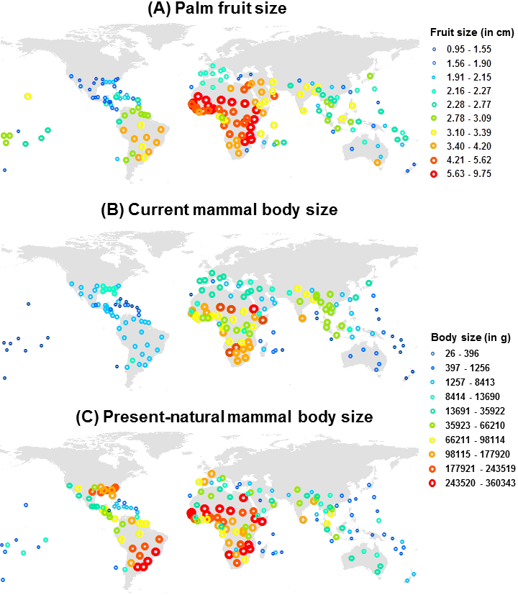
Figure 2.
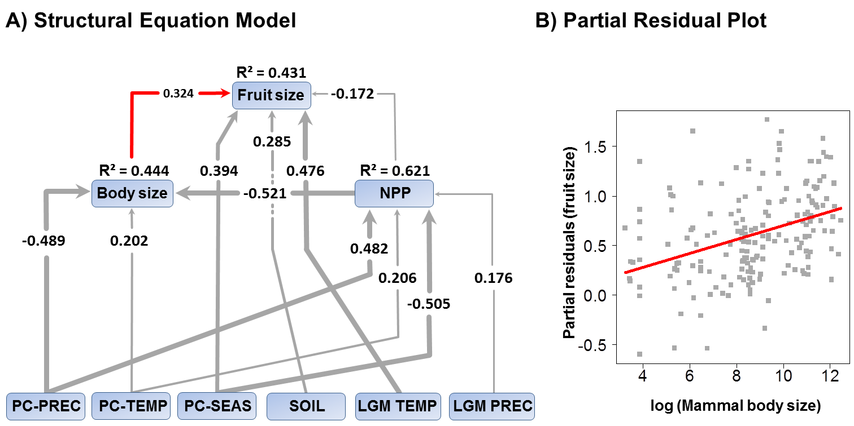
Figure 3.
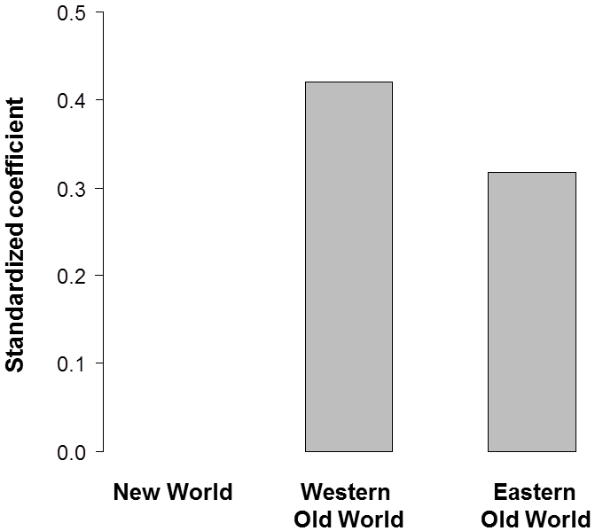
Figure 4.
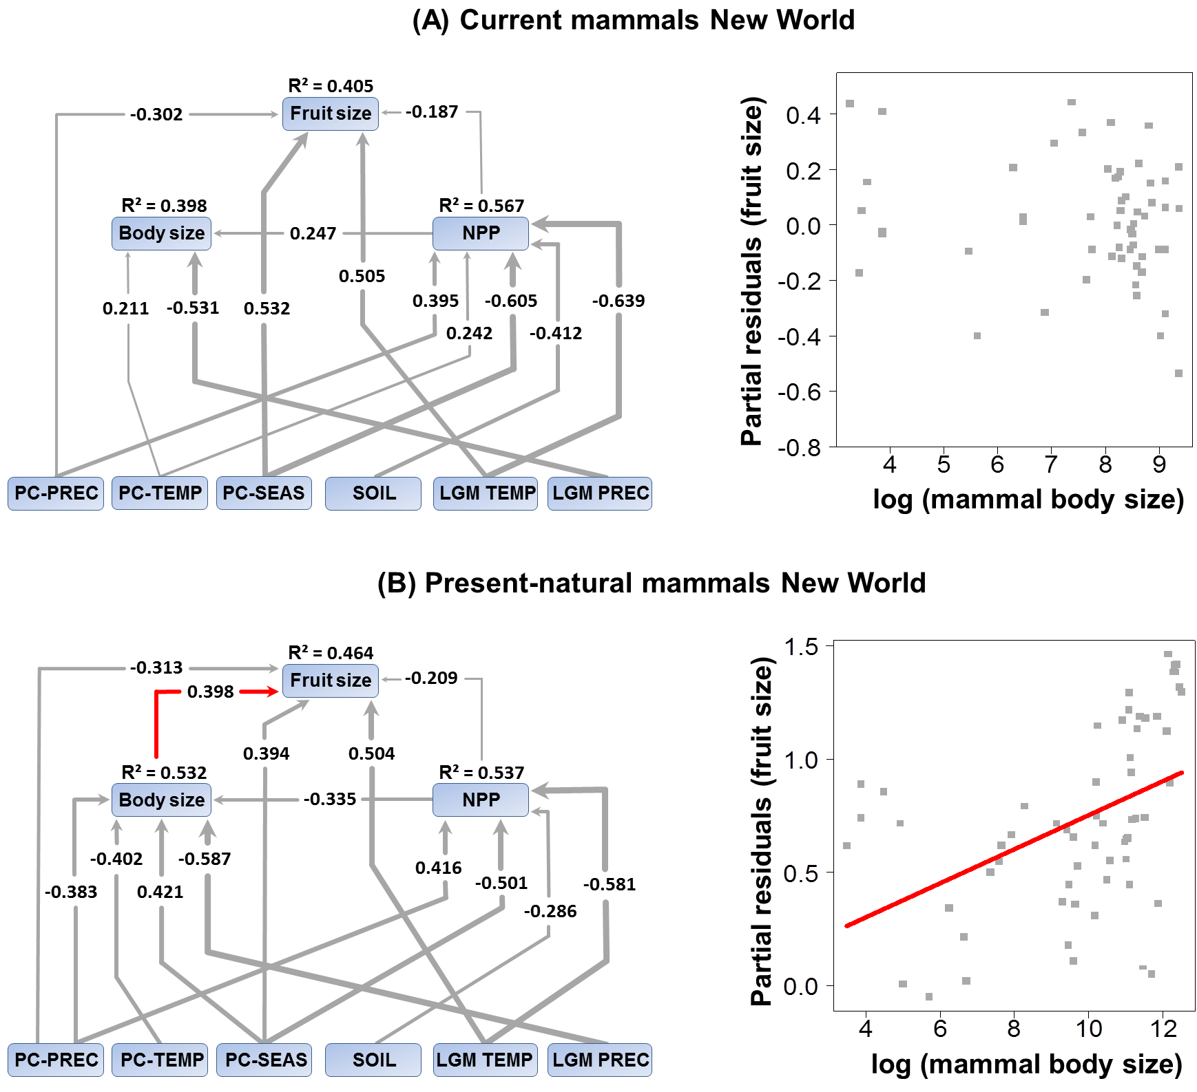
Appendix S1. Data sources
Table S1. The table shows all used palm species of the dataset (n = 2467) and attendant references which had been used to fulfill the values for average fruit size (length). For those species we were not able to find any literature sources (n = 669, marked with ‘—‘) we calculated the mean of congeners to estimate the value for the missing species.
Table S2. For each genus (n = 183), the number of all species, the number of species for which fruit size has been estimated, and the trait variation (mean, median and standard deviation SD) for all species with available data is given. Note that SD is not available for genera with only one species.
Table S3. Table shows the largest present-natural mammal species and their potential weight (in g) for each of the major biogeographical realms (New World, Western and Eastern Old World). Only mammal species are listed which occur in ≥5 TDWG level 3 units in which also palms occur.
Appendix S2. Supplementary methods
Figure S1. Map shows the geographic units as defined by the International Working Group on Taxonomic Databases (TDWG level 3 units) and the assignment of each TDWG level 3 unit to a major biogeographical realms (New World, n = 61 TDWG units; Western Old World, n = 62; Eastern Old World, n = 64).
Figure S2. Results of the structural equation models (SEM) of current frugivorous mammals within the Western Old World (A) and Eastern Old World (B) showing direct and indirect effects of biotic and abiotic drivers on the response variables palm fruit size, mammal body size and net primary productivity (NPP). All arrows illustrate statistically significant effects and values show standardized coefficients, with arrow thickness being proportional to effect strength. R²–values show the explained variance of the response variable. On the right partial residual plots illustrate the relationship between assemblage-level mean fruit sizes of palms and mammal body sizes with current distributions for the Western (C) and Eastern Old World (D) when all other predictor variables in the multi-predictor model are statistically accounted for. Abbreviations of predictor and response variables can be found in Table 1.
Figure S3. Barplots showing the results of structural equation models (SEMs) focusing on the direct, positive statistically significant relationships (standardized path coefficients) between assemblage means for mammal body sizes and palm fruit sizes. Effects are illustrated for current mammal ranges on a global scale (GLO, n = 187 TDWG units), for the New World (NW, n = 61), Western Old World (OWW, n = 62) and Eastern Old World (OWE, n = 64). The barplots are shown for all frugivorous mammals (A, n = 1806 species), for fruit specialists (B, n = 1578), for partial frugivores (C, n = 194) and for opportunists (D, n = 34). Specialists represent mammals with fruits as major important diet, partial frugivores with fruits as intermediate and opportunists with fruits as minor important diet.
Figure S4. Moran’s I correlograms of the raw trait data (white circles), of the residuals of the non-spatial OLS models (grey dots), and the residuals of the SAR model (black dots) for the three response variables (A, B: fruit size; C, D: body size; E, F: NPP) within the SEM models. This is illustrated for current mammal ranges (left) and present-natural mammal ranges (right).

