|  |  |
| --- | --- |
| **제출일** | **2017.12.04** |
| **학부** | **컴퓨터공학부** |
| **담당교수** | **최광남 교수님** |
| **팀번호** | **팀 5** |

**Team Project**



**Table of contents**

1. **Outline of program**
2. **Design of program**
3. **Capture of Execution Screen**
4. **Spending time**
5. **Process of project and record of project meeting**
6. **Member’s thoughts**
7. **Outline of program**  
   This program is a program that recognizes characters in the image or the characters through images captured with a webcam, encrypts the characters to generate QR codes, decrypts the original characters using encrypted QR codes and key values.

In summary, this program is a combination of image processing and cryptography.

1. **Design of program**
2. **Character mapping.**Tesseract-OCR is used to recognize characters in an image and then map each character to a different type of 3x3 matrix.

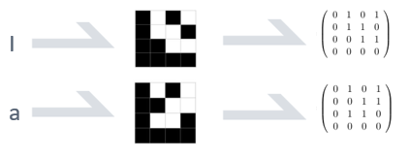

1. **Create tree.**  
   Considering the size of recognized characters, create a tree and put the characters in the tree in turn.

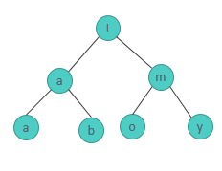

1. **Make the new text by traversal.**  
   It traverses the tree according to the key value (1. Pre-order, 2. In-order, 3. Post-order) to create a new sequence of characters.

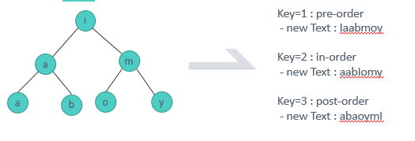

1. **Mapping the table.**  
   The size of the QR code depends on the length of the characters. Then, the characters mapped to the 3x3 matrix are arranged in the form of a snail, and then the remaining portion is filled with a 3x3 matrix designated at random.

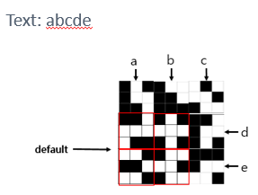

1. **Convert the table to tree.**  
   The QR code is used to read the 3x3 matrix in which each character is stored in the order of the snail shape. If a default 3x3 matrix is ​​recognized, the character is ignored.

After creating the empty tree, enter the characters read through the QR code into the tree according to the key value.

1. **Read the text from tree.**  
   It reads the result tree sequentially and outputs the decrypted characters.

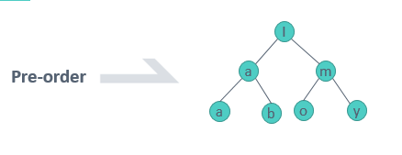

1. **Capture of Execution screen**
2. **Main screen**

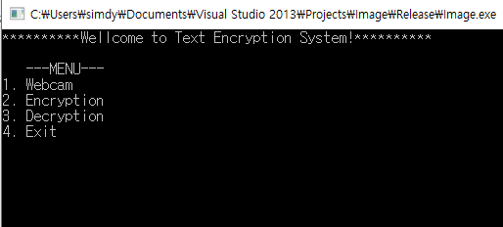

1. **Encryption**

Test Image, key=1





Result QR code

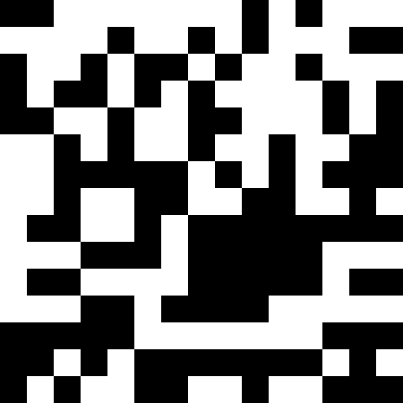

1. **Decryption**

Test QR code, key=1



Result text



1. **Spending Time**

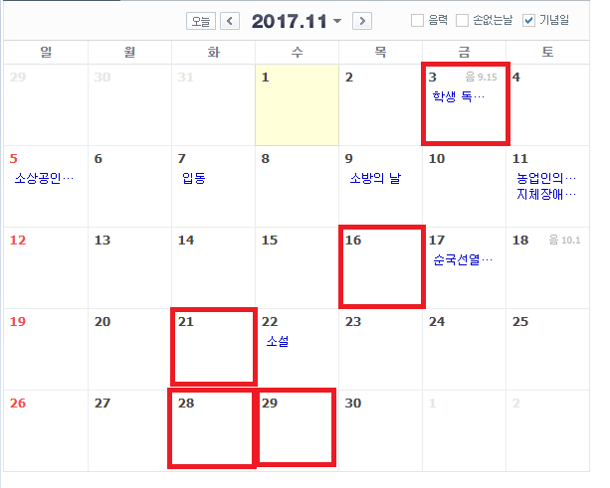

Develop Webcam Function

Functional integration

Develop Decryption Function

Develop Encryption Function

To form a Project Idea

1. **Process of project and record of project meeting**

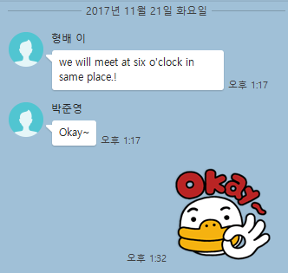

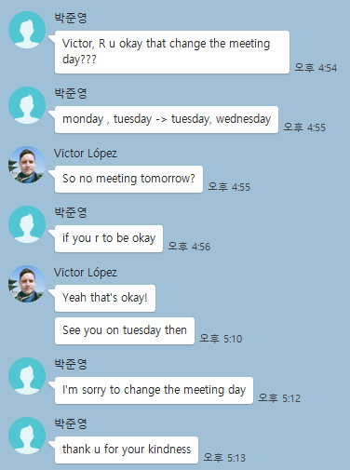

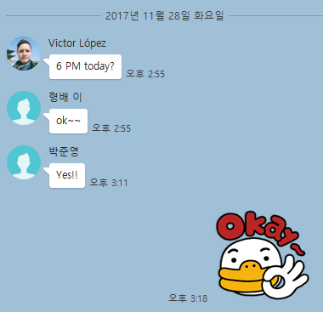

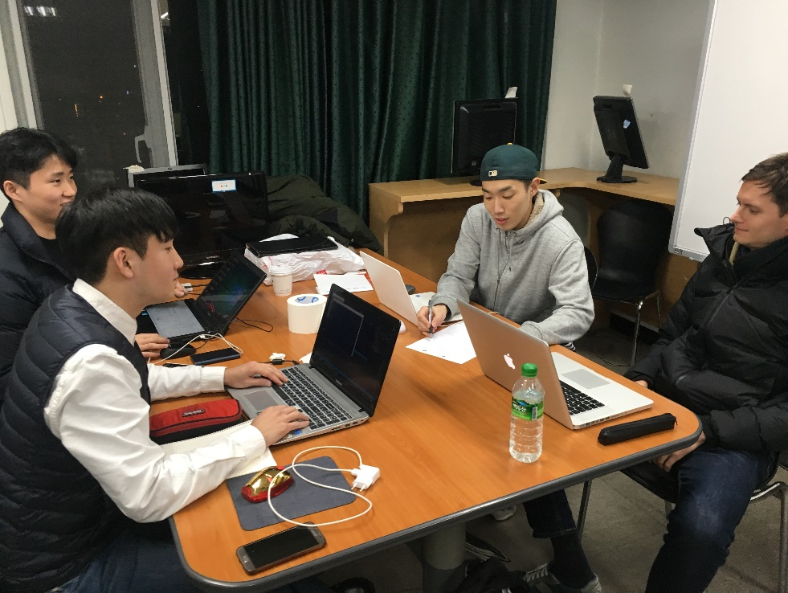

1. **Member’s thoughts**

**Hyungbae, Lee:** During this project, I found out why my professor asked me to do projects with foreign students. As with other team members, I was able to learn many things while I was working on the project with victor, for example, English conversation, and foreign culture. It seemed like we were doing projects in a foreign company while we were working on the project. Thanks to the team's ideas and efforts, the project was smoothly completed. It was so good that I had a really good team member and a interesting project in the last semester.

**Yongseok, Shim**: Before starting this project and implementing the theme, I was worried that I could implement this topic exactly as we thought it would be. But we used what we learned in practice, talked about problems with our team members and solved the problems we faced in turn, so the outcome we had in mind was complete. I was very proud and I felt a great sense of accomplishment.

**Junyoung, Park**: The project set itself different from the previous project. While communicating with Victor in English, It was difficult at first, but I got used to it. This is the second time to do a foreigner and a team, but it was very nice experience to have a image processing lecture. Also, working together to produce good results made me feel happy.

**Victor Lopez:** I think the project was interesting because it gave us an opportunity to use some of our aquired skills from the Image Processing class. Also it was a valuable experience interacting with external image processing libraries such as OpenCV and Tesseract. Although we mainly used them for input, output and character recognition and implemented the encryption and decryption algorithms ourselves. I think everybody in the team worked hard and contributed to the final result.