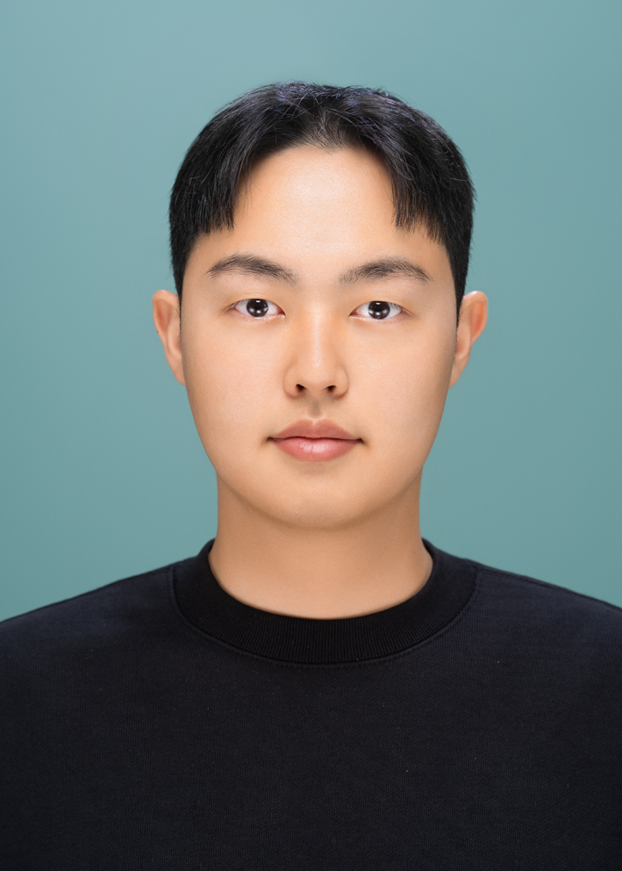
JUNYOUNG KWON
Seoul National University of Science and Technology (SeoulTech)
Department of Computer Science and Engineering, Junior (3rd Year, 2nd Semester)
Email: junoung6215@gmail.com | Phone: +82-10-4176-6374

EDUCATION
Bachelor of Science in Computer Science and Engineering
Seoul National University of Science and Technology (SeoulTech) | Expected Graduation: February 2027
- GPA: 3.95/4.5
- Transferred from the Department of Environmental Engineering to Computer Science and Engineering (Spring 2022)
- Academic Excellence Scholarship (2nd Year, 2nd Semester)

RESEARCH INTERESTS
Machine Learning for Financial Markets, Financial Time Series Modeling, Portfolio Optimization & Decision Analytics
Internships
Research Intern
Korea Institute of Science and Technology (KIST) | July 2025 - August 2025
- Developed gait analysis system using 5 pressure sensors at the Bionics Research Center
- Discovered and resolved critical Endian byte-order bug in sensor data processing pipeline through meticulous raw data analysis
- Refactored legacy C# codebase (7,500 → 5,250 lines, 30% reduction), improving system performance and maintainability
- Authored and presented an academic poster at the 2025 Fall Conference of the Korean Society for Precision Engineering (Bio-Health 25APP09-033)
PUBLICATIONS & PRESENTATIONS
Kim Choong Hyun, Kim Jin Wook, Lee Dong Wook, Jang Tae Won, Joo Yoon Jin, Kwon Jun young. (2025). "Gait Disorder Analysis Using Ground Reaction Force." Korean Society for Precision Engineering 2025 Fall Conference, Poster Presentation, November 14, 2025.

AWARDS
- Samsung AI Challenge : 2nd Place (Excellence Prize, KRW 5,000,000)
Recognized for outstanding performance in the Visual Rich Document Understanding Competition (2025).
- Seoul National University of Science and Technology – Excellence Award for Field Training Essay (Encouragement Prize)
Received an Encouragement Award for outstanding internship reflection essay based on field training experience at KIST Bionics Research Center .(2025)
- Academic Excellence Scholarship (Tuition 20% Reduction)
Awarded by Seoul National University of Science and Technology for academic excellence (Fall 2024).

PROJECT EXPERIENCE
Samsung AI Challenge Award
Visually- rich Document Understanding Competition| July 2025- August 2025
- Performed document understanding tasks using multimodal deep learning approaches
- Developed detection algorithms for text extraction from complex document layouts
- Developed reading order algorithms for complex document layouts
- Awarded Excellence Prize (KRW 5,000,000) for outstanding performance

LG Aimers 6th Hackathon: Pregnancy Success Prediction for Infertility Patients (Top 9%)
DACON Hackathon, LG AI Research | January 2025 - February 2025
- Led team project predicting pregnancy outcomes using medical data with 30%+ missing values
- Applied statistical significance testing and KNN-based imputation for robust data preprocessing
- Implemented domain-knowledge-driven feature engineering based on medical literature review
- Achieved ROC-AUC score of 0.741, ranking in top 9% among all participants

AI-based Investment Assistant Chatbot (1st Place among 80+ participants)
Open-Source Software Course Project | September 2024 - December 2024
- Developed AI chatbot using LangChain and RAG (Retrieval-Augmented Generation) to address hallucination issues
- Built data pipeline integrating Yahoo Finance, NewsAPI, and RSS feeds for real-time financial data
- Implemented FAISS vector database with optimized embedding dimensions and chunking strategies
- Automated multilingual news translation and normalization using LLM-based preprocessing

Media
Featured in SeoulTech Department of Computer Science News (2025)
SeoulTech student team recognized with the Excellence Prize (2nd Place) at the 2025 Samsung AI Challenge
TECHNICAL SKILLS
Programming Languages: Python, C++, C#, Java
Data Analysis & ML: NumPy, Pandas, Scikit-learn, PyTorch, TensorFlow, Matplotlib, Seaborn
Mathematical Foundation: Linear Algebra, Discrete Mathematics, Calculus (Probability & Statistics planned for Spring 2026)

ADDITIONAL EXPERIENCE
LG Aimers 6th Education Program
LG AI Research | 2024
- Completed comprehensive ML curriculum covering supervised/unsupervised learning, deep learning, and AI ethics
- Gained hands-on experience with algorithm selection, hyperparameter tuning, and ensemble methods
- Developed practical understanding of ML model optimization using Optuna and cross-validation techniques

Personal Investment Portfolio Management
2021 - Present
- Achieved 22.8% annual compound return (2021-2025), outperforming S&P 500 by 8.06%
LANGUAGES
Korean (Native), English (TOEIC 840, Fluent in reading academic papers and financial news)
REFERENCES
Prof. Sunglok Choi
Department of Computer Science and Engineering
Seoul National University of Science and Technology (SeoulTech)
Research Areas: Robotics, Autonomous Driving, 3D Computer Vision, Artificial Intelligence
Office: Mirae Building, Room 327
-Tel: +82-2-970-6708
Email: sunglok@seoultech.ac.kr

