Week3 2022145156 김준영
사용 프로그램: MATLAB R2023b
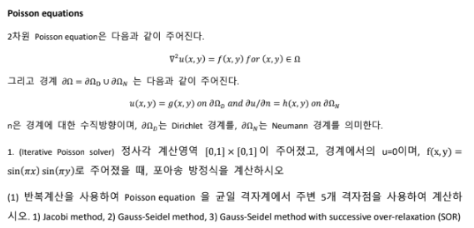
1) Jacobi method
-code
%% Poisson: jacobi
clear; clc;

% 변수 설정
N = 64; tol = 1e-8; maxit = 5e5;
% 그리드
h = 1/(N+1);
x = linspace(0,1,N+2);
y = linspace(0,1,N+2);

% f(x,y)
F = zeros(N+2,N+2);
for j = 1:N+2
for i = 1:N+2
F(i,j) = sin(pi*x(i))*sin(pi*y(j)); % 함수 정의
end
end

% Initialization
u = zeros(N+2,N+2); % 변수 설정
unew = u;

% bnorm = ||f||
bnorm = 0.0;
for j = 2:N+1
for i = 2:N+1
bnorm = bnorm + F(i,j)^2;
end
end
if bnorm == 0, bnorm = 1; end
bnorm = sqrt(bnorm);

res_hist = zeros(maxit,1); %잔차 행렬
t0 = tic; %계산 시간 측정 시작

% Jacobi iteration
for k = 1:maxit
for j = 2:N+1
for i = 2:N+1
unew(i,j) = 0.25 * (u(i+1,j) + u(i-1,j) + u(i,j+1) + u(i,j-1) - (h^2)*F(i,j) );
end
end

% 잔차 계산
res = 0.0;
for j = 2:N+1
for i = 2:N+1
Lap_ij = (unew(i+1,j) + unew(i-1,j) + unew(i,j+1) + unew(i,j-1)- 4*unew(i,j) ) / (h^2);
rij = F(i,j) - Lap_ij;
res = res + rij^2;
end
end
rrel = sqrt(res)/bnorm;
res_hist(k) = rrel; %잔차 행렬

u = unew;

if rrel < tol
res_hist = res_hist(1:k);
break;
end
end
t_elapsed = toc(t0); %계산 시간 측정 끝

% performance
fprintf('Jacobi (loops): N=%d, iters=%d, rel residual=%.3e, time=%.3fs\n', ...
N, numel(res_hist), res_hist(end), t_elapsed);

%Plots (iteration,residual)
figure; semilogy(res_hist,'-o','LineWidth',1); grid on;
xlabel('iteration'); ylabel('relative residual');
title(sprintf('Jacobi residual history (N=%d)',N));

%Plots
figure;
surf(x,y,u'); shading interp; colorbar; view(30,30);
title('u(x,y)'); xlabel x; ylabel y;

-answer
Jacobi (loops): N=64, iters=15765, rel residual=1.000e-08, time=0.866s

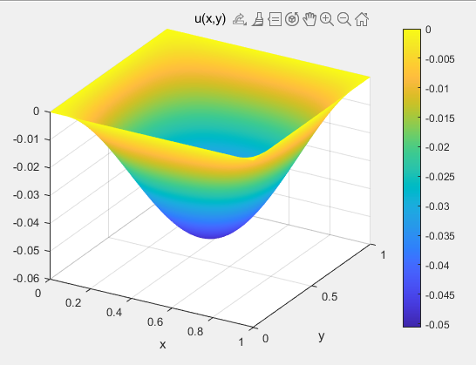
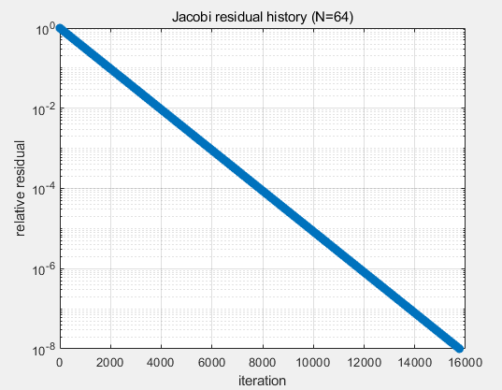
<iteration vs 잔차>
<u 그래프>

2) Gauss-Seidal method
-code
%% Poisson: gauss-seidel
clear; clc;

% 변수 설정
N = 64; % interior points per direction
tol = 1e-8; % relative residual tolerance
maxit = 5e5; % max iterations

% 그리드
h = 1/(N+1);
x = linspace(0,1,N+2);
y = linspace(0,1,N+2);

% f(x,y)
F = zeros(N+2,N+2);
for j = 1:N+2
for i = 1:N+2
F(i,j) = sin(pi*x(i))*sin(pi*y(j)); % 함수 정의
end
end

% Initialization
u = zeros(N+2,N+2); % in-place update

% bnorm = ||f|| (interior)
bnorm = 0.0;
for j = 2:N+1
for i = 2:N+1
bnorm = bnorm + F(i,j)^2;
end
end
if bnorm == 0, bnorm = 1; end
bnorm = sqrt(bnorm);

res_hist = zeros(maxit,1); %잔차 행렬
t0 = tic; %계산 시간 측정 시작

% Gauss-Seidel iteration (좌->우, 하->상 스윕)
for k = 1:maxit
for j = 2:N+1
for i = 2:N+1
u(i,j) = 0.25 * (u(i+1,j) + u(i-1,j) + u(i,j+1) + u(i,j-1) - (h^2)*F(i,j) );
end %갱신된 값을 바로 사용
end

% 잔차 = f - Lap(u)
res = 0.0;
for j = 2:N+1
for i = 2:N+1
Lap_ij = (u(i+1,j)+u(i-1,j)+u(i,j+1)+u(i,j-1)-4*u(i,j))/(h^2);
rij = F(i,j) - Lap_ij;
res = res + rij^2;
end
end
rrel = sqrt(res)/bnorm;
res_hist(k) = rrel; %잔차 행렬

if rrel < tol
res_hist = res_hist(1:k);
break;
end
end
t_elapsed = toc(t0); %계산 시간 측정 끝

% performance
fprintf('gauss–Seidel method: N=%d, iters=%d, rel residual=%.3e, time=%.3fs\n', ...
N, numel(res_hist), res_hist(end), t_elapsed);

% Plots
figure; semilogy(res_hist,'-o','LineWidth',1); grid on;
xlabel('iteration'); ylabel('relative residual');
title(sprintf('Gauss-Seidel residual history (N=%d)',N));

figure;
surf(x,y,u'); shading interp; colorbar; view(30,30);
title('u(x,y) - Gauss-Seidel'); xlabel x; ylabel y;

-answer
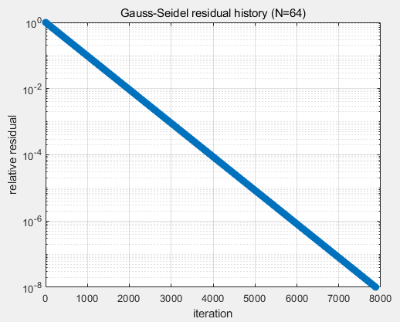
gauss–Seidel method: N=64, iters=7884, rel residual=9.988e-09, time=0.472s
<iteration vs 잔차>
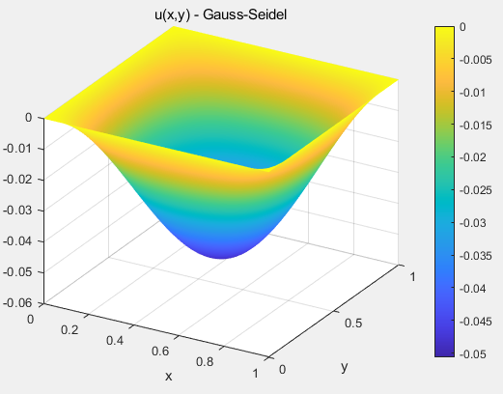
<u 그래프>
3) Gauss-Seidal method with successive over-relaxation (SOR)
-code
%% Poisson: SOR (Gauss-Seidel + over-relaxation)
clear; clc;

% 변수 설정
N = 64; tol = 1e-5;
maxit = 5e5;
omega = 1.85;
% 그리드
h = 1/(N+1);
x = linspace(0,1,N+2);
y = linspace(0,1,N+2);

% f(x,y)
F = zeros(N+2,N+2);
for j = 1:N+2
for i = 1:N+2
F(i,j) = sin(pi*x(i))*sin(pi*y(j)); % 함수 정의
end
end

% Initialization
u = zeros(N+2,N+2); % in-place update

% bnorm = ||f|| (interior)
bnorm = 0.0;
for j = 2:N+1
for i = 2:N+1
bnorm = bnorm + F(i,j)^2;
end
end
if bnorm == 0, bnorm = 1; end
bnorm = sqrt(bnorm);

res_hist = zeros(maxit,1);
t0 = tic;

% SOR iteration (in-place)
for k = 1:maxit
for j = 2:N+1
for i = 2:N+1
u_GS = 0.25 * ( u(i+1,j) + u(i-1,j) + u(i,j+1) + u(i,j-1) - (h^2)*F(i,j) );
u(i,j) = (1-omega)*u(i,j) + omega*u_GS; %SOR
end
end

% residual r = f - Lap(u)
res = 0.0;
for j = 2:N+1
for i = 2:N+1
Lap_ij = (u(i+1,j)+u(i-1,j)+u(i,j+1)+u(i,j-1)-4*u(i,j))/(h^2);
rij = F(i,j) - Lap_ij;
res = res + rij^2;
end
end
rrel = sqrt(res)/bnorm;
res_hist(k) = rrel;

if rrel < tol
res_hist = res_hist(1:k);
break;
end
end
t_elapsed = toc(t0);

% performance
fprintf('gauss–Seidel method(SOR): N=%d, iters=%d, rel residual=%.3e, time=%.3fs\n', ...
N, numel(res_hist), res_hist(end), t_elapsed);

% Plots
figure; semilogy(res_hist,'-o','LineWidth',1); grid on;
xlabel('iteration'); ylabel('relative residual');
title(sprintf('SOR(\\omega=%.2f) residual history (N=%d)',omega,N));

figure;
surf(x,y,u'); shading interp; colorbar; view(30,30);
title(sprintf('u(x,y) - SOR (\\omega=%.2f)',omega)); xlabel x; ylabel y;

-answer
gauss–Seidel method(SOR): N=64, iters=374, rel residual=9.742e-06, time=0.097s

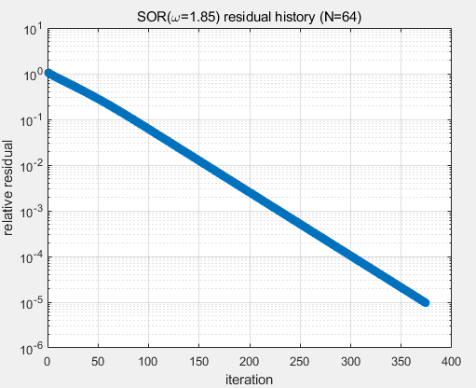
<iteration vs 잔차>
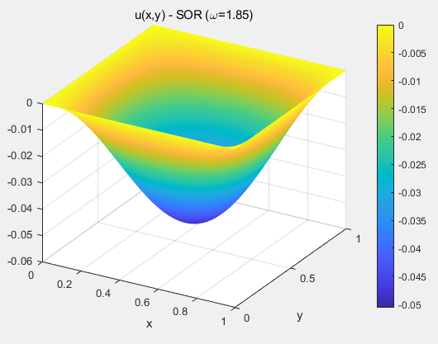
<u 그래프>
Jacobi (loops): N=64, iters=15765, rel residual=1.000e-08, time=0.866s
gauss–Seidel method: N=64, iters=7884, rel residual=9.988e-09, time=0.472s
gauss–Seidel method(SOR): N=64, iters=374, rel residual=9.742e-06, time=0.097s

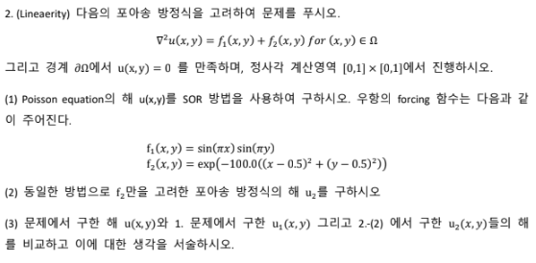
-code
%% Linearity test for Poisson via SOR
clear; clc;

% 변수 설정
N = 64;
tol = 1e-5;
maxit = 5e5;
omega = 1.90;
% 그리드
h = 1/(N+1);
x = linspace(0,1,N+2);
y = linspace(0,1,N+2);
[X,Y] = meshgrid(x,y);

% 함수 정의
F1 = sin(pi*X).*sin(pi*Y);
F2 = exp(-100*((X-0.5).^2 + (Y-0.5).^2));
F12 = F1 + F2;

% (1) f1+f2를 한 번에 계산한 u 계산
[u12, hist12] = sor_poisson(F12, N, h, tol, maxit, omega);

% (2) f2만으로 u2 계산
[u2, hist2 ] = sor_poisson(F2, N, h, tol, maxit, omega);

% (2)-1 f1만으로 u1 계산 (위에서 진행했던 것을 함수로만 정리)
[u1, hist1 ] = sor_poisson(F1, N, h, tol, maxit, omega);
% (3) 선형성 비교
lin_err_rel = norm(u12(2:end-1,2:end-1) - (u1(2:end-1,2:end-1)+u2(2:end-1,2:end-1)),'fro') / ...
norm(u12(2:end-1,2:end-1),'fro');

fprintf('Linearity check: ||u(f1+f2) - (u(f1)+u(f2))|| / ||u(f1+f2)|| = %.3e\n', lin_err_rel);

% 잔차 비교
figure; semilogy(hist1,'-','LineWidth',1); hold on;
semilogy(hist2,'--','LineWidth',1);
semilogy(hist12,'-.','LineWidth',1); grid on;
xlabel('iteration'); ylabel('relative residual');
legend('f1','f2','f1+f2'); title(sprintf('SOR(\\omega=%.2f) residual histories',omega));

% 각각 해 비교
figure; subplot(1,3,1); contourf(x,y,u1',20,'LineStyle','none'); colorbar; axis equal tight; title('u_1 (f_1)');
subplot(1,3,2); contourf(x,y,u2',20,'LineStyle','none'); colorbar; axis equal tight; title('u_2 (f_2)');
subplot(1,3,3); contourf(x,y,u12',20,'LineStyle','none'); colorbar; axis equal tight; title('u (f_1+f_2)');

figure; contourf(x,y,(u12-(u1+u2))',20,'LineStyle','none'); colorbar; axis equal tight;
title('u - (u_1+u_2) (선형성 잔차)');

% SOR 함수(위에서 했던 코드를 함수로 만듦)
function [u, res_hist] = sor_poisson(F, N, h, tol, maxit, omega)
u = zeros(N+2,N+2);

% ||f|| (interior)
b2=0;
for j=2:N+1,
for i=2:N+1
b2 = b2 + F(i,j)^2;
end
end
if b2==0, b2=1
end
bnorm = sqrt(b2);

res_hist = zeros(maxit,1);
for k = 1:maxit
for j = 2:N+1
for i = 2:N+1
uGS = 0.25*( u(i+1,j) + u(i-1,j) + u(i,j+1) + u(i,j-1) - h^2*F(i,j) );
u(i,j) = (1-omega)*u(i,j) + omega*uGS;
end
end
% residual r = f - Lap(u)
r2=0;
for j=2:N+1
for i=2:N+1
Lap = (u(i+1,j)+u(i-1,j)+u(i,j+1)+u(i,j-1)-4*u(i,j))/(h^2);
rij = F(i,j) - Lap; r2 = r2 + rij^2;
end
end
rrel = sqrt(r2)/bnorm; res_hist(k) = rrel;
if rrel < tol
res_hist = res_hist(1:k);
break;
end
end
end
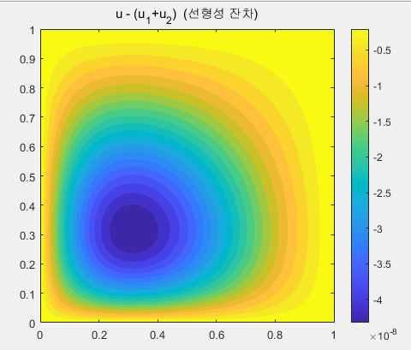
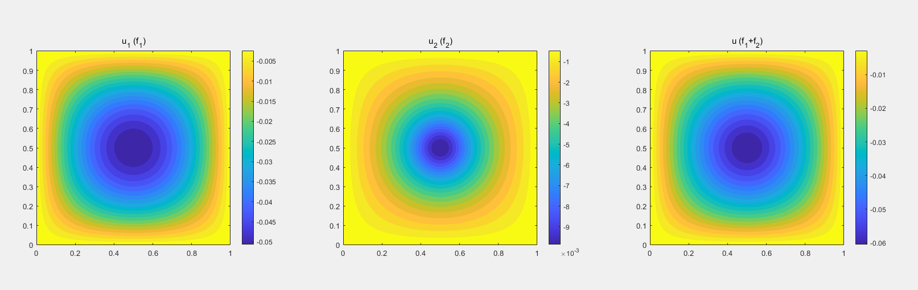
<u1, u2, u 그래프>
<위치별 잔차 분석>

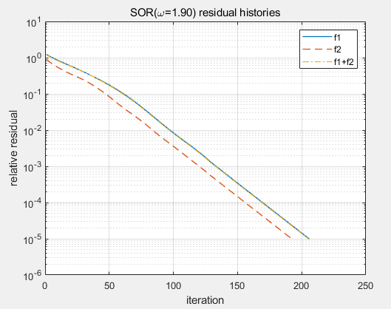
<iteration vs 잔차 그래프>
=> 결과적으로 분해를 해서 u1, u2를 각각 구해서 합하거나, f1, f2를 합해서 한 번에 u를 구하거나 해가 거의 일치한다. 따라서 복잡한 강제항을 가지더라도 단순한 항으로 쪼개어 계산을 한 후 합할 수 있다는 것을 알 수 있다.

