Week3 2022145156 김준영
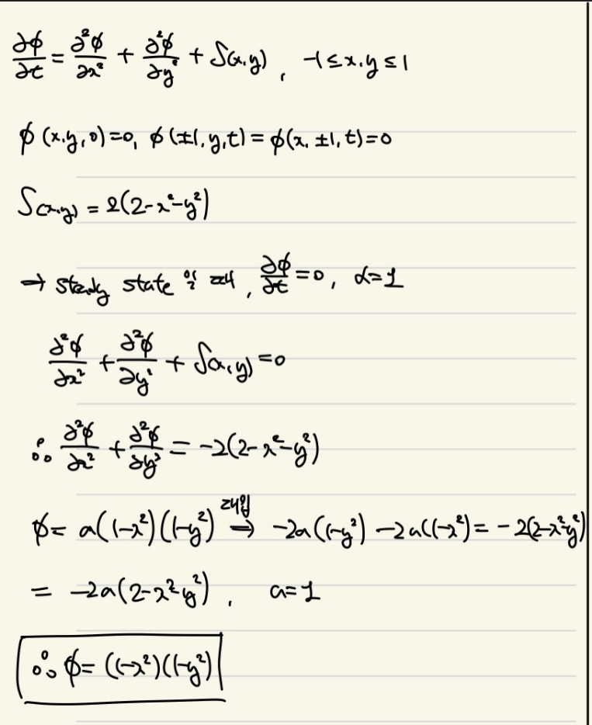
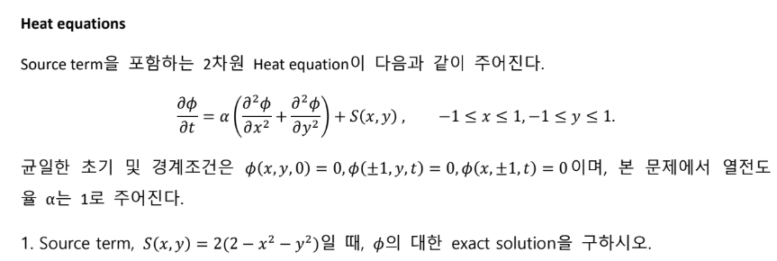
사용 프로그램: MATLAB R2023b

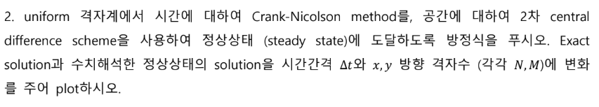
-code
clear; clc; close all;

%% -------- 기본 설정 --------
a = 1.0; % thermal diffusivity
tol_ss = 1e-10; % 정상상태(고정점) 판정 기준: ||u^{n+1}-u^n||_inf
maxSteps = 2e5; % 안전장치
Mser = 61; Nser = 61; % 정해(정상상태) 급수의 모드 수

% (A) 기본 케이스(표면 비교/오차 시각화)
Nx0 =61; Ny0 = 61; dt0 = 1e-2;

% (B) Δt 변화에 따른 수렴속도/오차
dt_list = [2e-3 5e-3 1e-2 2e-2 5e-2];

% (C) 격자(공간) 수렴 (Ny=Nx로 동일 증가)
Nx_list = [16 32 48 64 96]; Ny_list = Nx_list;
dt_for_hconv = 1e-2;

%% -------- (A) 수치해 vs 정해(정상상태) --------
[xi, yi, X, Y, Sxy] = make_grid_and_source(Nx0,Ny0);

[U_num, steps] = crank_nicolson_to_steady(Nx0,Ny0,dt0,a,Sxy,tol_ss,maxSteps);
U_num = reshape(U_num, Nx0, Ny0).'; % (Ny x Nx)

U_ex = exact_steady_on_grid(xi, yi, Mser, Nser); % (Ny x Nx)
E = U_num - U_ex;

fprintf('[Base] Nx=%d, Ny=%d, dt=%.3g -> steps=%d, ||err||_inf=%.3e\n', ...
Nx0,Ny0,dt0,steps,norm(E(:),inf));

figure(1);
surf(X,Y,U_num,'EdgeColor','none'); view(35,30); colorbar;
xlabel('x'); ylabel('y'); zlabel('\phi_{num}');
title(sprintf('Numerical steady state (CN), N=(%d,%d), dt=%.3g',Nx0,Ny0,dt0));

figure(2);
surf(X,Y,U_ex,'EdgeColor','none'); view(35,30); colorbar;
xlabel('x'); ylabel('y'); zlabel('\phi_{exact,ss}');
title(sprintf('Exact steady-state series, modes (%d,%d)',Mser,Nser));

figure(3);
surf(X,Y,abs(E),'EdgeColor','none'); view(35,30); colorbar;
xlabel('x'); ylabel('y'); zlabel('|error|');
title('Absolute error: | \phi_{num} - \phi_{exact,ss} |');

%% -------- (B) Δt 변화: 수렴속도(스텝 수) & 오차 --------
steps_dt = zeros(size(dt_list));
err_dt = zeros(size(dt_list));

U_ex_base = U_ex; % 동일 격자에서의 정해-정상상태

for k = 1:numel(dt_list)
dt = dt_list(k);

% 수치해 계산
[Uvec, steps] = crank_nicolson_to_steady(Nx0,Ny0,dt,a,Sxy,tol_ss,maxSteps);
U = reshape(Uvec, Nx0, Ny0).'; % (Ny x Nx)

% 오차
tmp = U - U_ex_base;
err_dt(k) = norm(tmp(:), inf);
steps_dt(k) = steps;

fprintf('dt=%.3g: steps=%d, ||err||_inf=%.3e\n', dt, steps, err_dt(k));
end

figure(4);
loglog(dt_list, max(err_dt,eps), 'o-','LineWidth',1.5); grid on;
xlabel('\Delta t'); ylabel('||error||_\infty');
title('Error vs \Delta t (steady state)');

%% ---- 시간 차수 검증 (고정된 시간에서) ----
NxT = 96; NyT = 96; % 충분히 촘촘하게
[xiT, yiT, ~, ~, SxyT] = make_grid_and_source(NxT,NyT);
tstar = 0.2; % 비교할 고정 시간
dt_listT = [1e-3 2e-3 5e-3 1e-2 2e-2]; % 여러 Δt

% t*의 정해(1번에서 유도한 시간 의존 해) - 급수 모드 수
Mser = 61; Nser = 61;
U_exact_t = exact_time_on_grid(xiT, yiT, tstar, Mser, Nser); % (NyT x NxT)

err_dt = zeros(size(dt_listT));
for k=1:numel(dt_listT)
dt = dt_listT(k);
Uvec = crank_nicolson_to_time(NxT,NyT,dt,1.0,SxyT,tstar); % 아래 함수 추가
U = reshape(Uvec, NxT, NyT).';
tmp = U - U_exact_t;
err_dt(k) = norm(tmp(:), inf);
fprintf('dt=%.3g -> ||err(t*)||_inf = %.3e\n', dt, err_dt(k));
end

figure(6);
loglog(dt_listT, max(err_dt,eps),'o-','LineWidth',1.5); grid on;
xlabel('\Delta t'); ylabel('||error at t^*||_\infty');
title('Temporal order at fixed t^*');

p_time = polyfit(log(dt_listT), log(max(err_dt,eps)), 1);
fprintf('Observed temporal order ~ %.3f (expected ~2 for CN)\n', -p_time(1));

%% -------- (C) 공간 수렴: ||err|| vs h --------
err_h = zeros(size(Nx_list));
hlist = zeros(size(Nx_list));

for k = 1:numel(Nx_list)
Nx = Nx_list(k); Ny = Ny_list(k);
[xi, yi, ~, ~, Sxy] = make_grid_and_source(Nx,Ny);
[U, steps] = crank_nicolson_to_steady(Nx,Ny,dt_for_hconv,a,Sxy,tol_ss,maxSteps); %#ok<ASGLU>
U = reshape(U, Nx, Ny).';
Uex = exact_steady_on_grid(xi, yi, Mser, Nser);
hx = 2/(Nx+1); hy = 2/(Ny+1);
hlist(k) = max(hx,hy);
temp1=U - Uex;
err_h(k) = norm(temp1(:), inf);
fprintf('N=(%d,%d): h=%.4f, ||err||_inf=%.3e\n', Nx,Ny,hlist(k),err_h(k));
end
figure(5);
loglog(hlist, max(err_h,eps), 'o-','LineWidth',1.5); grid on;
xlabel('h (max(h_x,h_y))'); ylabel('||error||_\infty');
title('Spatial convergence (expect ~O(h^2))');

%% ===================== 보조 함수들 =====================

function [xi, yi, X, Y, Sxy] = make_grid_and_source(Nx,Ny)
% 내부 격자점 (Dirichlet 0 경계는 제외)
hx = 2/(Nx+1); hy = 2/(Ny+1);
xi = (-1+hx) : hx : (1-hx); % 1 x Nx
yi = (-1+hy) : hy : (1-hy); % 1 x Ny
[X,Y] = meshgrid(xi, yi); % (Ny x Nx)
Sxy = 2*(2 - X.^2 - Y.^2); % source on interior grid
end

function [u, steps] = crank_nicolson_to_steady(Nx,Ny,dt,a,Sxy,tol_ss,maxSteps)
% Crank–Nicolson: (I - dt/2*A) u^{n+1} = (I + dt/2*A) u^n + dt*b
% A = a*(kron(Iy,Lx) + kron(Ly,Ix)), Dirichlet 0 (interior unknowns만)
hx = 2/(Nx+1); hy = 2/(Ny+1);
ex = ones(Nx,1); ey = ones(Ny,1);
Lx = spdiags([ex -2*ex ex], -1:1, Nx, Nx) / hx^2;
Ly = spdiags([ey -2*ey ey], -1:1, Ny, Ny) / hy^2;
Ix = speye(Nx); Iy = speye(Ny);
A = a*(kron(Iy,Lx) + kron(Ly,Ix)); % size (Nx*Ny) x (Nx*Ny)
Ntot = Nx*Ny; I = speye(Ntot);
LHS = (I - 0.5*dt*A);
RHS = (I + 0.5*dt*A);
b = Sxy(:); % time-independent source
u = zeros(Ntot,1);
steps = 0;
% 미리 분해(반복 루프에서 빠르게)
[Lfac, Ufac, P, Q] = lu(LHS); % sparse LU

for n = 1:maxSteps
rhs = RHS*u + dt*b;
u_new = Q*(Ufac \ (Lfac \ (P*rhs)));
steps = n;
if norm(u_new - u, inf) < tol_ss
u = u_new; break;
end
u = u_new;
end
end

function Uex = exact_steady_on_grid(xi, yi, Mser, Nser)
% 정상상태 정해 (t->∞):
% phi_ss = sum_{m,n>=1} [ S_mn / ( (pi^2/4)*(m^2+n^2) ) ] * sin(mπ(x+1)/2)*sin(nπ(y+1)/2)
% where S_mn = (64/π^4)*(1-(-1)^m)*(1-(-1)^n)*(1/(m^3 n)+1/(m n^3))
[X,Y] = meshgrid(xi, yi);
Uex = zeros(size(X));
pi2 = pi^2; % just for speed
for m = 1:Mser
fm = 1 - (-1)^m; % 0 (짝수) or 2 (홀수)
if fm==0, continue; end
sx = sin(m*pi*(X+1)/2);
for n = 1:Nser
fn = 1 - (-1)^n;
if fn==0, continue; end
Smn = (64/pi^4) * (fm*fn) * (1/(m^3*n) + 1/(m*n^3));
coeff = Smn / ( (pi2/4)*(m^2+n^2) );
Uex = Uex + coeff * sx .* sin(n*pi*(Y+1)/2);
end
end
end

function U = exact_time_on_grid(xi, yi, t, Mser, Nser)
[X,Y] = meshgrid(xi, yi);
U = zeros(size(X));
for m=1:Mser
fm = 1-(-1)^m; if fm==0, continue; end
sx = sin(m*pi*(X+1)/2);
for n=1:Nser
fn = 1-(-1)^n; if fn==0, continue; end
Smn = (64/pi^4)*(fm*fn)*(1/(m^3*n)+1/(m*n^3));
lam = (pi^2/4)*(m^2+n^2);
coeff= Smn/lam * (1 - exp(-lam*t));
U = U + coeff * sx .* sin(n*pi*(Y+1)/2);
end
end
end

function u = crank_nicolson_to_time(Nx,Ny,dt,a,Sxy,tstar)
hx = 2/(Nx+1); hy = 2/(Ny+1);
ex = ones(Nx,1); ey = ones(Ny,1);
Lx = spdiags([ex -2*ex ex], -1:1, Nx, Nx) / hx^2;
Ly = spdiags([ey -2*ey ey], -1:1, Ny, Ny) / hy^2;
Ix = speye(Nx); Iy = speye(Ny);
A = a*(kron(Iy,Lx) + kron(Ly,Ix));
Ntot = Nx*Ny; I = speye(Ntot);
LHS = (I - 0.5*dt*A); RHS = (I + 0.5*dt*A);
b = Sxy(:);
u = zeros(Ntot,1);
nsteps = ceil(tstar/dt);
[Lfac,Ufac,P,Q] = lu(LHS);
for n=1:nsteps
rhs = RHS*u + dt*b;
u = Q*(Ufac\(Lfac\(P*rhs)));
end
end
-answer
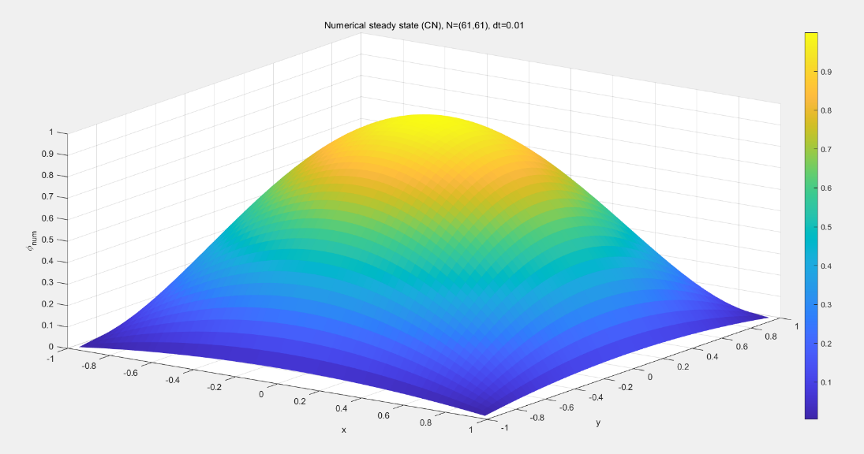
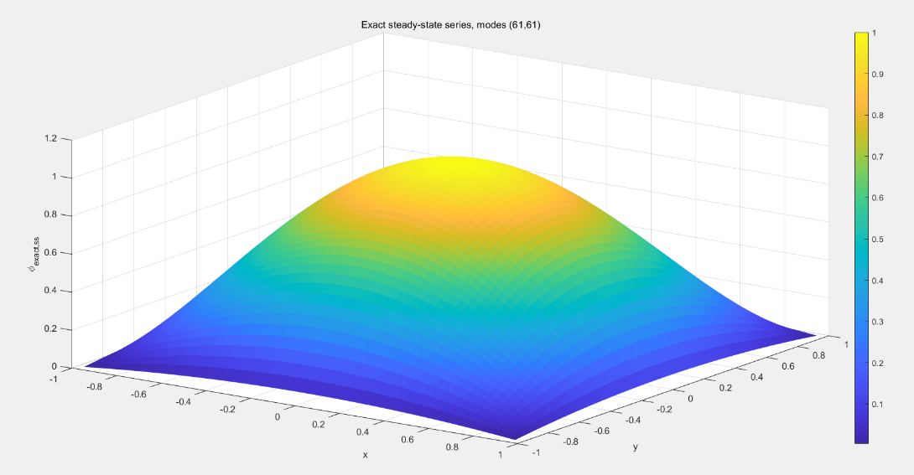
<numerical solution(steady state), N=M=61,dt=0.01>
<exact solution(steady state) N=M=61,dt=0.01>
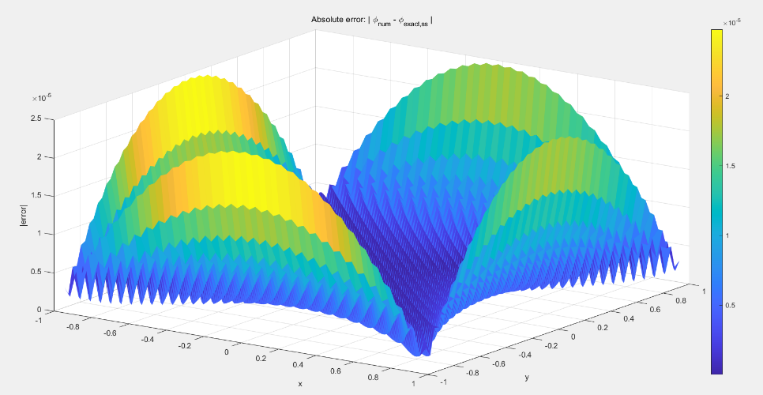
<두 해의 error, N=M=61, dt=0.01>
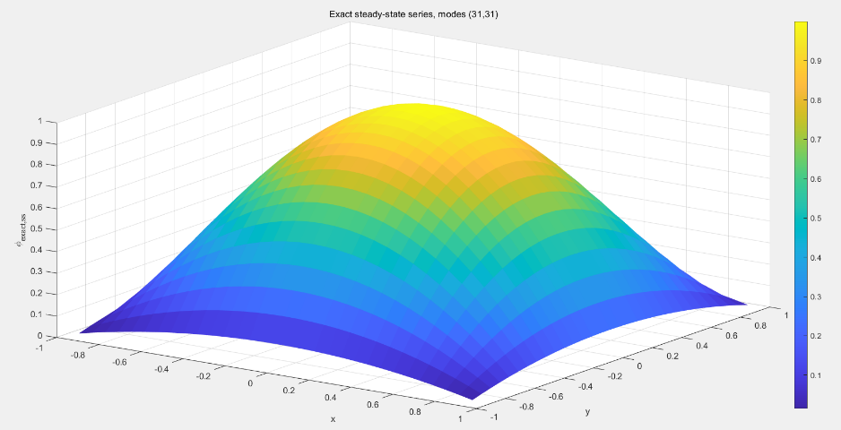
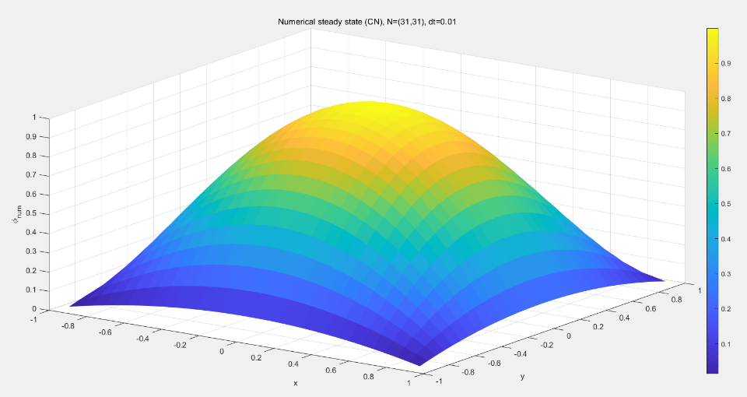
< numerical solution(steady state), N=M=31,dt=0.01>
<exact solution(steady state) N=M=31,dt=0.01>
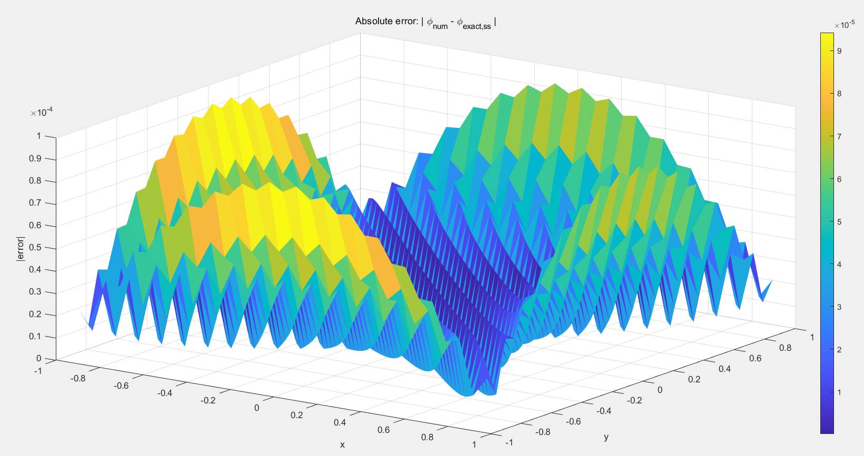
<두 해의 error, N=M=31, dt=0.01>

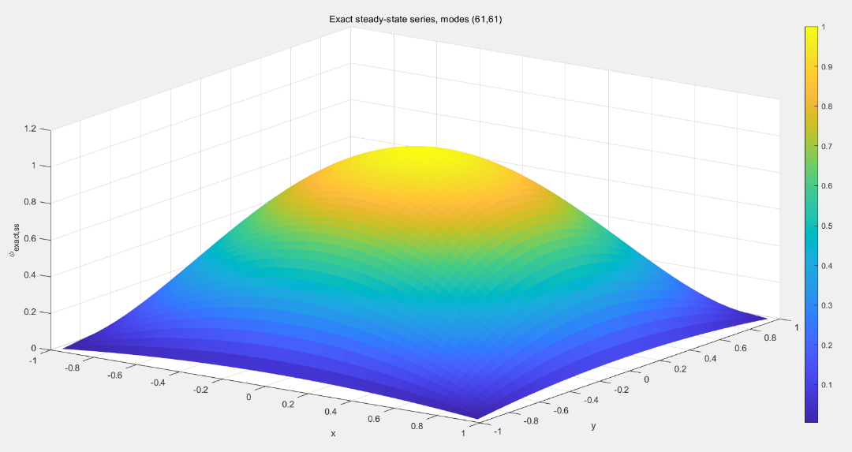
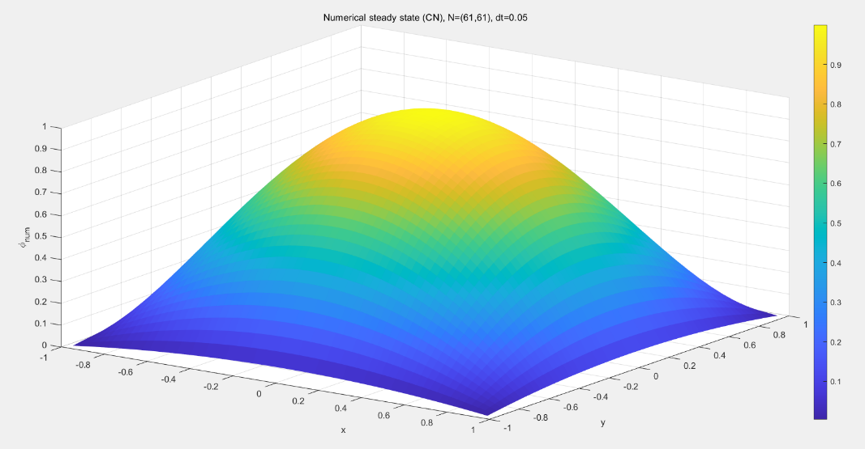
<numerical solution(steady state), N=M=61,dt=0.05>
<exact solution(steady state) N=M=61,dt=0.05>
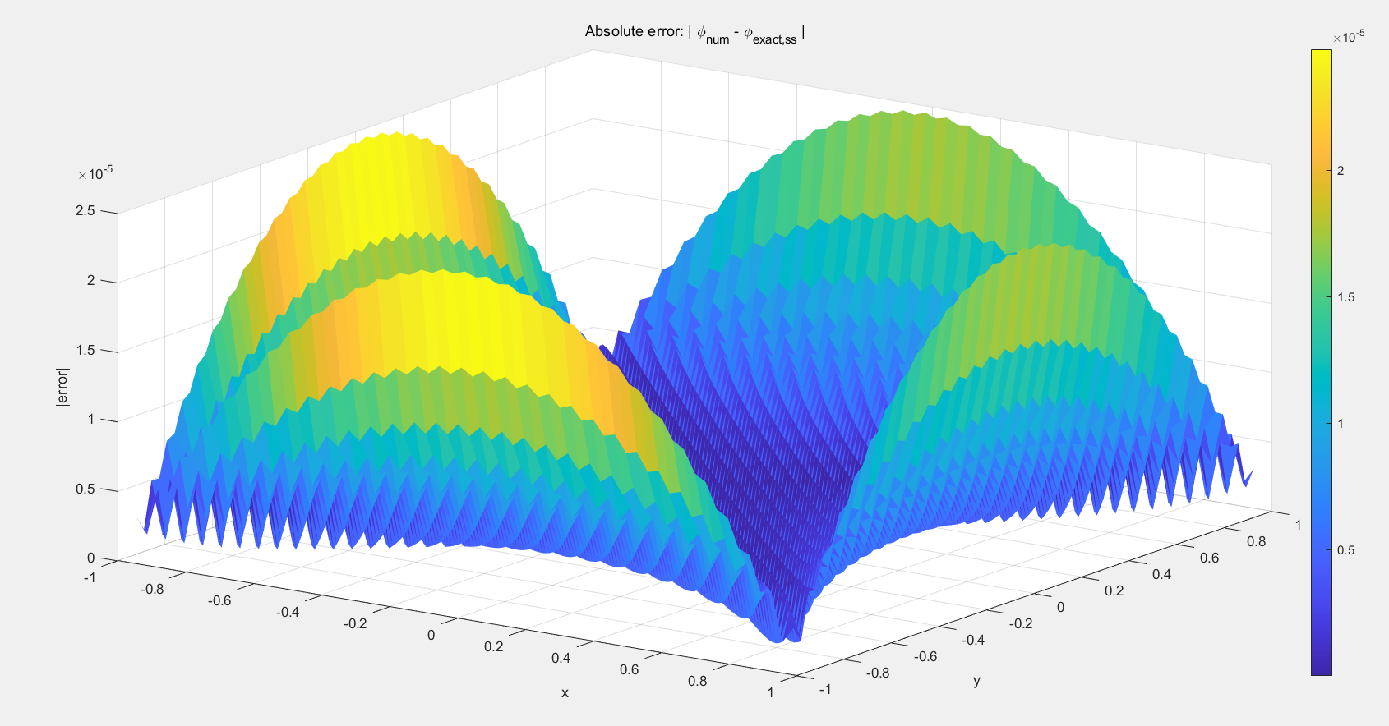
<두 해의 error, N=M=61, dt=0.05>

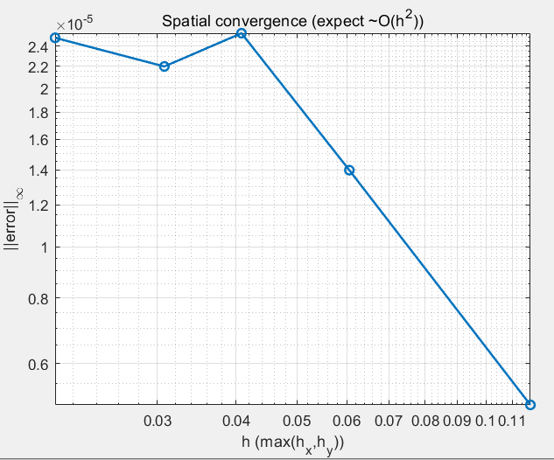
-answer
<공간에 대한 error>
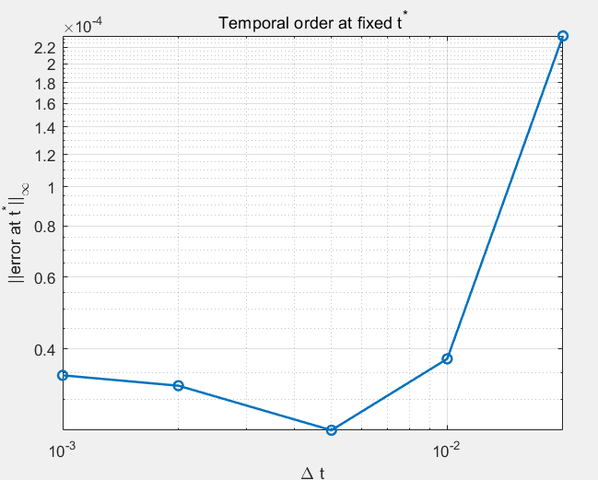
<고정된 시간(t=0.2)에 대한 error>

