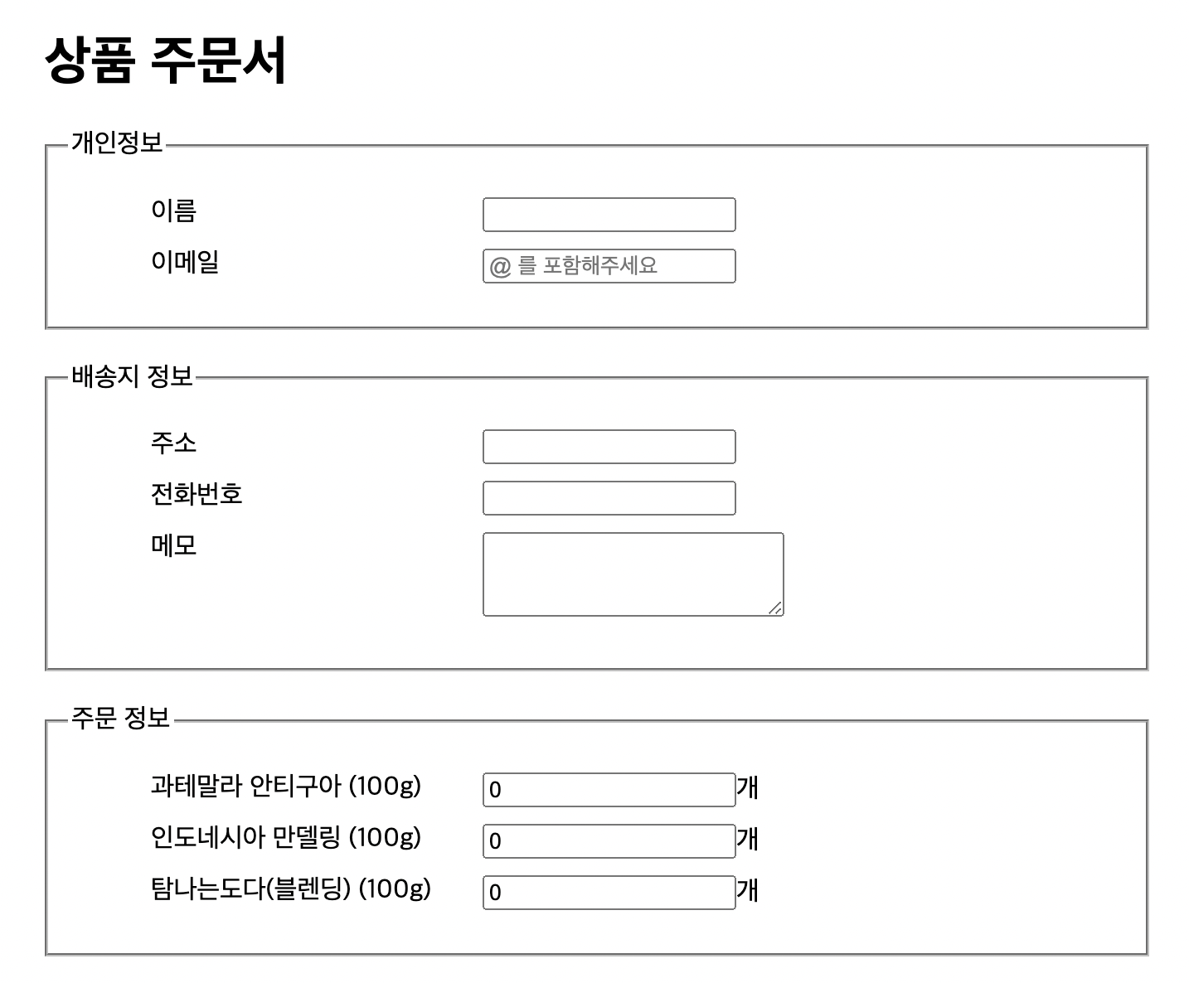

<!DOCTYPE html>

<html lang="en">

<head>

<meta charset="UTF-8" />

<meta http-equiv="X-UA-Compatible" content="IE=edge" />

<meta name="viewport" content="width=device-width, initial-scale=1.0" />

<title>Document</title>

</head>

<style>

ul {

list-style: none;

}

li {

margin: 10px;

}

li label {

float: left;

}

fieldset {

margin: 20px;

}

h1 {

margin: 20px;

}

label {

width: 200px;

}

</style>

<body>

<h1>상품 주문서</h1>

<form>

<fieldset>

<legend>개인정보</legend>

<ul>

<li>

<label>이름</label>

<input type="text" id="name" required />

</li>

<li>

<label>이메일</label>

<input type="email" id="email" placeholder="@ 를 포함해주세요" required />

</li>

</ul>

</fieldset>

<fieldset>

<legend>배송지 정보</legend>

<ul>

<li>

<label>주소</label>

<input type="text" id="address" required />

</li>

<li>

<label>전화번호</label>

<input type="tel" id="tel" required />

</li>

<li>

<label>메모</label>

<textarea cols="20" rows="3" name="con"></textarea>

</li>

</ul>

</fieldset>

<fieldset>

<legend>주문 정보</legend>

<ul>

<li>

<label>과테말라 안티구아 (100g) </label>

<input type="number" value="0" />개

</li>

<li>

<label>인도네시아 만델링 (100g) </label>

<input type="number" value="0" />개

</li>

<li>

<label>탐나는도다(블렌딩) (100g) </label>

<input type="number" value="0" />개

</li>

</ul>

</fieldset>

</form>

</body>

</html>